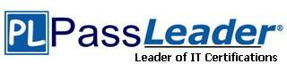

**Vendor:** Microsoft

**Exam Code:** AZ-104

**Exam Name:** Microsoft Azure Administrator

**Version:** 22.092

Important Notice

**Product**

Our Product Manager keeps an eye for Exam updates by Vendors. Free update is available within One year after your purchase.

You can login member center and download the latest product anytime. (Product downloaded from member center is always the latest.)

PS: Ensure you can pass the exam, please check the latest product in 2-3 days before the exam again.

**Feedback**

## We devote to promote the product quality and the grade of service to ensure customers interest.

If you have any questions about our product, please provide Exam Number, Version, Page Number, Question Number, and your Login Account to us, please contact us at [support@passleader.com](mailto:support@passleader.com) and our technical experts will provide support in 24 hours.

**Copyright**

The product of each order has its own encryption code, so you should use it independently.

If anyone who share the file we will disable the free update and account access.

Any unauthorized changes will be inflicted legal punishment. We will reserve the right of final explanation for this statement.

Order ID: ****************

PayPal Name: ****************

PayPal ID: ****************

### QUESTION 1

Hotspot Question

You have Azure virtual machines that run Windows Server 2019 and are configured as shown in the following table.

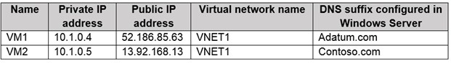

You create a private Azure DNS zone named adatum.com. You configure the adatum.com zone to allow auto registration from VNET1.

Which A records will be added to the adatum.com zone for each virtual machine? To answer, select the appropriate options in the answer area.

NOTE: Each correct selection is worth one point.

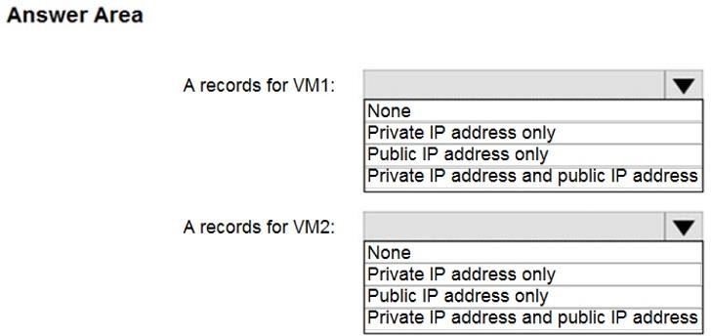

**Answer:**

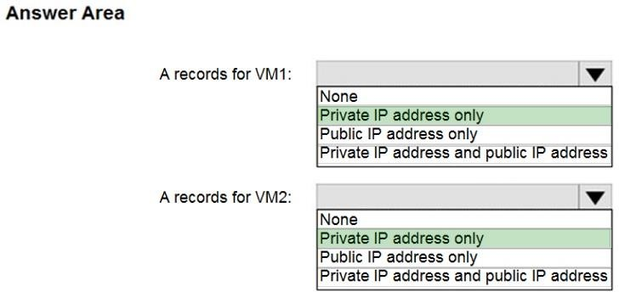

**Explanation:**

The virtual machines are registered (added) to the private zone as A records pointing to their private IP addresses.

Reference:

https://docs.microsoft.com/en-us/azure/dns/private-dns-overview https://docs.microsoft.com/en-us/azure/dns/private-dns-scenarios

### QUESTION 2

You plan to deploy three Azure virtual machines named VM1, VM2, and VM3. The virtual machines will host a web app named App1.

You need to ensure that at least two virtual machines are available if a single Azure datacenter becomes unavailable.

What should you deploy?

|  |  |
| --- | --- |
| A. | all three virtual machines in a single Availability Zone |
| B. | all virtual machines in a single Availability Set |
| C. | each virtual machine in a separate Availability Zone |
| D. | each virtual machine in a separate Availability Set |

**Answer:** C

**Explanation:**

Azure makes sure that the VMs you place within an Availability Set run across multiple physical servers, compute racks, storage units, and network switches.

Protecting the app from a data center outage would (imho) require the distribution of VMs among availability zones.

Reference:

https://docs.microsoft.com/en-us/azure/availability-zones/az-overview#availability-zones https://docs.microsoft.com/de-de/azure/virtual-machines/windows/tutorial-availability-sets

### QUESTION 3

You have an Azure virtual machine named VM1 that runs Windows Server 2019.

You save VM1 as a template named Template1 to the Azure Resource Manager library. You plan to deploy a virtual machine named VM2 from Template1.

What can you configure during the deployment of VM2?

|  |  |
| --- | --- |
| A. | operating system |
| B. | administrator username |
| C. | virtual machine size |
| D. | resource group |

**Answer:** D

**Explanation:**

When you deploy a template, you specify a resource group that will contain the resources. Before running the deployment command, create the resource group or during deployment also we can create the resource group. If you try to deploy your own template in the portal, there are 3 available options - "Subscription", "Resource Group", "Location".

### QUESTION 4

You have an Azure subscription that contains an Azure virtual machine named VM1. VM1 runs a financial reporting app named App1 that does not support multiple active instances.

At the end of each month, CPU usage for VM1 peaks when App1 runs.

You need to create a scheduled runbook to increase the processor performance of VM1 at the end of each month.

What task should you include in the runbook?

|  |  |
| --- | --- |
| A. | Add the Azure Performance Diagnostics agent to VM1. |
| B. | Modify the VM size property of VM1. |
| C. | Add VM1 to a scale set. |
| D. | Increase the vCPU quota for the subscription. |
| E. | Add a Desired State Configuration (DSC) extension to VM1. |

**Answer:** E

**Explanation:**

https://docs.microsoft.com/en-us/azure/automation/automation-quickstart-dsc-configuration

### QUESTION 5

**Note: This question is part of a series of questions that present the same scenario. Each question in the series contains a unique solution that might meet the stated goals. Some question sets might have more than one correct solution, while others might not have a correct solution.**

**After you answer a question in this section, you will NOT be able to return to it. As a result, these questions will not appear in the review screen.**

You have an Azure subscription that contains 10 virtual networks. The virtual networks are hosted in separate resource groups.

Another administrator plans to create several network security groups (NSGs) in the subscription.

You need to ensure that when an NSG is created, it automatically blocks TCP port 8080 between the virtual networks.

Solution: You configure a custom policy definition, and then you assign the policy to the subscription.

Does this meet the goal?

|  |  |
| --- | --- |
| A. | Yes |
| B. | No |

**Answer:** A

**Explanation:**

Resource policy definition used by Azure Policy enables you to establish conventions for resources in your organization by describing when the policy is enforced and what effect to take. By defining conventions, you can control costs and more easily manage your resources.

Reference:

https://docs.microsoft.com/en-us/azure/azure-policy/policy-definition

### QUESTION 6

You have two Azure virtual networks named VNet1 and VNet2. VNet1 contains an Azure virtual machine named VM1. VNet2 contains an Azure virtual machine named VM2.

VM1 hosts a frontend application that connects to VM2 to retrieve data. Users report that the frontend application is slower than usual.

You need to view the average round-trip time (RTT) of the packets from VM1 to VM2. Which Azure Network Watcher feature should you use?

|  |  |
| --- | --- |
| A. | IP flow verify |
| B. | Connection troubleshoot |
| C. | Connection monitor |
| D. | NSG flow logs |

**Answer:** C

**Explanation:**

The connection monitor capability monitors communication at a regular interval and informs you of reachability, latency, and network topology changes between the VM and the endpoint Incorrect Answers:

A: The IP flow verify capability enables you to specify a source and destination IPv4 address, port, protocol (TCP or UDP), and traffic direction (inbound or outbound). IP flow verify then tests the communication and informs you if the connection succeeds or fails. If the connection fails, IP flow verify tells you which security rule allowed or denied the communication, so that you can resolve the problem.

B: The connection troubleshoot capability enables you to test a connection between a VM and another VM, an FQDN, a URI, or an IPv4 address. The test returns similar information returned when using the connection monitor capability, but tests the connection at a point in time, rather than monitoring it over time, as connection monitor does.

D: The NSG flow log capability allows you to log the source and destination IP address, port, protocol, and whether traffic was allowed or denied by an NSG.

Reference:

https://docs.microsoft.com/en-us/azure/network-watcher/network-watcher-monitoring-overview

### QUESTION 7

You have an Azure subscription that has a Recovery Services vault named Vault1. The subscription contains the virtual machines shown in the following table:

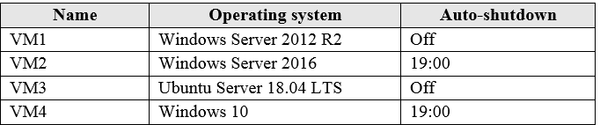

You plan to schedule backups to occur every night at 23:00. Which virtual machines can you back up by using Azure Backup?

|  |  |
| --- | --- |
| A. | VM1 and VM3 only |
| B. | VM1, VM2, VM3 and VM4 |
| C. | VM1 and VM2 only |
| D. | VM1 only |

**Answer:** B

**Explanation:**

Azure Backup supports backup of 64-bit Windows server operating system from Windows Server 2008.

Azure Backup supports backup of 64-bit Windows 10 operating system.

Azure Backup supports backup of 64-bit Ubuntu Server operating system from Ubuntu 12.04. Azure Backup supports backup of VM that are shutdown or offline.

Reference:

https://docs.microsoft.com/en-us/azure/backup/backup-support-matrix-iaas https://docs.microsoft.com/en-us/azure/virtual-machines/linux/endorsed-distros

### QUESTION 8

You have the Azure virtual machines shown in the following table:

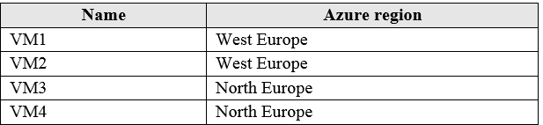

You have a Recovery Services vault that protects VM1 and VM2. You need to protect VM3 and VM4 by using Recovery Services. What should you do first?

|  |  |
| --- | --- |
| A. | Create a new Recovery Services vault |
| B. | Create a storage account |
| C. | Configure the extensions for VM3 and VM4 |
| D. | Create a new backup policy |

**Answer:** A

**Explanation:**

A Recovery Services vault is a storage entity in Azure that houses data. The data is typically copies of data, or configuration information for virtual machines (VMs), workloads, servers, or workstations. You can use Recovery Services vaults to hold backup data for various Azure services.

Reference:

https://docs.microsoft.com/en-us/azure/site-recovery/azure-to-azure-tutorial-enable-replicatio

### QUESTION 9

**Note: This question is part of a series of questions that present the same scenario. Each question in the series contains a unique solution that might meet the stated goals. Some question sets might have more than one correct solution, while others might not have a correct solution.**

**After you answer a question in this section, you will NOT be able to return to it. As a result, these questions will not appear in the review screen.**

You have an Azure subscription that contains the following users in an Azure Active Directory tenant named contoso.onmicrosoft.com:

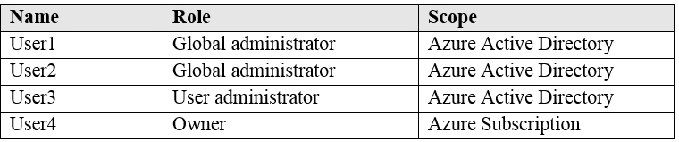

User1 creates a new Azure Active Directory tenant named external.contoso.onmicrosoft.com. You need to create new user accounts in external.contoso.onmicrosoft.com.

Solution: You instruct User2 to create the user accounts. Does that meet the goal?

|  |  |
| --- | --- |
| A. | Yes |
| B. | No |

**Answer:** B

**Explanation:**

When you make a new tenant the global admin who created the new tenant is then added as a global admin for the new tenant (as an external user). BUT any other global admin in the old tenant are not automatically added to the new tenant unless you manually invite them later.

### QUESTION 10

**Note: This question is part of a series of questions that present the same scenario. Each question in the series contains a unique solution that might meet the stated goals. Some question sets might have more than one correct solution, while others might not have a correct solution.**

**After you answer a question in this section, you will NOT be able to return to it. As a result, these questions will not appear in the review screen.**

You have an Azure subscription that contains the following users in an Azure Active Directory tenant named contoso.onmicrosoft.com:



User1 creates a new Azure Active Directory tenant named external.contoso.onmicrosoft.com. You need to create new user accounts in external.contoso.onmicrosoft.com.

Solution: You instruct User4 to create the user accounts. Does that meet the goal?

|  |  |
| --- | --- |
| A. | Yes |
| B. | No |

**Answer:** B

**Explanation:**

Only a global administrator can add users to this tenant. Reference:

https://docs.microsoft.com/en-us/azure/devops/organizations/accounts/add-users-to-azure-ad

### QUESTION 11

**Note: This question is part of a series of questions that present the same scenario. Each question in the series contains a unique solution that might meet the stated goals. Some question sets might have more than one correct solution, while others might not have a correct solution.**

**After you answer a question in this section, you will NOT be able to return to it. As a result, these questions will not appear in the review screen.**

You have an Azure subscription that contains the following users in an Azure Active Directory tenant named contoso.onmicrosoft.com:



User1 creates a new Azure Active Directory tenant named external.contoso.onmicrosoft.com. You need to create new user accounts in external.contoso.onmicrosoft.com.

Solution: You instruct User3 to create the user accounts. Does that meet the goal?

|  |  |
| --- | --- |
| A. | Yes |
| B. | No |

**Answer:** B

**Explanation:**

Only a global administrator can add users to this tenant. Reference:

https://docs.microsoft.com/en-us/azure/devops/organizations/accounts/add-users-to-azure-ad

### QUESTION 12

You have an Azure subscription that contains an Azure Active Directory (Azure AD) tenant named contoso.com and an Azure Kubernetes Service (AKS) cluster named AKS1.

An administrator reports that she is unable to grant access to AKS1 to the users in contoso.com. You need to ensure that access to AKS1 can be granted to the contoso.com users.

What should you do first?

|  |  |
| --- | --- |
| A. | From contoso.com, modify the Organization relationships settings. |
| B. | From contoso.com, create an OAuth 2.0 authorization endpoint. |
| C. | Recreate AKS1. |
| D. | From AKS1, create a namespace. |

**Answer:** B

**Explanation:**

https://kubernetes.io/docs/reference/access-authn-authz/authentication/

### QUESTION 13

You have a Microsoft 365 tenant and an Azure Active Directory (Azure AD) tenant named contoso.com.

You plan to grant three users named User1, User2, and User3 access to a temporary Microsoft SharePoint document library named Library1.

You need to create groups for the users. The solution must ensure that the groups are deleted

automatically after 180 days.

Which two groups should you create? Each correct answer presents a complete solution. NOTE: Each correct selection is worth one point.

|  |  |
| --- | --- |
| A. | an Office 365 group that uses the Assigned membership type |
| B. | a Security group that uses the Assigned membership type |
| C. | an Office 365 group that uses the Dynamic User membership type |
| D. | a Security group that uses the Dynamic User membership type |
| E. | a Security group that uses the Dynamic Device membership type |

**Answer:** AC

**Explanation:**

You can set expiration policy only for Office 365 groups in Azure Active Directory (Azure AD). Note: With the increase in usage of Office 365 Groups, administrators and users need a way to clean up unused groups. Expiration policies can help remove inactive groups from the system and make things cleaner.

When a group expires, all of its associated services (the mailbox, Planner, SharePoint site, etc.) are also deleted.

You can set up a rule for dynamic membership on security groups or Office 365 groups. Incorrect Answers:

B, D, E: You can set expiration policy only for Office 365 groups in Azure Active Directory (Azure AD).

Reference:

https://docs.microsoft.com/en-us/office365/admin/create-groups/office-365-groups-expiration- policy?view=o365-worldwide

### QUESTION 14

You have an Azure policy as shown in the following exhibit:

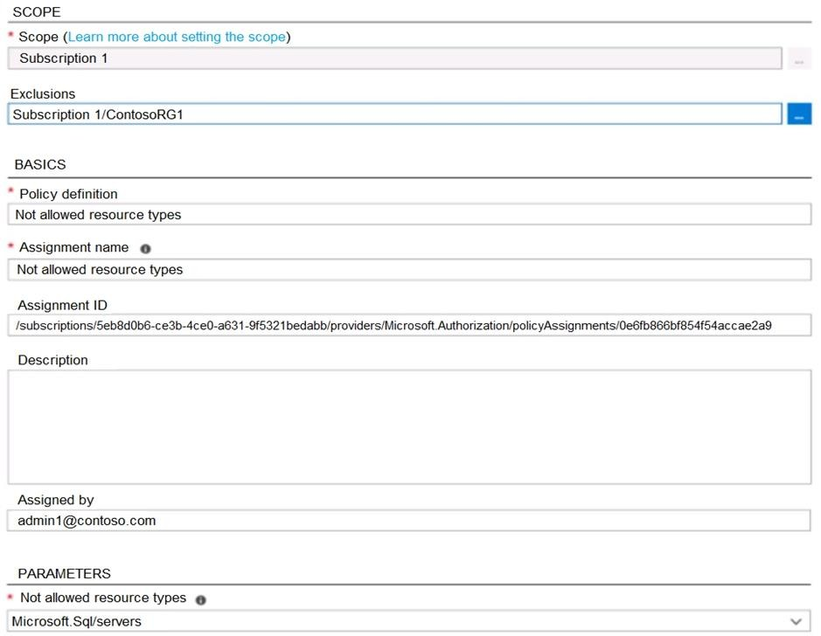

What is the effect of the policy?

|  |  |
| --- | --- |
| A. | You are prevented from creating Azure SQL servers anywhere in Subscription 1. |
| B. | You can create Azure SQL servers in ContosoRG1 only. |
| C. | You are prevented from creating Azure SQL Servers in ContosoRG1 only. |
| D. | You can create Azure SQL servers in any resource group within Subscription 1. |

**Answer:** B

**Explanation:**

You are prevented from creating Azure SQL servers anywhere in Subscription 1 with the exception of ContosoRG1

### QUESTION 15

You have an Azure subscription named AZPT1 that contains the resources shown in the following table:

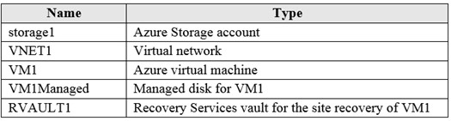

You create a new Azure subscription named AZPT2.

You need to identify which resources can be moved to AZPT2. Which resources should you identify?

|  |  |
| --- | --- |
| A. | VM1, storage1, VNET1, and VM1Managed only |
| B. | VM1 and VM1Managed only |
| C. | VM1, storage1, VNET1, VM1Managed, and RVAULT1 |
| D. | RVAULT1 only |

**Answer:** C

**Explanation:**

You can move a VM and its associated resources to a different subscription by using the Azure portal.

You can now move an Azure Recovery Service (ASR) Vault to either a new resource group within the current subscription or to a new subscription.

Reference:

https://docs.microsoft.com/en-us/azure/azure-resource-manager/management/move-resource- group-and-subscription

https://docs.microsoft.com/en-us/azure/key-vault/general/keyvault-move-subscription

### QUESTION 16

You recently created a new Azure subscription that contains a user named Admin1.

Admin1 attempts to deploy an Azure Marketplace resource by using an Azure Resource Manager template. Admin1 deploys the template by using Azure PowerShell and receives the following error message: "User failed validation to purchase resources. Error message: "Legal terms have not been accepted for this item on this subscription. To accept legal terms, please go to the Azure portal (http:// go.microsoft.com/fwlink/?LinkId=534873) and configure programmatic deployment for the Marketplace item or create it there for the first time."

You need to ensure that Admin1 can deploy the Marketplace resource successfully. What should you do?

|  |  |
| --- | --- |
| A. | From Azure PowerShell, run the Set-AzApiManagementSubscription cmdlet |
| B. | From the Azure portal, register the Microsoft.Marketplace resource provider |
| C. | From Azure PowerShell, run the Set-AzMarketplaceTerms cmdlet |
| D. | From the Azure portal, assign the Billing administrator role to Admin1 |

**Answer:** C

**Explanation:**

https://docs.microsoft.com/en-us/powershell/module/az.marketplaceordering/set- azmarketplaceterms?view=azps-4.1.0

### QUESTION 17

You have an Azure subscription that contains a policy-based virtual network gateway named GW1 and a virtual network named VNet1.

You need to ensure that you can configure a point-to-site connection from an on-premises computer to VNet1.

Which two actions should you perform? Each correct answer presents part of the solution. NOTE: Each correct selection is worth one point.

|  |  |
| --- | --- |
| A. | Add a service endpoint to VNet1 |
| B. | Reset GW1 |
| C. | Create a route-based virtual network gateway |
| D. | Add a connection to GW1 |
| E. | Delete GW1 |
| F. | Add a public IP address space to VNet1 |

**Answer:** CE

**Explanation:**

C: A VPN gateway is used when creating a VPN connection to your on-premises network. Route-based VPN devices use any-to-any (wildcard) traffic selectors, and let routing/forwarding tables direct traffic to different IPsec tunnels. It is typically built on router platforms where each IPsec tunnel is modeled as a network interface or VTI (virtual tunnel interface).

E: Policy-based VPN devices use the combinations of prefixes from both networks to define how traffic is encrypted/decrypted through IPsec tunnels. It is typically built on firewall devices that perform packet filtering. IPsec tunnel encryption and decryption are added to the packet filtering and processing engine.

Incorrect Answers:

F: Point-to-Site connections do not require a VPN device or a public-facing IP address. Reference:

https://docs.microsoft.com/en-us/azure/vpn-gateway/create-routebased-vpn-gateway-portal https://docs.microsoft.com/en-us/azure/vpn-gateway/vpn-gateway-connect-multiple-policybased- rm-ps

### QUESTION 18

You have five Azure virtual machines that run Windows Server 2016. The virtual machines are configured as web servers.

You have an Azure load balancer named LB1 that provides load balancing services for the virtual machines.

You need to ensure that visitors are serviced by the same web server for each request. What should you configure?

|  |  |
| --- | --- |
| A. | Floating IP (direct server return) to Enabled |
| B. | Idle Time-out (minutes) to 20 |
| C. | Protocol to UDP |

|  |  |
| --- | --- |
| D. | Session persistence to Client IP and Protocol |

**Answer:** D

**Explanation:**

With Sticky Sessions when a client starts a session on one of your web servers, session stays on that specific server. To configure An Azure Load-Balancer For Sticky Sessions set Session persistence to Client IP.

On the following image you can see sticky session configuration:

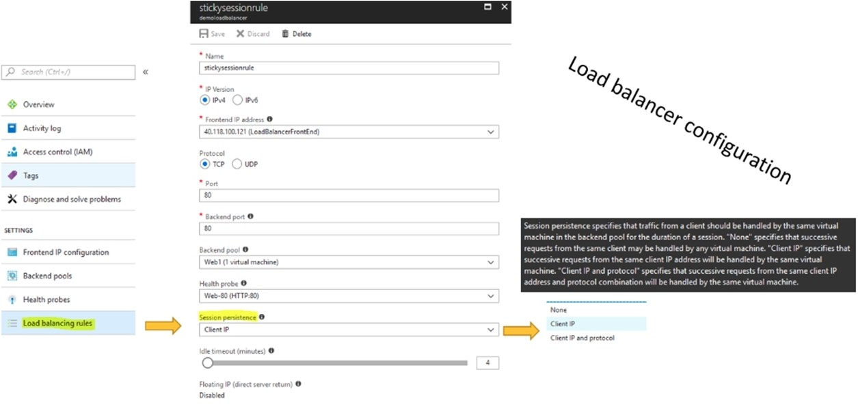

Reference:

https://cloudopszone.com/configure-azure-load-balancer-for-sticky-sessions/

### QUESTION 19

Your on-premises network contains an SMB share named Share1. You have an Azure subscription that contains the following resources:

* A web app named webapp1
* A virtual network named VNET1

You need to ensure that webapp1 can connect to Share1. What should you deploy?

|  |  |
| --- | --- |
| A. | an Azure Application Gateway |
| B. | an Azure Active Directory (Azure AD) Application Proxy |
| C. | an Azure Virtual Network Gateway |

**Answer:** C

**Explanation:**

A Site-to-Site VPN gateway connection can be used to connect your on-premises network to an Azure virtual network over an IPsec/IKE (IKEv1 or IKEv2) VPN tunnel.

This type of connection requires a VPN device, a VPN gateway, located on-premises that has an externally facing public IP address assigned to it.

Incorrect Answers:

B: Application Proxy is a feature of Azure AD that enables users to access on-premises web applications from a remote client.

Reference:

https://docs.microsoft.com/en-us/azure/vpn-gateway/vpn-gateway-howto-site-to-site-resource- manager-portal

### QUESTION 20

You plan to deploy several Azure virtual machines that will run Windows Server 2019 in a virtual machine scale set by using an Azure Resource Manager template.

You need to ensure that NGINX is available on all the virtual machines after they are deployed. What should you use?

|  |  |
| --- | --- |
| A. | Azure Active Directory (Azure AD) Application Proxy |
| B. | Azure Application Insights |
| C. | Azure Custom Script Extension |
| D. | the New-AzConfigurationAssignement cmdlet |

**Answer:** C

### QUESTION 21

You have an Azure web app named webapp1.

Users report that they often experience HTTP 500 errors when they connect to webapp1.

You need to provide the developers of webapp1 with real-time access to the connection errors. The solution must provide all the connection error details.

What should you do first?

|  |  |
| --- | --- |
| A. | From webapp1, enable Web server logging |
| B. | From Azure Monitor, create a workbook |
| C. | From Azure Monitor, create a Service Health alert |
| D. | From webapp1, turn on Application Logging |

**Answer:** A

### QUESTION 22

You have an Azure Active Directory (Azure AD) tenant that contains 5,000 user accounts. You create a new user account named AdminUser1.

You need to assign the User administrator administrative role to AdminUser1. What should you do from the user account properties?

|  |  |
| --- | --- |
| A. | From the Licenses blade, assign a new license |
| B. | From the Directory role blade, modify the directory role |
| C. | From the Groups blade, invite the user account to a new group |

**Answer:** B

**Explanation:**

Assign a role to a user

1. Sign in to the Azure portal with an account that's a global admin or privileged role admin for the directory.
2. Select Azure Active Directory, select Users, and then select a specific user from the list.
3. For the selected user, select Directory role, select Add role, and then pick the appropriate admin roles from the Directory roles list, such as Conditional access administrator.
4. Press Select to save.

Reference:

https://docs.microsoft.com/en-us/azure/active-directory/fundamentals/active-directory-users- assign-role-azure-portal

### QUESTION 23

You have an Azure Active Directory (Azure AD) tenant named contoso.onmicrosoft.com that contains 100 user accounts.

You purchase 10 Azure AD Premium P2 licenses for the tenant.

You need to ensure that 10 users can use all the Azure AD Premium features. What should you do?

|  |  |
| --- | --- |
| A. | From the Licenses blade of Azure AD, assign a license |
| B. | From the Groups blade of each user, invite the users to a group |
| C. | From the Azure AD domain, add an enterprise application |
| D. | From the Directory role blade of each user, modify the directory role |

**Answer:** A

**Explanation:**

https://docs.microsoft.com/en-us/azure/active-directory/fundamentals/license-users-groups

### QUESTION 24

You have an Azure subscription named Subscription1 and an on-premises deployment of Microsoft System Center Service Manager.

Subscription1 contains a virtual machine named VM1.

You need to ensure that an alert is set in Service Manager when the amount of available memory on VM1 is below 10 percent.

What should you do first?

|  |  |
| --- | --- |
| A. | Create an automation runbook |
| B. | Deploy a function app |
| C. | Deploy the IT Service Management Connector (ITSM) |
| D. | Create a notification |

**Answer:** C

**Explanation:**

The IT Service Management Connector (ITSMC) allows you to connect Azure and a supported IT Service Management (ITSM) product/service, such as the Microsoft System Center Service Manager.

With ITSMC, you can create work items in ITSM tool, based on your Azure alerts (metric alerts,

Activity Log alerts and Log Analytics alerts). Reference:

https://docs.microsoft.com/en-us/azure/azure-monitor/platform/itsmc-overview

### QUESTION 25

You have an on-premises server that contains a folder named D:\Folder1.

You need to copy the contents of D:\Folder1 to the public container in an Azure Storage account named contosodata.

Which command should you run?

|  |  |
| --- | --- |
| A. | https://contosodata.blob.core.windows.net/public |
| B. | azcopy sync D:\folder1 https://contosodata.blob.core.windows.net/public -- snapshot |
| C. | azcopy copy D:\folder1 https://contosodata.blob.core.windows.net/public -- recursive |
| D. | az storage blob copy start-batch D:\Folder1 https://contosodata.blob.core.windows.net/public |

**Answer:** C

**Explanation:**

The azcopy copy command copies a directory (and all of the files in that directory) to a blob container. The result is a directory in the container by the same name.

Incorrect Answers:

B: The azcopy sync command replicates the source location to the destination location. However, the file is skipped if the last modified time in the destination is more recent.

D: The az storage blob copy start-batch command copies multiple blobs to a blob container. Reference:

https://docs.microsoft.com/en-us/azure/storage/common/storage-use-azcopy-blobs https://docs.microsoft.com/en-us/azure/storage/common/storage-ref-azcopy-copy

### QUESTION 26

You have an Azure subscription named Subscription1 that contains the storage accounts shown in the following table:

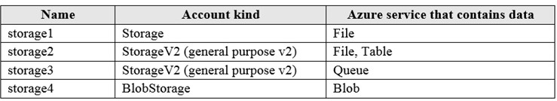

You plan to use the Azure Import/Export service to export data from Subscription1. You need to identify which storage account can be used to export the data.

What should you identify?

|  |  |
| --- | --- |
| A. | storage1 |
| B. | storage2 |
| C. | storage3 |
| D. | storage4 |

**Answer:** D

**Explanation:**

Azure Import/Export service supports the following of storage accounts:

Standard General Purpose v2 storage accounts (recommended for most scenarios) Blob Storage accounts

General Purpose v1 storage accounts (both Classic or Azure Resource Manager deployments), Azure Import/Export service supports the following storage types:

Import supports Azure Blob storage and Azure File storage Export supports Azure Blob storage

Reference:

https://docs.microsoft.com/en-us/azure/storage/common/storage-import-export-requirements

### QUESTION 27

You have an Azure Storage account named storage1. You plan to use AzCopy to copy data to storage1.

You need to identify the storage services in storage1 to which you can copy the data. What should you identify?

|  |  |
| --- | --- |
| A. | blob, file, table, and queue |
| B. | blob and file only |
| C. | file and table only |
| D. | file only |
| E. | blob, table, and queue only |

**Answer:** B

**Explanation:**

AzCopy is a command-line utility that you can use to copy blobs or files to or from a storage account.

Incorrect Answers:

A, C, E: AzCopy does not support table and queue storage services.

D: AzCopy supports file storage services, as well as blob storage services. Reference:

https://docs.microsoft.com/en-us/azure/storage/common/storage-use-azcopy-v10

### QUESTION 28

You have an Azure subscription that contains an Azure Storage account.

You plan to create an Azure container instance named container1 that will use a Docker image named Image1. Image1 contains a Microsoft SQL Server instance that requires persistent storage.

You need to configure a storage service for Container1. What should you use?

|  |  |
| --- | --- |
| A. | Azure Files |
| B. | Azure Blob storage |
| C. | Azure Queue storage |
| D. | Azure Table storage |

**Answer:** A

**Explanation:**

Azure file shares can be used as persistent volumes for stateful containers. Containers deliver "build once, run anywhere" capabilities that enable developers to accelerate innovation. For the containers that access raw data at every start, a shared file system is required to allow these containers to access the file system no matter which instance they run on. https://docs.microsoft.com/en-us/azure/storage/files/storage-files-introduction

### QUESTION 29

You have an Azure virtual machine named VM1 that runs Windows Server 2019. You sign in to VM1 as a user named User1 and perform the following actions:

* Create files on drive C.
* Create files on drive D.
* Modify the screen saver timeout.
* Change the desktop background.

You plan to redeploy VM1.

Which changes will be lost after you redeploy VM1?

|  |  |
| --- | --- |
| A. | the modified screen saver timeout |
| B. | the new desktop background |
| C. | the new files on drive D |
| D. | the new files on drive C |

**Answer:** C

**Explanation:**

For Windows Server, the temporary disk is mounted as “D:\”.

For Linux based VM’s the temporary disk is mounted as “/dev/sdb1”.

Reference:

https:/[/www.cloudelicious.net/azure-vms-and-their-temporary-storage](http://www.cloudelicious.net/azure-vms-and-their-temporary-storage)

### QUESTION 30

You have an Azure subscription.

You have an on-premises virtual machine named VM1. The settings for VM1 are shown in the exhibit.

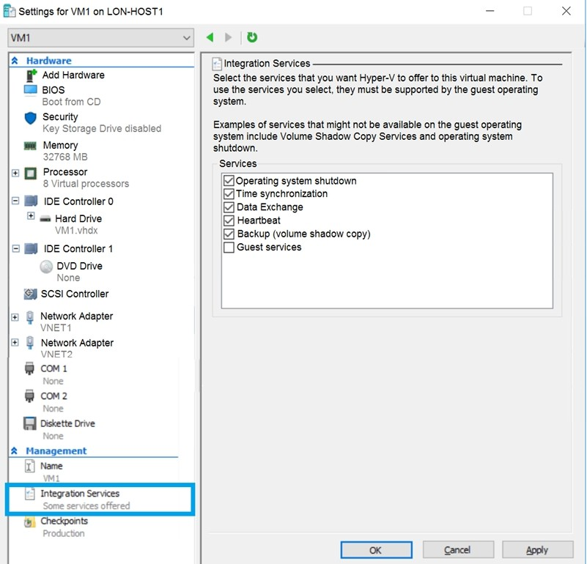

You need to ensure that you can use the disks attached to VM1 as a template for Azure virtual machines.

What should you modify on VM1?

|  |  |
| --- | --- |
| A. | the memory |
| B. | the network adapters |
| C. | the hard drive |
| D. | the processor |
| E. | Integration Services |

**Answer:** C

**Explanation:**

From the exhibit we see that the disk is in the VHDX format.

Before you upload a Windows virtual machine (VM) from on-premises to Microsoft Azure, you must prepare the virtual hard disk (VHD or VHDX). Azure supports only generation 1 VMs that are in the VHD file format and have a fixed sized disk. The maximum size allowed for the VHD is 1,023 GB. You can convert a generation 1 VM from the VHDX file system to VHD and from a dynamically expanding disk to fixed-sized.

Reference:

https://docs.microsoft.com/en-us/azure/virtual-machines/windows/prepare-for-upload-vhd-image

### QUESTION 31

You have an Azure subscription named Subscription1 that is used by several departments at your company. Subscription1 contains the resources in the following table:

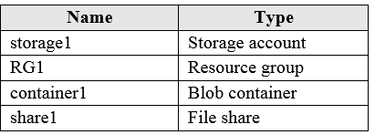

Another administrator deploys a virtual machine named VM1 and an Azure Storage account named storage2 by using a single Azure Resource Manager template.

You need to view the template used for the deployment.

From which blade can you view the template that was used for the deployment?

|  |  |
| --- | --- |
| A. | VM1 |
| B. | RG1 |
| C. | storage2 |
| D. | container1 |

**Answer:** B

**Explanation:**

View template from deployment history

1. Go to the resource group for your new resource group. Notice that the portal shows the result of the last deployment. Select this link.

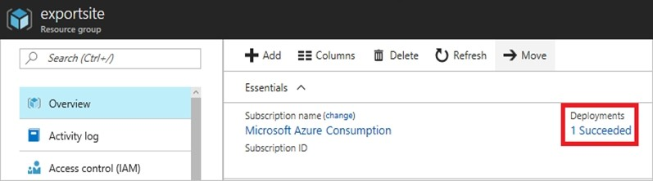

1. You see a history of deployments for the group. In your case, the portal probably lists only one deployment. Select this deployment.

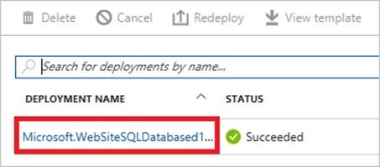

1. The portal displays a summary of the deployment. The summary includes the status of the deployment and its operations and the values that you provided for parameters. To see the template that you used for the deployment, select View template.

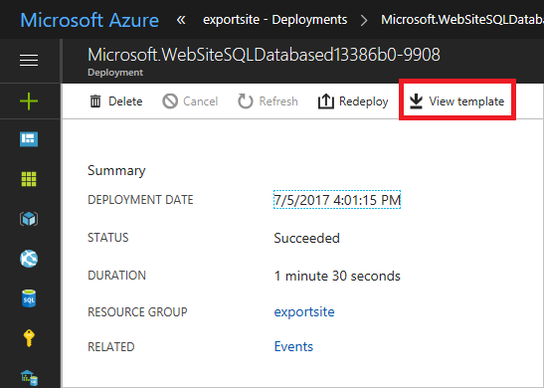

Reference:

https://docs.microsoft.com/en-us/azure/azure-resource-manager/resource-manager-export- template

### QUESTION 32

You have an Azure web app named App1. App1 has the deployment slots shown in the following table:

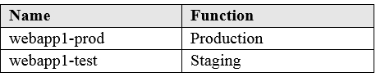

In webapp1-test, you test several changes to App1. You back up App1.

You swap webapp1-test for webapp1-prod and discover that App1 is experiencing performance issues. You need to revert to the previous version of App1 as quickly as possible.

What should you do?

|  |  |
| --- | --- |
| A. | Redeploy App1 |
| B. | Swap the slots |
| C. | Clone App1 |
| D. | Restore the backup of App1 |

**Answer:** B

**Explanation:**

When you swap deployment slots, Azure swaps the Virtual IP addresses of the source and destination slots, thereby swapping the URLs of the slots. We can easily revert the deployment by swapping back.

Reference:

https://docs.microsoft.com/en-us/azure/app-service/deploy-staging-slots

### QUESTION 33

**Note: This question is part of a series of questions that present the same scenario. Each question in the series contains a unique solution that might meet the stated goals. Some question sets might have more than one correct solution, while others might not have a correct solution.**

**After you answer a question in this section, you will NOT be able to return to it. As a result, these questions will not appear in the review screen.**

You have an Azure subscription that contains 10 virtual networks. The virtual networks are hosted in separate resource groups.

Another administrator plans to create several network security groups (NSGs) in the subscription.

You need to ensure that when an NSG is created, it automatically blocks TCP port 8080 between the virtual networks.

Solution: From the Resource providers blade, you unregister the Microsoft.ClassicNetwork provider.

Does this meet the goal?

|  |  |
| --- | --- |
| A. | Yes |
| B. | No |

**Answer:** B

**Explanation:**

You should use a policy definition.

Resource policy definition used by Azure Policy enables you to establish conventions for resources in your organization by describing when the policy is enforced and what effect to take. By defining conventions, you can control costs and more easily manage your resources.

Reference:

https://docs.microsoft.com/en-us/azure/azure-policy/policy-definition

### QUESTION 34

**Note: This question is part of a series of questions that present the same scenario. Each question in the series contains a unique solution that might meet the stated goals. Some question sets might have more than one correct solution, while others might not have a correct solution.**

**After you answer a question in this section, you will NOT be able to return to it. As a result, these questions will not appear in the review screen.**

You have an Azure subscription that contains 10 virtual networks. The virtual networks are hosted in separate resource groups.

Another administrator plans to create several network security groups (NSGs) in the subscription.

You need to ensure that when an NSG is created, it automatically blocks TCP port 8080 between the virtual networks.

Solution: You assign a built-in policy definition to the subscription. Does this meet the goal?

|  |  |
| --- | --- |
| A. | Yes |
| B. | No |

**Answer:** B

**Explanation:**

Resource policy definition used by Azure Policy enables you to establish conventions for resources in your organization by describing when the policy is enforced and what effect to take. By defining conventions, you can control costs and more easily manage your resources.

Reference:

https://docs.microsoft.com/en-us/azure/azure-policy/policy-definition

### QUESTION 35

You have an app named App1 that runs on two Azure virtual machines named VM1 and VM2.

You plan to implement an Azure Availability Set for App1. The solution must ensure that App1 is available during planned maintenance of the hardware hosting VM1 and VM2.

What should you include in the Availability Set?

|  |  |
| --- | --- |
| A. | one update domain |
| B. | two fault domains |
| C. | one fault domain |
| D. | two update domains |

**Answer:** D

**Explanation:**

Microsoft updates, which Microsoft refers to as planned maintenance events, sometimes require that VMs be rebooted to complete the update. To reduce the impact on VMs, the Azure fabric is divided into update domains to ensure that not all VMs are rebooted at the same time.

Incorrect Answers:

A: An update domain is a group of VMs and underlying physical hardware that can be rebooted at the same time.

B, C: A fault domain shares common storage as well as a common power source and network switch. It is used to protect against unplanned system failure.

References:

https://petri.com/understanding-azure-availability-sets

https://docs.microsoft.com/en-us/azure/virtual-machines/windows/tutorial-availability-sets

### QUESTION 36

**Note: This question is part of a series of questions that present the same scenario. Each question in the series contains a unique solution that might meet the stated goals. Some question sets might have more than one correct solution, while others might not have a correct solution.**

**After you answer a question in this section, you will NOT be able to return to it. As a result, these questions will not appear in the review screen.**

You have an Azure subscription named Subscription1. Subscription1 contains a resource group named RG1. RG1 contains resources that were deployed by using templates.

You need to view the date and time when the resources were created in RG1.

Solution: From the Subscriptions blade, you select the subscription, and then click Programmatic deployment.

Does this meet the goal?

|  |  |
| --- | --- |
| A. | Yes |
| B. | No |

**Answer:** B

**Explanation:**

From the RG1 blade, click Deployments. You see a history of deployment for the resource group. Reference:

https://docs.microsoft.com/en-us/azure/azure-resource-manager/templates/template-tutorial- create-first-template?tabs=azure-powershell

### QUESTION 37

**Note: This question is part of a series of questions that present the same scenario. Each question in the series contains a unique solution that might meet the stated goals. Some question sets might have more than one correct solution, while others might not have a correct solution.**

**After you answer a question in this section, you will NOT be able to return to it. As a result, these questions will not appear in the review screen.**

You have an Azure subscription named Subscription1. Subscription1 contains a resource group named RG1. RG1 contains resources that were deployed by using templates.

You need to view the date and time when the resources were created in RG1. Solution: From the RG1 blade, you click Automation script.

Does this meet the goal?

|  |  |
| --- | --- |
| A. | Yes |
| B. | No |

**Answer:** B

**Explanation:**

From the RG1 blade, click Deployments. You see a history of deployment for the resource group. Reference:

https://docs.microsoft.com/en-us/azure/azure-resource-manager/templates/template-tutorial- create-first-template?tabs=azure-powershell

### QUESTION 38

**Note: This question is part of a series of questions that present the same scenario. Each question in the series contains a unique solution that might meet the stated goals. Some question sets might have more than one correct solution, while others might not have a correct solution.**

**After you answer a question in this section, you will NOT be able to return to it. As a result, these questions will not appear in the review screen.**

You have an Azure subscription named Subscription1. Subscription1 contains a resource group named RG1. RG1 contains resources that were deployed by using templates.

You need to view the date and time when the resources were created in RG1. Solution: From the RG1 blade, you click Deployments.

Does this meet the goal?

|  |  |
| --- | --- |
| A. | Yes |
| B. | No |

**Answer:** A

**Explanation:**

From the RG1 blade, click Deployments. You see a history of deployment for the resource group. Reference:

https://docs.microsoft.com/en-us/azure/azure-resource-manager/templates/template-tutorial- create-first-template?tabs=azure-powershell

### QUESTION 39

Hotspot Question

You have an Azure subscription named Subscription1 that contains a resource group named RG1.

In RG1, you create an internal load balancer named LB1 and a public load balancer named LB2.

You need to ensure that an administrator named Admin1 can manage LB1 and LB2. The solution must follow the principle of least privilege.

Which role should you assign to Admin1 for each task? To answer, select the appropriate options in the answer area.

NOTE: Each correct selection is worth one point.

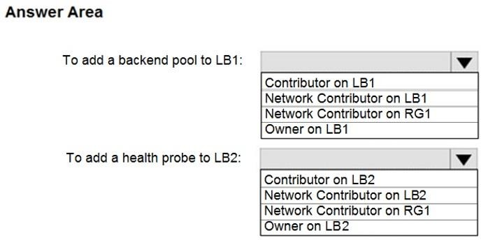

**Answer:**

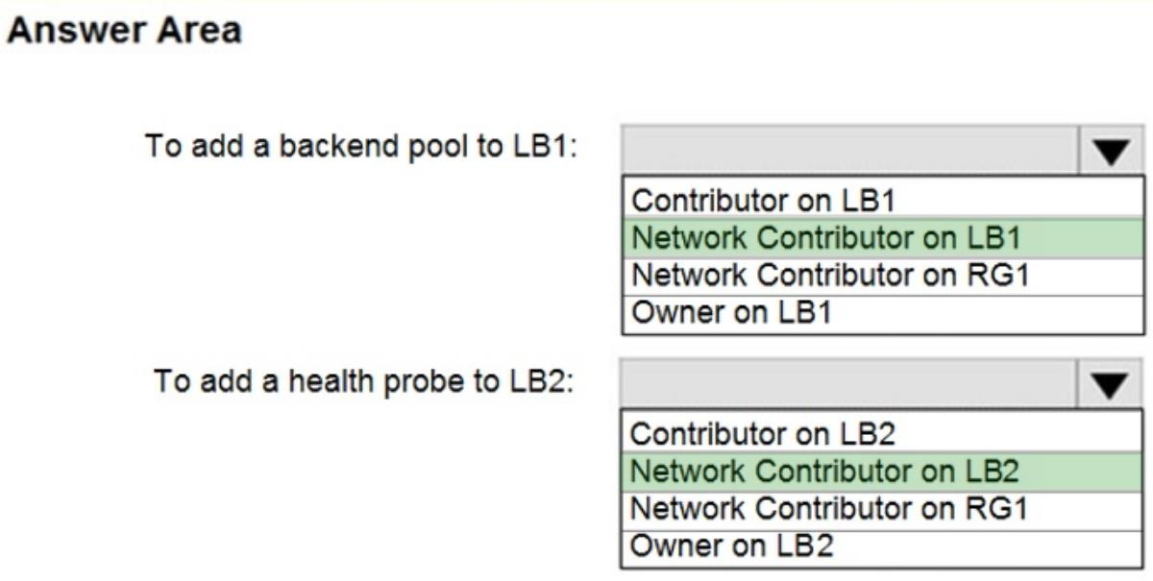

**Explanation:**

Box 1: Network Contributor on RG1

For creating a backend pool we need permission to access VNet on RG.

Box 2: Network Contributor on RG1

For creating a health probe we need to have permission for deployment on Resource Group.

Reference:

https://docs.microsoft.com/en-us/azure/role-based-access-control/built-in-roles https://docs.microsoft.com/en-us/azure/role-based-access-control/resource-provider- operations#microsoftnetwork

### QUESTION 40

Hotspot Question

You have an Azure Active Directory (Azure AD) tenant named contoso.com that contains the users shown in the following table:

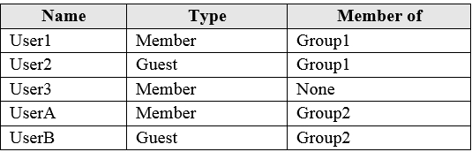

User3 is the owner of Group1. Group2 is a member of Group1.

You configure an access review named Review1 as shown in the following exhibit:

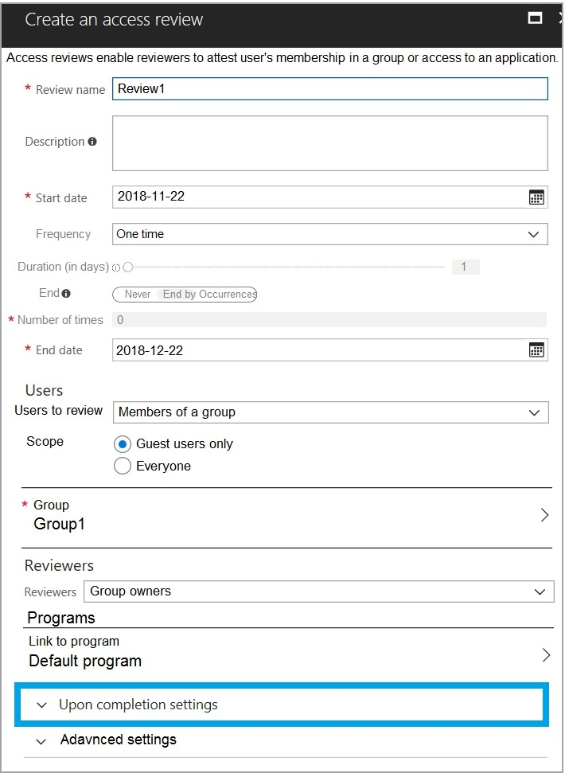

For each of the following statements, select Yes if the statement is true. Otherwise, select No. NOTE: Each correct selection is worth one point.

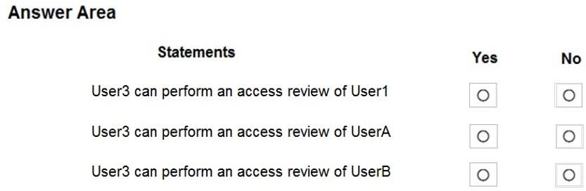

**Answer:**

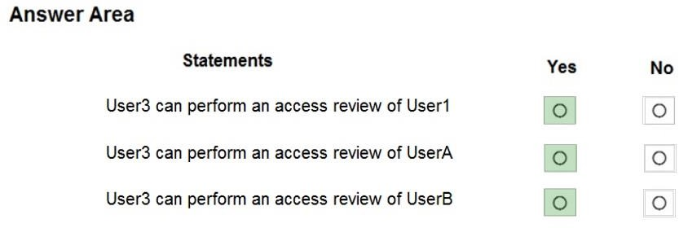

**Explanation:**

https://docs.microsoft.com/en-us/azure/active-directory/governance/create-access-review

### QUESTION 41

Hotspot Question

You have the Azure management groups shown in the following table:

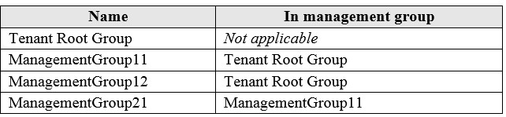

You add Azure subscriptions to the management groups as shown in the following table:

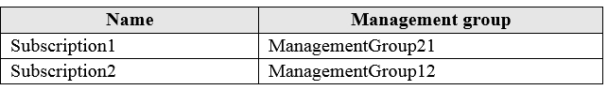

You create the Azure policies shown in the following table:

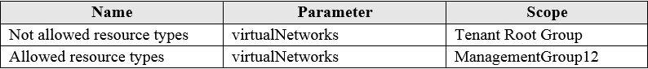

For each of the following statements, select Yes if the statement is true. Otherwise, select No. NOTE: Each correct selection is worth one point.

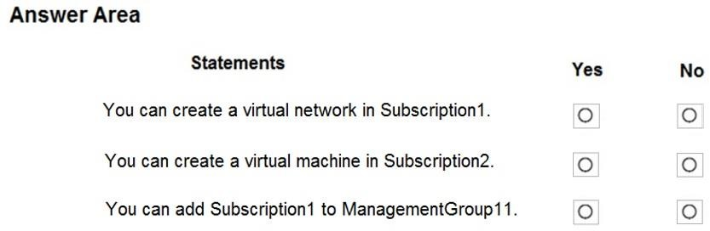

**Answer:**

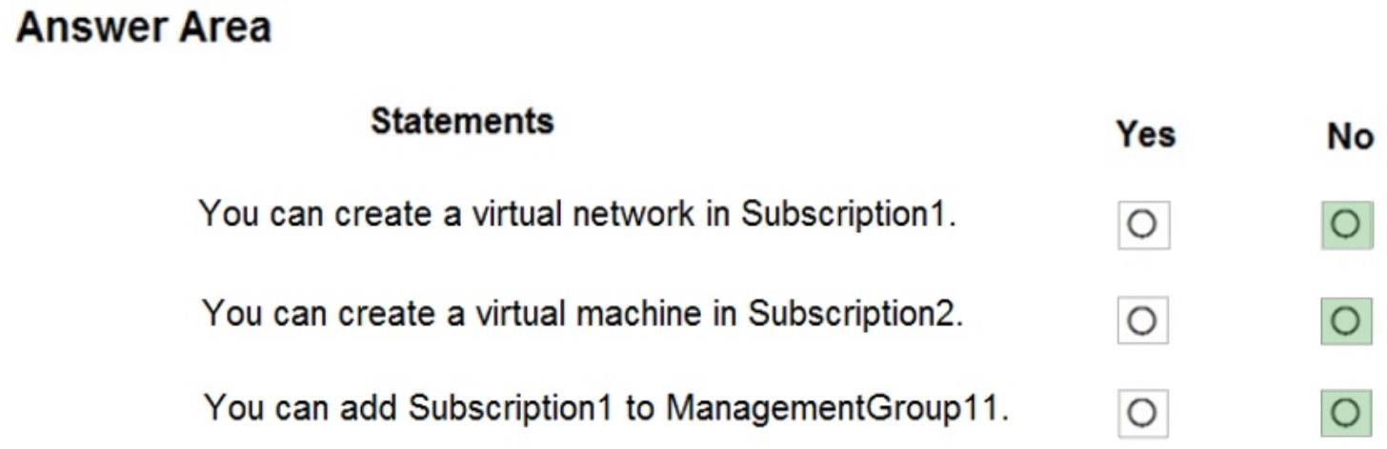

**Explanation:**

Box 1: No

Subscription1 is a member of ManagementGroup21, ManagementGroup21 is a member of ManagementGroup11, ManagementGroup11 is a member of the Tenant Root Group, The Tenant Root group has ‘Not allowed resource types for virtual network’.

Box 2: No:

You cannot create a VM, because based on the Policy you can only create VNETs in Sybscription2 (ManagementGroup12).

Box 3: No

You cannot ADD Subscription1 to ManagementGroup11, but you can MOVE Subscription1 from ManagementGroup21 to ManagmentGroup11. Subscriptions can only be a member of ONE ManagementGroup at a time.

Allowed Resource Type (Deny): Defines the resource types that you can deploy. Its effect is to deny all resources that aren't part of this defined list.

Not allowed resource types (Deny): Prevents a list of resource types from being deployed. Based on the Policies, VNETs are not allowed in the Tenant Root Group scope, so you cannot deploy VNETs. Also, VNETs only allowed in ManagementGroup12 scope, but you cannot deploy any other resource.

Reference:

https://docs.microsoft.com/en-us/azure/governance/management-groups/overview https://docs.microsoft.com/en-us/azure/governance/management-groups/manage#moving- management-groups-and-subscriptions

### QUESTION 42

Hotspot Question

You have an Azure subscription that contains the resources shown in the following table:

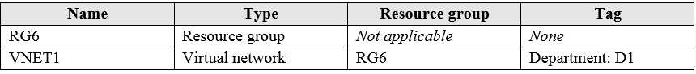

You assign a policy to RG6 as shown in the following table:

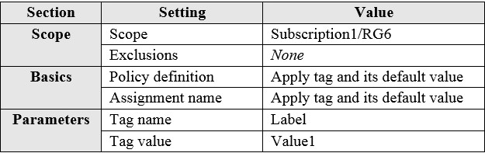

To RG6, you apply the tag: RGroup: RG6.

You deploy a virtual network named VNET2 to RG6.

Which tags apply to VNET1 and VNET2? To answer, select the appropriate options in the answer area.

NOTE: Each correct selection is worth one point.

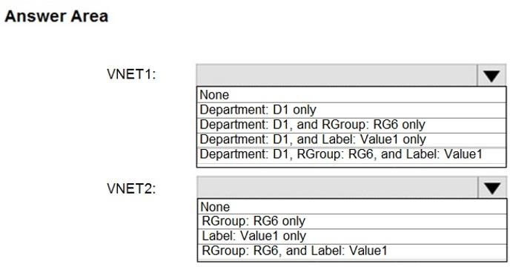

**Answer:**

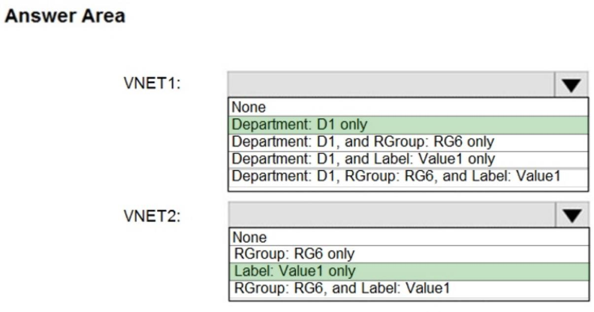

**Explanation:**

VNET1: Department: D1 only.

Resources created before policy creation will not inherit the policy rules.

VNET2: Label:Value1 only.

The built-in policy definition "Append a tag and its value to resources" appends the specified tag and value when any resource which is missing this tag is created or updated. Does not modify the tags of resources created before this policy was applied until those resources are changed. Does not apply to resource groups.

Reference:

https://docs.microsoft.com/en-us/azure/azure-resource-manager/management/tag-policies

### QUESTION 43

Hotspot Question

You have an Azure subscription named Subscription1.

In Subscription1, you create an Azure file share named share1.

You create a shared access signature (SAS) named SAS1 as shown in the following exhibit:

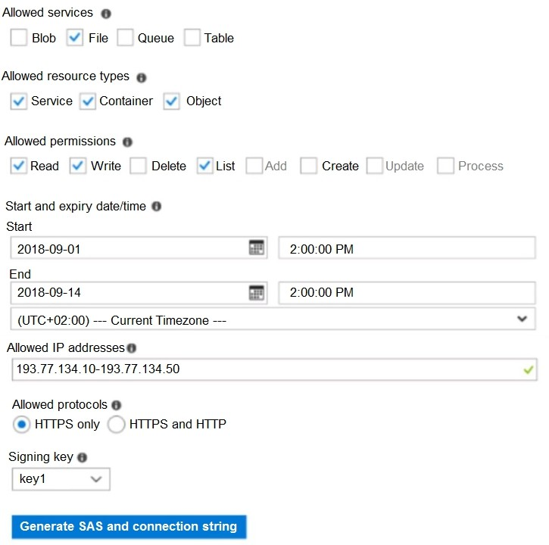

To answer, select the appropriate options in the answer area. NOTE: Each correct selection is worth one point.

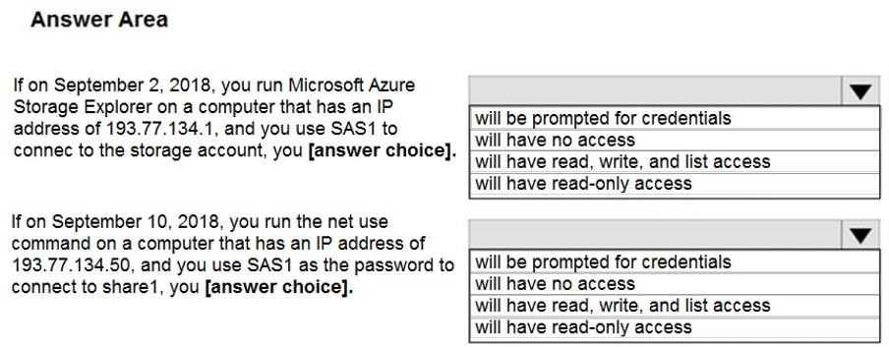

**Answer:**

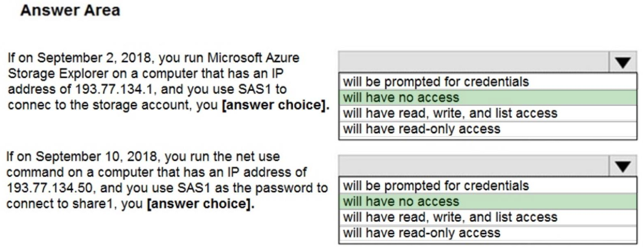

**Explanation:**

Box 1: will have no access

The IP 193.77.134.1 does not have access on the SAS, because it is not matching the SAS requirements. IP is out of range.

Box 2: will have no access

The SAS token is not supported in mounting Azure File share currently, it just supports the Azure storage account key.

Since it is using "net use" where it uses SMB, the SMB (Server Message Broker) protocol does not support SAS. it still asks for username/password. Accordingly, it will give error wrong username/pass and will not provide access.

Reference:

https://docs.microsoft.com/en-us/azure/storage/common/storage-dotnet-shared-access- signature-part-1

https://docs.microsoft.com/en-us/azure/vs-azure-tools-storage-manage-with-storage- explorer?tabs=windows

https://docs.microsoft.com/en-us/azure/storage/files/storage-how-to-use-files-windows https://docs.microsoft.com/en-us/answers/questions/40741/sas-key-for-unc-path.html

### QUESTION 44

Hotspot Question

You have Azure subscription that includes following Azure file shares:

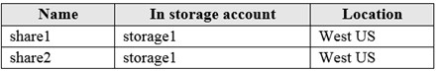

You have the following on-premises servers:

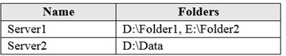

You create a Storage Sync Service named Sync1 and an Azure File Sync group named Group1. Group1 uses share1 as a cloud endpoint.

You register Server1 and Server2 in Sync1. You add D:\Folder1 on Server1 as a server endpoint of Group1.

For each of the following statements, select Yes if the statement is true. Otherwise, select No. NOTE: Each correct selection is worth one point.

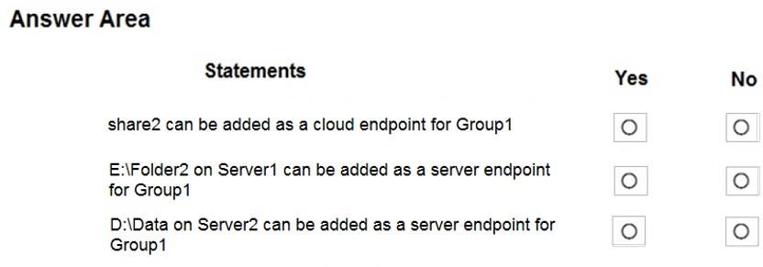

**Answer:**

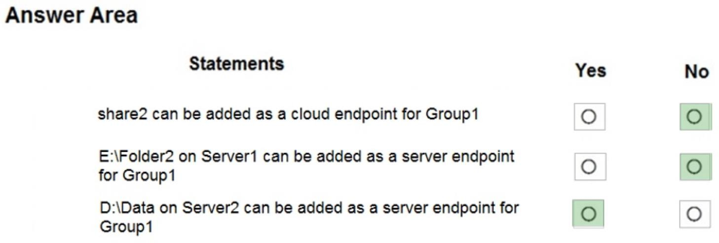

Box 1: No

A sync group contains one cloud endpoint, or Azure file share, and at least one server endpoint.

Box 2: No

Azure File Sync does not support more than one server endpoint from the same server in the same Sync Group.

Box 3: Yes

Multiple server endpoints can exist on the same volume if their namespaces are not overlapping (for example, F:\sync1 and F:\sync2) and each endpoint is syncing to a unique sync group.

Reference:

https://docs.microsoft.com/en-us/answers/questions/110822/azure-file-sync-multiple-sync- directories-for-same.html

https://docs.microsoft.com/en-us/azure/storage/files/storage-sync-files-deployment-guide

### QUESTION 45

Drag and Drop Question

You have an Azure subscription named Subscription1.

You create an Azure Storage account named contosostorage, and then you create a file share named data.

Which UNC path should you include in a script that references files from the data file share? To answer, drag the appropriate values to the correct targets. Each value may be used once, more than once or not at all. You may need to drag the split bar between panes or scroll to view content.

NOTE: Each correct selection is worth one point.

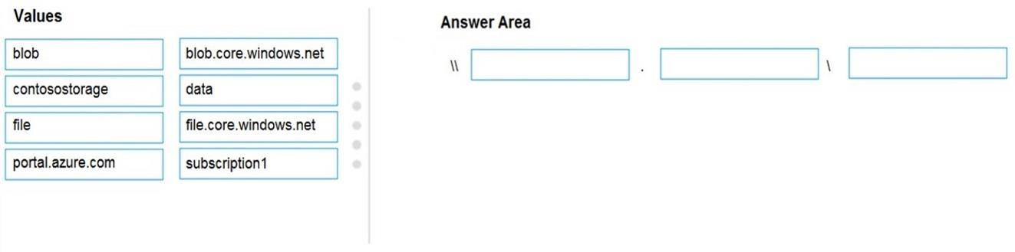

**Answer:**

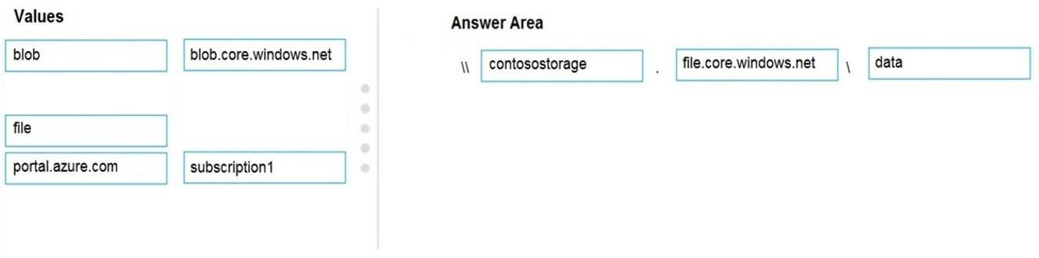

Box 1: contosostorage The name of account

Box 2: file.core.windows.net

Box 3: data

The name of the file share is data. Example:

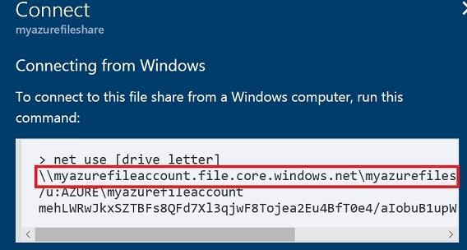

Reference:

https://docs.microsoft.com/en-us/azure/storage/files/storage-how-to-use-files-windows

### QUESTION 46

Drag and Drop Question

You have an on-premises file server named Server1 that runs Windows Server 2016. You have an Azure subscription that contains an Azure file share.

You deploy an Azure File Sync Storage Sync Service, and you create a sync group. You need to synchronize files from Server1 to Azure.

Which three actions should you perform in sequence? To answer, move the appropriate actions from the list of actions to the answer area and arrange them in the correct order.

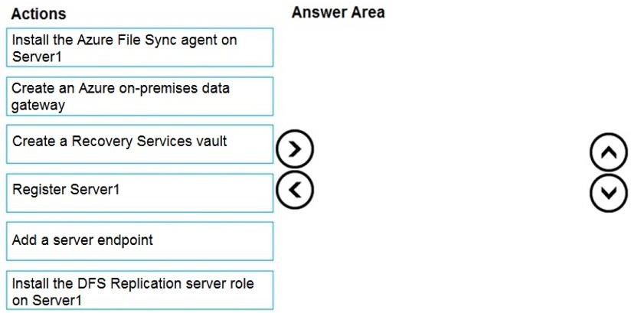

**Answer:**

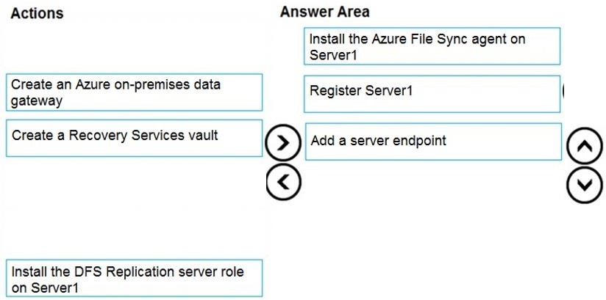

**Explanation:**

Step 1: Install the Azure File Sync agent on Server1

The Azure File Sync agent is a downloadable package that enables Windows Server to be synced with an Azure file share

Step 2: Register Server1.

Register Windows Server with Storage Sync Service

Registering your Windows Server with a Storage Sync Service establishes a trust relationship between your server (or cluster) and the Storage Sync Service.

Step 3: Add a server endpoint

Create a sync group and a cloud endpoint.

A sync group defines the sync topology for a set of files. Endpoints within a sync group are kept in sync with each other. A sync group must contain one cloud endpoint, which represents an

Azure file share and one or more server endpoints. A server endpoint represents a path on registered server.

Reference:

https://docs.microsoft.com/en-us/azure/storage/files/storage-sync-files-deployment-guide

### QUESTION 47

Hotspot Question

You have an Azure subscription. The subscription contains virtual machines that run Windows Server 2016 and are configured as shown in the following table.

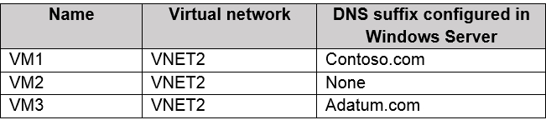

You create a public Azure DNS zone named adatum.com and a private Azure DNS zone named contoso.com.

You create a virtual network link for contoso.com as shown in the following exhibit.

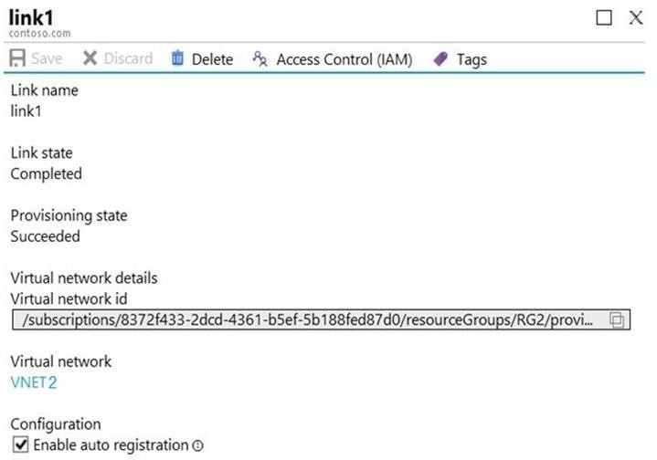

For each of the following statements, select Yes if the statement is true. Otherwise, select No.

NOTE: Each correct selection is worth one point.

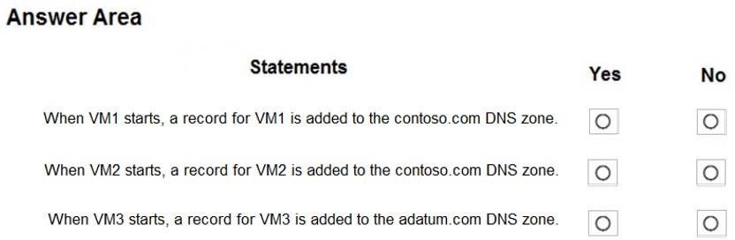

**Answer:**

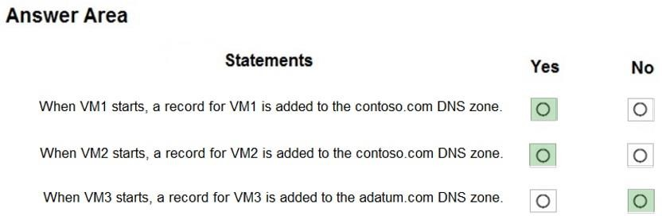

**Explanation:**

All three VMs are in VNET2. Auto registration is enabled for private Azure DNS zone named contoso.com, which is linked to VNET2. So, VM1, VM2 and VM3 will auto-register their host records to contoso.com.

None of the VM will auto-register to the public Azure DNS zone named adatum.com. You cannot register private IPs on the internet (adatum.com)

Box 1: Yes

Auto registration is enabled for private Azure DNS zone named contoso.com.

Box 2: Yes

Auto registration is enabled for private Azure DNS zone named contoso.com.

Box 3: No

None of the VM will auto-register to the public Azure DNS zone named adatum.com

Reference:

https://docs.microsoft.com/en-us/azure/virtual-network/virtual-networks-name-resolution-for-vms- and-role-instances

https://docs.microsoft.com/en-us/azure/dns/private-dns-autoregistration https://docs.microsoft.com/en-us/azure/dns/private-dns-virtual-network-links

### QUESTION 48

Hotspot Question

You have an Azure Storage account named storage1 that uses Azure Blob storage and Azure File storage.

You need to use AzCopy to copy data to the blob storage and file storage in storage1.

Which authentication method should you use for each type of storage? To answer, select the appropriate options in the answer area.

NOTE: Each correct selection is worth one point.

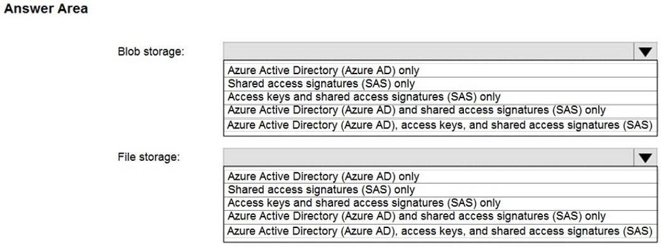

**Answer:**

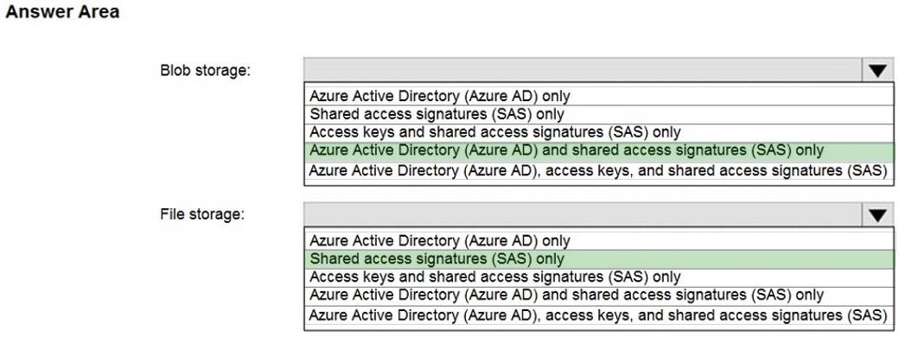

**Explanation:**

You can provide authorization credentials by using Azure Active Directory (AD), or by using a Shared Access Signature (SAS) token.

Box 1:

Both Azure Active Directory (AD) and Shared Access Signature (SAS) token are supported for Blob storage.

Box 2:

Only Shared Access Signature (SAS) token is supported for File storage.

Reference:

https://docs.microsoft.com/en-us/azure/storage/common/storage-use-azcopy-v10

### QUESTION 49

Hotspot Question

You have an Azure subscription named Subscription1 that contains the resources shown in the following table:

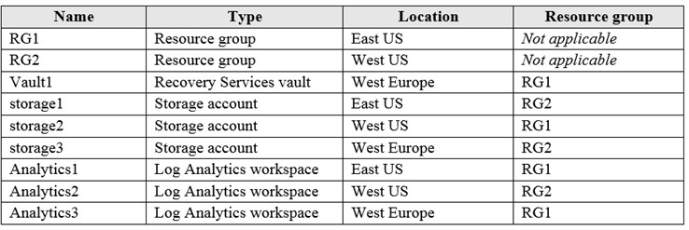

You plan to configure Azure Backup reports for Vault1.

You are configuring the Diagnostics settings for the AzureBackupReports log.

Which storage accounts and which Log Analytics workspaces can you use for the Azure Backup reports of Vault1? To answer, select the appropriate options in the answer area.

NOTE: Each correct selection is worth one point.

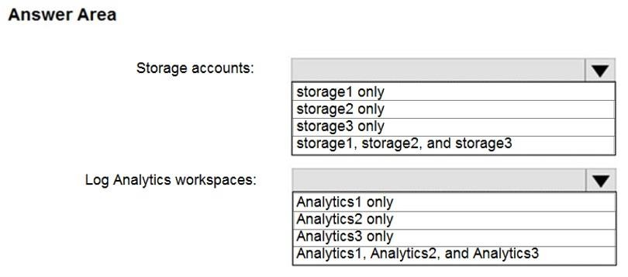

**Answer:**

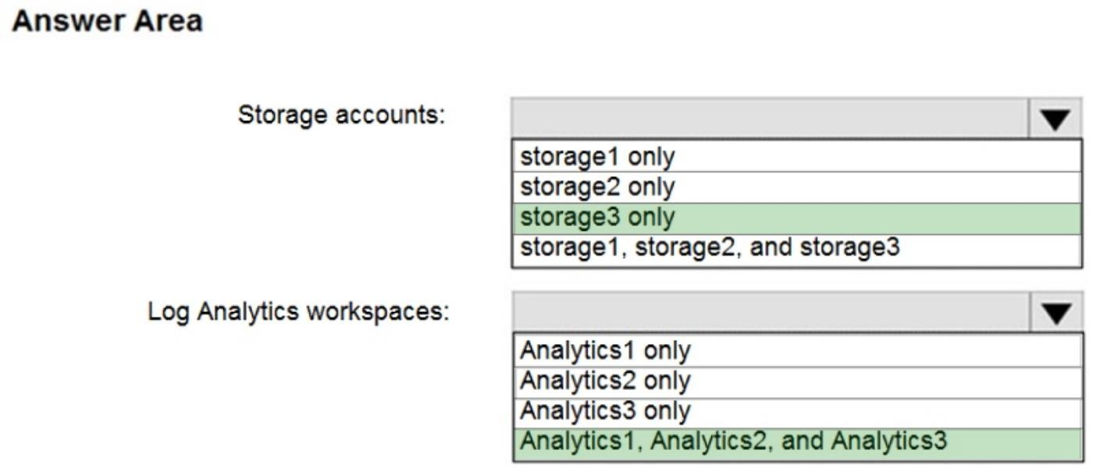

**Explanation:**

Box 1: storage3 only

Storage Account must be in the same Region as the Recovery Services Vault.

Box 2: Analytics1, Analytics2, and Analytics3

Set up one or more Log Analytics workspaces to store your Backup reporting data. The location and subscription where this Log Analytics workspace can be created is independent of the location and subscription where your Vaults exist..

Reference:

https://docs.microsoft.com/en-us/azure/backup/configure-reports#1-create-a-log-analytics- workspace-or-use-an-existing-one

### QUESTION 50

Hotspot Question

You have an Azure subscription named Subscription1. Subscription1 contains a virtual machine named VM1.

You install and configure a web server and a DNS server on VM1.

VM1 has the effective network security rules shown in the following exhibit:

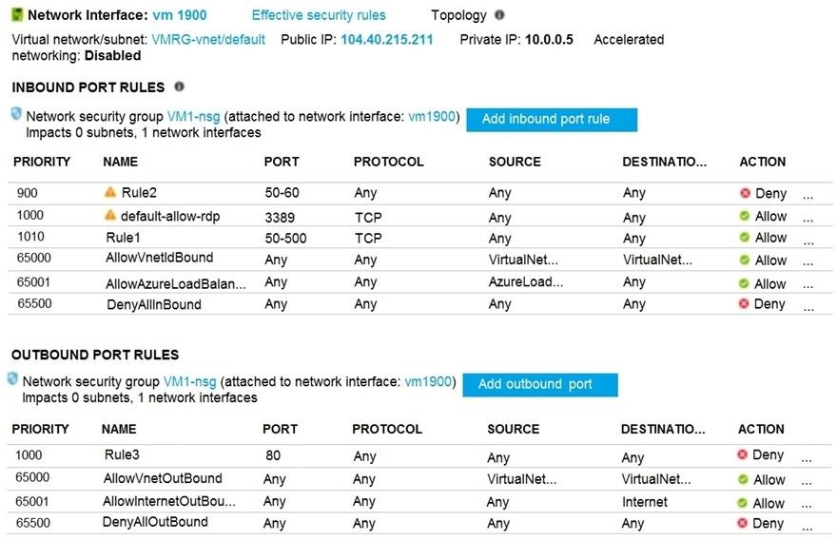

Use the drop-down menus to select the answer choice that completes each statement based on the information presented in the graphic.

NOTE: Each correct selection is worth one point.

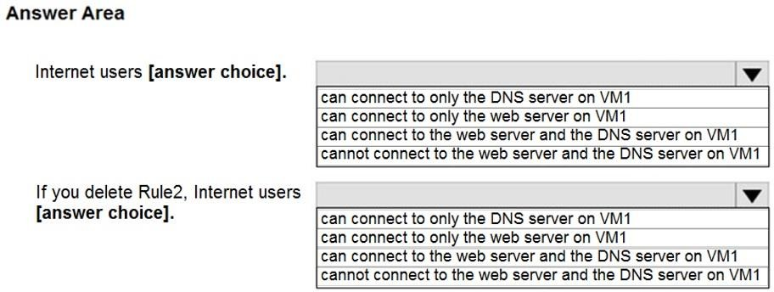

**Answer:**

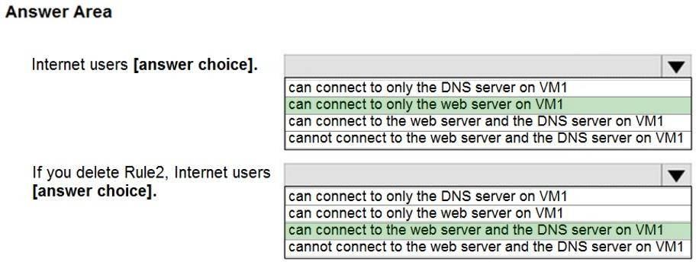

### QUESTION 51

Hotspot Question

You have an Azure subscription that contains a virtual machine scale set. The scale set contains four instances that have the following configurations:

* Operating system: Windows Server 2016
* Size: Standard_D1_v2

You run the get-azvmss cmdlet as shown in the following exhibit:

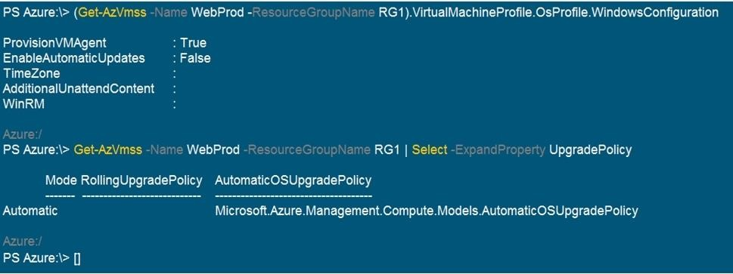

Use the drop-down menus to select the answer choice that completes each statement based on the information presented in the graphic.

NOTE: Each correct selection is worth one point.

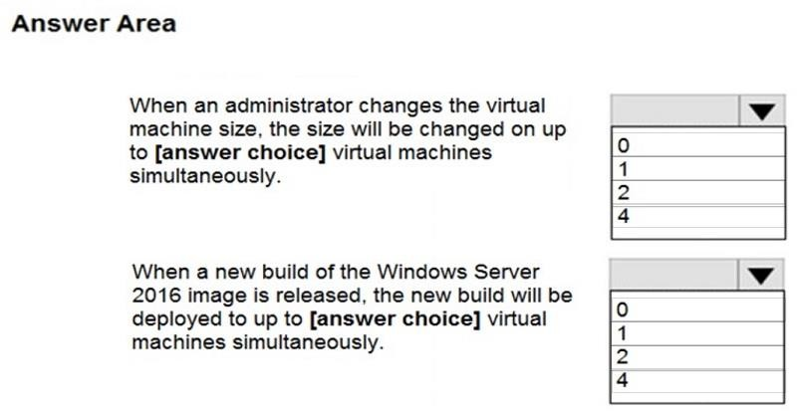

**Answer:**

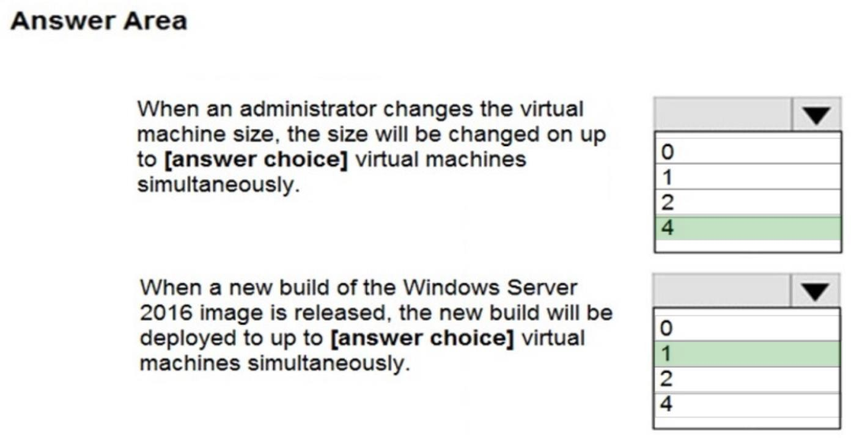

**Explanation:**

Box 1: 4

If you resize the Scale Set all the VMs get resized at once, thus 4 is the correct answer.

Box 2: 1

Automatic OS updates update 20% of the VMs at once, with a minimum of 1 VM instance at a time. Also 20% of 4 = 0.8.

Reference:

https://docs.microsoft.com/en-us/learn/modules/build-app-with-scale-sets/2-features-benefits- virtual-machine-scale-sets

https://docs.microsoft.com/en-us/azure/virtual-machine-scale-sets/virtual-machine-scale-sets- automatic-upgrade

https://docs.microsoft.com/en-us/azure/virtual-machine-scale-sets/virtual-machine-scale-sets- upgrade-scale-set

### QUESTION 52

Hotspot Question

You have an Azure subscription that contains the resources in the following table:

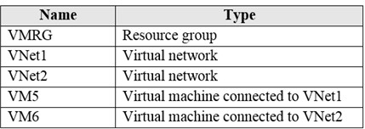

In Azure, you create a private DNS zone named adatum.com. You set the registration virtual network to VNet2. The adatum.com zone is configured as shown in the following exhibit:

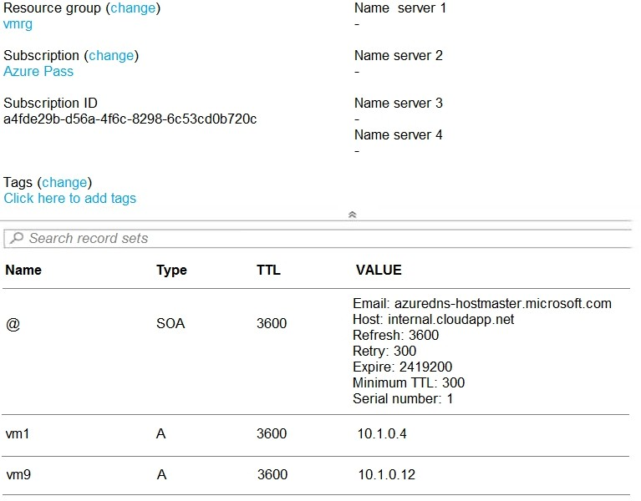

For each of the following statements, select Yes if the statement is true. Otherwise, select No.

NOTE: Each correct selection is worth one point.

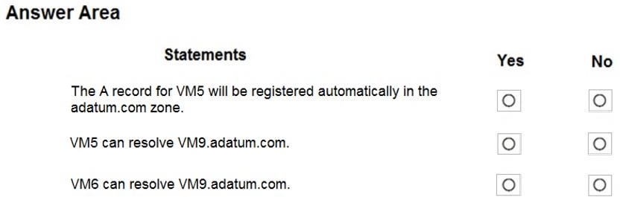

**Answer:**

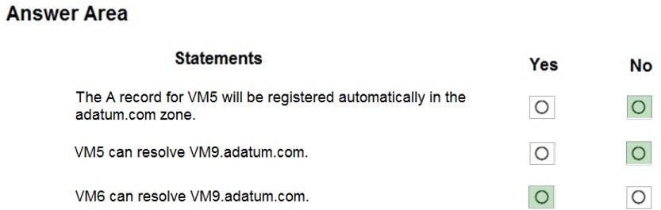

**Explanation:**

Box 1: No

Azure DNS provides automatic registration of virtual machines from a single virtual network that's linked to a private zone as a registration virtual network. VM5 does not belong to the registration virtual network though.

Box 2: No

Forward DNS resolution is supported across virtual networks that are linked to the private zone as resolution virtual networks. VM5 does belong to a resolution virtual network.

Box 3: Yes

VM6 belongs to registration virtual network, and an A (Host) record exists for VM9 in the DNS zone. By default, registration virtual networks also act as resolution virtual networks, in the sense that DNS resolution against the zone works from any of the virtual machines within the registration virtual network.

Reference:

https://docs.microsoft.com/en-us/azure/dns/private-dns-overview

### QUESTION 53

Hotspot Question

You have an Azure subscription that contains a virtual network named VNet1. VNet1 uses an IP address space of 10.0.0.0/16 and contains the subnets in the following table:

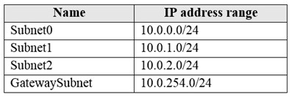

Subnet1 contains a virtual appliance named VM1 that operates as a router. You create a routing table named RT1.

You need to route all inbound traffic from the VPN gateway to VNet1 through VM1.

How should you configure RT1? To answer, select the appropriate options in the answer area. NOTE: Each correct selection is worth one point.

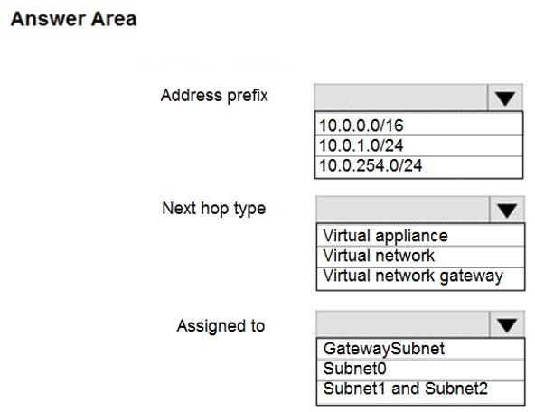

**Answer:**

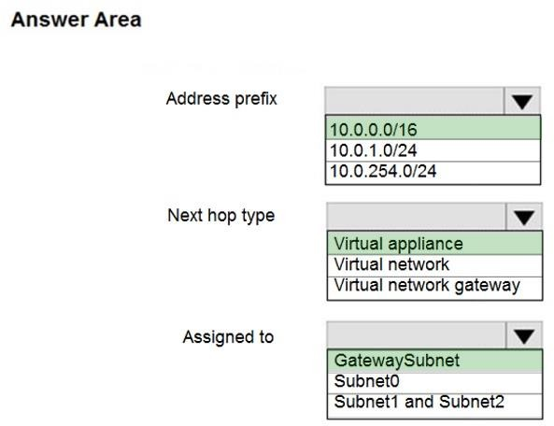

### QUESTION 54

Hotspot Question

You have an Azure subscription that contains the virtual machines shown in the following table:

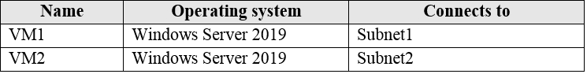

VM1 and VM2 use public IP addresses. From Windows Server 2019 on VM1 and VM2, you allow inbound Remote Desktop connections.

Subnet1 and Subnet2 are in a virtual network named VNET1.

The subscription contains two network security groups (NSGs) named NSG1 and NSG2. NSG1 uses only the default rules.

NSG2 uses the default rules and the following custom incoming rule:

* Priority: 100
* Name: Rule1

- Port: 3389

* Protocol: TCP
* Source: Any
* Destination: Any
* Action: Allow

NSG1 is associated to Subnet1. NSG2 is associated to the network interface of VM2.

For each of the following statements, select Yes if the statement is true. Otherwise, select No. NOTE: Each correct selection is worth one point.

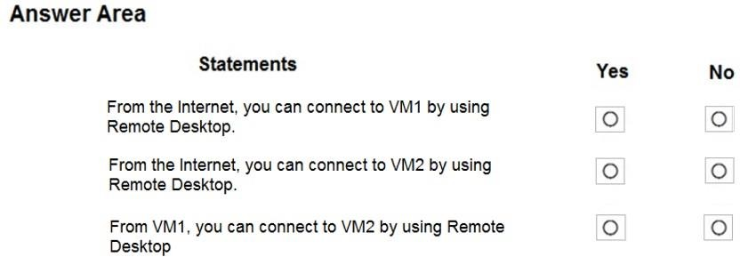

**Answer:**

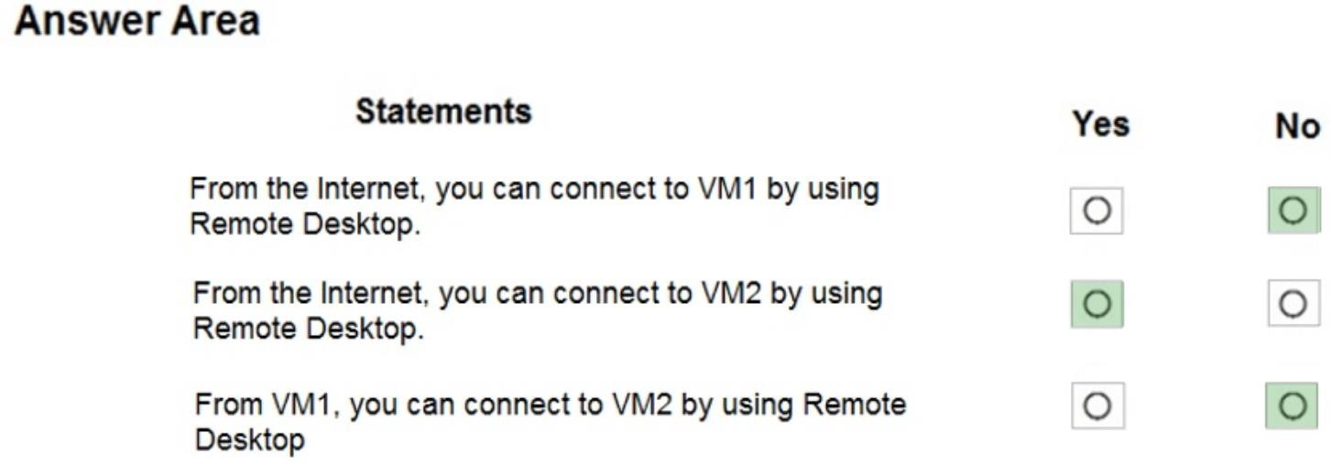

**Explanation:**

VM1-NSG1 is using only the default inbound and outbound rules, which does not include port 3389.

### QUESTION 55

Hotspot Question

You have a virtual network named VNET1 that contains the subnets shown in the following table:

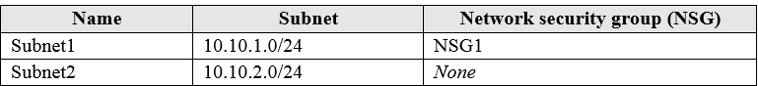

You have two Azure virtual machines that have the network configurations shown in the following table:

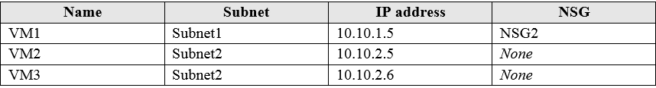

For NSG1, you create the inbound security rule shown in the following table:



For NSG2, you create the inbound security rule shown in the following table:



For each of the following statements, select Yes if the statement is true. Otherwise, select No. NOTE: Each correct selection is worth one point.

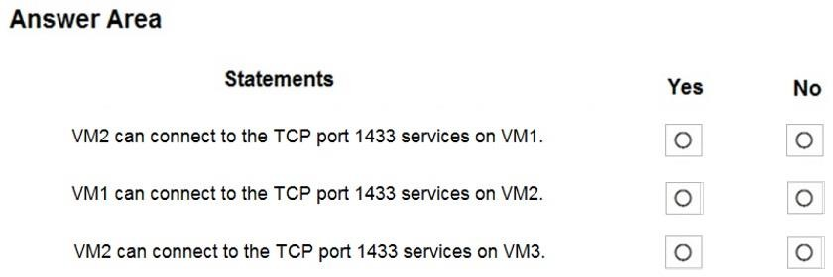

**Answer:**

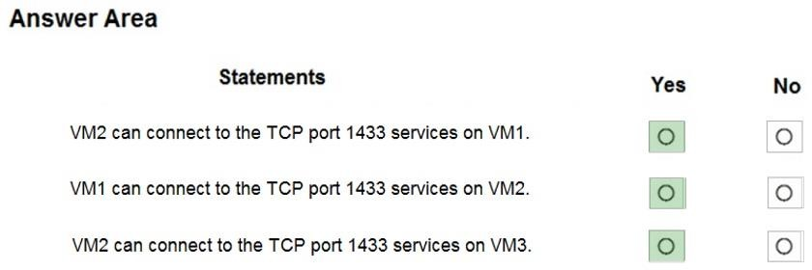

**Explanation:**

Box 1: Yes

The inbound security rule for NSG1 allows TCP port 1433 from 10.10.2.0/24 (or Subnet2 where VM2 and VM3 are located) to 10.10.1.0/24 (or Subnet1 where VM1 is located) while the inbound security rule for NSG2 blocks TCP port 1433 from 10.10.2.5 (or VM2) to 10.10.1.5 (or VM1).

However, the NSG1 rule has a higher priority (or lower value) than the NSG2 rule.

Box 2: Yes

No rule explicitly blocks communication from VM1. The default rules, which allow communication, are thus applied.

Box 3: Yes

No rule explicitly blocks communication between VM2 and VM3 which are both on Subnet2. The default rules, which allow communication, are thus applied.

Reference:

https://docs.microsoft.com/en-us/azure/virtual-network/security-overview

### QUESTION 56

Hotspot Question

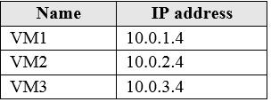You have an Azure subscription named Subscription1. Subscription1 contains the virtual machines in the following table:

Subscription1 contains a virtual network named VNet1 that has the subnets in the following table:

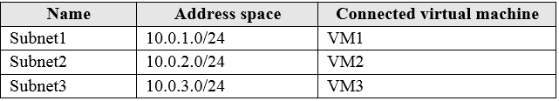

VM3 has multiple network adapters, including a network adapter named NIC3. IP forwarding is enabled on NIC3. Routing is enabled on VM3.

You create a route table named RT1 that contains the routes in the following table:

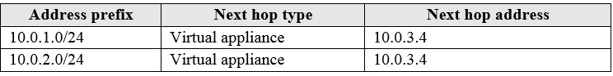

You apply RT1 to Subnet1 and Subnet2.

For each of the following statements, select Yes if the statement is true. Otherwise, select No. NOTE: Each correct selection is worth one point.

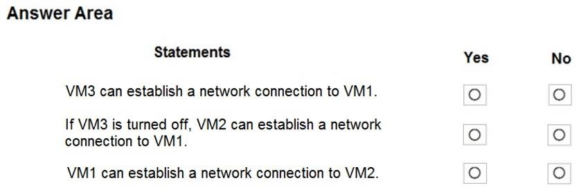

**Answer:**

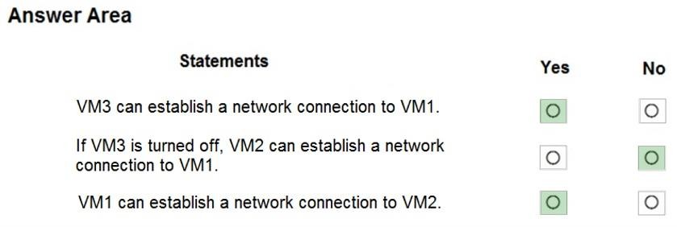

**Explanation:**

IP forwarding enables the virtual machine a network interface is attached to:

Receive network traffic not destined for one of the IP addresses assigned to any of the IP configurations assigned to the network interface.

Send network traffic with a different source IP address than the one assigned to one of a network interface's IP configurations.

The setting must be enabled for every network interface that is attached to the virtual machine that receives traffic that the virtual machine needs to forward. A virtual machine can forward traffic whether it has multiple network interfaces or a single network interface attached to it.

Box 1: Yes

The routing table allows connections from VM3 to VM1 and VM2. And as IP forwarding is enabled on VM3, VM3 can connect to VM1.

Box 2: No

VM3, which has IP forwarding, must be turned on, in order for VM2 to connect to VM1.

Box 3: Yes

The routing table allows connections from VM1 and VM2 to VM3. IP forwarding on VM3 allows VM1 to connect to VM2 via VM3.

Reference:

https://docs.microsoft.com/en-us/azure/virtual-network/virtual-networks-udr-overview

### QUESTION 57

Hotspot Question

You create a Recovery Services vault backup policy named Policy1 as shown in the following exhibit:

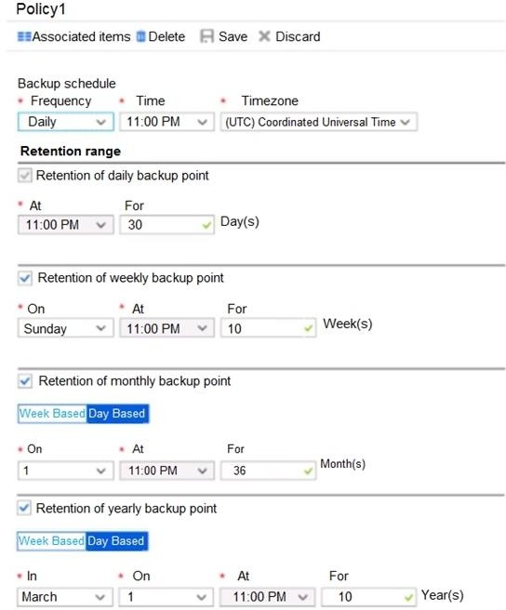

Use the drop-down menus to select the answer choice that completes each statement based on the information presented in the graphic.

NOTE: Each correct selection is worth one point.

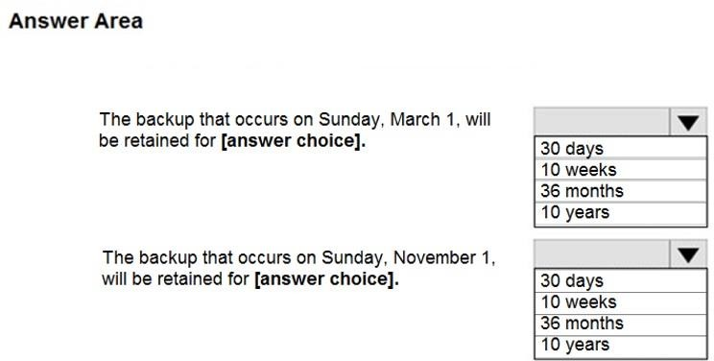

**Answer:**

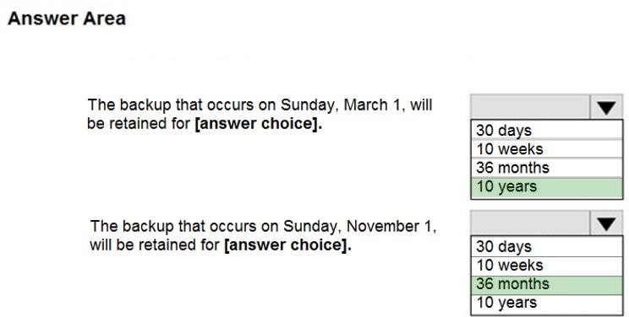

**Explanation:**

Box 1: 10 years

The yearly backup point occurs to 1 March and its retention period is 10 years.

Box 2: 36 months

The monthly backup point occurs on the 1st of every month and its retention period is 36 months.

### QUESTION 58

You have an Azure subscription that contains 10 virtual machines. You need to ensure that you receive an email message when any virtual machines are powered off, restarted, or deallocated. What is the minimum number of rules and action groups that you require?

|  |  |
| --- | --- |
| A. | three rules and three action groups |
| B. | one rule and one action group |
| C. | three rules and one action group |
| D. | one rule and three action groups |

**Answer:** C

**Explanation:**

An action group is a collection of notification preferences defined by the user. Azure Monitor and Service

Health alerts are configured to use a specific action group when the alert is triggered. Various alerts may use the same action group or different action groups depending on the user's requirements. References: https://docs.microsoft.com/en-us/azure/monitoring-and- diagnostics/monitoring-action-groups

### QUESTION 59

You have an Azure subscription that contains two resource groups named RG1 and RG2. RG2 does not contain any resources. RG1 contains the resources in the following table.

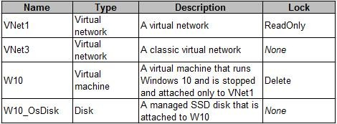

Which resource can you move to RG2?

|  |  |
| --- | --- |
| A. | W10_OsDisk |
| B. | VNet1 |
| C. | VNet3 |
| D. | W10 |

**Answer:** B

**Explanation:**

When moving a virtual network, you must also move its dependent resources. For example, you must move gateways with the virtual network. VM W10, which is in Vnet1, is not a dependent resource.

Incorrect Answers:

A: Managed disks don't support move.

C: Virtual networks (classic) can't be moved.

D: Virtual machines with the managed disks cannot be moved.

References: https://docs.microsoft.com/en-us/azure/azure-resource-manager/resource-group- move-resources#virtual-machines-limitations

### QUESTION 60

You have 100 Azure subscriptions. All the subscriptions are associated to the same Azure Active Directory (Azure AD) tenant named contoso.com.

You are a global administrator.

You plan to create a report that lists all the resources across all the subscriptions. You need to ensure that you can view all the resources in all the subscriptions.

What should you do?

|  |  |
| --- | --- |
| A. | From the Azure portal, modify the profile settings of your account. |
| B. | From Windows PowerShell, run the Add-AzureADAdministrativeUnitMember cmdlet. |
| C. | From Windows PowerShell, run the New-AzureADUserAppRoleAssignment cmdlet. |
| D. | From the Azure portal, modify the properties of the Azure AD tenant. |

**Answer:** D

**Explanation:**

https://docs.microsoft.com/en-us/azure/role-based-access-control/elevate-access-global- admin#azure-portal

### QUESTION 61

**Note: This question is part of a series of questions that present the same scenario. Each question in the series contains a unique solution that might meet the stated goals. Some question sets might have more than one correct solution, while others might not have a correct solution. After you answer a question in this section, you will NOT be able to return to it. As a result, these questions will not appear in the review screen.**

You have an Azure subscription named Subscription1. Subscription1 contains a resource group named RG1. RG1 contains resources that were deployed by using templates. You need to view the date and time when the resources were created in RG1.

Solution: From the Subscriptions blade, you select the subscription, and then click Programmatic deployment.

Does this meet the goal?

|  |  |
| --- | --- |
| A. | Yes |
| B. | No |

**Answer:** B

### QUESTION 62

**Note: This question is part of a series of questions that present the same scenario. Each question in the series contains a unique solution that might meet the stated goals. Some question sets might have more than one correct solution, while others might not have a correct solution. After you answer a question in this section, you will NOT be able to return to it. As a result, these questions will not appear in the review screen.**

You have an Azure subscription named Subscription1. Subscription1 contains a resource group named RG1. RG1 contains resources that were deployed by using templates. You need to view the date and time when the resources were created in RG1.

Solution: From the RG1 blade, you click Deployments. Does this meet the goal?

|  |  |
| --- | --- |
| A. | Yes |
| B. | No |

**Answer:** A

### QUESTION 63

**Note: This question is part of a series of questions that present the same scenario. Each question in the series contains a unique solution that might meet the stated goals. Some question sets might have more than one correct solution, while others might not have a correct solution. After you answer a question in this section, you will NOT be able to return to it. As a result, these questions will not appear in the review screen.**

You have an Azure subscription named Subscription1. Subscription1 contains a resource group named RG1. RG1 contains resources that were deployed by using templates. You need to view the date and time when the resources were created in RG1.

Solution: From the Subscriptions blade, you select the subscription, and then click Resource providers.

Does this meet the goal?

|  |  |
| --- | --- |
| A. | Yes |
| B. | No |

**Answer:** B

### QUESTION 64

You have the Azure virtual machines shown in the following table.

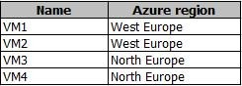

You have a Recovery Services vault that protects VM1 and VM2. You need to protect VM3 and VM4 by using Recovery Services. What should you do first?

|  |  |
| --- | --- |
| A. | Configure the extensions for VM3 and VM4. |
| B. | Create a new Recovery Services vault. |
| C. | Create a storage account. |
| D. | Create a new backup policy. |

**Answer:** B

**Explanation:**

A Recovery Services vault is a storage entity in Azure that houses data. The data is typically copies of data, or configuration information for virtual machines (VMs), workloads, servers, or workstations. You can use Recovery Services vaults to hold backup data for various Azure services References: https://docs.microsoft.com/en-us/azure/site-recovery/azure-to-azure- tutorial-enable-replication

### QUESTION 65

You have an Azure subscription that contains the resources in the following table.

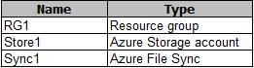

Store1 contains a file share named Data. Data contains 5,000 files.

You need to synchronize the files in Data to an on-premises server named Server1.

Which three actions should you perform? Each correct answer presents part of the solution.

**NOTE**: Each correct selection is worth one point.

|  |  |
| --- | --- |
| A. | Download an automation script. |
| B. | Create a container instance. |
| C. | Create a sync group. |
| D. | Register Server1. |
| E. | Install the Azure File Sync agent on Server1. |

**Answer:** CDE

**Explanation:**

Step 1 (E): Install the Azure File Sync agent on Server1 The Azure File Sync agent is a downloadable package that enables Windows Server to be synced with an Azure file share Step 2 (D): Register Server1.

Register Windows Server with Storage Sync Service

Registering your Windows Server with a Storage Sync Service establishes a trust relationship between your server (or cluster) and the Storage Sync Service. Step 3 (C): Create a sync group and a cloud endpoint. A sync group defines the sync topology for a set of files. Endpoints within a sync group are kept in sync with each other. A sync group must contain one cloud endpoint, which represents an Azure file share and one or more server endpoints. A server endpoint represents a path on registered server.

References: https://docs.microsoft.com/en-us/azure/storage/files/storage-sync-files-deployment- guide

### QUESTION 66

You plan to use the Azure Import/Export service to copy files to a storage account.

Which two files should you create before you prepare the drives for the import job? Each correct answer presents part of the solution.

NOTE: Each correct selection is worth one point.

|  |  |
| --- | --- |
| A. | an XML manifest file |
| B. | a driveset CSV file |
| C. | a dataset CSV file |
| D. | a PowerShell PS1 file |
| E. | a JSON configuration file |

**Answer:** BC

**Explanation:**

Modify the driveset.csv file in the root folder where the tool resides.

Modify the dataset.csv file in the root folder where the tool resides. Depending on whether you want to import a file or folder or both, add entries in the dataset.csv file

References: https://docs.microsoft.com/en-us/azure/storage/common/storage-import-export-data- to-files

### QUESTION 67

You have a Recovery Service vault that you use to test backups. The test backups contain two protected virtual machines.

You need to delete the Recovery Services vault. What should you do first?

|  |  |
| --- | --- |
| A. | From the Recovery Service vault, stop the backup of each backup item. |
| B. | From the Recovery Service vault, delete the backup data. |
| C. | Modify the disaster recovery properties of each virtual machine. |
| D. | Modify the locks of each virtual machine. |

**Answer:** A

**Explanation:**

You can't delete a Recovery Services vault if it is registered to a server and holds backup data. If you try to delete a vault, but can't, the vault is still configured to receive backup data.

Remove vault dependencies and delete vault

In the vault dashboard menu, scroll down to the Protected Items section, and click Backup Items. In this menu, you can stop and delete Azure File Servers, SQL Servers in Azure VM, and Azure virtual machines.

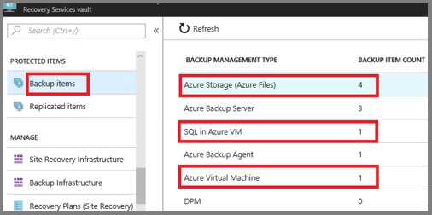

References: https://docs.microsoft.com/en-us/azure/backup/backup-azure-delete-vault

You can't delete a Recovery Services vault if it is registered to a server and holds backup data. If you try to delete a vault, but can't, the vault is still configured to receive backup data.

Remove vault dependencies and delete vault

In the vault dashboard menu, scroll down to the Protected Items section, and click Backup Items. In this menu, you can stop and delete Azure File Servers, SQL Servers in Azure VM, and Azure virtual machines.

### QUESTION 68

You have an Azure subscription that contains 100 virtual machines. You regularly create and delete virtual machines.

You need to identify unused disks that can be deleted. What should you do?

|  |  |
| --- | --- |
| A. | From Microsoft Azure Storage Explorer, view the Account Management properties. |
| B. | From the Azure portal, configure the Advisor recommendations. |
| C. | From Cloudyn, open the Optimizer tab and create a report. |
| D. | From Cloudyn, create a Cost Management report. |

**Answer:** A

**Explanation:**

https://docs.microsoft.com/en-us/azure/virtual-machines/windows/find-unattached-disks

### QUESTION 69

You have an Azure subscription named Subscription1.

You deploy a Linux virtual machine named VM1 to Subscription1. You need to monitor the metrics and the logs of VM1.

What should you use?

|  |  |
| --- | --- |
| A. | Linux Diagnostic Extension (LAD) 3.0 |
| B. | Azure Analysis Services |
| C. | The AzurePerformanceDiagnostics extension |
| D. | Azure HDInsight |

**Answer:** A

**Explanation:**

https://docs.microsoft.com/en-us/azure/virtual-machines/extensions/diagnostics-linux

### QUESTION 70

You have an Azure subscription named Subscription1. Subscription1 contains a virtual machine named VM1.

You have a computer named Computer1 that runs Windows 10. Computer1 is connected to the Internet.

You add a network interface named Interface1 to VM1 as shown in the exhibit (Click the **Exhibit**

button.)

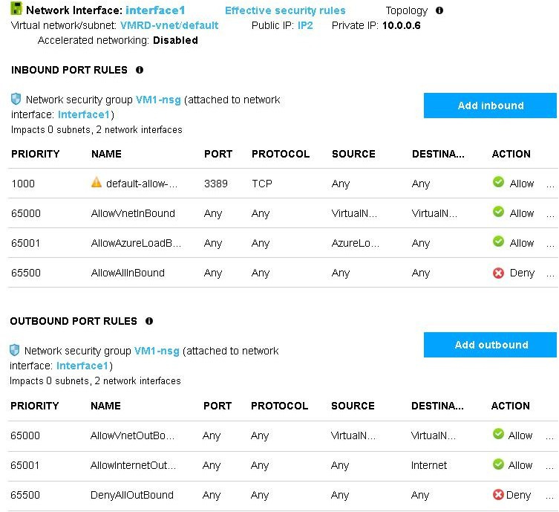

From Computer1, you attempt to connect to VM1 by using Remote Desktop, but the connection fails.

You need to establish a Remote Desktop connection to VM1. What should you do first?

|  |  |
| --- | --- |
| A. | Start VM1. |
| B. | Attach a network interface. |
| C. | Delete the DenyAllOutBound outbound port rule. |
| D. | Delete the DenyAllInBound inbound port rule. |

**Answer:** A

**Explanation:**

Incorrect Answers:

B: The network interface has already been added to VM. C: The Outbound rules are fine.

D: The inbound rules are fine. Port 3389 is used for Remote Desktop. Note: Rules are processed in priority order, with lower numbers processed before higher numbers, because lower numbers have higher priority. Once traffic matches a rule, processing stops. As a result, any rules that

exist with lower priorities (higher numbers) that have the same attributes as rules with higher priorities are not processed.

References: https://docs.microsoft.com/en-us/azure/virtual-network/security-overview

### QUESTION 71

You plan to automate the deployment of a virtual machine scale set that uses the Windows Server 2016 Datacenter image.

You need to ensure that when the scale set virtual machines are provisioned, they have web server components installed.

Which two actions should you perform? Each correct answer presents part of the solution. NOTE Each correct selection is worth one point.

|  |  |
| --- | --- |
| A. | Modify the extensionProfile section of the Azure Resource Manager template. |
| B. | Create a new virtual machine scale set in the Azure portal. |
| C. | Create an Azure policy. |
| D. | Create an automation account. |
| E. | Upload a configuration script. |

**Answer:** AE

**Explanation:**

https://docs.microsoft.com/en-us/azure/virtual-machine-scale-sets/virtual-machine-scale-sets- deploy-app

### QUESTION 72

You have an Azure subscription that contains a virtual machine named VM1. VM1 hosts a line-of- business application that is available 24 hours a day.

VM1 has one network interface and one managed disk. VM1 uses the D4s v3 size. You plan to make the following changes to VM1:

Change the size to D8s v3. Add a 500-GB managed disk.

Add the Puppet Agent extension.

Attach an additional network interface.

Which change will cause downtime for VM1?

|  |  |
| --- | --- |
| A. | Add a 500-GB managed disk. |
| B. | Attach an additional network interface. |
| C. | Add the Puppet Agent extension. |
| D. | Change the size to D8s v3. |

**Answer:** D

**Explanation:**

While resizing the VM it must be in a stopped state.

References: https://azure.microsoft.com/en-us/blog/resize-virtual-machines/

### QUESTION 73

**Note: This question is part of a series of questions that present the same scenario. Each question in the series contains a unique solution that might meet the stated goals. Some question sets might have more than one correct solution, while others might not have a correct solution. After you answer a question in this section, you will NOT be able to**

**return to it. As a result, these questions will not appear in the review screen.**

You have an Azure virtual machine named VM1. VM1 was deployed by using a custom Azure Resource Manager template named ARM1.json.

You receive a notification that VM1 will be affected by maintenance. You need to move VM1 to a different host immediately.

Solution: From the Redeploy blade, you click Redeploy. Does this meet the goal?

|  |  |
| --- | --- |
| A. | Yes |
| B. | No |

**Answer:** A

**Explanation:**

When you redeploy a VM, it moves the VM to a new node within the Azure infrastructure and then powers it back on, retaining all your configuration options and associated resources.

References: https://docs.microsoft.com/en-us/azure/virtual-machines/windows/redeploy-to-new- node

### QUESTION 74

**Note: This question is part of a series of questions that present the same scenario. Each question in the series contains a unique solution that might meet the stated goals. Some question sets might have more than one correct solution, while others might not have a correct solution. After you answer a question in this section, you will NOT be able to return to it. As a result, these questions will not appear in the review screen.**

You have an Azure virtual machine named VM1. VM1 was deployed by using a custom Azure Resource Manager template named ARM1.json.

You receive a notification that VM1 will be affected by maintenance. You need to move VM1 to a different host immediately.

Solution: From the Overview blade, you move the virtual machine to a different resource group. Does this meet the goal?

|  |  |
| --- | --- |
| A. | Yes |
| B. | No |

**Answer:** B

**Explanation:**

You should redeploy the VM.

References: https://docs.microsoft.com/en-us/azure/virtual-machines/windows/redeploy-to-new- node

### QUESTION 75

You have an Azure subscription that contains the resources in the following table.

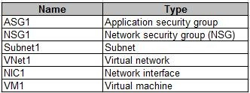

Subnet1 is associated to VNet1. NIC1 attaches VM1 to Subnet1. You need to apply ASG1 to VM1.

What should you do?

|  |  |
| --- | --- |
| A. | Modify the properties of NSG1. |
| B. | Modify the properties of ASG1. |
| C. | Associate NIC1 to ASG1. |

**Answer:** C

**Explanation:**

NSG’s are associated to NICs and Subnets, not VM’s. https://docs.microsoft.com/en-us/azure/virtual-network/tutorial-filter-network-traffic

### QUESTION 76

You have two subscriptions named Subscription1 and Subscription2. Each subscription is associated to a different Azure AD tenant.

Subscription1 contains a virtual network named VNet1.VNet1 contains an Azure virtual machine named VM1 and has an IP address space of 10.0.0.0/16. Subscription2 contains a virtual network named VNet2. VNet2 contains an Azure virtual machine named VM2 and has an IP address space of 10.10.0.0/24.

You need to connect VNet1 to VNet2. What should you do first?

|  |  |
| --- | --- |
| A. | Move VNet1 to Subscription2. |
| B. | Modify the IP address space of VNet2. |
| C. | Provision virtual network gateways. |
| D. | Move VM1 to Subscription2. |

**Answer:** C

**Explanation:**

The virtual networks can be in the same or different regions, and from the same or different subscriptions. When connecting VNets from different subscriptions, the subscriptions do not need to be associated with the same Active Directory tenant.

Configuring a VNet-to-VNet connection is a good way to easily connect VNets. Connecting a virtual network to another virtual network using the VNet-to-VNet connection type (VNet2VNet) is similar to creating a Site-to-Site IPsec connection to an on-premises location. Both connectivity types use a VPN gateway to provide a secure tunnel using IPsec/IKE, and both function the same way when communicating.

The local network gateway for each VNet treats the other VNet as a local site. This lets you specify additional address space for the local network gateway in order to route traffic.

References: https://docs.microsoft.com/en-us/azure/vpn-gateway/vpn-gateway-howto-vnet-vnet- resource-manager-portal

### QUESTION 77

Your company has an Azure subscription named Subscription1. The company also has two on- premises servers named Server1 and Server2 that run Windows Server 2016. Server1 is configured as a DNS server that has a primary DNS zone named adatum.com.

Adatum.com contains 1,000 DNS records.

You manage Server1 and Subscription1 from Server2. Server2 has the following tools installed:

* The DNS Manager console
* Azure PowerShell
* Azure CLI 2.0

You need to move the adatum.com zone to Subscription1. The solution must minimize administrative effort.

What should you use?

|  |  |
| --- | --- |
| A. | Azure PowerShell |
| B. | Azure CLI |
| C. | the Azure portal |
| D. | the DNS Manager console |

**Answer:** B

**Explanation:**

Azure DNS supports importing and exporting zone files by using the Azure command-line interface (CLI). Zone file import is not currently supported via Azure PowerShell or the Azure portal. References: https://docs.microsoft.com/en-us/azure/dns/dns-import-export

### QUESTION 78

You have an Azure subscription that contains the resources in the following table.

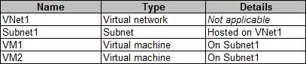

VM1 and VM2 are deployed from the same template and host line-of-business applications accessed by using Remote Desktop. You configure the network security group (NSG) shown in the exhibit. (Click the **Exhibit** button.)

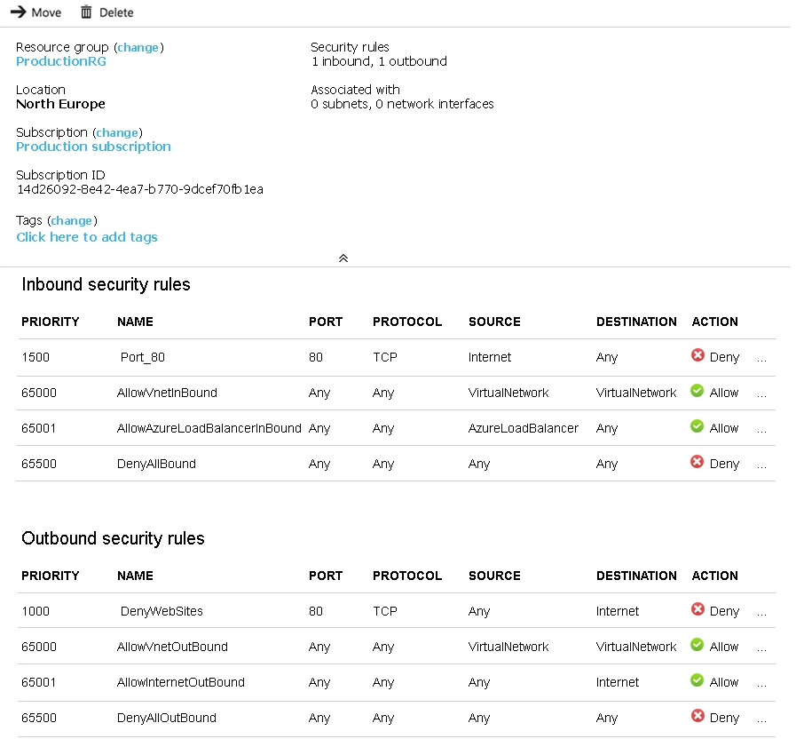

You need to prevent users of VM1 and VM2 from accessing websites on the Internet. What should you do?

|  |  |
| --- | --- |
| A. | Associate the NSG to Subnet1. |
| B. | Disassociate the NSG from a network interface. |
| C. | Change the DenyWebSites outbound security rule. |
| D. | Change the Port_80 inbound security rule. |

**Answer:** A

**Explanation:**

You can associate or dissociate a network security group from a network interface or subnet. The NSG has the appropriate rule to block users from accessing the Internet. We just need to associate it with Subnet1.

References: https://docs.microsoft.com/en-us/azure/virtual-network/manage-network-security- group

### QUESTION 79

You have an Azure subscription that contains the resources in the following table.

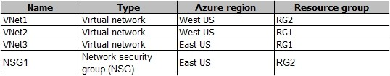

To which subnets can you apply NSG1?

|  |  |
| --- | --- |
| A. | the subnets on VNet2 only |
| B. | the subnets on VNet1 only |
| C. | the subnets on VNet2 and VNet3 only |
| D. | the subnets on VNet1, VNet2, and VNet3 |
| E. | the subnets on VNet3 only |

**Answer:** E

**Explanation:**

All Azure resources are created in an Azure region and subscription. A resource can only be created in a virtual network that exists in the same region and subscription as the resource. References: https://docs.microsoft.com/en-us/azure/virtual-network/virtual-network-vnet-plan- design-arm

### QUESTION 80

You create an Azure Storage account named contosostorage. You plan to create a file share named data.

Users need to map a drive to the data file share from home computers that run Windows 10. Which port should be open between the home computers and the data file share?

|  |  |
| --- | --- |
| A. | 80 |
| B. | 443 |
| C. | 445 |
| D. | 3389 |

**Answer:** C

**Explanation:**

Ensure port 445 is open: The SMB protocol requires TCP port 445 to be open; connections will fail if port 445 is blocked.

References: https://docs.microsoft.com/en-us/azure/storage/files/storage-how-to-use-files- windows

### QUESTION 81

You have an Azure Active Directory (Azure AD) tenant named contosocloud.onmicrosoft.com. Your company has a public DNS zone for contoso.com.

You add contoso.com as a custom domain name to Azure AD. You need to ensure that Azure can verify the domain name.

Which type of DNS record should you create?

|  |  |
| --- | --- |
| A. | RRSIG |
| B. | PTR |
| C. | DNSKEY |

|  |  |
| --- | --- |
| D. | TXT |

**Answer:** D

**Explanation:**

Create the TXT record. App Services uses this record only at configuration time to verify that you own the custom domain. You can delete this TXT record after your custom domain is validated and configured in App Service.

References: https://docs.microsoft.com/en-us/azure/dns/dns-web-sites-custom-domain

### QUESTION 82

**Note: This question is part of a series of questions that present the same scenario. Each question in the series contains a unique solution that might meet the stated goals. Some question sets might have more than one correct solution, while others might not have a correct solution. After you answer a question in this section, you will NOT be able to return to it. As a result, these questions will not appear in the review screen.**

You have an Azure subscription that contains 10 virtual networks. The virtual networks are hosted in separate resource groups.

Another administrator plans to create several network security groups (NSGs) in the subscription. You need to ensure that when an NSG is created, it automatically blocks TCP port 8080 between the virtual networks.

Solution: From the Resource providers blade, you unregister the Microsoft.ClassicNetwork provider.

Does this meet the goal?

|  |  |
| --- | --- |
| A. | Yes |
| B. | No |

**Answer:** B

### QUESTION 83

**Note: This question is part of a series of questions that present the same scenario. Each question in the series contains a unique solution that might meet the stated goals. Some question sets might have more than one correct solution, while others might not have a correct solution. After you answer a question in this section, you will NOT be able to return to it. As a result, these questions will not appear in the review screen.**

You have an Azure subscription that contains 10 virtual networks. The virtual networks are hosted in separate resource groups.

Another administrator plans to create several network security groups (NSGs) in the subscription. You need to ensure that when an NSG is created, it automatically blocks TCP port 8080 between the virtual networks.

Solution: You configure a custom policy definition, and then you assign the policy to the subscription.

Does this meet the goal?

|  |  |
| --- | --- |
| A. | Yes |
| B. | No |

**Answer:** A

**Explanation:**

Resource policy definition used by Azure Policy enables you to establish conventions for resources in your organization by describing when the policy is enforced and what effect to take. By defining conventions, you can control costs and more easily manage your resources.

References: https://docs.microsoft.com/en-us/azure/azure-policy/policy-definition

### QUESTION 84

**Note: This question is part of a series of questions that present the same scenario. Each question in the series contains a unique solution that might meet the stated goals. Some question sets might have more than one correct solution, while others might not have a correct solution. After you answer a question in this section, you will NOT be able to return to it. As a result, these questions will not appear in the review screen.**

You have an Azure subscription that contains 10 virtual networks. The virtual networks are hosted in separate resource groups.

Another administrator plans to create several network security groups (NSGs) in the subscription. You need to ensure that when an NSG is created, it automatically blocks TCP port 8080 between the virtual networks.

Solution: You create a resource lock, and then you assign the lock to the subscription. Does this meet the goal?

|  |  |
| --- | --- |
| A. | Yes |
| B. | No |

**Answer:** B

**Explanation:**

How can I freeze or lock my production/critical Azure resources from accidental deletion? There is way to do this with both ASM and ARM resources using Azure resource lock.

References: https://blogs.msdn.microsoft.com/azureedu/2016/04/27/using-azure-resource- manager-policy-and-azure-lock-to-control-your-azure-resources/

### QUESTION 85

You have an Azure Active Directory (Azure AD) domain that contains 5,000 user accounts. You create a new user account named AdminUser1.

You need to assign the User administrator administrative role to AdminUser1. What should you do from the user account properties?

|  |  |
| --- | --- |
| A. | From the Directory role blade, modify the directory role. |
| B. | From the Groups blade, invite the user account to a new group. |
| C. | From the Licenses blade, assign a new license. |

**Answer:** A

**Explanation:**

Assign a role to a user

Sign in to the Azure portal with an account that's a global admin or privileged role admin for the directory.

Select Azure Active Directory, select Users, and then select a specific user from the list. For the selected user, select Directory role, select Add role, and then pick the appropriate admin roles from the Directory roles list, such as Conditional access administrator.

Press Select to save.

References: https://docs.microsoft.com/en-us/azure/active-directory/fundamentals/active- directory-users-assign-role-azure-portal

### QUESTION 86

You have an Active Directory forest named contoso.com.

You install and configure Azure AD Connect to use password hash synchronization as the single sign-on (SSO) method. Staging mode is enabled.

You review the synchronization results and discover that the Synchronization Service Manager does not display any sync jobs.

You need to ensure that the synchronization completes successfully. What should you do?

|  |  |
| --- | --- |
| A. | From Synchronization Service Manager, run a full import. |
| B. | Run Azure AD Connect and set the SSO method to Pass-through Authentication. |
| C. | From Azure PowerShell, run Start-AdSyncSyncCycle -PolicyType Initial. |
| D. | Run Azure AD Connect and disable staging mode. |

**Answer:** D

**Explanation:**

Staging mode must be disabled. If the Azure AD Connect server is in staging mode, password hash synchronization is temporarily disabled.

References: https://docs.microsoft.com/en-us/azure/active-directory/connect/active-directory- aadconnectsync-troubleshoot-password-hash-synchronization#no-passwords-are-synchronized- troubleshoot-by-using-the-troubleshooting-task

### QUESTION 87

You have an Azure Active Directory (Azure AD) tenant named contoso.onmicrosoft.com that contains 100 user accounts.

You purchase 10 Azure AD Premium P2 licenses for the tenant. You need to ensure that 10 users can use all the Azure AD Premium features.

What should you do?

|  |  |
| --- | --- |
| A. | From the Groups blade of each user, invite the users to a group. |
| B. | From the Licenses blade of Azure AD, assign a license. |
| C. | From the Directory role blade of each user, modify the directory role. |
| D. | From the Azure AD domain, add an enterprise application. |

**Answer:** B

**Explanation:**

To assign a license, under Azure Active Directory > Licenses > All Products, select one or more products, and then select Assign on the command bar.

References: https://docs.microsoft.com/en-us/azure/active-directory/fundamentals/license-users- groups

### QUESTION 88

You download an Azure Resource Manager template based on an existing virtual machine. The template will be used to deploy 100 virtual machines. You need to modify the template to reference an administrative password. You must prevent the password from being stored in plain text.

What should you create to store the password?

|  |  |
| --- | --- |
| A. | Azure Active Directory (AD) Identity Protection and an Azure policy |
| B. | a Recovery Services vault and a backup policy |
| C. | an Azure Key Vault and an access policy |
| D. | an Azure Storage account and an access policy |

**Answer:** C

**Explanation:**

You can use a template that allows you to deploy a simple Windows VM by retrieving the password that is stored in a Key Vault. Therefore the password is never put in plain text in the template parameter file.

References: https://azure.microsoft.com/en-us/resources/templates/101-vm-secure-password/

### QUESTION 89

**Note: This question is part of a series of questions that present the same scenario. Each question in the series contains a unique solution that might meet the stated goals. Some question sets might have more than one correct solution, while others might not have a correct solution.**

**After you answer a question in this section, you will NOT be able to return to it. As a result, these questions will not appear in the review screen.**

Your company registers a domain name of contoso.com.

You create an Azure DNS named contoso.com and then you add an A record to the zone for a host named www that has an IP address of 131.107.1.10.

You discover that Internet hosts are unable to resolve [www.contoso.com](http://www.contoso.com/) to the 131.107.1.10 IP address.

You need to resolve the name resolution issue.

Solution: You modify the name server at the domain register. Does this meet the goal?

|  |  |
| --- | --- |
| A. | Yes |
| B. | No |

**Answer:** A

**Explanation:**

https://docs.microsoft.com/en-us/azure/dns/dns-delegate-domain-azure-dns Delegate the domain

Now that the DNS zone is created and you have the name servers, you need to update the parent domain with the Azure DNS name servers. Each registrar has its own DNS management tools to change the name server records for a domain.

### QUESTION 90

**Note: This question is part of a series of questions that present the same scenario. Each question in the series contains a unique solution that might meet the stated goals. Some question sets might have more than one correct solution, while others might not have a correct solution.**

**After you answer a question in this section, you will NOT be able to return to it. As a result, these questions will not appear in the review screen.**

Your company registers a domain name of contoso.com.

You create an Azure DNS zone named contoso.com, and then you add an A record to the zone for a host named www that has an IP address of 131.107.1.10.

You discover that Internet hosts are unable to resolve [www.contoso.com](http://www.contoso.com/) to the 131.107.1.10 IP address.

You need to resolve the name resolution issue.

Solution: You add an NS record to the contoso.com Azure DNS zone. Does this meet the goal?

|  |  |
| --- | --- |
| A. | Yes |
| B. | No |

**Answer:** B

**Explanation:**

Default NS records are created automatically and shouldn't be messed with in this case.

### QUESTION 91

**Note: This question is part of a series of questions that present the same scenario. Each question in the series contains a unique solution that might meet the stated goals. Some question sets might have more than one correct solution, while others might not have a correct solution.**

**After you answer a question in this section, you will NOT be able to return to it. As a result, these questions will not appear in the review screen.**

Your company registers a domain name of contoso.com.

You create an Azure DNS named contoso.com and then you add an A record to the zone for a host named www that has an IP address of 131.107.1.10.

You discover that Internet hosts are unable to resolve [www.contoso.com](http://www.contoso.com/) to the 131.107.1.10 IP address.

You need to resolve the name resolution issue.

Solution: You modify the SOA record in the contoso.com zone. Does this meet the goal?

|  |  |
| --- | --- |
| A. | Yes |
| B. | No |

**Answer:** B

**Explanation:**

Modify the NS record, not the SOA record.

Note: The SOA record stores information about the name of the server that supplied the data for the zone; the administrator of the zone; the current version of the data file; the number of seconds a secondary name server should wait before checking for updates; the number of seconds a secondary name server should wait before retrying a failed zone transfer; the maximum number of seconds that a secondary name server can use data before it must either be refreshed or expire; and a default number of seconds for the time-to-live file on resource records.

References: https://searchnetworking.techtarget.com/definition/start-of-authority-record

### QUESTION 92

**Note: This question is part of a series of questions that present the same scenario. Each question in the series contains a unique solution that might meet the stated goals. Some question sets might have more than one correct solution, while others might not have a correct solution. After you answer a question in this section, you will NOT be able to return to it. As a result, these questions will not appear in the review screen.**

You have an Azure subscription named Subscription1. Subscription1 contains a resource group named RG1. RG1 contains resources that were deployed by using templates. You need to view the date and time when the resources were created in RG1.

Solution: From the RG1 blade, you click Automation script. Does this meet the goal?

|  |  |
| --- | --- |
| A. | Yes |
| B. | No |

**Answer:** B

### QUESTION 93

**Note: This question is part of a series of questions that present the same scenario. Each question in the series contains a unique solution that might meet the stated goals. Some question sets might have more than one correct solution, while others might not have a correct solution. After you answer a question in this section, you will NOT be able to return to it. As a result, these questions will not appear in the review screen.**

You have an Azure virtual machine named VM1. VM1 was deployed by using a custom Azure Resource Manager template named ARM1.json.

You receive a notification that VM1 will be affected by maintenance. You need to move VM1 to a different host immediately.

Solution: From the Overview blade, you move the virtual machine to a different resource group. Does this meet the goal?

|  |  |
| --- | --- |
| A. | Yes |
| B. | No |

**Answer:** B

### QUESTION 94

**Note: This question is part of a series of questions that present the same scenario. Each question in the series contains a unique solution that might meet the stated goals. Some question sets might have more than one correct solution, while others might not have a correct solution. After you answer a question in this section, you will NOT be able to return to it. As a result, these questions will not appear in the review screen.**

You have an Azure virtual machine named VM1. VM1 was deployed by using a custom Azure Resource Manager template named ARM1.json.

You receive a notification that VM1 will be affected by maintenance. You need to move VM1 to a different host immediately.

Solution: From the Update management blade, you click enable. Does this meet the goal?

|  |  |
| --- | --- |
| A. | Yes |
| B. | No |

**Answer:** B

**Explanation:**

You would need to Redeploy the VM.

References: https://docs.microsoft.com/en-us/azure/virtual-machines/windows/redeploy-to-new- node

### QUESTION 95

You have an Azure Active Directory (Azure AD) tenant named contosocloud.onmicrosoft.com. Your company has a public DNS zone for contoso.com.

You add contoso.com as a custom domain name to Azure AD. You need to ensure that Azure can verify the domain name.

Which type of DNS record should you create?

|  |  |
| --- | --- |
| A. | PTR |
| B. | MX |
| C. | NSEC3 |
| D. | RRSIG |

**Answer:** B

### QUESTION 96

You manage an Azure Windows Server virtual machine (VM) that hosts several SQL Server databases.

You need to configure backup and retention policies for the VM. The backup policy must include transaction log backups.

What should you do?

|  |  |
| --- | --- |
| A. | Configure point-in-time and long-term retention policies from the SQL Servers Azure portal blade. |
| B. | Configure a SQL Server in Azure VM backup policy from the Recovery Services Azure portal blade. |
| C. | Configure a continuous delivery deployment group from the Virtual Machine Azure portal blade. |
| D. | Configure a point-in-time snapshot from the Disks Azure portal blade. |

**Answer:** B

**Explanation:**

You should configure a SQL Server in Azure VM backup policy from the Recovery Services Azure portal blade.

The Azure Recovery Services vault has three default policy templates: Azure Virtual Machine

Azure File Share

SQL Server in Azure VM

Because you need to back up both the SQL Server databases as well as transaction logs, you should create a SQL Server in Azure VM backup policy. These policies also enable you to specify backup retention durations at the daily, weekly, monthly, and yearly scopes.

You should not configure point-in-time and long-term retention policies from the SQL Servers Azure portal blade. These backup and retention policies are available for the Azure SQL Database platform-as-a-service (PaaS) offering, and not for Azure virtual machines hosting SQL Server databases.

You should not configure a continuous delivery deployment group from the Virtual Machine Azure portal blade. This feature is unrelated to VM backup and recovery, and allows you to integrate a VM in a Visual Studio Team Services (VSTS) continuous integration/continuous deployment (Cl/CD) workflow.

You should not configure a point-in-time snapshot from the Disks Azure portal blade. The snapshot functionality in Azure does not have formal policy associated with it, nor does it back up VM configuration.

### QUESTION 97

The development team asks you to provision an Azure storage account for their use.

To remain in compliance with IT security policy, you need to ensure that the new Azure storage account meets the following requirements:

* Data must be encrypted at rest.
* Access keys must facilitate automatic rotation.
* The company must manage the access keys.

What should you do?

|  |  |
| --- | --- |
| A. | Create a service endpoint between the storage account and a virtual network (VNet). |
| B. | Require secure transfer for the storage account. |
| C. | Enable Storage Service Encryption (SSE) on the storage account. |
| D. | Configure the storage account to store its keys in Azure Key Vault. |

**Answer:** D

**Explanation:**

You should configure the storage account to store its keys in Azure Key Vault. Azure Key Vault provides a mechanism to store secrets, such as storage account keys, user credentials, and digital certificates, securely in the Microsoft Azure cloud. You can access the underlying Representational State Transfer (REST) application programming interface (API) to rotate or retrieve the secrets in your source code.

You should not enable SSE on the storage account for two reasons. First, SSE is enabled automatically on all Azure storage accounts and encrypts all storage account data at rest. Second, SSE in its native form uses Microsoft-managed access keys, which violates the scenario constraint for customer-managed keys.

You should not require secure transfer for the storage account. Secure transfer forces all REST API calls to use HTTPS instead of HTTP. This feature has nothing to do with either access keys or their management and rotation.

You should not create a service endpoint between the storage account and a VNet. A service endpoint allows you limit traffic to a storage account from resources residing on an Azure VNet.

### QUESTION 98

You have several Windows Server and Ubuntu Linux virtual machines (VMs) distributed across two virtual networks (VNets):

* prod-vnet-west (West US region)
* prod-vnet-east (East US region)

You need to allow VMs in either VNet to connect and to share resources by using only the Azure

backbone network.

Your solution must minimize cost, complexity, and deployment time. What should you do?

|  |  |
| --- | --- |
| A. | Add a service endpoint to each VNet. |
| B. | Configure peering between prod-vnet-west and prod-vnet-west. |
| C. | Create a private zone in Azure DNS. |
| D. | Deploy a VNet-to-VNet virtual private network (VPN). |

**Answer:** B

**Explanation:**

You should configure peering between prod-vnet-west and prod-vnet-west. Peering enables VMs located on two different Azure VNets to be grouped logically together and thereby connect and share resources. Traditional VNet peering involves two VNets located in the same region.

However, global VNet peering, generally available in summer 2018, supports VNets distributed across any Azure public region.

You should not deploy a VNet-to-VNet VPN. First, global VNet peering means that you are no longer required to use a VPN gateway to link VNets located in different Azure regions. Second, the scenario requires that you minimize cost and complexity.

You should not create a private zone in Azure DNS. This action would be necessary for resources in peered VNets to resolve each other's DNS host names. However, the scenario makes no requirement for private host name resolution.

You should not add a service endpoint to each VNet. Service endpoints allow you to limit access to certain Azure resources, such as storage accounts and Azure SQL databases, to resources located on a single VNet. Thus, this feature cannot be used to link two VNets as the scenario mandates.

### QUESTION 99

Your company's local environment consists of a single Active Directory Domain Services (AD DS) domain.

You plan to offer your users single sign-on (SSO) access to Azure-hosted software-as-a-service (SaaS) applications that use Azure Active Directory (Azure AD) authentication.

The tenant's current domain name is companycom.onmicrosoft.com.

You need to configure Azure AD to use company.com, the organization's owned public domain name.

What should you do?

|  |  |
| --- | --- |
| A. | Add a company.com user principal name (UPN) suffix to the AD DS domain. |
| B. | Run Azure AD Connect from a domain member server and specify the custom installation option. |
| C. | Remove the companycom.onmicrosoft.com domain name from the Azure AD tenant. |
| D. | Add a DNS verification record at the domain registrar. |

**Answer:** D

**Explanation:**

You should add a Domain Name System (DNS) verification record at the domain registrar. This step is required to verify to Microsoft that you own the public DNS domain name in question. You perform the validation by creating either a text (TXT) or mail exchanger (MX) record in your DNS zone file at the registrar's website, using Microsoft-provided values. You can delete the verification record after Azure validates the domain for use with Azure AD.

You should not remove the companycom.onmicrosoft.com domain name from the Azure AD tenant. In fact, you cannot remove this domain name because Azure uses it to identify your directory uniquely across the entire Microsoft Azure global ecosystem.

You should not add a company.com user principal name (UPN) suffix to the AD DS domain. If you use a non-routable DNS domain in AD DS, then you may indeed be required to perform this

action. However, the scenario does not specify what AD DS domain name is currently defined. You should not run Azure AD Connect from a domain member server and specify the custom installation option. Configuring the proper public and private DNS domain names is one of the prerequisite steps that needs to be completed before you run the Azure AD Connect wizard for the first time.

### QUESTION 100

Drag and Drop Question

You have an Azure subscription that contains a storage account.

You have an on-premises server named Server1 that runs Window Server 2016. Server1 has 2 TB of data.

You need to transfer the data to the storage account by using the Azure Import/Export service. In which order should you perform the actions? To answer, move all actions from the list of actions to the answer area and arrange them in the correct order.

NOTE: More than one order of answer choices is correct. You will receive credit for any of the correct orders you select.

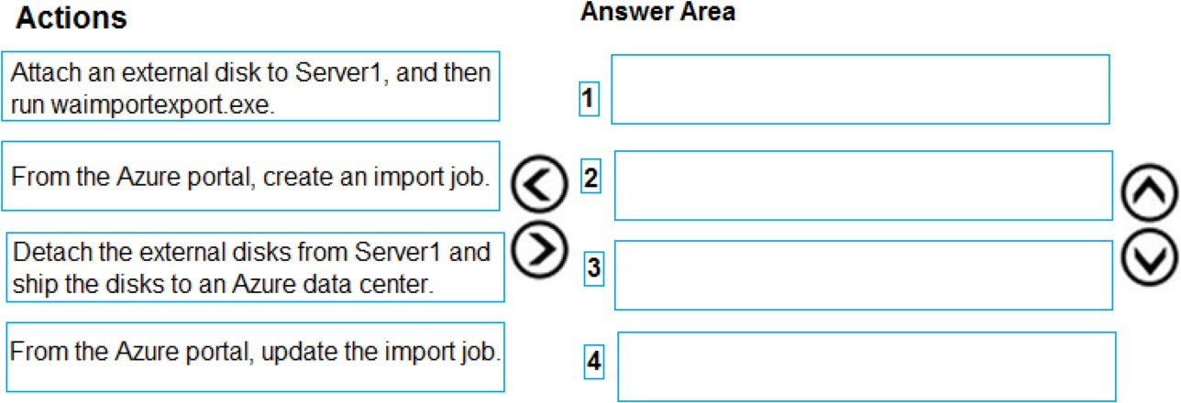

**Answer:**

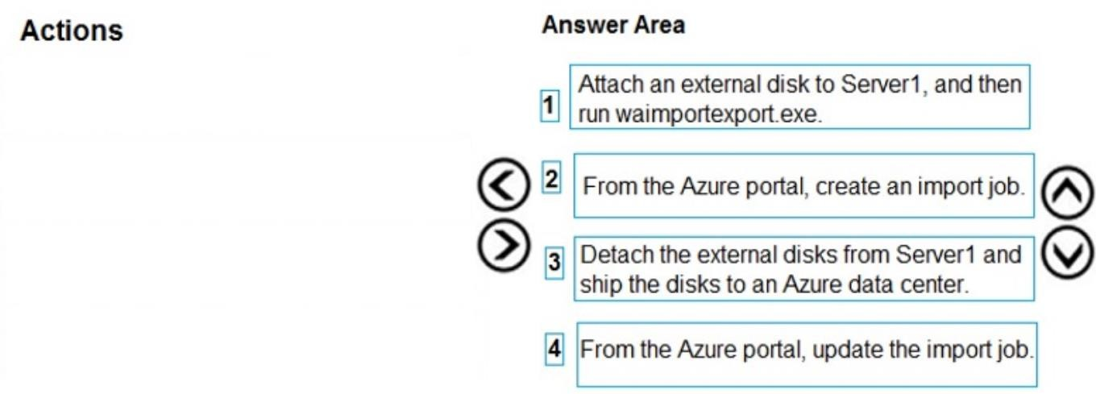

**Explanation:**

At a high level, an import job involves the following steps:

Step 1: Attach an external disk to Server1 and then run waimportexport.exe

Determine data to be imported, number of drives you need, destination blob location for your data in Azure storage.

Use the WAImportExport tool to copy data to disk drives. Encrypt the disk drives with BitLocker.

Step 2: From the Azure portal, create an import job.

Create an import job in your target storage account in Azure portal. Upload the drive journal files. Step 3: Detach the external disks from Server1 and ship the disks to an Azure data center.

Provide the return address and carrier account number for shipping the drives back to you. Ship the disk drives to the shipping address provided during job creation.

Step 4: From the Azure portal, update the import job

Update the delivery tracking number in the import job details and submit the import job. The drives are received and processed at the Azure data center.

The drives are shipped using your carrier account to the return address provided in the import job.

References:

https://docs.microsoft.com/en-us/azure/storage/common/storage-import-export-service

### QUESTION 101

Hotspot Question

You have an Azure subscription named Subscription1.

In Subscription1, you create an Azure file share named share1.

You create a shared access signature (SAS) named SAS1 as shown in the following exhibit.

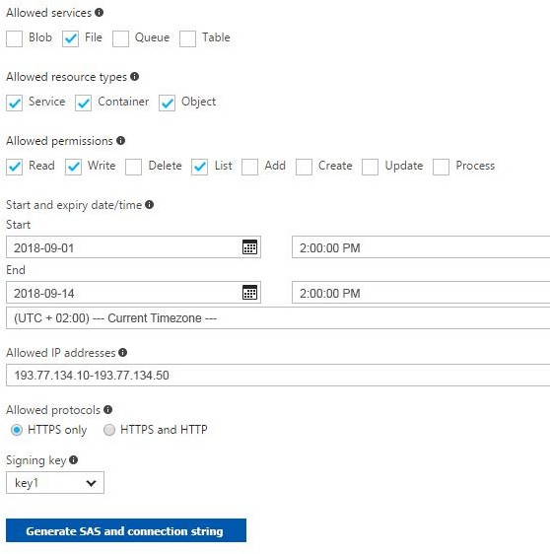

To answer, select the appropriate options in the answer area.

**NOTE**: Each correct selection is worth one point.

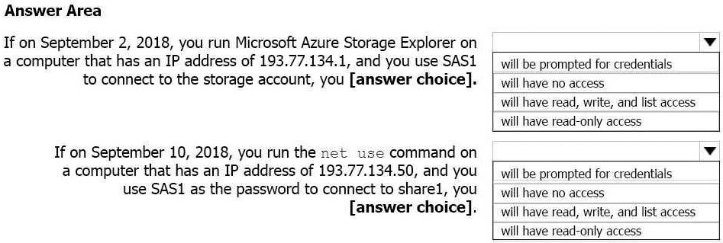

**Answer:**

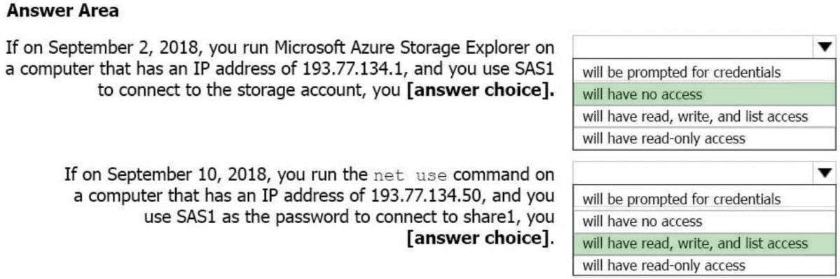

**Explanation:**

Box 1: Will have no access

The IP 193.77.134.1 does not have access on the SAS. Box 2: Will have read, write, and list access

The net use command is used to connect to file shares. References:

https://docs.microsoft.com/en-us/azure/storage/common/storage-dotnet-shared-access- signature-part-1

https://docs.microsoft.com/en-us/azure/vs-azure-tools-storage-manage-with-storage- explorer?tabs=windows

### QUESTION 102

Drag and Drop Question

You have an on-premises file server named Server1 that runs Windows Server 2016. You have an Azure subscription that contains an Azure file share.

You deploy an Azure File Sync Storage Sync Service, and you create a sync group. You need to synchronize files from Server1 to Azure.

Which three actions should you perform in sequence? To answer, move the appropriate actions from the list of actions to the answer area and arrange them in the correct order.

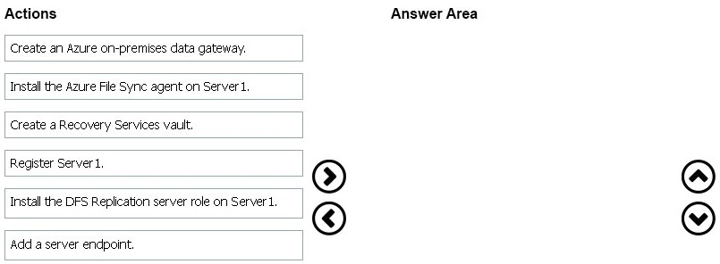

**Answer:**

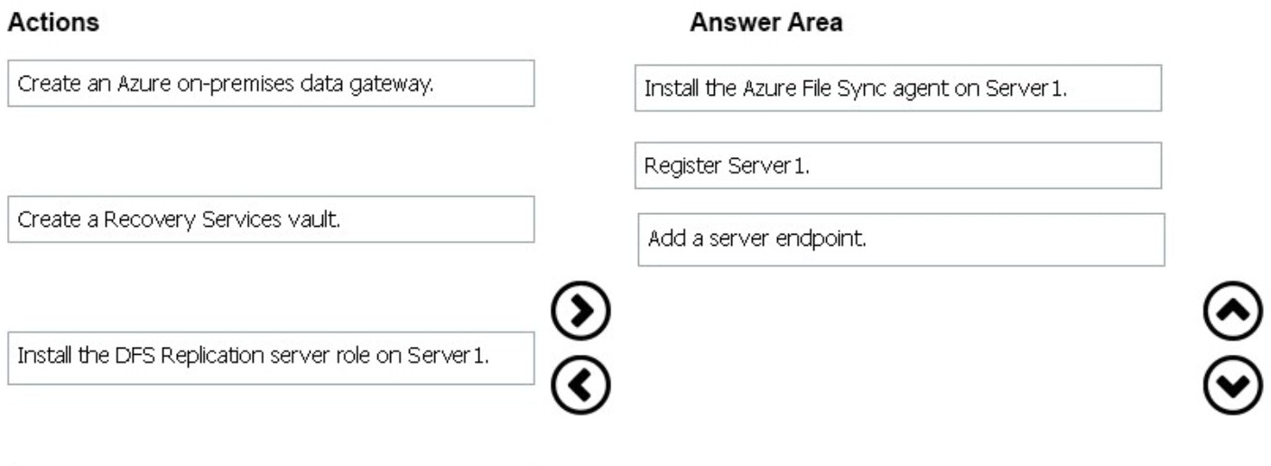

**Explanation:**

Step 1: Install the Azure File Sync agent on Server1

The Azure File Sync agent is a downloadable package that enables Windows Server to be synced with an Azure file share

Step 2: Register Server1.

Register Windows Server with Storage Sync Service

Registering your Windows Server with a Storage Sync Service establishes a trust relationship between your server (or cluster) and the Storage Sync Service.

Step 3: Add a server endpoint

Create a sync group and a cloud endpoint.

A sync group defines the sync topology for a set of files. Endpoints within a sync group are kept in sync with each other. A sync group must contain one cloud endpoint, which represents an Azure file share and one or more server endpoints. A server endpoint represents a path on registered server.

References: https://docs.microsoft.com/en-us/azure/storage/files/storage-sync-files-deployment- guide

### QUESTION 103

Hotspot Question

You plan to create an Azure Storage account in the Azure region of East US 2. You need to create a storage account that meets the following requirements:

* Replicates synchronously
* Remains available if a single data center in the region fails.

How should you configure the storage account? To answer, select the appropriate options in the answer area.

NOTE: Each correct selection is worth one point.

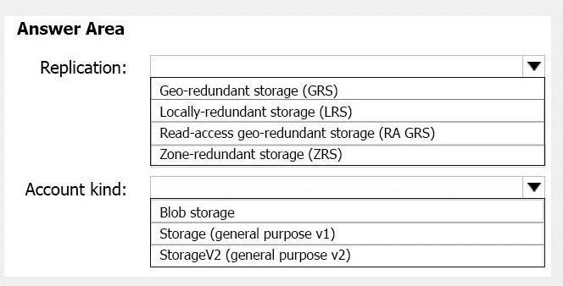

**Answer:**

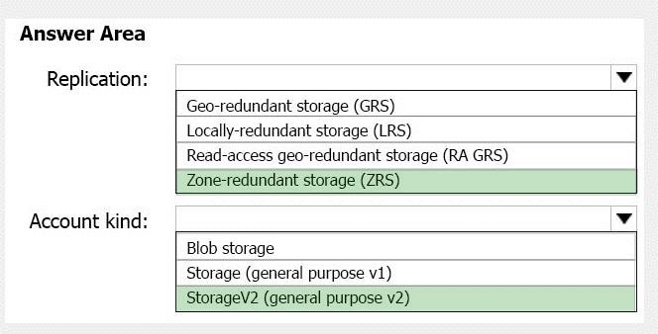

**Explanation:**

Box 1: Zone-redundant storage (ZRS)

Zone-redundant storage (ZRS) replicates your data synchronously across three storage clusters in a single region.

LRS would not remain available if a data center in the region fails GRS and RA GRS use asynchronous replication.

Box 2: StorageV2 (general purpose V2) ZRS only support GPv2.

References:

https://docs.microsoft.com/en-us/azure/storage/common/storage-redundancy https://docs.microsoft.com/en-us/azure/storage/common/storage-redundancy-zrs

### QUESTION 104

Drag and Drop Question

You have an Azure subscription named Subscription1.

You create an Azure Storage account named contosostorage, and then you create a file share named data.

Which UNC path should you include in a script that references files from the data file share? To answer, drag the appropriate values to the correct targets. Each value may be used once, more than once, or not at all. You may need to drag the split bar between panes or scroll to view content.

NOTE: Each correct selection is worth one point.

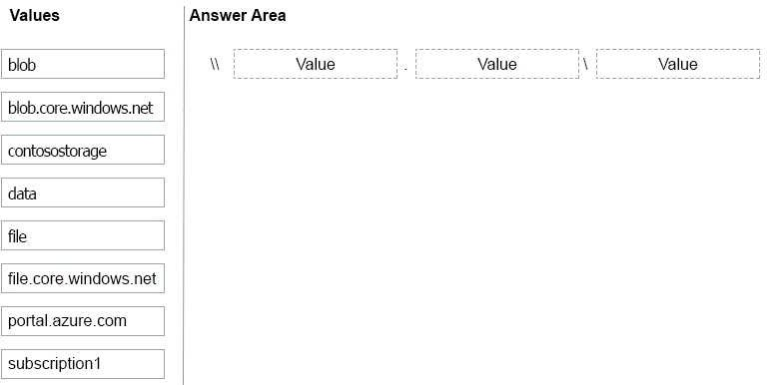

**Answer:**

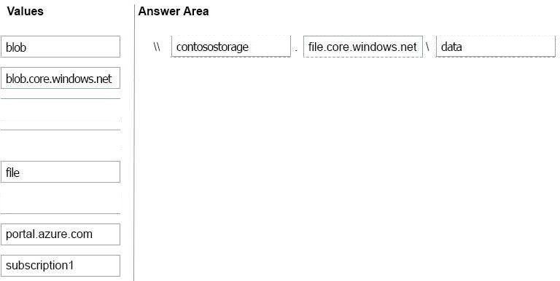

**Explanation:**

Box 1: contosostorage The name of account

Box 2: file.core.windows.net

Box 3: data

The name of the file share is data. Example:



References: https://docs.microsoft.com/en-us/azure/storage/files/storage-how-to-use-files- windows

### QUESTION 105

Hotspot Question

You have an Azure Storage accounts as shown in the following exhibit.

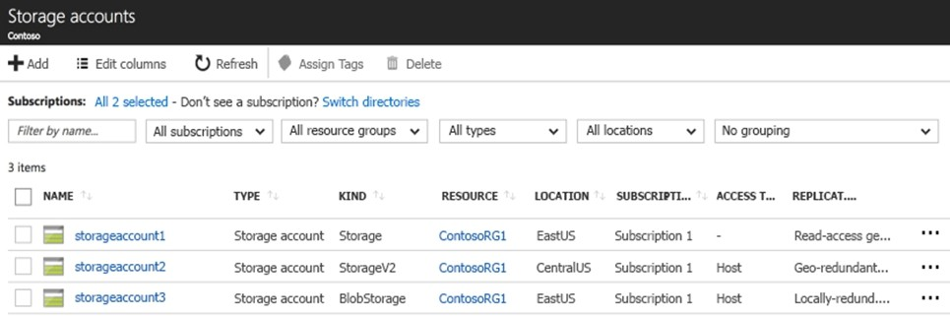

Use the drop-down menus to select the answer choice that completes each statement based on the information presented in the graphic.

**NOTE**: Each correct selection is worth one point.

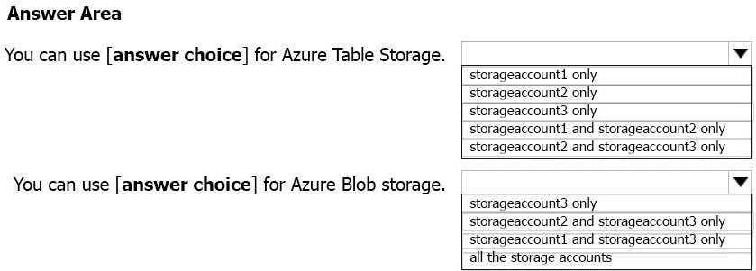

**Answer:**

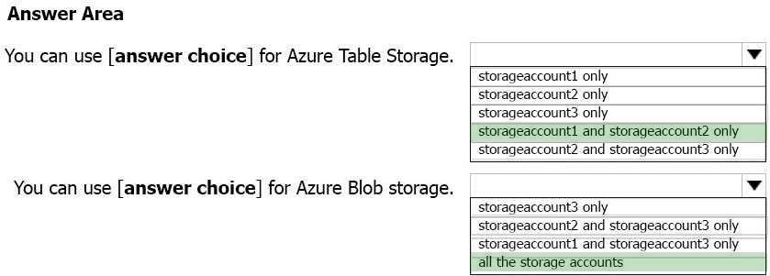

**Explanation:**

Box 1: storageaccount1 and storageaccount2 only Box 2: All the storage accounts

Note: The three different storage account options are: General-purpose v2 (GPv2) accounts, General-purpose v1 (GPv1) accounts, and Blob storage accounts. General-purpose v2 (GPv2) accounts are storage accounts that support all of the latest features for blobs, files, queues, and tables.

Blob storage accounts support all the same block blob features as GPv2, but are limited to supporting only block blobs.

General-purpose v1 (GPv1) accounts provide access to all Azure Storage services, but may not have the latest features or the lowest per gigabyte pricing.

References: https://docs.microsoft.com/en-us/azure/storage/common/storage-account-options

### QUESTION 106

Drag and Drop Question

You have an Azure subscription that contains an Azure virtual machine named VM1. VM1 runs Windows Server 2016 and is part of an availability set.

VM1 has virtual machine-level backup enabled. VM1 is deleted.

You need to restore VM1 from the backup. VM1 must be part of the availability set.

Which three actions should you perform in sequence? To answer, move the appropriate actions from the list of actions to the answer area and arrange them in the correct order.

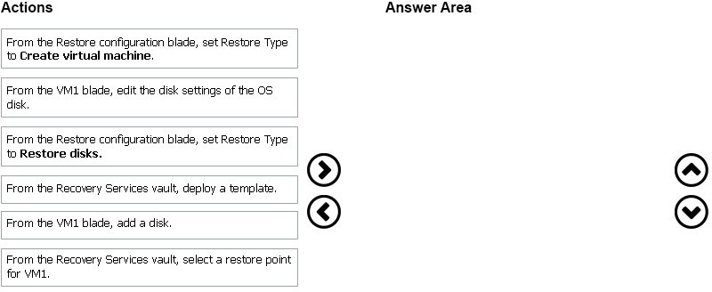

**Answer:**

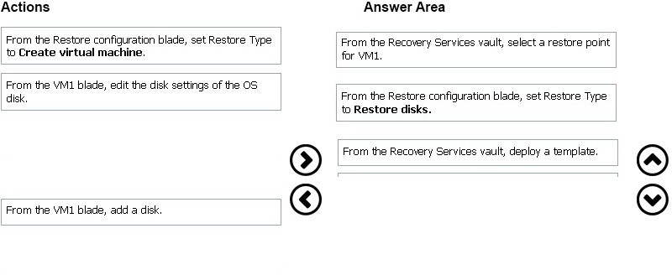

### QUESTION 107

Hotspot Question

You have an Azure subscription named Subscription1.

You plan to deploy an Ubuntu Server virtual machine named VM1 to Subscription1. You need to perform a custom deployment of the virtual machine.

A specific trusted root certification authority (CA) must be added during the deployment. What should you do? To answer, select the appropriate options in the answer area.

NOTE: Each correct selection is worth one point.

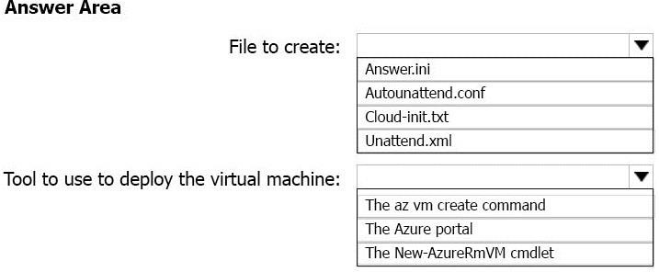

**Answer:**

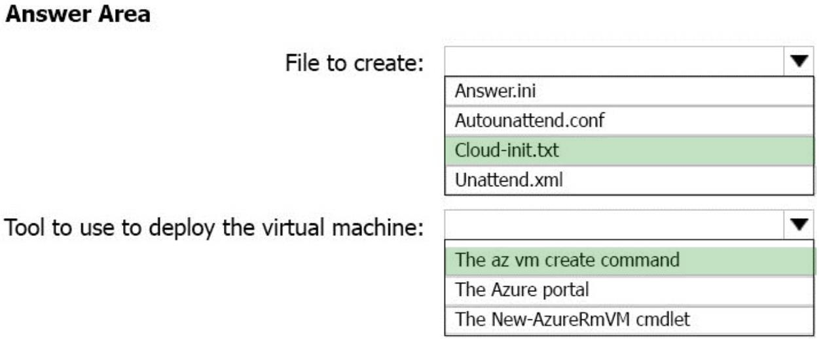

**Explanation:**

Box 1: Cloud-init.txt

Cloud-init.txt is used to customize a Linux VM on first boot up. It can be used to install packages and write files, or to configure users and security. No additional steps or agents are required to apply your configuration.

Box 2: The az vm create command

Once Cloud-init.txt has been created, you can deploy the VM with az vm create cmdlet, sing the -

-custom-data parameter to provide the full path to the cloud-init.txt file. References:

https://docs.microsoft.com/en-us/azure/virtual-machines/linux/tutorial-automate-vm-deployment

### QUESTION 108

Hotspot Question

You have an Azure subscription named Subscription1. Subscription1 contains two Azure virtual machines named VM1 and VM2.

VM1 and VM2 run Windows Server 2016. VM1 is backed up daily by Azure Backup without using the Azure Backup agent.

VM1 is affected by ransomware that encrypts data. You need to restore the latest backup of VM1.

To which location can you restore the backup? To answer, select the appropriate options in the

answer area.

NOTE: Each correct selection is worth one point.

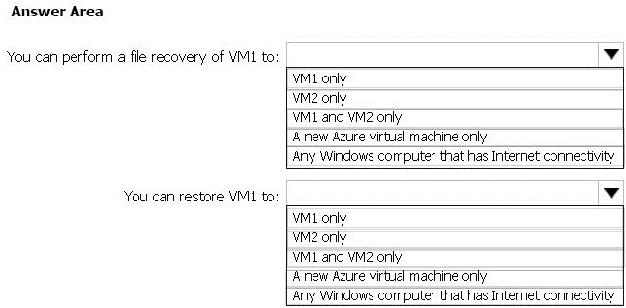

**Answer:**

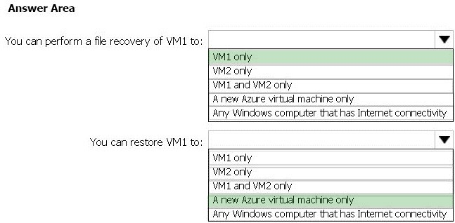

**Explanation:**

Box 1: VM1 only

To restore files or folders from the recovery point, go to the virtual machine and choose the desired recovery point.

Box 2: A new Azure virtual machine only

On the Restore configuration blade, you have two choices: Create virtual machine

Restore disks References:

https://docs.microsoft.com/en-us/azure/backup/backup-azure-restore-files-from-vm https://docs.microsoft.com/en-us/azure/backup/backup-azure-arm-restore-vms

### QUESTION 109

Hotspot Question

You purchase a new Azure subscription named Subscription1. You create a virtual machine named VM1 in Subscription1.

VM1 is not protected by Azure Backup.

You need to protect VM1 by using Azure Backup. Backups must be created at 01:00 and stored for 30 days.

What should you do? To answer, select the appropriate options in the answer area. NOTE: Each correct selection is worth one point.

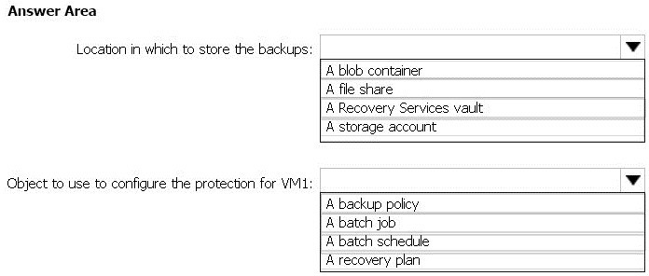

**Answer:**

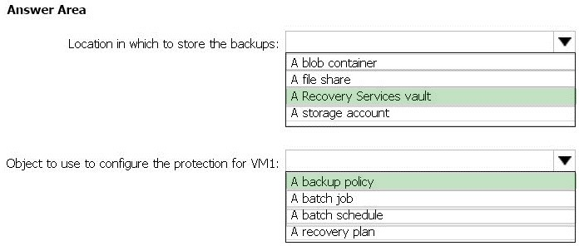

**Explanation:**

Box 1: A Recovery Services vault

A Recovery Services vault is an entity that stores all the backups and recovery points you create over time.

Box 2: A backup policy

What happens when I change my backup policy?

When a new policy is applied, schedule and retention of the new policy is followed.

References:

https://docs.microsoft.com/en-us/azure/backup/backup-configure-vault https://docs.microsoft.com/en-us/azure/backup/backup-azure-backup-faq

### QUESTION 110

Drag and Drop Question

You have an availability set named AS1 that contains three virtual machines named VM1, VM2, and VM3.

You attempt to reconfigure VM1 to use a larger size. The operation fails and you receive an allocation failure message.

You need to ensure that the resize operation succeeds.

Which three actions should you perform in sequence? To answer, move the appropriate actions from the list of actions to the answer area and arrange them in the correct order.

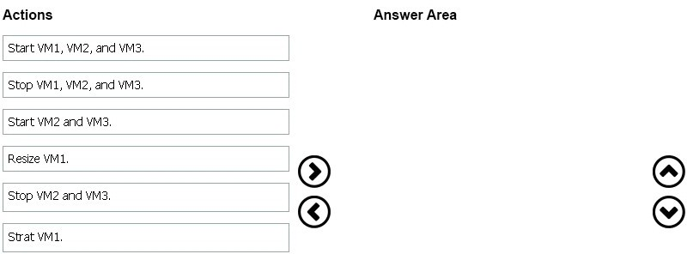

**Answer:**

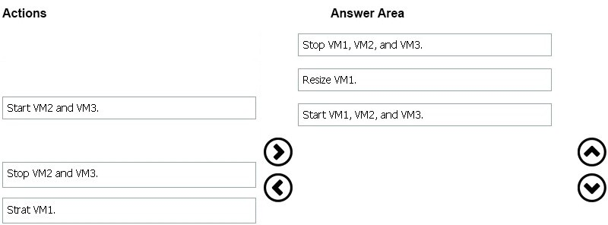

### QUESTION 111

Drag and Drop Question

You have an Azure subscription. The subscription includes a virtual network named VNet1. Currently, VNet1 does not contain any subnets.

You plan to create subnets on VNet1 and to use application security groups to restrict the traffic between the subnets.

You need to create the application security groups and to assign them to the subnets.

Which four cmdlets should you run in sequence? To answer, move the appropriate cmdlets from the list of cmdlets to the answer area and arrange them in the correct order.

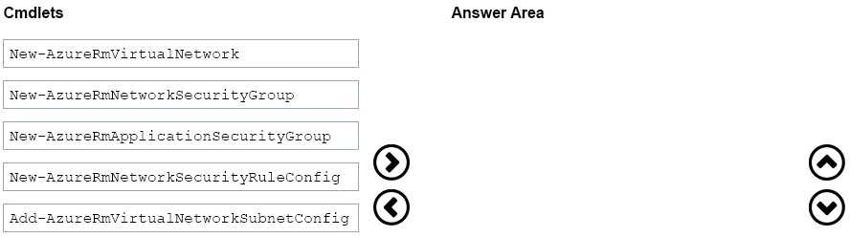

**Answer:**

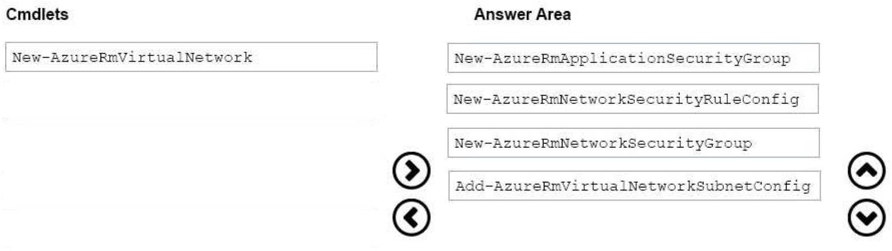

### QUESTION 112

Hotspot Question

You have an Azure subscription named Subscription1. Subscription1 contains the virtual machines in the following table.

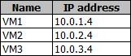

Subscription1 contains a virtual network named VNet1 that has the subnets in the following table.

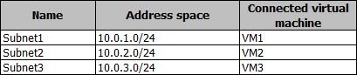

VM3 has a network adapter named NIC3. IP forwarding is enabled on NIC3. Routing is enabled on VM3.

You create a route table named RT1. RT1 is associated to Subnet1 and Subnet2 and contains the routes in the following table.

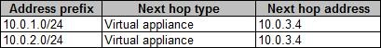

You apply RT1 to Subnet1.

For each of the following statements, select Yes if the statement is true. Otherwise, select No.

**NOTE**: Each correct selection is worth one point.

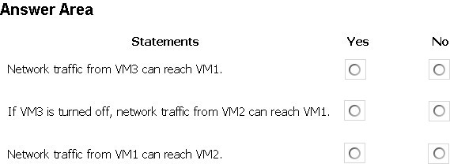

**Answer:**

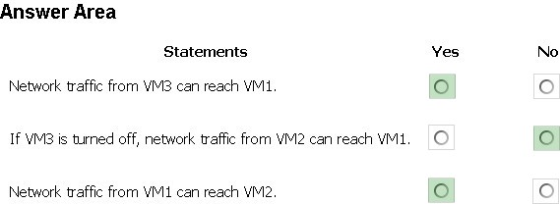

**Explanation:**

Box 1: Yes

Traffic from VM1 and VM2 can reach VM3 thanks to the routing table, and as IP forwarding is enabled on VM3, traffic from VM3 can reach VM1.

Box 2: No

VM3, which has IP forwarding, must be turned on, in order for traffic from VM2 to reach VM1. Box 3: Yes

The traffic from VM1 will reach VM3, which thanks to IP forwarding, will send the traffic to VM2.

References: https://www.quor a.com/What-is-IP-forwarding

### QUESTION 113

Hotspot Question

You plan to deploy five virtual machines to a virtual network subnet. Each virtual machine will have a public IP address and a private IP address.

Each virtual machine requires the same inbound and outbound security rules.

What is the minimum number of network interfaces and network security groups that you require? To answer, select the appropriate options in the answer area.

NOTE: Each correct selection is worth one point.

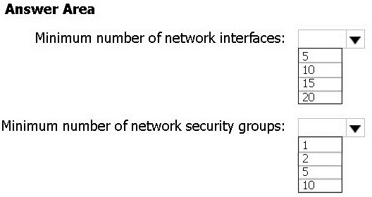

**Answer:**

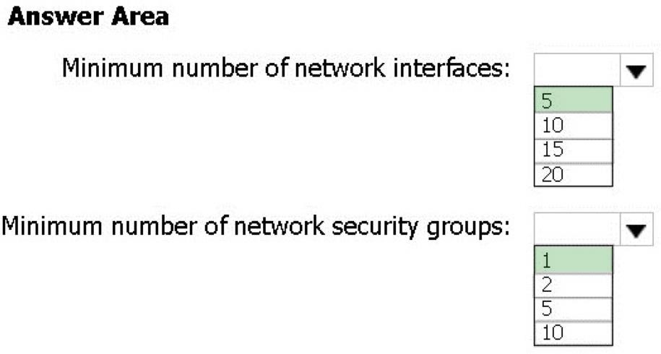

**Explanation:**

Box 1: 5

A NIC can only be attached to a single VM, thus 5 are necessary. Box 2: 1

A NSG can be assigned to zero or more NICs or Subnets; since the rules need to be the same, only one NSG rule set is needed, which will be applied to each NIC.

### QUESTION 114

Hotspot Question

You have an Azure subscription named Subscription1. Subscription1 contains the resources in the following table.

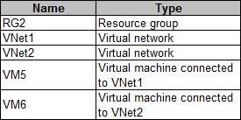

In Azure, you create a private DNS zone named adatum.com.

You set the registration virtual network to VNet2. The adatum.com zone is configured as shown in the following exhibit.

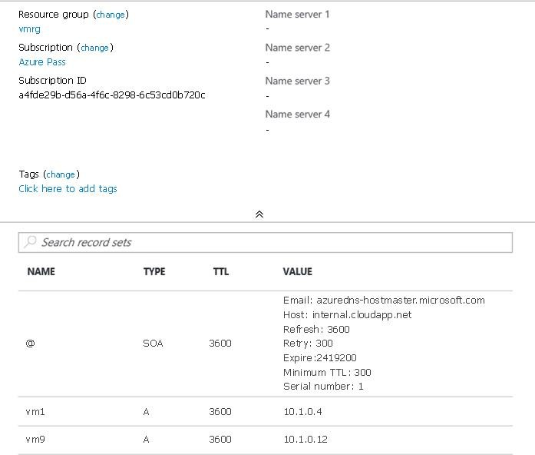

For each of the following statements, select Yes if the statement is true. Otherwise, select No.

**NOTE**: Each correct selection is worth one point.

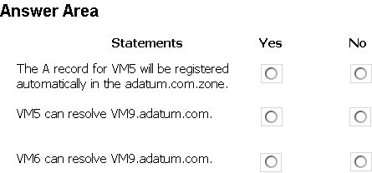

**Answer:**

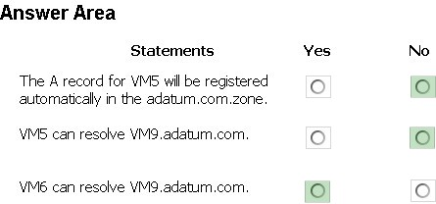

**Explanation:**

Box 1: No

Azure DNS provides automatic registration of virtual machines from a single virtual network that's linked to a private zone as a registration virtual network. VM5 does not belong to the registration virtual network though.

Box 2: No

Forward DNS resolution is supported across virtual networks that are linked to the private zone as resolution virtual networks. VM5 does belong to a resolution virtual network.

Box 3: Yes

VM6 belongs to registration virtual network, and an A (Host) record exists for VM9 in the DNS zone. By default, registration virtual networks also act as resolution virtual networks, in the sense that DNS resolution against the zone works from any of the virtual machines within the registration virtual network.

References: https://docs.microsoft.com/en-us/azure/dns/private-dns-overview

### QUESTION 115

Hotspot Question

You have an Azure subscription named Subscription1. Subscription1 contains a virtual machine named VM1.

You install and configure a web server and a DNS server on VM1.

VM1 has the effective network security rules shown in the following exhibit.

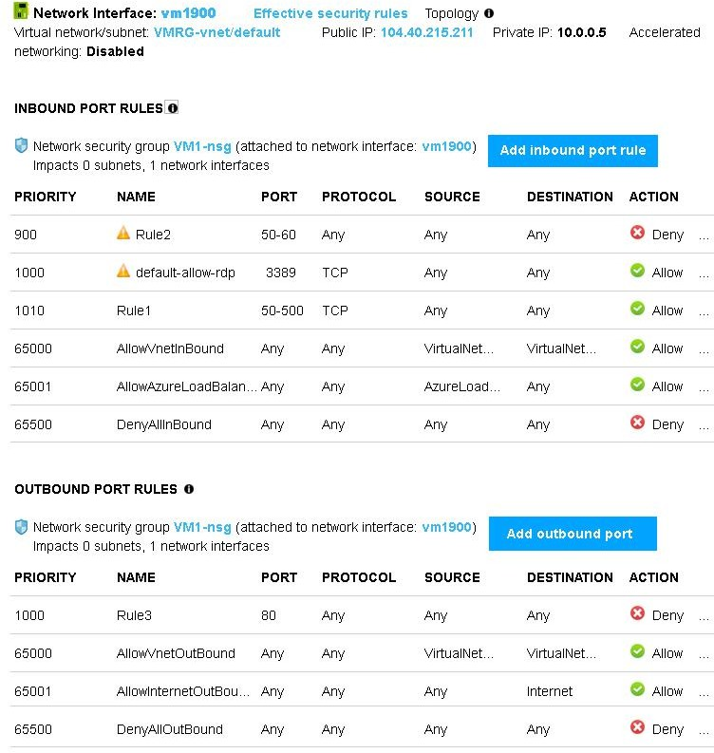

Use the drop-down menus to select the answer choice that completes each statement based on the information presented in the graphic.

**NOTE**: Each correct selection is worth one point.

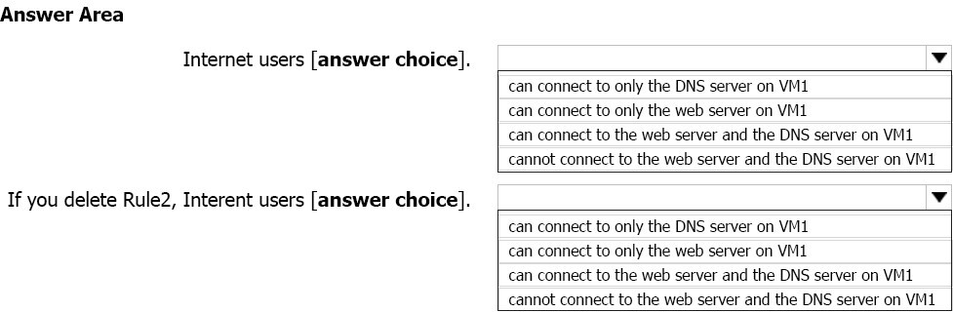

**Answer:**

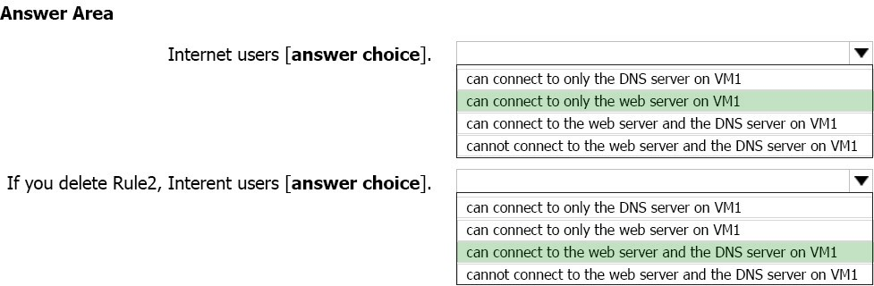

**Explanation:**

Box 1:

Rule2 blocks ports 50-60, which includes port 53, the DNS port. Internet users can reach the Web server, since it uses port 80.

Box 2:

If Rule2 is removed internet users can reach the DNS server as well.

Note: Rules are processed in priority order, with lower numbers processed before higher numbers, because lower numbers have higher priority. Once traffic matches a rule, processing stops. As a result, any rules that exist with lower priorities (higher numbers) that have the same attributes as rules with higher priorities are not processed.

References:

https://docs.microsoft.com/en-us/azure/virtual-network/security-overview

### QUESTION 116

Hotspot Question

You have peering configured as shown in the following exhibit.

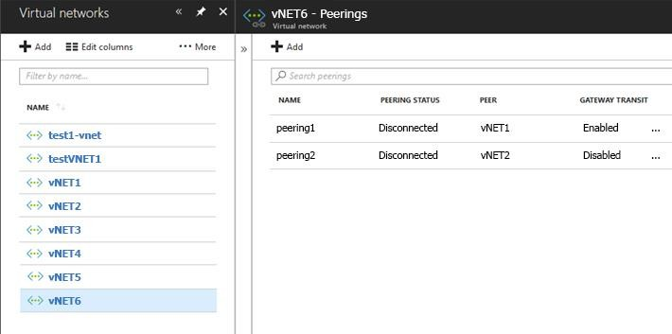

Use the drop-down menus to select the answer choice that completes each statement based on the information presented in the graphic.

**NOTE**: Each correct selection is worth one point.

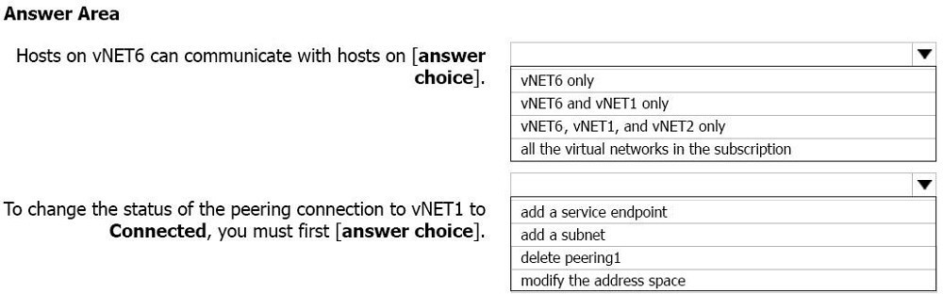

**Answer:**

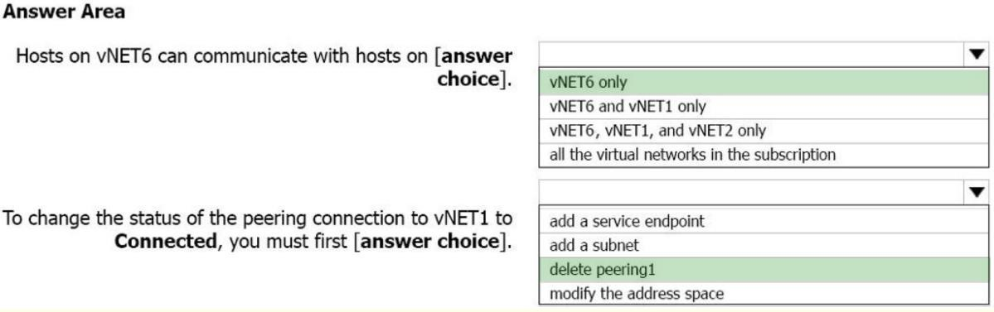

**Explanation:**

Box 1: vNET6 only

Peering status to both VNet1 and Vnet2 are disconnected. So, only communication inside vNET6.

Box 2: delete peering1

Peering to vNET1 is enabled but disconnected. We need to delete the peering from both virtual networks, and then re-create them. You can't add address ranges to or delete address ranges from a virtual network's address space once a virtual network is peered with another virtual network. To add or remove address ranges, delete the peering, add or remove the address ranges, then re-create the peering.

Reference:

https://docs.microsoft.com/en-us/azure/virtual-network/virtual-network-troubleshoot-peering- issues#the-peering-status-is-disconnected

### QUESTION 117

Hotspot Question

You have an Azure subscription named Subscription1. Subscription1 contains the virtual networks in the following table.

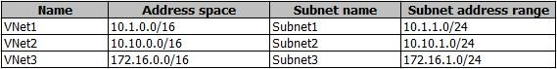

Subscription1 contains the virtual machines in the following table:

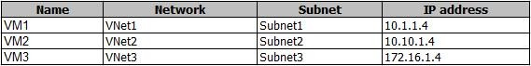

The firewalls on all the virtual machines are configured to allow all ICMP traffic. You add the peerings in the following table.

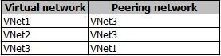

For each of the following statements, select Yes if the statement is true. Otherwise, select No.

**NOTE**: Each correct selection is worth one point.

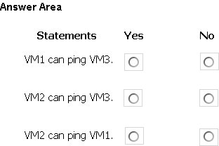

**Answer:**

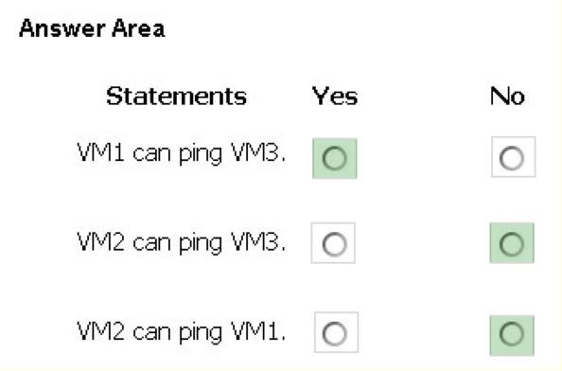

**Explanation:**

A bidirectional link must be created in order to establish a successful connection.

For example, to peer VNet A to VNet B, a link must be created from VNetA to VNetB and from VNetB to VNetA. Creating both links will change the state to Connected. https://docs.microsoft.com/en-us/azure/virtual-network/virtual-networks-faq#my-vnet-peering- connection-is-in-initiated-state-why-cant-i-connect

### QUESTION 118

Drag and Drop Question

You have an Azure Active Directory (Azure AD) tenant that has the initial domain name.

You have a domain name of contoso.com registered at a third-party registrar. You need to ensure that you can create Azure AD users that have names containing a suffix of @contoso.com.

Which three actions should you perform in sequence? To answer, move the appropriate cmdlets from the list of cmdlets to the answer area and arrange them in the correct order.

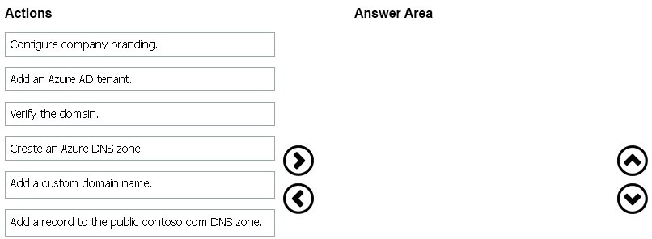

**Answer:**

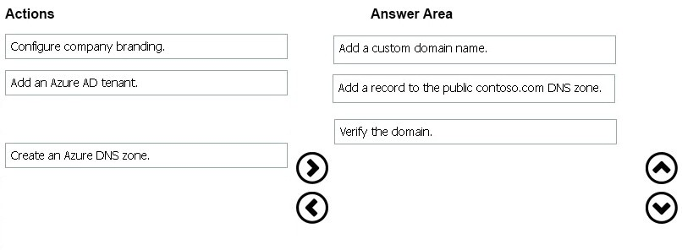

**Explanation:**

The process is simple:

Add the custom domain name to your directory

Add a DNS entry for the domain name at the domain name registrar Verify the custom domain name in Azure AD

References: https://docs.microsoft.com/en-us/azure/dns/dns-web-sites-custom-domain

### QUESTION 119

Hotspot Question

You have an Azure subscription named Subscription1. Subscription1 contains the resources in the following table.

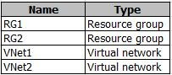

VNet1 is in RG1. VNet2 is in RG2. There is no connectivity between VNet1 and Vnet2.

An administrator named Admin1 creates an Azure virtual machine named VM1 in RG1.

M1 uses a disk named Disk1 and connects to VNet1. Admin1 then installs a custom application in VM1.

You need to move the custom application to Vnet2. The solution must minimize administrative effort.

Which two actions should you perform? To answer, select the appropriate options in the answer area.

**NOTE**: Each correct selection is worth one point.

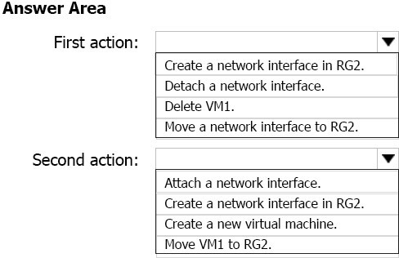

**Answer:**

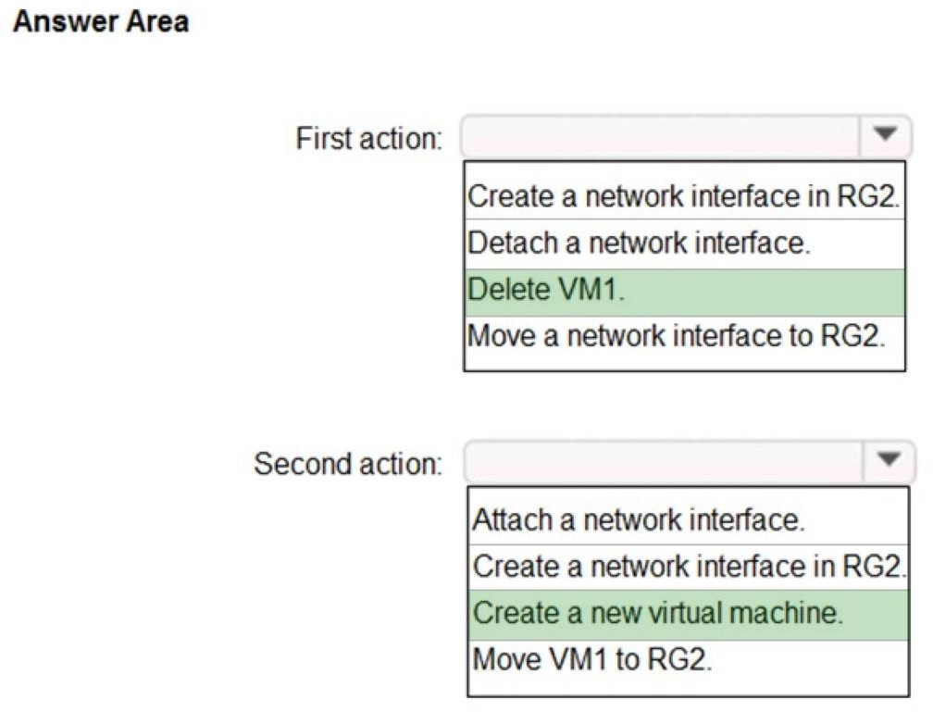

**Explanation:**

We cannot just move a virtual machine between networks. What we need to do is identify the disk used by the VM, delete the VM itself while retaining the disk, and recreate the VM in the target virtual network and then attach the original disk to it. https://blogs.technet.microsoft.com/canitpro/2014/06/16/step-by-step-move-a-vm-to-a-different- vnet-on-azure/

https://4sysops.com/archives/move-an-azure-vm-to-another-virtual-network-vnet/#migrate-an- azure-vm-between-vnets

### QUESTION 120

Hotspot Question

You have an Azure Active Directory (Azure AD) tenant named adatum.com. Adatum.com contains the groups in the following table.

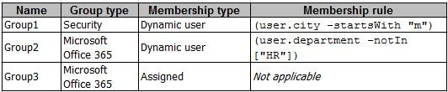

You create two user accounts that are configured as shown in the following table.

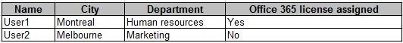

To which groups do User1 and User2 belong? To answer. select the appropriate options in the answer area.

**NOTE**: Each correct selection is worth one point.

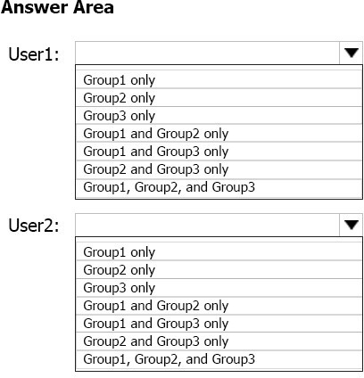

**Answer:**

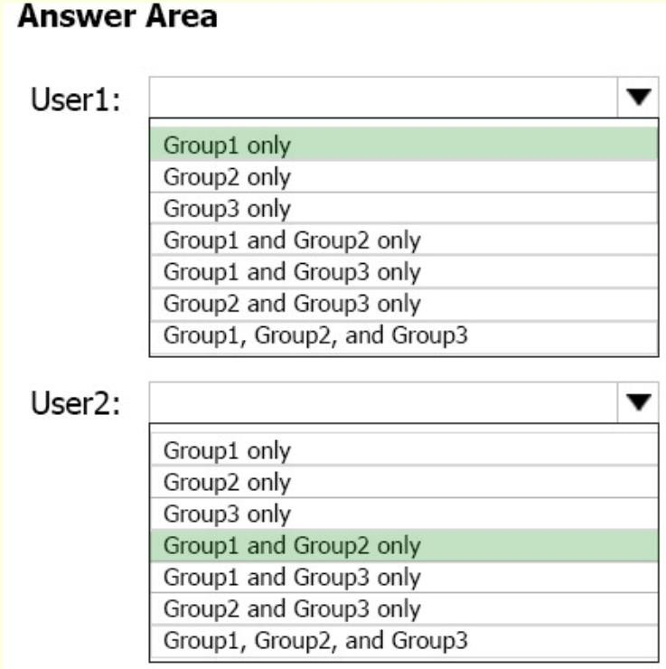

**Explanation:**

Box 1: Group 1 only

City starts with M, but their department is excluded for Group 2.

Box 2: Group1 and Group2 only

City starts with M, no restrictions for Group 2. Also, can belong to O365 Group regardless if user has O365 assigned or not. (Note: there might be a typo in the question about “Human resources” and “human resource”. If there is no typo, then the answer should be Group1 only)

References:

https://docs.microsoft.com/en-us/azure/data-explorer/kusto/query/datatypes-string-operators

### QUESTION 121

You have five Azure virtual machines that run Windows Server 2016. The virtual machines are configured as web servers.

You have an Azure load balancer named LB1 that provides load balancing services for the virtual machines.

You need to ensure that visitors are serviced by the same web server for each request. What should you configure?

|  |  |
| --- | --- |
| A. | Idle Time-out (minutes) to 20 |
| B. | Floating IP (direct server return) to Disabled |
| C. | Floating IP (direct server return) to Enabled |
| D. | Session persistence to Client IP and protocol |

**Answer:** D

**Explanation:**

You can set the sticky session in load balancer rules with setting the session persistence as the client IP and protocol. Client IP and Protocol specifies that successive requests from the same client IP address and protocol combinations will be handles by the same VM.

References:

https://cloudopszone.com/configure-azure-load-balancer-for-sticky-sessions

### QUESTION 122

You are the global administrator for an Azure Active Directory (Azure AD) tenant named adatum.com.

You need to enable two-step verification for Azure users. What should you do?

|  |  |
| --- | --- |
| A. | Configure a playbook in Azure AD conditional access policy. |
| B. | Create an Azure AD conditional access policy. |
| C. | Create and configure the Identify Hub. |
| D. | Install and configure Azure AD Connect. |

**Answer:** B

**Explanation:**

https://docs.microsoft.com/en-us/azure/active-directory/authentication/howto-mfa-mfasettings

### QUESTION 123

From the MFA Server blade, you open the Block/unblock users blade as shown in the exhibit.

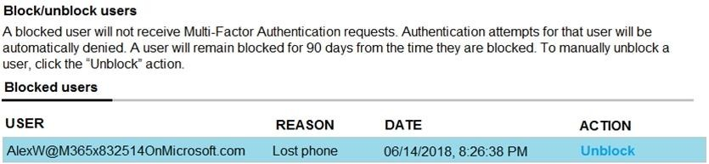

What caused AlexW to be blocked?

|  |  |
| --- | --- |
| A. | The user entered an incorrect PIN four times within 10 minutes. |
| B. | The user account password expired. |
| C. | An administrator manually blocked the user. |
| D. | The user reported a fraud alert when prompted for additional authentication. |

**Answer:** C

**Explanation:**

Only an admin can block users and not a reason and complaints in terms of the software way of working.

### QUESTION 124

You have the Azure virtual networks shown in the following table.

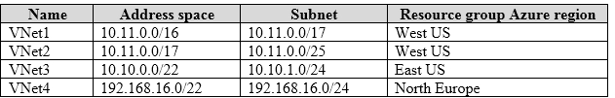

To which virtual networks can you establish a peering connection from VNet1?

|  |  |
| --- | --- |
| A. | VNet2 and VNet3 only |
| B. | VNet2 only |
| C. | VNet3 and VNet4 only |
| D. | VNet2, VNet3, and VNet4 |

**Answer:** C

**Explanation:**

The virtual networks you peer must have non-overlapping IP address spaces. The VNet1 and VNhet2 address spaces overlap. The range of VNet2 is contained inside the range of VNet1. References:

https://docs.microsoft.com/en-us/azure/virtual-network/virtual-network-manage- peering#requirements-and-constraints

### QUESTION 125

Hotspot Question

You have an Azure subscription that contains the virtual networks shown in the following table.

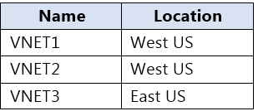

The subscription contains the private DNS zones shown in the following table.

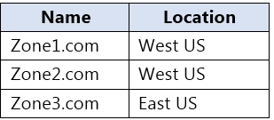

You add virtual network links to the private DNS zones as shown in the following table.

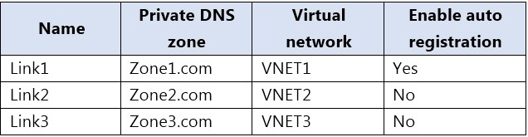

For each of the following statements, select Yes if the statement is true. Otherwise, select No. NOTE: Each correct selection is worth one point.

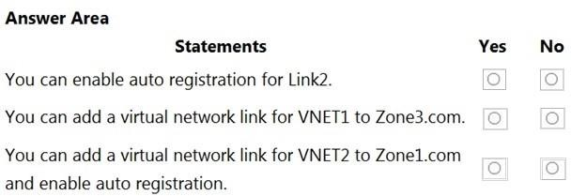

**Answer:**

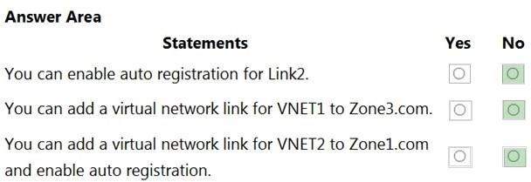

**Explanation:**

https://docs.microsoft.com/en-us/azure/dns/private-dns-virtual-network-links https://docs.microsoft.com/en-us/azure/dns/private-dns-autoregistration

### QUESTION 126

You are troubleshooting a performance issue for an Azure Application Gateway.

You need to compare the total requests to the failed requests during the past six hours. What should you use?

|  |  |
| --- | --- |
| A. | Metrics in Application Gateway |
| B. | Diagnostics logs in Application Gateway |

|  |  |
| --- | --- |
| C. | NSG flow logs in Azure Network Watcher |
| D. | Connection monitor in Azure Network Watcher |

**Answer:** A

**Explanation:**

Application Gateway currently has seven metrics to view performance counters. Metrics are a feature for certain Azure resources where you can view performance counters in the portal. For Application Gateway, the following metrics are available:

Total Requests Failed Requests Current Connections Healthy Host Count Response Status Throughput Unhealthy Host count

You can filter on a per backend pool basis to show healthy/unhealthy hosts in a specific backend pool

References: https://docs.microsoft.com/en-us/azure/application-gateway/application- gatewaydiagnostics#Metrics

### QUESTION 127

Drag and Drop Question

You have two Azure virtual machines named VM1 and VM2. VM1 has a single data disk named Disk1.

You need to attach Disk1 to VM2. The solution must minimize downtime for both virtual machines.

Which four actions should you perform in sequence? To answer, move the appropriate actions from the list of actions to the answer area and arrange them in the correct order.

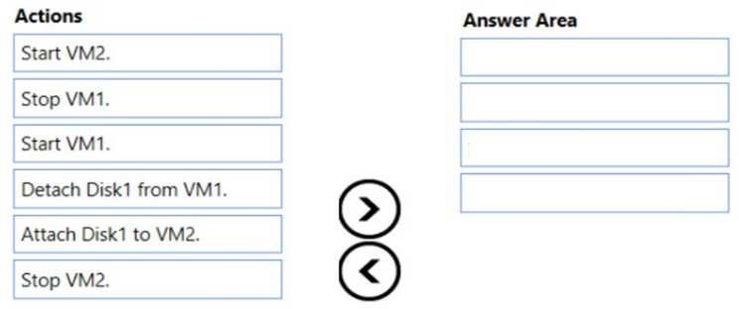

**Answer:**

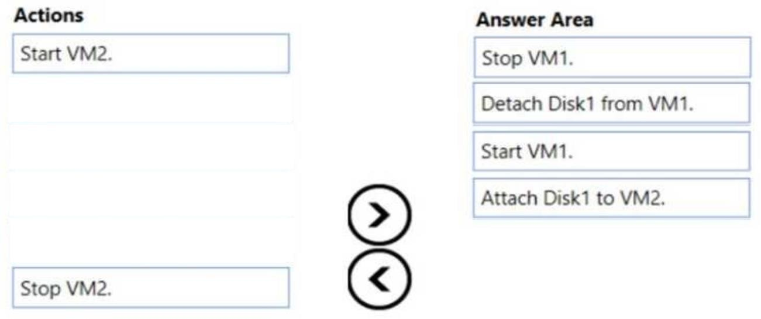

**Explanation:**

**Explanation:**

Step 1: Stop VM1.

Step 2: Detach Disk1 from VM1. Step 3: Start VM1.

Detach a data disk using the portal

1. In the left menu, select Virtual Machines.
2. Select the virtual machine that has the data disk you want to detach and click Stop to deallocate the VM.
3. In the virtual machine pane, select Disks.
4. At the top of the Disks pane, select Edit.
5. In the Disks pane, to the far right of the data disk that you would like to detach, click the Detach button image detach button.
6. After the disk has been removed, click Save on the top of the pane.
7. In the virtual machine pane, click Overview and then click the Start button at the top of the pane to restart the VM.
8. The disk stays in storage but is no longer attached to a virtual machine. Step 4: Attach Disk1 to VM2 -

Attach an existing disk -

Follow these steps to reattach an existing available data disk to a running VM.

1. Select a running VM for which you want to reattach a data disk.
2. From the menu on the left, select Disks.
3. Select Attach existing to attach an available data disk to the VM.
4. From the Attach existing disk pane, select OK. References:

https://docs.microsoft.com/en-us/azure/virtual-machines/windows/detach-disk https://docs.microsoft.com/en-us/azure/lab-services/devtest-lab-attach-detach-data-disk

### QUESTION 128

Drag and Drop Question

You have an Azure subscription that is used by four departments in your company.

The subscription contains 10 resource groups. Each department uses resources in several resource groups.

You need to send a report to the finance department. The report must detail the costs for each department.

Which three actions should you perform in sequence? To answer, move the appropriate actions from the list of actions to the answer area and arrange them in the correct order.

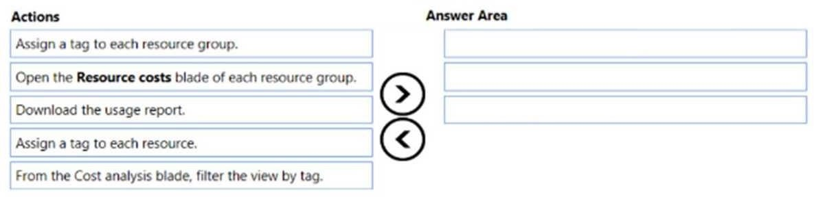

**Answer:**

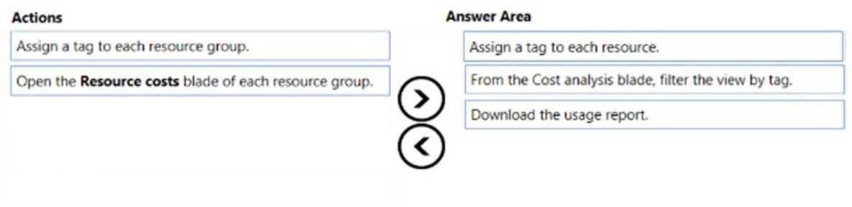

**Explanation:**

Box 1: Assign a tag to each resource.

You apply tags to your Azure resources giving metadata to logically organize them into a taxonomy. After you apply tags, you can retrieve all the resources in your subscription with that tag name and value. Each resource or resource group can have a maximum of 15 tag name/value pairs. Tags applied to the resource group are not inherited by the resources in that resource group.

Box 2: From the Cost analysis blade, filter the view by tag After you get your services running, regularly check how much they're costing you. You can see the current spend and burn rate in Azure portal.

Visit the Subscriptions blade in Azure portal and select a subscription. You should see the cost breakdown and burn rate in the popup blade. Click Cost analysis in the list to the left to see the cost breakdown by resource. Wait 24 hours after you add a service for the data to populate.

You can filter by different properties like tags, resource group, and timespan. Click Apply to confirm the filters and Download if you want to export the view to a Comma-Separated Values (.csv) file.

Box 3: Download the usage report References:

https://docs.microsoft.com/en-us/azure/azure-resource-manager/resource-group-using-tags https://docs.microsoft.com/en-us/azure/billing/billing-getting-started

### QUESTION 129

Hotspot Question

You have a virtual network named VNet1 that has the configuration shown in the following exhibit.

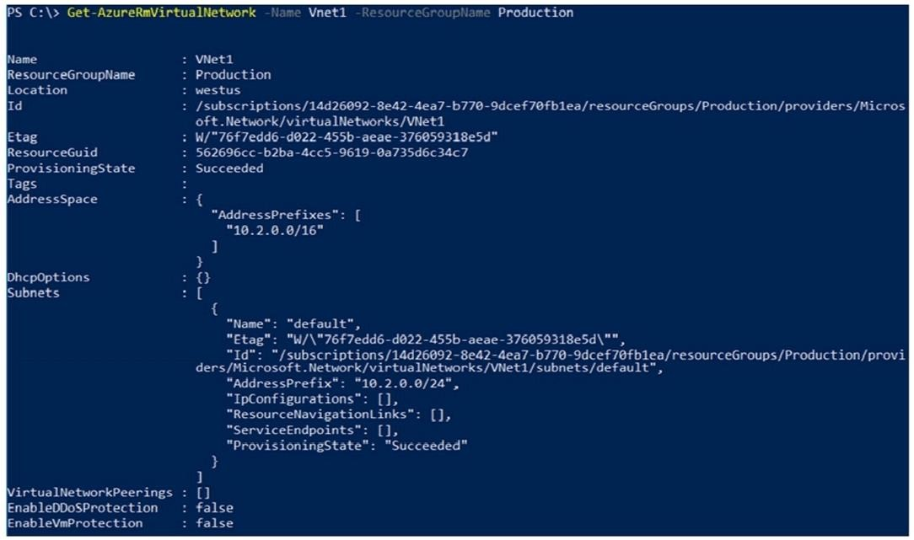

Use the drop-down menus to select the answer choice that completes each statement based on the information presented in the graphic.

NOTE: Each correct selection is worth one point.

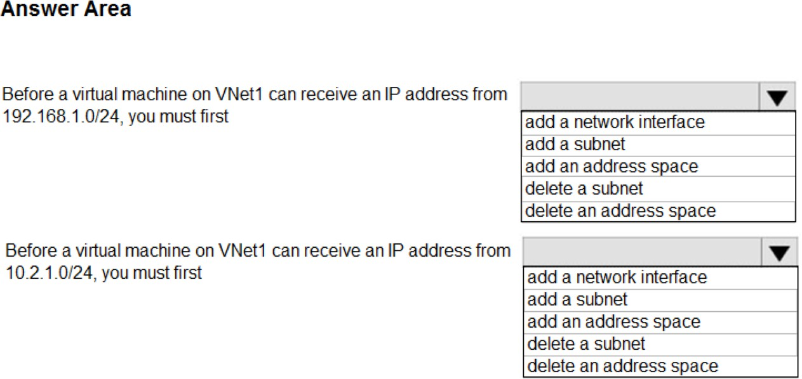

**Answer:**

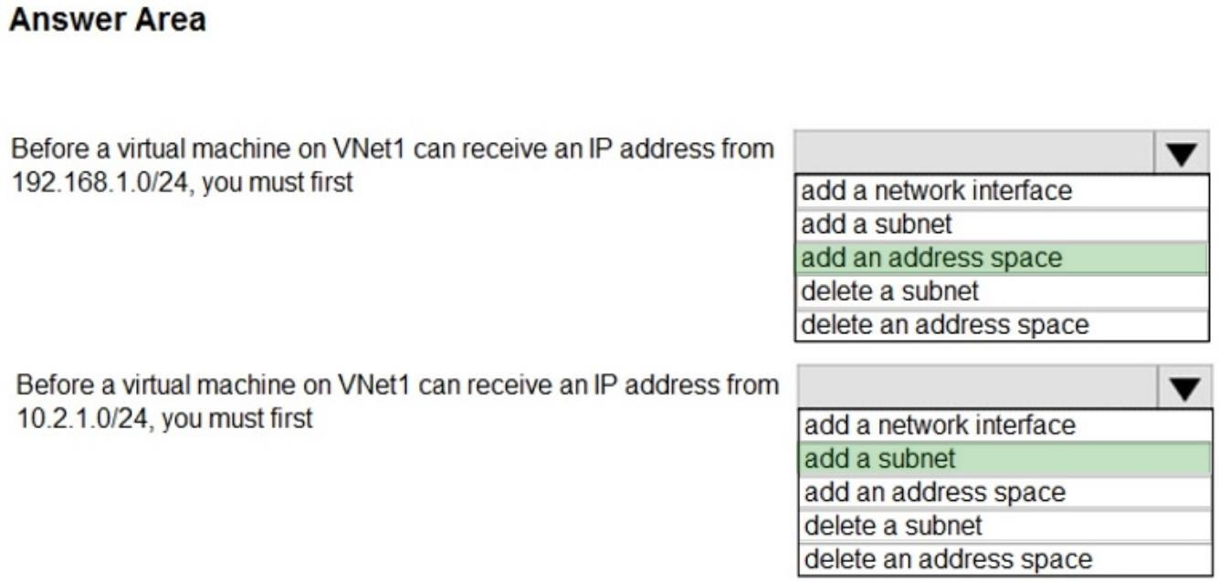

**Explanation:**

As 192.168.1.0/24 is outside of the configured address space of 10.2.0.0/16, the answer is to create an address space.

As 10.2.1.0/24 subnet doesn’t exist (only 10.2.0.0/24) the answer is to create a subnet.

### QUESTION 130

Hotspot Question

You have an Azure subscription named Subscrption1 that is associated to an Azure Active Directory (Azure AD) tenant named AAD1.

Subscription1 contains the objects in the following table:

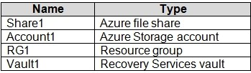

You plan to create a single backup policy for Vault1. To answer, select the appropriate options in the answer area.

NOTE: Each correct selection is worth one point.

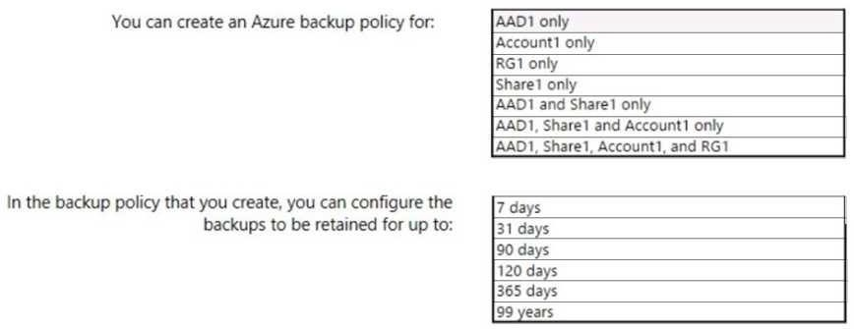

**Answer:**

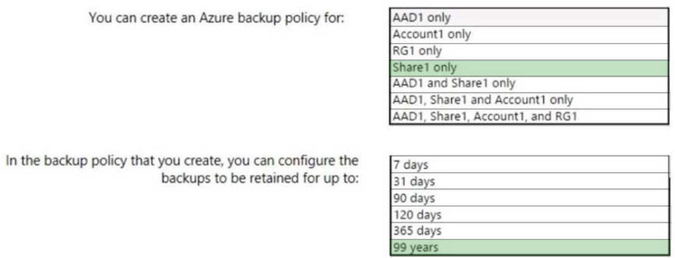

**Explanation:**

Box 1: Share1 only

Azure Backup policies can only back up an Azure VM, SQL in an Azure VM or File Share. As such the answer to the first part should be Share1 only.

Box 2: 99 years

With the latest update to Azure Backup, customers can retain their data for up to 99 years in Azure.

Note: A backup policy defines a matrix of when the data snapshots are taken, and how long those snapshots are retained.

The backup policy interface looks like this:

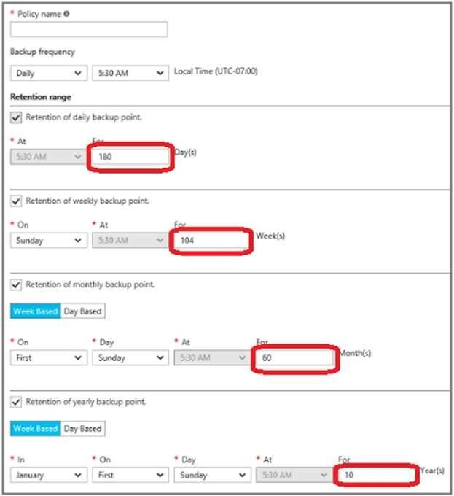

References: https://docs.microsoft.com/en-us/azure/backup/backup-azure-vms-first-look- arm#defining-a-backup-policy

https://blogs.microsoft.com/firehose/2015/02/16/february-update-to-azure-backup-includes-data- retention-up-to-99-years-offline-backup-and-more/

### QUESTION 131

Drag and Drop Question

You have an Azure Linux virtual machine that is protected by Azure Backup. One week ago, two files were deleted from the virtual machine.

You need to restore the deleted files to an on-premises computer as quickly as possible. Which four actions should you perform in sequence? To answer, move the appropriate actions from the list of actions to the answer area and arrange them in the correct order.

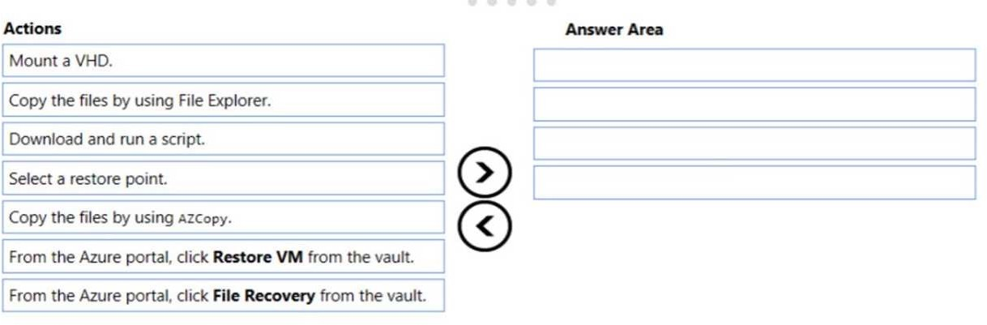

**Answer:**

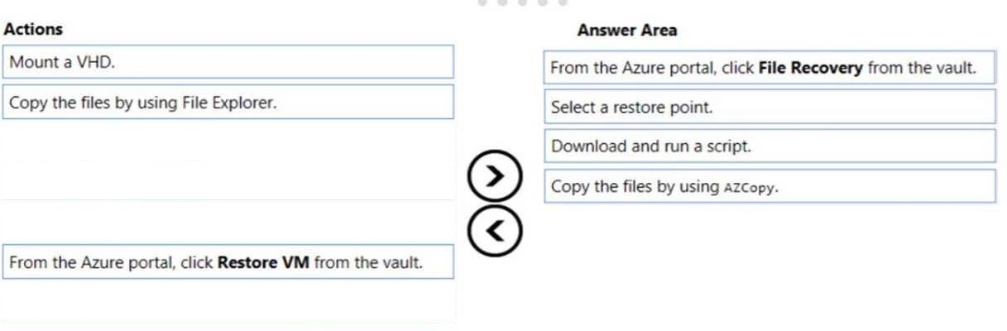

**Explanation:**

To restore files or folders from the recovery point, go to the virtual machine and choose the desired recovery point.

Step 0. In the virtual machine's menu, click Backup to open the Backup dashboard. Step 1. In the Backup dashboard menu, click File Recovery.

Step 2. From the Select recovery point drop-down menu, select the recovery point that holds the files you want. By default, the latest recovery point is already selected.

Step 3: To download the software used to copy files from the recovery point, click Download Executable (for Windows Azure VM) or Download Script (for Linux Azure VM, a python script is generated).

Step 4: Copy the files by using AzCopy

AzCopy is a command-line utility designed for copying data to/from Microsoft Azure Blob, File, and Table storage, using simple commands designed for optimal performance.

You can copy data between a file system and a storage account, or between storage accounts. References:

https://docs.microsoft.com/en-us/azure/backup/backup-azure-restore-files-from-vm https://docs.microsoft.com/en-us/azure/storage/common/storage-use-azcopy

### QUESTION 132

Hotspot Question

You have an Azure Migrate project that has the following assessment properties:

Target location: East US

Storage redundancy: Locally redundant. Comfort factor: 2.0

Performance history: 1 month Percentile utilization: 95th Pricing tier: Standard Offer: Pay as you go

You discover the following two virtual machines:

A virtual machine named VM1 that runs Windows Server 2016 and has 10 CPU cores at 20 percent utilization

A virtual machine named VM2 that runs Windows Server 2012 and has four CPU cores at 50 percent utilization

How many CPU cores will Azure Migrate recommend for each virtual machine? To answer, select the appropriate options in the answer area.

NOTE: Each correct selection is worth one point.

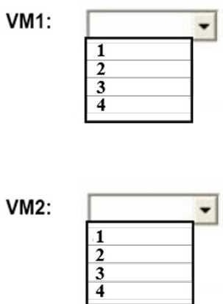

**Answer:**

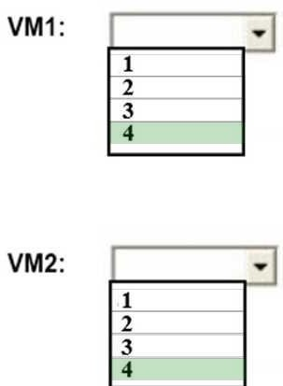

**Explanation:**

Box 2: 4

4 *0.50 * 0.95* 2 = 3.8

Note: The number of cores in the machines must be equal to or less than the maximum number of cores (128 cores) supported for an Azure VM.

If performance history is available, Azure Migrate considers the utilized cores for comparison. If a comfort factor is specified in the assessment settings, the number of utilized cores is multiplied by the comfort factor.

If there's no performance history, Azure Migrate uses the allocated cores, without applying the comfort factor.

References:

https://docs.microsoft.com/en-us/azure/migrate/concepts-assessment-calculation

### QUESTION 133

Hotspot Question

You have an Azure subscription named Subscroption1.

In Subscription1, you create an alert rule named Alert1. The Alert1 action group is configured as shown in the following exhibit.

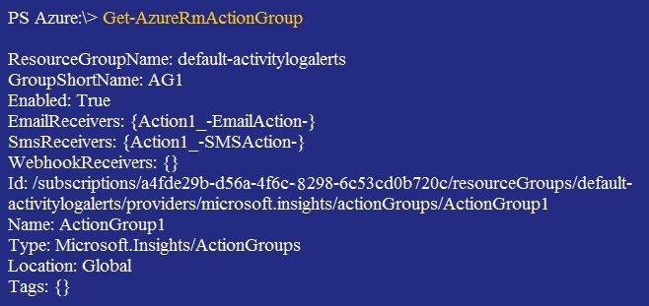

Alert1 alert criteria is triggered every minute.

Use the drop-down menus to select the answer choice that completes each statement based on the information presented in the graphic.

NOTE: Each correct selection is worth one point.

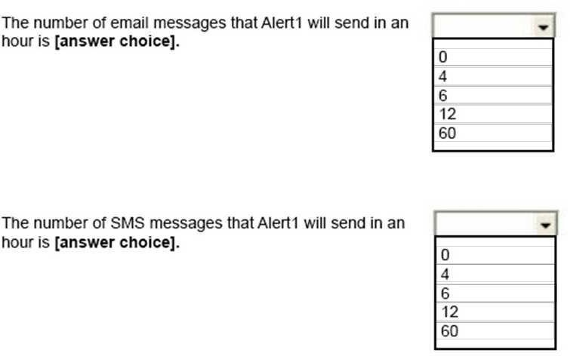

**Answer:**

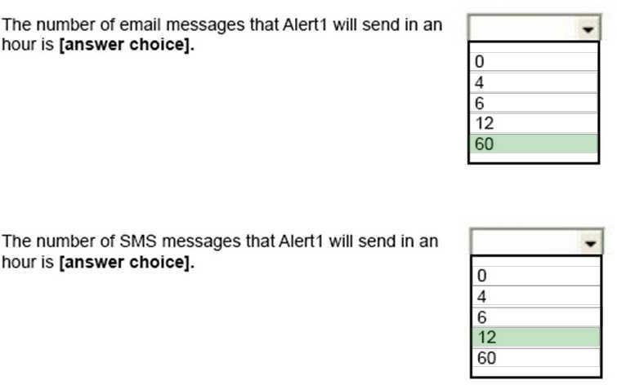

**Explanation:**

Box 1: 60

One alert per minute will trigger one email per minute. Box 2: 12

No more than 1 SMS every 5 minutes can be send, which equals 12 per hour. Note: Rate limiting is a suspension of notifications that occurs when too many are sent to a particular phone number, email address or device. Rate limiting ensures that alerts are manageable and actionable.

The rate limit thresholds are:

SMS: No more than 1 SMS every 5 minutes. Voice: No more than 1 Voice call every 5 minutes. Email: No more than 100 emails in an hour.

Other actions are not rate limited. References:

https://github.com/MicrosoftDocs/azure-docs/blob/master/articles/monitoring-and- diagnostics/monitoring-overview-alerts.md

### QUESTION 134

Hotspot Question

You have an Azure subscription named Subscription1.

You have a virtualization environment that contains the virtualization servers in the following table.

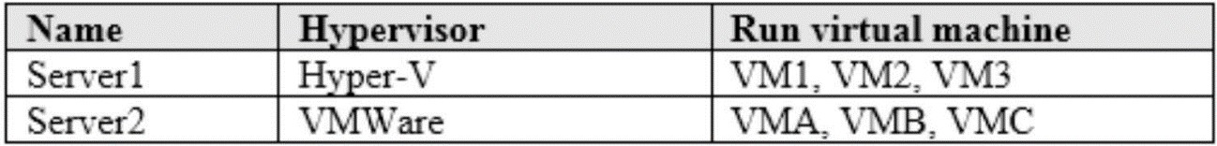

The virtual machines are configured as shown in the following table.

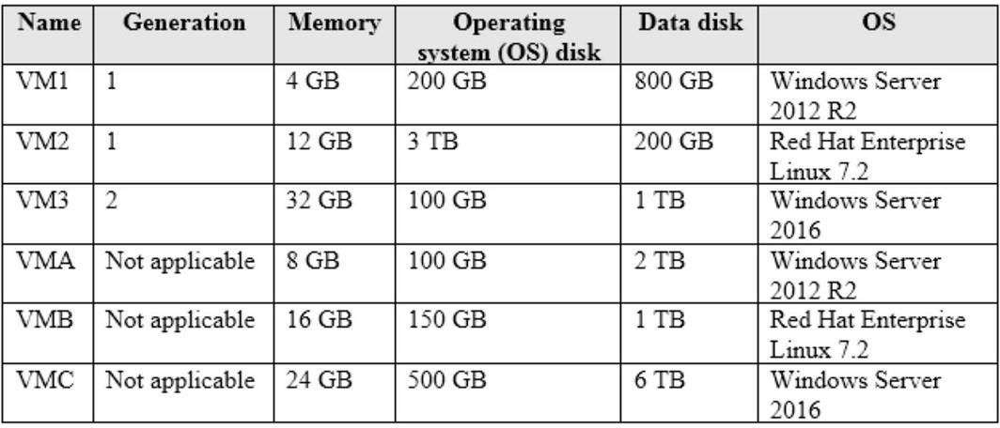

All the virtual machines use basic disks. VM1 is protected by using BitLocker Drive Encryption (BitLocker).

You plan to use Azure Site Recovery to migrate the virtual machines to Azure. Which virtual machines can you migrate? To answer, select the appropriate options in the answer area. NOTE: Each correct selection is worth one point.

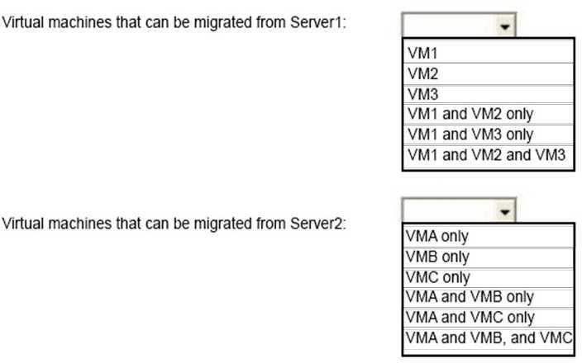

**Answer:**

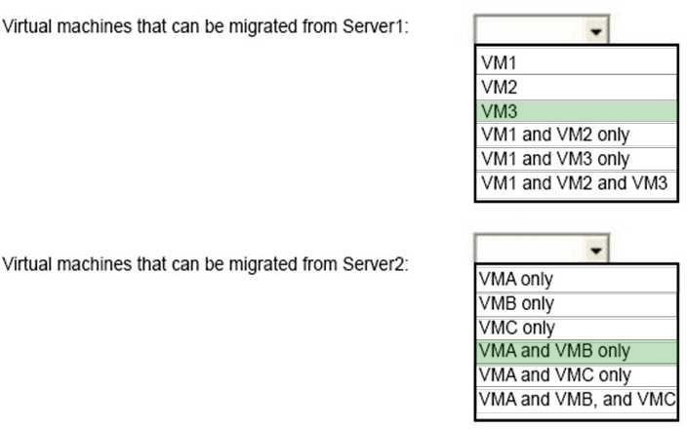

**Explanation:**

Box 1: VM3

Not VM1 as Bitlocker is not supported. BitLocker must be disabled before you enable replication for a VM.

Not VM2 as maximum Operating system disk size for a generation VM is 2,048 GB. Box 2: VMA and VMB only

Not VMC as the max data disk size is 4,095 GB References:

https://docs.microsoft.com/en-us/azure/site-recovery/hyper-v-azure-support-matrix https://docs.microsoft.com/en-us/azure/site-recovery/vmware-physical-azure-support- matrix#azure-vm-requirements

### QUESTION 135

Drag and Drop Question

Your network is configured as shown in the following exhibit.

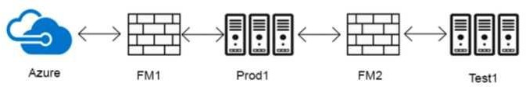

The firewalls are configured as shown in the following table.

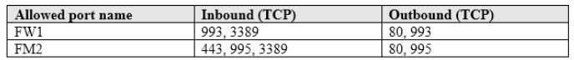

Prod1 contains a vCenter server.

You install an Azure Migrate Collector on Test1. You need to discover the virtual machines.

Which TCP port should be allowed on each firewall? To answer, drag the appropriate ports to the correct firewalls. Each port may be used once, more than once, or not at all. You may need to drag the split bar between panes or scroll to view content.

NOTE: Each correct selection is worth one point.

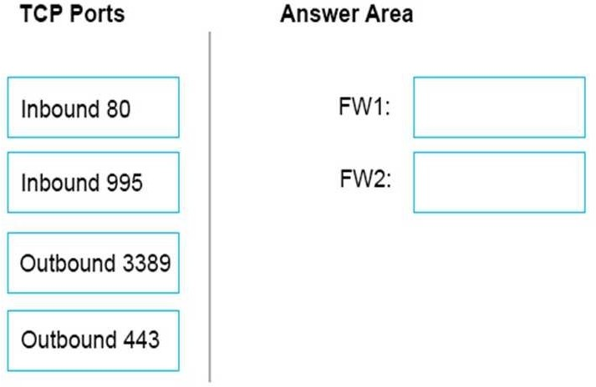

**Answer:**

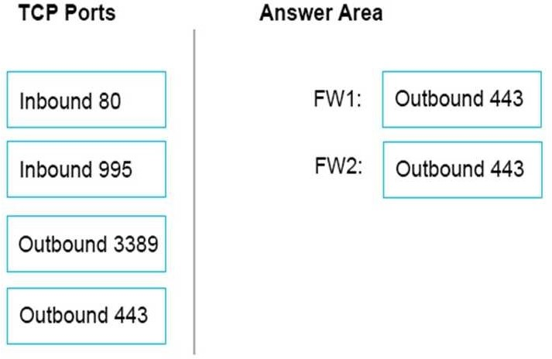

**Explanation:**

FW1: Outbound 443

Collector communicates with Azure Migrate service over SSL 443. FW2: Outbound 443

The Collector must be able to communicate with the vCenter Server. By default, it connects to vCenter on 443.

Note: The collector communicates as summarized in the following diagram.

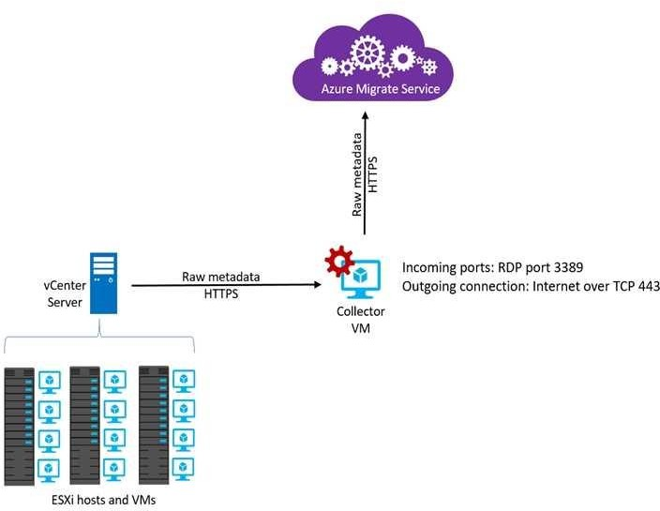

References:

https://docs.microsoft.com/en-us/azure/migrate/concepts-collector

### QUESTION 136

Drag and Drop Question

You have an on-premises network that includes a Microsoft SQL Server instance named SQL1. You create an Azure Logic App named App1.

You need to ensure that App1 can query a database on SQL1.

Which three actions should you perform in sequence? To answer, move the appropriate actions from the list of actions to the answer area and arrange them in the correct order.

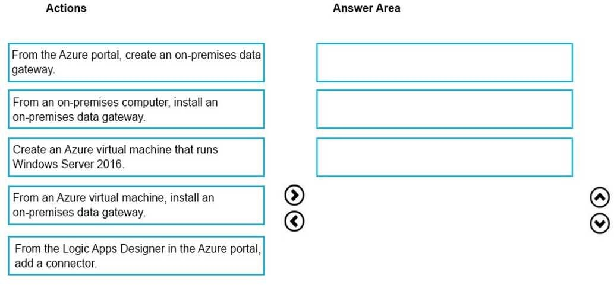

**Answer:**

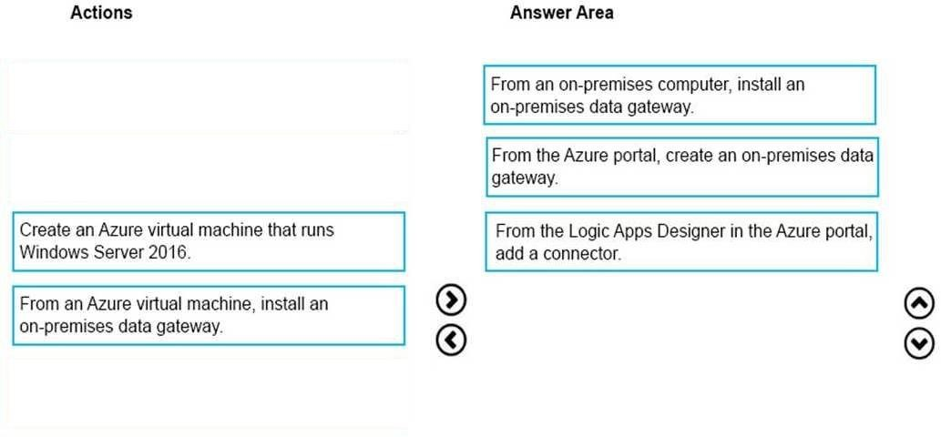

**Explanation:**

To access data sources on premises from your logic apps, you can create a data gateway resource in Azure so that your logic apps can use the on-premises connectors. Box 1: From an on-premises computer, install an on-premises data gateway. Before you can connect to on- premises data sources from Azure Logic Apps, download and install the on-premises data gateway on a local computer.

Box 2: From the Azure portal, create an on-premises data gateway Create Azure resource for gateway

After you install the gateway on a local computer, you can then create an Azure resource for your gateway. This step also associates your gateway resource with your Azure subscription. Sign in to the Azure portal. Make sure you use the same Azure work or school email address used to install the gateway.

On the main Azure menu, select Create a resource > Integration > On-premises data gateway.

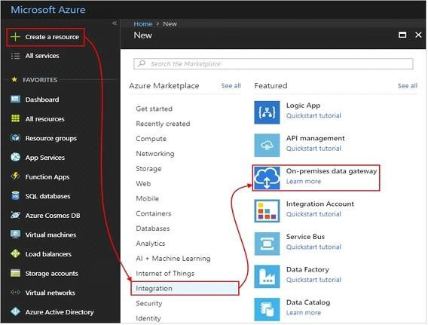

On the Create connection gateway page, provide this information for your gateway resource. To add the gateway resource to your Azure dashboard, select Pin to dashboard. When you're done, choose Create.

Box 3: From the Logic Apps Designer in the Azure portal, add a connector After you create your gateway resource and associate your Azure subscription with this resource, you can now create a connection between your logic app and your on-premises data source by using the gateway.

In the Azure portal, create or open your logic app in the Logic App Designer. Add a connector that supports on-premises connections, for example, SQL Server.

Set up your connection.

References:

https://docs.microsoft.com/en-us/azure/logic-apps/logic-apps-gateway-connection

### QUESTION 137

You have an Azure subscription. All users are enabled for multi-factor authentication (MFA).

You need to ensure that the users can lock out their own account if they receive an unsolicited MFA request from Azure.

Which MFA settings should you configure?

|  |  |
| --- | --- |
| A. | Block/unblock users |
| B. | Providers |
| C. | Notifications |
| D. | Fraud alert |

**Answer:** D

**Explanation:**

Configure the fraud alert feature so that your users can report fraudulent attempts to access their resources. Users can report fraud attempts by using the mobile app or through their phone.

Configuration options include:

Block user when fraud is reported: If a user reports fraud, their account is blocked for 90 days or until an administrator unblocks their account. An administrator can review sign-ins by using the sign-in report, and take appropriate action to prevent future fraud. An administrator can then unblock the user's account.

References:

https://docs.microsoft.com/en-us/azure/active-directory/authentication/howto-mfa- mfasettings#fraud-alert

### QUESTION 138

Hotspot Question

You plan to use Azure Network Watcher to perform the following tasks:

Task1: Identify a security rule that prevents a network packet from reaching an Azure virtual machine.

Task2: Validate outbound connectivity from an Azure virtual machine to an external host.

Which feature should you use for each task? To answer, select the appropriate options in the answer area.

NOTE: Each correct selection is worth one point.

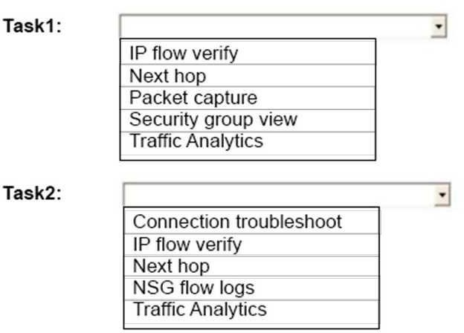

**Answer:**

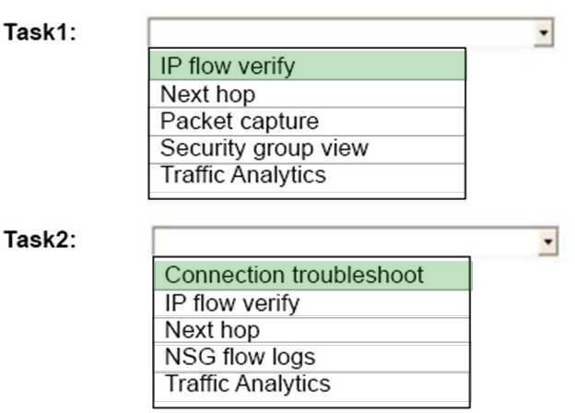

**Explanation:**

Task 1: IP flow verify

IP flow verify checks if a packet is allowed or denied to or from a virtual machine. The information consists of direction, protocol, local IP, remote IP, local port, and remote port. If the packet is denied by a security group, the name of the rule that denied the packet is returned. While any source or destination IP can be chosen, IP flow verify helps administrators quickly diagnose connectivity issues from or to the internet and from or to the on-premises environment.

Task 2:

With the addition of Connection Troubleshoot, Network Watcher will see an incremental increase in its capabilities and ways for you to utilize it in your day to day operations. You can now, for example, check connectivity between source (VM) and destination (VM, URI, FQDN, IP Address). References:

https://docs.microsoft.com/en-us/azure/network-watcher/network-watcher-ip-flow-verify-overview https://azure.microsoft.com/en-us/blog/network-watcher-connection-troubleshoot-now-generally- available/

### QUESTION 139

You have an Azure tenant that contains two subscriptions named Subscription1 and Subscription2.

In Subscription1, you deploy a virtual machine named Server1 that runs Windows Server 2016. Server1 uses managed disks.

You need to move Server1 to Subscription2. The solution must minimize administration effort.

What should you do first?

|  |  |
| --- | --- |
| A. | In Subscription2, create a copy of the virtual disk. |
| B. | From Azure PowerShell, run the Move-AzureRmResource cmdlet. |
| C. | Create a snapshot of the virtual disk. |
| D. | Create a new virtual machine in Subscription2. |

**Answer:** B

**Explanation:**

To move existing resources to another resource group or subscription, use the Move- AzureRmResource cmdlet.

https://docs.microsoft.com/en-in/azure/azure-resource-manager/resource-group-move- resources#move-resources

### QUESTION 140

You have an Azure subscription that contains a resource group named RG1. RG1 contains 100 virtual machines.

Your company has three cost centers named Manufacturing, Sales, and Finance. You need to associate each virtual machine to a specific cost center.

What should you do?

|  |  |
| --- | --- |
| A. | Add an extension to the virtual machines. |
| B. | Modify the inventory settings of the virtual machine. |
| C. | Assign tags to the virtual machines. |
| D. | Configure locks for the virtual machine. |

**Answer:** C

**Explanation:**

https://docs.microsoft.com/en-us/azure/billing/billing-getting-started https://docs.microsoft.com/en-us/azure/azure-resource-manager/resource-group-using-tags

### QUESTION 141

You have an Azure policy as shown in the following exhibit.

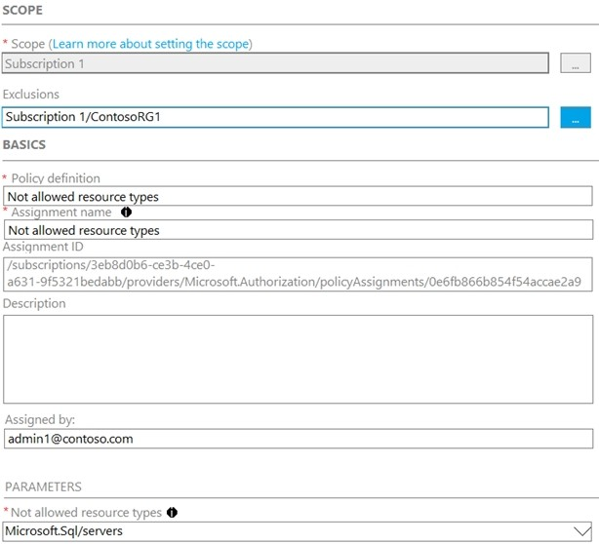

Which of the following statements are true?

|  |  |
| --- | --- |
| A. | You can create Azure SQL servers in ContosoRG1. |
| B. | You are prevented from creating Azure SQL servers anywhere in Subscription 1. |
| C. | You are prevented from creating Azure SQL Servers in ContosoRG1 only. |
| D. | You can create Azure SQL servers in any resource group within Subscription 1. |

**Answer:** A

**Explanation:**

You are prevented from creating Azure SQL servers anywhere in Subscription 1 with the exception of ContosoRG1

### QUESTION 142

SIMULATION

**Overview**

The following section of the exam is a lab. In this section, you will perform a set of tasks in a live environment. While most functionality will be available to you as it would be in a live environment, some functionality (e.g., copy and paste, ability to navigate to external websites) will not be possible by design.

Scoring is based on the outcome of performing the tasks stated in the lab. In other words, it doesn’t matter how you accomplish the task, if you successfully perform it, you will earn credit for that task.

Labs are not timed separately, and this exam may have more than one lab that you must complete. You can use as much time as you would like to complete each lab. But, you should manage your time appropriately to ensure that you are able to complete the lab(s) and all other sections of the exam in the time provided.

Please note that once you submit your work by clicking the Next button within a lab, you will NOT be able to return to the lab.

**To start the lab**

You may start the lab by clicking the Next button.

You plan to connect several virtual machines to the VNET01-USEA2 virtual network.

In the Web-RGlod8095859 resource group, you need to create a virtual machine that uses the Standard_B2ms size named Web01 that runs Windows Server 2016. Web01 must be added to an availability set.

What should you do from the Azure portal?

|  |  |
| --- | --- |
| A. | See below explanation |

**Answer:** A

**Explanation:**

Step 1. Choose Create a resource in the upper left-hand corner of the Azure portal.

Step 2. In the Basics tab, under Project details, make sure the correct subscription is selected and then choose Web-RGlod8095859 resource group

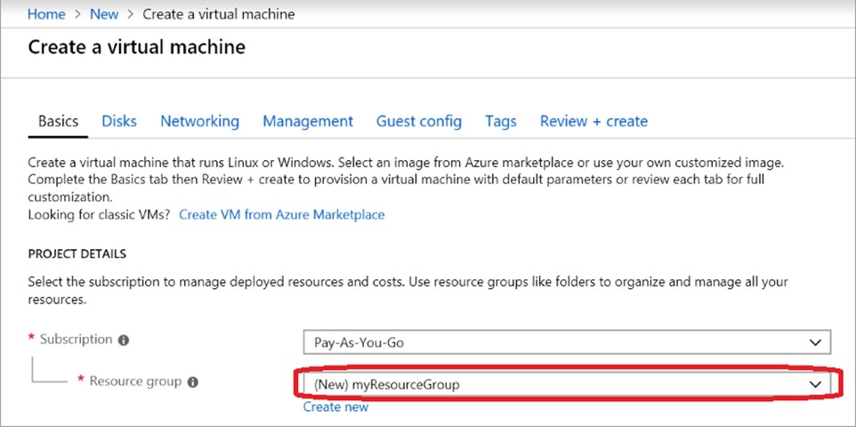

Step 3. Under Instance details type/select: Virtual machine name: Web01

Image: Windows Server 2016 Size: Standard_B2ms size

Leave the other defaults.

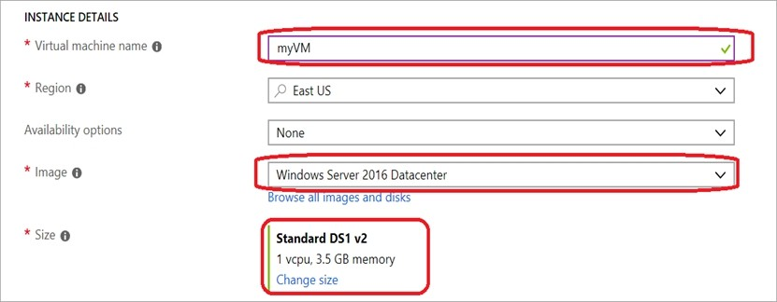

Step 4. Finish the Wizard

Note: You will have option to create Availability Set and VNET when you create a new VM through Azure Portal Wizard.

### QUESTION 143

You have an Azure subscription named Subscription1.

You have 5 TB of data that you need to transfer to Subscription. You plan to use an Azure Import/Export job.

What can you use as the destination of the imported data?

|  |  |
| --- | --- |
| A. | Azure SQL Database |
| B. | Azure Data Factory |
| C. | A virtual machine |
| D. | Azure Blob storage |

**Answer:** D

**Explanation:**

https://docs.microsoft.com/en-us/azure/storage/common/storage-import-export-service

### QUESTION 144

SIMULATION

**Overview**

The following section of the exam is a lab. In this section, you will perform a set of tasks in a live environment. While most functionality will be available to you as it would be in a live environment, some functionality (e.g., copy and paste, ability to navigate to external websites) will not be possible by design.

Scoring is based on the outcome of performing the tasks stated in the lab. In other words, it doesn’t matter how you accomplish the task, if you successfully perform it, you will earn credit for that task.

Labs are not timed separately, and this exam may have more than one lab that you must complete. You can use as much time as you would like to complete each lab. But, you should

manage your time appropriately to ensure that you are able to complete the lab(s) and all other sections of the exam in the time provided.

Please note that once you submit your work by clicking the Next button within a lab, you will NOT be able to return to the lab.

**To start the lab**

You may start the lab by clicking the Next button.

You plan to prevent users from accidentally deleting blob data from Azure.

You need to ensure that administrators can recover any blob data that is deleted accidentally from the storagelod8095859 storage account for 14 days after the deletion occurred.

What should you do from the Azure portal?

|  |  |
| --- | --- |
| A. | See below explanation |

**Answer:** A

**Explanation:**

Task A: Create a Recovery Services vault (if a vault already exists skip this task, go to Task B below)

A1. From Azure Portal, On the Hub menu, click All services and in the list of resources, type Recovery Services and click Recovery Services vaults.

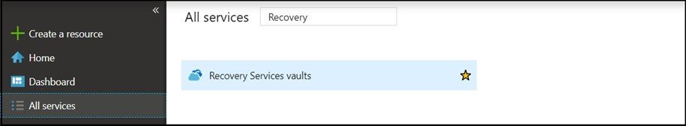

If there are recovery services vaults in the subscription, the vaults are listed. A2. On the Recovery Services vaults menu, click Add.

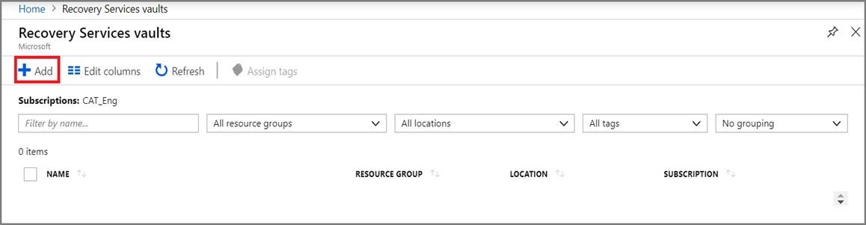

A3. The Recovery Services vault blade opens, prompting you to provide a Name, Subscription, Resource group, and Location

Task B. Create a backup goal

B1. On the Recovery Services vault blade (for the vault you just created), in the Getting Started section, click Backup, then on the Getting Started with Backup blade, select Backup goal.

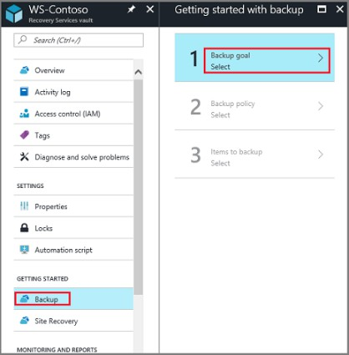

The Backup Goal blade opens. If the Recovery Services vault has been previously configured, then the Backup Goal blades opens when you click Backup on the Recovery Services vault blade.

B2. From the Where is your workload running? drop-down menu, select Azure.

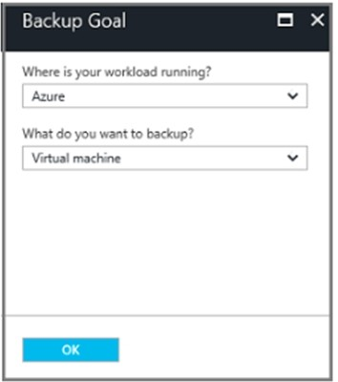

B3. From the What do you want to backup? menu, select Blob Storage, and click OK. B4. Finish the Wizard.

Task C. create a backup schedule

C1. Open the Microsoft Azure Backup agent. You can find it by searching your machine for Microsoft Azure Backup.

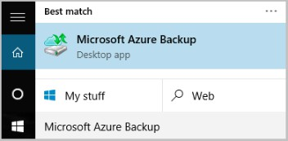

C2. In the Backup agent's Actions pane, click Schedule Backup to launch the Schedule Backup Wizard.

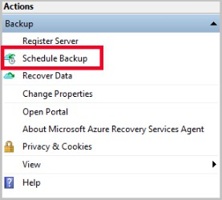

C3. On the Getting started page of the Schedule Backup Wizard, click Next. C4. On the Select Items to Backup page, click Add Items.

The Select Items dialog opens.

C5. Select Blob Storage you want to protect, and then click OK. C6.In the Select Items to Backup page, click Next.

On the Specify Backup Schedule page, specify Schedule a backup every day, and click Next.

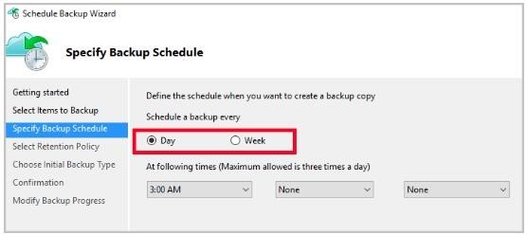

C7. On the Select Retention Policy page, set it to 14 days, and click Next.

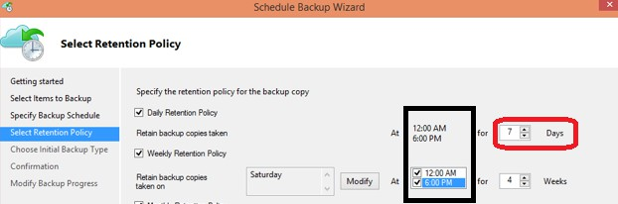

C8. Finish the Wizard.

References:

https://docs.microsoft.com/en-us/azure/backup/backup-configure-vault

### QUESTION 145

SIMULATION

**Overview**

The following section of the exam is a lab. In this section, you will perform a set of tasks in a live environment. While most functionality will be available to you as it would be in a live environment, some functionality (e.g., copy and paste, ability to navigate to external websites) will not be possible by design.

Scoring is based on the outcome of performing the tasks stated in the lab. In other words, it doesn’t matter how you accomplish the task, if you successfully perform it, you will earn credit for that task.

Labs are not timed separately, and this exam may have more than one lab that you must complete. You can use as much time as you would like to complete each lab. But, you should manage your time appropriately to ensure that you are able to complete the lab(s) and all other sections of the exam in the time provided.

Please note that once you submit your work by clicking the Next button within a lab, you will NOT be able to return to the lab.

**To start the lab**

You may start the lab by clicking the Next button.

Your company plans to store several documents on a public website.

You need to create a container named bios that will host the documents in the storagelod8095859 storage account. The solution must ensure anonymous access and must ensure that users can browse folders in the container.

What should you do from the Azure portal?

|  |  |
| --- | --- |
| A. | See below explanation |

**Answer:** A

**Explanation:**

Azure portal create public container

To create a container in the Azure portal, follow these steps:

Step 1. Navigate to your new storage account in the Azure portal.

Step 2. In the left menu for the storage account, scroll to the lob service section, then select Blobs.

Select the + Container button.

Type a name for your new container: bios

Set the level of public access to the container: Select anonymous access.

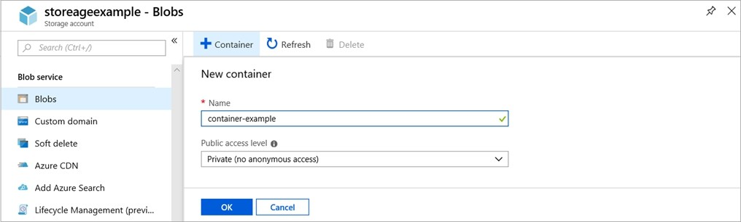

Step 3. Select OK to create the container. References:

https://docs.microsoft.com/en-us/azure/storage/blobs/storage-quickstart-blobs-portal

### QUESTION 146

SIMULATION

**Overview**

The following section of the exam is a lab. In this section, you will perform a set of tasks in a live environment. While most functionality will be available to you as it would be in a live environment, some functionality (e.g., copy and paste, ability to navigate to external websites) will not be possible by design.

Scoring is based on the outcome of performing the tasks stated in the lab. In other words, it doesn’t matter how you accomplish the task, if you successfully perform it, you will earn credit for that task.

Labs are not timed separately, and this exam may have more than one lab that you must complete. You can use as much time as you would like to complete each lab. But, you should manage your time appropriately to ensure that you are able to complete the lab(s) and all other sections of the exam in the time provided.

Please note that once you submit your work by clicking the Next button within a lab, you will NOT be able to return to the lab.

**To start the lab**

You may start the lab by clicking the Next button.

Your company plans to host in Azure the source files of several line-of-business applications. You need to create an Azure file share named corpsoftware in the storagelod8095859 storage

account. The solution must ensure the corpsoftware can store only up to 250 GB of data. What should you do from the Azure portal?

|  |  |
| --- | --- |
| A. | See below explanation |

**Answer:** A

**Explanation:**

Step 1. Go to the Storage Account blade on the Azure portal:

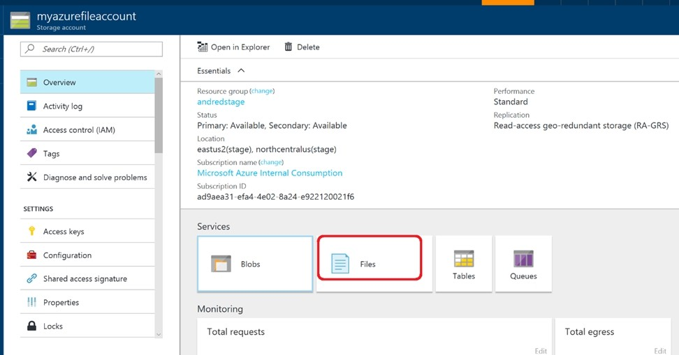

Step 2. Click on add File Share button:

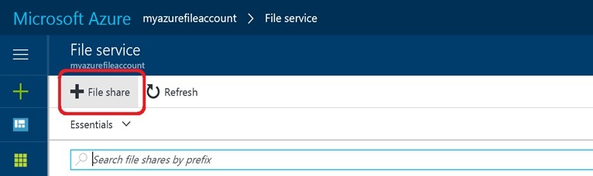

Step 3. Provide Name (storagelod8095859) and Quota (250 GB).

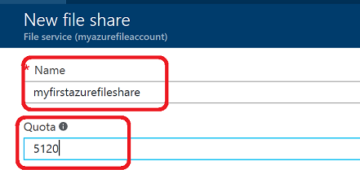

References:

https://docs.microsoft.com/en-us/azure/storage/files/storage-how-to-create-file-share

### QUESTION 147

You have an Azure subscription that contains 100 virtual machines. You regularly create and delete virtual machines.

You need to identify unattached disks that can be deleted. What should you do?

|  |  |
| --- | --- |
| A. | From Microsoft Azure Storage Explorer, view the Account Management properties. |
| B. | From the Azure portal, configure the Advisor recommendations. |
| C. | From Azure Cost Management, open the Optimizer tab and create a report. |
| D. | From Azure Cost Management, create a Cost Management report. |

**Answer:** A

**Explanation:**

https://docs.microsoft.com/en-us/azure/virtual-machines/windows/find-unattached-disks

### QUESTION 148

**Note: This question is part of a series of questions that present the same scenario. Each question in the series contains a unique solution that might meet the stated goals. Some question sets might have more than one correct solution, while others might not have a correct solution.**

**After you answer a question in this section, you will NOT be able to return to it. As a result, these questions will not appear in the review screen.**

You have an Azure virtual machine named VM1. VM1 was deployed by using a custom Azure Resource Manager template named ARM1.json.

You receive a notification that VM1 will be affected by maintenance. You need to move VM1 to a different host immediately.

Solution: From the Overview blade, you move the virtual machine to a different subscription.

Does this meet the goal?

|  |  |
| --- | --- |
| A. | Yes |
| B. | No |

**Answer:** B

**Explanation:**

You would need to Redeploy the VM. References:

https://docs.microsoft.com/en-us/azure/virtual-machines/windows/redeploy-to-new-node

### QUESTION 149

You plan to back up an Azure virtual machine named VM1.

You discover that the Backup Pre-Check status displays a status of Warning. What is a possible cause of the Warning status?

|  |  |
| --- | --- |
| A. | VM1 does not have the latest version of WaAppAgent.exe installed. |
| B. | VM1 has an unmanaged disk. |
| C. | VM1 is stopped. |
| D. | A Recovery Services vault is unavailable. |

**Answer:** A

**Explanation:**

The Warning state indicates one or more issues in VM's configuration that might lead to backup failures and provides recommended steps to ensure successful backups. Not having the latest VM Agent installed, for example, can cause backups to fail intermittently and falls in this class of issues.

References:

https://azure.microsoft.com/en-us/blog/azure-vm-backup-pre-checks/

### QUESTION 150

You have two Azure virtual machines named VM1 and VM2.

You have two Recovery Services vaults named RSV1 and RSV2. VM2 is protected by RSV1.

You need to use RSV2 to protect VM2. What should you do first?

|  |  |
| --- | --- |
| A. | From the RSV1 blade, click Backup items and stop the VM2 backup. |
| B. | From the RSV1 blade, click Backup Jobs and export the VM2 backup. |
| C. | From the RSV1 blade, click Backup. From the Backup blade, select the backup for the virtual machine, and then click Backup. |
| D. | From the VM2 blade, click Disaster recovery, click Replication settings, and then select RSV2 as the Recovery Services vault. |

**Answer:** A

**Explanation:**

https://docs.microsoft.com/en-us/azure/backup/backup-azure-vms-first-look-arm

### QUESTION 151

You have an Azure virtual machine named VM1 that you use for testing. VM1 is protected by Azure Backup.

You delete VM1.

You need to remove the backup data stored for VM1. What should you do first?

|  |  |
| --- | --- |
| A. | Modify the backup policy. |
| B. | Delete the Recovery Services vault. |
| C. | Stop the backup. |
| D. | Delete the storage account. |

**Answer:** C

**Explanation:**

Stop backup and delete recovery services vault, if no other backups. https://docs.microsoft.com/en-us/azure/backup/tutorial-backup-vm-at-scale

### QUESTION 152

You have an Azure subscription.

You have an on-premises virtual machine named VM1. The settings for VM1 are shown in the exhibit.

(Click the Exhibit button.)

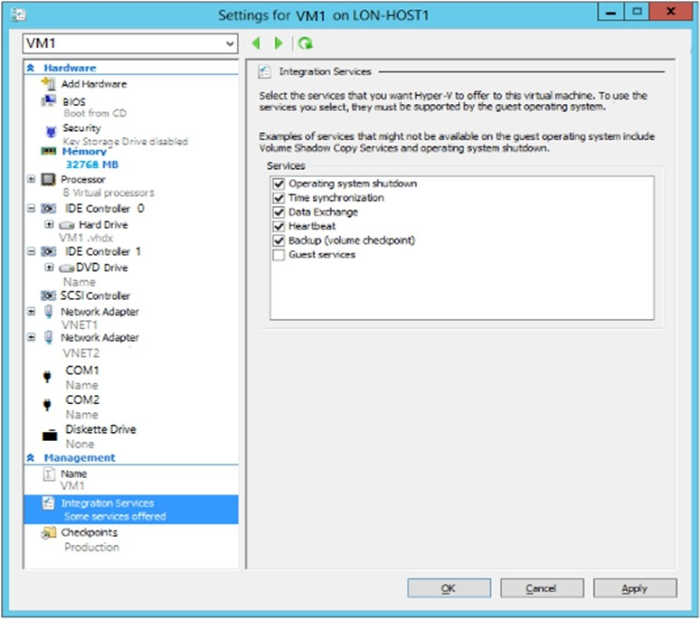

You need to ensure that you can use the disks attached to VM1 as a template for Azure virtual machines.

What should you modify on VM1?

|  |  |
| --- | --- |
| A. | Integration Services |
| B. | the network adapters |
| C. | the memory |
| D. | the hard drive |
| E. | the processor |

**Answer:** D

**Explanation:**

From the exhibit we see that the disk is in the VHDX format.

Before you upload a Windows virtual machines (VM) from on-premises to Microsoft Azure, you must prepare the virtual hard disk (VHD or VHDX). Azure supports only generation 1 VMs that are in the VHD file format and have a fixed sized disk. The maximum size allowed for the VHD is 1,023 GB. You can convert a generation 1 VM from the VHDX file system to VHD and from a dynamically expanding disk to fixed-sized.

### QUESTION 153

SIMULATION

Overview

The following section of the exam is a lab. In this section, you will perform a set of tasks in a live environment. While most functionality will be available to you as it would be in a live environment, some functionality (e.g., copy and paste, ability to navigate to external websites) will not be possible by design.

Scoring is based on the outcome of performing the tasks stated in the lab. In other words, it doesn't matter how you accomplish the task, if you successfully perform it, you will earn credit for that task.

Labs are not timed separately, and this exam may have more than one lab that you must complete. You can use as much time as you would like to complete each lab. But, you should manage your time appropriately to ensure that you are able to complete the lab(s) and all other sections of the exam in the time provided.

Please note that once you submit your work by clicking the Next button within a lab, you will NOT be able to return to the lab.

To start the lab

You may start the lab by clicking the Next button.

You plan to back up all the Azure virtual machines in your Azure subscription at 02:00 Coordinated Universal Time (UTC) daily.

You need to prepare the Azure environment to ensure that any new virtual machines can be configured quickly for backup. The solution must ensure that all the daily backups performed at 02:00 UTC are stored for only 90 days.

What should you do from the Azure portal?

|  |  |
| --- | --- |
| A. | See below explanation |

**Answer:** A

**Explanation:**

Task A: Create a Recovery Services vault (if a vault already exists skip this task, go to Task B below)

A1. From Azure Portal, On the Hub menu, click All services and in the list of resources, type Recovery Services and click Recovery Services vaults.

If there are recovery services vaults in the subscription, the vaults are listed. A2. On the Recovery Services vaults menu, click Add.

A3. The Recovery Services vault blade opens, prompting you to provide a Name, Subscription, Resource group, and Location

Task B.

B1. On the Recovery Services vault blade (for the vault you just created), in the Getting Started section, click Backup, then on the Getting Started with Backup blade, select Backup goal.

The Backup Goal blade opens. If the Recovery Services vault has been previously configured, then the Backup Goal blades opens when you click Backup on the Recovery Services vault blade.

B2. From the Where is your workload running? drop-down menu, select Azure.

B3. From the What do you want to backup? menu, select Virtual Machine, and click OK.

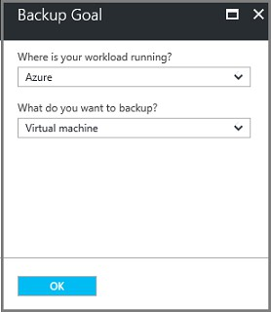

B4. Finish the Wizard.

Task C. create a backup schedule

C1. Open the Microsoft Azure Backup agent. You can find it by searching your machine for Microsoft Azure Backup.



C2. In the Backup agent's Actions pane, click Schedule Backup to launch the Schedule Backup Wizard.



C3. On the Getting started page of the Schedule Backup Wizard, click Next. C4. On the Select Items to Backup page, click Add Items.

The Select Items dialog opens.

C5. Select Blob Storage you want to protect, and then click OK. C6.In the Select Items to Backup page, click Next.

On the Specify Backup Schedule page, specify

Schedule a backup every: day At the following times: 2.00 AM

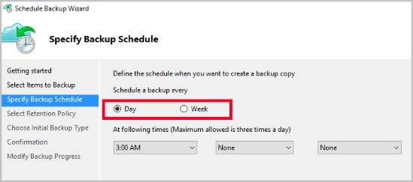

C7. On the Select Retention Policy page, set it to 90 days, and click Next.

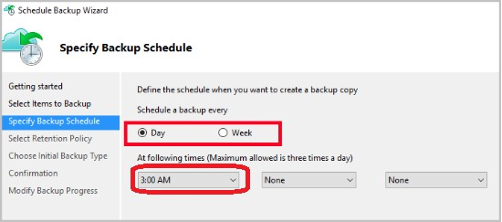

C8. Finish the Wizard.

References:

https://docs.microsoft.com/en-us/azure/backup/backup-configure-vault

### QUESTION 154

SIMULATION

Overview

The following section of the exam is a lab. In this section, you will perform a set of tasks in a live environment. While most functionality will be available to you as it would be in a live environment, some functionality (e.g., copy and paste, ability to navigate to external websites) will not be possible by design.

Scoring is based on the outcome of performing the tasks stated in the lab. In other words, it doesn't matter how you accomplish the task, if you successfully perform it, you will earn credit for that task.

Labs are not timed separately, and this exam may have more than one lab that you must complete. You can use as much time as you would like to complete each lab. But, you should manage your time appropriately to ensure that you are able to complete the lab(s) and all other sections of the exam in the time provided.

Please note that once you submit your work by clicking the Next button within a lab, you will NOT be able to return to the lab.

To start the lab

You may start the lab by clicking the Next button.

You recently created a virtual machine named Web01.

You need to attach a new 80-GB standard data disk named Web01-Disk1 to Web01. What should you do from the Azure portal?

|  |  |
| --- | --- |
| A. | See below explanation |

**Answer:** A

**Explanation:**

Add a data disk

Step 1. In the Azure portal, from the menu on the left, select **Virtual machines**. Step 2. Select the Web01 virtual machine from the list.

Step 3. On the **Virtual machine** page, , in Essentials, select **Disks**.

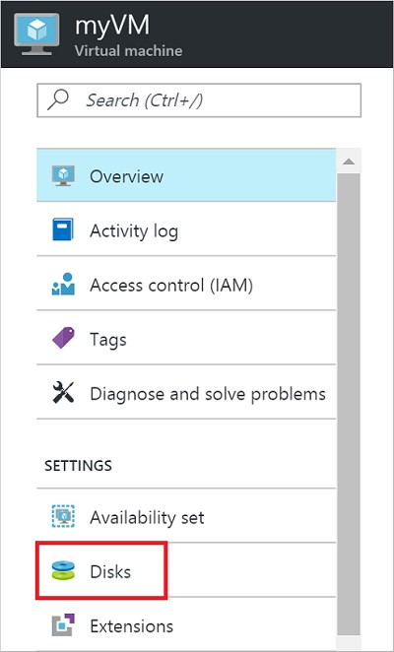

Step 4. On the **Disks** page, select the Web01-Disk1 from the list of existing disks. Step 5. In the Disks pane, click + Add data disk.

Step 6. Click the drop-down menu for Name to view a list of existing managed disks accessible to your Azure subscription. Select the managed disk Web01-Disk1 to attach:

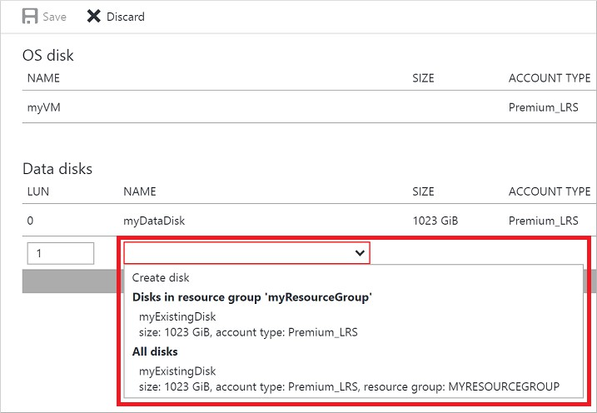

References:

https://docs.microsoft.com/en-us/azure/virtual-machines/linux/attach-disk-portal

### QUESTION 155

SIMULATION

Overview

The following section of the exam is a lab. In this section, you will perform a set of tasks in a live environment. While most functionality will be available to you as it would be in a live environment, some functionality (e.g., copy and paste, ability to navigate to external websites) will not be possible by design.

Scoring is based on the outcome of performing the tasks stated in the lab. In other words, it doesn't matter how you accomplish the task, if you successfully perform it, you will earn credit for that task.

Labs are not timed separately, and this exam may have more than one lab that you must complete. You can use as much time as you would like to complete each lab. But, you should manage your time appropriately to ensure that you are able to complete the lab(s) and all other sections of the exam in the time provided.

Please note that once you submit your work by clicking the Next button within a lab, you will NOT be able to return to the lab.

To start the lab

You may start the lab by clicking the Next button.

You plan to allow connections between the VNET01-USEA2 and VNET01-USWE2 virtual networks.

You need to ensure that virtual machines can communicate across both virtual networks by using their private IP address. The solution must NOT require any virtual network gateways.

What should you do from the Azure portal?

|  |  |
| --- | --- |
| A. | See below explanation |

**Answer:** A

**Explanation:**

Virtual network peering enables you to seamlessly connect two Azure virtual networks. Once peered, the virtual networks appear as one, for connectivity purposes.

Peer virtual networks

Step 1. In the Search box at the top of the Azure portal, begin typing VNET01-USEA2. When VNET01- USEA2 appears in the search results, select it.

Step 2. Select Peerings, under SETTINGS, and then select + Add, as shown in the following picture:

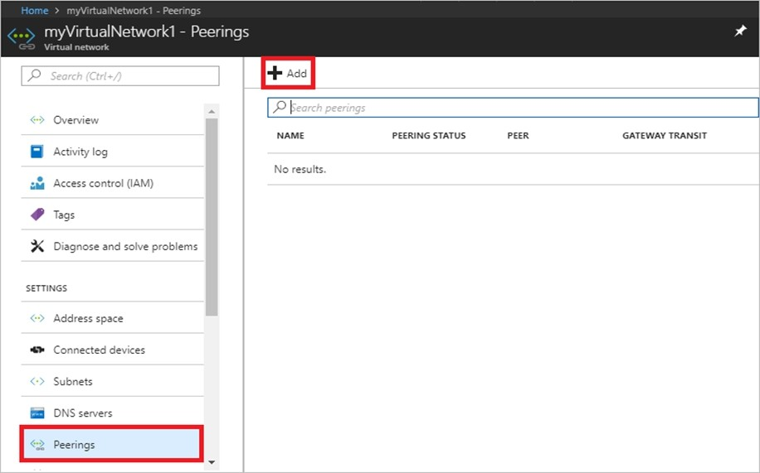

Step 3. Enter, or select, the following information, accept the defaults for the remaining settings, and then select OK.

Name: myVirtualNetwork1-myVirtualNetwork2 (for example) Subscription: elect your subscription.

Virtual network: VNET01-USWE2 - To select the VNET01-USWE2 virtual network, select Virtual network, then select VNET01-USWE2. You can select a virtual network in the same region or in a

different region.

Now we need to repeat steps 1-3 for the other network VNET01-USWE2:

Step 4. In the Search box at the top of the Azure portal, begin typing VNET01- USEA2. When VNET01- USEA2 appears in the search results, select it.

Step 5. Select Peerings, under SETTINGS, and then select + Add.

References:

https://docs.microsoft.com/en-us/azure/virtual-network/tutorial-connect-virtual-networks-portal

### QUESTION 156

SIMULATION

Overview

The following section of the exam is a lab. In this section, you will perform a set of tasks in a live environment. While most functionality will be available to you as it would be in a live environment, some functionality (e.g., copy and paste, ability to navigate to external websites) will not be possible by design.

Scoring is based on the outcome of performing the tasks stated in the lab. In other words, it doesn't matter how you accomplish the task, if you successfully perform it, you will earn credit for that task.

Labs are not timed separately, and this exam may have more than one lab that you must complete. You can use as much time as you would like to complete each lab. But, you should manage your time appropriately to ensure that you are able to complete the lab(s) and all other sections of the exam in the time provided.

Please note that once you submit your work by clicking the Next button within a lab, you will NOT be able to return to the lab.

To start the lab

You may start the lab by clicking the Next button.

You plan to host several secured websites on Web01.

You need to allow HTTPS over TCP port 443 to Web01 and to prevent HTTP over TCP port 80 to Web01.

What should you do from the Azure portal?

|  |  |
| --- | --- |
| A. | See below explanation |

**Answer:** A

**Explanation:**

You can filter network traffic to and from Azure resources in an Azure virtual network with a network security group. A network security group contains security rules that allow or deny inbound network traffic to, or outbound network traffic from, several types of Azure resources.

A network security group contains security rules that allow or deny inbound network traffic to, or outbound network traffic from, several types of Azure resources.

Step A: Create a network security group

A1. Search for and select the resource group for the VM, choose Add, then search for and select Network security group.

A2. Select Create.

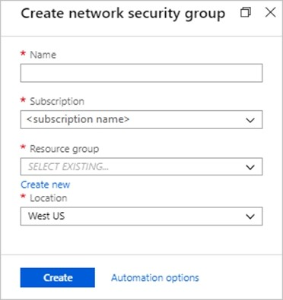

The Create network security group window opens. A3. Create a network security group

Enter a name for your network security group.

Select or create a resource group, then select a location. A4. Select Create to create the network security group.

Step B: Create an inbound security rule to allows HTTPS over TCP port 443 B1. Select your new network security group.

B2. Select Inbound security rules, then select Add. B3. Add inbound rule

B4. Select Advanced.

From the drop-down menu, select HTTPS.

You can also verify by clicking Custom and selecting TCP port, and 443. B5. Select Add to create the rule.

Repeat step B2-B5 to deny TCP port 80

B6. Select Inbound security rules, then select Add.

B7. Add inbound rule B8. Select Advanced.

Clicking Custom and selecting TCP port, and 80. B9. Select Deny.

Step C: Associate your network security group with a subnet

Your final step is to associate your network security group with a subnet or a specific network interface.

C1. In the Search resources, services, and docs box at the top of the portal, begin typing Web01. When the Web01 VM appears in the search results, select it.

C2. Under SETTINGS, select Networking. Select Configure the application security groups, select the Security Group you created in Step A, and then select Save, as shown in the following picture:

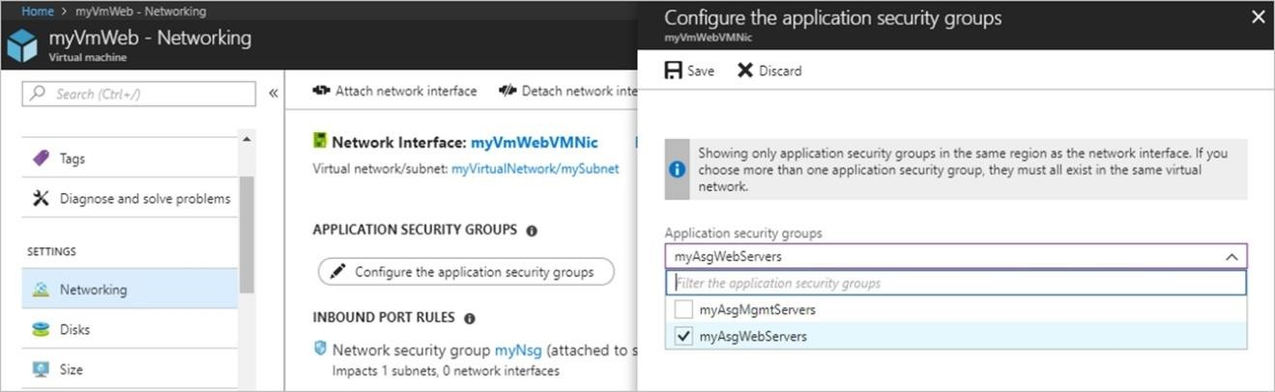

References:

https://docs.microsoft.com/en-us/azure/virtual-network/tutorial-filter-network-traffic

### QUESTION 157

Hotspot Question

You have an Azure subscription that contains an Azure Storage account named storage1 and the users shown in the following table.

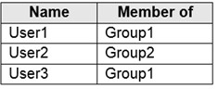

You plan to monitor storage1 and to configure email notifications for the signals shown in the following table.

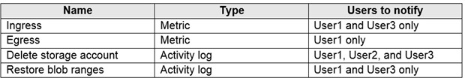

You need to identify the minimum number of alert rules and action groups required for the planned monitoring.

How many alert rules and action groups should you identify? To answer, select the appropriate options in the answer area.

NOTE: Each correct selection is worth one point.

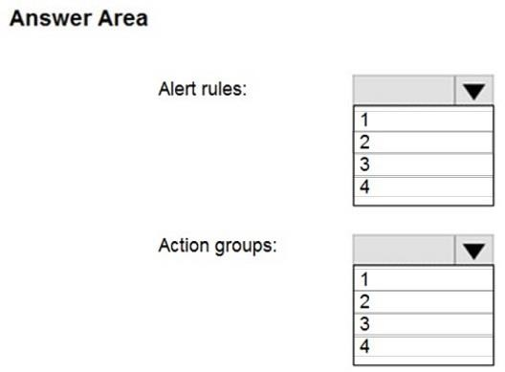

**Answer:**

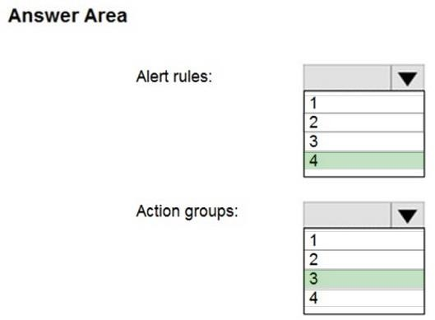

### QUESTION 158

Hotspot Question

You plan to deploy 20 Azure virtual machines by using an Azure Resource Manager template. The virtual machines will run the latest version of Windows Server 2016 Datacenter by using an Azure Marketplace image.

You need to complete the storageProfile section of the template.

How should you complete the storageProfile section? To answer, select the appropriate options in the answer area.

NOTE: Each correct selection is worth one point.

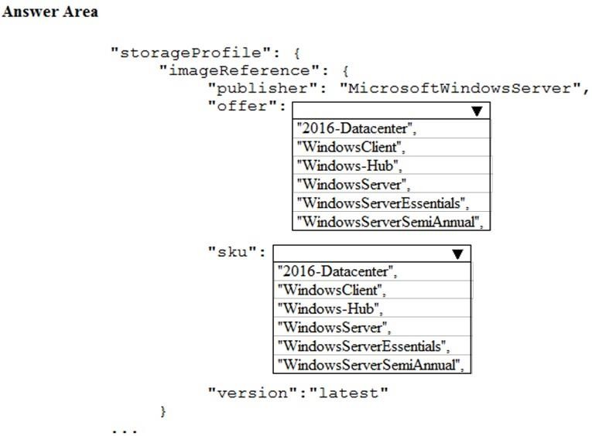

**Answer:**

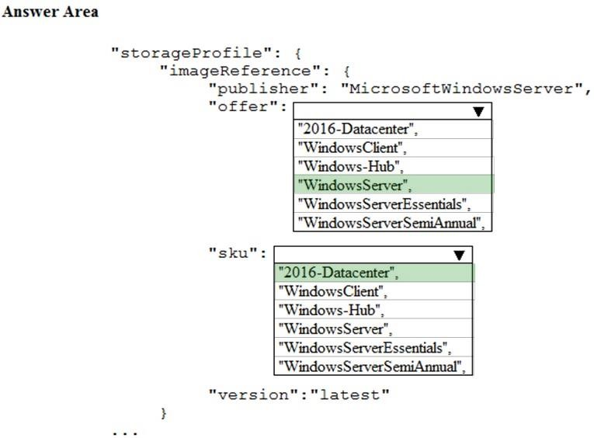

**Explanation:**

...

"storageProfile": { "imageReference": {

"publisher": "MicrosoftWindowsServer", "offer": "WindowsServer",

"sku": "2016-Datacenter", "version": "latest"

},

...

References:

https://docs.microsoft.com/en-us/rest/api/compute/virtualmachines/createorupdate

### QUESTION 159

Hotspot Question

You create a virtual machine scale set named Scale1. Scale1 is configured as shown in the following exhibit.

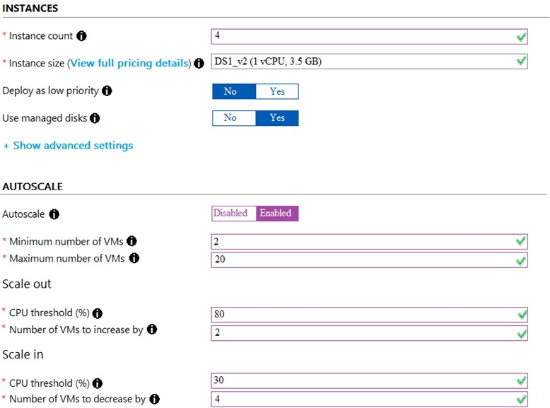

Use the drop-down menus to select the answer choice that completes each statement based on the information presented in the graphic.

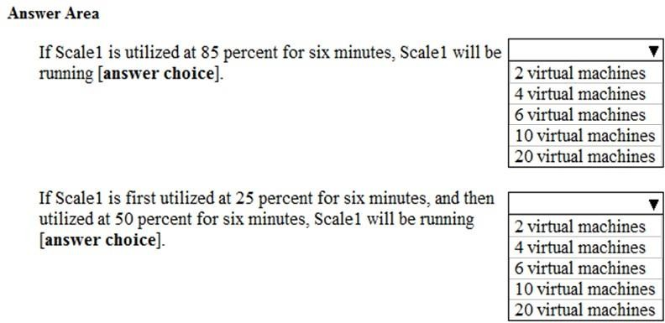

**Answer:**

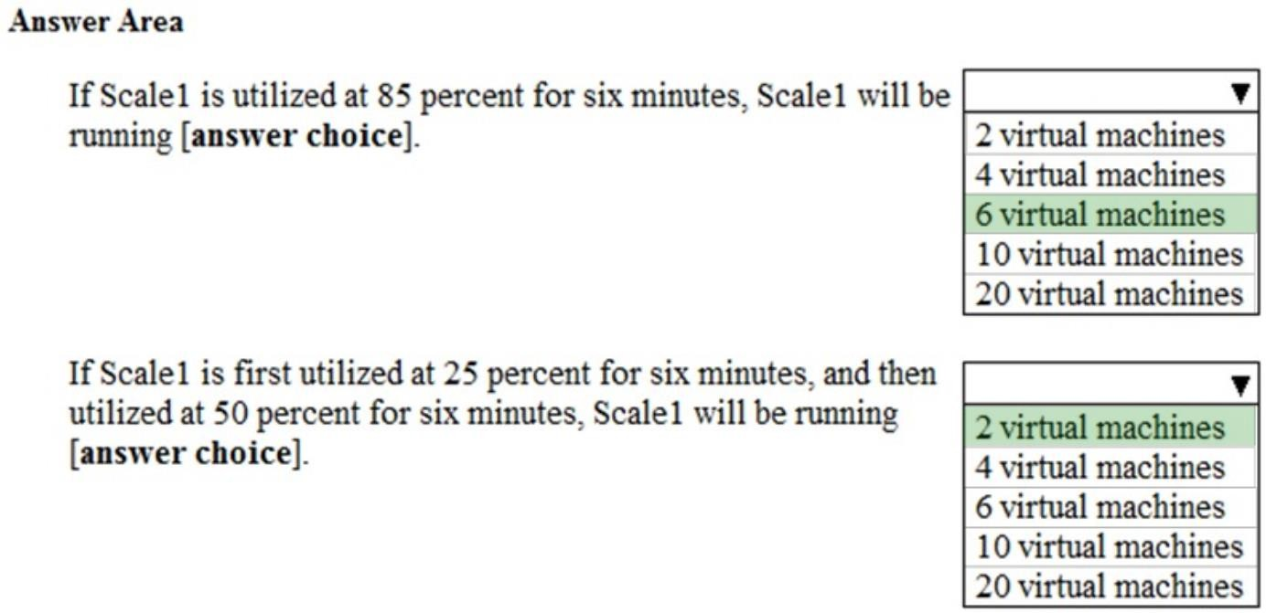

**Explanation:**

Box 1:

The Autoscale scale out rule increases the number of VMs by 2 if the CPU threshold is 80% or higher. The initial instance count is 4 and rises to 6 when the 2 extra instances of VMs are added. Box 2:

The Autoscale scale in rule decreases the number of VMs by 4 if the CPU threshold is 30% or lower. The initial instance count is 4 and thus cannot be reduced to 0 as the minimum instances is set to 2. Instances are only added when the CPU threshold reaches 80%.

References:

https://docs.microsoft.com/en-us/azure/azure-monitor/platform/autoscale-overview https://docs.microsoft.com/en-us/azure/azure-monitor/platform/autoscale-best-practices https://docs.microsoft.com/en-us/azure/azure-monitor/platform/autoscale-common-scale-patterns

### QUESTION 160

Hotspot Question

You have an Azure subscription.

You need to implement a custom policy that meet the following requirements:

* Ensures that each new resource group in the subscription has a tag named organization set to a value of Contoso.
* Ensures that resource group can be created from the Azure portal.
* Ensures that compliance reports in the Azure portal are accurate.

How should you complete the policy? To answer, select the appropriate options in the answers area.

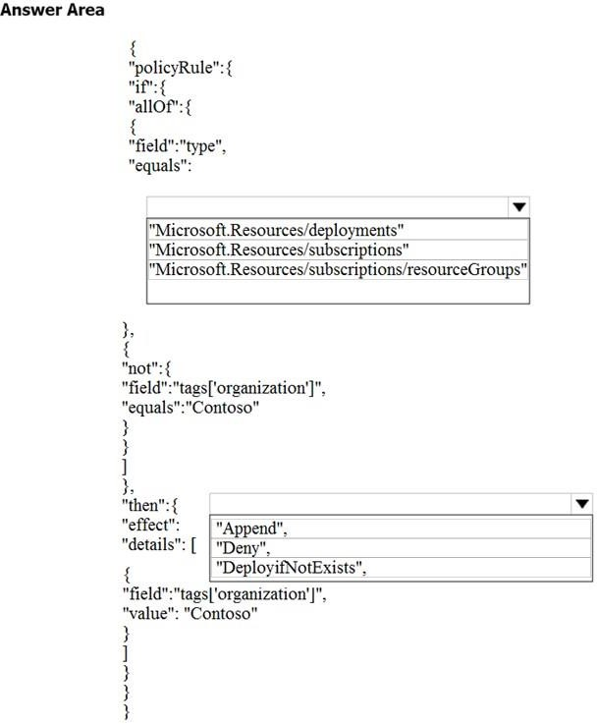

**Answer:**

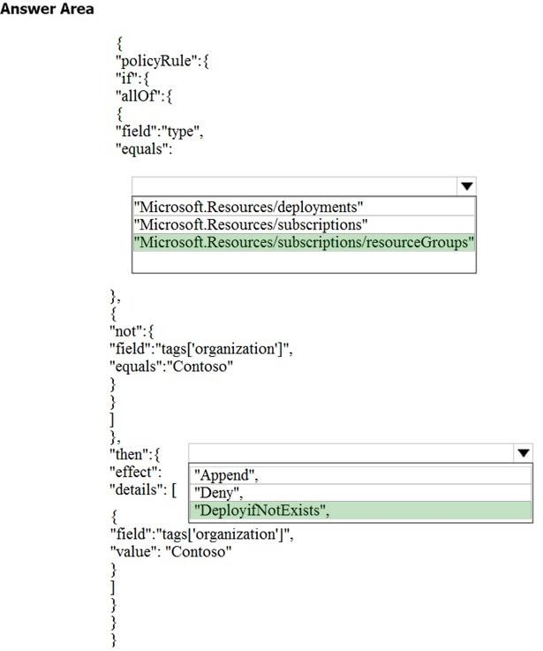

### QUESTION 161

**Note: This question is part of a series of questions that present the same scenario. Each question in the series contains a unique solution that might meet the stated goals. Some question sets might have more than one correct solution, while others might not have a correct solution.**

**After you answer a question in this section, you will NOT be able to return to it. As a result, these questions will not appear in the review screen.**

You have an Azure web app named App1. App1 runs in an Azure App Service plan named Plan1. Plan1 is associated to the Free pricing tier.

You discover that App1 stops each day after running continuously for 60 minutes. You need to ensure that App1 can run continuously for the entire day.

Solution: You change the pricing tier of Plan1 to Basic.

Does this meet the goal?

|  |  |
| --- | --- |
| A. | Yes |
| B. | No |

**Answer:** A

**Explanation:**

The Free Tier provides 60 CPU minutes / day. This explains why App1 is stops. The Basic tier has no such cap.

References:

https://azure.microsoft.com/en-us/pricing/details/app-service/windows/

### QUESTION 162

**Note: This question is part of a series of questions that present the same scenario. Each question in the series contains a unique solution that might meet the stated goals. Some question sets might have more than one correct solution, while others might not have a correct solution.**

**After you answer a question in this section, you will NOT be able to return to it. As a result, these questions will not appear in the review screen.**

You have an Azure web app named App1. App1 runs in an Azure App Service plan named Plan1. Plan1 is associated to the Free pricing tier.

You discover that App1 stops each day after running continuously for 60 minutes. You need to ensure that App1 can run continuously for the entire day.

Solution: You add a triggered WebJob to App1. Does this meet the goal?

|  |  |
| --- | --- |
| A. | Yes |
| B. | No |

**Answer:** B

**Explanation:**

You need to change to Basic pricing Tier.

Note: The Free Tier provides 60 CPU minutes / day. This explains why App1 is stops. The Basic tier has no such cap.

References:

https://azure.microsoft.com/en-us/pricing/details/app-service/windows/

### QUESTION 163

**Note: This question is part of a series of questions that present the same scenario. Each question in the series contains a unique solution that might meet the stated goals. Some question sets might have more than one correct solution, while others might not have a correct solution.**

**After you answer a question in this section, you will NOT be able to return to it. As a result, these questions will not appear in the review screen.**

You have an Azure web app named App1. App1 runs in an Azure App Service plan named Plan1. Plan1 is associated to the Free pricing tier.

You discover that App1 stops each day after running continuously for 60 minutes. You need to ensure that App1 can run continuously for the entire day.

Solution: You change the pricing tier of Plan1 to Shared. Does this meet the goal?

|  |  |
| --- | --- |
| A. | Yes |
| B. | No |

**Answer:** B

**Explanation:**

You should switch to the Basic Tier.

The Free Tier provides 60 CPU minutes / day. This explains why App1 is stops. The Shared Tier provides 240 CPU minutes / day. The Basic tier has no such cap.

References:

https://azure.microsoft.com/en-us/pricing/details/app-service/windows/

### QUESTION 164

**Note: This question is part of a series of questions that present the same scenario. Each question in the series contains a unique solution that might meet the stated goals. Some question sets might have more than one correct solution, while others might not have a correct solution.**

**After you answer a question in this section, you will NOT be able to return to it. As a result, these questions will not appear in the review screen.**

You have an Azure Active Directory (Azure AD) tenant named Adatum and an Azure Subscription named Subscription1. Adatum contains a group named Developers. Subscription1 contains a resource group named Dev.

You need to provide the Developers group with the ability to create Azure logic apps in the Dev resource group.

Solution: On Dev, you assign the Logic App Contributor role to the Developers group. Does this meet the goal?

|  |  |
| --- | --- |
| A. | Yes |
| B. | No |

**Answer:** A

**Explanation:**

The Logic App Contributor role lets you manage logic app, but not access to them. It provides access to view, edit, and update a logic app.

References:

https://docs.microsoft.com/en-us/azure/role-based-access-control/built-in-roles https://docs.microsoft.com/en-us/azure/logic-apps/logic-apps-securing-a-logic-app

### QUESTION 165

**Note: This question is part of a series of questions that present the same scenario. Each question in the series contains a unique solution that might meet the stated goals. Some question sets might have more than one correct solution, while others might not have a correct solution.**

**After you answer a question in this section, you will NOT be able to return to it. As a result, these questions will not appear in the review screen.**

You have an Azure Active Directory (Azure AD) tenant named Adatum and an Azure Subscription named Subscription1. Adatum contains a group named Developers. Subscription1 contains a resource group named Dev.

You need to provide the Developers group with the ability to create Azure logic apps in the Dev resource group.

Solution: On Subscription1, you assign the Logic App Operator role to the Developers group. Does this meet the goal?

|  |  |
| --- | --- |
| A. | Yes |
| B. | No |

**Answer:** B

**Explanation:**

The Logic App Operator role only lets you read, enable and disable logic app. With it you can view the logic app and run history, and enable/disable. Cannot edit or update the definition. You would need the Logic App Contributor role.

References:

https://docs.microsoft.com/en-us/azure/role-based-access-control/built-in-roles https://docs.microsoft.com/en-us/azure/logic-apps/logic-apps-securing-a-logic-app

### QUESTION 166

**Note: This question is part of a series of questions that present the same scenario. Each question in the series contains a unique solution that might meet the stated goals. Some question sets might have more than one correct solution, while others might not have a correct solution.**

**After you answer a question in this section, you will NOT be able to return to it. As a result, these questions will not appear in the review screen.**

You have an Azure Active Directory (Azure AD) tenant named Adatum and an Azure Subscription named Subscription1. Adatum contains a group named Developers. Subscription1 contains a resource group named Dev.

You need to provide the Developers group with the ability to create Azure logic apps in the Dev resource group.

Solution: On Subscription1, you assign the DevTest Labs User role to the Developers group. Does this meet the goal?

|  |  |
| --- | --- |
| A. | Yes |
| B. | No |

**Answer:** B

**Explanation:**

DevTest Labs User role only lets you connect, start, restart, and shutdown virtual machines in your Azure DevTest Labs.

You would need the Logic App Contributor role. References:

https://docs.microsoft.com/en-us/azure/role-based-access-control/built-in-roles https://docs.microsoft.com/en-us/azure/logic-apps/logic-apps-securing-a-logic-app

### QUESTION 167

**Note: This question is part of a series of questions that present the same scenario. Each question in the series contains a unique solution that might meet the stated goals. Some question sets might have more than one correct solution, while others might not have a correct solution.**

**After you answer a question in this section, you will NOT be able to return to it. As a result, these questions will not appear in the review screen.**

You manage a virtual network named VNet1 that is hosted in the West US Azure region. VNet1 hosts two virtual machines named VM1 and VM2 that run Windows Server.

You need to inspect all the network traffic from VM1 to VM2 for a period of three hours. Solution: From Performance Monitor, you create a Data Collector Set (DCS).

Does this meet the goal?

|  |  |
| --- | --- |
| A. | Yes |
| B. | No |

**Answer:** B

**Explanation:**

You should use Azure Network Watcher. References:

https://docs.microsoft.com/en-us/azure/network-watcher/network-watcher-monitoring-overview

### QUESTION 168

**Note: This question is part of a series of questions that present the same scenario. Each question in the series contains a unique solution that might meet the stated goals. Some question sets might have more than one correct solution, while others might not have a correct solution.**

**After you answer a question in this section, you will NOT be able to return to it. As a result, these questions will not appear in the review screen.**

You manage a virtual network named VNet1 that is hosted in the West US Azure region. VNet1 hosts two virtual machines named VM1 and VM2 that run Windows Server.

You need to inspect all the network traffic from VM1 to VM2 for a period of three hours. Solution: From Azure Network Watcher, you create a packet capture.

Does this meet the goal?

|  |  |
| --- | --- |
| A. | Yes |
| B. | No |

**Answer:** A

**Explanation:**

Packet Capture can inspect 18000 seconds (5 hours) Network Status.

### QUESTION 169

**Note: This question is part of a series of questions that present the same scenario. Each question in the series contains a unique solution that might meet the stated goals. Some question sets might have more than one correct solution, while others might not have a correct solution.**

**After you answer a question in this section, you will NOT be able to return to it. As a result, these questions will not appear in the review screen.**

You manage a virtual network named VNet1 that is hosted in the West US Azure region. VNet1 hosts two virtual machines named VM1 and VM2 that run Windows Server.

You need to inspect all the network traffic from VM1 to VM2 for a period of three hours. Solution: From Azure Monitor, you create a metric on Network In and Network Out.

Does this meet the goal?

|  |  |
| --- | --- |
| A. | Yes |
| B. | No |

**Answer:** B

**Explanation:**

You should use Azure Network Watcher. References:

https://docs.microsoft.com/en-us/azure/network-watcher/network-watcher-monitoring-overview

### QUESTION 170

A web developer creates a web application that you plan to deploy as an Azure web app. Users must enter credentials to access the web application.

You create a new web app named WebApp1 and deploy the web application to WebApp1. You need to disable anonymous access to WebApp1.

What should you configure?

|  |  |
| --- | --- |
| A. | Advanced Tools |
| B. | Authentication/Authorization |
| C. | Access control (IAM) |

|  |  |
| --- | --- |
| D. | Deployment credentials |

**Answer:** B

**Explanation:**

Anonymous access is an authentication method. It allows users to establish an anonymous connection.

References:

https://docs.microsoft.com/en-us/biztalk/core/guidelines-for-resolving-iis-permissions-problems

### QUESTION 171

You are building a custom Azure function app to connect to Azure Event Grid.

You need to ensure that resources are allocated dynamically to the function app. Billing must be based on the executions of the app.

What should you configure when you create the function app?

|  |  |
| --- | --- |
| A. | the Windows operating system and the Consumption plan hosting plan |
| B. | the Windows operating system and the App Service plan hosting plan |
| C. | the Docker container and an App Service plan that uses the B1 pricing tier |
| D. | the Docker container and an App Service plan that uses the S1 pricing tier |

**Answer:** A

**Explanation:**

Azure Functions runs in two different modes: Consumption plan and Azure App Service plan. The Consumption plan automatically allocates compute power when your code is running. Your app is scaled out when needed to handle load, and scaled down when code is not running.

Incorrect Answers:

B: When you run in an App Service plan, you must manage the scaling of your function app. References:

https://docs.microsoft.com/en-us/azure/azure-functions/functions-create-first-azure-function

### QUESTION 172

You have an Azure App Service plan named AdatumASP1 that uses the P2v2 pricing tier. AdatunASP1 hosts an Azure web app named adatumwebapp1.

You need to delegate the management of adatumwebapp1 to a group named Devs. Devs must be able to perform the following tasks:

* Add deployment slots.
* View the configuration of AdatunASP1.
* Modify the role assignment for adatumwebapp1.

Which role should you assign to the Devs group?

|  |  |
| --- | --- |
| A. | Owner |
| B. | Contributor |
| C. | Web Plan Contributor |
| D. | Website Contributor |

**Answer:** A

**Explanation:**

https://docs.microsoft.com/en-us/azure/role-based-access-control/built-in-roles

### QUESTION 173

You have an Azure App Service plan that hosts an Azure App Service named App1. You configure one production slot and four staging slots for App1.

You need to allocate 10 percent of the traffic to each staging slot and 60 percent of the traffic to the production slot.

What should you add to App1?

|  |  |
| --- | --- |
| A. | slots to the Testing in production blade |
| B. | a performance test |
| C. | a WebJob |
| D. | templates to the Automation script blade |

**Answer:** A

**Explanation:**

Besides swapping, deployment slots offer another killer feature: testing in production. Just like the name suggests, using this, you can actually test in production. This means that you can route a specific percentage of user traffic to one or more of your deployment slots.

Example:

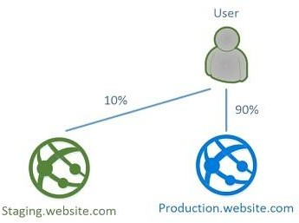

References:

https://stackify.com/azure-deployment-slots/

### QUESTION 174

You have an Azure Service Bus.

You need to implement a Service Bus queue that guarantees first-in-first-out (FIFO) delivery of messages.

What should you do?

|  |  |
| --- | --- |
| A. | Set the Lock Duration setting to 10 seconds. |
| B. | Enable duplicate detection. |
| C. | Set the Max Size setting of the queue to 5 GB. |
| D. | Enable partitioning. |
| E. | Enable sessions. |

**Answer:** E

**Explanation:**

Through the use of messaging sessions you can guarantee ordering of messages, that is first-in- first-out (FIFO) delivery of messages.

References:

https://docs.microsoft.com/en-us/azure/service-bus-messaging/service-bus-azure-and-service- bus-queues-compared-contrasted

### QUESTION 175

You have a Microsoft SQL Server Always On availability group on Azure virtual machines. You need to configure an Azure internal load balancer as a listener for the availability group. What should you do?

|  |  |
| --- | --- |
| A. | Enable Floating IP. |
| B. | Set Session persistence to Client IP and protocol. |
| C. | Set Session persistence to Client IP. |
| D. | Create an HTTP health probe on port 1433. |

**Answer:** A

**Explanation:**

Incorrect Answers:

D: The Health probe is created with the TCP protocol, not with the HTTP protocol. References:

https://docs.microsoft.com/en-us/azure/virtual-machines/windows/sql/virtual-machines-windows- portal-sql-alwayson-int-listener

### QUESTION 176

Hotspot Question

Your network contains an Active Directory domain named adatum.com and an Azure Active Directory (Azure AD) tenant named adatum.onmicrosoft.com.

Adatum.com contains the user accounts in the following table.

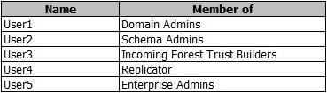

Adatum.onmicrosoft.com contains the user accounts in the following table.

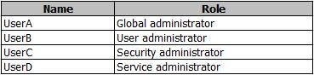

You need to implement Azure AD Connect. The solution must follow the principle of least privilege.

Which user accounts should you use? To answer, select the appropriate options in the answer area.

**NOTE**: Each correct selection is worth one point.

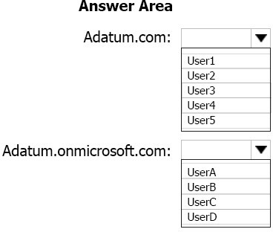

**Answer:**

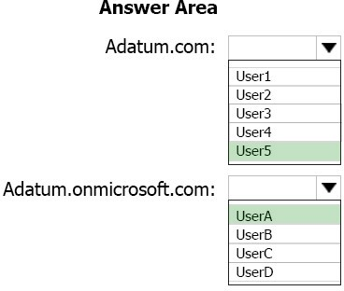

**Explanation:**

Box 1: User5

In Express settings, the installation wizard asks for the following:

AD DS Enterprise Administrator credentials Azure AD Global Administrator credentials

The AD DS Enterprise Admin account is used to configure your on-premises Active Directory. These credentials are only used during the installation and are not used after the installation has completed. The Enterprise Admin, not the Domain Admin should make sure the permissions in Active Directory can be set in all domains.

Box 2: UserA

Azure AD Global Admin credentials credentials are only used during the installation and are not used after the installation has completed. It is used to create the Azure AD Connector account used for synchronizing changes to Azure AD. The account also enables sync as a feature in Azure AD.

References: https://docs.microsoft.com/en-us/azure/active-directory/connect/active-directory- aadconnect-accounts-permissions

### QUESTION 177

You have an Azure subscription named Subscription1 that is used be several departments at your company. Subscription1 contains the resources in the following table:

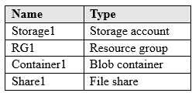

Another administrator deploys a virtual machine named VM1 and an Azure Storage account named Storage2 by using a single Azure Resource Manager template. You need to view the template used for the deployment. From which blade can you view the template that was used for

the deployment?

|  |  |
| --- | --- |
| A. | RG1 |
| B. | VM1 |
| C. | Storage1 |
| D. | Container1 |

**Answer:** A

**Explanation:**

1. View template from deployment history

Go to the resource group for your new resource group. Notice that the portal shows the result of the last deployment. Select this link.

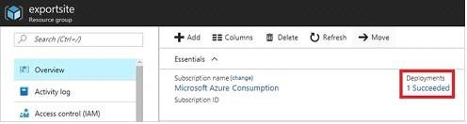

1. You see a history of deployments for the group. In your case, the portal probably lists only one deployment. Select this deployment.

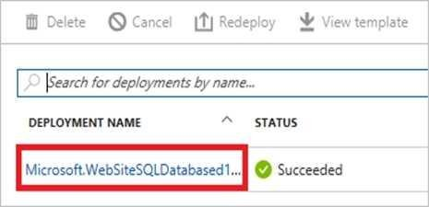

The portal displays a summary of the deployment. The summary includes the status of the deployment and its operations and the values that you provided for parameters. To see the template that you used for the deployment, select View template.

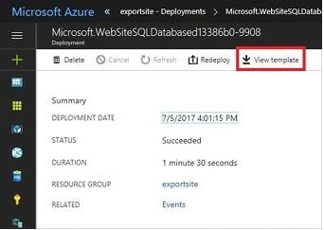

References: https://docs.microsoft.com/en-us/azure/azure-resource-manager/resource-manager- export-template

### QUESTION 178

Hotspot Question

You have an Azure subscription.

You need to use an Azure Resource Manager (ARM) template to create a virtual machine that will have multiple data disks.

How should you complete the template? To answer, select the appropriate options in the answer area.

NOTE: Each correct selection is worth one point.

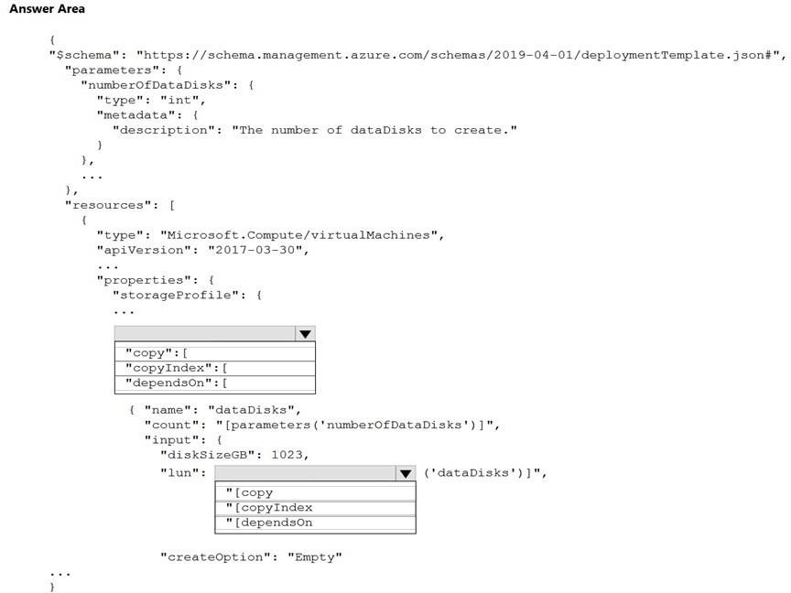

**Answer:**

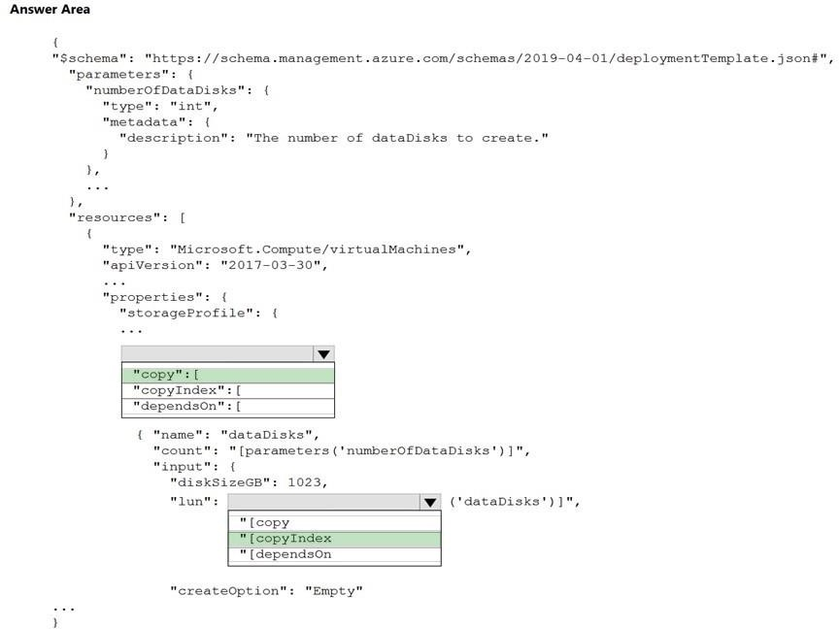

### QUESTION 179

You have a resource group named RG1. RG1 contains an Azure Storage account named storageaccount1 and a virtual machine named VM1 that runs Windows Server 2016.

Storageaccount1 contains the disk files for VM1. You apply a ReadOnly lock to RG1. What can you do from the Azure portal?

|  |  |
| --- | --- |
| A. | Generate an automation script for RG1. |
| B. | View the keys of storageaccount1. |
| C. | Upload a blob to storageaccount1. |
| D. | Start VM1. |

**Answer:** A

**Explanation:**

https://docs.microsoft.com/en-us/azure/azure-resource-manager/management/lock-resources Applying ReadOnly can lead to unexpected results because some operations that don't seem to modify the resource actually require actions that are blocked by the lock. The ReadOnly lock can be applied to the resource or to the resource group containing the resource. Some common examples of the operations that are blocked by a ReadOnly lock are:

A ReadOnly lock on a storage account prevents all users from listing the keys. The list keys operation is handled through a POST request because the returned keys are available for write operations.

### QUESTION 180

You configure Azure AD Connect for Azure Active Directory Seamless Single Sign-On (Azure AD Seamless SSO) for an on-premises network. Users report that when they attempt to access myapps.microsoft.com, they are prompted multiple times to sign in and are forced to use an account name that ends with onmicrosoft.com.

You discover that there is a UPN mismatch between Azure AD and the on-premises Active Directory. You need to ensure that the users can use single-sign on (SSO) to access Azure resources.

What should you do first?

|  |  |
| --- | --- |
| A. | From the on-premises network, deploy Active Directory Federation Services (AD FS). |
| B. | From Azure AD, add and verify a custom domain name. |
| C. | From the on-premises network, request a new certificate that contains the Active Directory domain name. |
| D. | From the server that runs Azure AD Connect, modify the filtering options. |

**Answer:** B

**Explanation:**

Azure AD Connect lists the UPN suffixes that are defined for the domains and tries to match them with a

custom domain in Azure AD. Then it helps you with the appropriate action that needs to be taken. The Azure AD sign-in page lists the UPN suffixes that are defined for on-premises Active Directory and displays the corresponding status against each suffix. The status values can be one of the following:

State: Verified Azure AD Connect found a matching verified domain in Azure AD. All users for this domain can sign in by using their on-premises credentials. State: Not verified Azure AD Connect found a matching custom domain in Azure AD, but it isn't verified. The UPN suffix of the users of this domain will be changed to the default .onmicrosoft.com suffix after synchronization if the domain isn't verified. Action Required: Verify the custom domain in Azure AD.

References: https://docs.microsoft.com/en-us/azure/active-directory/hybrid/plan-connect-user- signin

### QUESTION 181

You have two Azure Active Directory (Azure AD) tenants named contoso.com and fabrikam.com. You have a Microsoft account that you use to sign in to both tenants.

You need to configure the default sign-in tenant for the Azure portal. What should you do?

|  |  |
| --- | --- |
| A. | From the Azure portal, configure the portal settings. |
| B. | From the Azure portal, change the directory. |
| C. | From Azure Cloud Shell, run Set-AzureRmContext. |
| D. | From Azure Cloud Shell, run Set-AzureRmSubscription. |

**Answer:** B

**Explanation:**

Change the subscription directory in the Azure portal. The classic portal feature Edit Directory, that allows you to associate an existing subscription to your Azure Active Directory (AAD), is now available in Azure portal. It used to be available only to Service Admins with Microsoft accounts, but now it's available to users with AAD accounts as well.

To get started:

Go to Subscriptions.

Select a subscription.

Select Change directory.

Incorrect Answers:

C: The Set-AzureRmContext cmdlet sets authentication information for cmdlets that you run in

the current session. The context includes tenant, subscription, and environment information. References: https://azure.microsoft.com/en-us/updates/edit-directory-now-in-new-portal/

### QUESTION 182

You sign up for Azure Active Directory (Azure AD) Premium.

You need to add a user named [admin1@contoso.com](mailto:admin1@contoso.com) as an administrator on all the computers that will be joined to the Azure AD domain.

What should you configure in Azure AD?

|  |  |
| --- | --- |
| A. | Device settings from the Devices blade. |
| B. | General settings from the Groups blade. |
| C. | User settings from the Users blade. |
| D. | Providers from the MFA Server blade. |

**Answer:** A

**Explanation:**

When you connect a Windows device with Azure AD using an Azure AD join, Azure AD adds the following security principles to the local administrators group on the device:

 The Azure AD global administrator role  The Azure AD device administrator role  The user performing the Azure AD join

In the Azure portal, you can manage the device administrator role on the Devices page. To open

the Devices page:

1. Sign in to your Azure portal as a global administrator or device administrator.
2. On the left navbar, click Azure Active Directory.
3. In the Manage section, click Devices.
4. On the Devices page, click Device settings.
5. To modify the device administrator role, configure Additional local administrators on Azure AD joined devices.

References:

https://docs.microsoft.com/en-us/azure/active-directory/devices/assign-local-admin

### QUESTION 183

**Note: This question is part of a series of questions that present the same scenario. Each question in the series contains a unique solution that might meet the stated goals. Some question sets might have more than one correct solution, while others might not have a correct solution.**

**After you answer a question in this section, you will NOT be able to return to it As a result these questions will not appear in the review screen.**

Your company registers a domain name of contoso.com.

You create an Azure DNS zone named contoso.com, and then you add an A record to the zone for a host named www that has an IP address of 131.107.1.10. You discover that Internet hosts are unable to resolve [www.contoso.com](http://www.contoso.com/) to the 131.107.1.10 IP address.

You need to resolve the name resolution issue.

Solution: You create a PTR record for www in the contoso.com zone. Does this meet the goal?

|  |  |
| --- | --- |
| A. | Yes |
| B. | No |

**Answer:** B

**Explanation:**

Modify the Name Server (NS) record.

References: https://docs.microsoft.com/en-us/azure/dns/dns-delegate-domain-azure-dns

### QUESTION 184

**Note: This question is part of a series of questions that present the same scenario. Each question in the series contains a unique solution that might meet the stated goals. Some question sets might have more than one correct solution, while others might not have a correct solution.**

**After you answer a question in this section, you will NOT be able to return to it As a result these questions will not appear in the review screen.**

You have an Azure subscription that contains 10 virtual networks. The virtual networks are hosted in separate resource groups.

Another administrator plans to create several network security groups (NSGs) in the subscription. You need to ensure that when an NSG is created, it automatically blocks TCP port 8080 between the virtual networks.

Solution: You assign a built-in policy definition to the subscription. Does this meet the goal?

|  |  |
| --- | --- |
| A. | Yes |
| B. | No |

**Answer:** B

### QUESTION 185

You have an Azure DNS zone named adatum.com.

You need to delegate a subdomain named research.adatum.com to a different DNS server in Azure.

What should you do?

|  |  |
| --- | --- |
| A. | Create an PTR record named research in the adatum.com zone. |
| B. | Create an NS record named research in the adatum.com zone. |
| C. | Modify the SOA record of adatum.com. |
| D. | Create an A record named ".research in the adatum.com zone. |

**Answer:** B

**Explanation:**

You need to create a name server (NS) record for the zone. References:

https://docs.microsoft.com/en-us/azure/dns/delegate-subdomain

### QUESTION 186

Hotspot Question

You have an Azure subscription that contains the public load balancers shown in the following table.

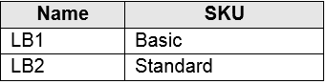

You plan to create six virtual machines and to load balance requests to the virtual machines. Each load balancer will load balance three virtual machines.

You need to create the virtual machines for the planned solution.

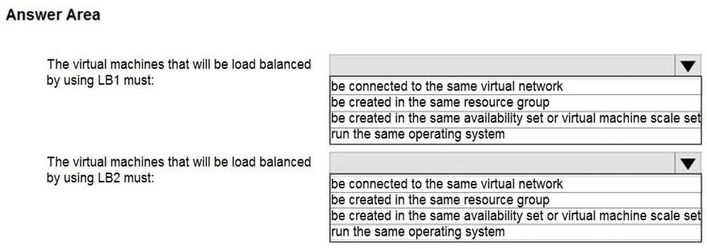

**Answer:**

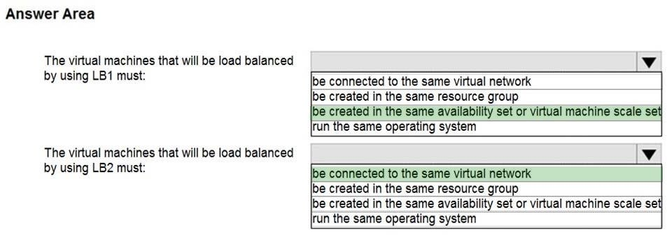

**Explanation:**

Box 1: be created in the same availability set or virtual machine scale set. The Basic tier is quite restrictive. A load balancer is restricted to a single availability set, virtual machine scale set, or a single machine.

Box 2: be connected to the same virtual network

The Standard tier can span any virtual machine in a single virtual network, including blends of scale sets, availability sets, and machines.

Reference:

https:/[/www.petri.com/comparing-basic-standard-azure-load-balancers](http://www.petri.com/comparing-basic-standard-azure-load-balancers)

### QUESTION 187

You have a virtual network named VNet1 as shown in the exhibit.

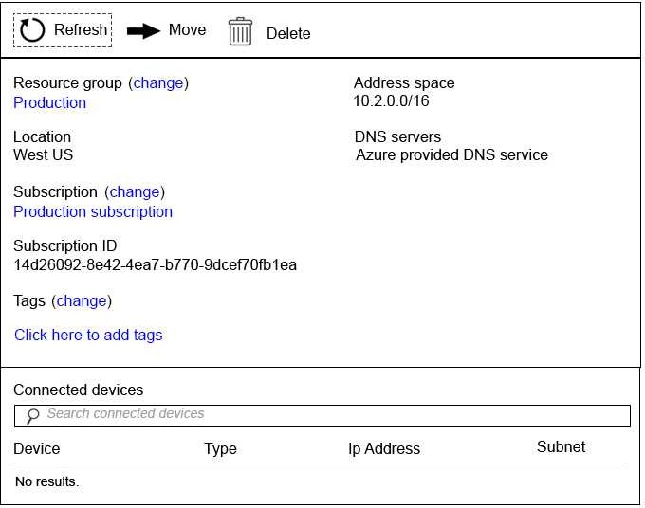

No devices are connected to VNet1.

You plan to peer VNet1 to another virtual network named Vnet2 in the same region. VNet2 has an address space of 10.2.0.0/16.

You need to create the peering. What should you do first?

|  |  |
| --- | --- |
| A. | Modify the address space of VNet1. |
| B. | Configure a service endpoint on VNet2 |
| C. | Add a gateway subnet to VNet1. |
| D. | Create a subnet on VNet1 and VNet2. |

**Answer:** A

**Explanation:**

The virtual networks you peer must have non-overlapping IP address spaces. References:

https://docs.microsoft.com/en-us/azure/virtual-network/virtual-network-manage- peering#requirements-and-constraints

### QUESTION 188

You have an Azure subscription that contains three virtual networks named VNet1, VNet2, VNet3.

VNet2 contains a virtual appliance named VM2 that operates as a router. You are configuring the virtual networks in a hub and spoke topology that uses VNet2 as the hub network.

You plan to configure peering between VNet1 and VNet2 and between VNet2 and VNet3. You need to provide connectivity between VNet1 and VNet3 through VNet2.

Which two configurations should you perform? Each correct answer presents part of the solution. NOTE: Each correct selection is worth one point.

|  |  |
| --- | --- |
| A. | On the peering connections, allow forwarded traffic. |
| B. | On the peering connections, allow gateway transit. |
| C. | Create route tables and assign the table to subnets. |
| D. | Create a route filter. |
| E. | On the peering connections, use remote gateways. |

**Answer:** AC

**Explanation:**

You need to provide connectivity between VNet1 and VNet3 through VNet2." It's not about remote gateways or connectivity outside the Vnets. So A (to forward traffic from a spoke vnet to another spoke) and C (without UDR and NVA as next hop IP traffic won't flow between the spokes).

### QUESTION 189

**Note: This question is part of a series of questions that present the same scenario. Each question in the series contains a unique solution that might meet the stated goals. Some question sets might have more than one correct solution, while others might not have a correct solution.**

**After you answer a question in this section, you will NOT be able to return to it. As a result, these questions will not appear in the review screen.**

You have an Azure web app named App1. App1 runs in an Azure App Service plan named Plan1. Plan1 is associated to the Free pricing tier.

You discover that App1 stops each day after running continuously for 60 minutes. You need to ensure that App1 can run continuously for the entire day.

Solution: You add a continuous WebJob to App1. Does this meet the goal?

|  |  |
| --- | --- |
| A. | Yes |
| B. | No |

**Answer:** B

### QUESTION 190

**Note: This question is part of a series of questions that present the same scenario. Each question in the series contains a unique solution that might meet the stated goals. Some question sets might have more than one correct solution, while others might not have a correct solution.**

**After you answer a question in this section, you will NOT be able to return to it. As a result, these questions will not appear in the review screen.**

You have an Azure Active Directory (Azure AD) tenant named Adatum and an Azure Subscription named Subscription1. Adatum contains a group named Developers. Subscription1 contains a resource group named Dev.

You need to provide the Developers group with the ability to create Azure logic apps in the Dev resource group.

Solution: On Dev, you assign the Contributor role to the Developers group. Does this meet the goal?

|  |  |
| --- | --- |
| A. | Yes |
| B. | No |

**Answer:** A

**Explanation:**

The Contributor role can manage all resources (and add resources) in a Resource Group.

### QUESTION 191

You have an Azure Logic App named App1. App1 provides a response when an HTTP POST request or an HTTP GET request is received.

During peak periods, App1 is expected to receive up to 200,000 requests in a five-minute period. You need to ensure that App1 can handle the expected load.

What should you configure?

|  |  |
| --- | --- |
| A. | Access control (IAM) |
| B. | API connections |
| C. | Workflow settings |
| D. | Access keys |

**Answer:** C

**Explanation:**

https://docs.microsoft.com/en-us/azure/logic-apps/logic-apps-limits-and-config#throughput-limits

### QUESTION 192

You have a Basic App Service plan named ASP1 that hosts an Azure App Service named App1. You need to configure a custom domain and enable backups for App1.

What should you do first?

|  |  |
| --- | --- |
| A. | Configure a WebJob for App1. |
| B. | Scale up ASP1. |
| C. | Scale out ASP1. |
| D. | Configure the application settings for App1. |

**Answer:** D

### QUESTION 193

You have an Azure App Service plan named AdatumASP1 that hosts several Azure web apps. You discover that the web apps respond slowly.

You need to provide additional memory and CPU resources to each instance of the web app. What should you do?

|  |  |
| --- | --- |
| A. | Scale out AdatumASP1. |
| B. | Add continuous WebJobs that use the multi-instance scale. |
| C. | Scale up AdatumASP1. |
| D. | Add a virtual machine scale set. |

**Answer:** C

**Explanation:**

https://github.com/MicrosoftDocs/azure-docs/blob/master/articles/app-service/web-sites-scale.md

### QUESTION 194

You have an Azure web app named App1 that streams video content to users. App1 is located in the East US Azure region.

Users in North America stream the video content without any interruption.

Users in Asia and Europe report that the video buffer often and do not play back smoothly.

You need to recommend a solution to improve video streaming to the European and Asian users. What should you recommend?

|  |  |
| --- | --- |
| A. | Scale out the App Service plan. |
| B. | Scale up the App Service plan. |
| C. | Configure an Azure Content Delivery Network (CDN) endpoint. |
| D. | Configure Azure File Sync. |

**Answer:** C

### QUESTION 195

**Note: This question is part of a series of questions that present the same scenario. Each question in the series contains a unique solution that might meet the stated goals. Some question sets might have more than one correct solution, while others might not have a correct solution. After you answer a question in this section, you will NOT be able to return to it. As a result, these questions will not appear in the review screen.**

You manage a virtual network named VNet1 that is hosted in the West US Azure region. VNet1 hosts two virtual machines named VM1 and VM2 that run Windows Server.

You need to inspect all the network traffic from VM1 to VM2 for a period of three hours. Solution: From Azure Network Watcher, you create a connection monitor.

Does this meet the goal?

|  |  |
| --- | --- |
| A. | Yes |
| B. | No |

**Answer:** B

**Explanation:**

Network Watcher packet capture allows you to create capture sessions to track traffic to and from a virtual machine. Filters are provided for the capture session to ensure you capture only the traffic you want. Packet capture helps to diagnose network anomalies, both reactively, and proactively.

Network Watcher Connection Monitor enables you to configure and track connection reachability, latency, and network topology changes. If there is an issue, it tells you why it occurred and how to fix it.

https://docs.microsoft.com/en-us/azure/network-watcher/network-watcher-packet-capture- manage-portal

### QUESTION 196

You have an Azure subscription.

Users access the resources in the subscription from either home or from customer sites. From home, users must establish a point-to-site VPN to access the Azure resources. The users on the customer sites access the Azure resources by using site-to-site VPNs.

You have a line-of-business app named App1 that runs on several Azure virtual machine. The virtual machines run Windows Server 2016.

You need to ensure that the connections to App1 are spread across all the virtual machines.

What are two possible Azure services that you can use? Each correct answer presents a complete solution.

NOTE: Each correct selection is worth one point.

|  |  |
| --- | --- |
| A. | a public load balancer |
| B. | Traffic Manager |
| C. | an Azure Content Delivery Network (CDN) |
| D. | an internal load balancer |
| E. | an Azure Application Gateway |

**Answer:** DE

### QUESTION 197

Drag and Drop Question

You have an Azure Linux virtual machine that is protected by Azure Backup. One week ago, two files were deleted from the virtual machine.

You need to restore the deleted files to an on-premises Windows Server 2016 computer as quickly as possible.

Which four actions should you perform in sequence? To answer, move the appropriate actions from the list of actions to the answer area and arrange them in the correct order.

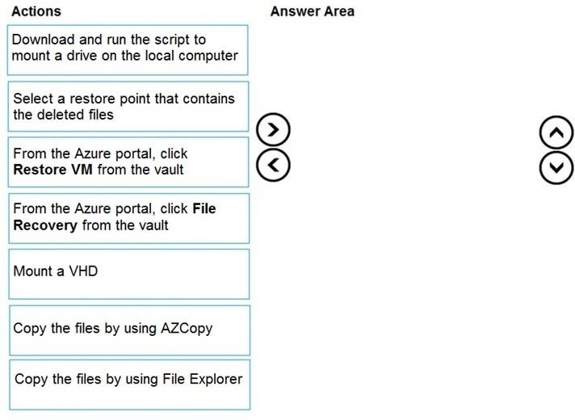

**Answer:**

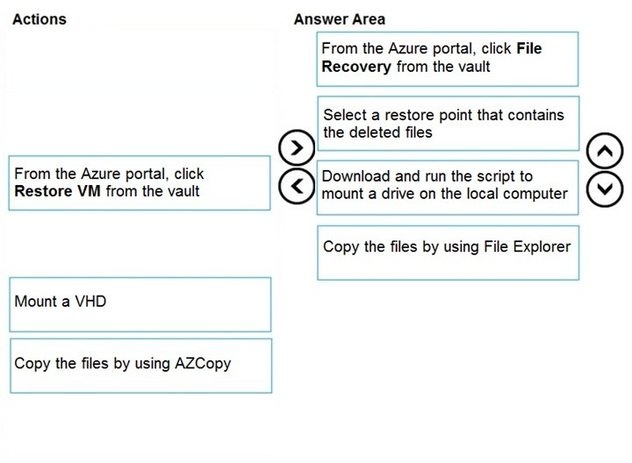

**Explanation:**

Step 1: From the Azure portal, click File Recovery from the vault Step 2. Select a restore point that contains the deleted files

Step 3: Download and run the script to mount a drive on the local computer Generate and download script to browse and recover files:

Step 4: Copy the files using File Explorer!

After the disks are attached, use Windows File Explorer to browse the new volumes and files. The restore files functionality provides access to all files in a recovery point. Manage the files via File Explorer as you would for normal files.

Step 1-3 below:

To restore files or folders from the recovery point, go to the virtual machine and perform the following steps:

1. Sign in to the Azure portal and in the left pane, select Virtual machines. From the list of virtual machines, select the virtual machine to open that virtual machine's dashboard.
2. In the virtual machine's menu, select Backup to open the Backup dashboard.
3. In the Backup dashboard menu, select File Recovery.

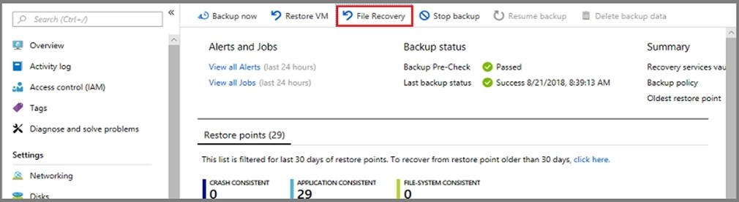

The File Recovery menu opens.

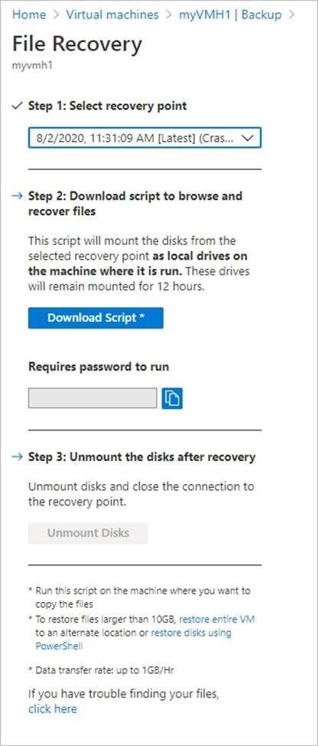

1. From the Select recovery point drop-down menu, select the recovery point that holds the files you want. By default, the latest recovery point is already selected.
2. Select Download Executable (for Windows Azure VMs) or Download Script (for Linux Azure VMs, a python script is generated) to download the software used to copy files from the recovery point.

Running the script and identifying volumes:

For Linux machines, a python script is generated. Download the script and copy it to the relevant/compatible Linux server.

Reference:

https://docs.microsoft.com/en-us/azure/backup/backup-azure-restore-files-from-vm https://docs.microsoft.com/en-us/azure/backup/backup-azure-vms-automation#restore-files-from- an-azure-vm-backup

### QUESTION 198

You have an Azure subscription named Subscription1 that contains two Azure virtual networks named VNet1 and VNet2. VNet1 contains a VPN gateway named VPNGW1 that uses static routing. There is a site-to-site VPN connection between your on-premises network and VNet1.

On a computer named Client1 that runs Windows10, you configure a point-to-site VPN connection to VNet1.

You configure virtual network peering between VNet1 and VNet2. You verify that you can connect to VNet2 from the on-premises network. Client1 is unable to connect to VNet2.

You need to ensure that you can connect Client1 to VNet2. What should you do?

|  |  |
| --- | --- |
| A. | Select Allow gateway transit on VNet2. |
| B. | Enable BGP on VPNGW1. |
| C. | Select Allow gateway transit on VNet1. |
| D. | Download and re-install the VPN client configuration package on Client1. |

**Answer:** D

**Explanation:**

https://docs.microsoft.com/en-us/azure/vpn-gateway/vpn-gateway-about-point-to-site-routing

### QUESTION 199

You are troubleshooting a performance issue for an Azure Application Gateway.

You need to compare the total requests to the failed requests during the past six hours. What should you use?

|  |  |
| --- | --- |
| A. | Connection monitor in Azure Network Watcher. |
| B. | Metrics in Application Gateway |
| C. | Diagnostics logs in Application Gateway |
| D. | NSG flow logs in Azure Network Watcher |

**Answer:** B

**Explanation:**

https://docs.microsoft.com/en-us/azure/application-gateway/application-gateway- diagnostics#metrics

### QUESTION 200

Hotspot Question

You have an Azure subscription.

You plan to use an Azure Resource Manager template to deploy a virtual network named VNET1 that will use Azure Bastion.

How should you complete the template? To answer, select the appropriate options in the answer area.

NOTE: Each correct selection is worth one point.

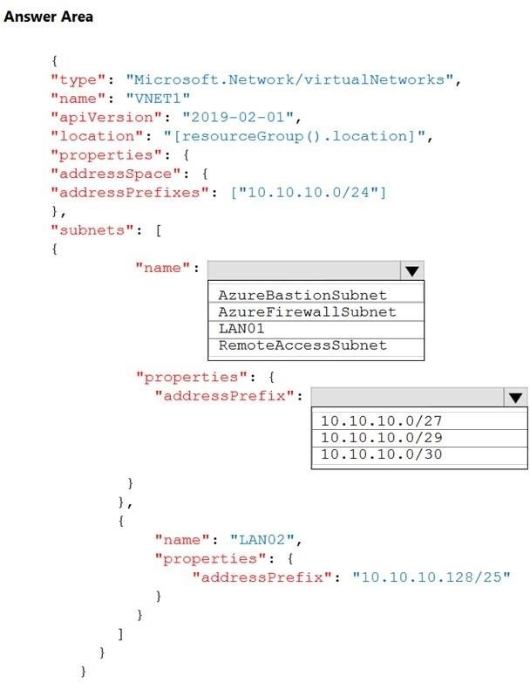

**Answer:**

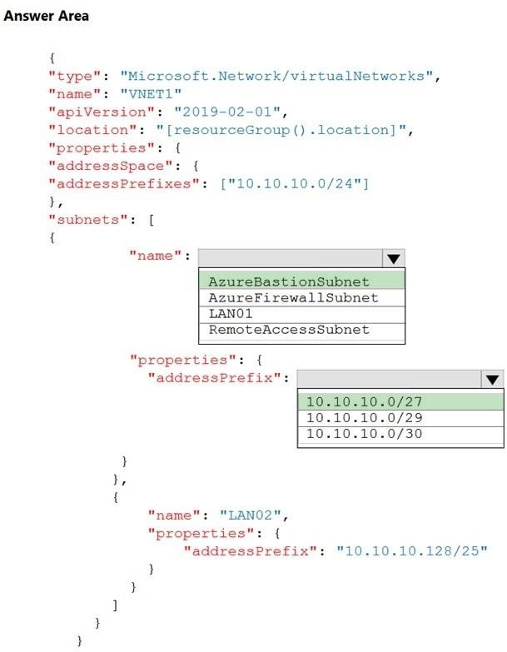

**Explanation:**

https://medium.com/charot/deploy-azure-bastion-preview-using-an-arm-template-15e3010767d6

### QUESTION 201

You deploy an Azure Application Gateway.

You need to ensure that all the traffic requesting https://adatum.com/internal resources is directed

to an internal server pool and all the traffic requesting https://adatum.com/external resources is directed to an external server pool.

What should you configure on the Application Gateway?

|  |  |
| --- | --- |
| A. | URL path-based routing |
| B. | multi-site listeners |
| C. | basic routing |
| D. | SSL termination |

**Answer:** A

### QUESTION 202

Hotspot Question

You have an Azure subscription that contains the resource groups shown in the following table.

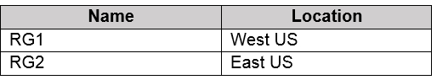

RG1 contains the resources shown in the following table.

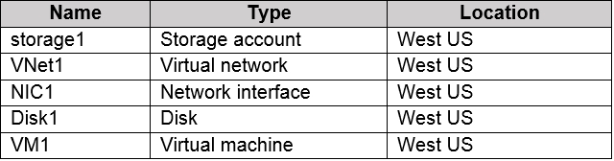

VM1 is running and connects to NIC1 and Disk1. NIC1 connects to VNET1.

RG2 contains a public IP address named IP2 that is in the East US location. IP2 is not assigned to a virtual machine.

For each of the following statements, select Yes if the statement is true. Otherwise, select No. NOTE: Each correct selection is worth one point.

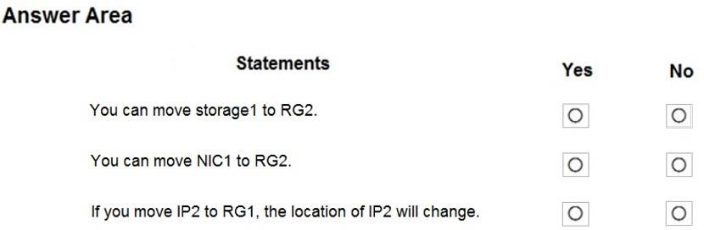

**Answer:**

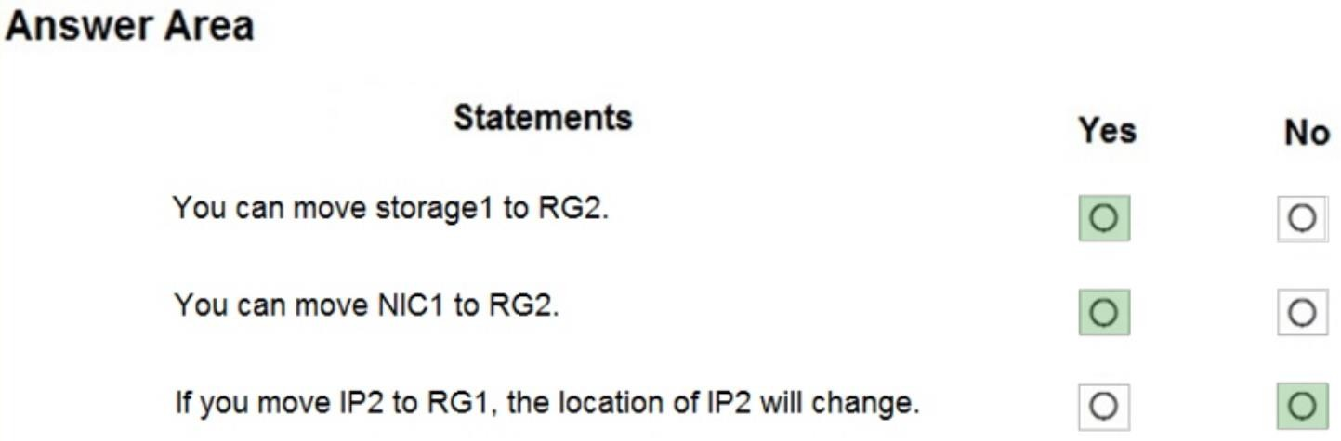

**Explanation:**

Box 1: Yes

You can move the Storage Account to RG2, however it stayed in the West US region. You cannot change the Region, you need to recreate the Storage Account.

Box 2: Yes

You can move move NIC1 to RG2 which was associated with VM1 and VNET1 subnet1, however it stayed in the West US region. You can move a NIC to a different RG or Subscription by selecting (change) next to the RG or Subscription name. If you move the NIC to a new Subscription, you must move all resources related to the NIC with it. If the network interface is attached to a virtual machine, for example, you must also move the virtual machine, and other virtual machine-related resources.

Box 3: No

You can move IP2 to RG1, as it isn't associated with any other resource, however it stayed in the East US region. The location will not change.

Note: Resources can be everywhere regardless of the resource group they belong to. The resource group is only a collection of metadata relative to the resources defined inside it. You can move a resource from one resource group to another group. The resources in a resource group can be located in different regions than the resource group.

Reference:

https://docs.microsoft.com/en-us/azure/azure-resource-manager/management/overview

### QUESTION 203

You have an Azure Active Directory (Azure AD) tenant that has Azure AD Privileged Identity Management configured.

You have 10 users who are assigned the Security Administrator role for the tenant. You need the users to verify whether they still require the Security Administrator role. What should you do?

|  |  |
| --- | --- |
| A. | From Azure AD Identity Protection, configure a user risk policy. |
| B. | From Azure AD Privileged Identity Management, create an access review. |
| C. | From Azure AD Identity Protection, configure the Weekly Digest. |
| D. | From Azure AD Privileged Identity Management, create a conditional access policy. |

**Answer:** B

**Explanation:**

https://docs.microsoft.com/en-us/azure/active-directory/privileged-identity-management/pim-how- to-start-security-review

### QUESTION 204

You are the global administrator for an Azure Active Directory (Azure AD) tenant named adatum.com.

You need to enable two-step verification for Azure users. What should you do?

|  |  |
| --- | --- |
| A. | Create an Azure AD conditional access policy. |
| B. | Enable Azure AD Privileged Identity Management. |
| C. | Install and configure Azure AD Connect. |
| D. | Configure a playbook in Azure Security Center. |

**Answer:** A

**Explanation:**

https://docs.microsoft.com/en-us/azure/active-directory/authentication/howto-mfa-getstarted

**QUESTION 205**

# Case Study 1 - Humongous Insurance

**Overview**

Humongous Insurance is an insurance company that has three offices in Miami, Tokyo and Bangkok. Each office has 5.000 users.

**Existing Environment**

**Active Directory Environment**

Humongous Insurance has a single-domain Active Directory forest named humongousinsurance.com. The functional level of the forest is Windows Server 2012.

You recently provisioned an Azure Active Directory (Azure AD) tenant.

**Network Infrastructure**

Each office has a local data center that contains all the servers for that office. Each office has a dedicated connection to the Internet.

Each office has several link load balancers that provide access to the servers.

**Active Directory Issue**

Several users in humongousinsurance.com have UPNs that contain special characters. You suspect that some of the characters are unsupported in Azure AD.

**Licensing Issue**

You attempt to assign a license in Azure to several users and receive the following error message: "Licenses not assigned. License agreement failed for one user."

You verify that the Azure subscription has the available licenses.

**Requirements Planned Changes**

Humongous Insurance plans to open a new office in Paris. The Paris office will contain 1,000 users who will be hired during the next 12 months. All the resources used by the Paris office users will be hosted in Azure.

**Planned Azure AD Infrastructure**

The on-premises Active Directory domain will be synchronized to Azure AD. All client computers in the Paris office will be joined to an Azure AD domain.

**Planned Azure Networking Infrastructure**

You plan to create the following networking resources in a resource group named All_Resources:

* Default Azure system routes that will be the only routes used to route traffic
* A virtual network named Paris-VNet that will contain two subnets named Subnet1 and Subnet2
* A virtual network named ClientResources-VNet that will contain one subnet named ClientSubnet
* A virtual network named AllOffices-VNet that will contain two subnets named Subnet3 and Subnet4

You plan to enable peering between Paris-VNet and AllOffices-VNet. You will enable the **Use remote gateways** setting for the Paris-VNet peerings.

You plan to create a private DNS zone named humongousinsurance.local and set the registration network to the ClientResources-VNet virtual network.

**Planned Azure Computer Infrastructure**

Each subnet will contain several virtual machines that will run either Windows Server 2012 R2, Windows Server 2016, or Red Hat Linux.

**Department Requirements**

Humongous Insurance identifies the following requirements for the company's departments:

* Web administrators will deploy Azure web apps for the marketing department. Each web app will be added to a separate resource group. The initial configuration of the web apps will be identical. The web administrators have permission to deploy web apps to resource groups.
* During the testing phase, auditors in the finance department must be able to review all Azure costs from the past week.

**Authentication Requirements**

Users in the Miami office must use Azure Active Directory Seamless Single Sign-on (Azure AD Seamless SSO) when accessing resources in Azure.

You need to resolve the licensing issue before you attempt to assign the license again. What should you do?

|  |  |
| --- | --- |
| A. | From the Groups blade, invite the user accounts to a new group. |
| B. | From the Profile blade, modify the usage location. |
| C. | From the Directory role blade, modify the directory role. |

**Answer:** B

**Explanation:**

License cannot be assigned to a user without a usage location specified. Scenario: Licensing Issue

You attempt to assign a license in Azure to several users and receive the following error message:

"Licenses not assigned. License agreement failed for one user." You verify that the Azure subscription has the available licenses.

**QUESTION 206**

# Case Study 1 - Humongous Insurance

**Overview**

Humongous Insurance is an insurance company that has three offices in Miami, Tokyo and Bangkok. Each office has 5.000 users.

**Existing Environment**

**Active Directory Environment**

Humongous Insurance has a single-domain Active Directory forest named humongousinsurance.com. The functional level of the forest is Windows Server 2012.

You recently provisioned an Azure Active Directory (Azure AD) tenant.

**Network Infrastructure**

Each office has a local data center that contains all the servers for that office. Each office has a dedicated connection to the Internet.

Each office has several link load balancers that provide access to the servers.

**Active Directory Issue**

Several users in humongousinsurance.com have UPNs that contain special characters. You suspect that some of the characters are unsupported in Azure AD.

**Licensing Issue**

You attempt to assign a license in Azure to several users and receive the following error message: "Licenses not assigned. License agreement failed for one user."

You verify that the Azure subscription has the available licenses.

**Requirements Planned Changes**

Humongous Insurance plans to open a new office in Paris. The Paris office will contain 1,000 users who will be hired during the next 12 months. All the resources used by the Paris office users will be hosted in Azure.

**Planned Azure AD Infrastructure**

The on-premises Active Directory domain will be synchronized to Azure AD. All client computers in the Paris office will be joined to an Azure AD domain.

**Planned Azure Networking Infrastructure**

You plan to create the following networking resources in a resource group named All_Resources:

* Default Azure system routes that will be the only routes used to route traffic
* A virtual network named Paris-VNet that will contain two subnets named Subnet1 and Subnet2
* A virtual network named ClientResources-VNet that will contain one subnet named ClientSubnet
* A virtual network named AllOffices-VNet that will contain two subnets named Subnet3 and Subnet4

You plan to enable peering between Paris-VNet and AllOffices-VNet. You will enable the **Use remote gateways** setting for the Paris-VNet peerings.

You plan to create a private DNS zone named humongousinsurance.local and set the registration network to the ClientResources-VNet virtual network.

**Planned Azure Computer Infrastructure**

Each subnet will contain several virtual machines that will run either Windows Server 2012 R2, Windows Server 2016, or Red Hat Linux.

**Department Requirements**

Humongous Insurance identifies the following requirements for the company's departments:

* Web administrators will deploy Azure web apps for the marketing department. Each web app will be added to a separate resource group. The initial configuration of the web apps will be identical. The web administrators have permission to deploy web apps to resource groups.
* During the testing phase, auditors in the finance department must be able to review all Azure costs from the past week.

**Authentication Requirements**

Users in the Miami office must use Azure Active Directory Seamless Single Sign-on (Azure AD Seamless SSO) when accessing resources in Azure.

Which blade should you instruct the finance department auditors to use?

|  |  |
| --- | --- |
| A. | Partner information |
| B. | Overview |
| C. | Payment methods |
| D. | Invoices |

**Answer:** D

**Explanation:**

You can opt in and configure additional recipients to receive your Azure invoice in an email. This feature may not be available for certain subscriptions such as support offers, Enterprise Agreements, or Azure in Open.

Select your subscription from the Subscriptions page. Opt-in for each subscription you own. Click

Invoices then Email my invoice.

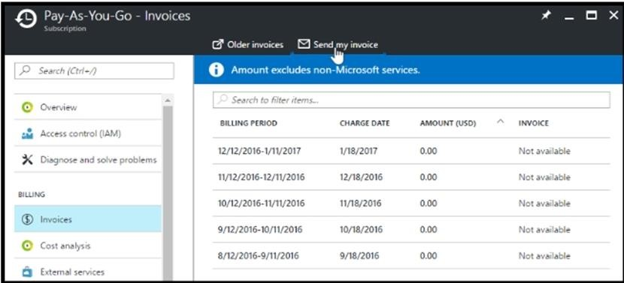

Click Opt in and accept the terms.

Scenario: During the testing phase, auditors in the finance department must be able to review all Azure costs from the past week.

References: https://docs.microsoft.com/en-us/azure/billing/billing-download-azure-invoice-daily- usage-date

**QUESTION 207**

# Case Study 1 - Humongous Insurance

**Overview**

Humongous Insurance is an insurance company that has three offices in Miami, Tokyo and Bangkok. Each office has 5.000 users.

**Existing Environment**

**Active Directory Environment**

Humongous Insurance has a single-domain Active Directory forest named humongousinsurance.com. The functional level of the forest is Windows Server 2012.

You recently provisioned an Azure Active Directory (Azure AD) tenant.

**Network Infrastructure**

Each office has a local data center that contains all the servers for that office. Each office has a dedicated connection to the Internet.

Each office has several link load balancers that provide access to the servers.

**Active Directory Issue**

Several users in humongousinsurance.com have UPNs that contain special characters. You suspect that some of the characters are unsupported in Azure AD.

**Licensing Issue**

You attempt to assign a license in Azure to several users and receive the following error message: "Licenses not assigned. License agreement failed for one user."

You verify that the Azure subscription has the available licenses.

**Requirements Planned Changes**

Humongous Insurance plans to open a new office in Paris. The Paris office will contain 1,000 users who will be hired during the next 12 months. All the resources used by the Paris office users will be hosted in Azure.

**Planned Azure AD Infrastructure**

The on-premises Active Directory domain will be synchronized to Azure AD. All client computers in the Paris office will be joined to an Azure AD domain.

**Planned Azure Networking Infrastructure**

You plan to create the following networking resources in a resource group named All_Resources:

* Default Azure system routes that will be the only routes used to route traffic
* A virtual network named Paris-VNet that will contain two subnets named Subnet1 and Subnet2
* A virtual network named ClientResources-VNet that will contain one subnet named ClientSubnet
* A virtual network named AllOffices-VNet that will contain two subnets named Subnet3 and Subnet4

You plan to enable peering between Paris-VNet and AllOffices-VNet. You will enable the **Use remote gateways** setting for the Paris-VNet peerings.

You plan to create a private DNS zone named humongousinsurance.local and set the registration network to the ClientResources-VNet virtual network.

**Planned Azure Computer Infrastructure**

Each subnet will contain several virtual machines that will run either Windows Server 2012 R2, Windows Server 2016, or Red Hat Linux.

**Department Requirements**

Humongous Insurance identifies the following requirements for the company's departments:

* Web administrators will deploy Azure web apps for the marketing department. Each web app will be added to a separate resource group. The initial configuration of the web apps will be identical. The web administrators have permission to deploy web apps to resource groups.
* During the testing phase, auditors in the finance department must be able to review all Azure costs from the past week.

**Authentication Requirements**

Users in the Miami office must use Azure Active Directory Seamless Single Sign-on (Azure AD Seamless SSO) when accessing resources in Azure.

Hotspot Question

You are evaluating the name resolution for the virtual machines after the planned implementation of the Azure networking infrastructure.

For each of the following statements, select Yes if the statement is true. Otherwise, select No.

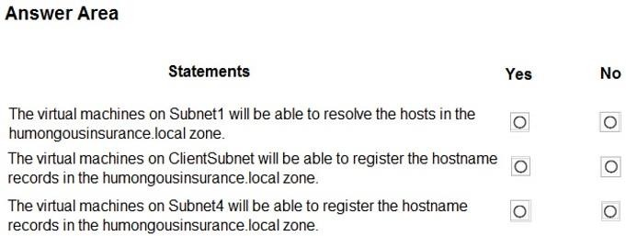

**Answer:**

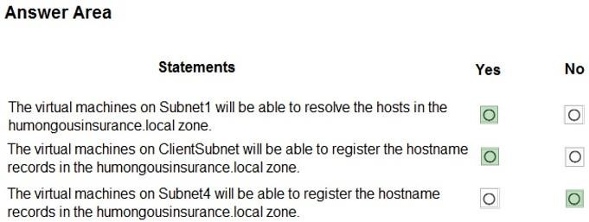

**Explanation:**

Box 1: Yes

All client computers in the Paris office will be joined to an Azure AD domain. A virtual network named Paris-VNet that will contain two subnets named Subnet1 and Subnet2

Box 2: Yes

A virtual network named ClientResources-VNet that will contain one subnet named ClientSubnet You plan to create a private DNS zone named humongousinsurance.local and set the registration network to the ClientResources-VNet virtual network.

Box 3: No

Only VMs in the registration network, here the ClientResources-VNet, will be able to register hostname records.

References:

https://docs.microsoft.com/en-us/azure/dns/private-dns-overview Testlet 3

**QUESTION 208**

# Case Study 1 - Humongous Insurance

**Overview**

Humongous Insurance is an insurance company that has three offices in Miami, Tokyo and Bangkok. Each office has 5.000 users.

**Existing Environment**

**Active Directory Environment**

Humongous Insurance has a single-domain Active Directory forest named humongousinsurance.com. The functional level of the forest is Windows Server 2012.

You recently provisioned an Azure Active Directory (Azure AD) tenant.

**Network Infrastructure**

Each office has a local data center that contains all the servers for that office. Each office has a dedicated connection to the Internet.

Each office has several link load balancers that provide access to the servers.

**Active Directory Issue**

Several users in humongousinsurance.com have UPNs that contain special characters. You suspect that some of the characters are unsupported in Azure AD.

**Licensing Issue**

You attempt to assign a license in Azure to several users and receive the following error message: "Licenses not assigned. License agreement failed for one user."

You verify that the Azure subscription has the available licenses.

**Requirements Planned Changes**

Humongous Insurance plans to open a new office in Paris. The Paris office will contain 1,000 users who will be hired during the next 12 months. All the resources used by the Paris office users will be hosted in Azure.

**Planned Azure AD Infrastructure**

The on-premises Active Directory domain will be synchronized to Azure AD. All client computers in the Paris office will be joined to an Azure AD domain.

**Planned Azure Networking Infrastructure**

You plan to create the following networking resources in a resource group named All_Resources:

* Default Azure system routes that will be the only routes used to route traffic
* A virtual network named Paris-VNet that will contain two subnets named Subnet1 and Subnet2
* A virtual network named ClientResources-VNet that will contain one subnet named ClientSubnet
* A virtual network named AllOffices-VNet that will contain two subnets named Subnet3 and Subnet4

You plan to enable peering between Paris-VNet and AllOffices-VNet. You will enable the **Use remote gateways** setting for the Paris-VNet peerings.

You plan to create a private DNS zone named humongousinsurance.local and set the registration network to the ClientResources-VNet virtual network.

**Planned Azure Computer Infrastructure**

Each subnet will contain several virtual machines that will run either Windows Server 2012 R2, Windows Server 2016, or Red Hat Linux.

**Department Requirements**

Humongous Insurance identifies the following requirements for the company's departments:

* Web administrators will deploy Azure web apps for the marketing department. Each web app will be added to a separate resource group. The initial configuration of the web apps will be identical. The web administrators have permission to deploy web apps to resource groups.
* During the testing phase, auditors in the finance department must be able to review all Azure costs from the past week.

**Authentication Requirements**

Users in the Miami office must use Azure Active Directory Seamless Single Sign-on (Azure AD Seamless SSO) when accessing resources in Azure.

You need to prepare the environment to meet the authentication requirements.

Which two actions should you perform? Each correct answer presents part of the solution.

**NOTE** Each correct selection is worth one point.

|  |  |
| --- | --- |
| A. | Join the client computers in the Miami office to Azure AD. |
| B. | Add [http://autologon.microsoftazuread-sso.com](http://autologon.microsoftazuread-sso.com/) to the intranet zone of each client computer in the Miami office. |
| C. | Allow inbound TCP port 8080 to the domain controllers in the Miami office. |
| D. | Install Azure AD Connect on a server in the Miami office and enable Pass-through Authentication |
| E. | Install the Active Directory Federation Services (AD FS) role on a domain controller in the Miami office. |

**Answer:** BD

**Explanation:**

D: Seamless SSO works with any method of cloud authentication - Password Hash Synchronization or Pass-through Authentication, and can be enabled via Azure AD Connect. B: You can gradually roll out Seamless SSO to your users. You start by adding the following Azure AD URL to all or selected users' Intranet zone settings by using Group Policy in Active Directory: https://autologon.microsoftazuread-sso.com

Incorrect Answers:

A: Seamless SSO needs the user's device to be domain-joined, but doesn't need for the device to be Azure AD Joined.

C: Azure AD connect does not port 8080. It uses port 443.

E: Seamless SSO is not applicable to Active Directory Federation Services (ADFS). Scenario: Users in the Miami office must use Azure Active Directory Seamless Single Sign-on (Azure AD Seamless SSO) when accessing resources in Azure.

Planned Azure AD Infrastructure include: The on-premises Active Directory domain will be synchronized to Azure AD.

References: https://docs.microsoft.com/en-us/azure/active-directory/connect/active-directory- aadconnect-sso-quick-start

**QUESTION 209**

# Case Study 1 - Humongous Insurance

**Overview**

Humongous Insurance is an insurance company that has three offices in Miami, Tokyo and Bangkok. Each office has 5.000 users.

**Existing Environment**

**Active Directory Environment**

Humongous Insurance has a single-domain Active Directory forest named humongousinsurance.com. The functional level of the forest is Windows Server 2012.

You recently provisioned an Azure Active Directory (Azure AD) tenant.

**Network Infrastructure**

Each office has a local data center that contains all the servers for that office. Each office has a dedicated connection to the Internet.

Each office has several link load balancers that provide access to the servers.

**Active Directory Issue**

Several users in humongousinsurance.com have UPNs that contain special characters. You suspect that some of the characters are unsupported in Azure AD.

**Licensing Issue**

You attempt to assign a license in Azure to several users and receive the following error message: "Licenses not assigned. License agreement failed for one user."

You verify that the Azure subscription has the available licenses.

**Requirements Planned Changes**

Humongous Insurance plans to open a new office in Paris. The Paris office will contain 1,000 users who will be hired during the next 12 months. All the resources used by the Paris office users will be hosted in Azure.

**Planned Azure AD Infrastructure**

The on-premises Active Directory domain will be synchronized to Azure AD. All client computers in the Paris office will be joined to an Azure AD domain.

**Planned Azure Networking Infrastructure**

You plan to create the following networking resources in a resource group named All_Resources:

* Default Azure system routes that will be the only routes used to route traffic
* A virtual network named Paris-VNet that will contain two subnets named Subnet1 and Subnet2
* A virtual network named ClientResources-VNet that will contain one subnet named ClientSubnet
* A virtual network named AllOffices-VNet that will contain two subnets named Subnet3 and Subnet4

You plan to enable peering between Paris-VNet and AllOffices-VNet. You will enable the **Use remote gateways** setting for the Paris-VNet peerings.

You plan to create a private DNS zone named humongousinsurance.local and set the registration network to the ClientResources-VNet virtual network.

**Planned Azure Computer Infrastructure**

Each subnet will contain several virtual machines that will run either Windows Server 2012 R2, Windows Server 2016, or Red Hat Linux.

**Department Requirements**

Humongous Insurance identifies the following requirements for the company's departments:

* Web administrators will deploy Azure web apps for the marketing department. Each web app will be added to a separate resource group. The initial configuration of the web apps will be identical. The web administrators have permission to deploy web apps to resource groups.
* During the testing phase, auditors in the finance department must be

able to review all Azure costs from the past week.

**Authentication Requirements**

Users in the Miami office must use Azure Active Directory Seamless Single Sign-on (Azure AD Seamless SSO) when accessing resources in Azure.

You need to resolve the Active Directory issue. What should you do?

|  |  |
| --- | --- |
| A. | From Active Directory Users and Computers, select the user accounts, and then modify the User  Principal Name value. |
| B. | Run the IdFix tool then use the Update actions. |
| C. | From Active Directory Domains and Trusts, modify the list of UPN suffixes. |
| D. | From Azure AD Connect, modify the outbound synchronization rule. |

**Answer:** B

**Explanation:**

IdFix is used to perform discovery and remediation of identity objects and their attributes in an on- premises Active Directory environment in preparation for migration to Azure Active Directory.

IdFix is intended for the Active Directory administrators responsible for directory synchronization with Azure Active Directory.

Scenario: Active Directory Issue

Several users in humongousinsurance.com have UPNs that contain special characters. You suspect that some of the characters are unsupported in Azure AD.

References: https://[www.microsoft.com/en-us/download/details.aspx?id=36832](http://www.microsoft.com/en-us/download/details.aspx?id=36832)

**QUESTION 210**

# Case Study 1 - Humongous Insurance

**Overview**

Humongous Insurance is an insurance company that has three offices in Miami, Tokyo and Bangkok. Each office has 5.000 users.

**Existing Environment**

**Active Directory Environment**

Humongous Insurance has a single-domain Active Directory forest named humongousinsurance.com. The functional level of the forest is Windows Server 2012.

You recently provisioned an Azure Active Directory (Azure AD) tenant.

**Network Infrastructure**

Each office has a local data center that contains all the servers for that office. Each office has a dedicated connection to the Internet.

Each office has several link load balancers that provide access to the servers.

**Active Directory Issue**

Several users in humongousinsurance.com have UPNs that contain special characters. You suspect that some of the characters are unsupported in Azure AD.

**Licensing Issue**

You attempt to assign a license in Azure to several users and receive the following error message: "Licenses not assigned. License agreement failed for one user."

You verify that the Azure subscription has the available licenses.

**Requirements Planned Changes**

Humongous Insurance plans to open a new office in Paris. The Paris office will contain 1,000 users who will be hired during the next 12 months. All the resources used by the Paris office users will be hosted in Azure.

**Planned Azure AD Infrastructure**

The on-premises Active Directory domain will be synchronized to Azure AD. All client computers in the Paris office will be joined to an Azure AD domain.

**Planned Azure Networking Infrastructure**

You plan to create the following networking resources in a resource group named All_Resources:

* Default Azure system routes that will be the only routes used to route traffic
* A virtual network named Paris-VNet that will contain two subnets named Subnet1 and Subnet2
* A virtual network named ClientResources-VNet that will contain one subnet named ClientSubnet
* A virtual network named AllOffices-VNet that will contain two subnets named Subnet3 and Subnet4

You plan to enable peering between Paris-VNet and AllOffices-VNet. You will enable the **Use remote gateways** setting for the Paris-VNet peerings.

You plan to create a private DNS zone named humongousinsurance.local and set the registration network to the ClientResources-VNet virtual network.

**Planned Azure Computer Infrastructure**

Each subnet will contain several virtual machines that will run either Windows Server 2012 R2, Windows Server 2016, or Red Hat Linux.

**Department Requirements**

Humongous Insurance identifies the following requirements for the company's departments:

* Web administrators will deploy Azure web apps for the marketing department. Each web app will be added to a separate resource group. The initial configuration of the web apps will be identical. The web administrators have permission to deploy web apps to resource groups.
* During the testing phase, auditors in the finance department must be able to review all Azure costs from the past week.

**Authentication Requirements**

Users in the Miami office must use Azure Active Directory Seamless Single Sign-on (Azure AD Seamless SSO) when accessing resources in Azure.

Which blade should you instruct the finance department auditors to use?

|  |  |
| --- | --- |
| A. | invoices |
| B. | partner information |
| C. | cost analysis |
| D. | External services |

**Answer:** A

**QUESTION 211**

# Case Study 1 - Humongous Insurance

**Overview**

Humongous Insurance is an insurance company that has three offices in Miami, Tokyo and Bangkok. Each office has 5.000 users.

**Existing Environment**

**Active Directory Environment**

Humongous Insurance has a single-domain Active Directory forest named humongousinsurance.com. The functional level of the forest is Windows Server 2012.

You recently provisioned an Azure Active Directory (Azure AD) tenant.

**Network Infrastructure**

Each office has a local data center that contains all the servers for that office. Each office has a dedicated connection to the Internet.

Each office has several link load balancers that provide access to the servers.

**Active Directory Issue**

Several users in humongousinsurance.com have UPNs that contain special characters. You suspect that some of the characters are unsupported in Azure AD.

**Licensing Issue**

You attempt to assign a license in Azure to several users and receive the following error message: "Licenses not assigned. License agreement failed for one user."

You verify that the Azure subscription has the available licenses.

**Requirements Planned Changes**

Humongous Insurance plans to open a new office in Paris. The Paris office will contain 1,000 users who will be hired during the next 12 months. All the resources used by the Paris office users will be hosted in Azure.

**Planned Azure AD Infrastructure**

The on-premises Active Directory domain will be synchronized to Azure AD. All client computers in the Paris office will be joined to an Azure AD domain.

**Planned Azure Networking Infrastructure**

You plan to create the following networking resources in a resource group named All_Resources:

* Default Azure system routes that will be the only routes used to route traffic
* A virtual network named Paris-VNet that will contain two subnets named Subnet1 and Subnet2
* A virtual network named ClientResources-VNet that will contain one subnet named ClientSubnet
* A virtual network named AllOffices-VNet that will contain two subnets named Subnet3 and Subnet4

You plan to enable peering between Paris-VNet and AllOffices-VNet. You will enable the **Use remote gateways** setting for the Paris-VNet peerings.

You plan to create a private DNS zone named humongousinsurance.local and set the registration network to the ClientResources-VNet virtual network.

**Planned Azure Computer Infrastructure**

Each subnet will contain several virtual machines that will run either Windows Server 2012 R2, Windows Server 2016, or Red Hat Linux.

**Department Requirements**

Humongous Insurance identifies the following requirements for the company's departments:

* Web administrators will deploy Azure web apps for the marketing department. Each web app will be added to a separate resource group. The initial configuration of the web apps will be identical. The web administrators have permission to deploy web apps to resource groups.
* During the testing phase, auditors in the finance department must be able to review all Azure costs from the past week.

**Authentication Requirements**

Users in the Miami office must use Azure Active Directory Seamless Single Sign-on (Azure AD Seamless SSO) when accessing resources in Azure.

You need to define a custom domain name for Azure AD to support the planned infrastructure. Which domain name should you use?

|  |  |
| --- | --- |
| A. | ad.humongousinsurance.com |
| B. | humongousinsurance.onmicrosoft.com |
| C. | humongousinsurance.local |
| D. | humongousinsurance.com |

**Answer:** D

**Explanation:**

Every Azure AD directory comes with an initial domain name in the form of domainname.onmicrosoft.com. The initial domain name cannot be changed or deleted, but you can add your corporate domain name to Azure AD as well. For example, your organization probably has other domain names used to do business and users who sign in using your corporate domain name. Adding custom domain names to Azure AD allows you to assign user names in the directory that are familiar to your users, such as [‘alice@contoso.com.](mailto:alice@contoso.com)’ instead of 'alice@domain name.onmicrosoft.com'.

Scenario:

**Network Infrastructure:** Each office has a local data center that contains all the servers for that office. Each office has a dedicated connection to the Internet.

Humongous Insurance has a single-domain Active Directory forest named humongousinsurance.com

Planned Azure AD Infrastructure: The on-premises Active Directory domain will be synchronized to Azure AD.

References: https://docs.microsoft.com/en-us/azure/active-directory/fundamentals/add-custom- domain

**QUESTION 212**

# Case Study 1 - Humongous Insurance

**Overview**

Humongous Insurance is an insurance company that has three offices in Miami, Tokyo and Bangkok. Each office has 5.000 users.

**Existing Environment**

**Active Directory Environment**

Humongous Insurance has a single-domain Active Directory forest named humongousinsurance.com. The functional level of the forest is Windows Server 2012.

You recently provisioned an Azure Active Directory (Azure AD) tenant.

**Network Infrastructure**

Each office has a local data center that contains all the servers for that office. Each office has a dedicated connection to the Internet.

Each office has several link load balancers that provide access to the servers.

**Active Directory Issue**

Several users in humongousinsurance.com have UPNs that contain special characters. You suspect that some of the characters are unsupported in Azure AD.

**Licensing Issue**

You attempt to assign a license in Azure to several users and receive the following error message: "Licenses not assigned. License agreement failed for one user."

You verify that the Azure subscription has the available licenses.

**Requirements Planned Changes**

Humongous Insurance plans to open a new office in Paris. The Paris office will contain 1,000 users who will be hired during the next 12 months. All the resources used by the Paris office users will be hosted in Azure.

**Planned Azure AD Infrastructure**

The on-premises Active Directory domain will be synchronized to Azure AD. All client computers in the Paris office will be joined to an Azure AD domain.

**Planned Azure Networking Infrastructure**

You plan to create the following networking resources in a resource group named All_Resources:

* Default Azure system routes that will be the only routes used to route traffic
* A virtual network named Paris-VNet that will contain two subnets named Subnet1 and Subnet2
* A virtual network named ClientResources-VNet that will contain one subnet named ClientSubnet
* A virtual network named AllOffices-VNet that will contain two subnets named Subnet3 and Subnet4

You plan to enable peering between Paris-VNet and AllOffices-VNet. You will enable the **Use remote gateways** setting for the Paris-VNet peerings.

You plan to create a private DNS zone named humongousinsurance.local and set the registration network to the ClientResources-VNet virtual network.

**Planned Azure Computer Infrastructure**

Each subnet will contain several virtual machines that will run either Windows Server 2012 R2, Windows Server 2016, or Red Hat Linux.

**Department Requirements**

Humongous Insurance identifies the following requirements for the company's departments:

* Web administrators will deploy Azure web apps for the marketing department. Each web app will be added to a separate resource group. The initial configuration of the web apps will be identical. The web administrators have permission to deploy web apps to resource groups.
* During the testing phase, auditors in the finance department must be able to review all Azure costs from the past week.

**Authentication Requirements**

Users in the Miami office must use Azure Active Directory Seamless Single Sign-on (Azure AD Seamless SSO) when accessing resources in Azure.

Drag and Drop Question

You need to prepare the environment to ensure that the web administrators can deploy the web apps as quickly as possible.

Which three actions should you perform in sequence? To answer, move the appropriate actions from the list of actions to the answer area and arrange them in the correct order.

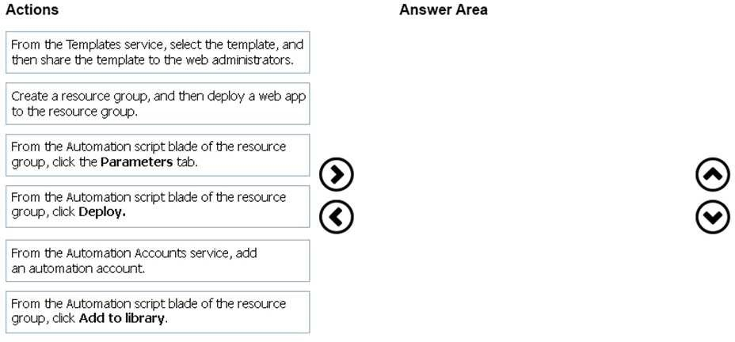

**Answer:**

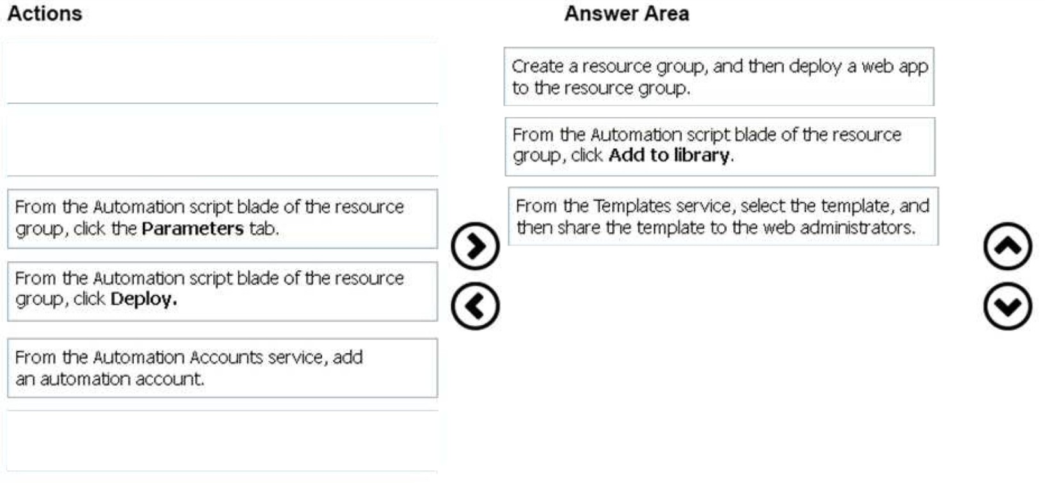

**QUESTION 213**

# Case Study 2 - Contoso, Ltd

**Overview**

Contoso, Ltd. is a manufacturing company that has offices worldwide. Contoso works with partner organizations to bring products to market.

Contoso products are manufactured by using blueprint files that the company authors and maintains.

**Existing Environment**

Currently, Contoso uses multiple types of servers for business operations, including the following:

* File servers
* Domain controllers
* Microsoft SQL Server servers

Your network contains an Active Directory forest named contoso.com. All servers and client computers are joined to Active Directory.

You have a public-facing application named App1. App1 is comprised of the following three tiers:

* A SQL database
* A web front end
* A processing middle tier

Each tier is comprised of five virtual machines. Users access the web front end by using HTTPS only.

**Requirements Planned Changes**

Contoso plans to implement the following changes to the infrastructure:

* Move all the tiers of App1 to Azure.
* Move the existing product blueprint files to Azure Blob storage.
* Create a hybrid directory to support an upcoming Microsoft Office 365 migration project.

**Technical Requirements**

Contoso must meet the following technical requirements:

* Move all the virtual machines for App1 to Azure.
* Minimize the number of open ports between the App1 tiers.
* Ensure that all the virtual machines for App1 are protected by backups.
* Copy the blueprint files to Azure over the Internet.
* Ensure that the blueprint files are stored in the archive storage tier.
* Ensure that partner access to the blueprint files is secured and temporary.
* Prevent user passwords or hashes of passwords from being stored in Azure.
* Use unmanaged standard storage for the hard disks of the virtualmachines.
* Ensure that when users join devices to Azure Active Directory (Azure AD), the users use a mobile phone to verify their identity.
* Minimize administrative effort whenever possible.

**User Requirements**

Contoso identifies the following requirements for users:

* Ensure that only users who are part of a group named Pilot can join devices to Azure AD.
* Designate a new user named Admin1 as the service administrator of the Azure subscription.
* Ensure that a new user named User3 can create network objects for the Azure subscription.

You need to meet the user requirement for Admin1. What should you do?

|  |  |
| --- | --- |
| A. | From the Subscriptions blade, select the subscription, and then modify the Properties. |
| B. | From the Subscriptions blade, select the subscription, and then modify the Access control (IAM) settings. |
| C. | From the Azure Active Directory blade, modify the Properties. |
| D. | From the Azure Active Directory blade, modify the Groups. |

**Answer:** A

**Explanation:**

Change the Service administrator for an Azure subscription Sign in to Account Center as the Account administrator.

Select a subscription.

On the right side, select Edit subscription details.

Scenario: Designate a new user named Admin1 as the service administrator of the Azure subscription.

References: https://docs.microsoft.com/en-us/azure/billing/billing-add-change-azure-subscription- administrator

**QUESTION 214**

# Case Study 2 - Contoso, Ltd

**Overview**

Contoso, Ltd. is a manufacturing company that has offices worldwide. Contoso works with partner organizations to bring products to market.

Contoso products are manufactured by using blueprint files that the company authors and maintains.

**Existing Environment**

Currently, Contoso uses multiple types of servers for business operations, including the following:

* File servers
* Domain controllers
* Microsoft SQL Server servers

Your network contains an Active Directory forest named contoso.com. All servers and client computers are joined to Active Directory.

You have a public-facing application named App1. App1 is comprised of the following three tiers:

* A SQL database
* A web front end
* A processing middle tier

Each tier is comprised of five virtual machines. Users access the web front end by using HTTPS only.

**Requirements Planned Changes**

Contoso plans to implement the following changes to the infrastructure:

* Move all the tiers of App1 to Azure.
* Move the existing product blueprint files to Azure Blob storage.
* Create a hybrid directory to support an upcoming Microsoft Office 365 migration project.

**Technical Requirements**

Contoso must meet the following technical requirements:

* Move all the virtual machines for App1 to Azure.
* Minimize the number of open ports between the App1 tiers.
* Ensure that all the virtual machines for App1 are protected by backups.
* Copy the blueprint files to Azure over the Internet.
* Ensure that the blueprint files are stored in the archive storage tier.
* Ensure that partner access to the blueprint files is secured and temporary.
* Prevent user passwords or hashes of passwords from being stored in Azure.
* Use unmanaged standard storage for the hard disks of the virtualmachines.
* Ensure that when users join devices to Azure Active Directory (Azure AD), the users use a mobile phone to verify their identity.
* Minimize administrative effort whenever possible.

**User Requirements**

Contoso identifies the following requirements for users:

* Ensure that only users who are part of a group named Pilot can join devices to Azure AD.
* Designate a new user named Admin1 as the service administrator of the Azure subscription.
* Ensure that a new user named User3 can create network objects for the Azure subscription.

You need to move the blueprint files to Azure. What should you do?

|  |  |
| --- | --- |
| A. | Generate a shared access signature (SAS). Map a drive, and then copy the files by using File  Explorer. |
| B. | Use the Azure Import/Export service. |
| C. | Generate an access key. Map a drive, and then copy the files by using File Explorer. |
| D. | Use Azure Storage Explorer to copy the files. |

**Answer:** D

**Explanation:**

Azure Storage Explorer is a free tool from Microsoft that allows you to work with Azure Storage data on Windows, macOS, and Linux. You can use it to upload and download data from Azure blob storage.

Scenario:

Planned Changes include: move the existing product blueprint files to Azure Blob storage. Technical Requirements include: Copy the blueprint files to Azure over the Internet. References: https://docs.microsoft.com/en-us/azure/machine-learning/team-data-science-process/move-data- to-azure-blob-using-azure-storage-explorer

**QUESTION 215**

# Case Study 2 - Contoso, Ltd

**Overview**

Contoso, Ltd. is a manufacturing company that has offices worldwide. Contoso works with partner organizations to bring products to market.

Contoso products are manufactured by using blueprint files that the company authors and maintains.

**Existing Environment**

Currently, Contoso uses multiple types of servers for business operations, including the following:

* File servers
* Domain controllers
* Microsoft SQL Server servers

Your network contains an Active Directory forest named contoso.com. All servers and client computers are joined to Active Directory.

You have a public-facing application named App1. App1 is comprised of the following three tiers:

* A SQL database
* A web front end
* A processing middle tier

Each tier is comprised of five virtual machines. Users access the web front end by using HTTPS only.

**Requirements Planned Changes**

Contoso plans to implement the following changes to the infrastructure:

* Move all the tiers of App1 to Azure.
* Move the existing product blueprint files to Azure Blob storage.
* Create a hybrid directory to support an upcoming Microsoft Office 365 migration project.

**Technical Requirements**

Contoso must meet the following technical requirements:

* Move all the virtual machines for App1 to Azure.
* Minimize the number of open ports between the App1 tiers.
* Ensure that all the virtual machines for App1 are protected by backups.
* Copy the blueprint files to Azure over the Internet.
* Ensure that the blueprint files are stored in the archive storage tier.
* Ensure that partner access to the blueprint files is secured and temporary.
* Prevent user passwords or hashes of passwords from being stored in Azure.
* Use unmanaged standard storage for the hard disks of the virtualmachines.
* Ensure that when users join devices to Azure Active Directory (Azure AD), the users use a mobile phone to verify their identity.
* Minimize administrative effort whenever possible.

**User Requirements**

Contoso identifies the following requirements for users:

* Ensure that only users who are part of a group named Pilot can join devices to Azure AD.
* Designate a new user named Admin1 as the service administrator of the Azure subscription.
* Ensure that a new user named User3 can create network objects for the Azure subscription.

You need to implement a backup solution for App1 after the application is moved. What should you create first?

|  |  |
| --- | --- |
| A. | a recovery plan |
| B. | an Azure Backup Server |
| C. | a backup policy |
| D. | a Recovery Services vault |

**Answer:** D

**Explanation:**

A Recovery Services vault is a logical container that stores the backup data for each protected resource, such as Azure VMs. When the backup job for a protected resource runs, it creates a recovery point inside the Recovery Services vault.

Scenario:

There are three application tiers, each with five virtual machines. Move all the virtual machines for App1 to Azure.

Ensure that all the virtual machines for App1 are protected by backups. References: https://docs.microsoft.com/en-us/azure/backup/quick-backup-vm-portal

**QUESTION 216**

# Case Study 2 - Contoso, Ltd

**Overview**

Contoso, Ltd. is a manufacturing company that has offices worldwide. Contoso works with partner organizations to bring products to market.

Contoso products are manufactured by using blueprint files that the company authors and maintains.

**Existing Environment**

Currently, Contoso uses multiple types of servers for business operations, including the following:

* File servers
* Domain controllers
* Microsoft SQL Server servers

Your network contains an Active Directory forest named contoso.com. All servers and client computers are joined to Active Directory.

You have a public-facing application named App1. App1 is comprised of the following three tiers:

* A SQL database
* A web front end
* A processing middle tier

Each tier is comprised of five virtual machines. Users access the web front end by using HTTPS only.

**Requirements**

**Planned Changes**

Contoso plans to implement the following changes to the infrastructure:

* Move all the tiers of App1 to Azure.
* Move the existing product blueprint files to Azure Blob storage.
* Create a hybrid directory to support an upcoming Microsoft Office 365 migration project.

**Technical Requirements**

Contoso must meet the following technical requirements:

* Move all the virtual machines for App1 to Azure.
* Minimize the number of open ports between the App1 tiers.
* Ensure that all the virtual machines for App1 are protected by backups.
* Copy the blueprint files to Azure over the Internet.
* Ensure that the blueprint files are stored in the archive storage tier.
* Ensure that partner access to the blueprint files is secured and temporary.
* Prevent user passwords or hashes of passwords from being stored in Azure.
* Use unmanaged standard storage for the hard disks of the virtualmachines.
* Ensure that when users join devices to Azure Active Directory (Azure AD), the users use a mobile phone to verify their identity.
* Minimize administrative effort whenever possible.

**User Requirements**

Contoso identifies the following requirements for users:

* Ensure that only users who are part of a group named Pilot can join devices to Azure AD.
* Designate a new user named Admin1 as the service administrator of the Azure subscription.
* Ensure that a new user named User3 can create network objects for the Azure subscription.

Hotspot Question

You need to recommend a solution for App1. The solution must meet the technical requirements. What should you include in the recommendation? To answer, select the appropriate options in the answer area.

NOTE: Each correct selection is worth one point.

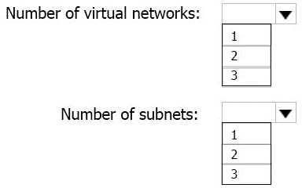

**Answer:**

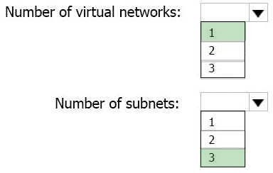

**Explanation:**

This reference architecture shows how to deploy VMs and a virtual network configured for an N- tier application, using SQL Server on Windows for the data tier.

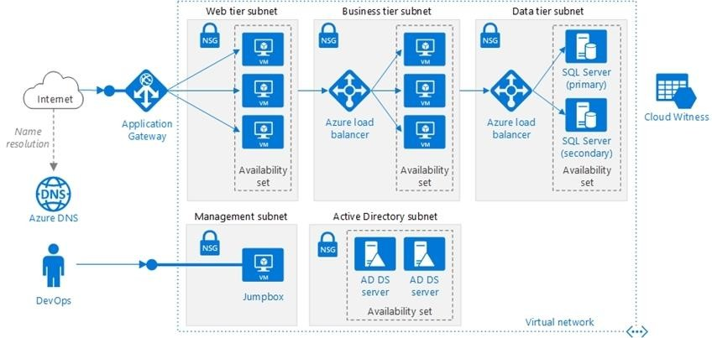

Scenario: You have a public-facing application named App1. App1 is comprised of the following three tiers:

A SQL database A web front end

A processing middle tier

Each tier is comprised of five virtual machines. Users access the web front end by using HTTPS only.

Technical requirements include:

Move all the virtual machines for App1 to Azure.

Minimize the number of open ports between the App1 tiers. References: https://docs.microsoft.com/en-us/azure/architecture/reference-architectures/n-tier/n-tier-sql-server

**QUESTION 217**

# Case Study 2 - Contoso, Ltd

**Overview**

Contoso, Ltd. is a manufacturing company that has offices worldwide. Contoso works with partner organizations to bring products to market.

Contoso products are manufactured by using blueprint files that the company authors and maintains.

**Existing Environment**

Currently, Contoso uses multiple types of servers for business operations, including the following:

* File servers
* Domain controllers
* Microsoft SQL Server servers

Your network contains an Active Directory forest named contoso.com. All servers and client computers are joined to Active Directory.

You have a public-facing application named App1. App1 is comprised of the following three tiers:

* A SQL database
* A web front end
* A processing middle tier

Each tier is comprised of five virtual machines. Users access the web front end by using HTTPS only.

**Requirements Planned Changes**

Contoso plans to implement the following changes to the infrastructure:

* Move all the tiers of App1 to Azure.
* Move the existing product blueprint files to Azure Blob storage.
* Create a hybrid directory to support an upcoming Microsoft Office 365 migration project.

**Technical Requirements**

Contoso must meet the following technical requirements:

* Move all the virtual machines for App1 to Azure.
* Minimize the number of open ports between the App1 tiers.
* Ensure that all the virtual machines for App1 are protected by backups.
* Copy the blueprint files to Azure over the Internet.
* Ensure that the blueprint files are stored in the archive storage tier.
* Ensure that partner access to the blueprint files is secured and temporary.
* Prevent user passwords or hashes of passwords from being stored in Azure.
* Use unmanaged standard storage for the hard disks of the virtualmachines.
* Ensure that when users join devices to Azure Active Directory (Azure AD), the users use a mobile phone to verify their identity.
* Minimize administrative effort whenever possible.

**User Requirements**

Contoso identifies the following requirements for users:

* Ensure that only users who are part of a group named Pilot can join devices to Azure AD.
* Designate a new user named Admin1 as the service administrator of the Azure subscription.
* Ensure that a new user named User3 can create network objects for the Azure subscription.

Hotspot Question

You need to configure the Device settings to meet the technical requirements and the user requirements.

Which two settings should you modify? To answer, select the appropriate settings in the answer area.

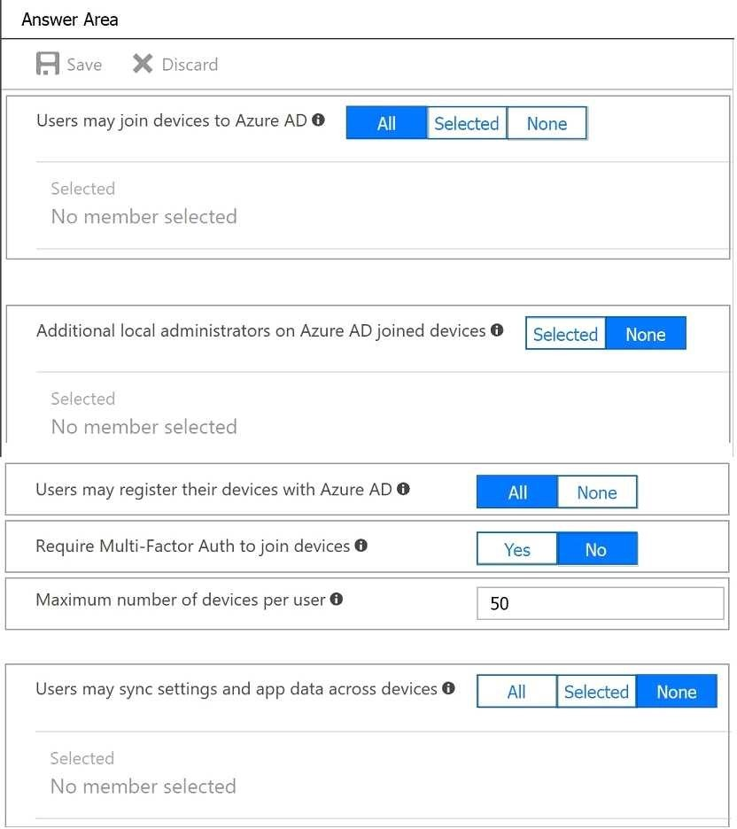

**Answer:**

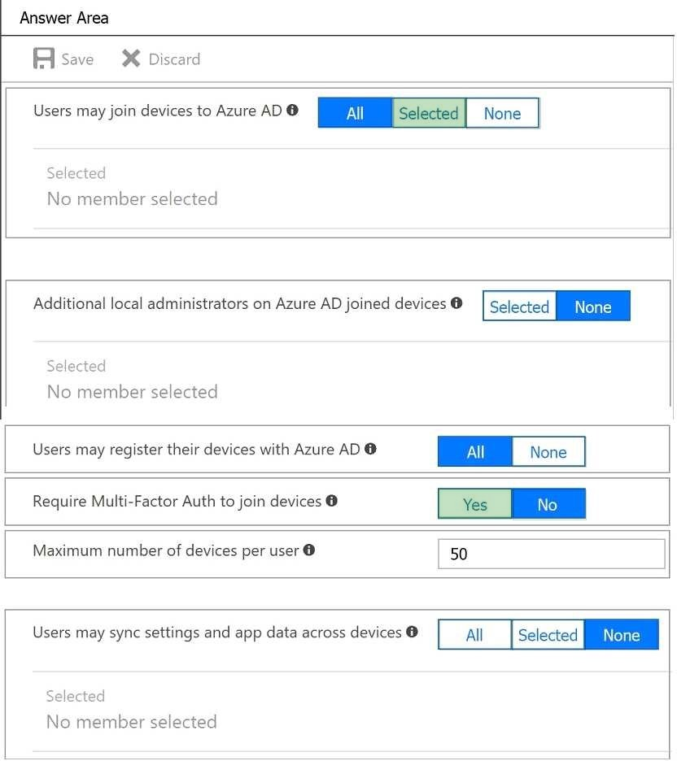

**Explanation:**

Box 1: Selected

Only selected users should be able to join devices Box 2: Yes

Require Multi-Factor Auth to join devices. From scenario:

Ensure that only users who are part of a group named Pilot can join devices to Azure AD Ensure that when users join devices to Azure Active Directory (Azure AD), the users use a mobile phone to verify their identity.

**QUESTION 218**

# Case Study 2 - Contoso, Ltd

**Overview**

Contoso, Ltd. is a manufacturing company that has offices worldwide. Contoso works with partner organizations to bring products to market.

Contoso products are manufactured by using blueprint files that the company authors and maintains.

**Existing Environment**

Currently, Contoso uses multiple types of servers for business operations, including the following:

* File servers
* Domain controllers
* Microsoft SQL Server servers

Your network contains an Active Directory forest named contoso.com. All servers and client computers are joined to Active Directory.

You have a public-facing application named App1. App1 is comprised of the following three tiers:

* A SQL database
* A web front end
* A processing middle tier

Each tier is comprised of five virtual machines. Users access the web front end by using HTTPS only.

**Requirements Planned Changes**

Contoso plans to implement the following changes to the infrastructure:

* Move all the tiers of App1 to Azure.
* Move the existing product blueprint files to Azure Blob storage.
* Create a hybrid directory to support an upcoming Microsoft Office 365 migration project.

**Technical Requirements**

Contoso must meet the following technical requirements:

* Move all the virtual machines for App1 to Azure.
* Minimize the number of open ports between the App1 tiers.
* Ensure that all the virtual machines for App1 are protected by backups.
* Copy the blueprint files to Azure over the Internet.
* Ensure that the blueprint files are stored in the archive storage tier.
* Ensure that partner access to the blueprint files is secured and temporary.
* Prevent user passwords or hashes of passwords from being stored in Azure.
* Use unmanaged standard storage for the hard disks of the virtualmachines.
* Ensure that when users join devices to Azure Active Directory (Azure AD), the users use a mobile phone to verify their identity.
* Minimize administrative effort whenever possible.

**User Requirements**

Contoso identifies the following requirements for users:

* Ensure that only users who are part of a group named Pilot can join devices to Azure AD.
* Designate a new user named Admin1 as the service administrator of the Azure subscription.
* Ensure that a new user named User3 can create network objects for the Azure subscription.

Hotspot Question

You need to identify the storage requirements for Contoso.

For each of the following statements, select Yes if the statement is true. Otherwise, select No. NOTE: Each correct selection is worth one point.

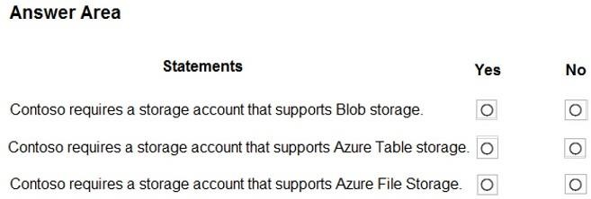

**Answer:**

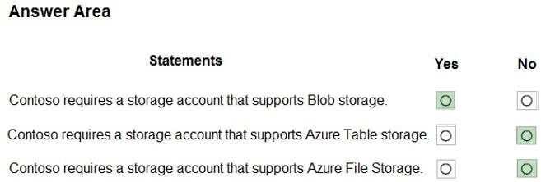

**Explanation:**

Box 1: Yes

Contoso is moving the existing product blueprint files to Azure Blob storage. Use unmanaged standard storage for the hard disks of the virtual machines. We use Page Blobs for these.

Box 2: No

Box 3: No

**QUESTION 219**

# Case Study 3 - Contoso, Ltd

**Overview**

Contoso, Ltd. is a consulting company that has a main office in Montreal and two branch offices in Seattle and New York.

The Montreal office has 2,000 employees. The Seattle office has 1,000 employees. The New York office has 200 employees.

All the resources used by Contoso are hosted on-premises.

Contoso creates a new Azure subscription. The Azure Active Directory (Azure AD) tenant uses adomain named contoso.onmicrosoft.com. The tenant uses the P1 pricing tier.

**Existing Environment**

The network contains an Active Directory forest named contoso.com. All domain controllers are configured as DNS servers and host the contoso.com DNS zone.

Contoso has finance, human resources, sales, research, and information technology departments. Each department has an organizational unit (OU) that contains all the accounts of that respective department. All the user accounts have the department attribute set to their respective department. New users are added frequently.

Contoso.com contains a user named User1. All the offices connect by using private links.

Contoso has data centers in the Montreal and Seattle offices. Each data center has a firewall that can be configured as a VPN device.

All infrastructure servers are virtualized.

The virtualization environment contains the servers in the following table.



Contoso uses two web applications named App1 and App2. Each instance on each web application requires 1GB of memory.

The Azure subscription contains the resources in the following table.

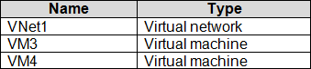

The network security team implements several network security groups (NSGs).

**Planned Changes**

Contoso plans to implement the following changes:

* Deploy Azure ExpressRoute to the Montreal office.
* Migrate the virtual machines hosted on Server1 and Server2 to Azure.
* Synchronize on-premises Active Directory to Azure Active Directory (Azure AD).
* Migrate App1 and App2 to two Azure web apps named WebApp1 and WebApp2.

**Technical requirements**

Contoso must meet the following technical requirements:

* Ensure that WebApp1 can adjust the number of instances automatically based on the load and can scale up to five instances.
* Ensure that VM3 can establish outbound connections over TCP port 8080 to the applications servers in the Montreal office.
* Ensure that routing information is exchanged automatically between Azure and the routers in the Montreal office.
* Ensure Azure Multi-Factor Authentication (MFA) for the users in the finance department only.
* Ensure that webapp2.azurewebsites.net can be accessed by using the name app2.contoso.com
* Connect the New York office to VNet1 over the Internet by using an encrypted connection.
* Create a workflow to send an email message when the settings of VM4 are modified.
* Create a custom Azure role named Role1 that is based on the Reader role.
* Minimize costs whenever possible.

You discover that VM3 does NOT meet the technical requirements. You need to verify whether the issue relates to the NSGs.

What should you use?

|  |  |
| --- | --- |
| A. | Diagram in VNet1 |
| B. | the security recommendations in Azure Advisor |
| C. | Diagnostic settings in Azure Monitor |
| D. | Diagnose and solve problems in Traffic Manager profiles |
| E. | IP flow verify in Azure Network Watcher |

**Answer:** E

**Explanation:**

Scenario: Contoso must meet technical requirements including:

Ensure that VM3 can establish outbound connections over TCP port 8080 to the applications servers in the Montreal office.

IP flow verify checks if a packet is allowed or denied to or from a virtual machine. The information consists of direction, protocol, local IP, remote IP, local port, and remote port. If the packet is denied by a security group, the name of the rule that denied the packet is returned. While any source or destination IP can be chosen, IP flow verify helps administrators quickly diagnose connectivity issues from or to the internet and from or to the on-premises environment.

References:

https://docs.microsoft.com/en-us/azure/network-watcher/network-watcher-ip-flow-verify-overview

**QUESTION 220**

# Case Study 3 - Contoso, Ltd

**Overview**

Contoso, Ltd. is a consulting company that has a main office in Montreal and two branch offices in Seattle and New York.

The Montreal office has 2,000 employees. The Seattle office has 1,000 employees. The New York office has 200 employees.

All the resources used by Contoso are hosted on-premises.

Contoso creates a new Azure subscription. The Azure Active Directory (Azure AD) tenant uses adomain named contoso.onmicrosoft.com. The tenant uses the P1 pricing tier.

**Existing Environment**

The network contains an Active Directory forest named contoso.com. All domain controllers are configured as DNS servers and host the contoso.com DNS zone.

Contoso has finance, human resources, sales, research, and information technology departments. Each department has an organizational unit (OU) that contains all the accounts of that respective department. All the user accounts have the department attribute set to their respective department. New users are added frequently.

Contoso.com contains a user named User1.

All the offices connect by using private links.

Contoso has data centers in the Montreal and Seattle offices. Each data center has a firewall that can be configured as a VPN device.

All infrastructure servers are virtualized.

The virtualization environment contains the servers in the following table.



Contoso uses two web applications named App1 and App2. Each instance on each web application requires 1GB of memory.

The Azure subscription contains the resources in the following table.



The network security team implements several network security groups (NSGs).

**Planned Changes**

Contoso plans to implement the following changes:

* Deploy Azure ExpressRoute to the Montreal office.
* Migrate the virtual machines hosted on Server1 and Server2 to Azure.
* Synchronize on-premises Active Directory to Azure Active Directory (Azure AD).
* Migrate App1 and App2 to two Azure web apps named WebApp1 and WebApp2.

**Technical requirements**

Contoso must meet the following technical requirements:

* Ensure that WebApp1 can adjust the number of instances automatically based on the load and can scale up to five instances.
* Ensure that VM3 can establish outbound connections over TCP port 8080 to the applications servers in the Montreal office.
* Ensure that routing information is exchanged automatically between Azure and the routers in the Montreal office.
* Ensure Azure Multi-Factor Authentication (MFA) for the users in the finance department only.
* Ensure that webapp2.azurewebsites.net can be accessed by using the name app2.contoso.com
* Connect the New York office to VNet1 over the Internet by using an encrypted connection.
* Create a workflow to send an email message when the settings of VM4 are modified.
* Create a custom Azure role named Role1 that is based on the Reader role.
* Minimize costs whenever possible.

You need to meet the technical requirement for VM4. What should you create and configure?

|  |  |
| --- | --- |
| A. | an Azure Notification Hub |
| B. | an Azure Event Hub |
| C. | an Azure Logic App |
| D. | an Azure Service Bus |

**Answer:** B

**Explanation:**

Scenario: Create a workflow to send an email message when the settings of VM4 are modified. You can start an automated logic app workflow when specific events happen in Azure resources or third- party resources. These resources can publish those events to an Azure event grid. In turn, the event grid pushes those events to subscribers that have queues, webhooks, or event hubs as endpoints. As a subscriber, your logic app can wait for those events from the event grid before running automated workflows to perform tasks - without you writing any code.

References:

https://docs.microsoft.com/en-us/azure/event-grid/monitor-virtual-machine-changes-event-grid- logic-app

**QUESTION 221**

# Case Study 3 - Contoso, Ltd

**Overview**

Contoso, Ltd. is a consulting company that has a main office in Montreal and two branch offices in Seattle and New York.

The Montreal office has 2,000 employees. The Seattle office has 1,000 employees. The New York office has 200 employees.

All the resources used by Contoso are hosted on-premises.

Contoso creates a new Azure subscription. The Azure Active Directory (Azure AD) tenant uses adomain named contoso.onmicrosoft.com. The tenant uses the P1 pricing tier.

**Existing Environment**

The network contains an Active Directory forest named contoso.com. All domain controllers are configured as DNS servers and host the contoso.com DNS zone.

Contoso has finance, human resources, sales, research, and information technology departments. Each department has an organizational unit (OU) that contains all the accounts of that respective department. All the user accounts have the department attribute set to their respective department. New users are added frequently.

Contoso.com contains a user named User1. All the offices connect by using private links.

Contoso has data centers in the Montreal and Seattle offices. Each data center has a firewall that can be configured as a VPN device.

All infrastructure servers are virtualized.

The virtualization environment contains the servers in the following table.



Contoso uses two web applications named App1 and App2. Each instance on each web application requires 1GB of memory.

The Azure subscription contains the resources in the following table.



The network security team implements several network security groups (NSGs).

**Planned Changes**

Contoso plans to implement the following changes:

* Deploy Azure ExpressRoute to the Montreal office.
* Migrate the virtual machines hosted on Server1 and Server2 to Azure.
* Synchronize on-premises Active Directory to Azure Active Directory (Azure AD).
* Migrate App1 and App2 to two Azure web apps named WebApp1 and WebApp2.

**Technical requirements**

Contoso must meet the following technical requirements:

* Ensure that WebApp1 can adjust the number of instances automatically based on the load and can scale up to five instances.
* Ensure that VM3 can establish outbound connections over TCP port 8080 to the applications servers in the Montreal office.
* Ensure that routing information is exchanged automatically between Azure and the routers in the Montreal office.
* Ensure Azure Multi-Factor Authentication (MFA) for the users in the finance department only.
* Ensure that webapp2.azurewebsites.net can be accessed by using the name app2.contoso.com
* Connect the New York office to VNet1 over the Internet by using an encrypted connection.
* Create a workflow to send an email message when the settings of VM4 are modified.
* Create a custom Azure role named Role1 that is based on the Reader role.
* Minimize costs whenever possible.

You need to recommend a solution to automate the configuration for the finance department users. The solution must meet the technical requirements.

What should you include in the recommendation?

|  |  |
| --- | --- |
| A. | Azure AD B2C |
| B. | Azure AD Identity Protection |
| C. | an Azure logic app and the Microsoft Identity Management (MIM) client |
| D. | dynamic groups and conditional access policies |

**Answer:** D

**Explanation:**

Scenario: Ensure Azure Multi-Factor Authentication (MFA) for the users in the finance department only.

The recommendation is to use conditional access policies that can then be targeted to groups of users, specific applications, or other conditions.

References:

https://docs.microsoft.com/en-us/azure/active-directory/authentication/howto-mfa-userstates

**QUESTION 222**

# Case Study 3 - Contoso, Ltd

**Overview**

Contoso, Ltd. is a consulting company that has a main office in Montreal and two branch offices in Seattle and New York.

The Montreal office has 2,000 employees. The Seattle office has 1,000 employees. The New York office has 200 employees.

All the resources used by Contoso are hosted on-premises.

Contoso creates a new Azure subscription. The Azure Active Directory (Azure AD) tenant uses adomain named contoso.onmicrosoft.com. The tenant uses the P1 pricing tier.

**Existing Environment**

The network contains an Active Directory forest named contoso.com. All domain controllers are configured as DNS servers and host the contoso.com DNS zone.

Contoso has finance, human resources, sales, research, and information technology departments. Each department has an organizational unit (OU) that contains all the accounts of that respective department. All the user accounts have the department attribute set to their respective department. New users are added frequently.

Contoso.com contains a user named User1. All the offices connect by using private links.

Contoso has data centers in the Montreal and Seattle offices. Each data center has a firewall that can be configured as a VPN device.

All infrastructure servers are virtualized.

The virtualization environment contains the servers in the following table.



Contoso uses two web applications named App1 and App2. Each instance on each web application requires 1GB of memory.

The Azure subscription contains the resources in the following table.



The network security team implements several network security groups (NSGs).

**Planned Changes**

Contoso plans to implement the following changes:

* Deploy Azure ExpressRoute to the Montreal office.
* Migrate the virtual machines hosted on Server1 and Server2 to Azure.
* Synchronize on-premises Active Directory to Azure Active Directory (Azure AD).
* Migrate App1 and App2 to two Azure web apps named WebApp1 and WebApp2.

**Technical requirements**

Contoso must meet the following technical requirements:

* Ensure that WebApp1 can adjust the number of instances automatically based on the load and can scale up to five instances.
* Ensure that VM3 can establish outbound connections over TCP port 8080 to the applications servers in the Montreal office.
* Ensure that routing information is exchanged automatically between Azure and the routers in the Montreal office.
* Ensure Azure Multi-Factor Authentication (MFA) for the users in the finance department only.
* Ensure that webapp2.azurewebsites.net can be accessed by using the name app2.contoso.com
* Connect the New York office to VNet1 over the Internet by using an encrypted connection.
* Create a workflow to send an email message when the settings of VM4 are modified.
* Create a custom Azure role named Role1 that is based on the Reader role.
* Minimize costs whenever possible.

Hotspot Question

You need to prepare the environment to implement the planned changes for Server2.

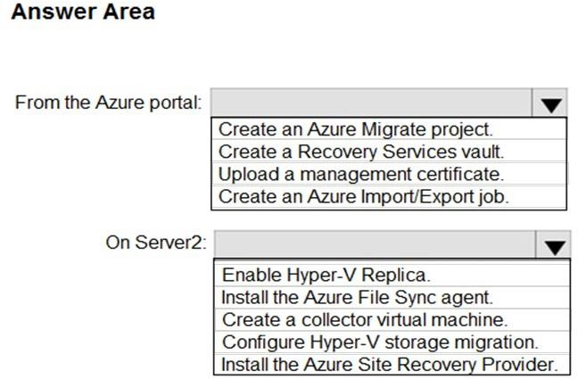What should you do? To answer, select the appropriate options in the answer area. NOTE: Each correct selection is worth one point.

**Answer:**

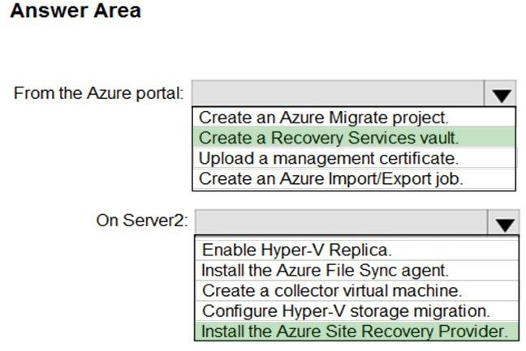

**Explanation:**

Box 1: Create a Recovery Services vault

Create a Recovery Services vault on the Azure Portal. Box 2: Install the Azure Site Recovery Provider

Azure Site Recovery can be used to manage migration of on-premises machines to Azure. Scenario: Migrate the virtual machines hosted on Server1 and Server2 to Azure.

Server2 has the Hyper-V host role. References:

https://docs.microsoft.com/en-us/azure/site-recovery/migrate-tutorial-on-premises-azure

**QUESTION 223**

# Case Study 3 - Contoso, Ltd

**Overview**

Contoso, Ltd. is a consulting company that has a main office in Montreal and two branch offices in Seattle and New York.

The Montreal office has 2,000 employees. The Seattle office has 1,000 employees. The New York office has 200 employees.

All the resources used by Contoso are hosted on-premises.

Contoso creates a new Azure subscription. The Azure Active Directory (Azure AD) tenant uses adomain named contoso.onmicrosoft.com. The tenant uses the P1 pricing tier.

**Existing Environment**

The network contains an Active Directory forest named contoso.com. All domain controllers are configured as DNS servers and host the contoso.com DNS zone.

Contoso has finance, human resources, sales, research, and information technology departments. Each department has an organizational unit (OU) that contains all the accounts of that respective department. All the user accounts have the department attribute set to their respective department. New users are added frequently.

Contoso.com contains a user named User1. All the offices connect by using private links.

Contoso has data centers in the Montreal and Seattle offices. Each data center has a firewall that can be configured as a VPN device.

All infrastructure servers are virtualized.

The virtualization environment contains the servers in the following table.



Contoso uses two web applications named App1 and App2. Each instance on each web application requires 1GB of memory.

The Azure subscription contains the resources in the following table.



The network security team implements several network security groups (NSGs).

**Planned Changes**

Contoso plans to implement the following changes:

* Deploy Azure ExpressRoute to the Montreal office.
* Migrate the virtual machines hosted on Server1 and Server2 to Azure.
* Synchronize on-premises Active Directory to Azure Active Directory (Azure AD).
* Migrate App1 and App2 to two Azure web apps named WebApp1 and WebApp2.

**Technical requirements**

Contoso must meet the following technical requirements:

* Ensure that WebApp1 can adjust the number of instances automatically based on the load and can scale up to five instances.
* Ensure that VM3 can establish outbound connections over TCP port 8080 to the applications servers in the Montreal office.
* Ensure that routing information is exchanged automatically between Azure and the routers in the Montreal office.
* Ensure Azure Multi-Factor Authentication (MFA) for the users in the finance department only.
* Ensure that webapp2.azurewebsites.net can be accessed by using the name app2.contoso.com
* Connect the New York office to VNet1 over the Internet by using an encrypted connection.
* Create a workflow to send an email message when the settings of VM4 are modified.
* Create a custom Azure role named Role1 that is based on the Reader role.
* Minimize costs whenever possible.

Hotspot Question

You need to meet the connection requirements for the New York office.

What should you do? To answer, select the appropriate options in the answer area.

NOTE: Each correct selection is worth one point.

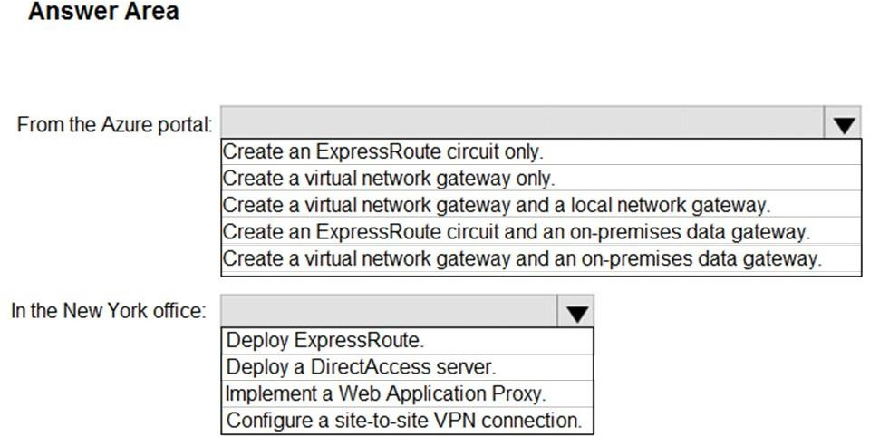

**Answer:**

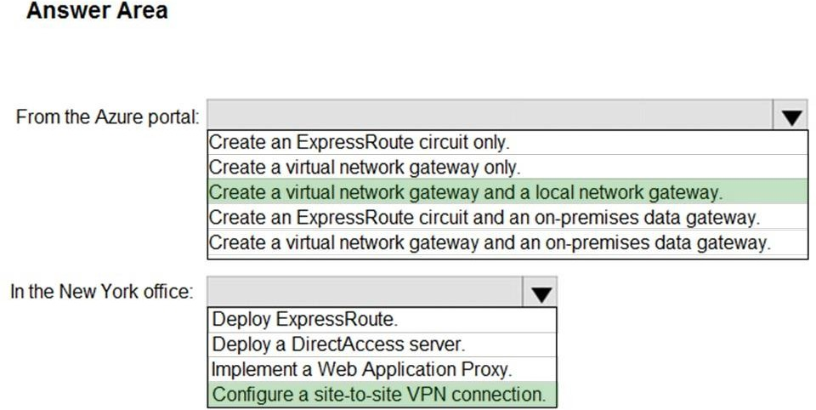

**Explanation:**

Box 1: Create a virtual network gateway and a local network gateway. Azure VPN gateway. The VPN gateway service enables you to connect the VNet to the on-premises network through a VPN appliance. For more information, see Connect an on-premises network to a Microsoft Azure virtual network. The VPN gateway includes the following elements:

Virtual network gateway. A resource that provides a virtual VPN appliance for the VNet. It is responsible for routing traffic from the on-premises network to the VNet. Local network gateway. An abstraction of the on-premises VPN appliance. Network traffic from the cloud application to the on-premises network is routed through this gateway. Connection. The connection has

properties that specify the connection type (IPSec) and the key shared with the on-premises VPN appliance to encrypt traffic.

Gateway subnet. The virtual network gateway is held in its own subnet, which is subject to various requirements, described in the Recommendations section below.

Box 2: Configure a site-to-site VPN connection

On premises create a site-to-site connection for the virtual network gateway and the local network gateway.

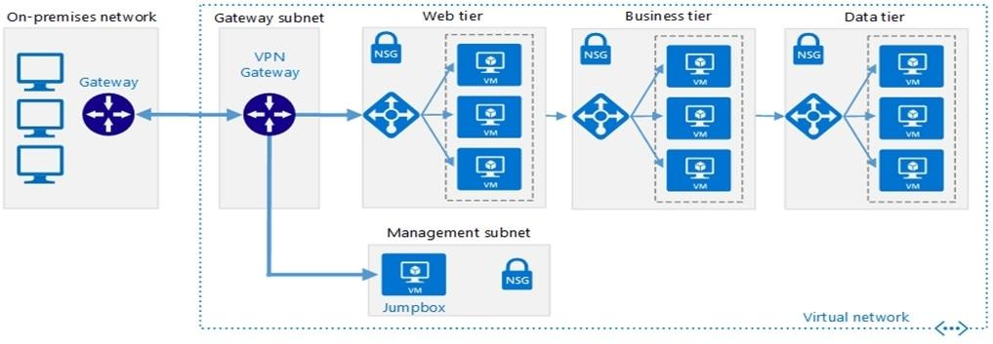

Scenario: Connect the New York office to VNet1 over the Internet by using an encrypted connection.

Incorrect Answers:

Azure ExpressRoute: Established between your network and Azure, through an ExpressRoute partner. This connection is private. Traffic does not go over the internet.

References:

https://docs.microsoft.com/en-us/azure/architecture/reference-architectures/hybrid- networking/vpn

**QUESTION 224**

# Case Study 3 - Contoso, Ltd

**Overview**

Contoso, Ltd. is a consulting company that has a main office in Montreal and two branch offices in Seattle and New York.

The Montreal office has 2,000 employees. The Seattle office has 1,000 employees. The New York office has 200 employees.

All the resources used by Contoso are hosted on-premises.

Contoso creates a new Azure subscription. The Azure Active Directory (Azure AD) tenant uses adomain named contoso.onmicrosoft.com. The tenant uses the P1 pricing tier.

**Existing Environment**

The network contains an Active Directory forest named contoso.com. All domain controllers are configured as DNS servers and host the contoso.com DNS zone.

Contoso has finance, human resources, sales, research, and information technology departments. Each department has an organizational unit (OU) that contains all the accounts of that respective department. All the user accounts have the department attribute set to their respective department. New users are added frequently.

Contoso.com contains a user named User1. All the offices connect by using private links.

Contoso has data centers in the Montreal and Seattle offices. Each data center has a firewall that can be configured as a VPN device.

All infrastructure servers are virtualized.

The virtualization environment contains the servers in the following table.



Contoso uses two web applications named App1 and App2. Each instance on each web application requires 1GB of memory.

The Azure subscription contains the resources in the following table.



The network security team implements several network security groups (NSGs).

**Planned Changes**

Contoso plans to implement the following changes:

* Deploy Azure ExpressRoute to the Montreal office.
* Migrate the virtual machines hosted on Server1 and Server2 to Azure.
* Synchronize on-premises Active Directory to Azure Active Directory (Azure AD).
* Migrate App1 and App2 to two Azure web apps named WebApp1 and WebApp2.

**Technical requirements**

Contoso must meet the following technical requirements:

* Ensure that WebApp1 can adjust the number of instances automatically based on the load and can scale up to five instances.
* Ensure that VM3 can establish outbound connections over TCP port 8080 to the applications servers in the Montreal office.
* Ensure that routing information is exchanged automatically between Azure and the routers in the Montreal office.
* Ensure Azure Multi-Factor Authentication (MFA) for the users in the finance department only.
* Ensure that webapp2.azurewebsites.net can be accessed by using the name app2.contoso.com
* Connect the New York office to VNet1 over the Internet by using an encrypted connection.
* Create a workflow to send an email message when the settings of VM4 are modified.
* Create a custom Azure role named Role1 that is based on the Reader role.
* Minimize costs whenever possible.

Hotspot Question

You need to implement Role1.

Which command should you run before you create Role1? To answer, select the appropriate options in the answer area.

NOTE: Each correct selection is worth one point.

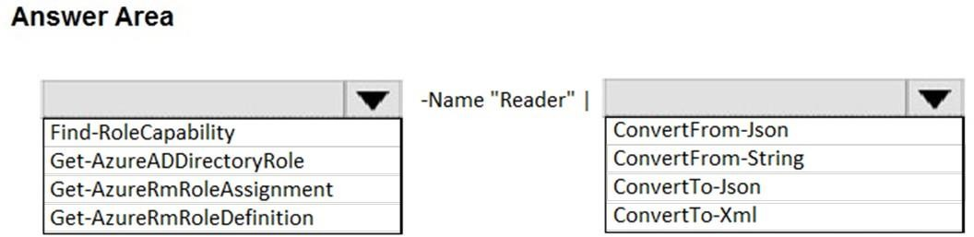

**Answer:**

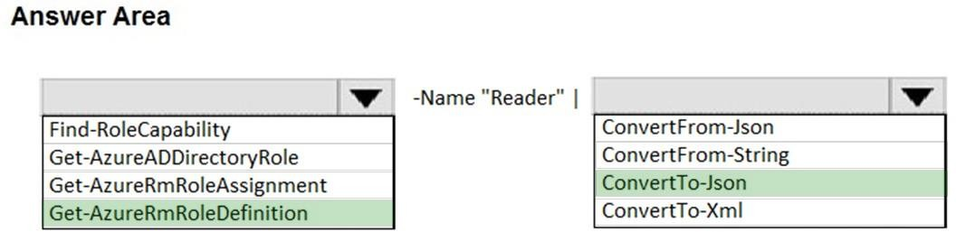

**QUESTION 225**

# Case Study 4 - ADatum

**Overview**

ADatum Corporation is a financial company that has two main offices in New York and Los Angeles. ADatum has a subsidiary named Fabrikam, Inc. that shares the Los Angeles office.

ADatum is conducting an initial deployment of Azure services to host new line-of-business applications and is preparing to migrate its existing on-premises workloads to Azure.

ADatum uses Microsoft Exchange Online for email.

**Existing Environment**

**On-Premises Environment**

The on-premises workloads run on virtual machines hosted in a VMware vSphere 6 infrastructure. All the virtual machines are members of an Active Directory forest named adatum.com and run Windows Server 2016.

The New York office uses an IP address space of 10.0.0.0/16. The Los Angeles office uses an IP address space of 10.10.0.0/16.

The offices connect by using a VPN provided by an ISP. Each office has one Azure ExpressRoute circuit that provides access to Azure services and Microsoft Online Services. Routing is implemented by using Microsoft peering.

The New York office has a virtual machine named VM1 that has the vSphere console installed.

**Azure Environment**

You provision the Azure infrastructure by using the Azure portal. The infrastructure contains the resources shown in the following table.

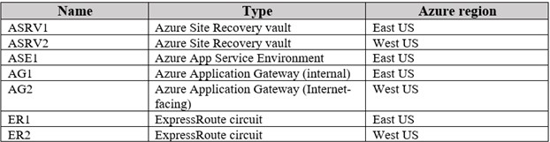

AG1 has two backend pools named Pool11 and Pool12. AG2 has two backend pools named Pool21 and Pool22.

**Requirements Planned Changes**

ADatum plans to migrate the virtual machines from the New York office to the East US Azure region by using Azure Site Recovery.

**Infrastructure Requirements**

ADatum identifies the following infrastructure requirements:

 A new web app named App1 that will access third-parties for credit card processing must be deployed.

 A newly developed API must be implemented as an Azure function named App2. App2 will use a blob storage trigger. App2 must process new blobs immediately.

 The Azure infrastructure and the on-premises infrastructure must be prepared for the migration of the VMware virtual machines to Azure.

 The sizes of the Azure virtual machines that will be used to migrate the on-premises workloads must be identified.

 All migrated and newly deployed Azure virtual machines must be joined to the adatum.com domain.

 AG1 must load balance incoming traffic in the following manner:

* [http://corporate.adatum.com/video/*](http://corporate.adatum.com/video/) will be load balanced across Pool11.
* [http://corporate.adatum.com/images/*](http://corporate.adatum.com/images/) will be load balanced across Pool12.

 AG2 must load balance incoming traffic in the following manner:

* [http://www.adatum.com](http://www.adatum.com/) will be load balanced across Pool21.
* [http://fabrikam.com](http://fabrikam.com/) will be load balanced across Pool22.

 ER1 must route traffic between the New York office and platform as a service (PaaS) services in the East US Azure region, as long as ER1 is available.

 ER1 must route traffic between the Los Angeles office and the PaaS services in the West US region, as long as ER2 is available.

 ER1 and ER2 must be configured to fail over automatically.

**Application Requirements**

App2 must be available to connect directly to the private IP addresses of the Azure virtual machines. App2 will be deployed directly to an Azure virtual network.

Inbound and outbound communications to App1 must be controlled by using NSGs.

**Pricing Requirements**

ADatum identifies the following pricing requirements:  The cost of App1 and App2 must be minimized

 The transactional charges of Azure Storage accounts must be minimized

You need to recommend an environment for the deployment of App1. What should you recommend?

|  |  |
| --- | --- |
| A. | a new App Service plan that uses the P3v2 pricing tier |
| B. | ASE1 and an App Service plan that uses the I1 pricing tier |
| C. | ASE1 and an App Service plan that uses the I3 pricing tier |
| D. | a new App Service plan that uses the S1 pricing tier |

**Answer:** B

**Explanation:**

https://docs.microsoft.com/en-us/azure/app-service/environment/app-service-app-service- environment-control-inbound-traffic

**QUESTION 226**

# Case Study 4 - ADatum

**Overview**

ADatum Corporation is a financial company that has two main offices in New York and Los Angeles. ADatum has a subsidiary named Fabrikam, Inc. that shares the Los Angeles office.

ADatum is conducting an initial deployment of Azure services to host new line-of-business applications and is preparing to migrate its existing on-premises workloads to Azure.

ADatum uses Microsoft Exchange Online for email.

**Existing Environment**

**On-Premises Environment**

The on-premises workloads run on virtual machines hosted in a VMware vSphere 6 infrastructure. All the virtual machines are members of an Active Directory forest named adatum.com and run Windows Server 2016.

The New York office uses an IP address space of 10.0.0.0/16. The Los Angeles office uses an IP address space of 10.10.0.0/16.

The offices connect by using a VPN provided by an ISP. Each office has one Azure ExpressRoute circuit that provides access to Azure services and Microsoft Online Services. Routing is implemented by using Microsoft peering.

The New York office has a virtual machine named VM1 that has the vSphere console installed.

**Azure Environment**

You provision the Azure infrastructure by using the Azure portal. The infrastructure contains the resources shown in the following table.



AG1 has two backend pools named Pool11 and Pool12. AG2 has two backend pools named Pool21 and Pool22.

**Requirements Planned Changes**

ADatum plans to migrate the virtual machines from the New York office to the East US Azure region by using Azure Site Recovery.

**Infrastructure Requirements**

ADatum identifies the following infrastructure requirements:

 A new web app named App1 that will access third-parties for credit card processing must be deployed.

 A newly developed API must be implemented as an Azure function named App2. App2 will use a blob storage trigger. App2 must process new blobs immediately.

 The Azure infrastructure and the on-premises infrastructure must be prepared for the migration of the VMware virtual machines to Azure.

 The sizes of the Azure virtual machines that will be used to migrate the on-premises workloads must be identified.

 All migrated and newly deployed Azure virtual machines must be joined to the adatum.com domain.

 AG1 must load balance incoming traffic in the following manner:

* [http://corporate.adatum.com/video/*](http://corporate.adatum.com/video/) will be load balanced across Pool11.
* [http://corporate.adatum.com/images/*](http://corporate.adatum.com/images/) will be load balanced across Pool12.

 AG2 must load balance incoming traffic in the following manner:

* [http://www.adatum.com](http://www.adatum.com/) will be load balanced across Pool21.
* [http://fabrikam.com](http://fabrikam.com/) will be load balanced across Pool22.

 ER1 must route traffic between the New York office and platform as a service (PaaS) services in the East US Azure region, as long as ER1 is available.

 ER1 must route traffic between the Los Angeles office and the PaaS services in the West US region, as long as ER2 is available.

 ER1 and ER2 must be configured to fail over automatically.

**Application Requirements**

App2 must be available to connect directly to the private IP addresses of the Azure virtual machines. App2 will be deployed directly to an Azure virtual network.

Inbound and outbound communications to App1 must be controlled by using NSGs.

**Pricing Requirements**

ADatum identifies the following pricing requirements:  The cost of App1 and App2 must be minimized

 The transactional charges of Azure Storage accounts must be minimized

You need to configure AG1. What should you create?

|  |  |
| --- | --- |
| A. | a multi-site listener |
| B. | a URL path-based routing rule |
| C. | a basic listener |
| D. | a basic routing rule |

**Answer:** B

**Explanation:**

https://docs.microsoft.com/en-us/azure/application-gateway/application-gateway-create-url-route- portal

**QUESTION 227**

# Case Study 4 - ADatum

**Overview**

ADatum Corporation is a financial company that has two main offices in New York and Los Angeles. ADatum has a subsidiary named Fabrikam, Inc. that shares the Los Angeles office.

ADatum is conducting an initial deployment of Azure services to host new line-of-business applications and is preparing to migrate its existing on-premises workloads to Azure.

ADatum uses Microsoft Exchange Online for email.

**Existing Environment**

**On-Premises Environment**

The on-premises workloads run on virtual machines hosted in a VMware vSphere 6 infrastructure. All the virtual machines are members of an Active Directory forest named adatum.com and run Windows Server 2016.

The New York office uses an IP address space of 10.0.0.0/16. The Los Angeles office uses an IP address space of 10.10.0.0/16.

The offices connect by using a VPN provided by an ISP. Each office has one Azure ExpressRoute circuit that provides access to Azure services and Microsoft Online Services. Routing is implemented by using Microsoft peering.

The New York office has a virtual machine named VM1 that has the vSphere console installed.

**Azure Environment**

You provision the Azure infrastructure by using the Azure portal. The infrastructure contains the resources shown in the following table.



AG1 has two backend pools named Pool11 and Pool12. AG2 has two backend pools named Pool21 and Pool22.

**Requirements Planned Changes**

ADatum plans to migrate the virtual machines from the New York office to the East US Azure region by using Azure Site Recovery.

**Infrastructure Requirements**

ADatum identifies the following infrastructure requirements:

 A new web app named App1 that will access third-parties for credit card processing must be deployed.

 A newly developed API must be implemented as an Azure function named App2. App2 will use a blob storage trigger. App2 must process new blobs immediately.

 The Azure infrastructure and the on-premises infrastructure must be prepared for the migration of the VMware virtual machines to Azure.

 The sizes of the Azure virtual machines that will be used to migrate the on-premises workloads must be identified.

 All migrated and newly deployed Azure virtual machines must be joined to the adatum.com domain.

 AG1 must load balance incoming traffic in the following manner:

* [http://corporate.adatum.com/video/*](http://corporate.adatum.com/video/) will be load balanced across Pool11.
* [http://corporate.adatum.com/images/*](http://corporate.adatum.com/images/) will be load balanced across Pool12.

 AG2 must load balance incoming traffic in the following manner:

* [http://www.adatum.com](http://www.adatum.com/) will be load balanced across Pool21.
* [http://fabrikam.com](http://fabrikam.com/) will be load balanced across Pool22.

 ER1 must route traffic between the New York office and platform as a service (PaaS) services in the East US Azure region, as long as ER1 is available.

 ER1 must route traffic between the Los Angeles office and the PaaS services in the West US region, as long as ER2 is available.

 ER1 and ER2 must be configured to fail over automatically.

**Application Requirements**

App2 must be available to connect directly to the private IP addresses of the Azure virtual machines. App2 will be deployed directly to an Azure virtual network.

Inbound and outbound communications to App1 must be controlled by using NSGs.

**Pricing Requirements**

ADatum identifies the following pricing requirements:

 The cost of App1 and App2 must be minimized

 The transactional charges of Azure Storage accounts must be minimized What should you create to configure AG2?

|  |  |
| --- | --- |
| A. | multi-site listeners |
| B. | basic listeners |
| C. | URL path-based routing rules |
| D. | basic routing rules |
| E. | an additional public IP address |

**Answer:** A

**Explanation:**

AG2 must load balance incoming traffic in the following manner:

-[http://www.adatum.com](http://www.adatum.com/) will be load balanced across Pool21.

-[http://fabrikam.com](http://fabrikam.com/) will be load balanced across Pool22.

You need to configure an Azure Application Gateway with multi-site listeners to direct different URLs to different pools.

https://docs.microsoft.com/en-us/azure/application-gateway/multiple-site-overview

**QUESTION 228**

# Case Study 4 - ADatum

**Overview**

ADatum Corporation is a financial company that has two main offices in New York and Los Angeles. ADatum has a subsidiary named Fabrikam, Inc. that shares the Los Angeles office.

ADatum is conducting an initial deployment of Azure services to host new line-of-business applications and is preparing to migrate its existing on-premises workloads to Azure.

ADatum uses Microsoft Exchange Online for email.

**Existing Environment**

**On-Premises Environment**

The on-premises workloads run on virtual machines hosted in a VMware vSphere 6 infrastructure. All the virtual machines are members of an Active Directory forest named adatum.com and run Windows Server 2016.

The New York office uses an IP address space of 10.0.0.0/16. The Los Angeles office uses an IP address space of 10.10.0.0/16.

The offices connect by using a VPN provided by an ISP. Each office has one Azure ExpressRoute circuit that provides access to Azure services and Microsoft Online Services. Routing is implemented by using Microsoft peering.

The New York office has a virtual machine named VM1 that has the vSphere console installed.

**Azure Environment**

You provision the Azure infrastructure by using the Azure portal. The infrastructure contains the resources shown in the following table.



AG1 has two backend pools named Pool11 and Pool12. AG2 has two backend pools named Pool21 and Pool22.

**Requirements Planned Changes**

ADatum plans to migrate the virtual machines from the New York office to the East US Azure region by using Azure Site Recovery.

**Infrastructure Requirements**

ADatum identifies the following infrastructure requirements:

 A new web app named App1 that will access third-parties for credit card processing must be deployed.

 A newly developed API must be implemented as an Azure function named App2. App2 will use a blob storage trigger. App2 must process new blobs immediately.

 The Azure infrastructure and the on-premises infrastructure must be prepared for the migration of the VMware virtual machines to Azure.

 The sizes of the Azure virtual machines that will be used to migrate the on-premises workloads must be identified.

 All migrated and newly deployed Azure virtual machines must be joined to the adatum.com domain.

 AG1 must load balance incoming traffic in the following manner:

* [http://corporate.adatum.com/video/*](http://corporate.adatum.com/video/) will be load balanced across Pool11.
* [http://corporate.adatum.com/images/*](http://corporate.adatum.com/images/) will be load balanced across Pool12.

 AG2 must load balance incoming traffic in the following manner:

* [http://www.adatum.com](http://www.adatum.com/) will be load balanced across Pool21.
* [http://fabrikam.com](http://fabrikam.com/) will be load balanced across Pool22.

 ER1 must route traffic between the New York office and platform as a service (PaaS) services in the East US Azure region, as long as ER1 is available.

 ER1 must route traffic between the Los Angeles office and the PaaS services in the West US region, as long as ER2 is available.

 ER1 and ER2 must be configured to fail over automatically.

**Application Requirements**

App2 must be available to connect directly to the private IP addresses of the Azure virtual machines. App2 will be deployed directly to an Azure virtual network.

Inbound and outbound communications to App1 must be controlled by using NSGs.

**Pricing Requirements**

ADatum identifies the following pricing requirements:

 The cost of App1 and App2 must be minimized

 The transactional charges of Azure Storage accounts must be minimized Drag and Drop Question

You need to identify the appropriate sizes for the Azure virtual machines.

Which five actions should you perform in sequence? To answer, move the appropriate actions from the list of actions to the answer area and arrange them in the correct order.

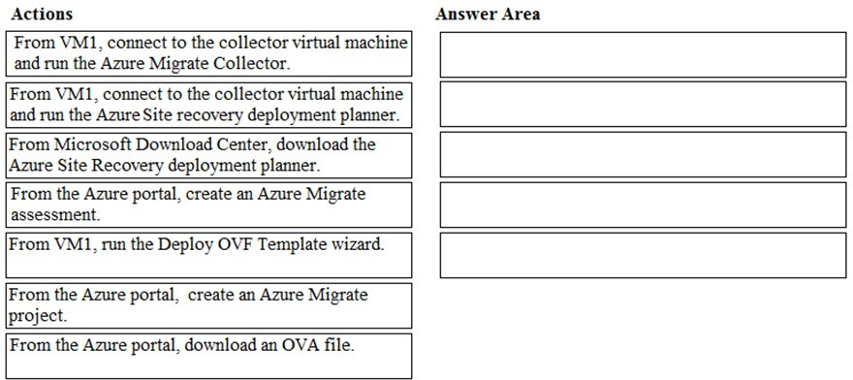

**Answer:**

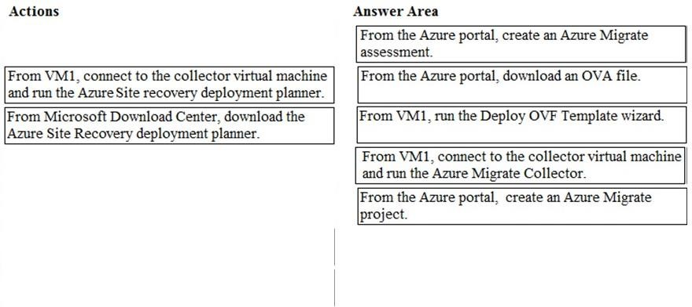

**Explanation:**

https://docs.microsoft.com/en-us/azure/migrate/tutorial-assessment-vmware

**QUESTION 229**

# Case Study 4 - ADatum

**Overview**

ADatum Corporation is a financial company that has two main offices in New York and Los Angeles. ADatum has a subsidiary named Fabrikam, Inc. that shares the Los Angeles office.

ADatum is conducting an initial deployment of Azure services to host new line-of-business applications and is preparing to migrate its existing on-premises workloads to Azure.

ADatum uses Microsoft Exchange Online for email.

**Existing Environment**

**On-Premises Environment**

The on-premises workloads run on virtual machines hosted in a VMware vSphere 6 infrastructure. All the virtual machines are members of an Active Directory forest named adatum.com and run Windows Server 2016.

The New York office uses an IP address space of 10.0.0.0/16. The Los Angeles office uses an IP address space of 10.10.0.0/16.

The offices connect by using a VPN provided by an ISP. Each office has one Azure ExpressRoute circuit that provides access to Azure services and Microsoft Online Services. Routing is implemented by using Microsoft peering.

The New York office has a virtual machine named VM1 that has the vSphere console installed.

**Azure Environment**

You provision the Azure infrastructure by using the Azure portal. The infrastructure contains the resources shown in the following table.



AG1 has two backend pools named Pool11 and Pool12. AG2 has two backend pools named Pool21 and Pool22.

**Requirements Planned Changes**

ADatum plans to migrate the virtual machines from the New York office to the East US Azure region by using Azure Site Recovery.

**Infrastructure Requirements**

ADatum identifies the following infrastructure requirements:

 A new web app named App1 that will access third-parties for credit card processing must be deployed.

 A newly developed API must be implemented as an Azure function named App2. App2 will use a blob storage trigger. App2 must process new blobs immediately.

 The Azure infrastructure and the on-premises infrastructure must be prepared for the migration of the VMware virtual machines to Azure.

 The sizes of the Azure virtual machines that will be used to migrate the on-premises workloads must be identified.

 All migrated and newly deployed Azure virtual machines must be joined to the adatum.com domain.

 AG1 must load balance incoming traffic in the following manner:

* [http://corporate.adatum.com/video/*](http://corporate.adatum.com/video/) will be load balanced across Pool11.
* [http://corporate.adatum.com/images/*](http://corporate.adatum.com/images/) will be load balanced across Pool12.

 AG2 must load balance incoming traffic in the following manner:

* [http://www.adatum.com](http://www.adatum.com/) will be load balanced across Pool21.
* [http://fabrikam.com](http://fabrikam.com/) will be load balanced across Pool22.

 ER1 must route traffic between the New York office and platform as a service (PaaS) services in the East US Azure region, as long as ER1 is available.

 ER1 must route traffic between the Los Angeles office and the PaaS services in the West US region, as long as ER2 is available.

 ER1 and ER2 must be configured to fail over automatically.

**Application Requirements**

App2 must be available to connect directly to the private IP addresses of the Azure virtual machines. App2 will be deployed directly to an Azure virtual network.

Inbound and outbound communications to App1 must be controlled by using NSGs.

**Pricing Requirements**

ADatum identifies the following pricing requirements:  The cost of App1 and App2 must be minimized

 The transactional charges of Azure Storage accounts must be minimized

Hotspot Question

You need to implement App2 to meet the application requirements.

What should you include in the implementation? To answer, select the appropriate options in the answer area.

NOTE: Each correct selection is worth one point.

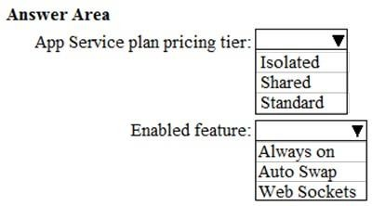

**Answer:**

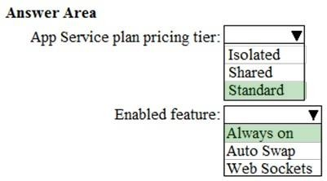

**Explanation:**

A newly developed API must be implemented as an Azure function named App2. App2 will use a blob storage trigger. App2 must process new blobs immediately. This requires "Always On".

The cost of App1 and App2 must be minimized

The Standard pricing tier is the cheapest tier that supports Always On.

**QUESTION 230**

# Case Study 4 - ADatum

**Overview**

ADatum Corporation is a financial company that has two main offices in New York and Los Angeles. ADatum has a subsidiary named Fabrikam, Inc. that shares the Los Angeles office.

ADatum is conducting an initial deployment of Azure services to host new line-of-business applications and is preparing to migrate its existing on-premises workloads to Azure.

ADatum uses Microsoft Exchange Online for email.

**Existing Environment**

**On-Premises Environment**

The on-premises workloads run on virtual machines hosted in a VMware vSphere 6 infrastructure. All the virtual machines are members of an Active Directory forest named adatum.com and run Windows Server 2016.

The New York office uses an IP address space of 10.0.0.0/16. The Los Angeles office uses an IP address space of 10.10.0.0/16.

The offices connect by using a VPN provided by an ISP. Each office has one Azure ExpressRoute circuit that provides access to Azure services and Microsoft Online Services. Routing is implemented by using Microsoft peering.

The New York office has a virtual machine named VM1 that has the vSphere console installed.

**Azure Environment**

You provision the Azure infrastructure by using the Azure portal. The infrastructure contains the resources shown in the following table.



AG1 has two backend pools named Pool11 and Pool12. AG2 has two backend pools named Pool21 and Pool22.

**Requirements Planned Changes**

ADatum plans to migrate the virtual machines from the New York office to the East US Azure region by using Azure Site Recovery.

**Infrastructure Requirements**

ADatum identifies the following infrastructure requirements:

 A new web app named App1 that will access third-parties for credit card processing must be deployed.

 A newly developed API must be implemented as an Azure function named App2. App2 will use a blob storage trigger. App2 must process new blobs immediately.

 The Azure infrastructure and the on-premises infrastructure must be prepared for the migration of the VMware virtual machines to Azure.

 The sizes of the Azure virtual machines that will be used to migrate the on-premises workloads must be identified.

 All migrated and newly deployed Azure virtual machines must be joined to the adatum.com domain.

 AG1 must load balance incoming traffic in the following manner:

* [http://corporate.adatum.com/video/*](http://corporate.adatum.com/video/) will be load balanced across Pool11.
* [http://corporate.adatum.com/images/*](http://corporate.adatum.com/images/) will be load balanced across Pool12.

 AG2 must load balance incoming traffic in the following manner:

* [http://www.adatum.com](http://www.adatum.com/) will be load balanced across Pool21.
* [http://fabrikam.com](http://fabrikam.com/) will be load balanced across Pool22.

 ER1 must route traffic between the New York office and platform as a service (PaaS) services in the East US Azure region, as long as ER1 is available.

 ER1 must route traffic between the Los Angeles office and the PaaS services in the West US region, as long as ER2 is available.

 ER1 and ER2 must be configured to fail over automatically.

**Application Requirements**

App2 must be available to connect directly to the private IP addresses of the Azure virtual machines. App2 will be deployed directly to an Azure virtual network.

Inbound and outbound communications to App1 must be controlled by using NSGs.

**Pricing Requirements**

ADatum identifies the following pricing requirements:

 The cost of App1 and App2 must be minimized

 The transactional charges of Azure Storage accounts must be minimized Drag and Drop Question

You need to configure the Azure ExpressRoute circuits.

How should you configure Azure ExpressRoute routing? To answer, drag the appropriate configurations to the correct locations. Each configuration may be used once, more than once, or not at all. You may need to drag the split bar between panes or scroll to view content.

NOTE: Each correct selection is worth one point.

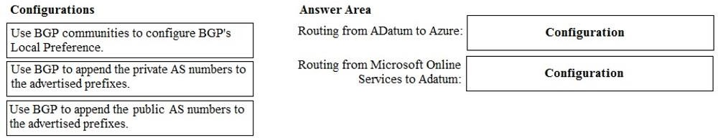

**Answer:**

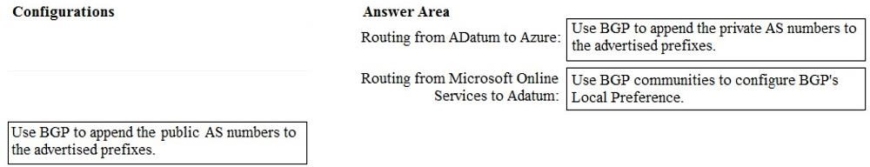

**QUESTION 231**

# Case Study 4 - ADatum

**Overview**

ADatum Corporation is a financial company that has two main offices in New York and Los Angeles. ADatum has a subsidiary named Fabrikam, Inc. that shares the Los Angeles office.

ADatum is conducting an initial deployment of Azure services to host new line-of-business applications and is preparing to migrate its existing on-premises workloads to Azure.

ADatum uses Microsoft Exchange Online for email.

**Existing Environment**

**On-Premises Environment**

The on-premises workloads run on virtual machines hosted in a VMware vSphere 6 infrastructure. All the virtual machines are members of an Active Directory forest named adatum.com and run Windows Server 2016.

The New York office uses an IP address space of 10.0.0.0/16. The Los Angeles office uses an IP address space of 10.10.0.0/16.

The offices connect by using a VPN provided by an ISP. Each office has one Azure ExpressRoute circuit that provides access to Azure services and Microsoft Online Services. Routing is implemented by using Microsoft peering.

The New York office has a virtual machine named VM1 that has the vSphere console installed.

**Azure Environment**

You provision the Azure infrastructure by using the Azure portal. The infrastructure contains the resources shown in the following table.



AG1 has two backend pools named Pool11 and Pool12. AG2 has two backend pools named Pool21 and Pool22.

**Requirements Planned Changes**

ADatum plans to migrate the virtual machines from the New York office to the East US Azure region by using Azure Site Recovery.

**Infrastructure Requirements**

ADatum identifies the following infrastructure requirements:

 A new web app named App1 that will access third-parties for credit card processing must be deployed.

 A newly developed API must be implemented as an Azure function named App2. App2 will use a blob storage trigger. App2 must process new blobs immediately.

 The Azure infrastructure and the on-premises infrastructure must be prepared for the migration of the VMware virtual machines to Azure.

The sizes of the Azure virtual machines that will be used to migrate the on-premises workloads must be identified.

All migrated and newly deployed Azure virtual machines must be joined to the adatum.com domain.

AG1 must load balance incoming traffic in the following manner:

* [http://corporate.adatum.com/video/*](http://corporate.adatum.com/video/) will be load balanced across Pool11.
* [http://corporate.adatum.com/images/*](http://corporate.adatum.com/images/) will be load balanced across Pool12.

AG2 must load balance incoming traffic in the following manner:

* [http://www.adatum.com](http://www.adatum.com/) will be load balanced across Pool21.
* [http://fabrikam.com](http://fabrikam.com/) will be load balanced across Pool22.

ER1 must route traffic between the New York office and platform as a service (PaaS) services in the East US Azure region, as long as ER1 is available.

ER1 must route traffic between the Los Angeles office and the PaaS services in the West US region, as long as ER2 is available.

 ER1 and ER2 must be configured to fail over automatically.

**Application Requirements**

App2 must be available to connect directly to the private IP addresses of the Azure virtual machines. App2 will be deployed directly to an Azure virtual network.

Inbound and outbound communications to App1 must be controlled by using NSGs.

**Pricing Requirements**

ADatum identifies the following pricing requirements:

 The cost of App1 and App2 must be minimized

 The transactional charges of Azure Storage accounts must be minimized Hotspot Question

You need to provision the resources in Azure to support the virtual machine that will be migrated from the New York office.

What should you include in the solution? To answer, select the appropriate options in the answer area.

NOTE: Each correct selection is worth one point.

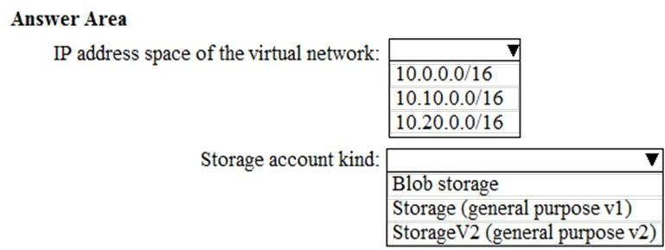

**Answer:**

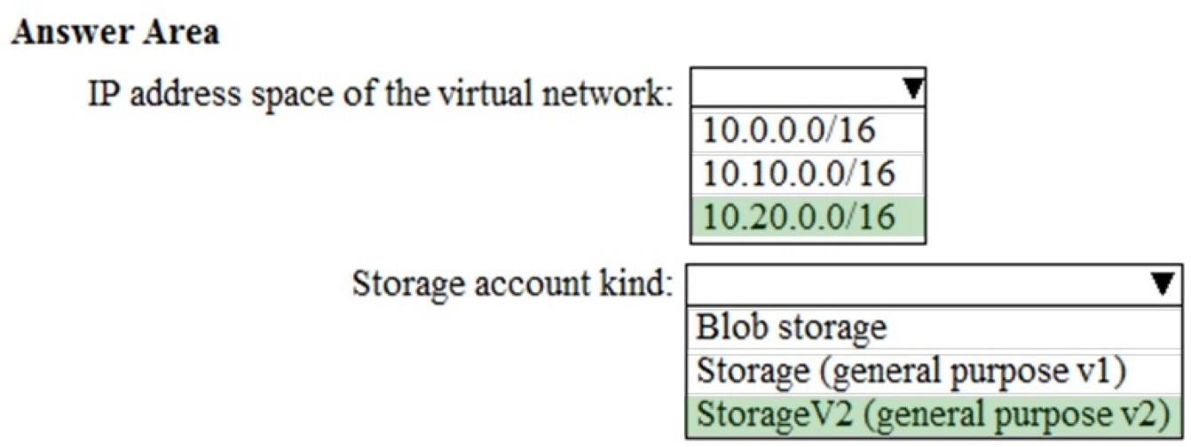

### QUESTION 232

You have an Azure subscription that contains a resource group named RG26.

RG26 is set to the West Europe location and is used to create temporary resources for a project. RG26 contains the resources shown in the following table.

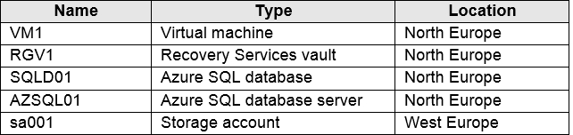

SQLDB01 is backed up to RGV1.

When the project is complete, you attempt to delete RG26 from the Azure portal. The deletion fails.

You need to delete RG26.

What should you do first?

|  |  |
| --- | --- |
| A. | Delete VM1 |
| B. | Stop VM1 |
| C. | Stop the backup of SQLDB01 |
| D. | Delete sa001 |

**Answer:** C

### QUESTION 233

You have an Azure subscription named Subscription1 that contains a virtual network named VNet1. VNet1 is in a resource group named RG1.

Subscription1 has a user named User1. User1 has the following roles:

* Reader
* Security Admin
* Security Reader

You need to ensure that User1 can assign the Reader role for VNet1 to other users. What should you do?

|  |  |
| --- | --- |
| A. | Remove User 1 from the Security Reader role for Subscription1. Assign User1 the Contributor  role for RG1. |
| B. | Assign User1 the Owner role for VNet1. |
| C. | Remove User1 from the Security Reader and Reader roles for Subscription1. |
| D. | Assign User1 the Network Contributor role for RG1. |

**Answer:** B

**Explanation:**

Has full access to all resources including the right to delegate access to others. Reference:

https://docs.microsoft.com/en-us/azure/role-based-access-control/overview

### QUESTION 234

You have an Azure subscription that contains the storage accounts shown in the following table.

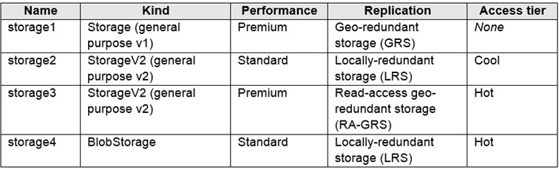

You need to identify which storage account can be converted to zone-redundant storage (ZRS) replication by requesting a live migration from Azure support.

What should you identify?

|  |  |
| --- | --- |
| A. | storage1 |
| B. | storage2 |
| C. | storage3 |
| D. | storage4 |

**Answer:** B

**Explanation:**

ZRS currently supports standard general-purpose v2, FileStorage and BlockBlobStorage storage account types.

Incorrect Answers:

A, not C: Live migration is supported only for storage accounts that use LRS replication. If your account uses GRS or RA-GRS, then you need to first change your account's replication type to LRS before proceeding. This intermediary step removes the secondary endpoint provided by

GRS/RA-GRS.

Also, only standard storage account types support live migration. Premium storage accounts must be migrated manually.

D: ZRS currently supports standard general-purpose v2, FileStorage and BlockBlobStorage storage account types.

Reference:

https://docs.microsoft.com/en-us/azure/storage/common/storage-redundancy-zrs

### QUESTION 235

You have an Azure subscription that contains a storage account named account1.

You plan to upload the disk files of a virtual machine to account1 from your on-premises network. The on- premises network uses a public IP address space of 131.107.1.0/24.

You plan to use the disk files to provision an Azure virtual machine named VM1. VM1 will be attached to a virtual network named VNet1. VNet1 uses an IP address space of 192.168.0.0/24.

You need to configure account1 to meet the following requirements:

* Ensure that you can upload the disk files to account1.
* Ensure that you can attach the disks to VM1.
* Prevent all other access to account1.

Which two actions should you perform? Each correct answer presents part of the solution. NOTE: Each correct selection is worth one point.

|  |  |
| --- | --- |
| A. | From the Firewalls and virtual networks blade of account1, select Selected networks. |
| B. | From the Firewalls and virtual networks blade of account1, select Allow trusted Microsoft services to access this storage account. |
| C. | From the Firewalls and virtual networks blade of account1, add the 131.107.1.0/24 IP address range. |
| D. | From the Firewalls and virtual networks blade of account1, add VNet1. |
| E. | From the Service endpoints blade of VNet1, add a service endpoint. |

**Answer:** AE

**Explanation:**

A: By default, storage accounts accept connections from clients on any network. To limit access to selected networks, you must first change the default action.

Azure portal

1. Navigate to the storage account you want to secure.
2. Click on the settings menu called Firewalls and virtual networks.
3. To deny access by default, choose to allow access from 'Selected networks'. To allow traffic from all networks, choose to allow access from 'All networks'.
4. Click Save to apply your changes. E: Grant access from a Virtual Network

Storage accounts can be configured to allow access only from specific Azure Virtual Networks. By enabling a Service Endpoint for Azure Storage within the Virtual Network, traffic is ensured an optimal route to the Azure Storage service. The identities of the virtual network and the subnet are also transmitted with each request.

Reference:

https://docs.microsoft.com/en-us/azure/storage/common/storage-network-security

### QUESTION 236

**Note: This question is part of a series of questions that present the same scenario. Each question in the series contains a unique solution that might meet the stated goals. Some question sets might have more than one correct solution, while others might not have a correct solution.**

**After you answer a question in this section, you will NOT be able to return to it. As a result, these questions will not appear in the review screen.**

You have an Azure virtual machine named VM1 that runs Windows Server 2016.

You need to create an alert in Azure when more than two error events are logged to the System event log on VM1 within an hour.

Solution: You create an Azure Log Analytics workspace and configure the data settings. You add the Microsoft Monitoring Agent VM extension to VM1. You create an alert in Azure Monitor and specify the Log Analytics workspace as the source.

Does this meet the goal?

|  |  |
| --- | --- |
| A. | Yes |
| B. | No |

**Answer:** B

**Explanation:**

You add the Microsoft Monitoring Agent VM extension to VM1 > This is WRONG You Install the Microsoft Monitoring Agent VM agent to VM1 > This is Correct

1. Log analytics agent - Install in VM.
2. Log analytics workspace - collect the log files from Log Analytics Agent.
3. Azure Monitor - Create alert based on logs read from Log Analytics Workspace.

Reference:

https://docs.microsoft.com/en-us/azure/azure-monitor/platform/agents-overviewplatform/agents- overview

### QUESTION 237

**Note: This question is part of a series of questions that present the same scenario. Each question in the series contains a unique solution that might meet the stated goals. Some question sets might have more than one correct solution, while others might not have a correct solution.**

**After you answer a question in this section, you will NOT be able to return to it. As a result, these questions will not appear in the review screen.**

You have an Azure virtual machine named VM1 that runs Windows Server 2016.

You need to create an alert in Azure when more than two error events are logged to the System event log on VM1 within an hour.

Solution: You create an Azure Log Analytics workspace and configure the data settings. You install the Microsoft Monitoring Agent on VM1. You create an alert in Azure Monitor and specify the Log Analytics workspace as the source.

Does this meet the goal?

|  |  |
| --- | --- |
| A. | Yes |
| B. | No |

**Answer:** A

**Explanation:**

You add the Microsoft Monitoring Agent VM extension to VM1 > This is WRONG You Install the Microsoft Monitoring Agent VM agent to VM1 > This is Correct

1. Log analytics agent - Install in VM.
2. Log analytics workspace - collect the log files from Log Analytics Agent.
3. Azure Monitor - Create alert based on logs read from Log Analytics Workspace.

Reference:

https://docs.microsoft.com/en-us/azure/azure-monitor/platform/agents-overviewplatform/agents- overview

### QUESTION 238

**Note: This question is part of a series of questions that present the same scenario. Each question in the series contains a unique solution that might meet the stated goals. Some question sets might have more than one correct solution, while others might not have a correct solution.**

**After you answer a question in this section, you will NOT be able to return to it. As a result, these questions will not appear in the review screen.**

You have an Azure virtual machine named VM1 that runs Windows Server 2016.

You need to create an alert in Azure when more than two error events are logged to the System event log on VM1 within an hour.

Solution: You create an Azure storage account and configure shared access signatures (SASs). You install the Microsoft Monitoring Agent on VM1. You create an alert in Azure Monitor and specify the storage account as the source.

Does this meet the goal?

|  |  |
| --- | --- |
| A. | Yes |
| B. | No |

**Answer:** B

**Explanation:**

Instead: You create an Azure Log Analytics workspace and configure the data settings. You install the Microsoft Monitoring Agent on VM1. You create an alert in Azure Monitor and specify the Log Analytics workspace as the source.

Reference:

https://docs.microsoft.com/en-us/azure/azure-monitor/platform/agents-overview

### QUESTION 239

**Note: This question is part of a series of questions that present the same scenario. Each question in the series contains a unique solution that might meet the stated goals. Some question sets might have more than one correct solution, while others might not have a**

**correct solution.**

**After you answer a question in this section, you will NOT be able to return to it. As a result, these questions will not appear in the review screen.**

You have an Azure subscription that contains the resources shown in the following table.

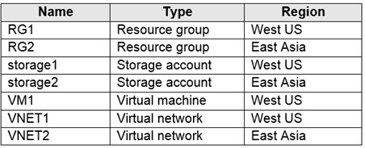

VM1 connects to VNET1.

You need to connect VM1 to VNET2.

Solution: You move VM1 to RG2, and then you add a new network interface to VM1. Does this meet the goal?

|  |  |
| --- | --- |
| A. | Yes |
| B. | No |

**Answer:** B

**Explanation:**

Instead you should delete VM1. You recreate VM1, and then you add the network interface for VM1.

Note: When you create an Azure virtual machine (VM), you must create a virtual network (VNet) or use an existing VNet. You can change the subnet a VM is connected to after it's created, but you cannot change the VNet.

Reference:

https://docs.microsoft.com/en-us/azure/virtual-machines/windows/network-overview

### QUESTION 240

**Note: This question is part of a series of questions that present the same scenario. Each question in the series contains a unique solution that might meet the stated goals. Some question sets might have more than one correct solution, while others might not have a correct solution.**

**After you answer a question in this section, you will NOT be able to return to it. As a result, these questions will not appear in the review screen.**

You have an Azure subscription that contains the resources shown in the following table.

VM1 connects to VNET1.

You need to connect VM1 to VNET2.

Solution: You delete VM1. You recreate VM1, and then you create a new network interface for VM1 and connect it to VNET2.

Does this meet the goal?

|  |  |
| --- | --- |
| A. | Yes |
| B. | No |

**Answer:** A

**Explanation:**

You should delete VM1. You recreate VM1, and then you add the network interface for VM1. Note: When you create an Azure virtual machine (VM), you must create a virtual network (VNet) or use an existing VNet. You can change the subnet a VM is connected to after it's created, but you cannot change the VNet.

Reference:

https://docs.microsoft.com/en-us/azure/virtual-machines/windows/network-overview

### QUESTION 241

**Note: This question is part of a series of questions that present the same scenario. Each question in the series contains a unique solution that might meet the stated goals. Some question sets might have more than one correct solution, while others might not have a correct solution.**

**After you answer a question in this section, you will NOT be able to return to it. As a result, these questions will not appear in the review screen.**

You have an Azure subscription that contains the resources shown in the following table.

VM1 connects to VNET1.

You need to connect VM1 to VNET2.

Solution: You turn off VM1, and then you add a new network interface to VM1. Does this meet the goal?

|  |  |
| --- | --- |
| A. | Yes |
| B. | No |

**Answer:** B

**Explanation:**

Instead you should delete VM1. You recreate VM1, and then you add the network interface for VM1.

Note: When you create an Azure virtual machine (VM), you must create a virtual network (VNet) or use an existing VNet. You can change the subnet a VM is connected to after it's created, but you cannot change the VNet.

Reference:

https://docs.microsoft.com/en-us/azure/virtual-machines/windows/network-overview

### QUESTION 242

You deploy an Azure Kubernetes Service (AKS) cluster named Cluster1 that uses the IP addresses shown in the following table.

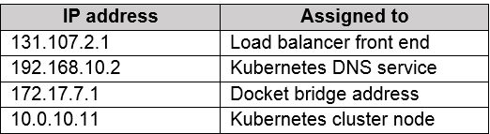

You need to provide internet users with access to the applications that run in Cluster1. Which IP address should you include in the DNS record for Cluster1?

|  |  |
| --- | --- |
| A. | 131.107.2.1 |

|  |  |
| --- | --- |
| B. | 10.0.10.11 |
| C. | 172.17.7.1 |
| D. | 192.168.10.2 |

**Answer:** A

### QUESTION 243

You have a deployment template named Template1 that is used to deploy 10 Azure web apps.

You need to identify what to deploy before you deploy Template1. The solution must minimize Azure costs.

What should you identify?

|  |  |
| --- | --- |
| A. | five Azure Application Gateways |
| B. | one App Service plan |
| C. | 10 App Service plans |
| D. | one Azure Traffic Manager |
| E. | one Azure Application Gateway |

**Answer:** B

**Explanation:**

You create Azure web apps in an App Service plan. Reference:

https://docs.microsoft.com/en-us/azure/app-service/overview-hosting-plans

### QUESTION 244

You have an Azure subscription that contains a virtual machine named VM1. VM1 hosts a line-of- business application that is available 24 hours a day. VM1 has one network interface and one managed disk. VM1 uses the D4s v3 size.

You plan to make the following changes to VM1:

* Change the size to D8s v3.
* Add a 500-GB managed disk.
* Add the Puppet Agent extension.
* Enable Desired State Configuration Management.

Which change will cause downtime for VM1?

|  |  |
| --- | --- |
| A. | Enable Desired State Configuration Management |
| B. | Add a 500-GB managed disk |
| C. | Change the size to D8s v3 |
| D. | Add the Puppet Agent extension |

**Answer:** C

**Explanation:**

While resizing the VM it must be in a stopped state. Reference:

https://azure.microsoft.com/en-us/blog/resize-virtual-machines/

### QUESTION 245

You have an app named App1 that runs on an Azure web app named webapp1.

The developers at your company upload an update of App1 to a Git repository named Git1. Webapp1 has the deployment slots shown in the following table.

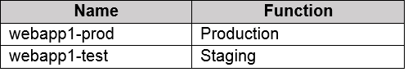

You need to ensure that the App1 update is tested before the update is made available to users. Which two actions should you perform? Each correct answer presents part of the solution.

|  |  |
| --- | --- |
| A. | Swap the slots |
| B. | Deploy the App1 update to webapp1-prod, and then test the update |
| C. | Stop webapp1-prod |
| D. | Deploy the App1 update to webapp1-test, and then test the update |
| E. | Stop webapp1-test |

**Answer:** AD

### QUESTION 246

You have an Azure subscription named Subscription1 that has the following providers registered:

 Authorization  Automation

 Resources  Compute

 KeyVault  Network  Storage  Billing

 Web

Subscription1 contains an Azure virtual machine named VM1 that has the following configurations:

 Private IP address: 10.0.0.4 (dynamic)  Network security group (NSG): NSG1  Public IP address: None

 Availability set: AVSet  Subnet: 10.0.0.0/24

 Managed disks: No  Location: East US

You need to record all the successful and failed connection attempts to VM1.

Which three actions should you perform? Each correct answer presents part of the solution. NOTE: Each correct selection is worth one point.

|  |  |
| --- | --- |
| A. | Enable Azure Network Watcher in the East US Azure region. |
| B. | Add an Azure Network Watcher connection monitor. |
| C. | Register the MicrosoftLogAnalytics provider. |
| D. | Create an Azure Storage account. |
| E. | Register the Microsoft.Insights resource provider. |
| F. | Enable Azure Network Watcher flow logs. |

**Answer:** AEF

**Explanation:**

https://docs.microsoft.com/en-us/azure/network-watcher/network-watcher-nsg-flow-logging-portal

### QUESTION 247

You need to deploy an Azure virtual machine scale set that contains five instances as quickly as possible.

What should you do?

|  |  |
| --- | --- |
| A. | Deploy five virtual machines. Modify the Availability Zones settings for each virtual machine. |
| B. | Deploy five virtual machines. Modify the Size setting for each virtual machine. |
| C. | Deploy one virtual machine scale set that is set to VM (virtual machines) orchestration mode. |
| D. | Deploy one virtual machine scale set that is set to ScaleSetVM orchestration mode. |

**Answer:** D

**Explanation:**

https://docs.microsoft.com/en-us/azure/virtual-machine-scale-sets/orchestration-modes

### QUESTION 248

You plan to create the Azure web apps shown in the following table.

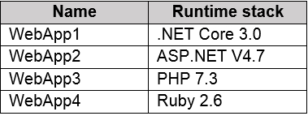

What is the minimum number of App Service plans you should create for the web apps?

|  |  |
| --- | --- |
| A. | 1 |
| B. | 2 |
| C. | 3 |
| D. | 4 |

**Answer:** B

**Explanation:**

It is possible to add more than one web app with different runtime stacks to the same app service plan, if the runtime stack is supported on the given operating system type.

.NET Core 3.0 -> supported on Windows and Linux ASP .NET V4.7 -> Windows only

PHP -> Windows and Linux Ruby 2.6 -> Linux only

So the minimum number of app service plans should be 2.

### QUESTION 249

Your company has three offices. The offices are located in Miami, Los Angeles, and New York. Each office contains datacenter.

You have an Azure subscription that contains resources in the East US and West US Azure regions. Each region contains a virtual network. The virtual networks are peered.

You need to connect the datacenters to the subscription. The solution must minimize network latency between the datacenters.

What should you create?

|  |  |
| --- | --- |
| A. | three Azure Application Gateways and one On-premises data gateway |
| B. | three virtual hubs and one virtual WAN |
| C. | three virtual WANs and one virtual hub |
| D. | three On-premises data gateways and one Azure Application Gateway |

**Answer:** C

**Explanation:**

https://docs.microsoft.com/en-us/azure/virtual-wan/virtual-wan-about

### QUESTION 250

Drag and Drop Question

You have an Azure subscription that contains two virtual networks named VNet1 and VNet2. Virtual machines connect to the virtual networks.

The virtual networks have the address spaces and the subnets configured as shown in the following table.

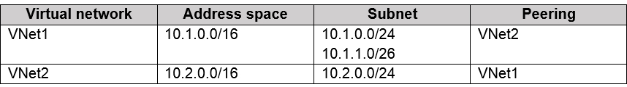

You need to add the address space of 10.33.0.0/16 to VNet1. The solution must ensure that the hosts on VNet1 and VNet2 can communicate.

Which three actions should you perform in sequence? To answer, move the appropriate actions from the list of actions to the answer area and arrange them in the correct order.

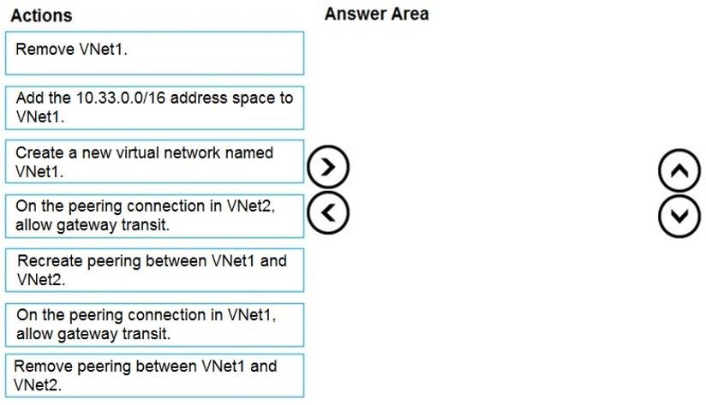

**Answer:**

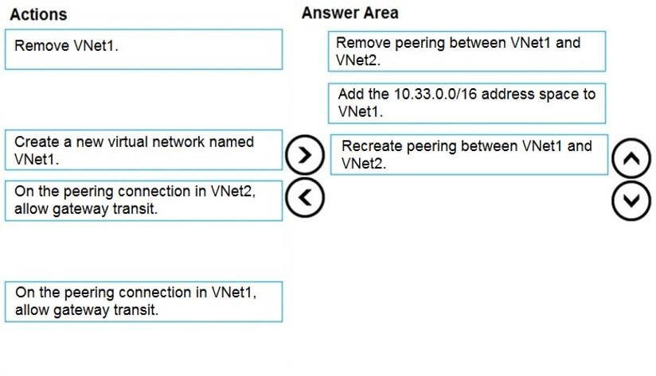

**Explanation:**

Step 1: Remove peering between Vnet1 and VNet2.

You can't add address ranges to, or delete address ranges from a virtual network's address space once a virtual network is peered with another virtual network. To add or remove address ranges, delete the peering, add or remove the address ranges, then re-create the peering.

Step 2: Add the 10.44.0.0/16 address space to VNet1. Step 3: Recreate peering between VNet1 and VNet2

Reference:

https://docs.microsoft.com/en-us/azure/virtual-network/virtual-network-manage-peering

### QUESTION 251

You have an Azure subscription that contains a virtual network named VNet1. VNet1 contains four subnets named Gateway, Perimeter, NVA, and Production.

The NVA subnet contains two network virtual appliances (NVAs) that will perform network traffic inspection between the Perimeter subnet and the Production subnet.

You need to implement an Azure load balancer for the NVAs. The solution must meet the following requirements:

* The NVAs must run in an active-active configuration that uses automatic failover.
* The NVA must load balance traffic to two services on the Production subnet. The services have different IP addresses.

Which three actions should you perform? Each correct answer presents part of the solution. NOTE: Each correct selection is worth one point.

|  |  |
| --- | --- |
| A. | Deploy a basic load balancer |
| B. | Deploy a standard load balancer |
| C. | Add two load balancing rules that have HA Ports and Floating IP enabled |
| D. | Add two load balancing rules that have HA Ports enabled and Floating IP disabled |
| E. | Add a frontend IP configuration, a backend pool, and a health probe |
| F. | Add a frontend IP configuration, two backend pools, and a health probe |

**Answer:** BCF

**Explanation:**

A standard load balancer is required for the HA ports.

Two backend pools are needed as there are two services with different IP addresses. Floating IP rule is used where backend ports are reused.

Incorrect Answers:

E: HA Ports are not available for the basic load balancer. Reference:

https://docs.microsoft.com/en-us/azure/load-balancer/load-balancer-standard-overview https://docs.microsoft.com/en-us/azure/load-balancer/load-balancer-multivip-overview

### QUESTION 252

You have an Azure subscription named Subscription1 that contains two Azure virtual networks named VNet1 and VNet2. VNet1 contains a VPN gateway named VPNGW1 that uses static routing. There is a site-to-site VPN connection between your on-premises network and VNet1.

On a computer named Client1 that runs Windows 10, you configure a point-to-site VPN connection to VNet1.

You configure virtual network peering between VNet1 and VNet2. You verify that you can connect to VNet2 from the on-premises network. Client1 is unable to connect to VNet2.

You need to ensure that you can connect Client1 to VNet2.

What should you do?

|  |  |
| --- | --- |
| A. | Download and re-install the VPN client configuration package on Client1. |
| B. | Select Allow gateway transit on VNet1. |
| C. | Select Allow gateway transit on VNet2. |
| D. | Enable BGP on VPNGW1 |

**Answer:** A

**Explanation:**

https://docs.microsoft.com/en-us/azure/vpn-gateway/vpn-gateway-about-point-to-site-routing

### QUESTION 253

You have an Azure subscription that contains the resources in the following table.

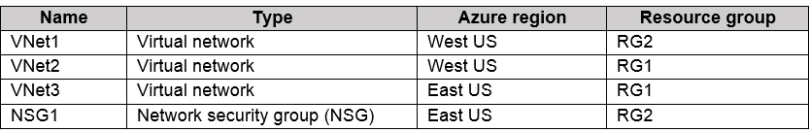

To which subnets can you apply NSG1?

|  |  |
| --- | --- |
| A. | the subnets on VNet1 only |
| B. | the subnets on VNet2 and VNet3 only |
| C. | the subnets on VNet2 only |
| D. | the subnets on VNet3 only |
| E. | the subnets on VNet1, VNet2, and VNet3 |

**Answer:** D

**Explanation:**

All Azure resources are created in an Azure region and subscription. A resource can only be created in a virtual network that exists in the same region and subscription as the resource. Reference:

https://docs.microsoft.com/en-us/azure/virtual-network/virtual-network-vnet-plan-design-arm

### QUESTION 254

Hotspot Question

You have Azure Active Directory tenant named Contoso.com that includes following users:

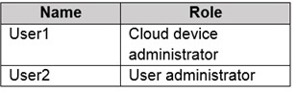

Contoso.com includes following Windows 10 devices:

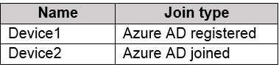

You create following security groups in Contoso.com:

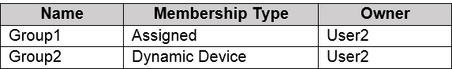

For each of the following statements, select Yes if the statement is true. Otherwise, select No.

**NOTE**: Each correct selection is worth one point.

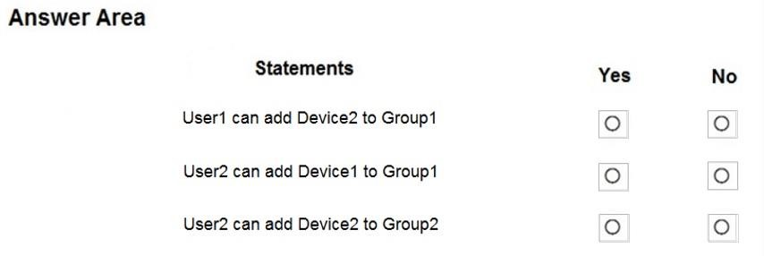

**Answer:**

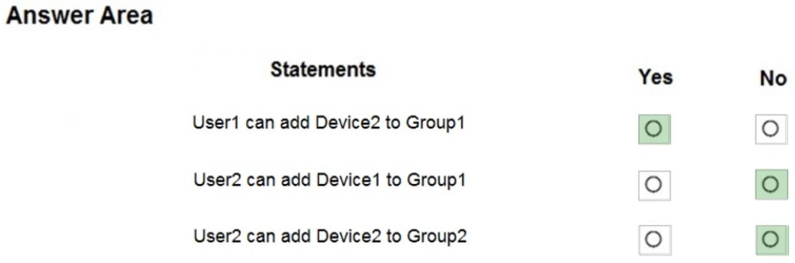

**Explanation:**

Box 1: Yes

User1 is a Cloud Device Administrator. Device2 is Azure AD joined.

Group1 has the assigned to join type. User1 is the owner of Group1.

Note: Assigned groups - Manually add users or devices into a static group. Azure AD joined or hybrid Azure AD joined devices utilize an organizational account in Azure AD

Box 2: No

User2 is a User Administrator. Device1 is Azure AD registered.

Group1 has the assigned join type, and the owner is User1.

Note: Azure AD registered devices utilize an account managed by the end user, this account is either a Microsoft account or another locally managed credential.

Box 3: No

When any attributes of a user or device change, the system evaluates all dynamic group rules in a directory to see if the change would trigger any group adds or removes. If a user or device satisfies a rule on a group, they are added as a member of that group. If they no longer satisfy the rule, they are removed. **You can't manually add or remove a member of a dynamic group.**

Dynamic rules are based on a written logic and not manually managed by users.

Reference:

https://docs.microsoft.com/en-us/azure/active-directory/devices/overview

### QUESTION 255

Hotspot Question

You have an Azure subscription that contains an Azure Storage account.

You plan to copy an on-premises virtual machine image to a container named vmimages. You need to create the container for the planned image.

Which command should you run? To answer, select the appropriate options in the answer area. NOTE: Each correct selection is worth one point.

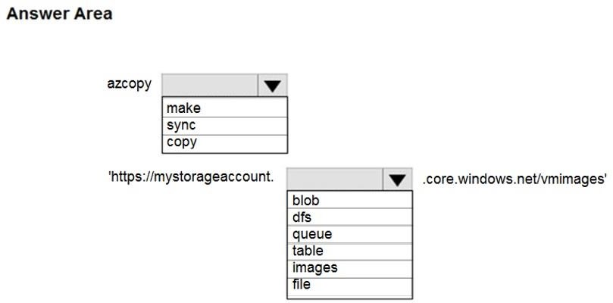

**Answer:**

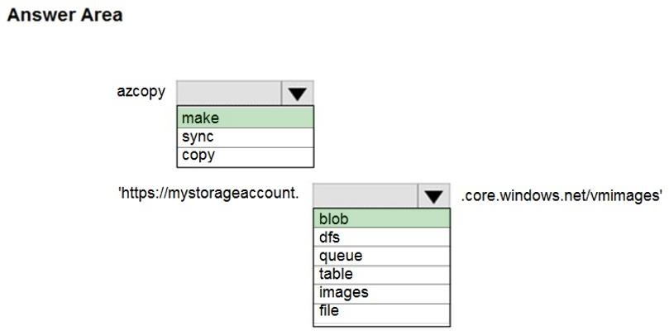

### QUESTION 256

Hotspot Question

You have an Azure File sync group that has the endpoints shown in the following table.

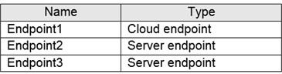

Cloud tiering is enabled for Endpoint3.

You add a file named File1 to Endpoint1 and a file named File2 to Endpoint2.

On which endpoints will File1 and File2 be available within 24 hours of adding the files? To answer, select the appropriate options in the answer area.

NOTE: Each correct selection is worth one point.

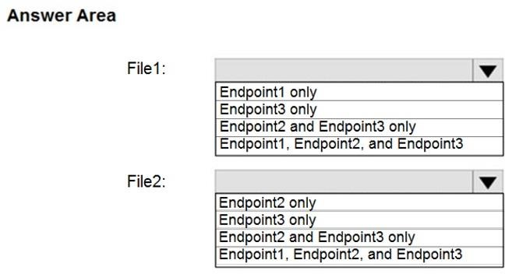

**Answer:**

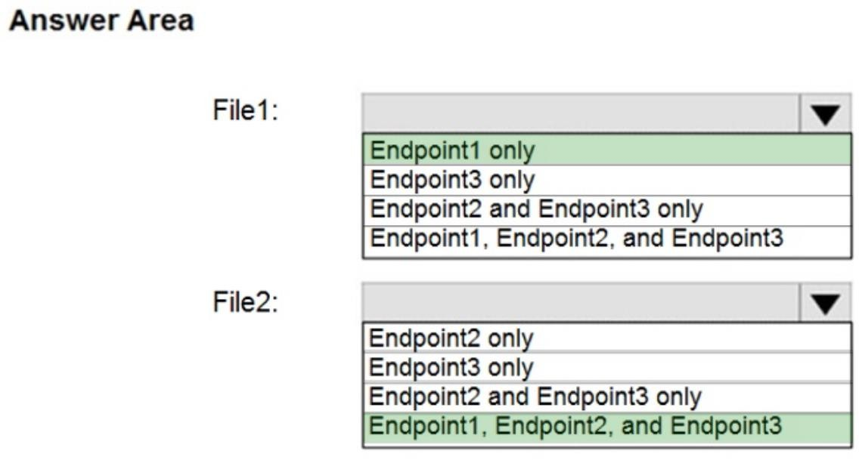

**Explanation:**

File1: Endpoint1 only

It is a cloud endpoint, and it is scanned by the detection job every 24 hours.

File2: Endpoint1, Endpoint2 and Endpoint3

With the on-premises servers the file is scanned and synced automatically after it's being added.

Reference:

https://docs.microsoft.com/en-us/azure/storage/files/storage-sync-cloud-tiering

Note: If they changed the question in Exam from "within 24 hours" to "after 24 hours". So, the answer is:

File1: Endpoint1, Endpoint2 and Endpoint3 File2: Endpoint1, Endpoint2 and Endpoint3

Reference:

https://docs.microsoft.com/en-us/learn/modules/extend-share-capacity-with-azure-file-sync/2- what-azure-file-sync

### QUESTION 257

Hotspot Question

You have several Azure virtual machines on a virtual network named VNet1. You configure an Azure Storage account as shown in the following exhibit.

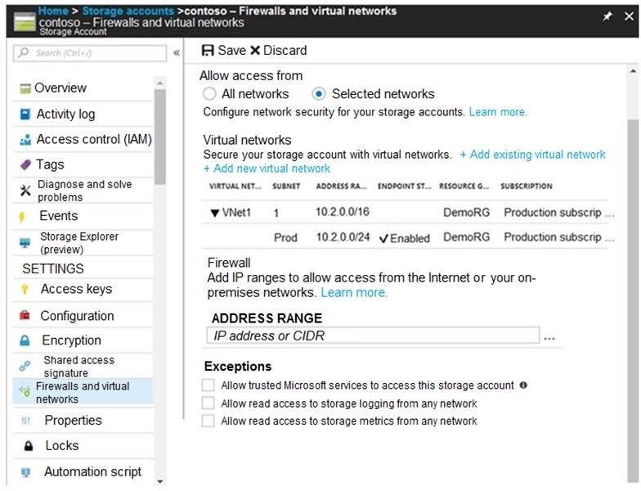

Use the drop-down menus to select the answer choice that completes each statement based on the information presented in the graphic.

NOTE: Each correct selection is worth one point.

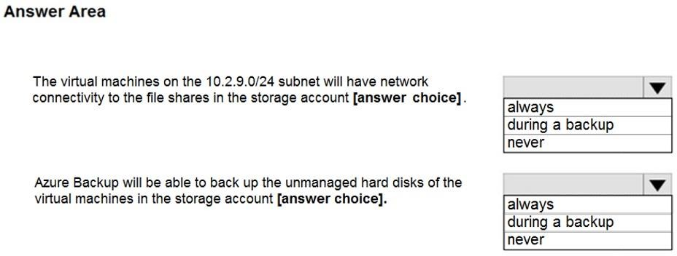

**Answer:**

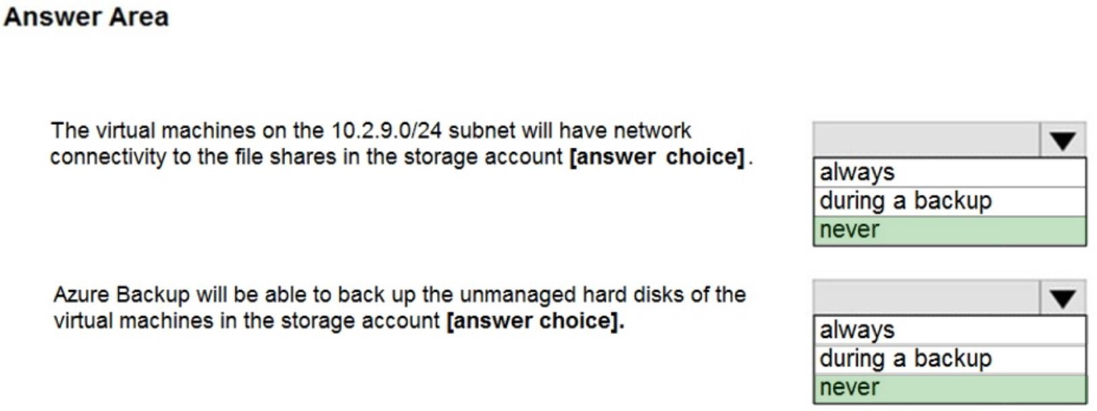

**Explanation:**

Box 1: Never

The 10.2.9.0/24 is part of the first subnet listed in the exhibit. The endpoint status is not enabled.

Box 2: Never

After you configure firewall and virtual network settings for your storage account, select Allow trusted Microsoft services to access this storage account as an exception to enable Azure Backup service to access the network restricted storage account.

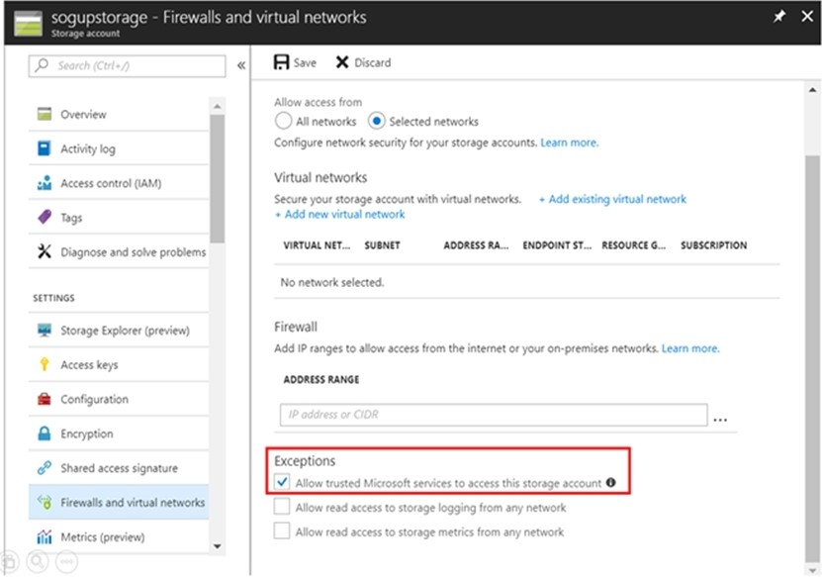

Reference:

https://docs.microsoft.com/en-us/azure/storage/files/storage-how-to-use-files-windows https://azure.microsoft.com/en-us/blog/azure-backup-now-supports-storage-accounts-secured- with-azure-storage-firewalls-and-virtual-networks/

### QUESTION 258

Hotspot Question

You have a sync group named Sync1 that has a cloud endpoint. The cloud endpoint includes a file named File1.txt.

Your on-premises network contains servers that run Windows Server 2016. The servers are configured as shown in the following table.

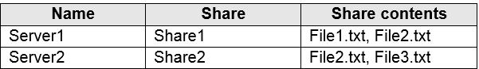

You add Share1 as an endpoint for Sync1. One hour later, you add Share2 as an endpoint for Sync1.

For each of the following statements, select Yes if the statement is true. Otherwise, select No. NOTE: Each correct selection is worth one point.

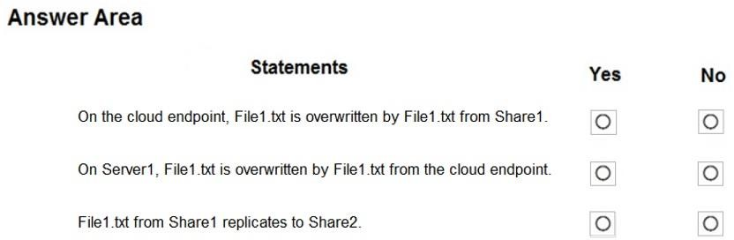

**Answer:**

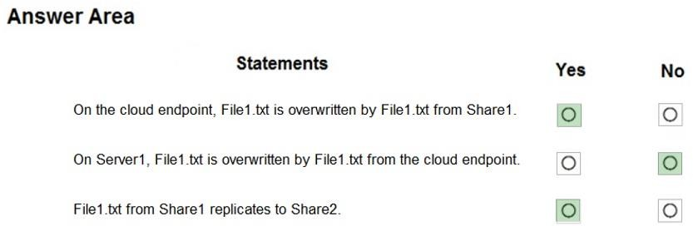

**Explanation:**

Box 1: Yes

If you add an Azure file share that has an existing set of files as a cloud endpoint to a sync group, the existing files are merged with any other files that are already on other endpoints in the sync group.

Box 2: No

Box 3: Yes Reference:

https://docs.microsoft.com/en-us/azure/storage/files/storage-sync-files-planning

### QUESTION 259

Hotspot Question

You have an Azure subscription named Subscription1 that contains the quotas shown in the following table.

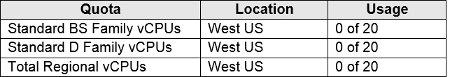

You deploy virtual machine to Subscription1 as shown in the following table.

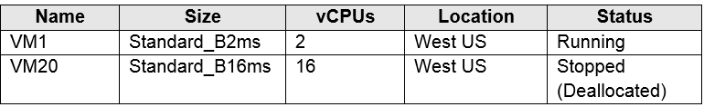

You plan to deploy the virtual machines shown in the following table.

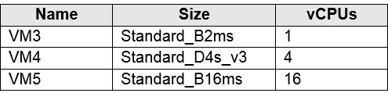

For each of the following statements, select Yes if the statement is true. Otherwise, select No. NOTE: Each correct selection is worth one point.

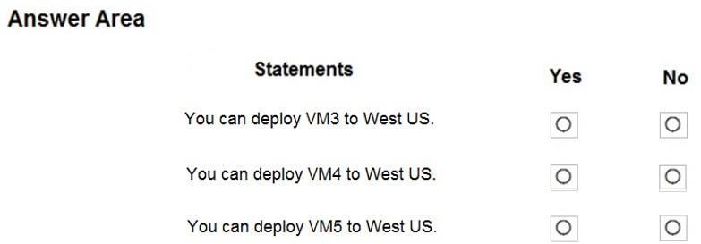

**Answer:**

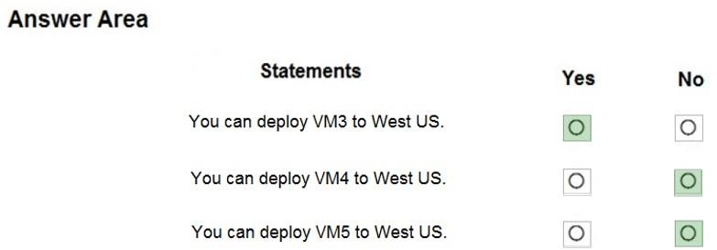

**Explanation:**

The total regional vCPUs is 20 so that means a maximum total of 20 vCPUs across all the different VM sizes. The deallocated VM with 16 vCPUs counts towards the total. VM20 and VM1 are using 18 of the maximum 20 vCPUs leaving only two vCPUs available.

Reference:

https://docs.microsoft.com/en-us/azure/virtual-machines/windows/quotas

### QUESTION 260

Hotspot Question

You have an Azure subscription that contains an Azure Availability Set named WEBPROD-AS- USE2 as shown in the following exhibit.

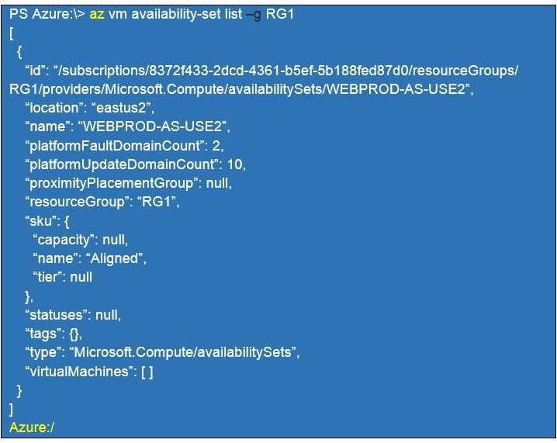

You add 14 virtual machines to WEBPROD-AS-USE2.

Use the drop-down menus to select the answer choice that completes each statement based on the information presented in the graphic.

NOTE: Each correct selection is worth one point.

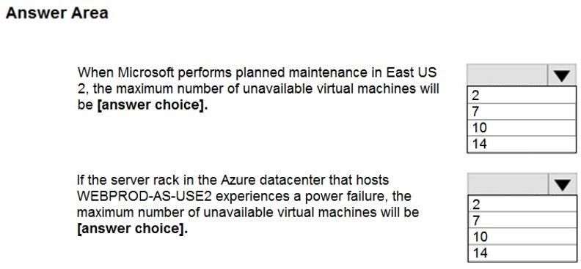

**Answer:**

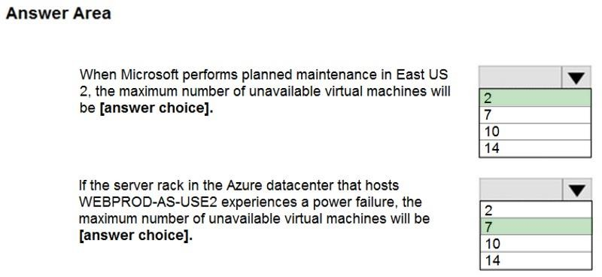

**Explanation:**

Box 1: 2

There are 10 update domains. The 14 VMs are shared across the 10 update domains so four update domains will have two VMs and six update domains will have one VM. Only one update domain is rebooted at a time. Therefore, a maximum of two VMs will be offline.

Box 2: 7

There are 2 fault domains. The 14 VMs are shared across the 2 fault domains, so 7 VMs in each fault domain. A rack failure will affect one fault domain so 7 VMs will be offline.

Reference:

https://docs.microsoft.com/en-us/azure/virtual-machines/windows/manage-availability

### QUESTION 261

Hotspot Question

You plan to deploy an Azure container instance by using the following Azure Resource Manager template.

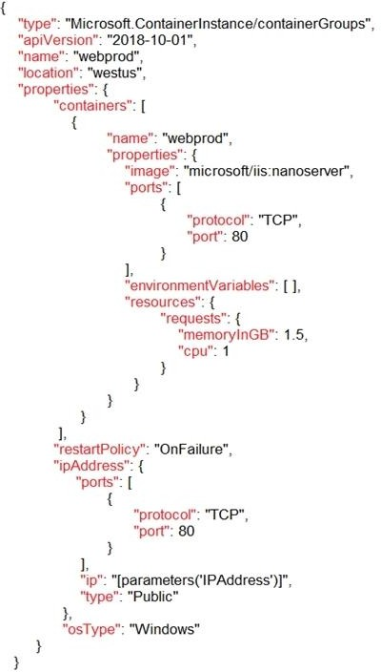

Use the drop-down menus to select the answer choice that completes each statement based on the information presented in the template.

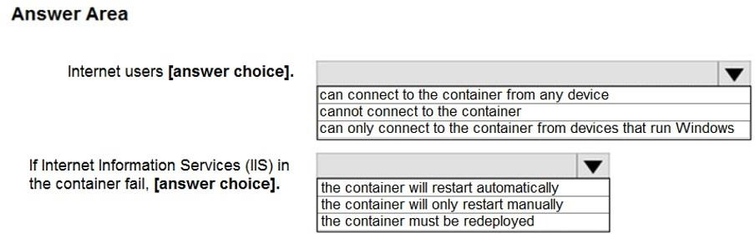

**Answer:**

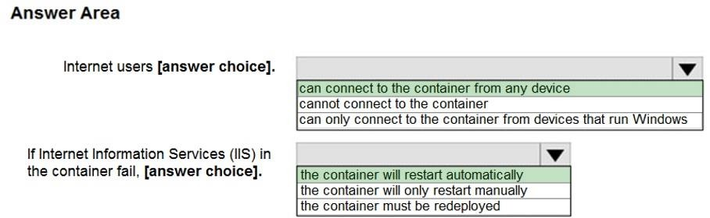

### QUESTION 262

Hotspot Question

You have a pay-as-you-go Azure subscription that contains the virtual machines shown in the following table.

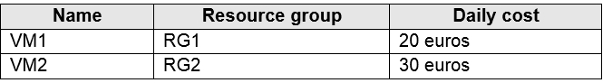

You create the budget shown in the following exhibit.

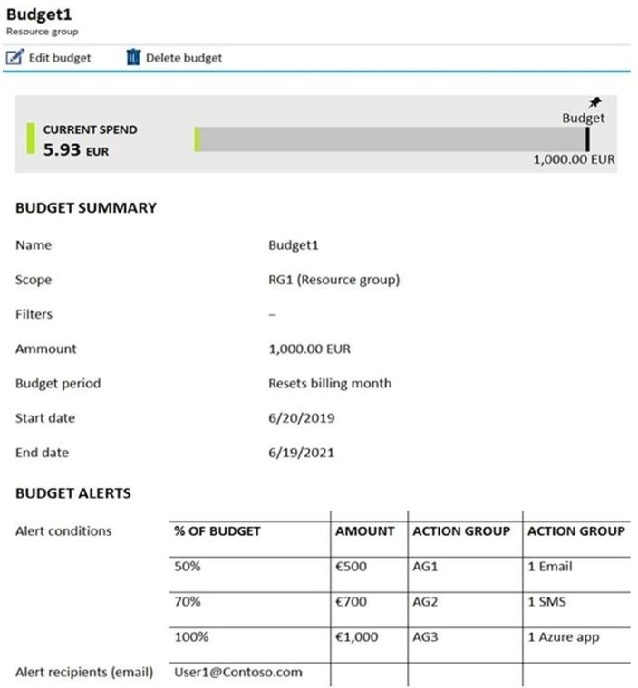

The AG1 action group contains a user named [admin@contoso.com](mailto:admin@contoso.com) only.

Use the drop-down menus to select the answer choice that completes each statement based on the information presented in the graphic.

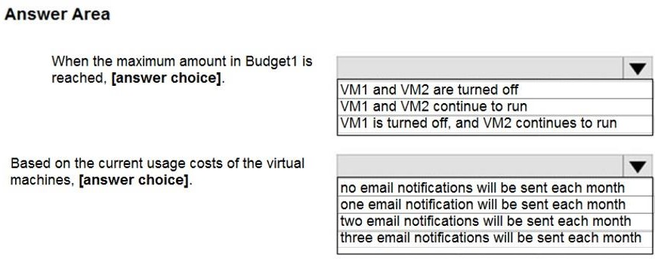

**Answer:**

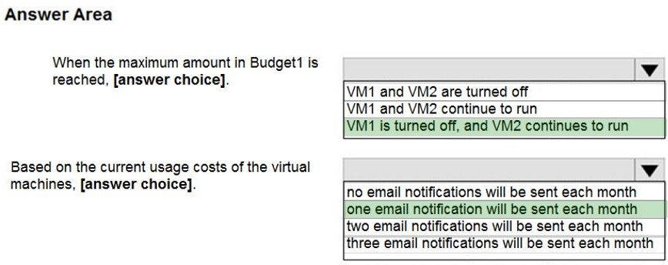

**Explanation:**

Box 1: VM1 is turned off, and VM2 continues to run

The budget alerts are for Resource Group RG1, which include VM1, but not VM2.

Box 2: one email notification will be sent each month.

Budget alerts for Resource Group RG1, which include VM1, but not VM2.VM1 consumes 20 Euro/day. The 50%, 500 Euro limit, will be reached in 25 days, and an email will be sent.

The 70% and 100% alert conditions will not be reached within a month, and they don't trigger email actions anyway.

Credit alerts: Credit alerts are generated automatically at 90% and at 100% of your Azure credit balance. Whenever an alert is generated, it's reflected in cost alerts and in the email sent to the account owners.

90% and 100% will not be reached though.

Reference:

https://docs.microsoft.com/en-us/azure/cost-management-billing/costs/cost-mgt-alerts-monitor- usage-spending

### QUESTION 263

Hotspot Question

You have an Azure subscription named Sub1.

You plan to deploy a multi-tiered application that will contain the tiers shown in the following table.

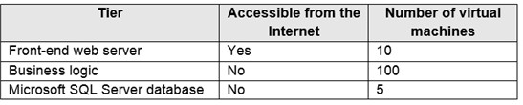

You need to recommend a networking solution to meet the following requirements:

* Ensure that communication between the web servers and the business logic tier spreads equally across the virtual machines.
* Protect the web servers from SQL injection attacks.

Which Azure resource should you recommend for each requirement? To answer, select the appropriate options in the answer area.

NOTE: Each correct selection is worth one point

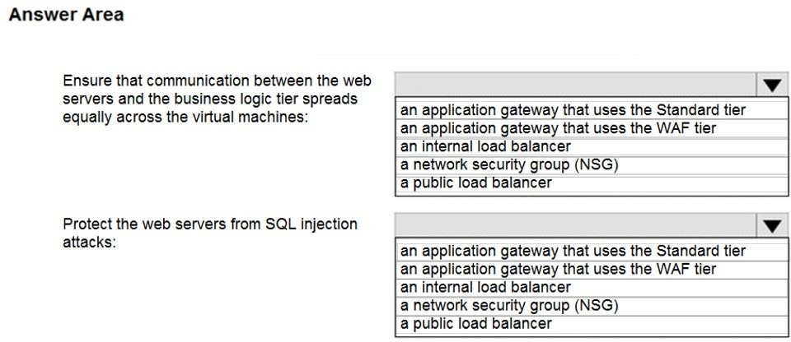

**Answer:**

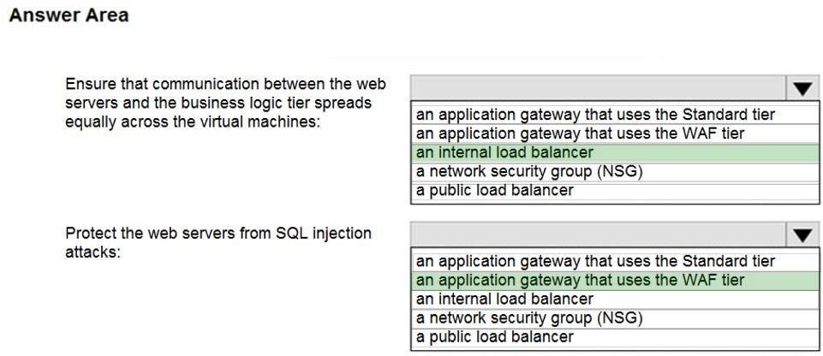

**Explanation:**

Box 1: an internal load balancer

Azure Internal Load Balancer (ILB) provides network load balancing between virtual machines that reside inside a cloud service or a virtual network with a regional scope.

Box 2: an application gateway that uses the WAF tier

Azure Web Application Firewall (WAF) on Azure Application Gateway provides centralized protection of your web applications from common exploits and vulnerabilities. Web applications are increasingly targeted by malicious attacks that exploit commonly known vulnerabilities.

Reference:

https://docs.microsoft.com/en-us/azure/web-application-firewall/ag/ag-overview

### QUESTION 264

Hotspot Question

You have an Azure virtual network named VNet1 that connects to your on-premises network by using a site-to-site VPN. VNet1 contains one subnet named Sunet1.

Subnet1 is associated to a network security group (NSG) named NSG1. Subnet1 contains a basic internal load balancer named ILB1. ILB1 has three Azure virtual machines in the backend pool.

You need to collect data about the IP addresses that connects to ILB1. You must be able to run interactive queries from the Azure portal against the collected data.

What should you do? To answer, select the appropriate options in the answer area. NOTE: Each correct selection is worth one point.

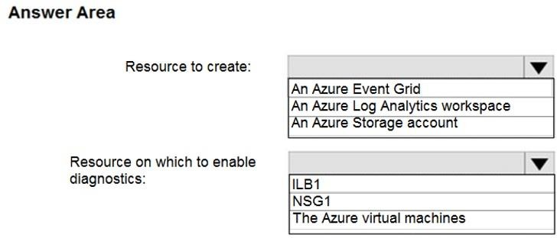

**Answer:**

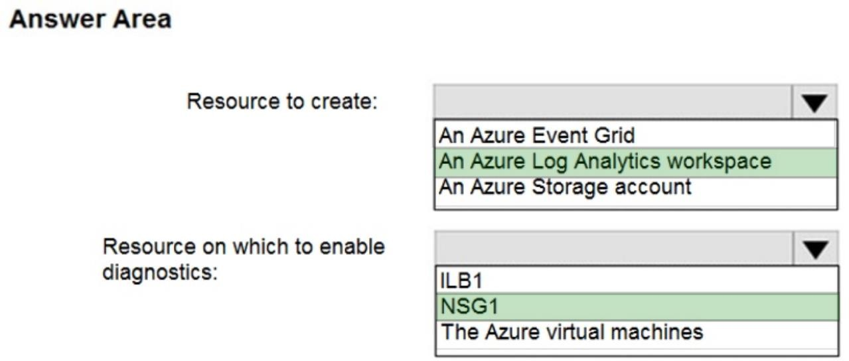

**Explanation:**

Box 1: An Log analytics workspace

Log analytics workspace: An instance of log analytics, where the data pertaining to an Azure account, is stored.

Log Analytics: An Azure service that collects monitoring data and stores the data in a central repository. This data can include events, performance data, or custom data provided through the Azure API. Once collected, the data is available for alerting, analysis, and export. Monitoring applications such as network performance monitor and traffic analytics are built using Log Analytics as a foundation.

Box 2: NSG1

Network security group (NSG): Contains a list of security rules that allow or deny network traffic to resources connected to an Azure Virtual Network. NSGs can be associated to subnets, individual VMs (classic), or individual network interfaces (NIC) attached to VMs (Resource Manager).

References:

https://docs.microsoft.com/en-us/azure/network-watcher/traffic-analytics

**QUESTION 265**

# Case Study 2 - Contoso, Ltd

**Overview**

Contoso, Ltd. is a manufacturing company that has offices worldwide. Contoso works with partner organizations to bring products to market.

Contoso products are manufactured by using blueprint files that the company authors and maintains.

**Existing Environment**

Currently, Contoso uses multiple types of servers for business operations, including the following:

* File servers
* Domain controllers
* Microsoft SQL Server servers

Your network contains an Active Directory forest named contoso.com. All servers and client computers are joined to Active Directory.

You have a public-facing application named App1. App1 is comprised of the following three tiers:

* A SQL database
* A web front end
* A processing middle tier

Each tier is comprised of five virtual machines. Users access the web front end by using HTTPS only.

**Requirements Planned Changes**

Contoso plans to implement the following changes to the infrastructure:

* Move all the tiers of App1 to Azure.
* Move the existing product blueprint files to Azure Blob storage.
* Create a hybrid directory to support an upcoming Microsoft Office 365 migration project.

**Technical Requirements**

Contoso must meet the following technical requirements:

* Move all the virtual machines for App1 to Azure.
* Minimize the number of open ports between the App1 tiers.
* Ensure that all the virtual machines for App1 are protected by backups.
* Copy the blueprint files to Azure over the Internet.
* Ensure that the blueprint files are stored in the archive storage tier.
* Ensure that partner access to the blueprint files is secured and temporary.
* Prevent user passwords or hashes of passwords from being stored in Azure.
* Use unmanaged standard storage for the hard disks of the virtualmachines.
* Ensure that when users join devices to Azure Active Directory (Azure AD), the users use a mobile phone to verify their identity.
* Minimize administrative effort whenever possible.

**User Requirements**

Contoso identifies the following requirements for users:

* Ensure that only users who are part of a group named Pilot can join devices to Azure AD.
* Designate a new user named Admin1 as the service administrator of the Azure subscription.
* Ensure that a new user named User3 can create network objects for the Azure subscription.

Hotspot Question

You need to recommend a solution for App1. The solution must meet the technical requirements.

What should you include in the recommendation? To answer, select the appropriate options in the answer area.

NOTE: Each correct selection is worth one point.

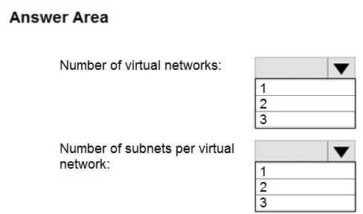

**Answer:**

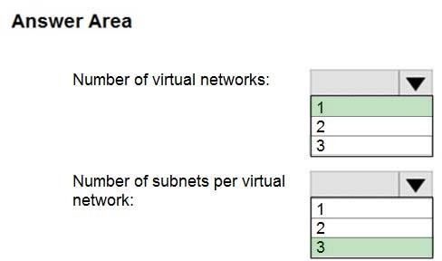

**Explanation:**

This reference architecture shows how to deploy VMs and a virtual network configured for an N- tier application, using SQL Server on Windows for the data tier.

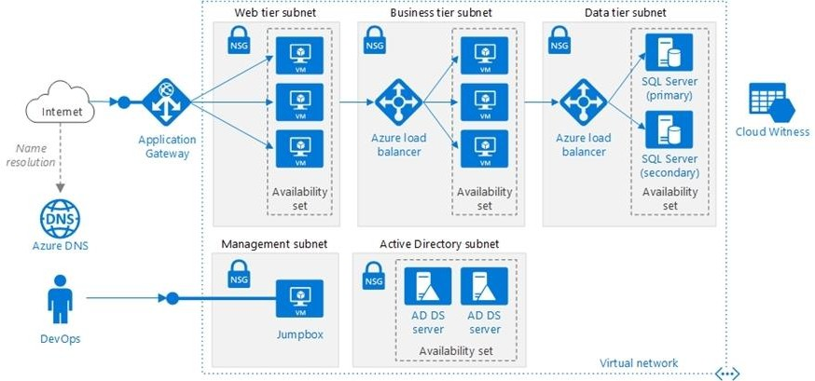

Scenario: You have a public-facing application named App1. App1 is comprised of the following three tiers:

A SQL database A web front end

A processing middle tier

Each tier is comprised of five virtual machines. Users access the web front end by using HTTPS only.

Technical requirements include:

Move all the virtual machines for App1 to Azure.

Minimize the number of open ports between the App1 tiers. Reference:

https://docs.microsoft.com/en-us/azure/architecture/reference-architectures/n-tier/n-tier-sql-server

**QUESTION 266**

# Case Study 3 - Contoso, Ltd

**Overview**

Contoso, Ltd. is a consulting company that has a main office in Montreal and two branch offices in Seattle and New York.

The Montreal office has 2,000 employees. The Seattle office has 1,000 employees. The New York office has 200 employees.

All the resources used by Contoso are hosted on-premises.

Contoso creates a new Azure subscription. The Azure Active Directory (Azure AD) tenant uses adomain named contoso.onmicrosoft.com. The tenant uses the P1 pricing tier.

**Existing Environment**

The network contains an Active Directory forest named contoso.com. All domain controllers are configured as DNS servers and host the contoso.com DNS zone.

Contoso has finance, human resources, sales, research, and information technology departments. Each department has an organizational unit (OU) that contains all the accounts of that respective department. All the user accounts have the department attribute set to their respective department. New users are added frequently.

Contoso.com contains a user named User1. All the offices connect by using private links.

Contoso has data centers in the Montreal and Seattle offices. Each data center has a firewall that can be configured as a VPN device.

All infrastructure servers are virtualized.

The virtualization environment contains the servers in the following table.



Contoso uses two web applications named App1 and App2. Each instance on each web application requires 1GB of memory.

The Azure subscription contains the resources in the following table.



The network security team implements several network security groups (NSGs).

**Planned Changes**

Contoso plans to implement the following changes:

* Deploy Azure ExpressRoute to the Montreal office.
* Migrate the virtual machines hosted on Server1 and Server2 to Azure.
* Synchronize on-premises Active Directory to Azure Active Directory (Azure AD).
* Migrate App1 and App2 to two Azure web apps named WebApp1 and WebApp2.

**Technical requirements**

Contoso must meet the following technical requirements:

* Ensure that WebApp1 can adjust the number of instances automatically based on the load and can scale up to five instances.
* Ensure that VM3 can establish outbound connections over TCP port 8080 to the applications servers in the Montreal office.
* Ensure that routing information is exchanged automatically between Azure and the routers in the Montreal office.
* Ensure Azure Multi-Factor Authentication (MFA) for the users in the finance department only.
* Ensure that webapp2.azurewebsites.net can be accessed by using the name app2.contoso.com
* Connect the New York office to VNet1 over the Internet by using an encrypted connection.
* Create a workflow to send an email message when the settings of VM4 are modified.
* Create a custom Azure role named Role1 that is based on the Reader role.
* Minimize costs whenever possible.

You need to recommend a solution to automate the configuration for the finance department users. The solution must meet the technical requirements.

What should you include in the recommendation?

|  |  |
| --- | --- |
| A. | Azure AD B2C |
| B. | dynamic groups and conditional access policies |
| C. | Azure AD Identity Protection |
| D. | an Azure logic app and the Microsoft Identity Management (MIM) client |

**Answer:** B

**Explanation:**

Scenario: Ensure Azure Multi-Factor Authentication (MFA) for the users in the finance department only.

The recommendation is to use conditional access policies that can then be targeted to groups of users, specific applications, or other conditions.

Reference:

https://docs.microsoft.com/en-us/azure/active-directory/authentication/howto-mfa-userstates

**QUESTION 267**

# Case Study 3 - Contoso, Ltd

**Overview**

Contoso, Ltd. is a consulting company that has a main office in Montreal and two branch offices in Seattle and New York.

The Montreal office has 2,000 employees. The Seattle office has 1,000 employees. The New York office has 200 employees.

All the resources used by Contoso are hosted on-premises.

Contoso creates a new Azure subscription. The Azure Active Directory (Azure AD) tenant uses adomain named contoso.onmicrosoft.com. The tenant uses the P1 pricing tier.

**Existing Environment**

The network contains an Active Directory forest named contoso.com. All domain controllers are configured as DNS servers and host the contoso.com DNS zone.

Contoso has finance, human resources, sales, research, and information technology departments. Each department has an organizational unit (OU) that contains all the accounts of that respective department. All the user accounts have the department attribute set to their respective department. New users are added frequently.

Contoso.com contains a user named User1. All the offices connect by using private links.

Contoso has data centers in the Montreal and Seattle offices. Each data center has a firewall that can be configured as a VPN device.

All infrastructure servers are virtualized.

The virtualization environment contains the servers in the following table.



Contoso uses two web applications named App1 and App2. Each instance on each web application requires 1GB of memory.

The Azure subscription contains the resources in the following table.



The network security team implements several network security groups (NSGs).

**Planned Changes**

Contoso plans to implement the following changes:

* Deploy Azure ExpressRoute to the Montreal office.
* Migrate the virtual machines hosted on Server1 and Server2 to Azure.
* Synchronize on-premises Active Directory to Azure Active Directory (Azure AD).
* Migrate App1 and App2 to two Azure web apps named WebApp1 and WebApp2.

**Technical requirements**

Contoso must meet the following technical requirements:

* Ensure that WebApp1 can adjust the number of instances automatically based on the load and can scale up to five instances.
* Ensure that VM3 can establish outbound connections over TCP port 8080 to the applications servers in the Montreal office.
* Ensure that routing information is exchanged automatically between Azure and the routers in the Montreal office.
* Ensure Azure Multi-Factor Authentication (MFA) for the users in the finance department only.
* Ensure that webapp2.azurewebsites.net can be accessed by using the name app2.contoso.com
* Connect the New York office to VNet1 over the Internet by using an encrypted connection.
* Create a workflow to send an email message when the settings of VM4 are modified.
* Create a custom Azure role named Role1 that is based on the Reader role.
* Minimize costs whenever possible.

Hotspot Question

You need to meet the connection requirements for the New York office.

What should you do? To answer, select the appropriate options in the answer area. NOTE: Each correct selection is worth one point.

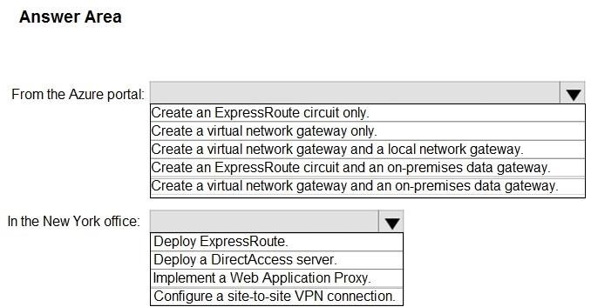

**Answer:**

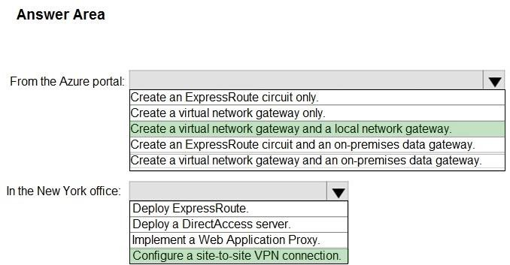

**Explanation:**

Box 1: Create a virtual network gateway and a local network gateway. Azure VPN gateway. The VPN gateway service enables you to connect the VNet to the on-premises network through a

VPN appliance. For more information, see Connect an on-premises network to a Microsoft Azure virtual network. The VPN gateway includes the following elements:

Virtual network gateway. A resource that provides a virtual VPN appliance for the VNet. It is responsible for routing traffic from the on-premises network to the VNet. Local network gateway. An abstraction of the on-premises VPN appliance. Network traffic from the cloud application to the on-premises network is routed through this gateway. Connection. The connection has properties that specify the connection type (IPSec) and the key shared with the on-premises VPN appliance to encrypt traffic. Gateway subnet. The virtual network gateway is held in its own subnet, which is subject to various requirements, described in the Recommendations section below.

Box 2: Configure a site-to-site VPN connection

On premises create a site-to-site connection for the virtual network gateway and the local network gateway.

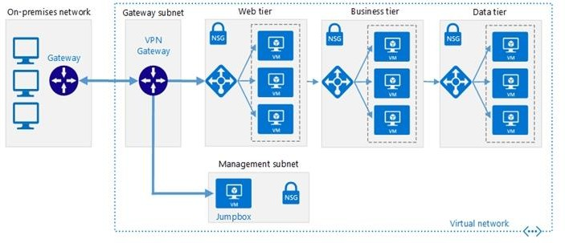

Scenario: Connect the New York office to VNet1 over the Internet by using an encrypted connection.

Incorrect Answers:

Azure ExpressRoute: Established between your network and Azure, through an ExpressRoute partner. This connection is private. Traffic does not go over the internet.

Reference:

https://docs.microsoft.com/en-us/azure/architecture/reference-architectures/hybrid- networking/vpn

**QUESTION 268**

# Case Study 3 - Contoso, Ltd

**Overview**

Contoso, Ltd. is a consulting company that has a main office in Montreal and two branch offices in Seattle and New York.

The Montreal office has 2,000 employees. The Seattle office has 1,000 employees. The New York office has 200 employees.

All the resources used by Contoso are hosted on-premises.

Contoso creates a new Azure subscription. The Azure Active Directory (Azure AD) tenant uses adomain named contoso.onmicrosoft.com. The tenant uses the P1 pricing tier.

**Existing Environment**

The network contains an Active Directory forest named contoso.com. All domain controllers are configured as DNS servers and host the contoso.com DNS zone.

Contoso has finance, human resources, sales, research, and information technology departments. Each department has an organizational unit (OU) that contains all the accounts of that respective department. All the user accounts have the department attribute set to their respective department. New users are added frequently.

Contoso.com contains a user named User1. All the offices connect by using private links.

Contoso has data centers in the Montreal and Seattle offices. Each data center has a firewall that can be configured as a VPN device.

All infrastructure servers are virtualized.

The virtualization environment contains the servers in the following table.



Contoso uses two web applications named App1 and App2. Each instance on each web application requires 1GB of memory.

The Azure subscription contains the resources in the following table.



The network security team implements several network security groups (NSGs).

**Planned Changes**

Contoso plans to implement the following changes:

* Deploy Azure ExpressRoute to the Montreal office.
* Migrate the virtual machines hosted on Server1 and Server2 to Azure.
* Synchronize on-premises Active Directory to Azure Active Directory (Azure AD).
* Migrate App1 and App2 to two Azure web apps named WebApp1 and WebApp2.

**Technical requirements**

Contoso must meet the following technical requirements:

* Ensure that WebApp1 can adjust the number of instances automatically based on the load and can scale up to five instances.
* Ensure that VM3 can establish outbound connections over TCP port 8080 to the applications servers in the Montreal office.
* Ensure that routing information is exchanged automatically between Azure and the routers in the Montreal office.
* Ensure Azure Multi-Factor Authentication (MFA) for the users in the finance department only.
* Ensure that webapp2.azurewebsites.net can be accessed by using the name app2.contoso.com
* Connect the New York office to VNet1 over the Internet by using an encrypted connection.
* Create a workflow to send an email message when the settings of VM4 are modified.
* Create a custom Azure role named Role1 that is based on the Reader role.
* Minimize costs whenever possible.

Hotspot Question

You need to implement Role1.

Which command should you run before you create Role1? To answer, select the appropriate options in the answer area.

NOTE: Each correct selection is worth one point.

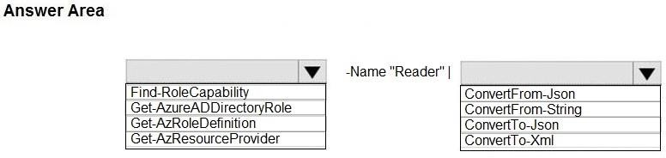

**Answer:**

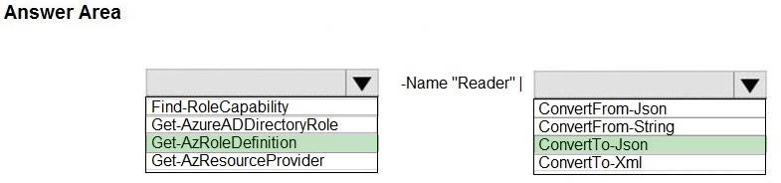

### QUESTION 269

You have an Azure subscription named Subscription1 that contains an Azure Log Analytics workspace named Workspace1.

You need to view the error from a table named Event. Which query should you run in Workspace1?

|  |  |
| --- | --- |
| A. | Get-Event Event | where {$_. EventType == "error"} |
| B. | Event | search "error" |
| C. | select * from Event where EnventType == "error" |
| D. | Event | where EventType is "error" |

**Answer:** B

**Explanation:**

https://docs.microsoft.com/en-us/azure/azure-monitor/log-query/search-queries https://docs.microsoft.com/en-us/azure/azure-monitor/log-query/get-started-portal

### QUESTION 270

You have an Azure subscription named Subscription1. Subscription1 contains the resource groups in the following table.

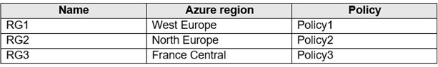

RG1 has a web app named WebApp1. WebApp1 is located in West Europe. You move WebApp1 to RG2.

What is the effect of the move?

|  |  |
| --- | --- |
| A. | The App Service plan for WebApp1 remains in West Europe. Policy2 applies to WebApp1. |
| B. | The App Service plan for WebApp1 moves to North Europe. Policy2 applies to WebApp1. |
| C. | The App Service plan for WebApp1 remains in West Europe. Policy1 applies to WebApp1. |
| D. | The App Service plan for WebApp1 moves to North Europe. Policy1 applies to WebApp1. |

**Answer:** A

**Explanation:**

You can move an app to another App Service plan, as long as the source plan and the target plan are in the same resource group and geographical region.

The region in which your app runs is the region of the App Service plan it's in. However, you cannot change an App Service plan's region.

Reference:

https://docs.microsoft.com/en-us/azure/app-service/app-service-plan-manage

### QUESTION 271

You have an Azure subscription.

Users access the resources in the subscription from either home or from customer sites. From home, users must establish a point-to-site VPN to access the Azure resources. The users on the customer sites access the Azure resources by using site-to-site VPNs.

You have a line-of-business-app named App1 that runs on several Azure virtual machine. The virtual machines run Windows Server 2016.

You need to ensure that the connections to App1 are spread across all the virtual machines.

What are two possible Azure services that you can use? Each correct answer presents a complete solution.

NOTE: Each correct selection is worth one point.

|  |  |
| --- | --- |
| A. | an internal load balancer |
| B. | a public load balancer |
| C. | an Azure Content Delivery Network (CDN) |
| D. | Traffic Manager |
| E. | an Azure Application Gateway |

**Answer:** A

**Explanation:**

Line-of-business apps are custom apps that are used by internal staff members.

### QUESTION 272

You have an Azure subscription.

You have 100 Azure virtual machines.

You need to quickly identify underutilized virtual machines that can have their service tier changed to a less expensive offering.

Which blade should you use?

|  |  |
| --- | --- |
| A. | Monitor |
| B. | Advisor |
| C. | Metrics |
| D. | Customer insights |

**Answer:** B

**Explanation:**

Advisor helps you optimize and reduce your overall Azure spend by identifying idle and underutilized resources. You can get cost recommendations from the Cost tab on the Advisor dashboard.

Reference:

https://docs.microsoft.com/en-us/azure/advisor/advisor-cost-recommendations

### QUESTION 273

You have Azure subscription that includes data in following locations:

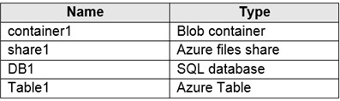

You plan to export data by using Azure import/export job named Export1. You need to identify the data that can be exported by using Export1.

Which data should you identify?

|  |  |
| --- | --- |
| A. | DB1 |
| B. | container1 |
| C. | Share1 |
| D. | Table1 |

**Answer:** B

**Explanation:**

The service only supports Export of Azure Blobs. Export of Azure files is not supported. Import is supported for Azure Blob storage and Azure File storage as well.

Reference:

https://docs.microsoft.com/en-us/azure/storage/common/storage-import-export-service

### QUESTION 274

You have an Azure subscription that contains the resources in the following table.

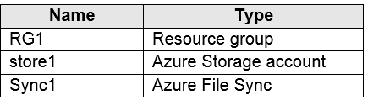

Store1 contains a file share named data. Data contains 5,000 files.

You need to synchronize the files in the file share named data to an on-premises server named Server1.

Which three actions should you perform? Each correct answer presents part of the solution. NOTE: Each correct selection is worth one point.

|  |  |
| --- | --- |
| A. | Create a container instance |
| B. | Register Server1 |
| C. | Install the Azure File Sync agent on Server1 |
| D. | Download an automation script |
| E. | Create a sync group |

**Answer:** BCE

**Explanation:**

Step 1 (C): Install the Azure File Sync agent on Server1 The Azure File Sync agent is a downloadable package that enables Windows Server to be synced with an Azure file share Step 2 (B): Register Server1.

Register Windows Server with Storage Sync Service

Registering your Windows Server with a Storage Sync Service establishes a trust relationship between your server (or cluster) and the Storage Sync Service.

Step 3 (E): Create a sync group and a cloud endpoint.

A sync group defines the sync topology for a set of files. Endpoints within a sync group are kept in sync with each other. A sync group must contain one cloud endpoint, which represents an Azure file share and one or more server endpoints. A server endpoint represents a path on registered server.

Reference:

https://docs.microsoft.com/en-us/azure/storage/files/storage-sync-files-deployment-guide

### QUESTION 275

You download an Azure Resource Manager template based on an existing virtual machine. The template will be used to deploy 100 virtual machines.

You need to modify the template to reference an administrative password. You must prevent the

password from being stored in plain text.

What should you create to store the password?

|  |  |
| --- | --- |
| A. | an Azure Key Vault and an access policy |
| B. | an Azure Storage account and an access policy |
| C. | a Recovery Services vault and a backup policy |
| D. | Azure Active Directory (AD) Identity Protection and an Azure policy |

**Answer:** A

**Explanation:**

You can use a template that allows you to deploy a simple Windows VM by retrieving the password that is stored in a Key Vault. Therefore, the password is never put in plain text in the template parameter file.

Reference:

https://azure.microsoft.com/en-us/resources/templates/101-vm-secure-password/

### QUESTION 276

You plan to automate the deployment of a virtual machine scale set that uses the Windows Server 2016 Datacenter image.

You need to ensure that when the scale set virtual machines are provisioned, they have web server components installed.

Which two actions should you perform? Each correct answer presents part of the solution. NOTE: Each correct selection is worth one point.

|  |  |
| --- | --- |
| A. | Upload a configuration script |
| B. | Create an automation account |
| C. | Create an Azure policy |
| D. | Modify the extensionProfile section of the Azure Resource Manager template |
| E. | Create a new virtual scale set in the Azure portal |

**Answer:** DE

**Explanation:**

Virtual Machine Scale Sets can be used with the Azure Desired State Configuration (DSC) extension handler. Virtual machine scale sets provide a way to deploy and manage large numbers of virtual machines, and can elastically scale in and out in response to load. DSC is used to configure the VMs as they come online so they are running the production software. Reference:

https://docs.microsoft.com/en-us/azure/virtual-machine-scale-sets/virtual-machine-scale-sets-dsc

### QUESTION 277

You have an Azure Resource Manager template named Template1 that is used to deploy an Azure virtual machine.

Template1 contains the following text:

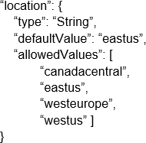

The variables section in Template1 contains the following text:

"location": "westeurope"

The resources section in Template1 contains the following text:

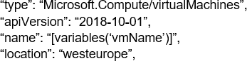

You need to deploy the virtual machine to the West US location by using Template1. What should you do?

|  |  |
| --- | --- |
| A. | Modify the location in the resource section to westus |
| B. | Select West US during the deployment |
| C. | Modify the location in the variables section to westus |

**Answer:** A

### QUESTION 278

You create an App Service plan named Plan1 and an Azure web app named webapp1. You discover that the option to create a staging slot is unavailable.

You need to create a staging slot for Plan1. What should you do first?

|  |  |
| --- | --- |
| A. | From Plan1, scale up the App Service plan |
| B. | From webapp1, modify the Application settings |
| C. | From webapp1, add a custom domain |
| D. | From Plan1, scale out the App Service plan |

**Answer:** A

**Explanation:**

The app must be running in the Standard, Premium, or Isolated tier in order for you to enable multiple deployment slots.

If the app isn't already in the Standard, Premium, or Isolated tier, you receive a message that indicates the supported tiers for enabling staged publishing. At this point, you have the option to select Upgrade and go to the Scale tab of your app before continuing.

Scale up: Get more CPU, memory, disk space, and extra features like dedicated virtual machines (VMs), custom domains and certificates, staging slots, autoscaling, and more.

Incorrect:

Scale out: Increase the number of VM instances that run your app. You can scale out to as many as 30 instances

Reference:

https://docs.microsoft.com/en-us/azure/app-service/deploy-staging-slots https://docs.microsoft.com/en-us/azure/app-service/manage-scale-up

### QUESTION 279

You plan to move a distributed on-premises app named App1 to an Azure subscription. After the planned move, App1 will be hosted on several Azure virtual machines.

You need to ensure that App1 always runs on at least eight virtual machines during planned Azure maintenance.

What should you create?

|  |  |
| --- | --- |
| A. | one virtual machine scale set that has 10 virtual machines instances |
| B. | one Availability Set that has three fault domains and one update domain |
| C. | one Availability Set that has 10 update domains and one fault domain |
| D. | one virtual machine scale set that has 12 virtual machines instances |

**Answer:** C

**Explanation:**

An update domain is a logical group of underlying hardware that can undergo maintenance or be rebooted at the same time. As you create VMs within an availability set, the Azure platform automatically distributes your VMs across these update domains. This approach ensures that at least one instance of your application always remains running as the Azure platform undergoes periodic maintenance.

Reference:

<http://www.thatlazyadmin.com/azure-fault-update-domains/>

### QUESTION 280

**Note: This question is part of a series of questions that present the same scenario. Each question in the series contains a unique solution that might meet the stated goals. Some question sets might have more than one correct solution, while others might not have a correct solution.**

**After you answer a question in this section, you will NOT be able to return to it. As a result, these questions will not appear in the review screen.**

You have an Azure virtual machine named VM1 that runs Windows Server 2016.

You need to create an alert in Azure when more than two error events are logged to the System event log on VM1 within an hour.

Solution: You create an event subscription on VM1. You create an alert in Azure Monitor and specify VM1 as the source.

Does this meet the goal?

|  |  |
| --- | --- |
| A. | Yes |
| B. | No |

**Answer:** B

**Explanation:**

Instead: You create an Azure Log Analytics workspace and configure the data settings. You install the Microsoft Monitoring Agent on VM1. You create an alert in Azure Monitor and specify the Log Analytics workspace as the source.

Reference:

https://docs.microsoft.com/en-us/azure/azure-monitor/platform/agents-overview

### QUESTION 281

**Note: This question is part of a series of questions that present the same scenario. Each question in the series contains a unique solution that might meet the stated goals. Some question sets might have more than one correct solution, while others might not have a correct solution.**

**After you answer a question in this section, you will NOT be able to return to it. As a result, these questions will not appear in the review screen.**

You have an Azure virtual machine named VM1. VM1 was deployed by using a custom Azure Resource Manager template named ARM1.json.

You receive a notification that VM1 will be affected by maintenance. You need to move VM1 to a different host immediately.

Solution: From the Overview blade, you move the virtual machine to a different subscription. Does this meet the goal?

|  |  |
| --- | --- |
| A. | Yes |
| B. | No |

**Answer:** B

**Explanation:**

You would need to redeploy the VM. Reference:

https://docs.microsoft.com/en-us/azure/virtual-machines/windows/redeploy-to-new-node

### QUESTION 282

**Note: This question is part of a series of questions that present the same scenario. Each question in the series contains a unique solution that might meet the stated goals. Some question sets might have more than one correct solution, while others might not have a correct solution.**

**After you answer a question in this section, you will NOT be able to return to it. As a result, these questions will not appear in the review screen.**

You have an Azure virtual machine named VM1. VM1 was deployed by using a custom Azure Resource Manager template named ARM1.json.

You receive a notification that VM1 will be affected by maintenance. You need to move VM1 to a different host immediately.

Solution: From the Redeploy blade, you click Redeploy. Does this meet the goal?

|  |  |
| --- | --- |
| A. | Yes |
| B. | No |

**Answer:** A

**Explanation:**

When you redeploy a VM, it moves the VM to a new node within the Azure infrastructure and then powers it back on, retaining all your configuration options and associated resources.

References:

https://docs.microsoft.com/en-us/azure/virtual-machines/windows/redeploy-to-new-node

### QUESTION 283

**Note: This question is part of a series of questions that present the same scenario. Each question in the series contains a unique solution that might meet the stated goals. Some question sets might have more than one correct solution, while others might not have a correct solution.**

**After you answer a question in this section, you will NOT be able to return to it. As a result, these questions will not appear in the review screen.**

You have an Azure virtual machine named VM1. VM1 was deployed by using a custom Azure Resource Manager template named ARM1.json.

You receive a notification that VM1 will be affected by maintenance. You need to move VM1 to a different host immediately.

Solution: From the Update management blade, you click Enable. Does this meet the goal?

|  |  |
| --- | --- |
| A. | Yes |
| B. | No |

**Answer:** B

**Explanation:**

You would need to redeploy the VM. Reference:

https://docs.microsoft.com/en-us/azure/virtual-machines/windows/redeploy-to-new-node

### QUESTION 284

You have an Azure web app named webapp1.

You have a virtual network named VNET1 and an Azure virtual machine named VM1 that hosts a MySQL database. VM1 connects to VNET1.

You need to ensure that webapp1 can access the data hosted on VM1. What should you do?

|  |  |
| --- | --- |
| A. | Deploy an internal load balancer |
| B. | Peer VNET1 to another virtual network |
| C. | Connect webapp1 to VNET1 |
| D. | Deploy an Azure Application Gateway |

**Answer:** C

**Explanation:**

Connect the webapp to VNET using webapp VNET integration. where webapp can access the resources in the VNET.

https://docs.microsoft.com/en-us/azure/app-service/web-sites-integrate-with-vnet

### QUESTION 285

**Note: This question is part of a series of questions that present the same scenario. Each question in the series contains a unique solution that might meet the stated goals. Some question sets might have more than one correct solution, while others might not have a correct solution.**

**After you answer a question in this section, you will NOT be able to return to it. As a result, these questions will not appear in the review screen.**

You have a computer named Computer1 that has a point-to-site VPN connection to an Azure virtual network named VNet1. The point-to-site connection uses a self-signed certificate.

From Azure, you download and install the VPN client configuration package on a computer named Computer2.

You need to ensure that you can establish a point-to-site VPN connection to VNet1 from Computer2.

Solution: You modify the Azure Active Directory (Azure AD) authentication policies. Does this meet the goal?

|  |  |
| --- | --- |
| A. | Yes |
| B. | No |

**Answer:** B

**Explanation:**

Instead export the client certificate from Computer1 and install the certificate on Computer2. Note:

Each client computer that connects to a VNet using Point-to-Site must have a client certificate installed.

You generate a client certificate from the self-signed root certificate, and then export and install the client certificate. If the client certificate is not installed, authentication fails.

Reference:

https://docs.microsoft.com/en-us/azure/vpn-gateway/vpn-gateway-certificates-point-to-site

### QUESTION 286

**Note: This question is part of a series of questions that present the same scenario. Each question in the series contains a unique solution that might meet the stated goals. Some question sets might have more than one correct solution, while others might not have a correct solution.**

**After you answer a question in this section, you will NOT be able to return to it. As a result, these questions will not appear in the review screen.**

You have a computer named Computer1 that has a point-to-site VPN connection to an Azure virtual network named VNet1. The point-to-site connection uses a self-signed certificate.

From Azure, you download and install the VPN client configuration package on a computer named Computer2.

You need to ensure that you can establish a point-to-site VPN connection to VNet1 from Computer2.

Solution: You join Computer2 to Azure Active Directory (Azure AD) Does this meet the goal?

|  |  |
| --- | --- |
| A. | Yes |
| B. | No |

**Answer:** B

**Explanation:**

A client computer that connects to a VNet using Point-to-Site must have a client certificate installed.

Reference:

https://docs.microsoft.com/en-us/azure/vpn-gateway/vpn-gateway-certificates-point-to-site

### QUESTION 287

**Note: This question is part of a series of questions that present the same scenario. Each question in the series contains a unique solution that might meet the stated goals. Some question sets might have more than one correct solution, while others might not have a correct solution.**

**After you answer a question in this section, you will NOT be able to return to it. As a result, these questions will not appear in the review screen.**

You have an Azure subscription that contains 10 virtual networks. The virtual networks are hosted in separate resource groups.

Another administrator plans to create several network security groups (NSGs) in the subscription.

You need to ensure that when an NSG is created, it automatically blocks TCP port 8080 between the virtual networks.

Solution: You create a resource lock, and then you assign the lock to the subscription. Does this meet the goal?

|  |  |
| --- | --- |
| A. | Yes |
| B. | No |

**Answer:** B

### QUESTION 288

You have an Azure subscription named Subscription1. Subscription1 contains a virtual machine named VM1.

You have a computer named Computer1 that runs Windows 10. Computer1 is connected to the Internet.

You add a network interface named vm1173 to VM1 as shown in the exhibit. (Click the Exhibit tab.)

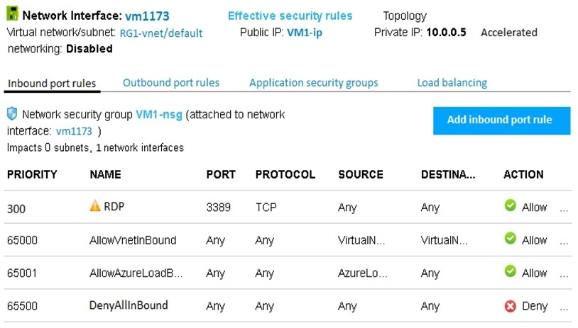

From Computer1, you attempt to connect to VM1 by using Remote Desktop, but the connection fails.

You need to establish a Remote Desktop connection to VM1. What should you do first?

|  |  |
| --- | --- |
| A. | Change the priority of the RDP rule |
| B. | Attach a network interface |
| C. | Delete the DenyAllInBound rule |
| D. | Start VM1 |

**Answer:** D **Explanation:** Incorrect Answers:

A: Rules are processed in priority order, with lower numbers processed before higher numbers, because lower numbers have higher priority. Once traffic matches a rule, processing stops. RDP already has the lowest number and thus the highest priority.

B: The network interface has already been added to VM. C: The Outbound rules are fine.

Reference:

https://docs.microsoft.com/en-us/azure/virtual-network/security-overview

### QUESTION 289

You have the Azure virtual machines shown in the following table.

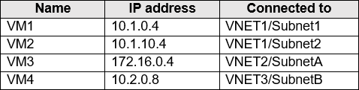

A DNS service is installed on VM1.

You configure the DNS servers settings for each virtual network as shown in the following exhibit.

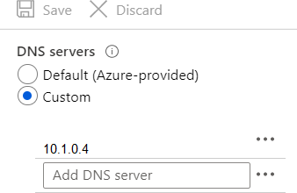

You need to ensure that all the virtual machines can resolve DNS names by using the DNS service on VM1.

What should you do?

|  |  |
| --- | --- |
| A. | Configure a conditional forwarder on VM1 |
| B. | Add service endpoints on VNET1 |
| C. | Add service endpoints on VNET2 and VNET3 |
| D. | Configure peering between VNET1, VNET2, and VNET3 |

**Answer:** D

**Explanation:**

Virtual network peering enables you to seamlessly connect networks in Azure Virtual Network.

The virtual networks appear as one for connectivity purposes. The traffic between virtual machines uses the Microsoft backbone infrastructure.

Incorrect Answers:

B, C: Virtual Network (VNet) service endpoint provides secure and direct connectivity to Azure services over an optimized route over the Azure backbone network. Endpoints allow you to secure your critical Azure service resources to only your virtual networks. Service Endpoints enables private IP addresses in the VNet to reach the endpoint of an Azure service without needing a public IP address on the VNet.

Reference:

https://docs.microsoft.com/en-us/azure/virtual-network/virtual-network-service-endpoints-overview https://docs.microsoft.com/en-us/azure/virtual-network/virtual-network-peering-overview

### QUESTION 290

You have the Azure virtual network named VNet1 that contains a subnet named Subnet1. Subnet1 contains three Azure virtual machines. Each virtual machine has a public IP address.

The virtual machines host several applications that are accessible over port 443 to users on the Internet.

Your on-premises network has a site-to-site VPN connection to VNet1.

You discover that the virtual machines can be accessed by using the Remote Desktop Protocol (RDP) from the Internet and from the on-premises network.

You need to prevent RDP access to the virtual machines from the Internet, unless the RDP connection is established from the on-premises network. The solution must ensure that all the applications can still be accessed by the Internet users.

What should you do?

|  |  |
| --- | --- |
| A. | Modify the address space of the local network gateway |
| B. | Create a deny rule in a network security group (NSG) that is linked to Subnet1 |
| C. | Remove the public IP addresses from the virtual machines |
| D. | Modify the address space of Subnet1 |

**Answer:** B

**Explanation:**

You can use a site-to-site VPN to connect your on-premises network to an Azure virtual network. Users on your on-premises network connect by using the RDP or SSH protocol over the site-to- site VPN connection.

You don't have to allow direct RDP or SSH access over the internet. Reference:

https://docs.microsoft.com/en-us/azure/security/fundamentals/network-best-practices

### QUESTION 291

You have an Azure subscription that contains the resources in the following table.

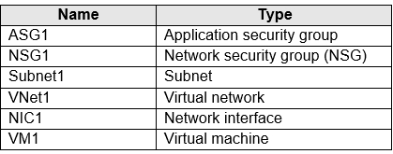

Subnet1 is associated to VNet1. NIC1 attaches VM1 to Subnet1. You need to apply ASG1 to VM1.

What should you do?

|  |  |
| --- | --- |
| A. | Associate NIC1 to ASG1 |
| B. | Modify the properties of ASG1 |
| C. | Modify the properties of NSG1 |

**Answer:** A

**Explanation:**

Application Security Group can be associated with NICs. References:

https://docs.microsoft.com/en-us/azure/virtual-network/security-overview#application-security- groups

### QUESTION 292

You have an Azure subscription named Subscription1 that contains an Azure virtual network named VNet1. VNet1 connects to your on-premises network by using Azure ExpressRoute.

You plan to prepare the environment for automatic failover in case of ExpressRoute failure.

You need to connect VNet1 to the on-premises network by using a site-to-site VPN. The solution must minimize cost.

Which three actions should you perform? Each correct answer presents part of the solution. NOTE: Each correct selection is worth one point.

|  |  |
| --- | --- |
| A. | Create a connection |
| B. | Create a local site VPN gateway |
| C. | Create a VPN gateway that uses the VpnGw1 SKU |
| D. | Create a gateway subnet |
| E. | Create a VPN gateway that uses the Basic SKU |

**Answer:** ABC

**Explanation:**

For a site to site VPN, you need a local gateway, a gateway subnet, a VPN gateway, and a connection to connect the local gateway and the VPN gateway. That would be four answers in this question. However, the question states that VNet1 connects to your on-premises network by

using Azure ExpressRoute. For an ExpressRoute connection, VNET1 must already be configured with a gateway subnet so we don't need another one.

https://docs.microsoft.com/en-us/azure/expressroute/expressroute-howto-coexist-resource- manager

### QUESTION 293

Your company has a main office in London that contains 100 client computers. Three years ago, you migrated to Azure Active Directory (Azure AD).

The company's security policy states that all personal devices and corporate-owned devices must be registered or joined to Azure AD.

A remote user named User1 is unable to join a personal device to Azure AD from a home network.

You verify that User1 was able to join devices to Azure AD in the past. You need to ensure that User1 can join the device to Azure AD.

What should you do?

|  |  |
| --- | --- |
| A. | Assign the User administrator role to User1. |
| B. | From the Device settings blade, modify the Maximum number of devices per user setting. |
| C. | Create a point-to-site VPN from the home network of User1 to Azure. |
| D. | From the Device settings blade, modify the Users may join devices to Azure AD setting. |

**Answer:** B

**Explanation:**

The Maximum number of devices setting enables you to select the maximum number of devices that a

user can have in Azure AD. If a user reaches this quota, they will not be able to add additional devices until one or more of the existing devices are removed.

Incorrect Answers:

C: Azure AD Join enables users to join their devices to Active Directory from anywhere as long as they have connectivity with the Internet.

D: The Users may join devices to Azure AD setting enables you to select the users who can join devices to Azure AD. Options are All, Selected and None. The default is All.

Reference:

https://docs.microsoft.com/en-us/azure/active-directory/devices/device-management-azure-portal <http://techgenix.com/pros-and-cons-azure-ad-join/>

### QUESTION 294

**Note: This question is part of a series of questions that present the same scenario. Each question in the series contains a unique solution that might meet the stated goals. Some question sets might have more than one correct solution, while others might not have a correct solution.**

**After you answer a question in this section, you will NOT be able to return to it. As a result, these questions will not appear in the review screen.**

You have an Azure subscription that contains the following users in an Azure Active Directory tenant named contoso.onmicrosoft.com:

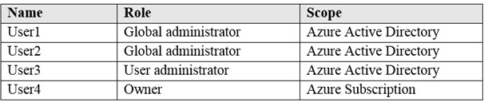

User1 creates a new Azure Active Directory tenant named external.contoso.onmicrosoft.com. You need to create new user accounts in external.contoso.onmicrosoft.com.

Solution: You instruct User1 to create the user accounts. Does that meet the goal?

|  |  |
| --- | --- |
| A. | Yes |
| B. | No |

**Answer:** A

**Explanation:**

Only a global administrator can add users to this tenant. Reference:

https://docs.microsoft.com/en-us/azure/devops/organizations/accounts/add-users-to-azure-ad

### QUESTION 295

Hotspot Question

You have an Azure subscription that contains a virtual network named VNET1 in the East US 2 region.

You have the following resources in an Azure Resource Manager template.

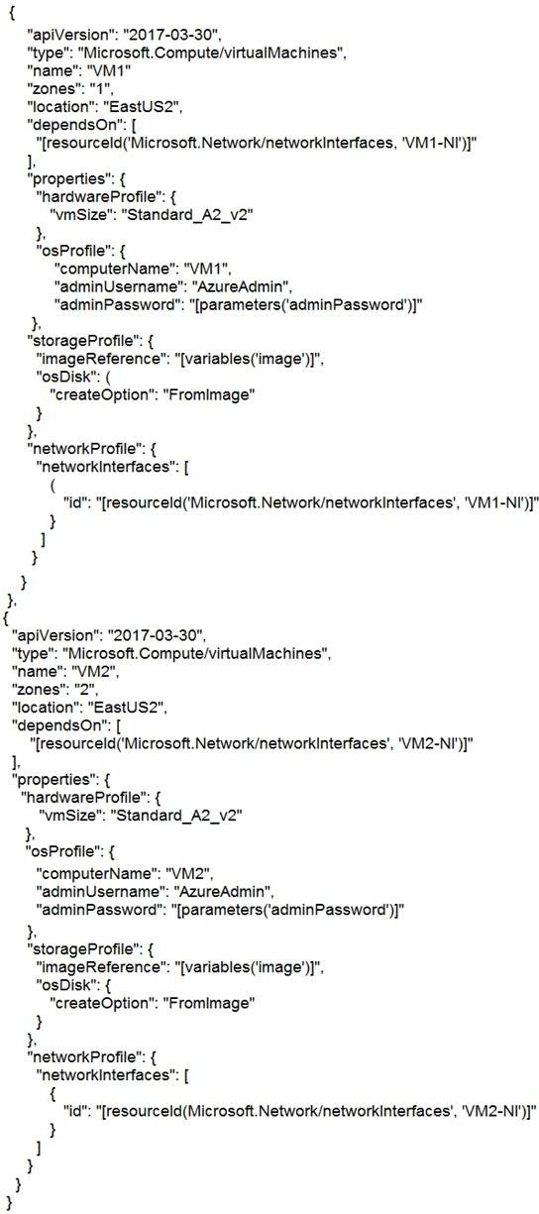

For each of the following statements, select Yes if the statement is true. Otherwise, select No. NOTE: Each correct selection is worth one point.

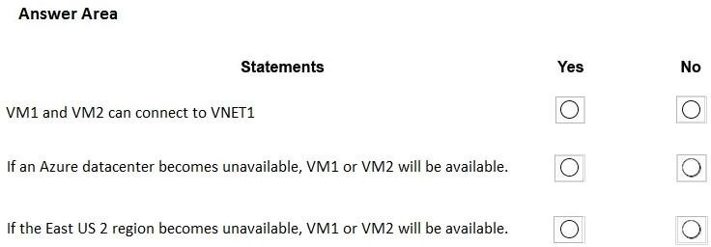

**Answer:**

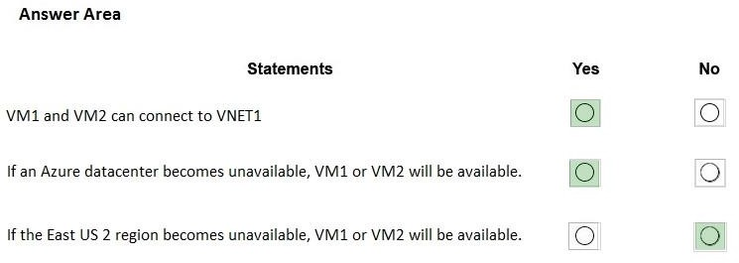

**Explanation:**

Box 1: Yes

Box 2: Yes

VM1 is in Zone1, while VM2 is on Zone2. Box 3: No

Reference:

https://docs.microsoft.com/en-us/azure/architecture/resiliency/recovery-loss-azure-region

### QUESTION 296

Hotspot Question

You have an Azure subscription named Subscription1 that has a subscription ID of c276fc76- 9cd4-44c9- 99a7-4fd71546436e.

You need to create a custom RBAC role named CR1 that meets the following requirements:

* Can be assigned only to the resource groups in Subscription1
* Prevents the management of the access permissions for the resource groups
* Allows the viewing, creating, modifying, and deleting of resources within the resource groups

What should you specify in the assignable scopes and the permission elements of the definition of CR1? To answer, select the appropriate options in the answer area.

NOTE: Each correct selection is worth one point.

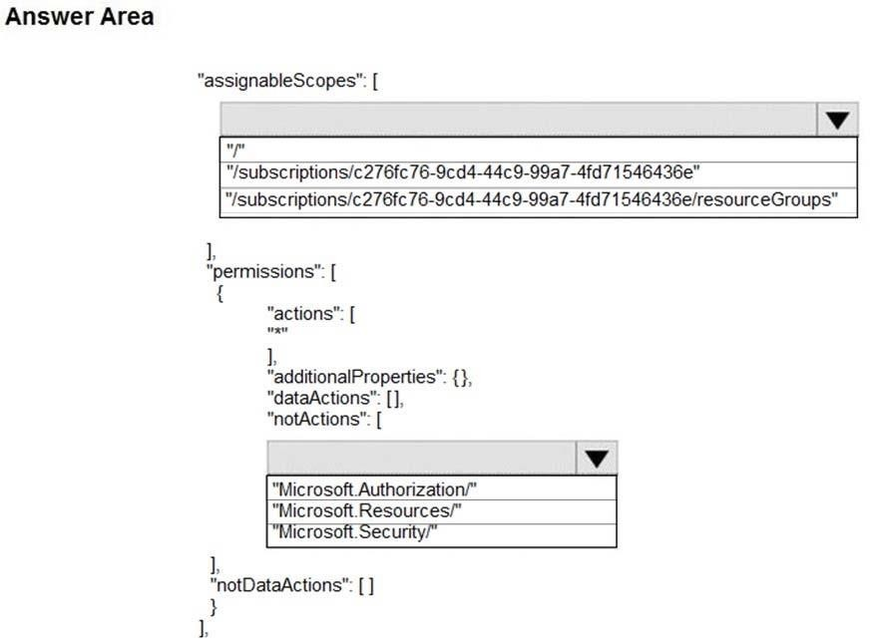

**Answer:**

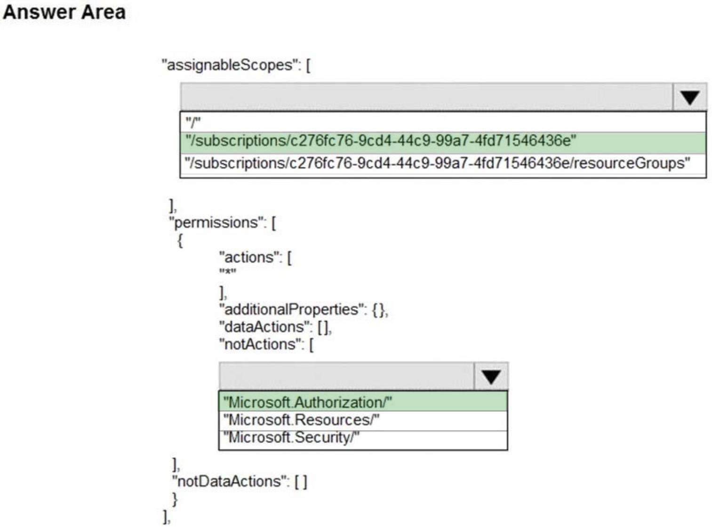

**Explanation:**

Box 1: /subscriptions/c276fc76-9cd4-44c9-99a7-4fd71546436e

There is nothing called "resourceGroups" only or "resourceGroups/*" . You can specify either a subscription, specific resource group, management group or specific resource. for example it should "/subcription/subcription_id/resourceGroups/resource_group_name"

Box 2: Microsoft Authorization

The AssignableScopes property specifies the scopes (management groups, subscriptions, or resource groups) where this role definition can be assigned. You can make the role available for assignment in only the management groups, subscriptions, or resource groups that require it. You must use at least one management group, subscription, or resource group.

Not Actions: An array of strings that specifies the control plane actions that are excluded from the allowed Actions.

Reference:

https://github.com/MicrosoftDocs/azure-docs/blob/master/articles/role-based-access-control/role- definitions.md#role-definition-structure

https://docs.microsoft.com/en-us/azure/role-based-access-control/role- definitions#assignablescopes

### QUESTION 297

Hotspot Question

You have Azure Storage accounts as shown in the following exhibit.

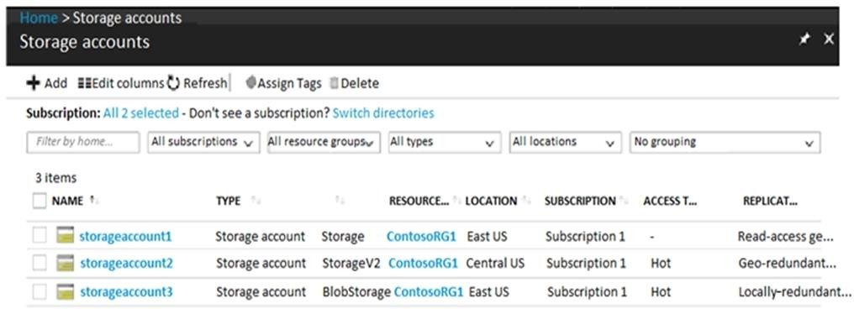

Use the drop-down menus to select the answer choice that completes each statement based on the information presented in the graphic.

NOTE: Each correct selection is worth one point.

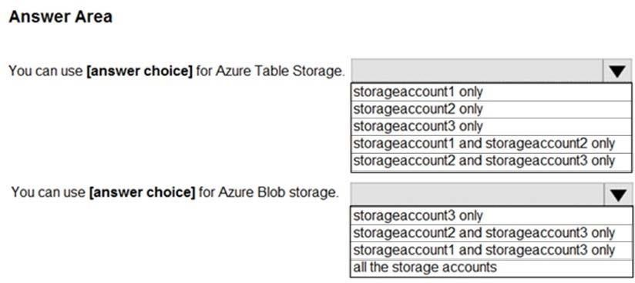

**Answer:**

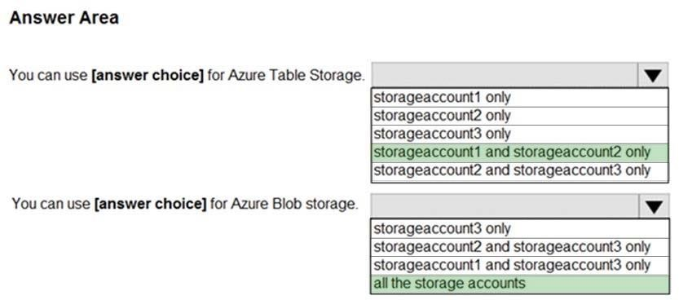

**Explanation:**

Box 1: storageaccount1 and storageaccount2 only Box 2: All the storage accounts

Note: The three different storage account options are: General-purpose v2 (GPv2) accounts, General- purpose v1 (GPv1) accounts, and Blob storage accounts.

General-purpose v2 (GPv2) accounts are storage accounts that support all of the latest features for blobs, files, queues, and tables.

Blob storage accounts support all the same block blob features as GPv2, but are limited to supporting only block blobs.

General-purpose v1 (GPv1) accounts provide access to all Azure Storage services, but may not have the latest features or the lowest per gigabyte pricing.

Reference:

https://docs.microsoft.com/en-us/azure/storage/common/storage-account-options

### QUESTION 298

Hotspot Question

You have an Azure Storage account named storage1.

You have an Azure Service app named App1 and an app named App2 that runs in an Azure container instance. Each app uses a managed identity.

You need to ensure that App1 and App2 can read blobs from storage1. The solution must meet the following requirements:

* Minimize the number of secrets used.
* Ensure that App2 can only read from storage1 for the next 30 days.

What should you configure in storage1 for each app? To answer, select the appropriate options in the answer area.

NOTE: Each correct selection is worth one point.

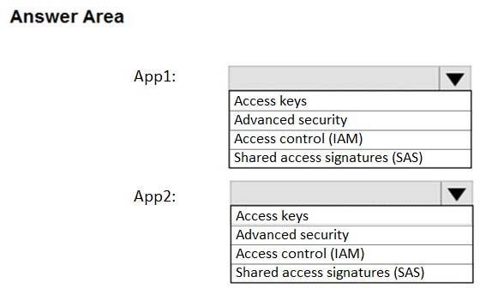

**Answer:**

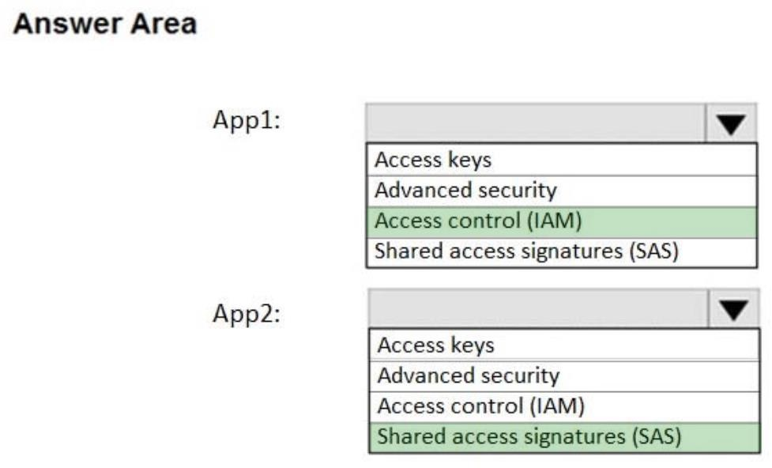

**Explanation:**

Box 1: Access Control (IAM)

Since the App1 uses Managed Identity, App1 can access the Storage Account via IAM. As per requirement, we need to minimize the number of secrets used, so Access keys is not ideal.

Box 2: Shared access signatures (SAS)

We need temp access for App2, so we need to use SAS.

Reference:

https://docs.microsoft.com/en-us/azure/storage/common/storage-auth

### QUESTION 299

Hotspot Question

You need to create an Azure Storage account that meets the following requirements:

* Minimizes costs
* Supports hot, cool, and archive blob tiers
* Provides fault tolerance if a disaster affects the Azure region where the account resides

How should you complete the command? To answer, select the appropriate options in the answer area.

NOTE: Each correct selection is worth one point.

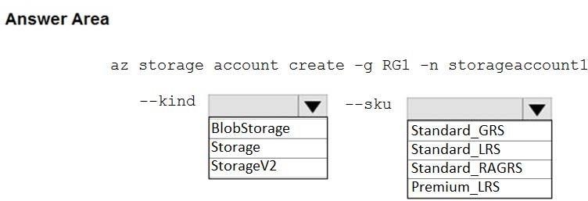

**Answer:**

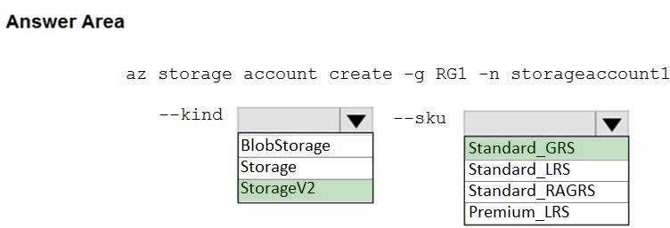

**Explanation:**

Box 1: StorageV2

You may only tier your object storage data to hot, cool, or archive in Blob storage and General Purpose v2 (GPv2) accounts. General Purpose v1 (GPv1) accounts do not support tiering.

General-purpose v2 accounts deliver the lowest per-gigabyte capacity prices for Azure Storage, as well as industry-competitive transaction prices.

Box 2: Standard_GRS

Geo-redundant storage (GRS): Cross-regional replication to protect against region-wide unavailability.

Incorrect Answers:

Locally-redundant storage (LRS): A simple, low-cost replication strategy. Data is replicated within a single storage scale unit.

Read-access geo-redundant storage (RA-GRS): Cross-regional replication with read access to the replica. RA-GRS provides read-only access to the data in the secondary location, in addition to geo-replication across two regions, but is more expensive compared to GRS.

Reference:

https://docs.microsoft.com/en-us/azure/storage/common/storage-redundancy-grs https://docs.microsoft.com/en-us/azure/storage/blobs/storage-blob-storage-tiers

### QUESTION 300

Hotspot Question

You have an Azure subscription that contains the resources shown in the following table.

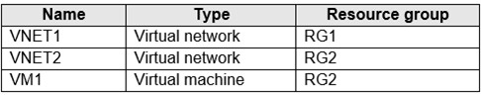

The status of VM1 is Running.

You assign an Azure policy as shown in the exhibit. (Click the Exhibit tab.)

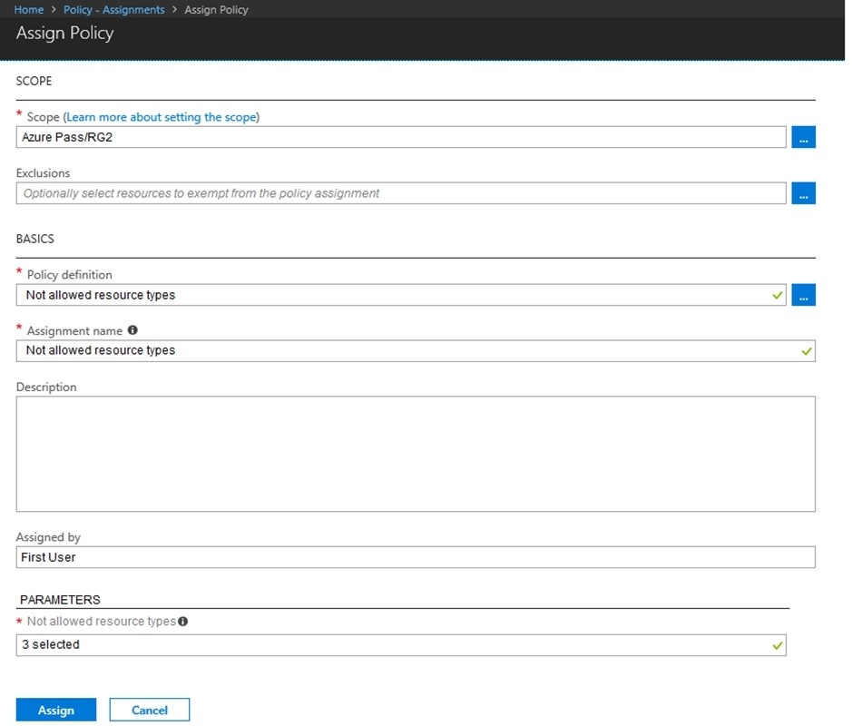

You assign the policy by using the following parameters:

Microsoft.ClassicNetwork/virtualNetworks Microsoft.Network/virtualNetworks Microsoft.Compute/virtualMachines

For each of the following statements, select Yes if the statement is true. Otherwise, select No. NOTE: Each correct selection is worth one point.

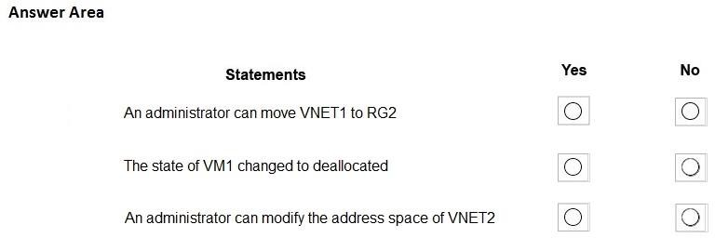

**Answer:**

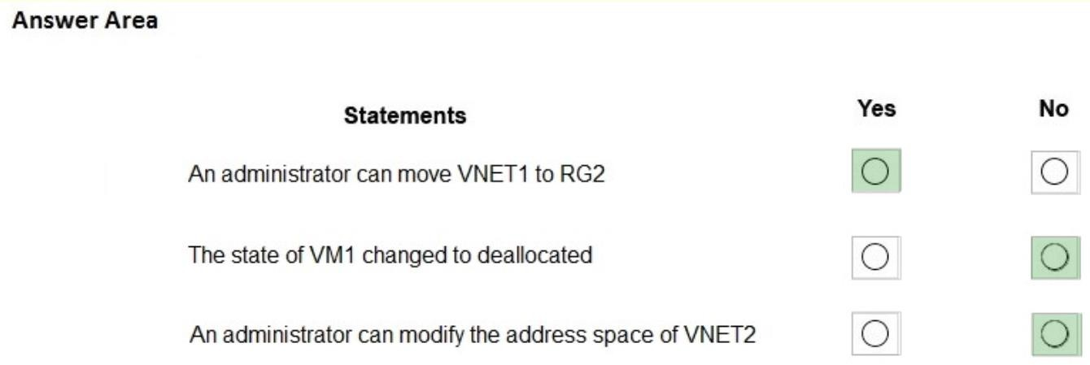

**Explanation:**

https://docs.microsoft.com/en-us/azure/governance/policy/overview#azure-policy-objects "Not allowed resource types (Deny): Prevents a list of resource types from being deployed."

Prevents a list of resource types from being deployed it says...which means that move or start/stop operations and others than deployments are not prevented. Only deployments are. Not quite true though.

So also tested the policy myself and the outcome was the following: Started VM stayed on, was able to stop and start again.

Could not create Vnet or VM. Could not change VM size.

Could not change the address space. Could move Vnet and VM.

So basically the correct answer is Yes - No - No

### QUESTION 301

Drag and Drop Question

You have an Azure subscription that contains a storage account.

You have an on-premises server named Server1 that runs Windows Server 2016. Server1 has 2 TB of data.

You need to transfer the data to the storage account by using the Azure Import/Export service.

In which order should you perform the actions? To answer, move all actions from the list of actions to the answer area and arrange them in the correct order.

NOTE: More than one order of answer choices is correct. You will receive credit for any of the correct orders you select.

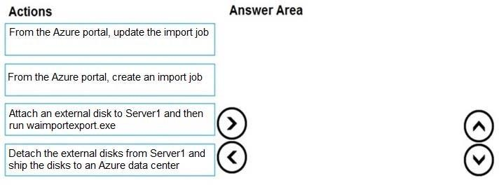

**Answer:**

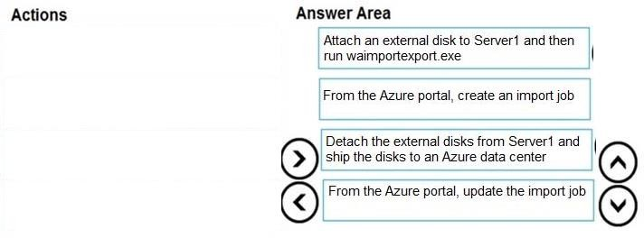

**Explanation:**

At a high level, an import job involves the following steps:

Step 1: Attach an external disk to Server1 and then run waimportexport.exe Determine data to be imported, number of drives you need, destination blob location for your data in Azure storage.

Use the WAImportExport tool to copy data to disk drives. Encrypt the disk drives with BitLocker.

Step 2: From the Azure portal, create an import job.

Create an import job in your target storage account in Azure portal. Upload the drive journal files.

Step 3: Detach the external disks from Server1 and ship the disks to an Azure data center. Provide the return address and carrier account number for shipping the drives back to you. Ship the disk drives to the shipping address provided during job creation.

Step 4: From the Azure portal, update the import job

Update the delivery tracking number in the import job details and submit the import job. The drives are received and processed at the Azure data center. The drives are shipped using your carrier account to the return address provided in the import job.

Reference:

https://docs.microsoft.com/en-us/azure/storage/common/storage-import-export-service

### QUESTION 302

Hotspot Question

You have an Azure subscription named Subscription1. Subscription1 contains the resources in the following table.

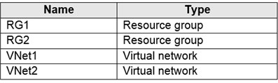

VNet1 is in RG1. VNet2 is in RG2. There is no connectivity between VNet1 and VNet2.

An administrator named Admin1 creates an Azure virtual machine named VM1 in RG1. VM1 uses a disk named Disk1 and connects to VNet1. Admin1 then installs a custom application in VM1.

You need to move the custom application to VNet2. The solution must minimize administrative effort.

Which two actions should you perform? To answer, select the appropriate options in the answer area.

NOTE: Each correct selection is worth one point.

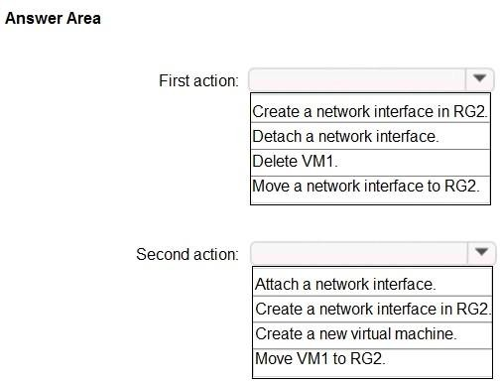

**Answer:**

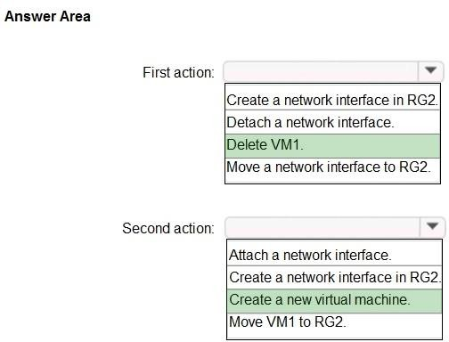

**Explanation:**

We cannot just move a virtual machine between networks. What we need to do is identify the disk used by the VM, delete the VM itself while retaining the disk, and recreate the VM in the target virtual network and then attach the original disk to it.

Reference:

https://blogs.technet.microsoft.com/canitpro/2014/06/16/step-by-step-move-a-vm-to-a-different- vnet-on-azure/

https://4sysops.com/archives/move-an-azure-vm-to-another-virtual-network-vnet/#migrate-an- azure-vm-between-vnets

### QUESTION 303

Hotspot Question

You have the App Service plans shown in the following table.

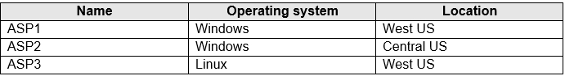

You plan to create the Azure web apps shown in the following table.

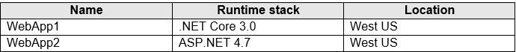

You need to identify which App Service plans can be used for the web apps.

What should you identify? To answer, select the appropriate options in the answer area. NOTE: Each correct selection is worth one point.

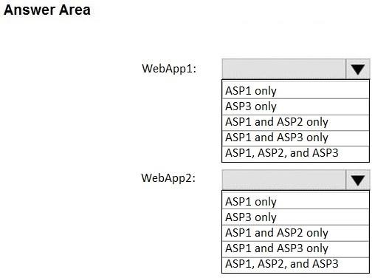

**Answer:**

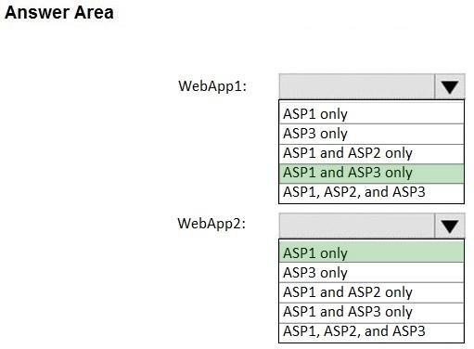

**Explanation:**

Box 1: ASP1 and ASP3 only

.NET Core apps can be hosted both on Windows or Linux.

The region in which your app runs is the region of the App Service Plan is in. ASP2 is in Central US, not the same as WebApp1. Different locations.

Box 2: ASP1 only

ASP.NET apps can be hosted on Windows only. Only ASP1 is in the same Location as the WebApp2 (West US).

Reference:

https://docs.microsoft.com/en-us/azure/app-service/quickstart-dotnetcore?pivots=platform-linux https://docs.microsoft.com/en-us/azure/app-service/app-service-plan-manage

### QUESTION 304

Hotspot Question

You create a virtual machine scale set named Scale1. Scale1 is configured as shown in the following exhibit.

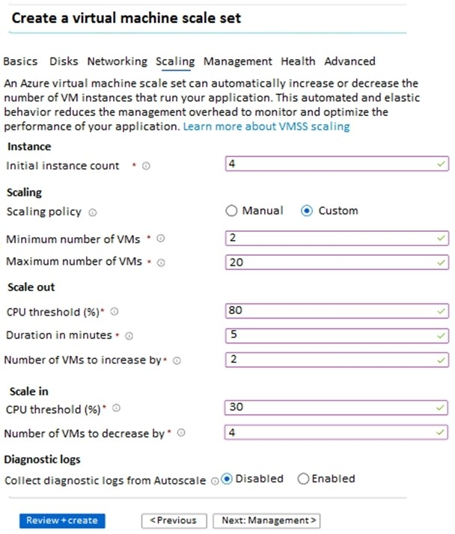

Use the drop-down menus to select the answer choice that completes each statement based on the information presented in the graphic.

NOTE: Each correct selection is worth one point.

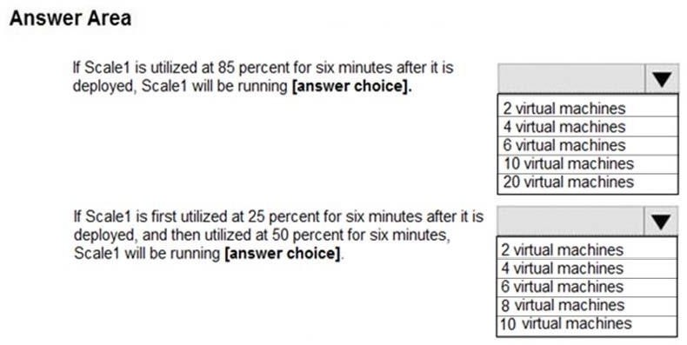

**Answer:**

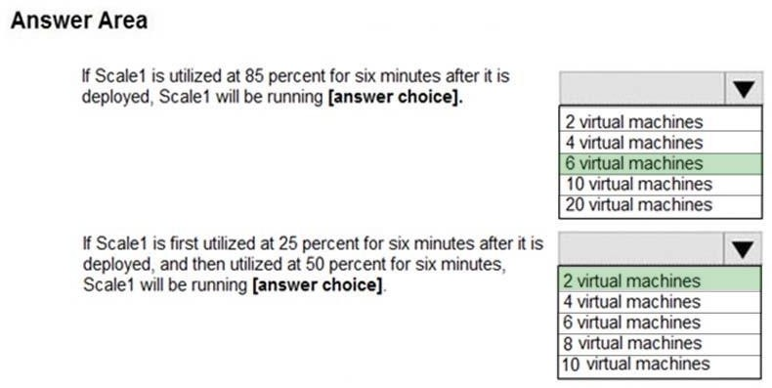

**Explanation:**

Box 1: 6 virtual machines

The Autoscale scale out rule increases the number of VMs by 2 if the CPU threshold is 80% or higher. The initial instance count is 4 and rises to 6 when the 2 extra instances of VMs are added.

Box 2: 2 virtual machnes

The Autoscale scale in rule decreases the number of VMs by 4 if the CPU threshold is 30% or lower. The initial instance count is 4 and thus cannot be reduced to 0 as the minimum instances is set to 2. Instances are only added when the CPU threshold reaches 80%.

Reference:

https://docs.microsoft.com/en-us/azure/azure-monitor/platform/autoscale-overview https://docs.microsoft.com/en-us/azure/azure-monitor/platform/autoscale-best-practices https://docs.microsoft.com/en-us/azure/azure-monitor/platform/autoscale-common-scale-patterns

### QUESTION 305

Hotspot Question

You have an Azure Kubernetes Service (AKS) cluster named AKS1 and a computer named Computer1 that runs Windows 10. Computer1 that has the Azure CLI installed.

You need to install the kubectl client on Computer1.

Which command should you run? To answer, select the appropriate options in the answer area. NOTE: Each correct selection is worth one point.

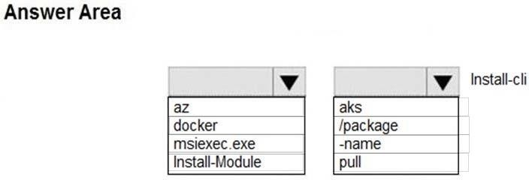

**Answer:**

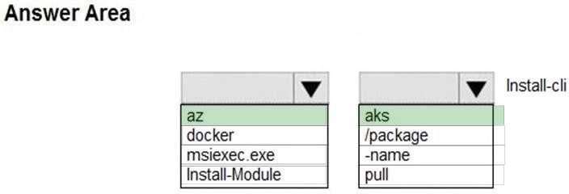

**Explanation:**

To install kubectl locally, use the az aks install-cli command: az aks install-cli

Reference:

https://docs.microsoft.com/en-us/azure/aks/kubernetes-walkthrough

### QUESTION 306

Drag and Drop Question

You onboard 10 Azure virtual machines to Azure Automation State Configuration.

You need to use Azure Automation State Configuration to manage the ongoing consistency of the virtual machine configurations.

Which three actions should you perform in sequence? To answer, move the appropriate actions from the list of actions to the answer area and arrange them in the correct order.

NOTE: More than one order of answer choices is correct. You will receive credit for any of the correct orders you select.

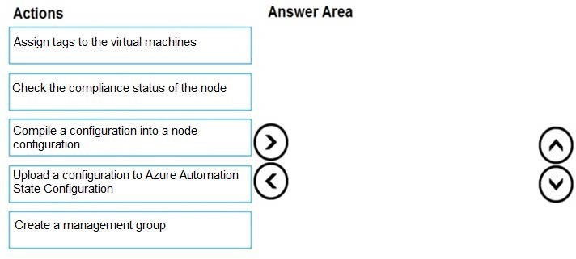

**Answer:**

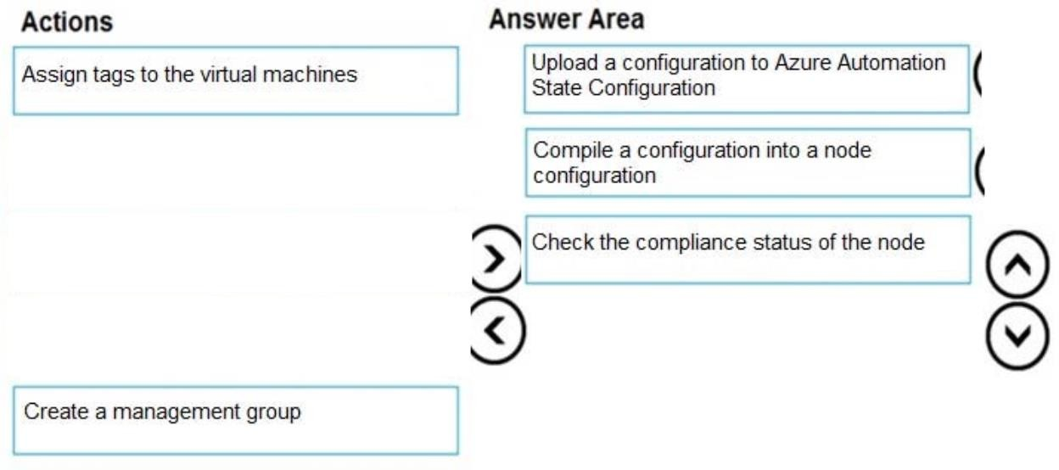

**Explanation:**

Step 1: Upload a configuration to Azure Automation State Configuration. Import the configuration into the Automation account.

Step 2: Compile a configuration into a node configuration. A DSC configuration defining that state must be compiled into one or more node configurations (MOF document), and placed on the Automation DSC Pull Server.

Step 3: Assign the node configuration

Step 4: Check the compliance status of the node

Each time Azure Automation State Configuration performs a consistency check on a managed node, the node sends a status report back to the pull server. You can view these reports on the page for that node. On the blade for an individual report, you can see the following status information for the corresponding consistency check:

The report status -- whether the node is "Compliant", the configuration "Failed", or the node is "Not Compliant"

Reference:

https://docs.microsoft.com/en-us/azure/automation/automation-dsc-getting-started

### QUESTION 307

Hotspot Question

You have an Azure subscription that contains the Azure virtual machines shown in the following table.

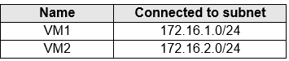

You add inbound security rules to a network security group (NSG) named NSG1 as shown in the following table.

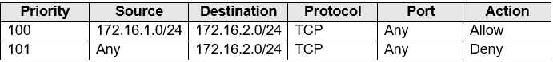

You run Azure Network Watcher as shown in the following exhibit. You run Network Watcher again as shown in the following exhibit.

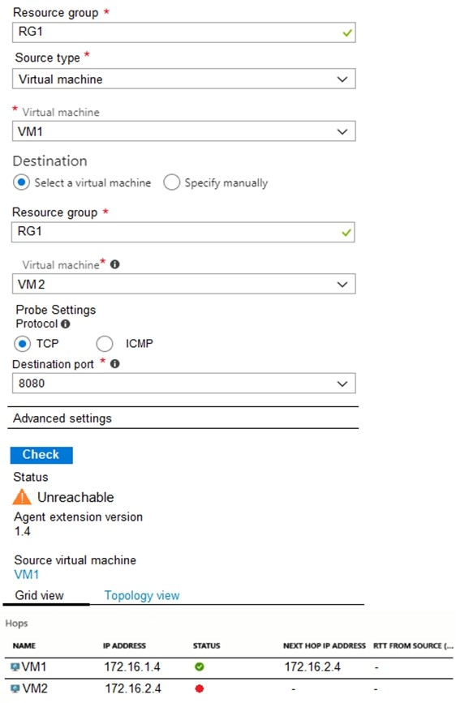

For each of the following statements, select Yes if the statement is true. Otherwise, select No. NOTE: Each correct selection is worth one point.

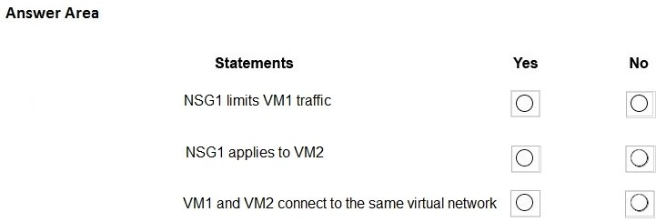

**Answer:**

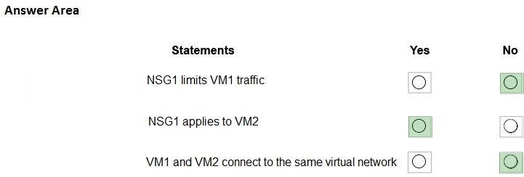

**Explanation:**

Box 1: No

It limits traffic to VM2, but not VM1 traffic.

Box 2: Yes

Yes, the destination is VM2. Box 3: No

Reference:

https://docs.microsoft.com/en-us/azure/virtual-network/network-security-group-how-it-works

### QUESTION 308

Hotspot Question

You have peering configured as shown in the following exhibit.

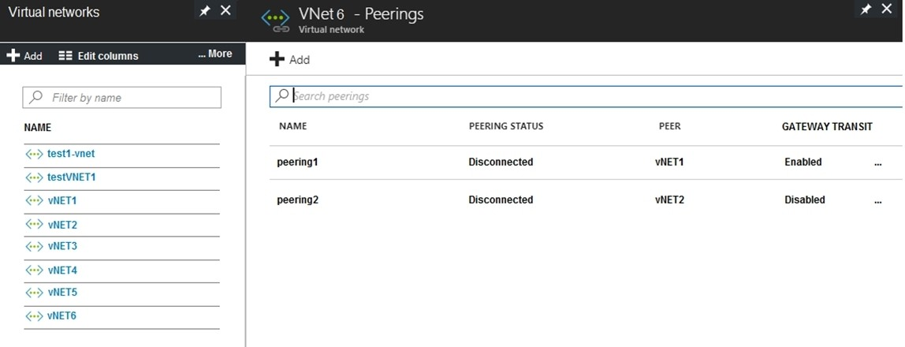

Use the drop-down menus to select the answer choice that completes each statement based on the information presented in the graphic.

NOTE: Each correct selection is worth one point.

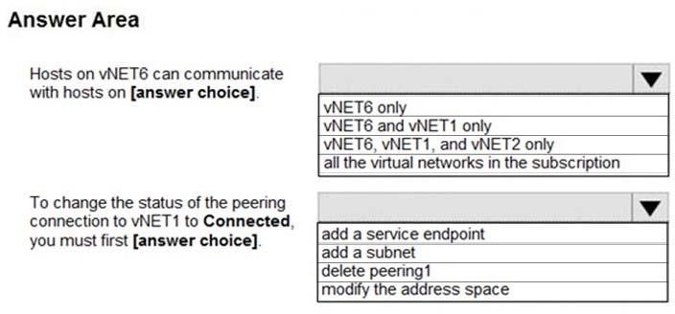

**Answer:**

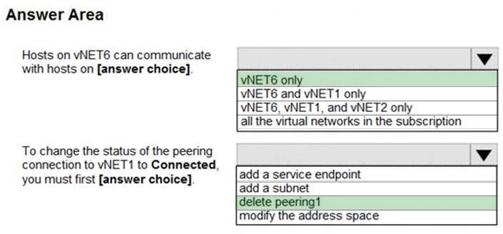

**Explanation:**

Box 1: vNET6 only

Peering status to both VNet1 and Vnet2 are disconnected.

Box 2: delete peering1

Peering to Vnet1 is Enabled but disconnected. We need to update or re-create the remote peering to get it back to Initiated state.

Reference:

https://blog.kloud.com.au/2018/10/19/address-space-maintenance-with-vnet-peering/

### QUESTION 309

Hotspot Question

You have an Azure virtual machine named VM1 and a Recovery Services vault named Vault1. You create a backup policy named Policy1 as shown in the exhibit. (Click the Exhibit tab.)

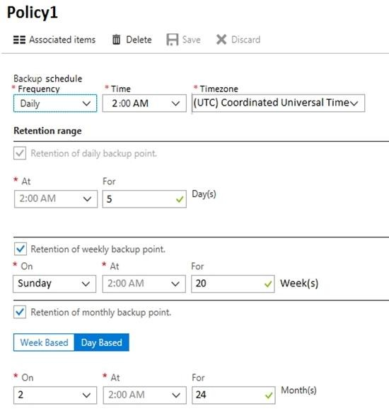

You configure the backup of VM1 to use Policy1 on Thursday, January 1. You need to identify the number of available recovery points for VM1.

How many recovery points are available on January 8 and January 15? To answer, select the appropriate options in the answer area.

NOTE: Each correct selection is worth one point.

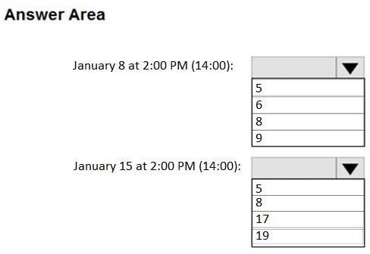

**Answer:**

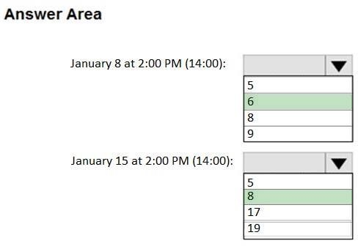

**Explanation:**

Box 1: 6

5 latest daily recovery points, which includes the weekly backup from the previous Sunday, plus the monthly recovery point.

Box 2: 8

5 latest daily recovery points, plus two weekly backups, plus the monthly recovery point.

Reference:

https://social.technet.microsoft.com/Forums/en-US/854ab6ae-79aa-4bad-ac65- 471c4d422e94/daily-monthly-yearly-recovery-points-and-storage- used?forum=windowsazureonlinebackup

### QUESTION 310

Hotspot Question

You have an Azure Active Directory (Azure AD) tenant named contoso.onmicrosoft.com that contains the users shown in the following table.

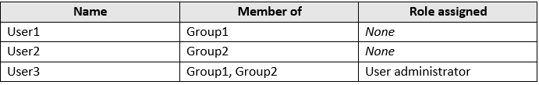

You enable password reset for contoso.onmicrosoft.com as shown in the Password Reset exhibit. (Click the Password Reset tab.)

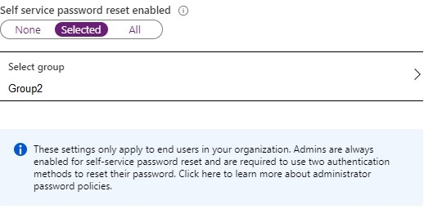

You configure the authentication methods for password reset as shown in the Authentication Methods exhibit. (Click the Authentication Methods tab.)

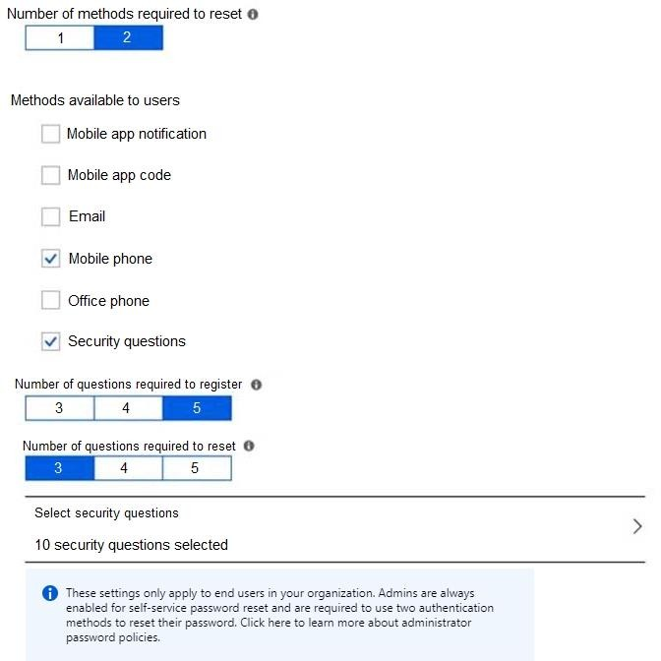

For each of the following statements, select Yes if the statement is true. Otherwise, select No. NOTE: Each correct selection is worth one point.

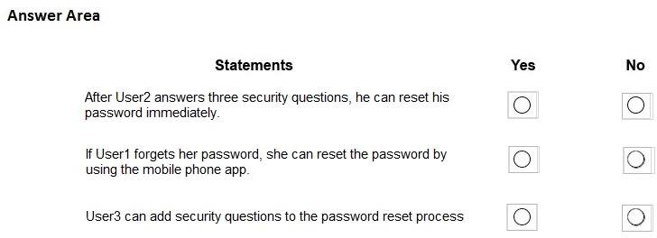

**Answer:**

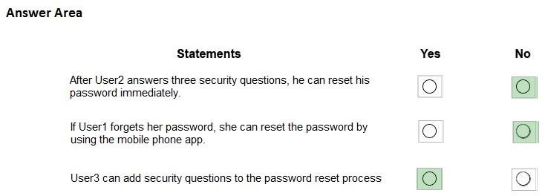

**Explanation:**

Box 1: No

Two methods are required.

Box 2: No

Self-service password reset is only enabled for Group2, and User1 is not a member of Group2.

Box 3: Yes

As a User Administrator, User3 can add security questions to the reset process.

Reference:

https://docs.microsoft.com/en-us/azure/active-directory/authentication/quickstart-sspr https://docs.microsoft.com/en-us/azure/active-directory/authentication/active-directory- passwords-faq

### QUESTION 311

You have an Azure Active Directory (Azure AD) tenant named contoso.onmicrosoft.com. The User administrator role is assigned to a user named Admin1.

An external partner has a Microsoft account that uses the [user1@outlook.com](mailto:user1@outlook.com) sign in.

Admin1 attempts to invite the external partner to sign in to the Azure AD tenant and receives the following error message: "Unable to invite user [user1@outlook.com](mailto:user1@outlook.com) - Generic authorization exception."

You need to ensure that Admin1 can invite the external partner to sign in to the Azure AD tenant. What should you do?

|  |  |
| --- | --- |
| A. | From the Users blade, modify the External collaboration settings. |
| B. | From the Custom domain names blade, add a custom domain. |
| C. | From the Organizational relationships blade, add an identity provider. |
| D. | From the Roles and administrators blade, assign the Security administrator role to Admin1. |

**Answer:** A

**Explanation:**

https://techcommunity.microsoft.com/t5/Azure-Active-Directory/Generic-authorization-exception- inviting-Azure-AD-gests/td-p/274742

### QUESTION 312

You have an Azure subscription that contains a user account named User1.

You need to ensure that User1 can assign a policy to the tenant root management group. What should you do?

|  |  |
| --- | --- |
| A. | Assign the Owner role for the Azure Subscription to User1, and then modify the default  conditional access policies. |
| B. | Assign the Owner role for the Azure subscription to User1, and then instruct User1 to configure access management for Azure resources. |
| C. | Assign the Global administrator role to User1, and then instruct User1 to configure access management for Azure resources. |
| D. | Create a new management group and delegate User1 as the owner of the new management group. |

**Answer:** B

**Explanation:**

The following chart shows the list of roles and the supported actions on management groups.

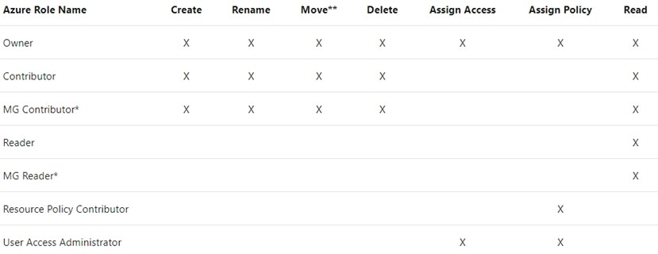

Note:

Each directory is given a single top-level management group called the "Root" management group. This root management group is built into the hierarchy to have all management groups and subscriptions fold up to it. This root management group allows for global policies and Azure role assignments to be applied at the directory level. The Azure AD Global Administrator needs to elevate themselves to the User Access Administrator role of this root group initially. After elevating access, the administrator can assign any Azure role to other directory users or groups to manage the hierarchy. As administrator, you can assign your own account as owner of the root management group.

Reference:

https://docs.microsoft.com/en-us/azure/governance/management-groups/overview

### QUESTION 313

**Note: This question is part of a series of questions that present the same scenario. Each question in the series contains a unique solution that might meet the stated goals. Some question sets might have more than one correct solution, while others might not have a correct solution.**

**After you answer a question in this section, you will NOT be able to return to it. As a result, these questions will not appear in the review screen.**

You need to ensure that an Azure Active Directory (Azure AD) user named Admin1 is assigned the required role to enable Traffic Analytics for an Azure subscription.

Solution: You assign the Network Contributor role at the subscription level to Admin1. Does this meet the goal?

|  |  |
| --- | --- |
| A. | Yes |
| B. | No |

**Answer:** A

**Explanation:**

Your account must meet one of the following to enable traffic analytics:

Your account must have any one of the following Azure roles at the subscription scope: owner, contributor, reader, or network contributor.

Reference:

https://docs.microsoft.com/en-us/azure/network-watcher/traffic-analytics-faq

### QUESTION 314

**Note: This question is part of a series of questions that present the same scenario. Each question in the series contains a unique solution that might meet the stated goals. Some question sets might have more than one correct solution, while others might not have a correct solution.**

**After you answer a question in this section, you will NOT be able to return to it. As a result, these questions will not appear in the review screen.**

You need to ensure that an Azure Active Directory (Azure AD) user named Admin1 is assigned the required role to enable Traffic Analytics for an Azure subscription.

Solution: You assign the Owner role at the subscription level to Admin1. Does this meet the goal?

|  |  |
| --- | --- |
| A. | Yes |
| B. | No |

**Answer:** A

**Explanation:**

Your account must meet one of the following to enable traffic analytics:

Your account must have any one of the following Azure roles at the subscription scope: owner, contributor, reader, or network contributor.

Reference:

https://docs.microsoft.com/en-us/azure/network-watcher/traffic-analytics-faq

### QUESTION 315

**Note: This question is part of a series of questions that present the same scenario. Each question in the series contains a unique solution that might meet the stated goals. Some question sets might have more than one correct solution, while others might not have a correct solution.**

**After you answer a question in this section, you will NOT be able to return to it. As a result, these questions will not appear in the review screen.**

You need to ensure that an Azure Active Directory (Azure AD) user named Admin1 is assigned the required role to enable Traffic Analytics for an Azure subscription.

Solution: You assign the Reader role at the subscription level to Admin1. Does this meet the goal?

|  |  |
| --- | --- |
| A. | Yes |
| B. | No |

**Answer:** A

**Explanation:**

Your account must meet one of the following to enable traffic analytics:

Your account must have any one of the following Azure roles at the subscription scope: owner, contributor, reader, or network contributor.

Reference:

https://docs.microsoft.com/en-us/azure/network-watcher/traffic-analytics-faq

### QUESTION 316

You have an Azure subscription that contains a user named User1.

You need to ensure that User1 can deploy virtual machines and manage virtual networks. The solution must use the principle of least privilege.

Which role-based access control (RBAC) role should you assign to User1?

|  |  |
| --- | --- |
| A. | Owner |
| B. | Virtual Machine Contributor |
| C. | Contributor |
| D. | Virtual Machine Administrator Login |

**Answer:** C

**Explanation:**

Virtual Machine Contributor don't have permission to manage networks. Reference:

https://docs.microsoft.com/en-us/azure/role-based-access-control/built-in-roles

### QUESTION 317

You plan to use the Azure Import/Export service to copy files to a storage account.

Which two files should you create before you prepare the drives for the import job? Each correct answer presents part of the solution.

NOTE: Each correct selection is worth one point.

|  |  |
| --- | --- |
| A. | an XML manifest file |
| B. | a dataset CSV file |
| C. | a JSON configuration file |
| D. | a PowerShell PS1 file |
| E. | a driveset CSV file |

**Answer:** BE

**Explanation:**

Modify the dataset.csv file in the root folder where the tool resides. Depending on whether you want to import a file or folder or both, add entries in the dataset.csv file

Modify the driveset.csv file in the root folder where the tool resides. Reference:

https://docs.microsoft.com/en-us/azure/storage/common/storage-import-export-data-to-files

### QUESTION 318

You have a Recovery Service vault that you use to test backups. The test backups contain two protected virtual machines.

You need to delete the Recovery Services vault. What should you do first?

|  |  |
| --- | --- |
| A. | From the Recovery Service vault, delete the backup data. |
| B. | Modify the disaster recovery properties of each virtual machine. |
| C. | Modify the locks of each virtual machine. |
| D. | From the Recovery Service vault, stop the backup of each backup item. |

**Answer:** D

**Explanation:**

You can't delete a Recovery Services vault if it is registered to a server and holds backup data. If you try to delete a vault, but can't, the vault is still configured to receive backup data.

Remove vault dependencies and delete vault

In the vault dashboard menu, scroll down to the Protected Items section, and click Backup Items. In this menu, you can stop and delete Azure File Servers, SQL Servers in Azure VM, and Azure virtual machines.

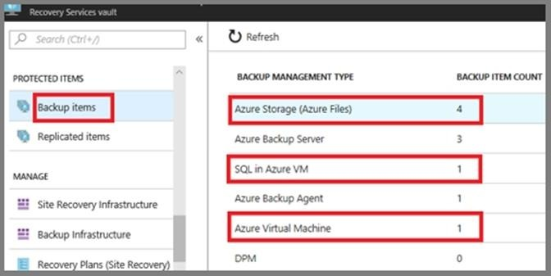

Reference:

https://docs.microsoft.com/en-us/azure/backup/backup-azure-delete-vault

### QUESTION 319

You have an Azure subscription named Subscription1.

You have 5 TB of data that you need to transfer to Subscription1. You plan to use an Azure Import/Export job.

What can you use as the destination of the imported data?

|  |  |
| --- | --- |
| A. | a virtual machine |
| B. | an Azure Cosmos DB database |
| C. | Azure File Storage |
| D. | the Azure File Sync Storage Sync Service |

**Answer:** C

**Explanation:**

Azure Import/Export service is used to securely import large amounts of data to Azure Blob storage and Azure Files by shipping disk drives to an Azure datacenter.

The maximum size of an Azure Files Resource of a file share is 5 TB. Reference:

https://docs.microsoft.com/en-us/azure/storage/common/storage-import-export-service

### QUESTION 320

**Note: This question is part of a series of questions that present the same scenario. Each question in the series contains a unique solution that might meet the stated goals. Some question sets might have more than one correct solution, while others might not have a correct solution.**

**After you answer a question in this section, you will NOT be able to return to it. As a result, these questions will not appear in the review screen.**

You have an Azure subscription named Subscription1. Subscription1 contains a resource group named RG1. RG1 contains resources that were deployed by using templates.

You need to view the date and time when the resources were created in RG1.

Solution: From the Subscriptions blade, you select the subscription, and then click Programmatic deployment.

Does this meet the goal?

|  |  |
| --- | --- |
| A. | Yes |
| B. | No |

**Answer:** B

**Explanation:**

From the RG1 blade, click Deployments. You see a history of deployment for the resource group. Reference:

https://docs.microsoft.com/en-us/azure/azure-resource-manager/templates/template-tutorial- create-first-template?tabs=azure-powershell

### QUESTION 321

**Note: This question is part of a series of questions that present the same scenario. Each question in the series contains a unique solution that might meet the stated goals. Some question sets might have more than one correct solution, while others might not have a correct solution.**

**After you answer a question in this section, you will NOT be able to return to it. As a result, these questions will not appear in the review screen.**

You have an Azure subscription that contains the resources shown in the following table.



VM1 connects to VNET1.

You need to connect VM1 to VNET2.

Solution: You create a new network interface, and then you add the network interface to VM1. Does this meet the goal?

|  |  |
| --- | --- |
| A. | Yes |

|  |  |
| --- | --- |
| B. | No |

**Answer:** B

**Explanation:**

You should delete VM1. You recreate VM1, and then you add the network interface for VM1. Note: When you create an Azure virtual machine (VM), you must create a virtual network (VNet) or use an existing VNet. You can change the subnet a VM is connected to after it's created, but you cannot change the VNet.

Reference:

https://docs.microsoft.com/en-us/azure/virtual-machines/windows/network-overview

### QUESTION 322

You have an Azure Active Directory (Azure AD) tenant named adatum.com that contains the users shown in the following table.

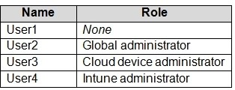

Adatum.com has the following configurations:

* Users may join devices to Azure AD is set to User1.
* Additional local administrators on Azure AD joined devices is set to None.

You deploy Windows 10 to a computer named Computer1. User1 joins Computer1 to adatum.com.

You need to identify the local Administrator group membership on Computer1. Which users are members of the local Administrators group?

|  |  |
| --- | --- |
| A. | User1 only |
| B. | User2 only |
| C. | User1 and User2 only |
| D. | User1, User2, and User3 only |
| E. | User1, User2, User3, and User4 |

**Answer:** C

**Explanation:**

Users may join devices to Azure AD -This setting enables you to select the users who can register their devices as Azure AD joined devices. The default is All.

Additional local administrators on Azure AD joined devices -You can select the users that are granted local administrator rights on a device. Users added here are added to the Device Administrators role in

Azure AD. Global administrators, here User2, in Azure AD and device owners are granted local administrator rights by default.

Reference:

https://docs.microsoft.com/en-us/azure/active-directory/devices/device-management-azure-portal

### QUESTION 323

You have an Azure subscription named Subscription1 that contains the resources shown in the following table.

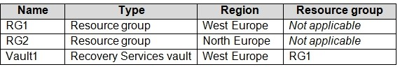

You create virtual machines in Subscription1 as shown in the following table.

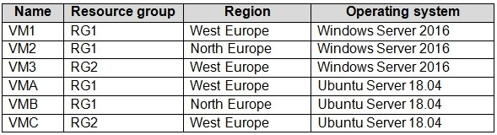

You plan to use Vault1 for the backup of as many virtual machines as possible. Which virtual machines can be backed up to Vault1?

|  |  |
| --- | --- |
| A. | VM1 only |
| B. | VM3 and VMC only |
| C. | VM1, VM2, VM3, VMA, VMB, and VMC |
| D. | VM1, VM3, VMA, and VMC only |
| E. | VM1 and VM3 only |

**Answer:** D

**Explanation:**

To create a vault to protect virtual machines, the vault must be in the same region as the virtual machines.

If you have virtual machines in several regions, create a Recovery Services vault in each region. Reference:

https://docs.microsoft.com/bs-cyrl-ba/azure/backup/backup-create-rs-vault

### QUESTION 324

You have an Azure Kubernetes Service (AKS) cluster named AKS1. You need to configure cluster autoscaler for AKS1.

Which two tools should you use? Each correct answer presents a complete solution. NOTE: Each correct selection is worth one point.

|  |  |
| --- | --- |
| A. | the kubectl command |
| B. | the az aks command |
| C. | the Set-AzVm cmdlet |
| D. | the Azure portal |
| E. | the Set-AzAks cmdlet |

**Answer:** AB

**Explanation:**

A: The following example uses the kubectl autoscale command to autoscale the number of pods in the azure-vote-front deployment. If average CPU utilization across all pods exceeds 50% of their requested usage, the autoscaler increases the pods up to a maximum of 10 instances. A minimum of 3 instances is then defined for the deployment:

kubectl autoscale deployment azure-vote-front --cpu-percent=50 --min=3 --max=10

B: Use the az aks update command to enable and configure the cluster autoscaler on the node pool for the existing cluster.

Reference:

https://docs.microsoft.com/en-us/azure/aks/tutorial-kubernetes-scale https://docs.microsoft.com/en-us/azure/aks/cluster-autoscaler

### QUESTION 325

You create the following resources in an Azure subscription:

* An Azure Container Registry instance named Registry1
* An Azure Kubernetes Service (AKS) cluster named Cluster1 You create a container image named App1 on your administrative workstation. You need to deploy App1 to Cluster1.

What should you do first?

|  |  |
| --- | --- |
| A. | Run the docker push command. |
| B. | Create an App Service plan. |
| C. | Run the az acr build command. |
| D. | Run the az aks create command. |

**Answer:** C

**Explanation:**

You should sign in and push a container image to Container Registry. Run the az acr build command to build and push the container image. az acr build \

--image contoso-website \

--registry $ACR_NAME \

--file Dockerfile . Reference:

https://docs.microsoft.com/en-us/learn/modules/aks-deploy-container-app/5-exercise-deploy-app

### QUESTION 326

You have an Azure subscription that contains the resources shown in the following table.

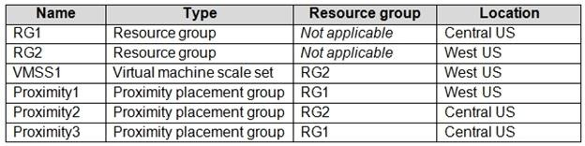

You need to configure a proximity placement group for VMSS1. Which proximity placement groups should you use?

|  |  |
| --- | --- |
| A. | Proximity2 only |
| B. | Proximity1, Proximity2, and Proximity3 |
| C. | Proximity1 only |
| D. | Proximity1 and Proximity3 only |

**Answer:** C

**Explanation:**

The VMSS should share the same region even it should be the same zone as proximity groups are located in the same data central.

### QUESTION 327

**Note: This question is part of a series of questions that present the same scenario. Each question in the series contains a unique solution that might meet the stated goals. Some question sets might have more than one correct solution, while others might not have a correct solution.**

**After you answer a question in this section, you will NOT be able to return to it. As a result, these questions will not appear in the review screen.**

You have an Azure subscription named Subscription1. Subscription1 contains a resource group named RG1. RG1 contains resources that were deployed by using templates.

You need to view the date and time when the resources were created in RG1.

Solution: From the Subscriptions blade, you select the subscription, and then click Resource providers.

Does this meet the goal?

|  |  |
| --- | --- |
| A. | Yes |
| B. | No |

**Answer:** B

### QUESTION 328

You create an Azure VM named VM1 that runs Windows Server 2019. VM1 is configured as shown in the exhibit. (Click the Exhibit tab.)

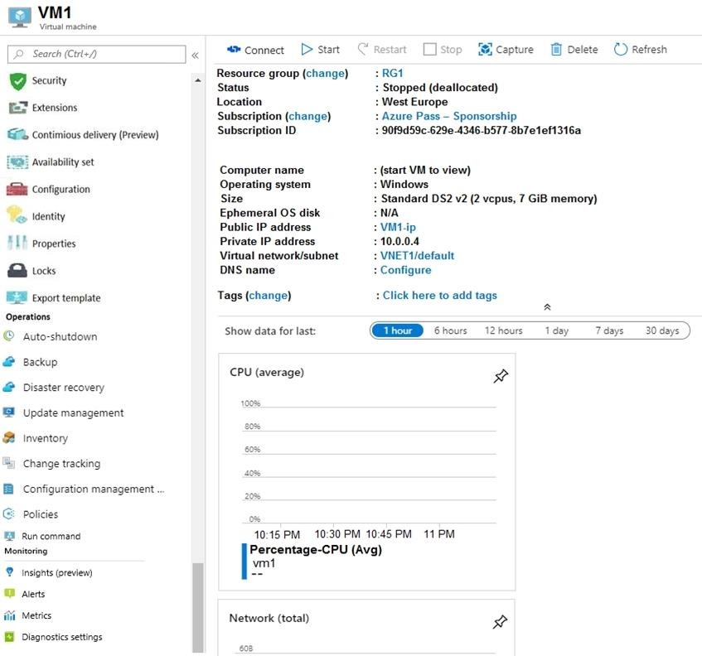

You need to enable Desired State Configuration for VM1. What should you do first?

|  |  |
| --- | --- |
| A. | Connect to VM1. |
| B. | Start VM1. |
| C. | Capture a snapshot of VM1. |
| D. | Configure a DNS name for VM1. |

**Answer:** B

**Explanation:**

Status is Stopped (Deallocated).

The DSC extension for Windows requires that the target virtual machine is able to communicate with Azure.

The VM needs to be started. Reference:

https://docs.microsoft.com/en-us/azure/virtual-machines/extensions/dsc-windows

### QUESTION 329

You have five Azure virtual machines that run Windows Server 2016. The virtual machines are configured as web servers.

You have an Azure load balancer named LB1 that provides load balancing services for the virtual machines.

You need to ensure that visitors are serviced by the same web server for each request. What should you configure?

|  |  |
| --- | --- |
| A. | Floating IP (direct server return) to Disabled |
| B. | Idle Time-out (minutes) to 20 |
| C. | Protocol to UDP |
| D. | Session persistence to Client IP |

**Answer:** D

**Explanation:**

With Sticky Sessions when a client starts a session on one of your web servers, session stays on that specific server. To configure An Azure Load-Balancer For Sticky Sessions set Session persistence to Client IP or to Client IP and protocol.

On the following image you can see sticky session configuration:

Note:

Client IP and protocol specifies that successive requests from the same client IP address and protocol combination will be handled by the same virtual machine.

Client IP specifies that successive requests from the same client IP address will be handled by the same virtual machine.

Reference:

https://cloudopszone.com/configure-azure-load-balancer-for-sticky-sessions/

### QUESTION 330

**Note: This question is part of a series of questions that present the same scenario. Each question in the series contains a unique solution that might meet the stated goals. Some question sets might have more than one correct solution, while others might not have a correct solution.**

**After you answer a question in this section, you will NOT be able to return to it. As a result, these questions will not appear in the review screen.**

You have an Azure subscription that contains the following resources:  A virtual network that has a subnet named Subnet1

 Two network security groups (NSGs) named NSG-VM1 and NSG-Subnet1

 A virtual machine named VM1 that has the required Windows Server configurations to allow Remote Desktop connections

NSG-Subnet1 has the default inbound security rules only.

NSG-VM1 has the default inbound security rules and the following custom inbound security rule:  Priority: 100

 Source: Any

 Source port range: *

 Destination: *

 Destination port range: 3389  Protocol: UDP

 Action: Allow

VM1 has a public IP address and is connected to Subnet1. NSG-VM1 is associated to the network interface of VM1. NSG-Subnet1 is associated to Subnet1.

You need to be able to establish Remote Desktop connections from the internet to VM1.

Solution: You add an inbound security rule to NSG-Subnet1 that allows connections from the Any source to the *destination for port range 3389 and uses the TCP protocol. You remove NSG-VM1 from the network interface of VM1.

Does this meet the goal?

|  |  |
| --- | --- |
| A. | Yes |
| B. | No |

**Answer:** A

**Explanation:**

Network Security Group: NSG-VM1 is removed from the network interface of VM1. Also this NSG is not associated with Subnet. So, this will not execute any inbound rules when a user is connecting to VM1.

Network Security Group: NSG-Subnet1 is associated to Subnet1 and also it has the custom inbound security rule is added to allow RDP (TCP Port 3389) connections from internet.

So, while connecting to VM1 through RDP from internet, then only NSG-Subnet1 inbound security rules will get executed and so the RDP traffic is allowed to VM1.

### QUESTION 331

**Note: This question is part of a series of questions that present the same scenario. Each question in the series contains a unique solution that might meet the stated goals. Some question sets might have more than one correct solution, while others might not have a correct solution.**

**After you answer a question in this section, you will NOT be able to return to it. As a result, these questions will not appear in the review screen.**

You have an Azure subscription that contains the following resources:  A virtual network that has a subnet named Subnet1

 Two network security groups (NSGs) named NSG-VM1 and NSG-Subnet1

 A virtual machine named VM1 that has the required Windows Server configurations to allow Remote Desktop connections

NSG-Subnet1 has the default inbound security rules only.

NSG-VM1 has the default inbound security rules and the following custom inbound security rule:  Priority: 100

 Source: Any

 Source port range: *  Destination: *

 Destination port range: 3389  Protocol: UDP

 Action: Allow

VM1 has a public IP address and is connected to Subnet1. NSG-VM1 is associated to the network interface of VM1. NSG-Subnet1 is associated to Subnet1.

You need to be able to establish Remote Desktop connections from the internet to VM1.

Solution: You add an inbound security rule to NSG-Subnet1 that allows connections from the internet source to the VirtualNetwork destination for port range 3389 and uses the UDP protocol.

Does this meet the goal?

|  |  |
| --- | --- |
| A. | Yes |
| B. | No |

**Answer:** B

**Explanation:**

The default port for RDP is TCP port 3389. A rule to permit RDP traffic must be created automatically when you create your VM.

Note on NSG-Subnet1: Azure routes network traffic between all subnets in a virtual network, by default.

Reference:

https://docs.microsoft.com/en-us/azure/virtual-machines/troubleshooting/troubleshoot-rdp- connection

### QUESTION 332

Note: This question is part of a series of questions that present the same scenario. Each question in the series contains a unique solution that might meet the stated goals. Some question sets might have more than one correct solution, while others might not have a correct solution.

After you answer a question in this section, you will NOT be able to return to it. As a result, these questions will not appear in the review screen.

You have an Azure subscription that contains the following resources:  A virtual network that has a subnet named Subnet1

 Two network security groups (NSGs) named NSG-VM1 and NSG-Subnet1

 A virtual machine named VM1 that has the required Windows Server configurations to allow Remote Desktop connections

NSG-Subnet1 has the default inbound security rules only.

NSG-VM1 has the default inbound security rules and the following custom inbound security rule:  Priority: 100

 Source: Any

 Source port range: *  Destination: *

 Destination port range: 3389  Protocol: UDP

 Action: Allow

VM1 has a public IP address and is connected to Subnet1. NSG-VM1 is associated to the network interface of VM1. NSG-Subnet1 is associated to Subnet1.

You need to be able to establish Remote Desktop connections from the internet to VM1.

Solution: You add an inbound security rule to NSG-Subnet1 and NSG-VM1 that allows connections from the internet source to the VirtualNetwork destination for port range 3389 and uses the TCP protocol.

Does this meet the goal?

|  |  |
| --- | --- |
| A. | Yes |
| B. | No |

**Answer:** A

**Explanation:**

The default port for RDP is TCP port 3389. A rule to permit RDP traffic must be created automatically when you create your VM.

Note on NSG-Subnet1: Azure routes network traffic between all subnets in a virtual network, by default.

Reference:

https://docs.microsoft.com/en-us/azure/virtual-machines/troubleshooting/troubleshoot-rdp- connection

### QUESTION 333

You have an Azure subscription that contains a virtual network named VNET1. VNET1 contains the subnets shown in the following table.

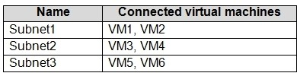

Each virtual machine uses a static IP address.

You need to create network security groups (NSGs) to meet following requirements:

* Allow web requests from the internet to VM3, VM4, VM5, and VM6.
* Allow all connections between VM1 and VM2.
* Allow Remote Desktop connections to VM1.
* Prevent all other network traffic to VNET1.

What is the minimum number of NSGs you should create?

|  |  |
| --- | --- |
| A. | 1 |
| B. | 3 |
| C. | 4 |
| D. | 12 |

**Answer:** C

**Explanation:**

Each network security group also contains default security rules.

Note: A network security group (NSG) contains a list of security rules that allow or deny network traffic to resources connected to Azure Virtual Networks (VNet). NSGs can be associated to subnets, individual VMs (classic), or individual network interfaces (NIC) attached to VMs (Resource Manager).

Reference:

https://docs.microsoft.com/en-us/azure/virtual-network/security-overview#default-security-rules

### QUESTION 334

You have an Azure subscription that contains the resources shown in the following table.

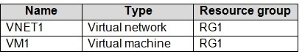

The Not allowed resource types Azure policy is assigned to RG1 and uses the following parameters:

Microsoft.Network/virtualNetworks Microsoft.Compute/virtualMachines

In RG1, you need to create a new virtual machine named VM2, and then connect VM2 to VNET1. What should you do first?

|  |  |
| --- | --- |
| A. | Remove Microsoft.Compute/virtualMachines from the policy. |
| B. | Create an Azure Resource Manager template |
| C. | Add a subnet to VNET1. |
| D. | Remove Microsoft.Network/virtualNetworks from the policy. |

**Answer:** A

**Explanation:**The Not allowed resource types Azure policy prohibits the deployment of specified resource types. You specify an array of the resource types to block.

Virtual Networks and Virtual Machines are prohibited. Reference:

https://docs.microsoft.com/en-us/azure/governance/policy/samples/not-allowed-resource-types

### QUESTION 335

Your company has an Azure subscription named Subscription1.

The company also has two on-premises servers named Server1 and Server2 that run Windows Server 2016. Server1 is configured as a DNS server that has a primary DNS zone named adatum.com. Adatum.com contains 1,000 DNS records.

You manage Server1 and Subscription1 from Server2. Server2 has the following tools installed:

* The DNS Manager console
* Azure PowerShell
* Azure CLI 2.0

You need to move the adatum.com zone to an Azure DNS zone in Subscription1. The solution must minimize administrative effort.

What should you use?

|  |  |
| --- | --- |
| A. | Azure CLI |
| B. | Azure PowerShell |
| C. | the Azure portal |
| D. | the DNS Manager console |

**Answer:** A

**Explanation:**

Azure DNS supports importing and exporting zone files by using the Azure command-line interface (CLI). Zone file import is not currently supported via Azure PowerShell or the Azure portal.

References: https://docs.microsoft.com/en-us/azure/dns/dns-import-export

### QUESTION 336

You have a public load balancer that balances ports 80 and 443 across three virtual machines. You need to direct all the Remote Desktop Protocol (RDP) connections to VM3 only.

What should you configure?

|  |  |
| --- | --- |
| A. | an inbound NAT rule |
| B. | a new public load balancer for VM3 |
| C. | a frontend IP configuration |
| D. | a load balancing rule |

**Answer:** A

**Explanation:**

https://docs.microsoft.com/en-us/azure/load-balancer/tutorial-load-balancer-port-forwarding-portal https://pixelrobots.co.uk/2017/08/azure-load-balancer-for-rds/

### QUESTION 337

You have an Azure subscription that contains the resources in the following table.

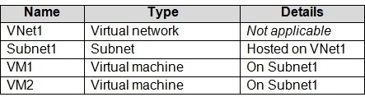

VM1 and VM2 are deployed from the same template and host line-of-business applications. You configure the network security group (NSG) shown in the exhibit. (Click the **Exhibit** tab.)

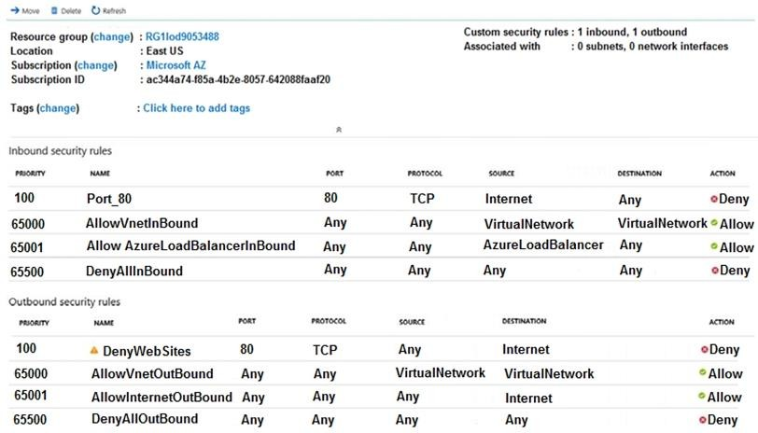

You need to prevent users of VM1 and VM2 from accessing websites on the Internet over TCP port 80.

What should you do?

|  |  |
| --- | --- |
| A. | Disassociate the NSG from a network interface |
| B. | Change the Port_80 inbound security rule. |
| C. | Associate the NSG to Subnet1. |
| D. | Change the DenyWebSites outbound security rule. |

**Answer:** C

**Explanation:**

You can associate or dissociate a network security group from a network interface or subnet. The NSG has the appropriate rule to block users from accessing the Internet. We just need to associate it with Subnet1.

Reference:

https://docs.microsoft.com/en-us/azure/virtual-network/manage-network-security-group

### QUESTION 338

You have two subscriptions named Subscription1 and Subscription2. Each subscription is associated to a different Azure AD tenant.

Subscription1 contains a virtual network named VNet1. VNet1 contains an Azure virtual machine named VM1 and has an IP address space of 10.0.0.0/16.

Subscription2 contains a virtual network named VNet2. VNet2 contains an Azure virtual machine named VM2 and has an IP address space of 10.10.0.0/24.

You need to connect VNet1 to VNet2. What should you do first?

|  |  |
| --- | --- |
| A. | Move VM1 to Subscription2. |
| B. | Move VNet1 to Subscription2. |
| C. | Modify the IP address space of VNet2. |
| D. | Provision virtual network gateways. |

**Answer:** D

**Explanation:**The virtual networks can be in the same or different regions, and from the same or different subscriptions.

When connecting VNets from different subscriptions, the subscriptions do not need to be associated with the same Active Directory tenant.

Configuring a VNet-to-VNet connection is a good way to easily connect VNets. Connecting a virtual network to another virtual network using the VNet-to-VNet connection type (VNet2VNet) is similar to creating a Site-to-Site IPsec connection to an on-premises location. Both connectivity types use a VPN gateway to provide a secure tunnel using IPsec/IKE, and both function the same way when communicating.

The local network gateway for each VNet treats the other VNet as a local site. This lets you specify additional address space for the local network gateway in order to route traffic.

Reference:

https://docs.microsoft.com/en-us/azure/vpn-gateway/vpn-gateway-howto-vnet-vnet-resource- manager-portal

### QUESTION 339

You plan to create an Azure virtual machine named VM1 that will be configured as shown in the following exhibit.

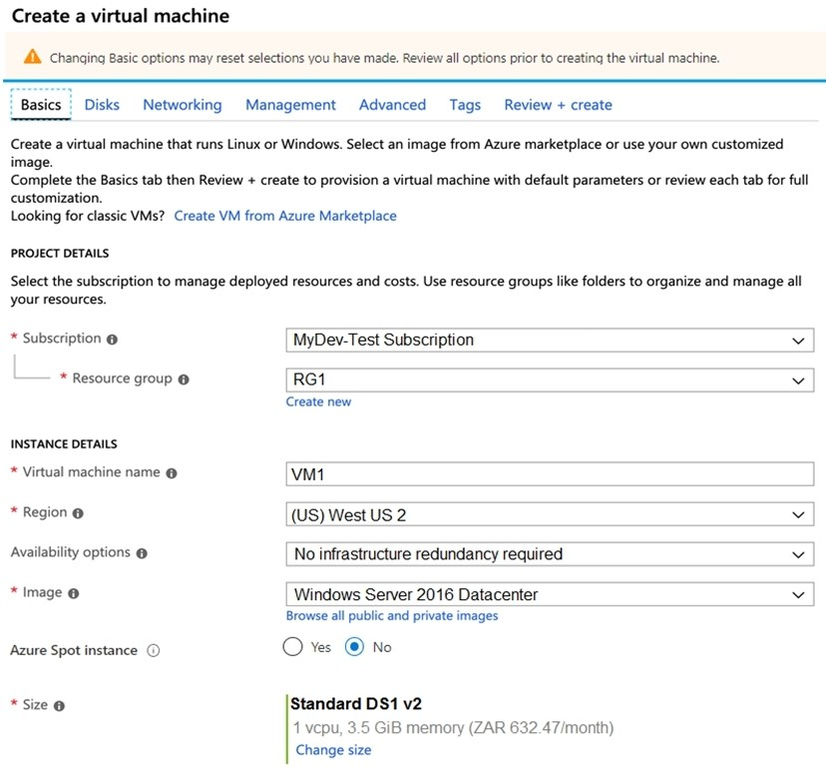

The planned disk configurations for VM1 are shown in the following exhibit.

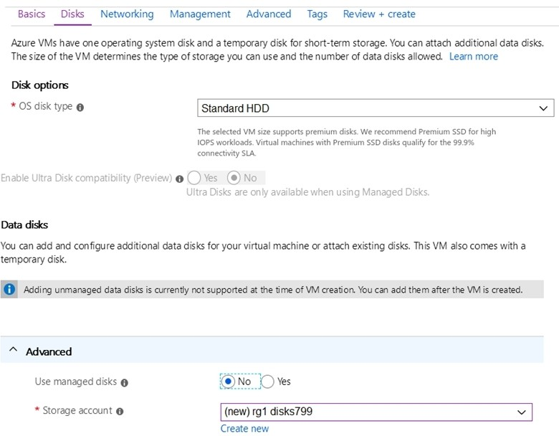

You need to ensure that VM1 can be created in an Availability Zone.

Which two settings should you modify? Each correct answer presents part of the solution. NOTE: Each correct selection is worth one point.

|  |  |
| --- | --- |
| A. | Use managed disks |
| B. | OS disk type |
| C. | Availability options |
| D. | Size |
| E. | Image |

**Answer:** AC

**Explanation:**

Your VMs should use managed disks if you want to move them to an Availability Zone by using Site Recovery.

When you create a VM for an Availability Zone, Under Settings > High availability, select one of the numbered zones from the Availability zone dropdown.

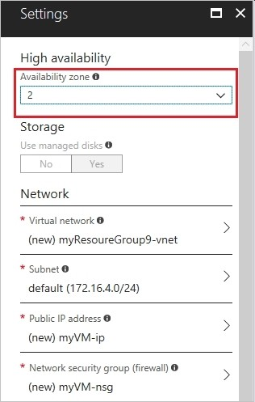

Reference:

https://docs.microsoft.com/en-us/azure/site-recovery/move-azure-vms-avset-azone https://docs.microsoft.com/en-us/azure/virtual-machines/windows/create-portal-availability-zone

### QUESTION 340

You have an existing Azure subscription that contains 10 virtual machines.

You need to monitor the latency between your on-premises network and the virtual machines. What should you use?

|  |  |
| --- | --- |
| A. | Service Map |
| B. | Connection troubleshoot |
| C. | Network Performance Monitor |
| D. | Effective routes |

**Answer:** C

**Explanation:**

Network Performance Monitor is a cloud-based hybrid network monitoring solution that helps you monitor network performance between various points in your network infrastructure. It also helps you monitor network connectivity to service and application endpoints and monitor the

performance of Azure ExpressRoute.

You can monitor network connectivity across cloud deployments and on-premises locations, multiple data centers, and branch offices and mission-critical multitier applications or microservices. With Performance Monitor, you can detect network issues before users complain. Reference:

https://docs.microsoft.com/en-us/azure/azure-monitor/insights/network-performance-monitor

**QUESTION 341**

# Case Study 2 - Contoso, Ltd

**Overview**

Contoso, Ltd. is a manufacturing company that has offices worldwide. Contoso works with partner organizations to bring products to market.

Contoso products are manufactured by using blueprint files that the company authors and maintains.

**Existing Environment**

Currently, Contoso uses multiple types of servers for business operations, including the following:

* File servers
* Domain controllers
* Microsoft SQL Server servers

Your network contains an Active Directory forest named contoso.com. All servers and client computers are joined to Active Directory.

You have a public-facing application named App1. App1 is comprised of the following three tiers:

* A SQL database
* A web front end
* A processing middle tier

Each tier is comprised of five virtual machines. Users access the web front end by using HTTPS only.

**Requirements Planned Changes**

Contoso plans to implement the following changes to the infrastructure:

* Move all the tiers of App1 to Azure.
* Move the existing product blueprint files to Azure Blob storage.
* Create a hybrid directory to support an upcoming Microsoft Office 365 migration project.

**Technical Requirements**

Contoso must meet the following technical requirements:

* Move all the virtual machines for App1 to Azure.
* Minimize the number of open ports between the App1 tiers.
* Ensure that all the virtual machines for App1 are protected by backups.
* Copy the blueprint files to Azure over the Internet.
* Ensure that the blueprint files are stored in the archive storage tier.
* Ensure that partner access to the blueprint files is secured and temporary.
* Prevent user passwords or hashes of passwords from being stored in Azure.
* Use unmanaged standard storage for the hard disks of the virtualmachines.
* Ensure that when users join devices to Azure Active Directory (Azure AD), the users use a mobile phone to verify their identity.
* Minimize administrative effort whenever possible.

**User Requirements**

Contoso identifies the following requirements for users:

* Ensure that only users who are part of a group named Pilot can join devices to Azure AD.
* Designate a new user named Admin1 as the service administrator of the Azure subscription.
* Ensure that a new user named User3 can create network objects for the Azure subscription.

Hotspot Question

You need to configure the Device settings to meet the technical requirements and the user requirements.

Which two settings should you modify? To answer, select the appropriate settings in the answer area.

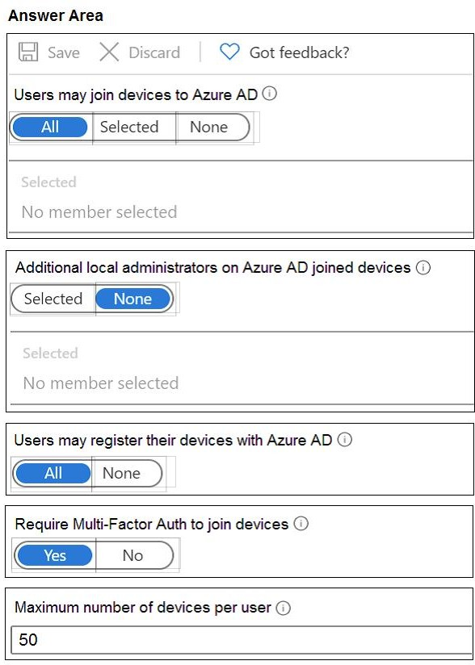

**Answer:**

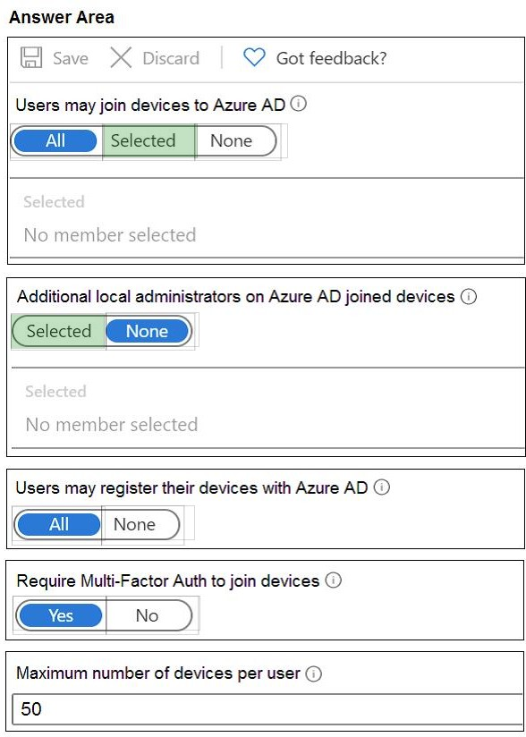

### QUESTION 342

Hotspot Question

You have an Azure Active Directory (Azure AD) tenant.

You need to create a conditional access policy that requires all users to use multi-factor authentication when they access the Azure portal.

Which three settings should you configure? To answer, select the appropriate settings in the answer area.

NOTE: Each correct selection is worth one point.

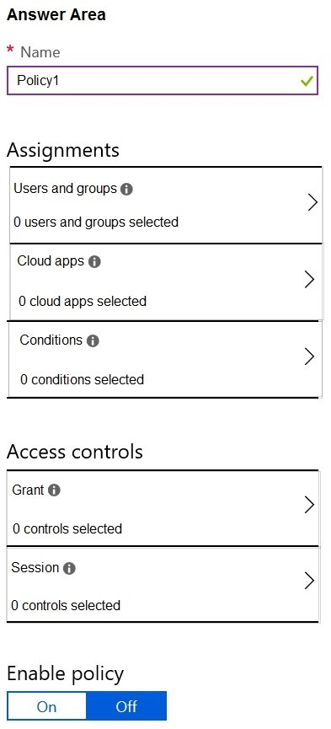

**Answer:**

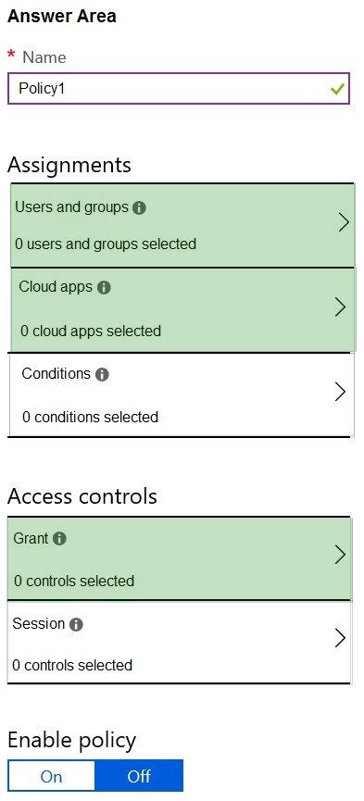

**Explanation:**

https://docs.microsoft.com/en-us/azure/active-directory/conditional-access/app-based-mfa

### QUESTION 343

Hotspot Question

You have an Azure Active Directory (Azure AD) tenant named adatum.com. Adatum.com contains the groups in the following table.

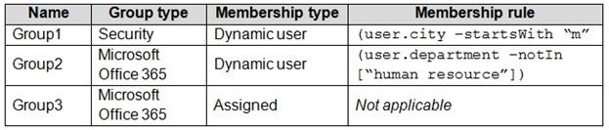

You create two user accounts that are configured as shown in the following table.

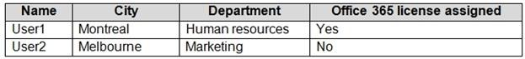

To which groups do User1 and User2 belong? To answer, select the appropriate options in the answer area.

NOTE: Each correct selection is worth one point.

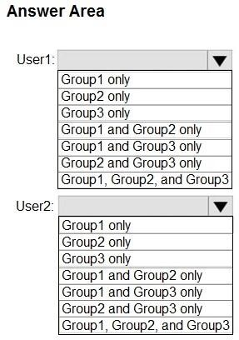

**Answer:**

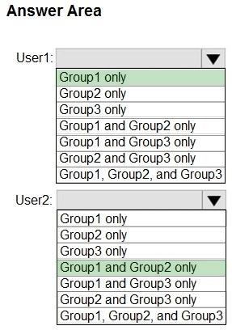

**Explanation:**

Box 1: Group 1 only First rule applies

Box 2: Group1 and Group2 only Both membership rules apply.

Reference:

https://docs.microsoft.com/en-us/sccm/core/clients/manage/collections/create-collections

### QUESTION 344

Hotspot Question

You have a hybrid deployment of Azure Active Directory (Azure AD) that contains the users shown in the following table.

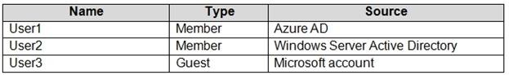

You need to modify the JobTitle and UsageLocation attributes for the users.

For which users can you modify the attributes from Azure AD? To answer, select the appropriate options in the answer area.

NOTE: Each correct selection is worth one point.

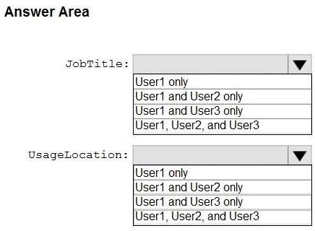

**Answer:**

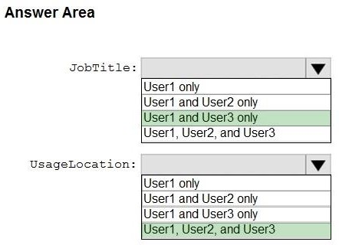

**Explanation:**

Box 1: User1 and User3 only

You must use Windows Server Active Directory to update the identity, contact info, or job info for users whose source of authority is Windows Server Active Directory.

Box 2: User1, User2, and User3

Reference:

https://docs.microsoft.com/en-us/azure/active-directory/fundamentals/active-directory-users- profile-azure-portal

### QUESTION 345

Hotspot Question

You have an Azure subscription named Subscription1 that contains the resources shown in the following table.

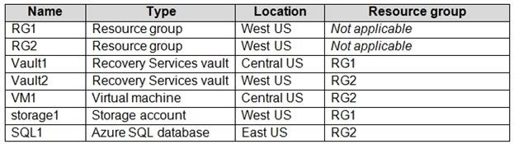

In storage1, you create a blob container named blob1 and a file share named share1.

Which resources can be backed up to Vault1 and Vault2? To answer, select the appropriate options in the answer area.

NOTE: Each correct selection is worth one point.

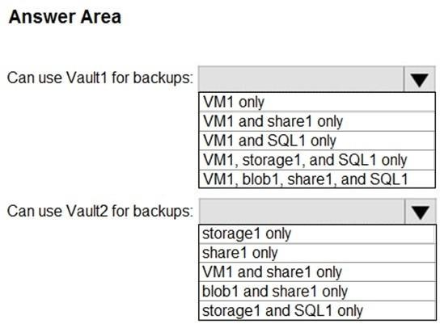

**Answer:**

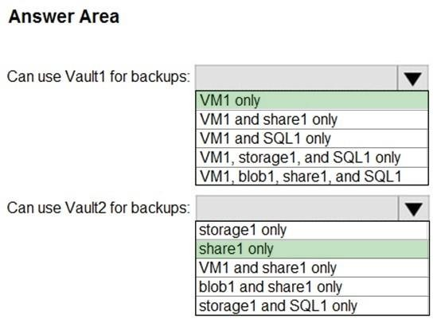

**Explanation:**

Box 1: VM1 only

VM1 is in the same region as Vault1. Share1 is not in the same region as Vautl1. SQL is not in the same region as Vault1.

Blobs cannot be backup up to service vaults.

Note: To create a vault to protect virtual machines, the vault must be in the same region as the virtual machines.

Box 2: Share1 only.

Storage1 is in the same region (West USA) as Vault2. Share1 is in Storage1.

Note: After you select Backup, the Backup pane opens and prompts you to select a storage account from a list of discovered supported storage accounts. They're either associated with this vault or present in the same region as the vault, but not yet associated to any Recovery Services vault.

Reference:

https://docs.microsoft.com/bs-cyrl-ba/azure/backup/backup-create-rs-vault https://docs.microsoft.com/en-us/azure/backup/backup-afs

### QUESTION 346

Hotspot Question

You have an Azure subscription.

You create the Azure Storage account shown in the following exhibit.

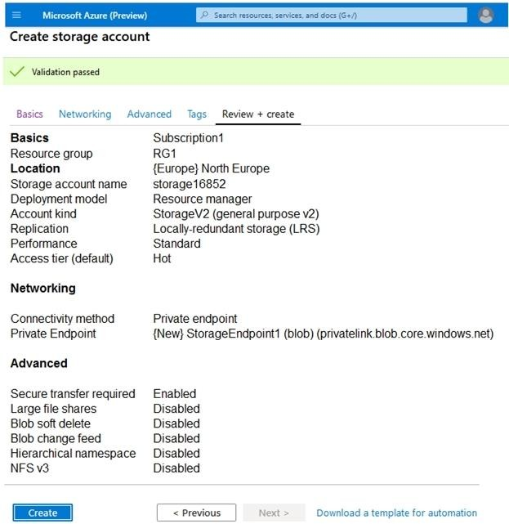

Use the drop-down menus to select the answer choice that completes each statement based on the information presented in the graphic.

NOTE: Each correct selection is worth one point.

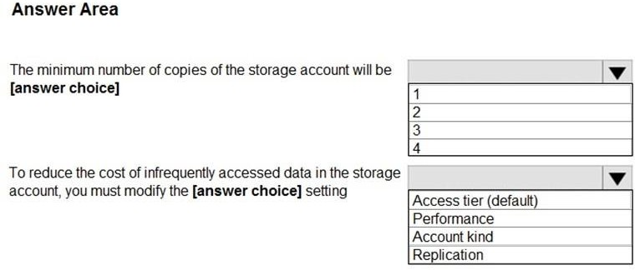

**Answer:**

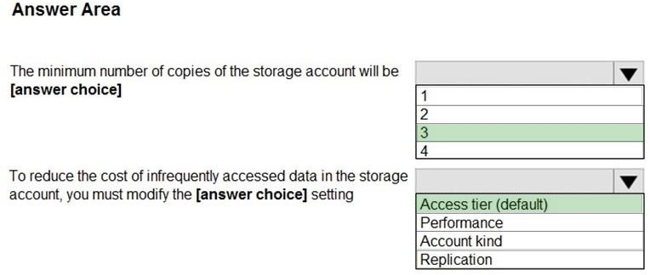

**Explanation:**

Box 1: 3

Locally Redundant Storage (LRS) provides highly durable and available storage within a single location (sub region). We maintain an equivalent of 3 copies (replicas) of your data within the primary location as described in our SOSP paper; this ensures that we can recover from common failures (disk, node, rack) without impacting your storage account's availability and durability.

Box 2: Access tier

Change the access tier from Hot to Cool.

Note: Azure storage offers different access tiers, which allow you to store blob object data in the most cost-effective manner. The available access tiers include:

Hot -Optimized for storing data that is accessed frequently. Cool -Optimized for storing data that is infrequently accessed and stored for at least 30 days. Archive -Optimized for storing data that is rarely accessed and stored for at least 180 days with flexible latency requirements (on the order of hours).

Reference:

https://azure.microsoft.com/en-us/blog/data-series-introducing-locally-redundant-storage-for- windows-azure-storage/

https://docs.microsoft.com/en-us/azure/storage/blobs/storage-blob-storage-tiers

### QUESTION 347

Hotspot Question

You have Azure subscriptions named Subscription1 and Subscription2. Subscription1 has following resource groups:

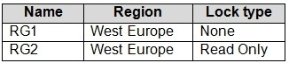

RG1 includes a web app named App1 in the West Europe location. Subscription2 contains the following resource groups:

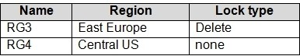

For each of the following statements, select Yes if the statement is true. Otherwise, select No. NOTE: Each correct selection is worth one point.

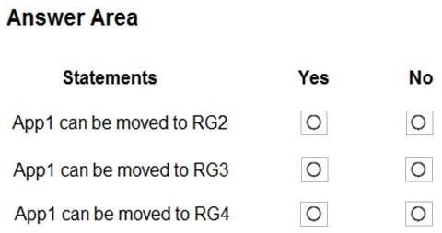

**Answer:**

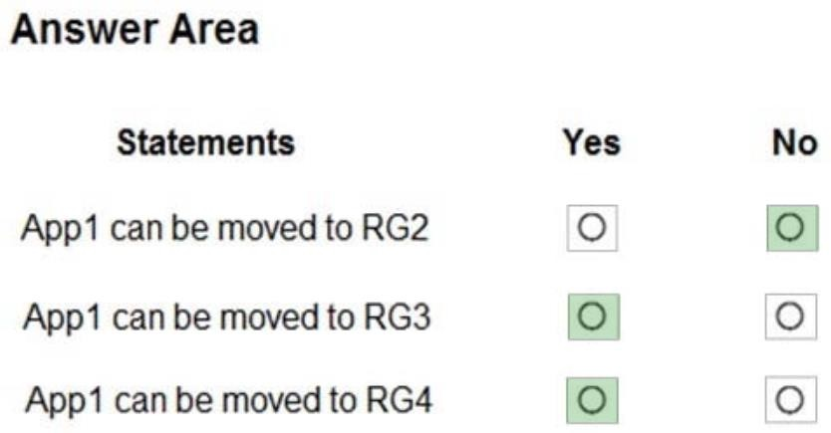

**Explanation:**

Box 1: No

RG2 is read only. ReadOnly means authorized users can read a resource, but they cannot delete or update the resource.

Box 2: Yes

Box 3: Yes Note:

App Service resources are region-specific and cannot be moved directly across regions. You can move the App Service resource by creating a copy of your existing App Service resource in the target region, then move your content over to the new app. You can then delete the source app and App Service plan.

To make copying your app easier, you can clone an individual App Service app into an App Service plan in another region.

Reference:

https://docs.microsoft.com/en-us/azure/app-service/manage-move-across-regions https://docs.microsoft.com/en-us/azure/azure-resource-manager/management/move- limitations/app-service-move-limitations

### QUESTION 348

Hotspot Question

You have an Azure subscription named Subscription1 that contains the following resource group:

* Name: RG1
* Region: West US
* Tag: "tag1": "value1"

You assign an Azure policy named Policy1 to Subscription1 by using the following configurations:

* Exclusions: None
* Policy definition: Append a tag and its value to resources
* Assignment name: Policy1
* Parameters:
* Tag name: Tag2
* Tag value: Value2

After Policy1 is assigned, you create a storage account that has the following configuration:

* Name: storage1
* Location: West US
* Resource group: RG1
* Tags: "tag3": "value3"

You need to identify which tags are assigned to each resource.

What should you identify? To answer, select the appropriate options in the answer area. NOTE: Each correct selection is worth one point.

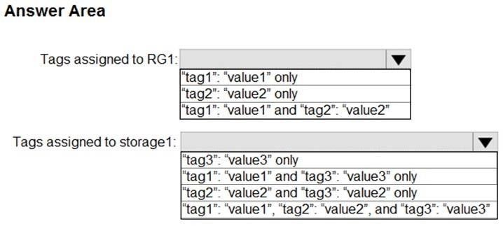

**Answer:**

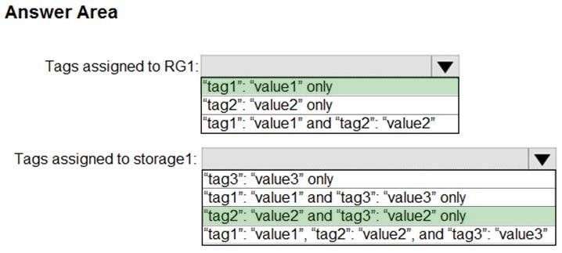

**Explanation:**

Box 1: "tag1": "value1" only

Box 2: "tag2": "value2" and "tag3": "value2" only

Tags applied to the resource group are not inherited by the resources in that resource group. Reference:

https://docs.microsoft.com/en-us/azure/azure-resource-manager/resource-group-using-tags

### QUESTION 349

Hotspot Question

You have an Azure subscription named Subscription1. In Subscription1, you create an alert rule named Alert1.

The Alert1 action group is configured as shown in the following exhibit.

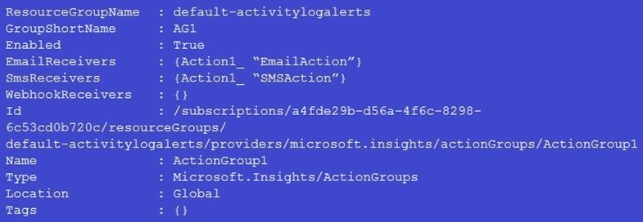

Alert1 alert criteria triggered every minute.

Use the drop-down menus to select the answer choice that completes each statement based on the information presented in the graphic.

NOTE: Each correct selection is worth one point.

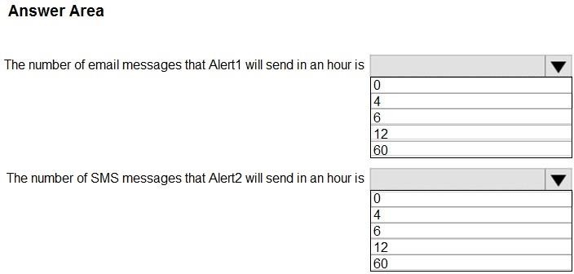

**Answer:**

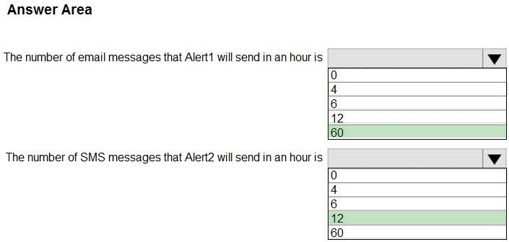

**Explanation:**

Box 1: 60

One alert per minute will trigger one email per minute.

Box 2: 12

No more than 1 SMS every 5 minutes can be send, which equals 12 per hour.

Note: Rate limiting is a suspension of notifications that occurs when too many are sent to a particular phone number, email address or device. Rate limiting ensures that alerts are manageable and actionable.

The rate limit thresholds are:

SMS: No more than 1 SMS every 5 minutes. Voice: No more than 1 Voice call every 5 minutes. Email: No more than 100 emails in an hour.

Other actions are not rate limited.

Reference:

https://docs.microsoft.com/en-us/azure/azure-monitor/platform/alerts-rate-limiting

### QUESTION 350

Your on-premises network contains an Active Directory domain named adatum.com that is synced to Azure Active Directory (Azure AD). Password writeback is disabled.

In adatum.com, you create the users shown in the following table.

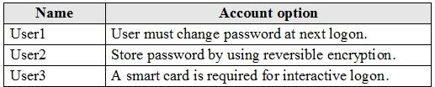

Which users must sign in from a computer joined to adatum.com?

|  |  |
| --- | --- |
| A. | User2 only |
| B. | User1 and User3 only |
| C. | User1, User2, and User3 |
| D. | User2 and User3 only |
| E. | User1 only |

**Answer:** E

**Explanation:**

Password writeback is a feature enabled with Azure AD Connect that allows password changes in the cloud to be written back to an existing on-premises directory in real time.

References:

https://docs.microsoft.com/en-us/azure/active-directory/authentication/concept-sspr-writeback

### QUESTION 351

Hotspot Question

You have an Azure subscription named Subscription1 that contains the virtual networks in the following table.

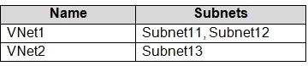

Subscription1 contains the virtual machines in the following table.

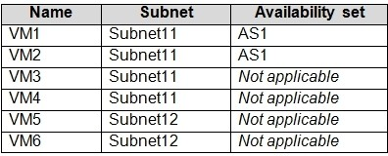

In Subscription1, you create a load balancer that has the following configurations:

 Name: LB1  SKU: Basic

 Type: Internal

 Subnet: Subnet12

 Virtual network: VNET1

For each of the following statements, select Yes if the statement is true. Otherwise, select No. NOTE: Each correct selection is worth one point.

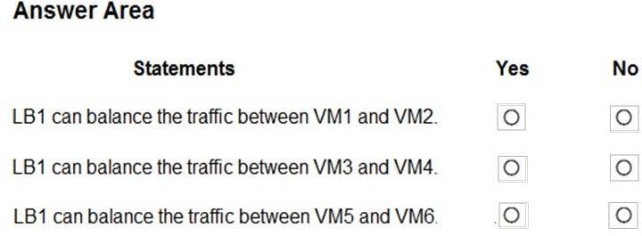

**Answer:**

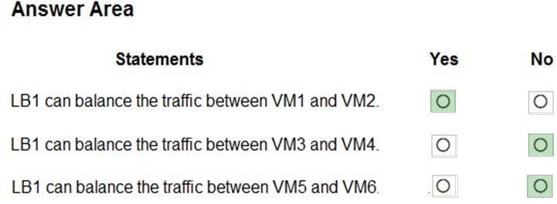

**Explanation:**

https://docs.microsoft.com/en-us/azure/load-balancer/load-balancer-standard-overview

### QUESTION 352

Hotspot Question

You have an Azure virtual machine that runs Windows Server 2019 and has the following configurations:

 Name: VM1

 Location: West US

 Connected to: VNET1

 Private IP address: 10.1.0.4

 Public IP addresses: 52.186.85.63

 DNS suffix in Windows Server: Adatum.com

You create the Azure DNS zones shown in the following table.

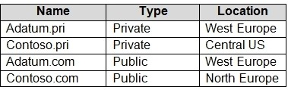

You need to identify which DNS zones you can link to VNET1 and the DNS zones to which VM1 can automatically register.

Which zones should you identify? To answer, select the appropriate options in the answer area. NOTE: Each correct selection is worth one point.

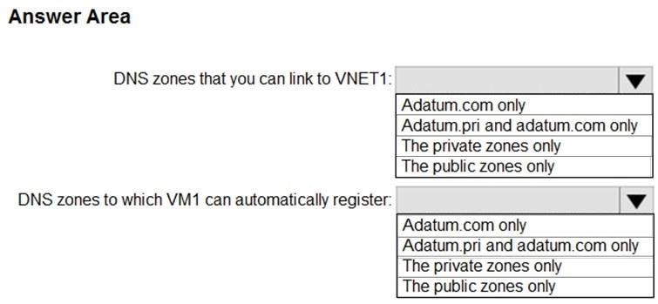

**Answer:**

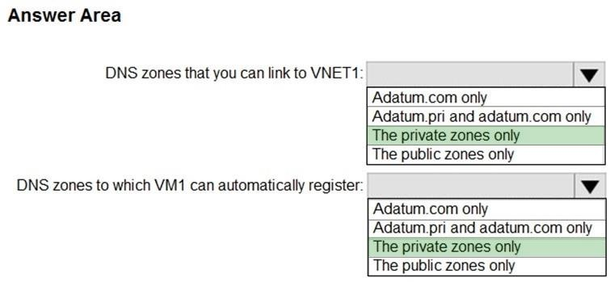

**Explanation:**

https://docs.microsoft.com/en-us/azure/dns/private-dns-overview

### QUESTION 353

Drag and Drop Question

You have an on-premises network that you plan to connect to Azure by using a site-so-site VPN.

In Azure, you have an Azure virtual network named VNet1 that uses an address space of 10.0.0.0/16 VNet1 contains a subnet named Subnet1 that uses an address space of 10.0.0.0/24.

You need to create a site-to-site VPN to Azure.

Which four actions should you perform in sequence? To answer, move the appropriate actions from the list of actions to the answer area and arrange them in the correct order.

NOTE: More than one order of answer choice is correct. You will receive credit for any of the correct orders you select.

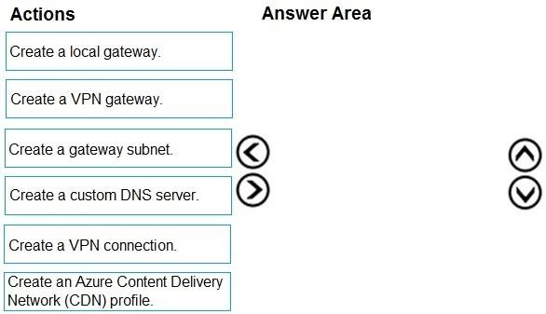

**Answer:**

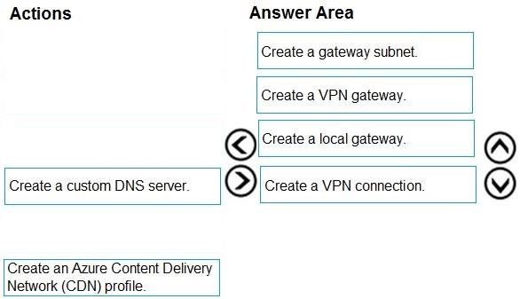

### QUESTION 354

Hotspot Question

You have an Azure subscription that contains the resources shown in the following table.

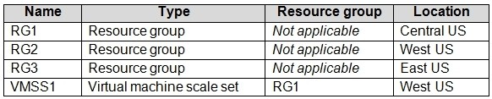

VMSS1 is set to VM (virtual machines) orchestration mode.

You need to deploy a new Azure virtual machine named VM1, and then add VM1 to VMSS1.

Which resource group and location should you use to deploy VM1? To answer, select the appropriate options in the answer area.

NOTE: Each correct selection is worth one point.

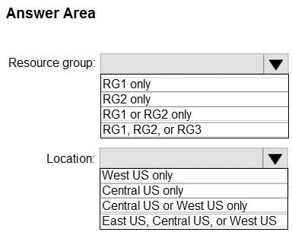

**Answer:**

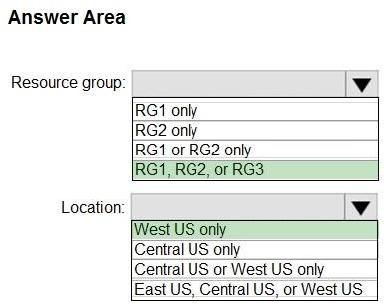

**Explanation:**

Box 1: RG1, RG2, or RG3

The resource group stores metadata about the resources. When you specify a location for the resource group, you're specifying where that metadata is stored. The location of the RG doesn't influence the choice of the location of VM. best practice would be to create the VM1 in the RG1 because the scale set is in RG1. And Microsoft recommends that resources contained in a Resource Group share the same resource lifecycle.

Box 2: West US only

You can add the virtual machine to a scale set in the same region, zone, and resource group.

Reference:

https://docs.microsoft.com/en-us/azure/azure-resource-manager/management/overview

https://docs.microsoft.com/en-us/azure/virtual-machine-scale-sets/virtual-machine-scale-sets- orchestration-modes

### QUESTION 355

Hotspot Question

Peering for VNET2 is configured as shown in the following exhibit.

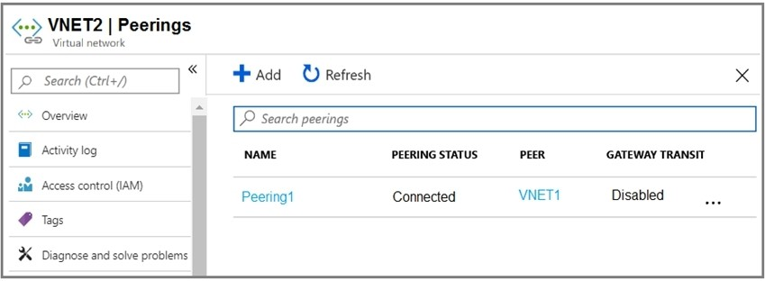

Peering for VNET3 is configured as shown in the following exhibit.

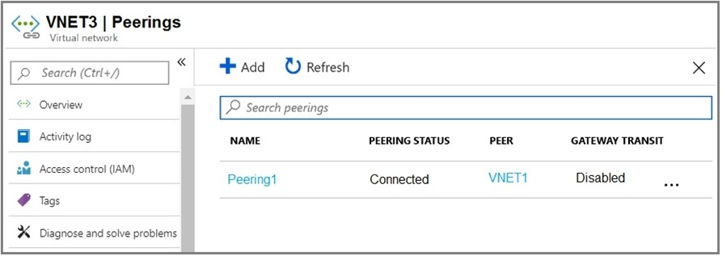

How can packets be routed between the virtual networks? To answer, select the appropriate options in the answer area.

NOTE: Each correct selection is worth one point.

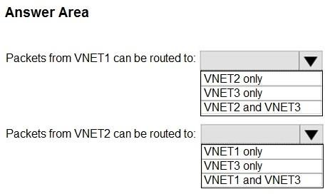

**Answer:**

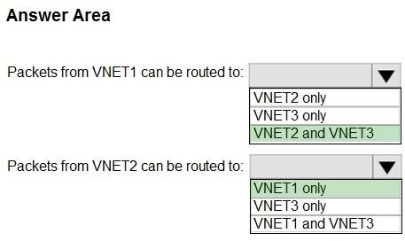

**Explanation:**

Box 1. VNET2 and VNET3

Box 2: VNET1

Gateway transit is disabled.

Reference:

https://docs.microsoft.com/en-us/azure/virtual-network/virtual-network-peering-overview

### QUESTION 356

You have an Azure subscription that contains a virtual network named VNet1. VNet 1 has two subnets named Subnet1 and Subnet2. VNet1 is in the West Europe Azure region.

The subscription contains the virtual machines in the following table.

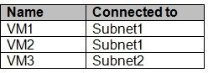

You need to deploy an application gateway named AppGW1 to VNet1. What should you do first?

|  |  |
| --- | --- |
| A. | Add a service endpoint. |
| B. | Add a virtual network. |
| C. | Move VM3 to Subnet1. |
| D. | Stop VM1 and VM2. |

**Answer:** C

**Explanation:**

Tested this movement (inside assigned NIC in section IPConfiguration, there is an option to change subnet, which restarted VM). After restart VM had new private IP from different subnet. I also tried to stop VM in subnet, where only this VM was assigned. Then I tried to create new

AppGtw to this subnet and portal did not give me the option, selected subnet was not possible to use. Even if VM was stopped, it still had its privateID (public was released) what was probably the reason, why this subnet is not usable for AppGtw.

### QUESTION 357

You are the global administrator for an Azure Active Directory (Azure AD) tenant named adatum.com.

From the Azure Active Directory blade, you assign the Conditional Access Administrator role to a user named Admin1.

You need to ensure that Admin1 has just-in-time access as a conditional access administrator. What should you do next?

|  |  |
| --- | --- |
| A. | Enable Azure AD Multi-Factor Authentication (MFA). |
| B. | Set Admin1 as Eligible for the Privileged Role Administrator role. |
| C. | Set Admin1 as Eligible for the Conditional Access Administrator role. |
| D. | Enable Azure AD Identity Protection. |

**Answer:** A

**Explanation:**

Require MFA for admins is a baseline policy that requires MFA for the following directory roles:  Global administrator

 SharePoint administrator  Exchange administrator

 Conditional access administrator

 Security administrator References:

https://docs.microsoft.com/en-us/azure/active-directory/conditional-access/baseline-protection

### QUESTION 358

You are the global administrator for an Azure Directory (Azure AD) tenant named adatum.com. You need to enable two-step verification for Azure users.

What should you do?

|  |  |
| --- | --- |
| A. | Create a single sign-in risk policy in Azure AD Identity Protection. |
| B. | Enable Azure AD Privileged Identity Management. |
| C. | Create and configure the Identity Hub. |
| D. | Configure a security policy in Azure Security Center. |

**Answer:** A

**Explanation:**

With Azure Active Directory Identity Protection, you can:

require users to register for multi-factor authentication handle risky sign-ins and compromised users References:

https://docs.microsoft.com/en-us/azure/active-directory/identity-protection/flows

### QUESTION 359

You have an Azure subscription named Subscription1 that contains an Azure virtual machine named VM1.

VM1 is in a resource group named RG1.

VM1 runs services that will be used to deploy resources to RG1.

You need to ensure that a service running on VM1 can manage the resources in RG1 by using the identity of VM1.

What should you do first?

|  |  |
| --- | --- |
| A. | From the Azure portal, modify the Access control (IAM) settings of VM1. |
| B. | From the Azure portal, modify the Policies settings of RG1. |
| C. | From the Azure portal, modify the value of the Managed Service Identity option for VM1. |
| D. | From the Azure portal, modify the Access control (IAM) settings of RG1. |

**Answer:** C

**Explanation:**

A managed identity from Azure Active Directory allows your app to easily access other AAD- protected resources such as Azure Key Vault. The identity is managed by the Azure platform and does not require you to provision or rotate any secrets.

User assigned managed identities can be used on Virtual Machines and Virtual Machine Scale Sets.

References:

https://docs.microsoft.com/en-us/azure/app-service/app-service-managed-service-identity

### QUESTION 360

You are configuring Azure Active Directory (AD) Privileged Identity Management.

You need to provide a user named Admin1 with read access to a resource group named RG1 for only one month. The user role must be assigned immediately.

What should you do?

|  |  |
| --- | --- |
| A. | Assign an active role. |
| B. | Assign an eligible role. |
| C. | Assign a permanently active role. |
| D. | Create a custom role and a conditional access policy. |

**Answer:** A

**Explanation:**

https://docs.microsoft.com/en-us/azure/active-directory/privileged-identity-management/pim- configure

### QUESTION 361

You have an Azure Active Directory (Azure AD) tenant named Tenant1 and an Azure subscription named Subscription1.

You enable Azure AD Privileged Identity Management.

You need to secure the members of the Lab Creator role. The solution must ensure that the lab creators request access when they create labs.

What should you do first?

|  |  |
| --- | --- |
| A. | From Azure AD Privileged Identity Management, edit the role settings for Lab Creator. |
| B. | From Subscription1, edit the members of the Lab Creator role. |
| C. | From Azure AD Identity Protection, create a user risk policy. |
| D. | From Azure AD Privileged Identity Management, discover the Azure resources of Subscription1. |

**Answer:** A

**Explanation:**

As a Privileged Role Administrator you can:

Enable approval for specific roles

Specify approver users and/or groups to approve requests View request and approval history for all privileged roles References:

https://docs.microsoft.com/en-us/azure/active-directory/privileged-identity-management/pim- configure

### QUESTION 362

You create an Azure subscription that is associated to a basic Azure Active Directory (Azure AD) tenant.

You need to receive an email notification when any user activates an administrative role. What should you do?

|  |  |
| --- | --- |
| A. | Purchase Azure AD Premium P2 and configure Azure AD Privileged Identity Management. |
| B. | Purchase Enterprise Mobility + Security E3 and configure conditional access policies. |
| C. | Purchase Enterprise Mobility + Security E5 and create a custom alert rule in Azure Security Center. |
| D. | Purchase Azure AD Premium P1 and enable Azure AD Identity Protection. |

**Answer:** A

**Explanation:**

When key events occur in Azure AD Privileged Identity Management (PIM), email notifications are sent.

For example, PIM sends emails for the following events:

When a privileged role activation is pending approval When a privileged role activation request is completed When a privileged role is activated

When a privileged role is assigned When Azure AD PIM is enabled References:

https://docs.microsoft.com/en-us/azure/active-directory/privileged-identity-management/pim- email-notifications

### QUESTION 363

You have an Azure Active Directory (Azure AD) tenant.

You have an existing Azure AD conditional access policy named Policy1. Policy1 enforces the use of Azure AD-joined devices when members of the Global Administrators group authenticate to Azure AD from untrusted locations.

You need to ensure that members of the Global Administrators group will also be forced to use multi-factor authentication when authenticating from untrusted locations.

What should you do?

|  |  |
| --- | --- |
| A. | From the multi-factor authentication page, modify the service settings. |
| B. | From the multi-factor authentication page, modify the user settings. |
| C. | From the Azure portal, modify grant control of Policy1. |
| D. | From the Azure portal, modify session control of Policy1. |

**Answer:** C

**Explanation:**

There are two types of controls:

Grant controls - To gate access

Session controls - To restrict access to a session

Grant controls oversee whether a user can complete authentication and reach the resource that they're attempting to sign-in to. If you have multiple controls selected, you can configure whether all of them are required when your policy is processed. The current implementation of Azure Active Directory enables you to set the following grant control requirements:

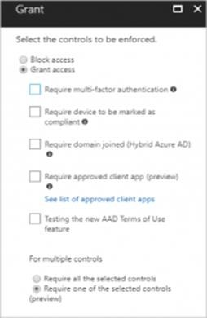

References:

https://blog.lumen21.com/2017/12/15/conditional-access-in-azure-active-directory/

### QUESTION 364

You have an Azure subscription.

You enable multi-factor authentication for all users.

Some users report that the email applications on their mobile device cannot connect to their Microsoft Exchange Online mailbox. The users can access Exchange Online by using a web browser and from Microsoft Outlook 2016 on their computer.

You need to ensure that the users can use the email applications on their mobile device. What should you instruct the users to do?

|  |  |
| --- | --- |
| A. | Enable self-service password reset. |
| B. | Create an app password. |
| C. | Reset the Azure Active Directory (Azure AD) password. |
| D. | Reinstall the Microsoft Authenticator app. |

**Answer:** B

### QUESTION 365

You have an Azure subscription named Subscription1 and two Azure Active Directory (Azure AD) tenants named Tenant1 and Tenant2.

Subscription1 is associated to Tenant1. Multi-factor authentication (MFA) is enabled for all the users in Tenant1.

You need to enable MFA for the users in Tenant2. The solution must maintain MFA for Tenant1. What should you do first?

|  |  |
| --- | --- |
| A. | Transfer the administration of Subscription1 to a global administrator of Tenant2 |
| B. | Configure the MFA Server setting in Tenant1. |
| C. | Create and link a subscription to Tenant2. |
| D. | Change the directory for Subscription1. |

**Answer:** C

### QUESTION 366

Your VMware vSphere on-premises infrastructure hosts 600 virtual machines (VMs). Your company is planning to move all of these VMs to Azure. You are asked to provide information about

the resources that will be needed in Azure to host all of the VMs.

All VMs hosted in your on-premise infrastructure are based on Windows Server 2012 R2 or newer and RedHat Enterprise Linux 7.0 or newer.

You conduct the initial migration assessment and get a message that some virtual machines are conditionally ready for Azure.

You need to find the cause of this message.

What are two reasons why are you might get this message on some VMs? Each correct answer presents part of the solution.

|  |  |
| --- | --- |
| A. | The vCenter user does not have enough permissions on affected VMs. |
| B. | The operating system is configured as Windows Server 2003 in vCenter Server. |
| C. | The operating system is configured as Others in vCenter Server. |
| D. | The VMs are configured with the BIOS boot type. |
| E. | The VMs are configured with the UEFI boot type. |

**Answer:** BE

### QUESTION 367

You have five Windows Server 2008 R2 physical servers. The servers satisfy all requirements for failover protection using Azure Site Recovery (ASR).

ASR is correctly configured and active.

You need to ensure that only 10 minutes of data is lost in the event of an incident by using the minimum amount of effort.

Which PowerShell cmdlet should you run?

|  |  |
| --- | --- |
| A. | Edit-AzureRmSiteRecoveryPolicy |
| B. | Edit-AzureRmSiteRecoveryRecoveryPlan |
| C. | New-AzureRmSiteRecoveryPolicy |
| D. | Get-AzureRmSiteRecoveryRecoveryPlan |

**Answer:** A

### QUESTION 368

You manage an on-premises infrastructure based on VMware vSphere 6.0 with 250 virtual machines (VMs). You are evaluating the possibility of moving those VMs to Azure.

You decide to use the Azure Migrate service to help you with the assessment of your on- premises infrastructure.

You configure the default data collection level for your VMware vCenter server.

After performing the initial assessment, you find that there is some missing information in the assessment.

You need to make needed configurations so Azure Migrate service can collect all of the available information.

What should you do?

|  |  |
| --- | --- |
| A. | Configure the data collector level in VMware vCenter to level 3. |
| B. | Configure the collector VM with a user account with administrative privileges. |
| C. | Configure the data collector level in VMware vCenter to level 2. |
| D. | Configure the collector VM with a user account with read-only privileges. |

**Answer:** A

### QUESTION 369

Hotspot Question

You create an Azure web app named WebApp1.

WebApp1 has the autoscale settings shown in the following exhibit.

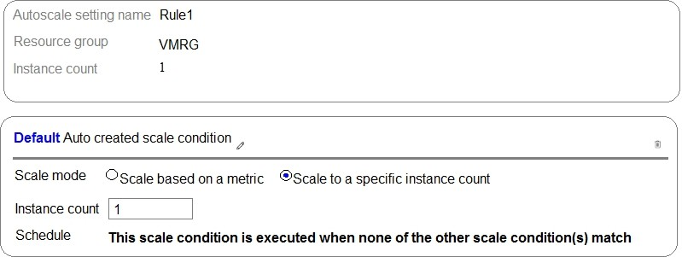

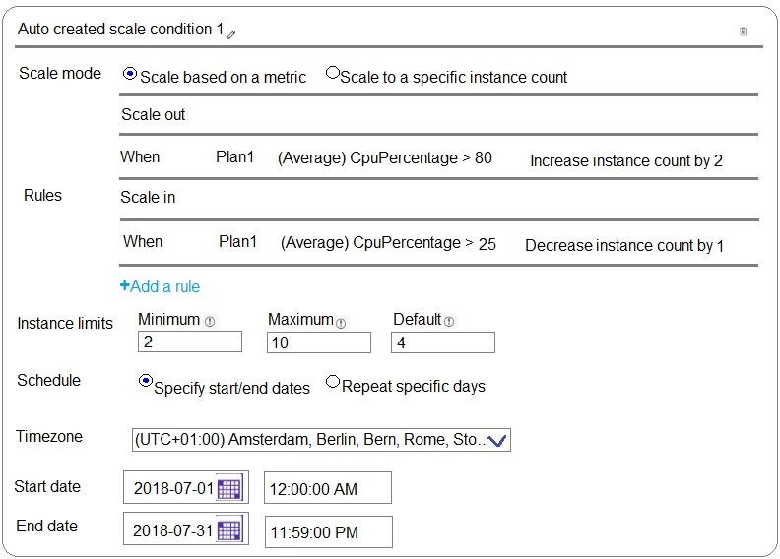

The scale out and scale in rules are configured to have a duration of 10 minutes and a cool down time of five minutes.

Use the drop-down menus to select the answer choice that completes each statement based on the information presented in the graphic.

NOTE: Each correct selection is worth one point.

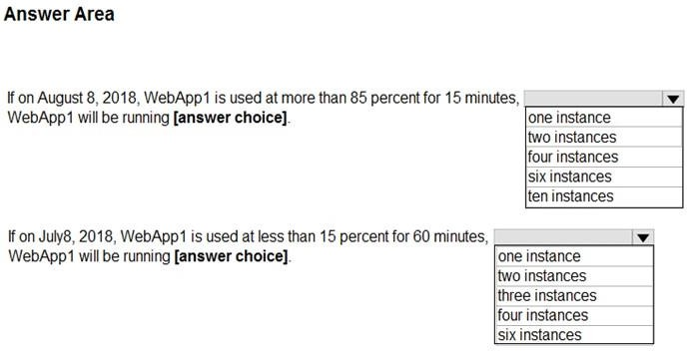

**Answer:**

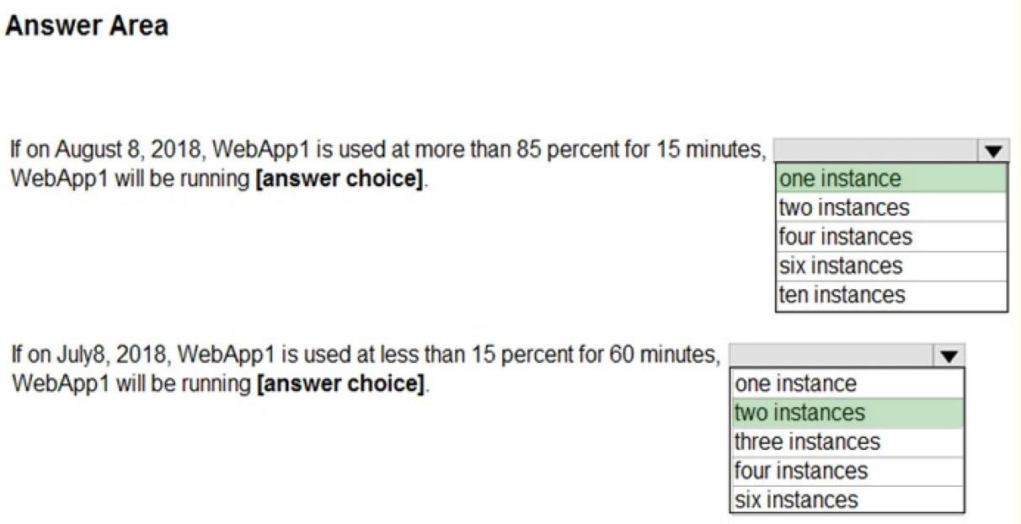

**Explanation:**

https://docs.microsoft.com/en-us/azure/monitoring-and-diagnostics/insights-autoscale-best- practices

### QUESTION 370

Drag and Drop Question

You have an Azure subscription that contains an Azure Service Bus named Bus1.

Your company plans to deploy two Azure web apps named App1 and App2. The web apps will create messages that have the following requirements:

* Each message created by App1 must be consumed by only a single consumer
* Each message created by App2 will be consumed by multiple consumers.

Which resource should you create for each web app? To answer, drag the appropriate resources to the correct web apps. Each resource may be used once, more than once, or not at all. You may need to drag the split bar between panes or scroll to view content.

NOTE: Each correct selection is worth one point.

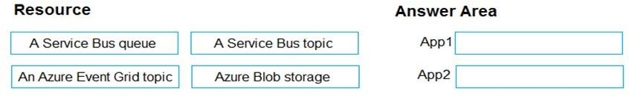

**Answer:**

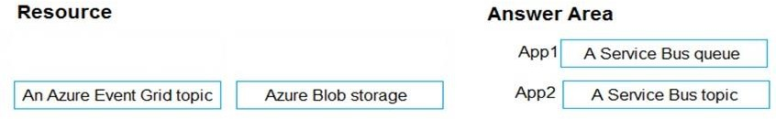

**Explanation:**

App1: A service Bus queue

In Queues each message is processed by a single consumer. App2: A Service Bus topic

In contrast to queues, in which each message is processed by a single consumer, topics and subscriptions provide a one-to-many form of communication, in a publish/subscribe pattern. References:

https:/[/www.codit.eu/blog/exploring-azure-event-grid-are-service-bus-topic-dead/](http://www.codit.eu/blog/exploring-azure-event-grid-are-service-bus-topic-dead/)

### QUESTION 371

Drag and Drop Question

You are developing an Azure web app named WebApp1. WebApp1 uses an Azure App Service plan named Plan1 that uses the B1 pricing tier.

You need to configure WebApp1 to add additional instances of the app when CPU usage exceeds 70 percent for 10 minutes.

Which three actions should you perform in sequence? To answer, move the appropriate actions from the list of actions to the answer area and arrange them in the correct order.

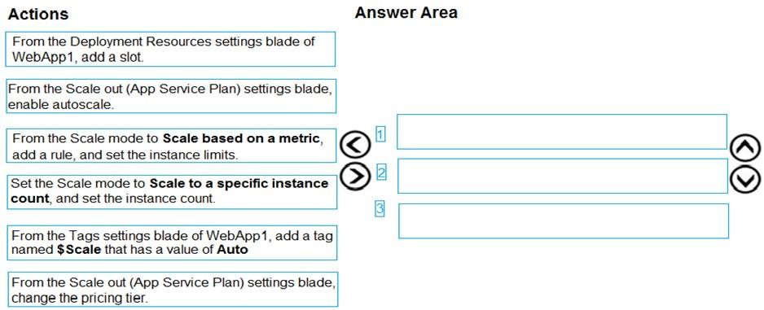

**Answer:**

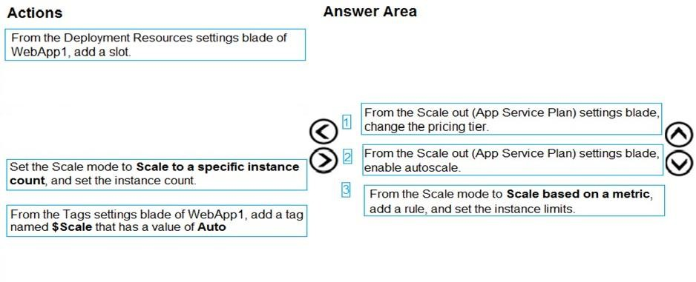

**Explanation:**

Box 1: From the Scale out (App Service Plan) settings blade, change the pricing tier The B1 pricing tier only allows for 1 core. We must choose another pricing tier.

Box 2: From the Scale out (App Service Plan) settings blade, enable autoscale

1. Log in to the Azure portal at [http://portal.azure.com](http://portal.azure.com/)
2. Navigate to the App Service you would like to autoscale.
3. Select Scale out (App Service plan) from the menu
4. Click on Enable autoscale. This activates the editor for scaling rules.

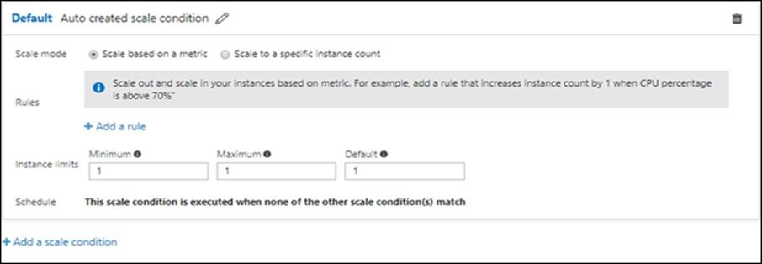

Box 3: From the Scale mode to Scale based on metric, add a rule, and set the instance limits.

Click on Add a rule. This shows a form where you can create a rule and specify details of the scaling.

References:

https://azure.microsoft.com/en-us/pricing/details/app-service/windows/ https://blogs.msdn.microsoft.com/hsirtl/2017/07/03/autoscaling-azure-web-apps/

### QUESTION 372

Hotspot Question

You have an Azure web app named WebApp1 that runs in an Azure App Service plan named ASP1. ASP1 is based on the D1 pricing tier.

You need to ensure that WebApp1 can be accessed only from computers on your on-premises network.

The solution must minimize costs.

What should you configure? To answer, select the appropriate options in the answer area. NOTE: Each correct selection is worth one point.

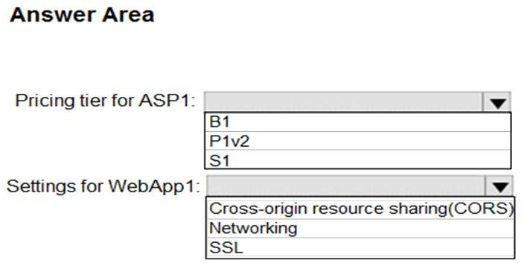

**Answer:**

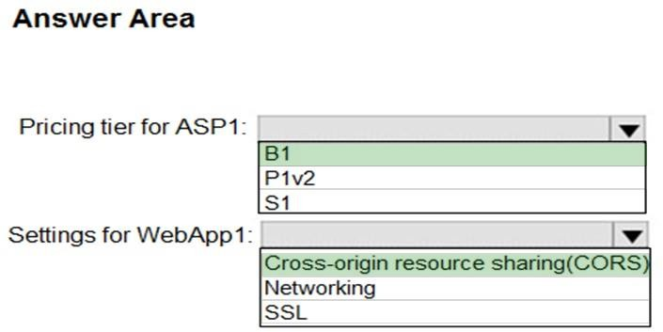

**Explanation:**

Box 1: B1

B1 (Basic) would minimize cost compared P1v2 (premium) and S1 (standard). Box 2: Cross Origin Resource Sharing (CORS)

Once you set the CORS rules for the service, then a properly authenticated request made against the service from a different domain will be evaluated to determine whether it is allowed according to the rules you have specified.

Note: CORS (Cross Origin Resource Sharing) is an HTTP feature that enables a web application

running under one domain to access resources in another domain. In order to reduce the possibility of cross-site scripting attacks, all modern web browsers implement a security restriction known as same-origin policy. This prevents a web page from calling APIs in a different domain.

CORS provides a secure way to allow one origin (the origin domain) to call APIs in another origin. References:

https://azure.microsoft.com/en-us/pricing/details/app-service/windows/ https://docs.microsoft.com/en-us/azure/cdn/cdn-cors

### QUESTION 373

Hotspot Question

You have an Azure web app named WebApp1.

You need to provide developers with a copy of WebApp1 that they can modify without affecting the production WebApp1. When the developers finish testing their changes, you must be able to switch the current line version of WebApp1 to the new version.

Which command should you run prepare the environment? To answer, select the appropriate options in the answer area.

NOTE: Each correct selection is worth one point.

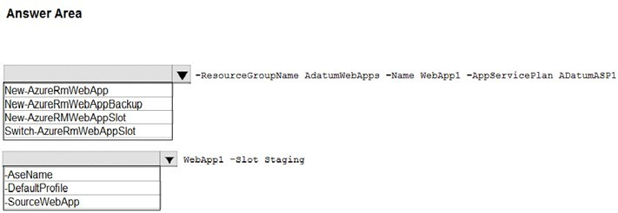

**Answer:**

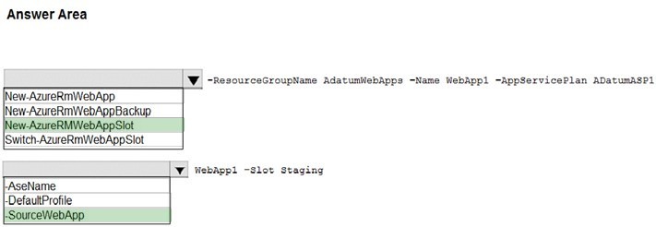

**Explanation:**

Box 1: New-AzureRmWebAppSlot

The New-AzureRmWebAppSlot cmdlet creates an Azure Web App Slot in a given a resource

group that uses the specified App Service plan and data center. Box 2: -SourceWebApp

References:

https://docs.microsoft.com/en-us/powershell/module/azurerm.websites/new-azurermwebappslot

### QUESTION 374

Drag and Drop Question

You have an Azure subscription that contains the following resources:

* a virtual network named VNet1
* a replication policy named ReplPolicy1
* a Recovery Services vault named Vault1
* an Azure Storage account named Storage1

You have an Amazon Web Services (AWS) EC2 virtual machine named VM1 that runs Windows Server 2016.

You need to migrate VM1 to VNet1 by using Azure Site Recovery.

Which three actions should you perform in sequence? To answer, move the appropriate actions from the list of actions to the answer area and arrange them in the correct order.

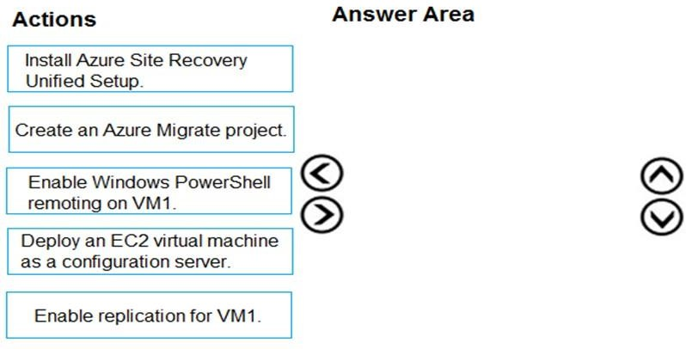

**Answer:**

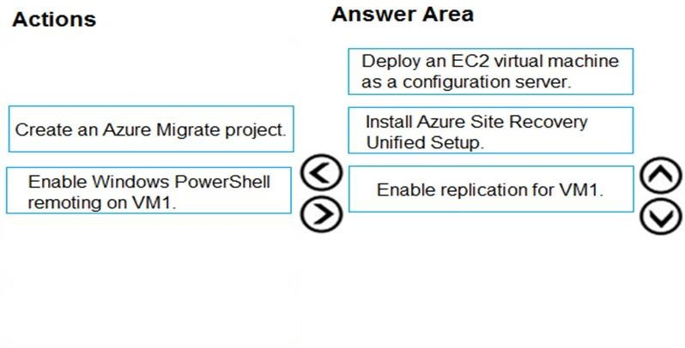

**Explanation:**

Step 1: Deploy an EC2 virtual machine as a configuration server Prepare source include:

1. Use an EC2 instance that's running Windows Server 2012 R2 to create a configuration server and register it with your recovery vault.
2. Configure the proxy on the EC2 instance VM you're using as the configuration server so that it can access the service URLs.

Step 2: Install Azure Site Recovery Unified Setup.

Download Microsoft Azure Site Recovery Unified Setup. You can download it to your local machine and then copy it to the VM you're using as the configuration server.

Step 3: Enable replication for VM1.

Enable replication for each VM that you want to migrate. When replication is enabled, Site Recovery automatically installs the Mobility service.

References:

https://docs.microsoft.com/en-us/azure/site-recovery/migrate-tutorial-aws-azure

### QUESTION 375

Drag and Drop Question

You create an Azure Migrate project named TestMig in a resource group named test-migration. You need to discover which on-premises virtual machines to assess for migration.

Which three actions should you perform in sequence? To answer, move the appropriate actions from the list of actions to the answer area and arrange them in the correct order.

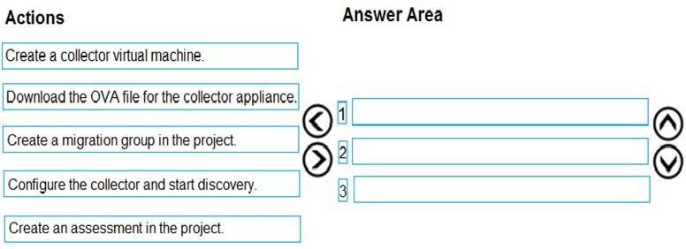

**Answer:**

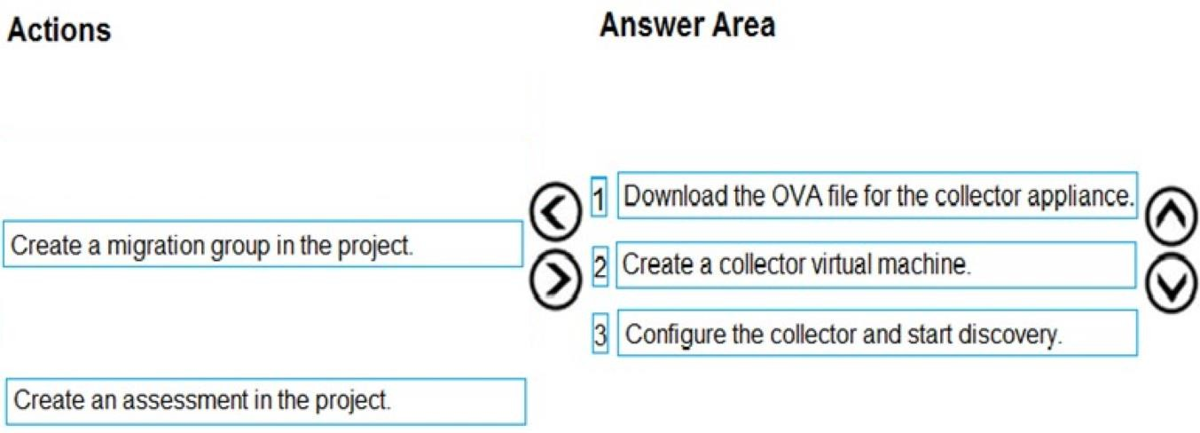

### QUESTION 376

Hotspot Question

Your company has offices in New York and Los Angeles.

You have an Azure subscription that contains an Azure virtual network named VNet1. Each office has a site-to-site VPN connection to VNet1.

Each network uses the address spaces shown in the following table.

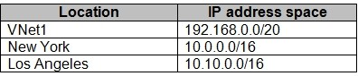

You need to ensure that all Internet-bound traffic from VNet1 is routed through the New York office.

What should you do? To answer, select the appropriate options in the answer area. NOTE: Each correct selection is worth one point.

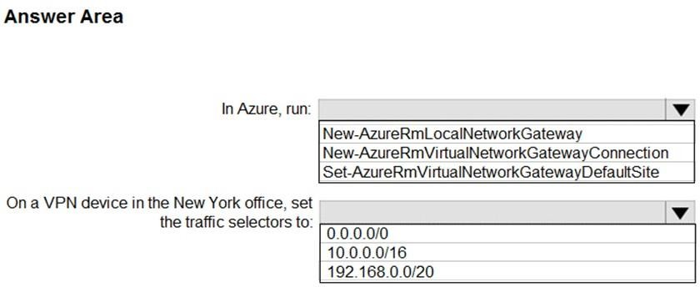

**Answer:**

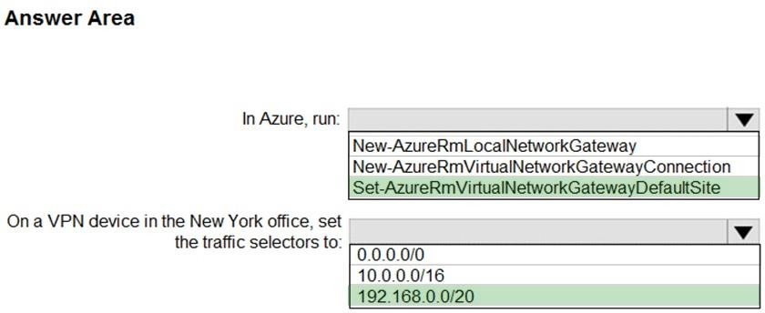

**Explanation:**

Box 1: Set-AzureRmVirtualNetworkGatewayDefaultSite

The Set-AzureRmVirtualNetworkGatewayDefaultSite cmdlet assigns a forced tunneling default site to a virtual network gateway. Forced tunneling provides a way for you to redirect Internet- bound traffic from Azure virtual machines to your on-premises network; this enables you to inspect and audit traffic before releasing it. Forced tunneling is carried out by using a virtual private network (VPN) tunnel; this tunnel requires a default site, a local gateway where all the Azure Internet-bound traffic is redirected. Set- AzureRmVirtualNetworkGatewayDefaultSite provides a way to change the default site assigned to a gateway.

Incorrect Answers:

Not: New-AzureRmVirtualNetworkGatewayConnection

This command creates the Site-to-Site VPN connection between the virtual network gateway and the on- prem VPN device. We already have Site-to-Site VPN connections.

Box 2: 192.168.0.0/20

Specify the VNET1 address.

Incorrect Answers:

Not: New-AzureRmVirtualNetworkGatewayConnection

This command creates the Site-to-Site VPN connection between the virtual network gateway and

the on- prem VPN device. We already have Site-to-Site VPN connections. Box 2: 192.168.0.0/20

Specify the VNET1 address.

References:

https://docs.microsoft.com/en-us/powershell/module/azurerm.network/set- azurermvirtualnetworkgatewaydefaultsite

### QUESTION 377

Hotspot Question

You have an Azure virtual network named VNet1 that connects to your on-premises network by using a site-to-site VPN. VMet1 contains one subnet named Subnet1.

Subnet1 is associated to a network security group (NSG) named NSG1. Subnet1 contains a basic internal load balancer named ILB1. ILB1 has three Azure virtual machines in the backend pool.

You need to collect data about the IP addresses that connects to ILB1. You must be able to run interactive queries from the Azure portal against the collected data.

What should you do? To answer, select the appropriate options in the answer area. NOTE: Each correct selection is worth one point.

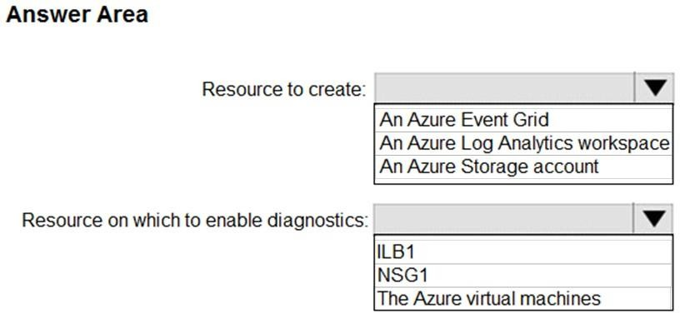

**Answer:**



**Explanation:**

Box 1: An Log analytics workspace

Log analytics workspace: An instance of log analytics, where the data pertaining to an Azure account, is stored.

Log Analytics: An Azure service that collects monitoring data and stores the data in a central repository. This data can include events, performance data, or custom data provided through the Azure API. Once collected, the data is available for alerting, analysis, and export. Monitoring applications such as network performance monitor and traffic analytics are built using Log Analytics as a foundation.

Box 2: NSG1

Network security group (NSG): Contains a list of security rules that allow or deny network traffic to resources connected to an Azure Virtual Network. NSGs can be associated to subnets, individual VMs (classic), or individual network interfaces (NIC) attached to VMs (Resource Manager).

References:

https://docs.microsoft.com/en-us/azure/network-watcher/traffic-analytics

### QUESTION 378

Hotspot Question

You have an Azure subscription named Subscription1 that contains the resources in the following table.

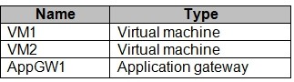

VM1 and VM2 run the websites in the following table.

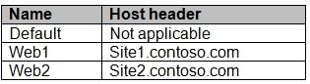

AppGW1 has the backend pools in the following table.

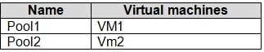

DNS resolves site1.contoso.com, site2.contoso.com, and site3.contoso.com to the IP address of AppGW1.

AppGW1 has the listeners in the following table.

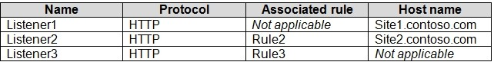

AppGW1 has the rules in the following table.



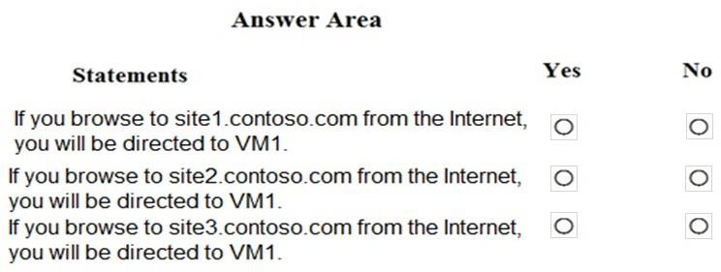For each of the following statements, select Yes if the statement is true. Otherwise, select No. NOTE: Each correct selection is worth one point.

**Answer:**

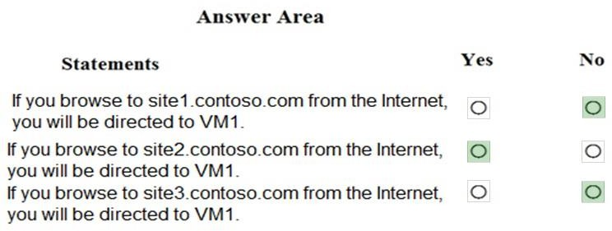

**Explanation:**

Vm1 is in Pool1. Rule2 applies to Pool1, Listener 2, and site2.contoso.com

### QUESTION 379

Hotspot Question

You have an on-premises data center and an Azure subscription. The data center contains two VPN devices. The subscription contains an Azure virtual network named VNet1. VNet1 contains a gateway subnet.

You need to create a site-to-site VPN. The solution must ensure that is a single instance of an Azure VPN gateway fails, or a single on-premises VPN device fails, the failure will not cause an interruption that is longer than two minutes.

What is the minimum number of public IP addresses, virtual network gateways, and local network gateways required in Azure? To answer, select the appropriate options in the answer area.

NOTE: Each correct selection is worth one point.

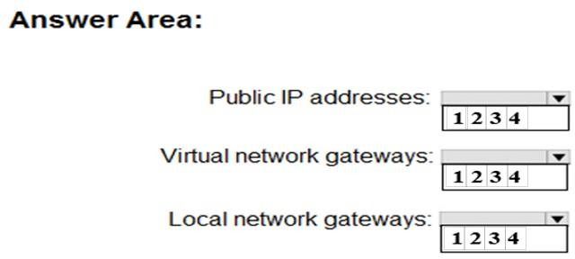

**Answer:**

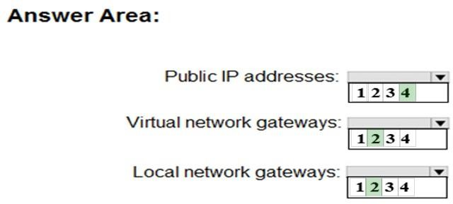

**Explanation:**

Box 1: 4

Two public IP addresses in the on-premises data center, and two public IP addresses in the VNET. The most reliable option is to combine the active-active gateways on both your network and Azure, as shown in the diagram below.

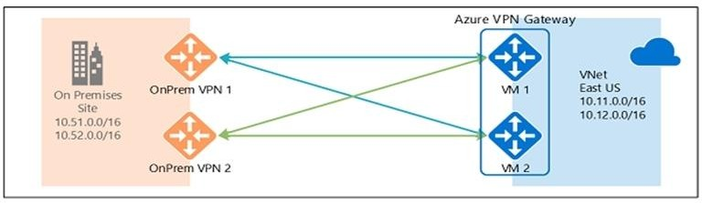

Box 2: 2

Every Azure VPN gateway consists of two instances in an active-standby configuration. For any planned maintenance or unplanned disruption that happens to the active instance, the standby instance would take over (failover) automatically, and resume the S2S VPN or VNet-to-VNet connections.

Box 3: 2

Dual-redundancy: active-active VPN gateways for both Azure and on-premises networks

References:

https://docs.microsoft.com/en-us/azure/vpn-gateway/vpn-gateway-highlyavailable

### QUESTION 380

You have Azure virtual machines that run Windows Server 2019 and are configured as shown in the following table:

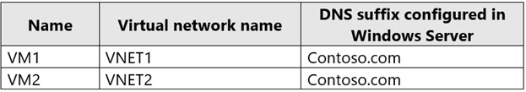

You create a public Azure DNS zone named adatum.com and a private Azure DNS zone named contoso.com.

For contoso.com, you create a virtual network link named link1 as shown in the exhibit. (Click the

**Exhibit** tab.)

**Exhibit**

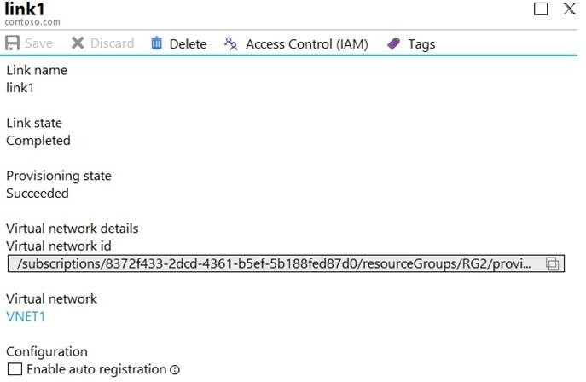

You discover that VM1 can resolve names in contoso.com but **cannot** resolve names in adatum.com. VM1 can resolve other hosts on the internet.

You need to ensure that VM1 can resolve host names in adatum.com. What should you do?

|  |  |
| --- | --- |
| A. | Modify the Access control (IAM) settings for link1. |
| B. | Configure the name servers for adatum.com at the domain registrar. |
| C. | Update the DNS suffix on VM1 to be adatum.com. |
| D. | Create an SRV record in the contoso.com zone. |

**Answer:** B

**Explanation:**

Adatum.com is a public DNS zone. The Internet top level domain DNS servers need to know which DNS servers to direct DNS queries for adatum.com to. You configure this by configuring the name servers for adatum.com at the domain registrar.

### QUESTION 381

Hotspot Question

You plan to create a new Azure Active Directory (Azure AD) role.

You need to ensure that the new role can view all the resources in the Azure subscription and issue support requests to Microsoft. The solution must use the principle of least privilege.

How should you complete the JSON definition? To answer, select the appropriate options in the answer area.

NOTE: Each correct selection is worth one point.

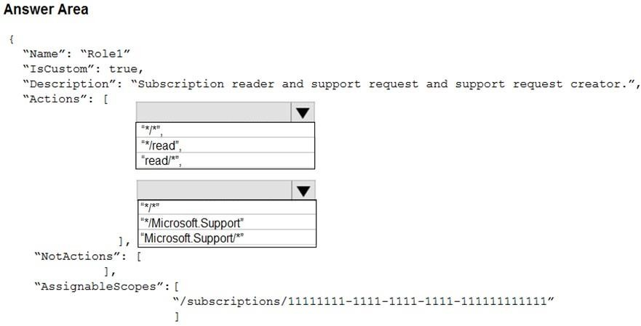

**Answer:**

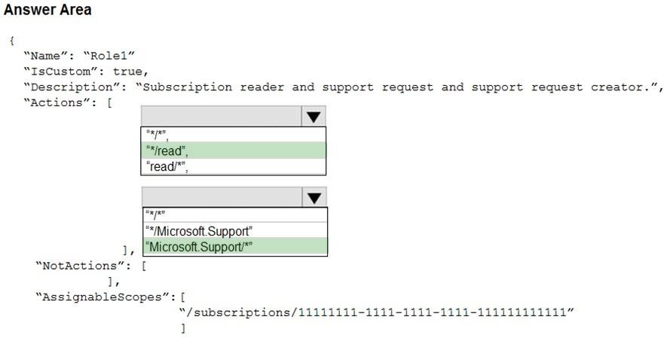

**Explanation:**

Box 1: "*/read",

*/read lets you view everything, but not make any changes.

Box 2: " Microsoft.Support/*"

The action Microsoft.Support/* enables creating and management of support tickets.

References:

https://docs.microsoft.com/en-us/azure/role-based-access-control/tutorial-custom-role-powershell https://docs.microsoft.com/en-us/azure/role-based-access-control/built-in-roles

### QUESTION 382

Hotspot Question

You have an Azure Active Directory (Azure AD) tenant that contains three global administrators named Admin1, Admin2, and Admin3.

The tenant is associated to an Azure subscription. Access control for the subscription is configured as shown in the **Access control** exhibit. (Click the **Exhibit** tab.)

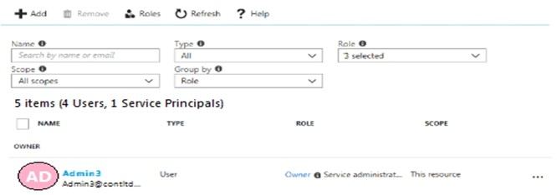

You sign in to the Azure portal as Admin1 and configure the tenant as shown in the **Tenant**

exhibit. (Click the **Exhibit** tab.)

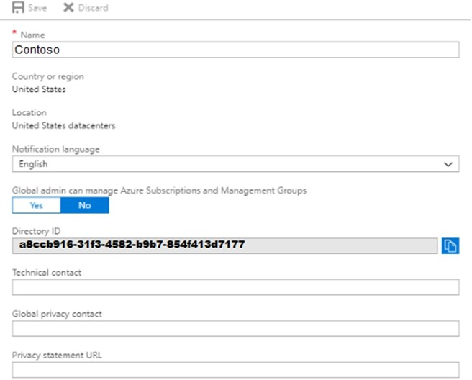

For each of the following statements, select Yes if the statement is true. Otherwise, select No.

**NOTE:** Each correct selection is worth one point.

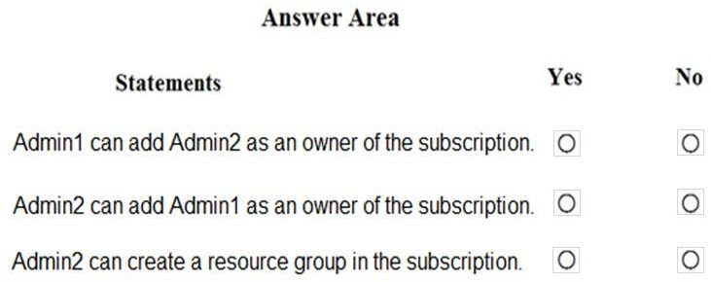

**Answer:**

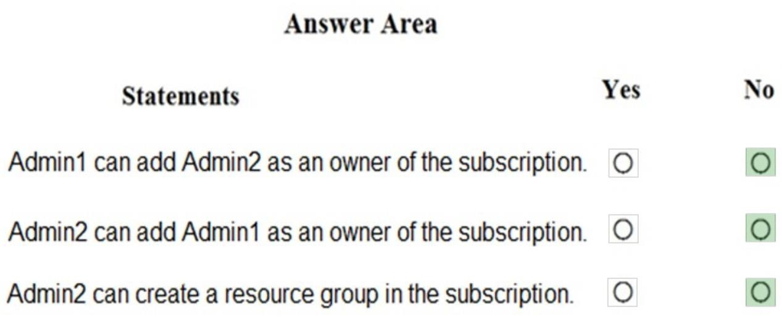

### QUESTION 383

You create an Azure subscription named Subscription1 and an associated Azure Active Directory (Azure AD) tenant named Tenant1. Tenant1 contains the users in the following table.

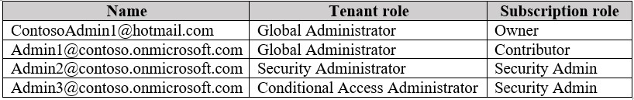

You need to add an Azure AD Privileged Identity Management application to Tenant1. Which account can you use?

|  |  |
| --- | --- |
| A. | [Admin3@contoso.onmicrosoft.com](mailto:Admin3@contoso.onmicrosoft.com) |
| B. | [Admin1@contoso.onmicrosoft.com](mailto:Admin1@contoso.onmicrosoft.com) |
| C. | [Admin2@contoso.onmicrosoft.com](mailto:Admin2@contoso.onmicrosoft.com) |

|  |  |
| --- | --- |
| D. | [ContosoAdmin1@hotmail.com](mailto:ContosoAdmin1@hotmail.com) |

**Answer:** B

**Explanation:**

https://docs.microsoft.com/en-us/azure/active-directory/privileged-identity-management/pim- getting-started

### QUESTION 384

Hotspot Question

You have an Azure web app named App1 that has two deployment slots named Production and Staging. Each slot has the unique settings shown in the following table.



You perform a slot swap.

What are the configurations of the Production slot after the swap? To answer, select the appropriate options in the answer area.

NOTE: Each correction is worth one point.

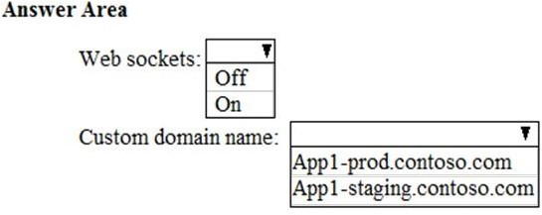

**Answer:**

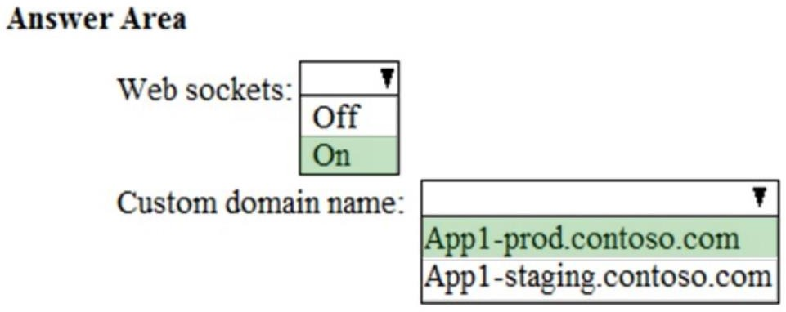

### QUESTION 385

Hotspot Question

You have an Azure subscription named Subscription1.

In Subscription1, you create an Azure web app named WebApp1. WebApp1 will access an external service that requires certificate authentication.

You plan to require the use of HTTPS to access WebApp1. You need to upload certificates to WebApp1.

In which formats should you upload the certificate? To answer, select the appropriate options in the answer area.

NOTE: Each correct selection is worth one point.

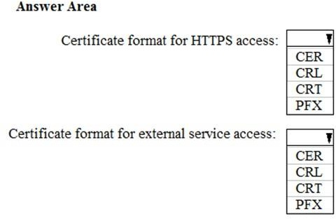

**Answer:**

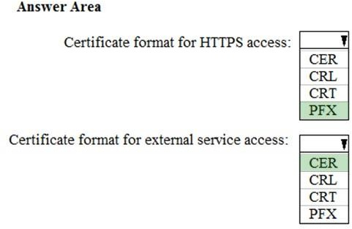

**Explanation:**

A PFX file contains the public key file (SSL Certificate) and its unique private key file. This is required for HTTPS access. The web app will distribute the public key (in a CER file) to clients that connect to the web app.

The CER file is an SSL Certificate which has the public key of the external service. The external service will have the private key associated with the public key contained in the CER file.

### QUESTION 386

Hotspot Question

You are creating an Azure load balancer.

You need to add an IPv6 load balancing rule to the load balancer.

How should you complete the Azure PowerShell script? To answer, select the appropriate options in the answer area.

NOTE: Each correct selection is worth one point.

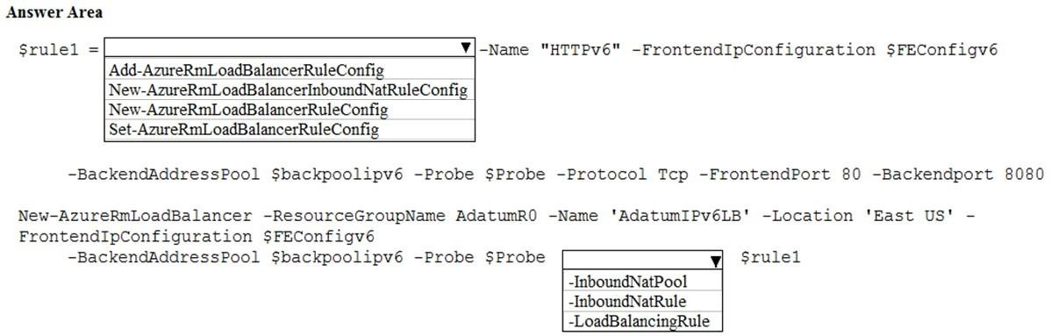

**Answer:**

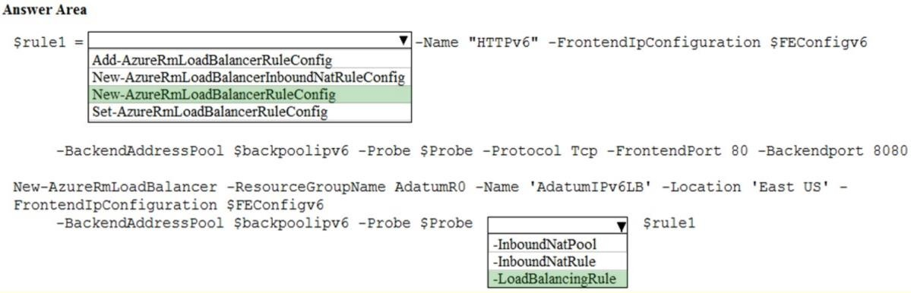

### QUESTION 387

Hotspot Question

You have an Azure virtual machine named VM1 that connects to a virtual network named VNet1. VM1 has the following configurations:

Subnet: 10.0.0.0/24 Availability set: AVSet

Network security group (NSG): None Private IP address: 10.0.0.4 (dynamic) Public IP address: 40.90.219.6 (dynamic)

You deploy a standard, Internet-facing load balancer named slb1. You need to configure slb1 to allow connectivity to VM1.

Which changes should you apply to VM1 as you configure slb1? To answer, select the appropriate options in the answer area.

NOTE: Each correct selection is worth one point.

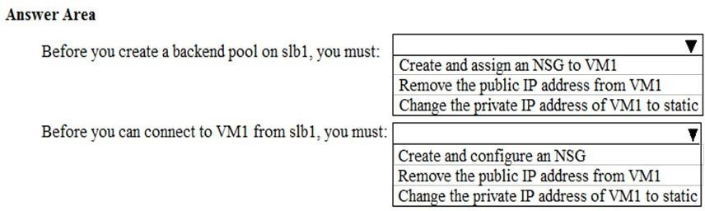

**Answer:**

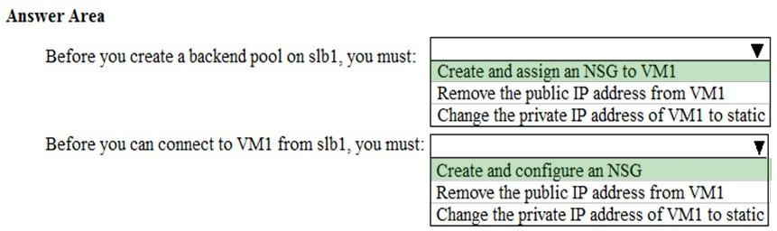

### QUESTION 388

Hotspot Question

You have an Azure subscription named Subscription1.

You enable Azure Active Directory (AD) Privileged Identity Management.

From Azure AD Privileged Identity Management, you configure the Global Administrator role for the Azure Active Directory (Azure AD) tenant as shown in the Role settings exhibit. (Click the Exhibit tab.)

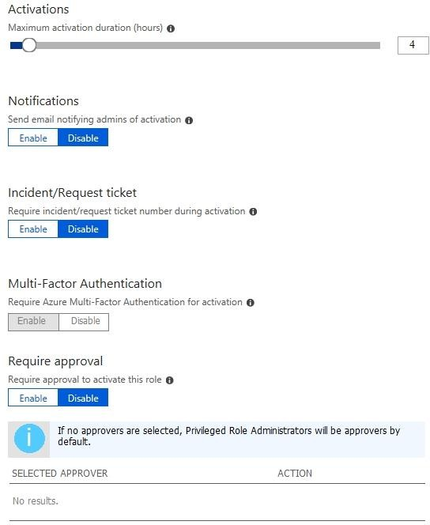

From Azure AD Privileged Identity Management, you configure the global administrators as shown in the Members exhibit. (Click the Exhibit tab.)

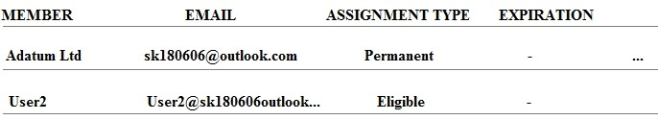

User2 activates the Global Administrator role on July 16, 2018, at 10:00, as shown in the Activation exhibit.

(Click the Exhibit tab.)

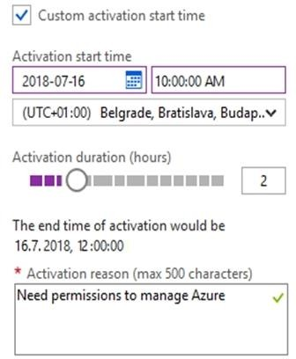

For each of the following statements, select Yes if the statement is true. Otherwise, select No. NOTE: Each correct selection is worth one point.

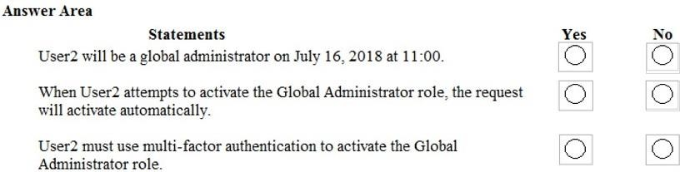

**Answer:**

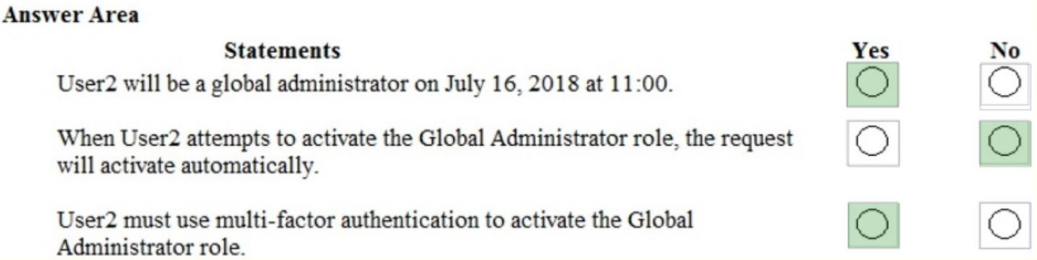

### QUESTION 389

You have an on-premises network that contains a Hyper-V host named Host1. Host1 runs Windows Server 2016 and hosts 10 virtual machines that run Windows Server 2016.

You plan to replicate the virtual machines to Azure by using Azure Site Recovery. You create a Recovery Services vault named ASR1 and a Hyper-V site named Site1. You need to add Host1 to ASR1.

What should you do?

|  |  |
| --- | --- |
| A. | Download the installation file for the Azure Site Recovery Provider. Download the vault registration key.  Install the Azure Site Recovery Provider on Host1 and register the server. |
| B. | Download the installation file for the Azure Site Recovery Provider. Download the storage account key.  Install the Azure Site Recovery Provider on Host1 and register the server. |
| C. | Download the installation file for the Azure Site Recovery Provider. Download the vault registration key.  Install the Azure Site Recovery Provider on each virtual machine and register the virtual machines. |
| D. | Download the installation file for the Azure Site Recovery Provider. Download the storage account key.  Install the Azure Site Recovery Provider on each virtual machine and register the virtual machines. |

**Answer:** A

**Explanation:**

Download the Vault registration key. You need this when you install the Provider. The key is valid for five days after you generate it.

Install the Provider on each VMM server. You don't need to explicitly install anything on Hyper-V hosts.

Incorrect Answers:

B, D: Use the Vault Registration Key, not the storage account key. References:

https://docs.microsoft.com/en-us/azure/site-recovery/migrate-tutorial-on-premises-azure

### QUESTION 390

You plan to move services from your on-premises network to Azure.

You identify several virtual machines that you believe can be hosted in Azure. The virtual machines are shown in the following table.

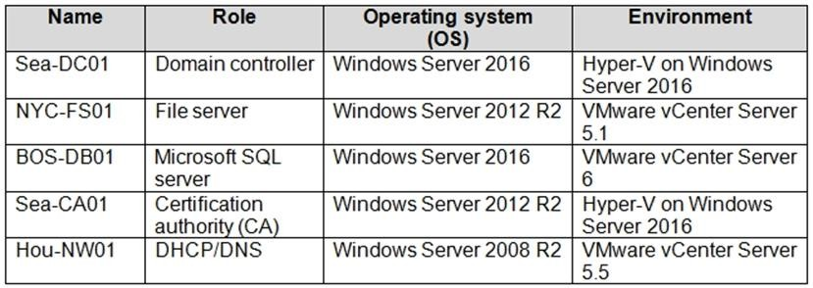

Which two virtual machines can you access by using Azure migrate? Each correct answer presents a complete solution.

NOTE: Each correct selection is worth one point.

|  |  |
| --- | --- |
| A. | Sea-CA01 |
| B. | Hou-NW01 |
| C. | NYC-FS01 |
| D. | Sea-DC01 |
| E. | BOS-DB01 |

**Answer:** CE

**Explanation:**

Azure Migrate provides a centralized hub to assess and migrate to Azure on-premises servers, infrastructure, applications, and data. It provides the following:

* Unified migration platform: A single portal to start, run, and track your migration to Azure.
* Range of tools: A range of tools for assessment and migration. Azure Migrate tools include Azure Migrate: Discovery and assessment and Azure Migrate: Server Migration. Azure Migrate also integrates with other Azure services and tools, and with independent software vendor (ISV) offerings.
* Assessment and migration: In the Azure Migrate hub, you can assess and migrate:

 Servers, databases, and web apps: Assess on-premises servers including web apps and SQL Server instances and migrate them to Azure virtual machines or Azure VMware Solution (AVS) (Preview).

 Databases: Assess on-premises databases and migrate them to Azure SQL Database or to SQL Managed Instance.

 Web applications: Assess on-premises web applications and migrate them to Azure App Service.

 Virtual desktops: Assess your on-premises virtual desktop infrastructure (VDI) and migrate it to Windows Virtual Desktop in Azure.

 Data: Migrate large amounts of data to Azure quickly and cost-effectively using Azure Data Box products.

Based on this information let's analyze each option:

NYC-FS01 : Its role "Server" fall under above categories. Hence it can be accessed by using Azure migrate.

BOS-DB01 : Its role "server" fall under above categories. Hence it can be accessed by using Azure migrate.

Sea-CA01 : Its role "CA" does not fall under above categories. Hence it can not be accessed by using Azure migrate.

Hou-NW01 : Its role "DNS" does not fall under above categories. Hence it can not be accessed by using Azure migrate.

Sea-DC01 : Its role "DC" does not fall under above categories. Hence it can not be accessed by using Azure migrate.

Reference:

https://docs.microsoft.com/en-us/azure/migrate/migrate-services-overview

### QUESTION 391

You have an Azure Active Directory (Azure AD) tenant named contoso.onmicrosoft.com.

You hire a temporary vendor. The vendor uses a Microsoft account that has a sign-in of [user1@outlook.com.](mailto:user1@outlook.com)

You need to ensure that the vendor can authenticate to the tenant by using [user1@outlook.com.](mailto:user1@outlook.com) What should you do?

|  |  |
| --- | --- |
| A. | From the Azure portal, add a custom domain name, create a new Azure AD user, and then  specify [user1@outlook.com](mailto:user1@outlook.com) as the username. |
| B. | From Azure Cloud Shell, run the New-AzureADUser cmdlet and specify the |
| C. | From the Azure portal, add a new guest user, and then specify [user1@outlook.com](mailto:user1@outlook.com) as the email address. |
| D. | From Windows PowerShell, run the New-AzureADUser cmdlet and specify the |

**Answer:** C

**Explanation:**

We should use Azure portal, add a new guest user, and then specify [user1@outlook.com](mailto:user1@outlook.com) as the email address.

The New-AzureADUser cmdlet creates a new user not a new guest user. The New- AzureADMSInvitation cmdlet is used to invite a new external user to your directory, but the cmdlet uses the -InvitedUserEmailAddress parameter instead of -UserPrincipalName.

### QUESTION 392

You set the multi-factor authentication status for a user named [admin1@contoso.com](mailto:admin1@contoso.com) to Enabled. Admin1 accesses the Azure portal by using a web browser.

Which additional security verifications can Admin1 use when accessing the Azure portal?

|  |  |
| --- | --- |
| A. | a phone call, a text message that contains a verification code, and a notification or a verification  code sent from the Microsoft Authenticator app |
| B. | an app password, a text message that contains a verification code, and a notification sent from the Microsoft Authenticator app |
| C. | an app password, a text message that contains a verification code, and a verification code sent from the Microsoft Authenticator app |
| D. | a phone call, an email message that contains a verification code, and a text message that contains an app password |

**Answer:** A

### QUESTION 393

Your company has a main office in London that contains 100 client computers. Three years ago, you migrated to Azure Active Directory (Azure AD).

The company's security policy states that all personal devices and corporate-owned devices must be registered or joined to Azure AD.

A remote user named User1 is unable to join a personal device to Azure AD from a home network. You verify that other users can join their devices to Azure AD.

You need to ensure that User1 can join the device to Azure AD. What should you do?

|  |  |
| --- | --- |
| A. | From the Device settings blade, modify the Users may join devices to Azure AD setting. |
| B. | From the Device settings blade, modify the Maximum number of devices per user setting. |
| C. | Create a point-to-site VPN from the home network of User1 to Azure. |
| D. | Assign the User administrator role to User1. |

**Answer:** B

**Explanation:**

The Maximum number of devices setting enables you to select the maximum number of devices that a user can have in Azure AD. If a user reaches this quota, they will not be able to add additional devices until one or more of the existing devices are removed.

Incorrect Answers:

A: The Users may join devices to Azure AD setting enables you to select the users who can join devices to Azure AD. Options are All, Selected and None. The default is All.

C: Azure AD Join enables users to join their devices to Active Directory from anywhere as long as they have connectivity with the Internet.

References:

https://docs.microsoft.com/en-us/azure/active-directory/devices/device-management-azure-portal <http://techgenix.com/pros-and-cons-azure-ad-join/>

### QUESTION 394

You have an Azure Active Directory (Azure AD) tenant named contoso.onmicrosoft.com. The User administrator role is assigned to a user named Admin1.

An external partner has a Microsoft account that uses the [user1@outlook.com](mailto:user1@outlook.com) sign in.

Admin1 attempts to invite the external partner to sign in to the Azure AD tenant and receives the following error message: "Unable to invite user [user1@outlook.com](mailto:user1@outlook.com) ?Generic authorization exception."

You need to ensure that Admin1 can invite the external partner to sign in to the Azure AD tenant. What should you do?

|  |  |
| --- | --- |
| A. | From the Roles and administrators blade, assign the Security administrator role to Admin1. |
| B. | From the Organizational relationships blade, add an identity provider. |
| C. | From the Custom domain names blade, add a custom domain. |
| D. | From the Users blade, modify the External collaboration settings. |

**Answer:** D

**Explanation:**

https://techcommunity.microsoft.com/t5/Azure-Active-Directory/Generic-authorization-exception- inviting-Azure-AD-gests/td-p/274742

### QUESTION 395

Your company has an Azure Active Directory (Azure AD) tenant named contoso.com that is configured for hybrid coexistence with the on-premises Active Directory domain. The tenant contains the users shown in the following table.

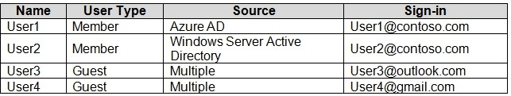

Whenever possible, you need to enable Azure Multi-Factor Authentication (MFA) for the users in contoso.com.

Which users should you enable for Azure MFA?

|  |  |
| --- | --- |
| A. | User1 only |
| B. | User1, User2, and User3 only |
| C. | User1 and User2 only |
| D. | User1, User2, User3, and User4 |
| E. | User2 only |

**Answer:** D

### QUESTION 396

You have an Azure Active Directory (Azure AD) tenant.

All administrators must enter a verification code to access the Azure portal.

You need to ensure that the administrators can access the Azure portal only from your on- premises network.

What should you configure?

|  |  |
| --- | --- |
| A. | an Azure AD Identity Protection user risk policy. |
| B. | the multi-factor authentication service settings. |
| C. | the default for all the roles in Azure AD Privileged Identity Management |
| D. | an Azure AD Identity Protection sign-in risk policy |

**Answer:** B

### QUESTION 397

Hotspot Question

You have an Azure subscription.

You plan to use Azure Resource Manager templates to deploy 50 Azure virtual machines that will be part of the same availability set.

You need to ensure that as many virtual machines as possible are available if the fabric fails or during servicing.

How should you configure the template? To answer, select the appropriate options in the answer area.

NOTE: Each correct selection is worth one point.

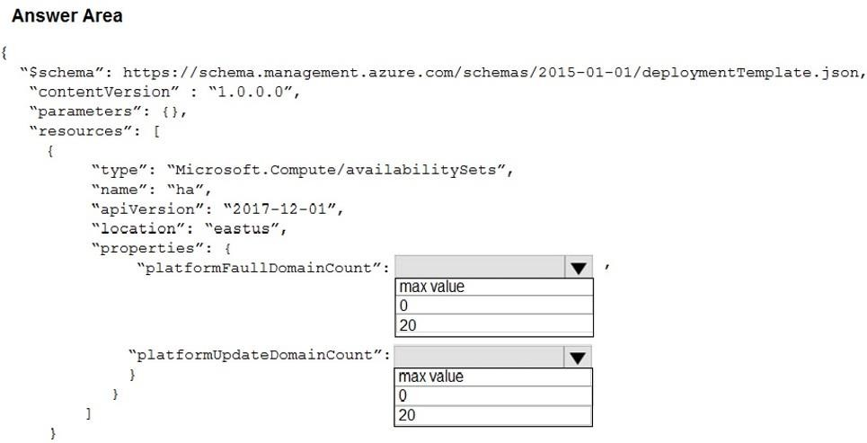

**Answer:**

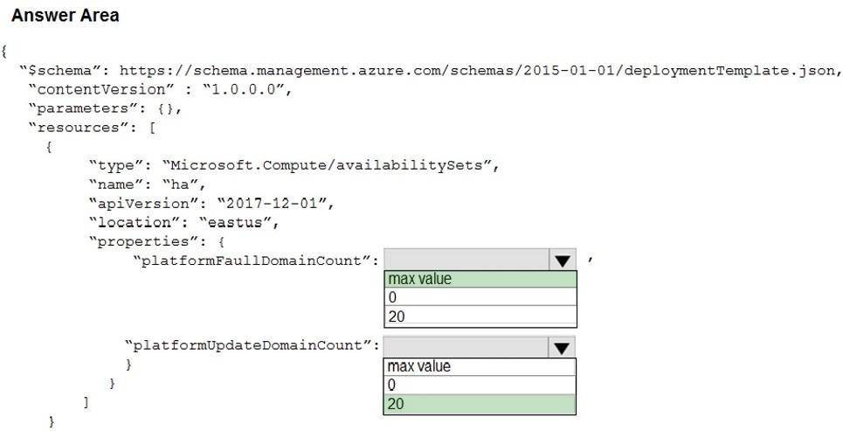

**Explanation:**

Use two fault domains.

2 or 3 is max value, depending on which region you are in. Use 20 for platformUpdateDomainCount

Increasing the update domain (platformUpdateDomainCount) helps with capacity and availability planning when the platform reboots nodes. A higher number for the pool (20 is max) means that fewer of their nodes in any given availability set would be rebooted at once.

References:

https:/[/www.itprotoday.com/microsoft-azure/check-if-azure-region-supports-2-or-3-fault-domains-](http://www.itprotoday.com/microsoft-azure/check-if-azure-region-supports-2-or-3-fault-domains-) managed-disks

https://github.com/Azure/acs-engine/issues/1030

### QUESTION 398

You have an Azure subscription named Subscription1 that contains an Azure Log Analytics workspace named Workspace1.

You need to view the error events from a table named Event. Which query should you run in Workspace1?

|  |  |
| --- | --- |
| A. | Get-Event Event | where ($_.EventType -eq "error") |
| B. | Get-Event Event | where ($_.EventType == "error") |
| C. | search in (Event) * | where EventType –eq "error" |
| D. | search in (Event) "error" |
| E. | select *from Event where EventType == "error" |
| F. | Event | where EventType is "error" |

**Answer:** D

**Explanation:**

To search a term in a specific table, add in (table-name) just after the search operator References:

https://docs.microsoft.com/en-us/azure/azure-monitor/log-query/search-queries https://docs.microsoft.com/en-us/azure/azure-monitor/log-query/get-started-portal

### QUESTION 399

**Note: This question is part of a series of questions that present the same scenario. Each question in the series contains a unique solution that might meet the stated goals. Some question sets might have more than one correct solution, while others might not have a correct solution.**

**After you answer a question in this section, you will NOT be able to return to it. As a result, these questions will not appear in the review screen.**

Your company registers a domain name of contoso.com.

You create an Azure DNS zone named contoso.com, and then you add an A record to the zone for a host named www that has an IP address of 131.107.1.10.

You discover that Internet hosts are unable to resolve [www.contoso.com](http://www.contoso.com/) to the 131.107.1.10 IP address.

You need to resolve the name resolution issue.

Solution: You modify the name servers at the domain registrar. Does this meet the goal?

|  |  |
| --- | --- |
| A. | Yes |
| B. | No |

**Answer:** A

**Explanation:**

https://docs.microsoft.com/en-us/azure/dns/dns-delegate-domain-azure-dns Delegate the domain

Now that the DNS zone is created and you have the name servers, you need to update the parent domain with the Azure DNS name servers. Each registrar has its own DNS management tools to change the name server records for a domain.

### QUESTION 400

You have an Azure subscription named Subscription1 that contains the resource groups shown in the following table.

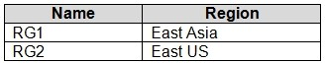

In RG1, you create a virtual machine named VM1 in the East Asia location. You plan to create a virtual network named VNET1.

You need to create VNET1, and then connect VM1 to VNET1.

What are two possible ways to achieve this goal? Each correct answer presents a complete solution.

NOTE: Each correct selection is worth one point.

|  |  |
| --- | --- |
| A. | Create VNET1 in RG2, and then set East Asia as the location. |
| B. | Create VNET1 in a new resource group in the West US location, and then set West US as the location. |
| C. | Create VNET1 in RG1, and then set East US as the location. |
| D. | Create VNET1 in RG2, and then set East US as the location. |
| E. | Create VNET1 in RG1, and then set East Asia as the location. |

**Answer:** AE

### QUESTION 401

You have an Azure virtual machine named VM1. Azure collects events from VM1.

You are creating an alert rule in Azure Monitor to notify an administrator when an error is logged in the System event log of VM1.

You need to specify which resource type to monitor. What should you specify?

|  |  |
| --- | --- |
| A. | metric alert |
| B. | Azure Log Analytics workspace |
| C. | virtual machine |
| D. | virtual machine extension |

**Answer:** D

**Explanation:**

Azure Monitor can collect data directly from your Azure virtual machines into a Log Analytics workspace for detailed analysis and correlation. Installing the Log Analytics VM extension for Windows and Linux allows Azure Monitor to collect data from your Azure VMs.

Incorrect Answers:

B: Azure Log Analytics workspace is used for on-premises computers monitored by System Center Operations Manager.

Reference:

https://docs.microsoft.com/en-us/azure/azure-monitor/learn/quick-collect-azurevm

### QUESTION 402

You have an Azure virtual machine named VM1.

The network interface for VM1 is configured as shown in the exhibit. (Click the Exhibit tab.)

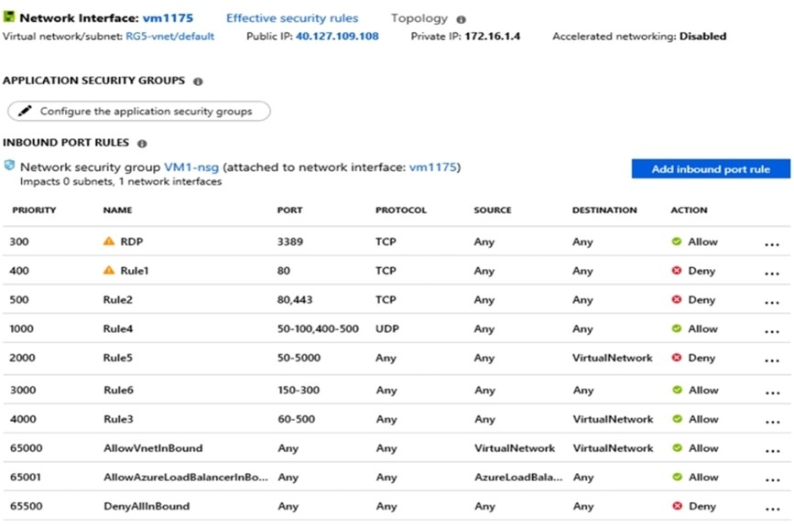

You deploy a web server on VM1, and then create a secure website that is accessible by using the HTTPS protocol. VM1 is used as a web server only.

You need to ensure that users can connect to the website from the internet.

What should you do?

|  |  |
| --- | --- |
| A. | Create a new inbound rule that allows TCP protocol 443 and configure the protocol to have a  priority of 501. |
| B. | For Rule5, change the Action to Allow and change the priority to 401. |
| C. | Delete Rule1. |
| D. | Modify the protocol of Rule4. |

**Answer:** B

**Explanation:**

Rule 2 is blocking HTTPS access (port 443) and has a priority of 500.

Changing Rule 5 (ports 50-5000) and giving it a lower priority number will allow access on port 443.

Note: Rules are processed in priority order, with lower numbers processed before higher numbers, because lower numbers have higher priority. Once traffic matches a rule, processing stops.

Incorrect Answers:

A: Rule 2 is blocking HTTPS access (port 443) and has a priority of 500. Creating a rule for the same protocol (443) with a higher priority number will not help.

C: Rule 1 blocks access to port 80, which is used for HTTP, not HTTPS.

D: Rule 2 is blocking HTTPS access (port 443). Changing Rule 4 allows access on UDP but is a higher priority number than Rule. Changing the protocol on Rule 4 to TCP will not help if we don't also change the priority to a lower number.

References:

https://docs.microsoft.com/en-us/azure/virtual-network/security-overview

### QUESTION 403

Hotspot Question

You have an Azure subscription that contains several virtual machines and an Azure Log Analytics workspace named Workspace1.

You create a log search query as shown in the following exhibit.

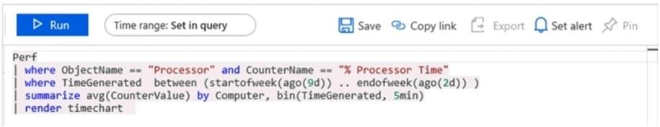

Use the drop-down menus to select the answer choice that completes each statement based on the information presented in the graphic.

NOTE: Each correct selection is worth one point.

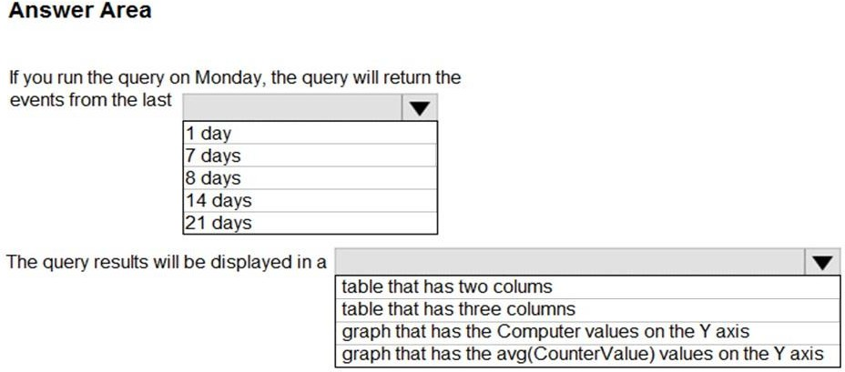

**Answer:**

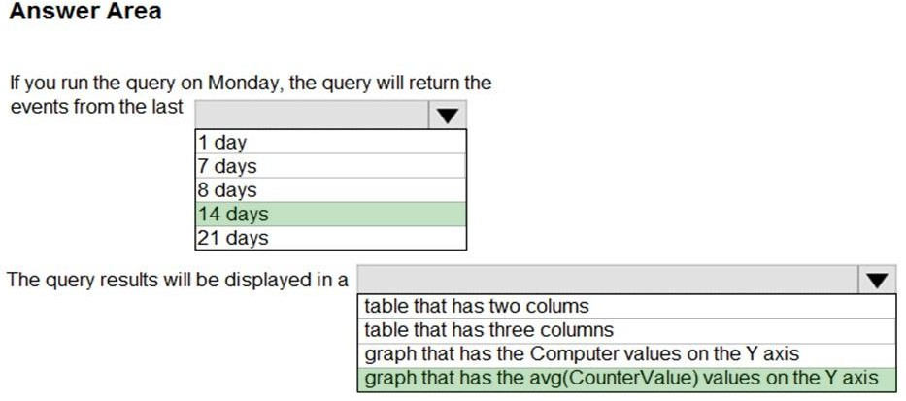

**Explanation:**

Box 1: 14 days

Two weeks will be covered.

Note: Startofweek returns the start of the week containing the date, shifted by an offset, if provided.

Start of the week is considered to be a Sunday.

Endofweek returns the end of the week containing the date, shifted by an offset, if provided. Last day of the week is considered to be a Saturday.

Box 2:

The render operator renders results in as graphical output. Timechart is a Line graph, where the first column is x-axis, and should be datetime. Other columns are y-axes. In this case the Y axis has avg (CounterValue) Values.

Reference:

https://docs.microsoft.com/en-us/azure/azure-monitor/log-query/log-query-overview https://docs-analytics- eus.azurewebsites.net/queryLanguage/query_language_renderoperator.html

### QUESTION 404

You have an Azure subscription that contains a resource group named TestRG. You use TestRG to validate an Azure deployment.

TestRG contains the following resources:

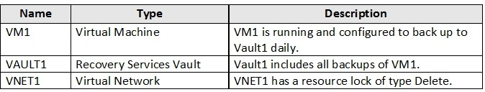

You need to delete TestRG. What should you do first?

|  |  |
| --- | --- |
| A. | Modify the backup configurations of VM1 and modify the resource lock type of VNET1. |
| B. | Turn off VM1 and delete all data in Vault1. |
| C. | Remove the resource lock from VNET1 and delete all data in Vault1. |
| D. | Turn off VM1 and remove the resource lock from VNET1. |

**Answer:** D

**Explanation:**

When you want to delete the resource, you first need to remove the lock. References:

https://docs.microsoft.com/sv-se/azure/azure-resource-manager/management/lock-resources docs.microsoft.com/en-us/azure/azure-monitor/platform/itsmc-overview

### QUESTION 410

**Note: This question is part of a series of questions that present the same scenario. Each question in the series contains a unique solution that might meet the stated goals. Some question sets might have more than one correct solution, while others might not have a correct solution.**

**After you answer a question in this section, you will NOT be able to return to it. As a result, these questions will not appear in the review screen.**

You have an Azure subscription named Subscription1 that contains the resources shown in the following table.

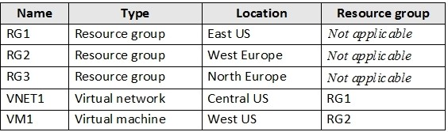

VM1 connects to a virtual network named VNET2 by using a network interface named NIC1. You need to create a new network interface named NIC2 for VM1.

Solution: You create NIC2 in RG1 and West US. Does this meet the goal?

|  |  |
| --- | --- |
| A. | Yes |
| B. | No |

**Answer:** A

**Explanation:**

The virtual machine you attach a network interface to and the virtual network you connect it to must exist in the same location, here West US, also referred to as a region.

References:

https://docs.microsoft.com/en-us/azure/virtual-network/virtual-network-network-interface

### QUESTION 411

**Note: This question is part of a series of questions that present the same scenario. Each question in the series contains a unique solution that might meet the stated goals. Some question sets might have more than one correct solution, while others might not have a correct solution.**

**After you answer a question in this section, you will NOT be able to return to it. As a result, these questions will not appear in the review screen.**

You have an Azure subscription named Subscription1 that contains the resources shown in the following table.



VM1 connects to a virtual network named VNET2 by using a network interface named NIC1.

You need to create a new network interface named NIC2 for VM1. Solution: You create NIC2 in RG2 and West US.

Does this meet the goal?

|  |  |
| --- | --- |
| A. | Yes |
| B. | No |

**Answer:** A

**Explanation:**

Each NIC attached to a VM must exist in the same location and subscription as the VM. Each NIC must be connected to a VNet that exists in the same Azure location and subscription as the NIC. You can change the subnet a VM is connected to after it's created, but you cannot change the VNet.

Meaning that VM <--> VNET <---> NIC. All the three resources MUST be in the same location

References:

https://docs.microsoft.com/en-us/azure/virtual-machines/network- overview#:~:text=Each%20NIC%20attached%20to%20a,you%20cannot%20change%20the%20 VNet.

### QUESTION 412

**Note: This question is part of a series of questions that present the same scenario. Each question in the series contains a unique solution that might meet the stated goals. Some question sets might have more than one correct solution, while others might not have a correct solution.**

**After you answer a question in this section, you will NOT be able to return to it. As a result, these questions will not appear in the review screen.**

You have an Azure subscription that contains the following resources:

* A virtual network that has a subnet named Subnet1
* Two network security groups (NSGs) named NSG-VM1 and NSG-Subnet1
* A virtual machine named VM1 that has the required Windows Server configurations to allow Remote Desktop connections

NSG-Subnet1 has the default inbound security rules only.

NSG-VM1 has the default inbound security rules and the following custom inbound security rule:  Priority: 100

 Source: Any

 Source port range: *  Destination: *

 Destination port range: 3389  Protocol: UDP

 Action: Allow

VM1 connects to Subnet1. NSG1-VM1 is associated to the network interface of VM1. NSG- Subnet1 is associated to Subnet1.

You need to be able to establish Remote Desktop connections from the internet to VM1.

Solution: You modify the custom rule for NSG-VM1 to use the internet as a source and TCP as a protocol.

Does this meet the goal?

|  |  |
| --- | --- |
| A. | Yes |
| B. | No |

**Answer:** B

**Explanation:**

The NSG on the subnet does not allow inbound TCP 3389.

NSGs deny all inbound traffic except from virtual network or load balancers. https://docs.microsoft.com/en-us/azure/virtual-network/security-overview#default-security-rules

### QUESTION 413

You have an Azure subscription that contains the resources shown in the following table.

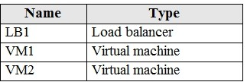

VM1 and VM2 run a website that is configured as shown in the following table.

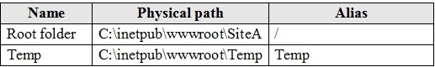

LB1 is configured to balance requests to VM1 and VM2.

You configure a health probe as shown in the exhibit. (Click the **Exhibit** tab.)

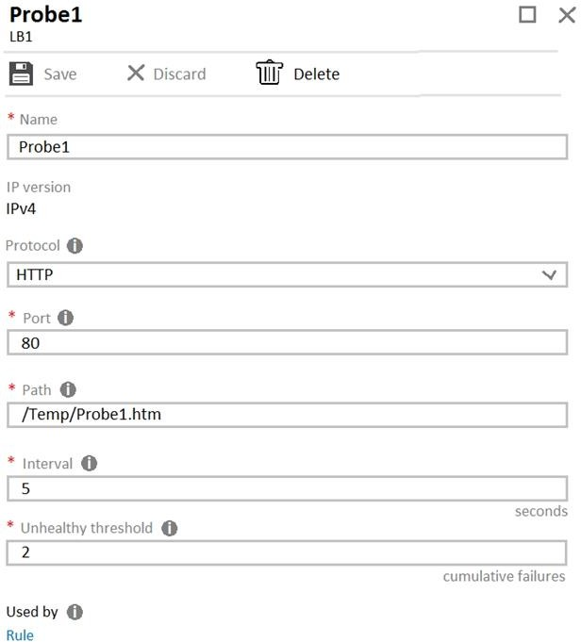

You need to ensure that the health probe functions correctly. What should you do?

|  |  |
| --- | --- |
| A. | On LB1, change the Unhealthy threshold to 65536. |
| B. | On LB1, change the port to 8080. |
| C. | On VM1 and VM2, create a file named Probe1.htm in the C:\intepub\wwwroot\Temp folder. |
| D. | On VM1 and VM2, create a file named Probe1.htm in the C:\intepub\wwwroot\SiteA\Temp folder. |

**Answer:** D

**Explanation:**

https://docs.microsoft.com/en-us/azure/load-balancer/tutorial-load-balancer-standard-internal-

portal

### QUESTION 414

You have an Azure Active Directory (Azure AD) tenant named contoso.com. Multi-factor authentication (MFA) is enabled for all users.

You need to provide users with the ability to bypass MFA for 10 days on devices to which they have successfully signed in by using MFA.

What should you do?

|  |  |
| --- | --- |
| A. | From the multi-factor authentication page, configure the users' settings. |
| B. | From Azure AD, create a conditional access policy. |
| C. | From the multi-factor authentication page, configure the service settings. |
| D. | From the MFA blade in Azure AD, configure the MFA Server settings. |

**Answer:** C

**Explanation:**

Enable remember Multi-Factor Authentication

1. Sign in to the Azure portal.
2. On the left, select Azure Active Directory > Users.
3. Select Multi-Factor Authentication.
4. Under Multi-Factor Authentication, select service settings.
5. On the Service Settings page, manage remember multi-factor authentication, select the Allow users to remember multi-factor authentication on devices they trust option.
6. Set the number of days to allow trusted devices to bypass two-step verification. The default is 14 days.
7. Select Save.

References:

https://docs.microsoft.com/en-us/azure/active-directory/authentication/howto-mfa-mfasettings

### QUESTION 415

You have a hybrid infrastructure that contains an Azure Active Directory (Azure AD) tenant named contoso.onmicrosoft.com. The tenant contains the users shown in the following table.

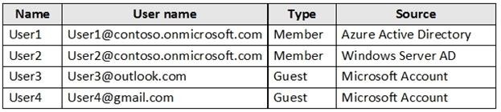

You plan to share a cloud resource to the All Users group.

You need to ensure that User1, User2, User3, and User4 can connect successfully to the cloud resource.

What should you do first?

|  |  |
| --- | --- |
| A. | Create a user account of the member type for User4. |

|  |  |
| --- | --- |
| B. | Create a user account of the member type for User3. |
| C. | Modify the Directory-wide Groups settings. |
| D. | Modify the External collaboration settings. |

**Answer:** C

**Explanation:**

Ensure that "Enable an 'All Users' group in the directory" policy is set to "Yes" in your Azure Active Directory (AD) settings in order to enable the "All Users" group for centralized access administration. This group represents the entire collection of the Active Directory users, including guests and external users, that you can use to make the access permissions easier to manage within your directory.

Incorrect Answers:

A, B: User3 and User4 are guests already.

Note: By default, all users and guests in your directory can invite guests even if they're not assigned to an admin role. External collaboration settings let you turn guest invitations on or off for different types of users in your organization. You can also delegate invitations to individual users by assigning roles that allow them to invite guests.

References:

https:/[/www.cloudconformity.com/knowledge-base/azure/ActiveDirectory/enable-all-users-](http://www.cloudconformity.com/knowledge-base/azure/ActiveDirectory/enable-all-users-) group.html

### QUESTION 416

You have a Microsoft 365 subscription and a hybrid deployment of Azure Active Directory (Azure AD).

User identities and password hashes are synced. You have a user account named User1.

From Active Directory, you select the User must change password at next logon account option for User1.

What will occur if User1 attempts to sigh in to myapps.microsoft.com?

|  |  |
| --- | --- |
| A. | User1 will be prompted for a password change. |
| B. | User1 will sign in by using the old password. |
| C. | User1 will be prevented from signing in. |

**Answer:** C

**Explanation:**

Troubleshoot password synchronization

Some users can't sign in to Office 365, Azure, or Microsoft Intune In this scenario, passwords of most users appear to be syncing. However, there are some users whose passwords appear not to sync. The following are scenarios in which a user cannot sign in to a Microsoft cloud service such as Office 365, Azure, or Intune. They include information about how to troubleshoot each scenario.

Scenario 1: The "User must change password at next logon" check box is selected for the user's account To resolve this issue, follow these steps:

1. Do one of the following:

In the user account properties in Active Directory Users and Computers, clear the User must change password at next logon check box.

Have the user change their on-premises user account password.

1. Wait a few minutes for the change to sync between the on-premises Active Directory Domain Services (AD DS) and Azure AD.

References:

https://support.microsoft.com/en-us/help/2855271/how-to-troubleshoot-password- synchronization-when-using-an-azure-ad-sy

### QUESTION 417

**Note: This question is part of a series of questions that present the same scenario. Each question in the series contains a unique solution that might meet the stated goals. Some question sets might have more than one correct solution, while others might not have a correct solution.**

**After you answer a question in this section, you will NOT be able to return to it. As a result, these questions will not appear in the review screen.**

You have an Azure Active Directory (Azure AD) tenant named contoso.com that is synced to an Active Directory domain.

The tenant contains the users shown in the following table.

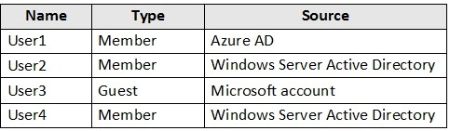

The users have the attributes shown in the following table.

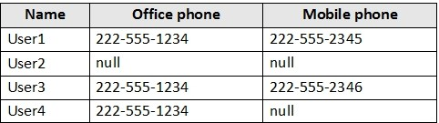

You need to ensure that you can enable Azure Multi-Factor Authentication (MFA) for all users. Solution: You create a new user account in Azure AD for User3.

Does this meet the goal?

|  |  |
| --- | --- |
| A. | Yes |
| B. | No |

**Answer:** A

**Explanation:**

User3 requires a user account in Azure AD.

Note: Your Azure AD password is considered an authentication method. It is the one method that cannot be disabled.

References:

### QUESTION 418

**Note: This question is part of a series of questions that present the same scenario. Each question in the series contains a unique solution that might meet the stated goals. Some question sets might have more than one correct solution, while others might not have a correct solution.**

**After you answer a question in this section, you will NOT be able to return to it. As a result, these questions will not appear in the review screen.**

You have an Azure Active Directory (Azure AD) tenant named contoso.com that is synced to an Active Directory domain.

The tenant contains the users shown in the following table.



The users have the attributes shown in the following table.



You need to ensure that you can enable Azure Multi-Factor Authentication (MFA) for all users. Solution: You add an office phone number for User2.

Does this meet the goal?

|  |  |
| --- | --- |
| A. | Yes |
| B. | No |

**Answer:** B

**Explanation:**

User3 requires a user account in Azure AD.

Note: Your Azure AD password is considered an authentication method. It is the one method that cannot be disabled.

References:

### QUESTION 419

**Note: This question is part of a series of questions that present the same scenario. Each question in the series contains a unique solution that might meet the stated goals. Some question sets might have more than one correct solution, while others might not have a correct solution.**

**After you answer a question in this section, you will NOT be able to return to it. As a result, these questions will not appear in the review screen.**

You have an Azure Active Directory (Azure AD) tenant named contoso.com that is synced to an Active Directory domain.

The tenant contains the users shown in the following table.



The users have the attributes shown in the following table.



You need to ensure that you can enable Azure Multi-Factor Authentication (MFA) for all users. Solution: You add a mobile phone number for User2 and User4.

Does this meet the goal?

|  |  |
| --- | --- |
| A. | Yes |
| B. | No |

**Answer:** A

**Explanation:**

When MS states that phone calls can be used by MFA Authetication and the question is mentioning user2 and user4.

https://docs.microsoft.com/en-us/azure/active-directory/authentication/concept-mfa-howitworks

**QUESTION 420**

# Case Study 2 - Contoso, Ltd

**Overview**

Contoso, Ltd. is a manufacturing company that has offices worldwide. Contoso works with partner organizations to bring products to market.

Contoso products are manufactured by using blueprint files that the company authors and maintains.

**Existing Environment**

Currently, Contoso uses multiple types of servers for business operations, including the following:

* File servers
* Domain controllers
* Microsoft SQL Server servers

Your network contains an Active Directory forest named contoso.com. All servers and client computers are joined to Active Directory.

You have a public-facing application named App1. App1 is comprised of the following three tiers:

* A SQL database
* A web front end
* A processing middle tier

Each tier is comprised of five virtual machines. Users access the web front end by using HTTPS only.

**Requirements Planned Changes**

Contoso plans to implement the following changes to the infrastructure:

* Move all the tiers of App1 to Azure.
* Move the existing product blueprint files to Azure Blob storage.
* Create a hybrid directory to support an upcoming Microsoft Office 365 migration project.

**Technical Requirements**

Contoso must meet the following technical requirements:

* Move all the virtual machines for App1 to Azure.
* Minimize the number of open ports between the App1 tiers.
* Ensure that all the virtual machines for App1 are protected by backups.
* Copy the blueprint files to Azure over the Internet.
* Ensure that the blueprint files are stored in the archive storage tier.
* Ensure that partner access to the blueprint files is secured and temporary.
* Prevent user passwords or hashes of passwords from being stored in Azure.
* Use unmanaged standard storage for the hard disks of the virtualmachines.
* Ensure that when users join devices to Azure Active Directory (Azure AD), the users use a mobile phone to verify their identity.
* Minimize administrative effort whenever possible.

**User Requirements**

Contoso identifies the following requirements for users:

* Ensure that only users who are part of a group named Pilot can join devices to Azure AD.
* Designate a new user named Admin1 as the service administrator of the Azure subscription.
* Ensure that a new user named User3 can create network objects for the Azure subscription.

You are planning the move of App1 to Azure. You create a network security group (NSG).

You need to recommend a solution to provide users with access to App1. What should you recommend?

|  |  |
| --- | --- |
| A. | Create an incoming security rule for port 443 from the Internet.  Associate the NSG to the subnet that contains the web servers. |
| B. | Create an outgoing security rule for port 443 from the Internet. Associate the NSG to the subnet that contains the web servers. |
| C. | Create an incoming security rule for port 443 from the Internet. Associate the NSG to all the subnets. |
| D. | Create an outgoing security rule for port 443 from the Internet. Associate the NSG to all the subnets. |

**Answer:** A

**Explanation:**

Incoming and the web server subnet only, as users access the web front end by using HTTPS only.

Note Scenario: You have a public-facing application named App1. App1 is comprised of the following three tiers:

A SQL database A web front end

A processing middle tier

Each tier is comprised of five virtual machines. Users access the web front end by using HTTPS only.

### QUESTION 421

You have an Azure subscription named Subscription1.

You have 5 TB of data that you need to transfer to Subscription1. You plan to use an Azure Import/Export job.

What can you use as the destination of the imported data?

|  |  |
| --- | --- |
| A. | an Azure Cosmos DB database |
| B. | Azure Blob storage |
| C. | Azure Data Lake Store |
| D. | the Azure File Sync Storage Sync Service |

**Answer:** B

**Explanation:**

Azure Import/Export service is used to securely import large amounts of data to Azure Blob

storage and Azure Files by shipping disk drives to an Azure datacenter. Reference:

https://docs.microsoft.com/en-us/azure/storage/common/storage-import-export-service

### QUESTION 422

You plan to deploy several Azure virtual machines that will run Windows Server 2019 in a virtual machine scale set by using an Azure Resource Manager template.

You need to ensure that NGINX is available on all the virtual machines after they are deployed. What should you use?

|  |  |
| --- | --- |
| A. | Deployment Center in Azure App Service |
| B. | A Desired State Configuration (DSC) extension |
| C. | the New-AzConfigurationAssignment cmdlet |
| D. | a Microsoft Intune device configuration profile |

**Answer:** B

**Explanation:**

Azure virtual machine extensions are small packages that run post-deployment configuration and automation on Azure virtual machines.

In the following example, the Azure CLI is used to deploy a custom script extension to an existing virtual machine, which installs a Nginx webserver.

az vm extension set \

--resource-group myResourceGroup \

--vm-name myVM --name customScript \

--publisher Microsoft.Azure.Extensions \

--settings '{"commandToExecute": "apt-get install -y nginx"} Reference: https://docs.microsoft.com/en-us/azure/architecture/framework/devops/automation-configuration

### QUESTION 423

**Note: This question is part of a series of questions that present the same scenario. Each question in the series contains a unique solution that might meet the stated goals. Some question sets might have more than one correct solution, while others might not have a correct solution.**

**After you answer a question in this section, you will NOT be able to return to it. As a result, these questions will not appear in the review screen.**

You have an Azure subscription that contains the virtual machines shown in the following table.

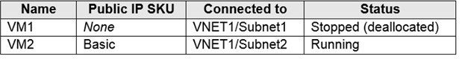

You deploy a load balancer that has the following configurations:

* Name: LB1
* Type: Internal
* SKU: Standard
* Virtual network: VNET1

You need to ensure that you can add VM1 and VM2 to the backend pool of LB1.

Solution: You create a Basic SKU public IP address, associate the address to the network interface of VM1, and then start VM1.

Does this meet the goal?

|  |  |
| --- | --- |
| A. | Yes |
| B. | No |

**Answer:** B

**Explanation:**

"You can only attach virtual machines that are in the same location and on the same virtual network as the loadbalancer. Virtual machines must have a standard SKU public IP or no public IP."

* It does not matter if the VM is stopped or started.
* The LB needs to be a standard SKU to accept individual VMs outside an availability set or vmss. VMs do not need to have public IPs but if they do have them they have to be standard SKU. Vms can only be from a single network.

https://docs.microsoft.com/en-us/azure/load-balancer/backend-pool-management

* When they dont have a public IP they are assigned an ephemeral IP. https://docs.microsoft.com/en-us/azure/load-balancer/quickstart-load-balancer-standard-internal- portal?tabs=option-1-create-internal-load-balancer-standard#create-virtual-machines

### QUESTION 424

**Note: This question is part of a series of questions that present the same scenario. Each question in the series contains a unique solution that might meet the stated goals. Some question sets might have more than one correct solution, while others might not have a correct solution.**

**After you answer a question in this section, you will NOT be able to return to it. As a result, these questions will not appear in the review screen.**

You have an Azure subscription that contains the virtual machines shown in the following table.



You deploy a load balancer that has the following configurations:

* Name: LB1
* Type: Internal
* SKU: Standard
* Virtual network: VNET1

You need to ensure that you can add VM1 and VM2 to the backend pool of LB1.

Solution: You create a Standard SKU public IP address, associate the address to the network interface of VM1, and then stop VM2.

Does this meet the goal?

|  |  |
| --- | --- |
| A. | Yes |
| B. | No |

**Answer:** B

**Explanation:**

A Backend Pool configured by IP address has the following limitations: Standard load balancer only

Reference:

https://docs.microsoft.com/en-us/azure/load-balancer/backend-pool-management

### QUESTION 425

**Note: This question is part of a series of questions that present the same scenario. Each question in the series contains a unique solution that might meet the stated goals. Some question sets might have more than one correct solution, while others might not have a correct solution.**

**After you answer a question in this section, you will NOT be able to return to it. As a result, these questions will not appear in the review screen.**

You have an Azure subscription that contains the virtual machines shown in the following table.



You deploy a load balancer that has the following configurations:

* Name: LB1
* Type: Internal
* SKU: Standard
* Virtual network: VNET1

You need to ensure that you can add VM1 and VM2 to the backend pool of LB1.

Solution: You create two Standard public IP addresses and associate a Standard SKU public IP address to the network interface of each virtual machine.

Does this meet the goal?

|  |  |
| --- | --- |
| A. | Yes |
| B. | No |

**Answer:** A

**Explanation:**

A Backend Pool configured by IP address has the following limitations: Standard load balancer only

Reference:

https://docs.microsoft.com/en-us/azure/load-balancer/backend-pool-management

### QUESTION 426

**Note: This question is part of a series of questions that present the same scenario. Each question in the series contains a unique solution that might meet the stated goals. Some question sets might have more than one correct solution, while others might not have a correct solution.**

**After you answer a question in this section, you will NOT be able to return to it. As a result, these questions will not appear in the review screen.**

You have a computer named Computer1 that has a point-to-site VPN connection to an Azure virtual network named VNet1. The point-to-site connection uses a self-signed certificate.

From Azure, you download and install the VPN client configuration package on a computer named Computer2.

You need to ensure that you can establish a point-to-site VPN connection to VNet1 from Computer2.

Solution: You export the client certificate from Computer1 and install the certificate on Computer2.

Does this meet the goal?

|  |  |
| --- | --- |
| A. | Yes |
| B. | No |

**Answer:** A

**Explanation:**

Each client computer that connects to a VNet using Point-to-Site must have a client certificate installed.

You generate a client certificate from the self-signed root certificate, and then export and install the client certificate. If the client certificate is not installed, authentication fails.

Reference:

https://docs.microsoft.com/en-us/azure/vpn-gateway/vpn-gateway-certificates-point-to-site

### QUESTION 427

You have an Azure subscription that contains 100 virtual machines. You regularly create and delete virtual machines.

You need to identify unattached disks that can be deleted. What should you do?

|  |  |
| --- | --- |
| A. | From Azure Cost Management, view Cost Analysis |
| B. | From Azure Advisor, modify the Advisor configuration |
| C. | From Microsoft Azure Storage Explorer, view the Account Management properties |
| D. | From Azure Cost Management, view Advisor Recommendations |

**Answer:** C

**Explanation:**

https://docs.microsoft.com/en-us/azure/virtual-machines/windows/find-unattached-disks

### QUESTION 428

Hotspot Question

You have an Azure Active Directory (Azure AD) tenant that contains three global administrators named Admin1, Admin2, and Admin3.

The tenant is associated to an Azure subscription. Access control for the subscription is configured as shown in the Access control exhibit. (Click the Access Control tab.)

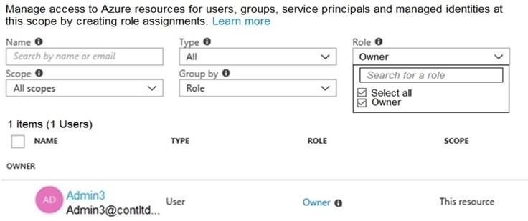

You sign in to the Azure portal as Admin1 and configure the tenant as shown in the Tenant exhibit. (Click the Tenant tab.)

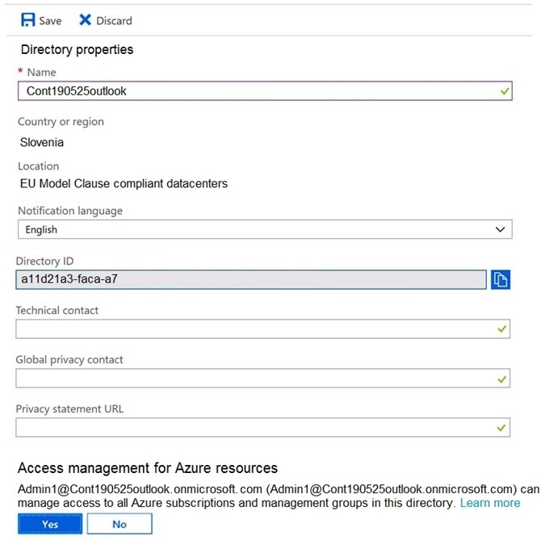

For each of the following statements, select Yes if the statement is true. Otherwise, select No. NOTE: Each correct selection is worth one point.

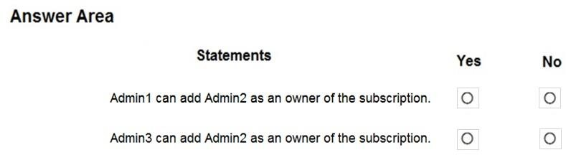

**Answer:**

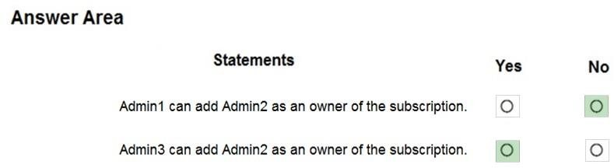

**Explanation:**

Box 1: No

Only Admin3, the owner, can assign ownership. Box 2: Yes

Reference:

https://docs.microsoft.com/en-us/azure/cost-management-billing/manage/add-change- subscription-administrator

### QUESTION 429

Hotspot Question

You have an Azure subscription that contains the file shares shown in the following table.

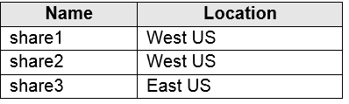

You have the on-premises file shares shown in the following table.

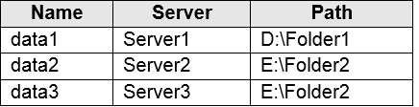

You create an Azure file sync group named Sync1 and perform the following actions:

* Add share1 as the cloud endpoint for Sync1.
* Add data1 as a server endpoint for Sync1.
* Register Server1 and Server2 to Sync1.

For each of the following statements, select Yes if the statement is true. Otherwise, select No. NOTE: Each correct selection is worth one point.

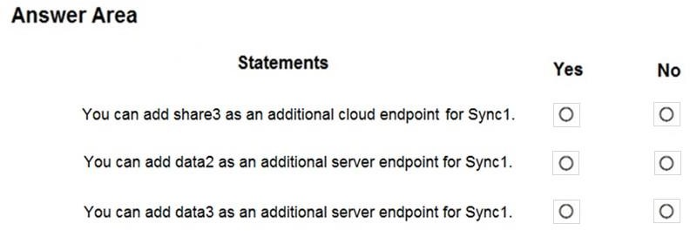

**Answer:**

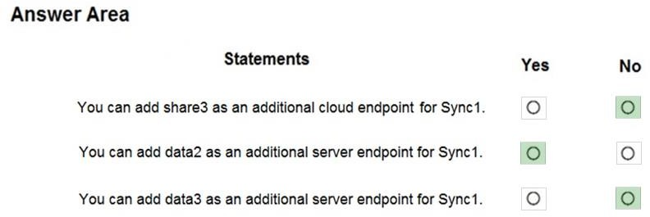

**Explanation:**

Box 1: No

A sync group must contain one cloud endpoint, which represents an Azure file share and one or more server endpoints.

Box 2: Yes

Data2 is located on Server2 which is registered to Sync1.

Box 3: No

Data3 is located on Server3 which is not registered to Sync1.

Reference:

https://docs.microsoft.com/en-us/azure/storage/files/storage-sync-files-deployment- guide?tabs=azure-portal%2Cproactive-portal#create-a-sync-group-and-a-cloud-endpoint

### QUESTION 430

Drag and Drop Question

You have an Azure subscription that contains an Azure file share.

You have an on-premises server named Server1 that runs Windows Server 2016. You plan to set up Azure File Sync between Server1 and the Azure file share.

You need to prepare the subscription for the planned Azure File Sync.

Which two actions should you perform in the Azure subscription? To answer, drag the appropriate actions to the correct targets. Each action may be used once, more than once, or not at all. You may need to drag the split bar between panes or scroll to view content.

NOTE: Each correct selection is worth one point.

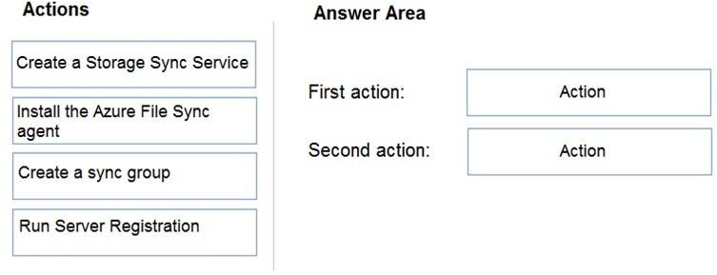

**Answer:**

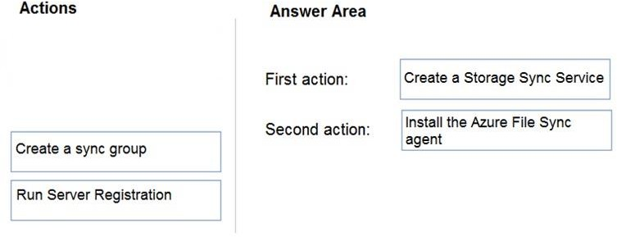

**Explanation:**

First action: Create a Storage Sync Service

The deployment of Azure File Sync starts with placing a Storage Sync Service resource into a resource group of your selected subscription.

Second action: Install the Azure File Sync agent

The Azure File Sync agent is a downloadable package that enables Windows Server to be synced with an Azure file share.

Reference:

https://docs.microsoft.com/en-us/azure/storage/files/storage-sync-files-deployment-guide

### QUESTION 431

Hotspot Question

You deploy an Azure Kubernetes Service (AKS) cluster that has the network profile shown in the following exhibit.

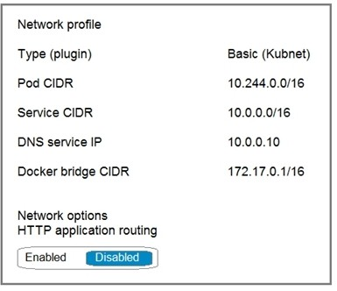

Use the drop-down menus to select the answer choice that completes each statement based on the information presented in the graphic.

NOTE: Each correct selection is worth one point.

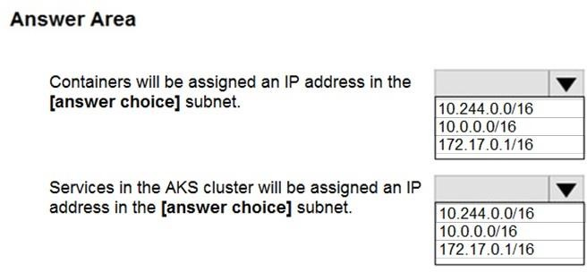

**Answer:**

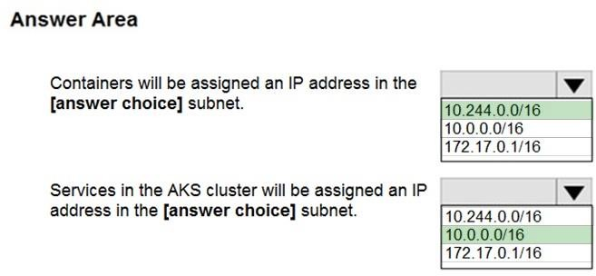

**Explanation:**

Box 1: 10.244.0.0/16

The Pod CIDR.

Note: The --pod-cidr should be a large address space that isn't in use elsewhere in your network environment. This range includes any on-premises network ranges if you connect, or plan to connect, your Azure virtual networks using Express Route or a Site-to-Site VPN connection.

This address range must be large enough to accommodate the number of nodes that you expect to scale up to. You can't change this address range once the cluster is deployed if you need more addresses for additional nodes.

Box 2: 10.0.0.0/16

The --service-cidr is used to assign internal services in the AKS cluster an IP address.

Reference:

https://docs.microsoft.com/en-us/azure/aks/configure-kubenet

### QUESTION 432

Hotspot Question

You have the App Service plan shown in the following exhibit.

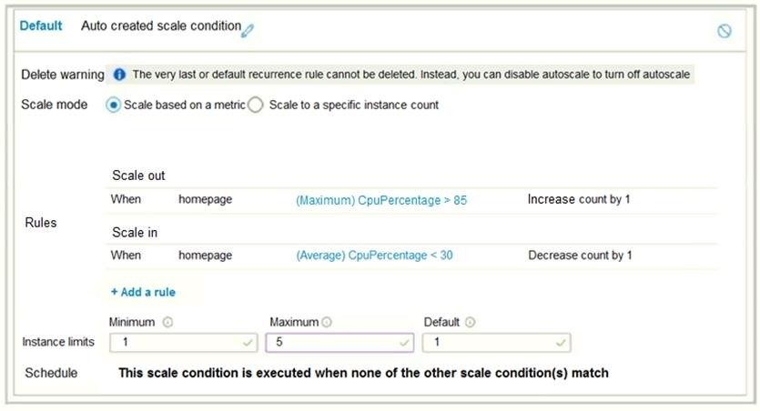

The scale-in settings for the App Service plan are configured as shown in the following exhibit.

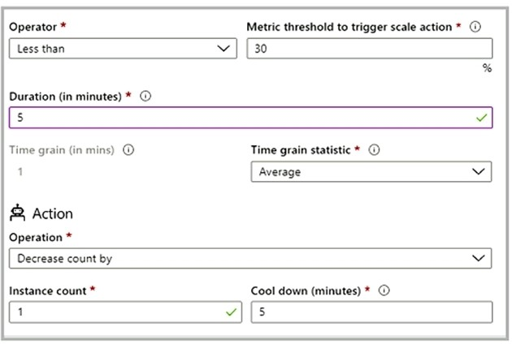

The scale out rule is configured with the same duration and cool down tile as the scale in rule.

Use the drop-down menus to select the answer choice that completes each statement based on the information presented in the graphic.

NOTE: Each correct selection is worth one point.

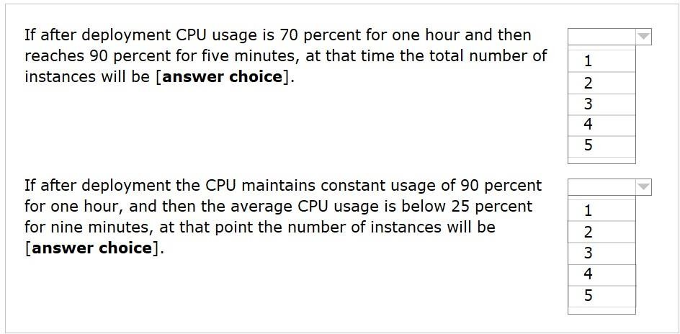

**Answer:**

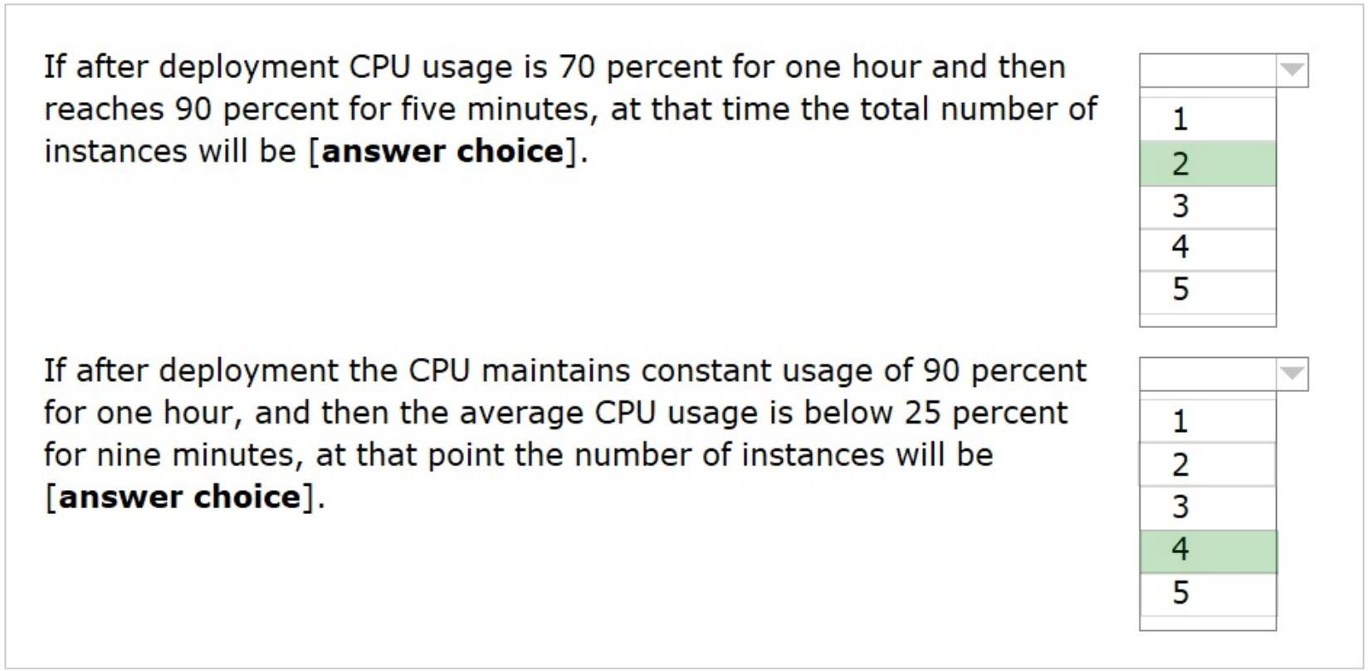

**Explanation:**

Box 1: 2

70% for 1h, and then 90% for 5 minutes. So, from the default of 1 it will scale out out 1 more. So, 2 in total.

Box 2: 4

90% for 1h and then 25% for 9minutes. So, from the default of 1 it will it scale in to the max 5 (60/5 = 12, which means 6 times scale out, because we have 5 minutes period of cool down). Then when it drops to 25% for 9 minutes and it will scale in once after 5 mins (since the average of the last 5 minutes is under 30% ), so it will decrease by 1, so 4 in total. Then it will have a cooldown of 5 minutes before scaling in again, but since only 4 minutes left from 9 minutes (9-5 = 4), it won't scale in again. So, 4 in total.

Reference:

https://docs.microsoft.com/en-us/azure/azure-monitor/learn/tutorial-autoscale-performance- schedule

https://docs.microsoft.com/en-us/azure/azure-monitor/autoscale/autoscale-understanding-settings

### QUESTION 433

Hotspot Question

You have an Azure subscription that contains the resources in the following table.

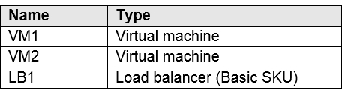

You install the Web Server server role (IIS) on VM1 and VM2, and then add VM1 and VM2 to LB1.

LB1 is configured as shown in the LB1 exhibit. (Click the LB1 tab.)

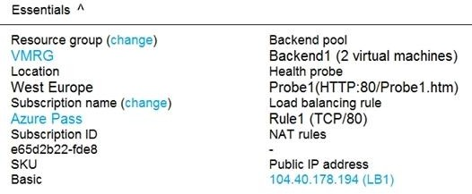

Rule1 is configured as shown in the Rule1 exhibit. (Click the Rule1 tab.)

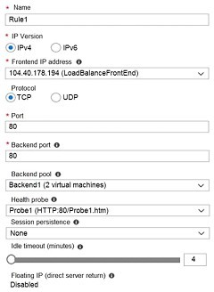

For each of the following statements, select Yes if the statement is true. Otherwise, select No. NOTE: Each correct selection is worth one point.

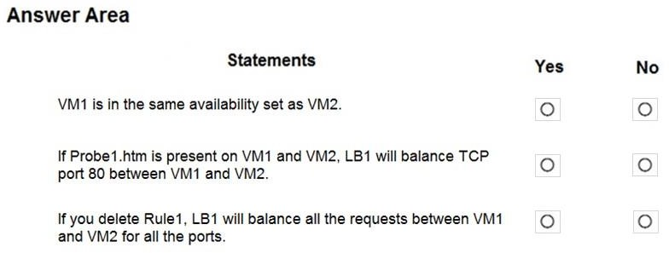

**Answer:**

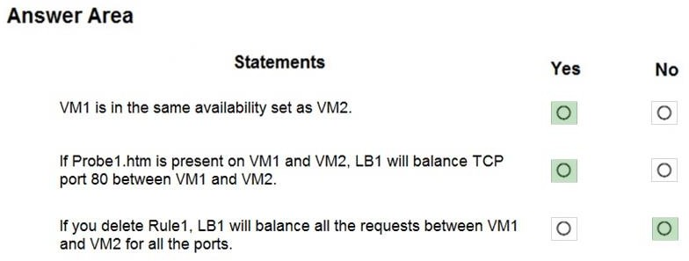

**Explanation:**

Box 1: Yes

A Basic Load Balancer supports virtual machines in a single availability set or virtual machine scale set.

Box 2: Yes

When using load-balancing rules with Azure Load Balancer, you need to specify health probes to allow Load Balancer to detect the backend endpoint status. The configuration of the health probe and probe responses determine which backend pool instances will receive new flows. You can use health probes to detect the failure of an application on a backend endpoint. You can also generate a custom response to a health probe and use the health probe for flow control to manage load or planned downtime. When a health probe fails, Load Balancer will stop sending new flows to the respective unhealthy instance. Outbound connectivity is not impacted, only inbound connectivity is impacted.

Box 3: No Reference:

https://docs.microsoft.com/en-us/azure/load-balancer/skus

https://docs.microsoft.com/en-us/azure/load-balancer/load-balancer-custom-probe-overview

### QUESTION 434

Hotspot Question

You have an Azure subscription that contains the Azure virtual machines shown in the following table.

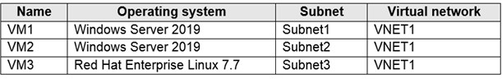

You configure the network interfaces of the virtual machines to use the settings shown in the following table.

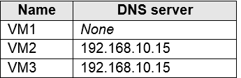

From the settings of VNET1 you configure the DNS servers shown in the following exhibit.

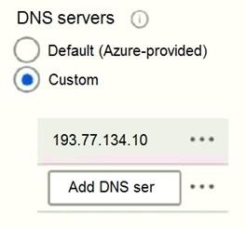

The virtual machines can successfully connect to the DNS server that has an IP address of 192.168.10.15 and the DNS server that has an IP address of 193.77.134.10.

For each of the following statements, select Yes if the statement is true. Otherwise, select No. NOTE: Each correct selection is worth one point.

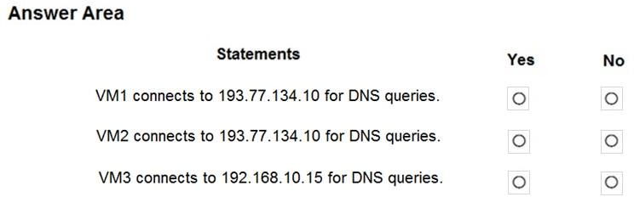

**Answer:**

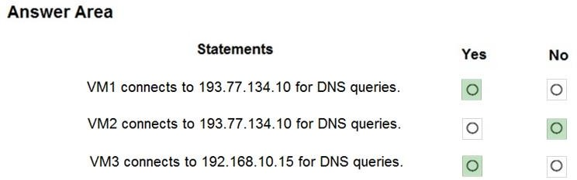

**Explanation:**

Box 1: Yes

You can specify DNS server IP addresses in the VNet settings. The setting is applied as the default DNS server(s) for all VMs in the VNet.

Box 2: No

You can set DNS servers per VM or cloud service to override the default network settings.

Box 3: Yes

You can set DNS servers per VM or cloud service to override the default network settings.

Reference:

https://docs.microsoft.com/en-us/azure/virtual-network/virtual-networks-faq#name-resolution-dns

### QUESTION 435

Hotspot Question

You have an Azure subscription that contains the resource groups shown in the following table.

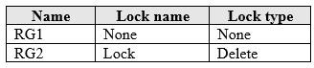

RG1 contains the resources shown in the following table.

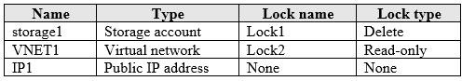

RG2 contains the resources shown in the following table.

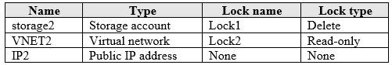

You need to identify which resources you can move from RG1 to RG2, and which resources you can move from RG2 to RG1.

Which resources should you identify? To answer, select the appropriate options in the answer area.

NOTE: Each correct selection is worth one point.

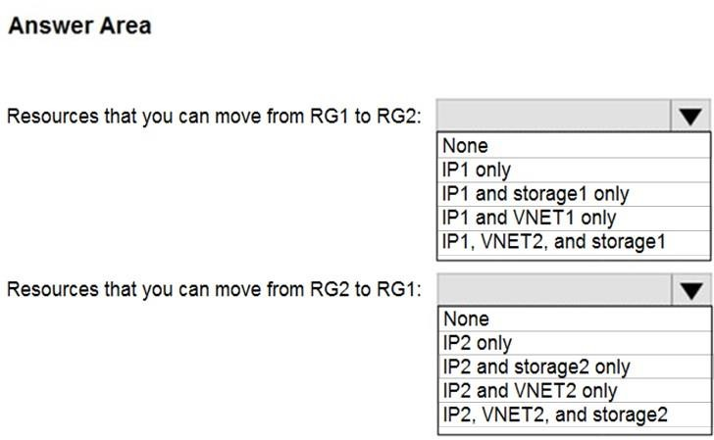

**Answer:**

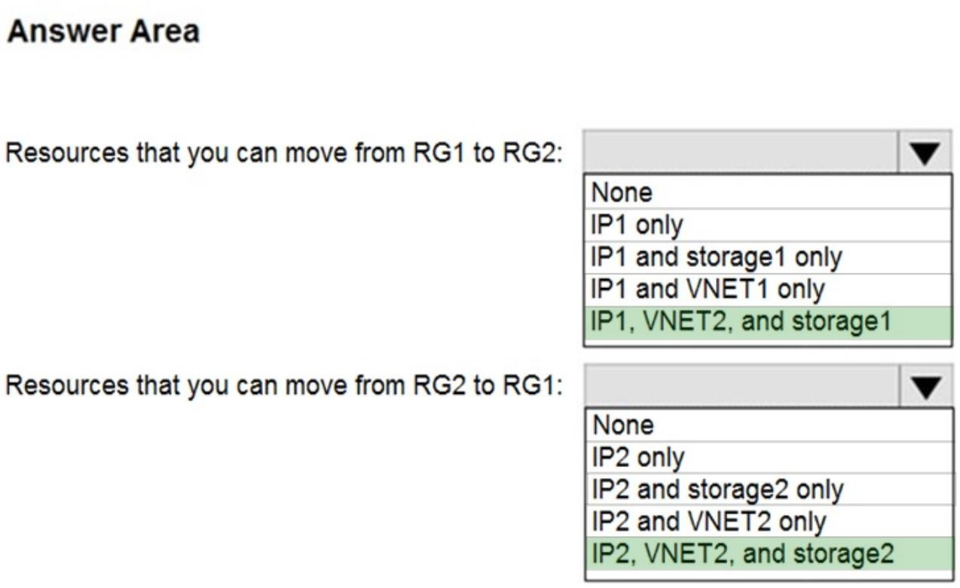

**Explanation:**

Box 1: IP1, VNET2, and storage1 Box 2: IP2, VNET2, and storage2

Locks are designed for any update or removal. In this case we want to move only, we are not deleting, and we are not changing anything in the resource.

### QUESTION 436

You have an Azure DNS zone named adatum.com.

You need to delegate a subdomain named research.adatum.com to a different DNS server in Azure.

What should you do?

|  |  |
| --- | --- |
| A. | Create an NS record named research in the adatum.com zone. |
| B. | Create an PTR record named research in the adatum.com zone. |
| C. | Modify the SOA record of adatum.com. |
| D. | Create an A record named *.research in the adatum.com zone. |

**Answer:** A

**Explanation:**

You need to create a name server (NS) record for the zone. Reference:

https://docs.microsoft.com/en-us/azure/dns/delegate-subdomain

### QUESTION 437

**Note: This question is part of a series of questions that present the same scenario. Each question in the series contains a unique solution that might meet the stated goals. Some question sets might have more than one correct solution, while others might not have a**

**correct solution.**

**After you answer a question in this section, you will NOT be able to return to it. As a result, these questions will not appear in the review screen.**

You have an app named App1 that is installed on two Azure virtual machines named VM1 and VM2. Connections to App1 are managed by using an Azure Load Balancer.

The effective network security configurations for VM2 are shown in the following exhibit.

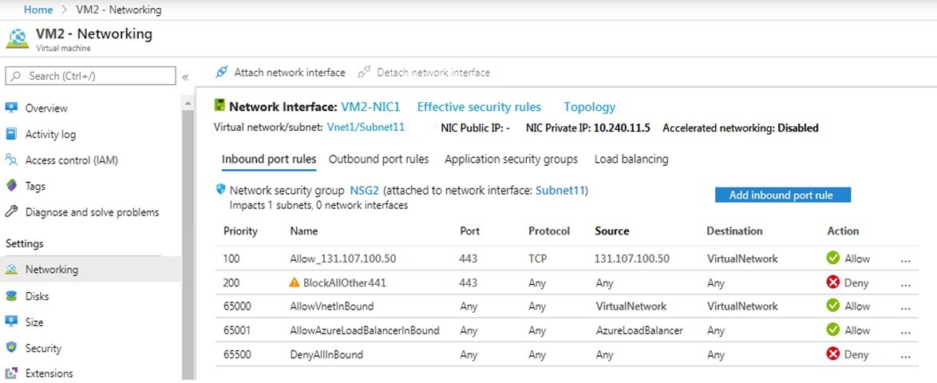

You discover that connections to App1 from 131.107.100.50 over TCP port 443 fail. You verify that the Load Balancer rules are configured correctly.

You need to ensure that connections to App1 can be established successfully from 131.107.100.50 over TCP port 443.

Solution: You create an inbound security rule that denies all traffic from the 131.107.100.50 source and has a cost of 64999.

Does this meet the goal?

|  |  |
| --- | --- |
| A. | Yes |
| B. | No |

**Answer:** B

**Explanation:**

https://fastreroute.com/azure-network-security-groups-explained/

### QUESTION 438

**Note: This question is part of a series of questions that present the same scenario. Each question in the series contains a unique solution that might meet the stated goals. Some question sets might have more than one correct solution, while others might not have a correct solution.**

**After you answer a question in this section, you will NOT be able to return to it. As a result, these questions will not appear in the review screen.**

You have an app named App1 that is installed on two Azure virtual machines named VM1 and VM2. Connections to App1 are managed by using an Azure Load Balancer.

The effective network security configurations for VM2 are shown in the following exhibit.



You discover that connections to App1 from 131.107.100.50 over TCP port 443 fail. You verify that the Load Balancer rules are configured correctly.

You need to ensure that connections to App1 can be established successfully from 131.107.100.50 over TCP port 443.

Solution: You delete the BlockAllOther443 inbound security rule. Does this meet the goal?

|  |  |
| --- | --- |
| A. | Yes |
| B. | No |

**Answer:** B

**Explanation:**

https://fastreroute.com/azure-network-security-groups-explained/

### QUESTION 439

**Note: This question is part of a series of questions that present the same scenario. Each question in the series contains a unique solution that might meet the stated goals. Some question sets might have more than one correct solution, while others might not have a correct solution.**

**After you answer a question in this section, you will NOT be able to return to it. As a result, these questions will not appear in the review screen.**

You have an app named App1 that is installed on two Azure virtual machines named VM1 and VM2. Connections to App1 are managed by using an Azure Load Balancer.

The effective network security configurations for VM2 are shown in the following exhibit.



You discover that connections to App1 from 131.107.100.50 over TCP port 443 fail. You verify that the Load Balancer rules are configured correctly.

You need to ensure that connections to App1 can be established successfully from 131.107.100.50 over TCP port 443.

Solution: You modify the priority of the Allow_131.107.100.50 inbound security rule. Does this meet the goal?

|  |  |
| --- | --- |
| A. | Yes |
| B. | No |

**Answer:** B

**Explanation:**

The rule currently has the highest priority. Reference:

https://fastreroute.com/azure-network-security-groups-explained/

### QUESTION 440

You have an Azure subscription.

You plan to deploy an Azure Kubernetes Service (AKS) cluster to support an app named App1. On- premises clients connect to App1 by using the IP address of the pod.

For the AKS cluster, you need to choose a network type that will support App1. What should you choose?

|  |  |
| --- | --- |
| A. | kubenet |
| B. | Azure Container Networking Interface (CNI) |
| C. | Hybrid Connection endpoints |
| D. | Azure Private Link |

**Answer:** B

**Explanation:**

With Azure CNI, every pod gets an IP address from the subnet and can be accessed directly. These IP addresses must be unique across your network space.

Incorrect Answers:

A: The kubenet networking option is the default configuration for AKS cluster creation. With kubenet, nodes get an IP address from the Azure virtual network subnet. Pods receive an IP address from a logically different address space to the Azure virtual network subnet of the nodes. Network address translation (NAT) is then configured so that the pods can reach resources on the Azure virtual network.

C, D: AKS only supports Kubenet networking and Azure Container Networking Interface (CNI) networking

Reference:

https://docs.microsoft.com/en-us/azure/aks/concepts-network

### QUESTION 441

**Note: This question is part of a series of questions that present the same scenario. Each question in the series contains a unique solution that might meet the stated goals. Some question sets might have more than one correct solution, while others might not have a correct solution.**

**After you answer a question in this section, you will NOT be able to return to it. As a result, these questions will not appear in the review screen.**

You have an Azure subscription that contains the virtual machines shown in the following table.



You deploy a load balancer that has the following configurations:  Name: LB1

 Type: Internal  SKU: Standard

 Virtual network: VNET1

You need to ensure that you can add VM1 and VM2 to the backend pool of LB1. Solution: You disassociate the public IP address from the network interface of VM2. Does this meet the goal?

|  |  |
| --- | --- |
| A. | Yes |
| B. | No |

**Answer:** B

### QUESTION 442

You have an Azure subscription that contains the identities shown in the following table.

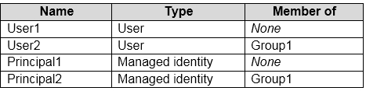

User1, Principal1, and Group1 are assigned the Monitoring Reader role.

An action group named AG1 has the Email Azure Resource Manager Role notification type and is configured to email the Monitoring Reader role.

You create an alert rule named Alert1 that uses AG1.

You need to identity who will receive an email notification when Alert1 is triggered. Who should you identify?

|  |  |
| --- | --- |
| A. | User1 and Principal1 only |
| B. | User1, User2, Principal1, and Principal2 |
| C. | User1 only |
| D. | User1 and User2 only |

**Answer:** C

**Explanation:**

Email will only be sent to Azure AD user members of the Monitoring Reader role. Email will not be sent to Azure AD groups or service principals.

Reference:

https://docs.microsoft.com/en-us/azure/azure-monitor/platform/action-groups

### QUESTION 443

Hotspot Question

You have an Azure subscription that contains the storage accounts shown in the following exhibit.

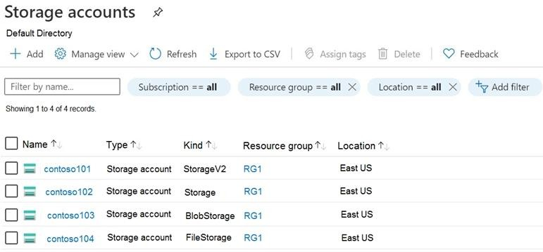

Use the drop-down menus to select the answer choice that completes each statement based on the information presented in the graphic.

NOTE: Each correct selection is worth one point.

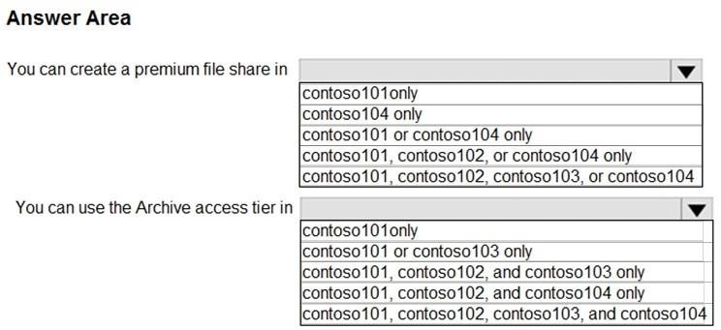

**Answer:**

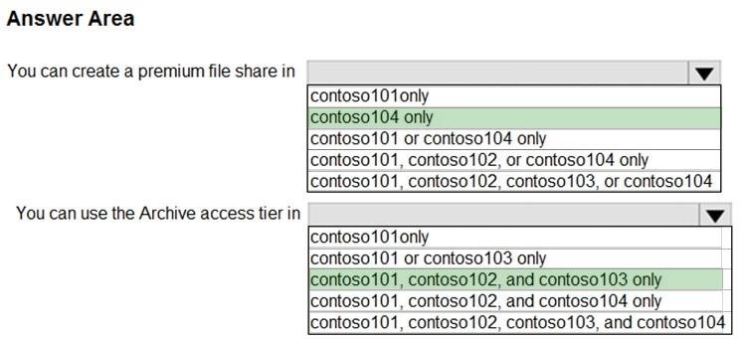

**Explanation:**

Box 1: contoso104 only

Premium file shares are hosted in a special purpose storage account kind, called a FileStorage account.

Box 2: contoso101, contoso102, and contos103 only Reference:

https://docs.microsoft.com/en-us/azure/storage/files/storage-how-to-create-premium-

fileshare?tabs=azure-portal

https://docs.microsoft.com/en-us/azure/storage/blobs/storage-blob-storage-tiers

### QUESTION 444

Hotspot Question

You manage two Azure subscriptions named Subscription1 and Subscription2. Subscription1 has following virtual networks:

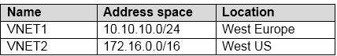

The virtual networks contain the following subnets:

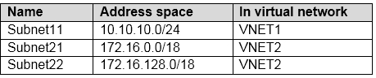

Subscription2 contains the following virtual network:

* Name: VNETA

- Address space: 10.10.128.0/17

* Location: Canada Central

VNETA contains the following subnets:

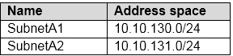

For each of the following statements, select Yes if the statement is true. Otherwise, select No. NOTE: Each correct selection is worth one point.

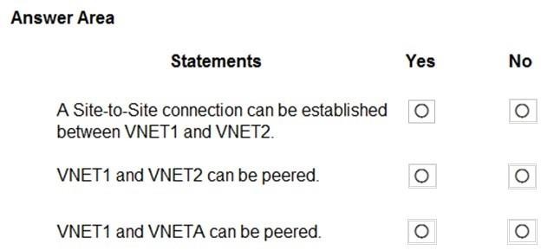

**Answer:**

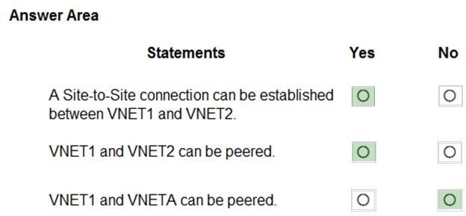

**Explanation:**

Box 1: Yes

With VNet-to-VNet you can connect Virtual Networks in Azure across different regions.

Box 2: Yes

Azure supports the following types of peering:

Virtual network peering: Connect virtual networks within the same Azure region. Global virtual network peering: Connecting virtual networks across Azure regions.

Box 3: No

The virtual networks you peer must have non-overlapping IP address spaces.

Reference:

https://azure.microsoft.com/en-us/blog/vnet-to-vnet-connecting-virtual-networks-in-azure-across- different-regions/

https://docs.microsoft.com/en-us/azure/virtual-network/virtual-network-manage-

peering#requirements-and-constraints

### QUESTION 445

You have an Azure subscription named Subscription1 that contains an Azure Log Analytics workspace named Workspace1.

You need to view the error event from a table named Event. Which query should you run in Workspace1?

|  |  |
| --- | --- |
| A. | Get-Event Event | where {$_.EventType == "error"} |
| B. | Event | search "error" |
| C. | select * from Event where EventType == "error" |
| D. | Event | where EventType is "error" |

**Answer:** B

**Explanation:**

https://docs.microsoft.com/en-us/azure/azure-monitor/log-query/search-queries https://docs.microsoft.com/en-us/azure/azure-monitor/log-query/get-started-portal https://docs.microsoft.com/en-us/azure/data- explorer/kusto/query/searchoperator?pivots=azuredataexplorer

### QUESTION 446

You have two Azure virtual machines named VM1 and VM2. You have two Recovery Services vaults named RSV1 and RSV2.

VM2 is backed up to RSV1.

You need to back up VM2 to RSV2. What should you do first?

|  |  |
| --- | --- |
| A. | From the RSV1 blade, click Backup items and stop the VM2 backup |
| B. | From the RSV2 blade, click Backup. From the Backup blade, select the backup for the virtual machine, and then click Backup |
| C. | From the VM2 blade, click Disaster recovery, click Replication settings, and then select RSV2 as the Recovery Services vault |
| D. | From the RSV1 blade, click Backup Jobs and export the VM2 job |

**Answer:** C

**Explanation:**

https://docs.microsoft.com/en-us/azure/backup/backup-azure-vms-first-look-arm

### QUESTION 447

You have a general-purpose v1 Azure Storage account named storage1 that uses locally- redundant storage (LRS).

You need to ensure that the data in the storage account is protected if a zone fails. The solution must minimize costs and administrative effort.

What should you do first?

|  |  |
| --- | --- |
| A. | Create a new storage account. |
| B. | Configure object replication rules. |
| C. | Upgrade the account to general-purpose v2. |
| D. | Modify the Replication setting of storage1. |

**Answer:** C

**Explanation:**

https://docs.microsoft.com/en-us/azure/storage/common/storage-redundancy

### QUESTION 448

You have an Azure subscription that contains the storage accounts shown in the following table.

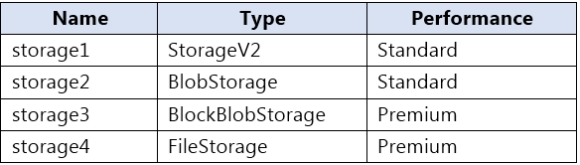

You plan to manage the data stored in the accounts by using lifecycle management rules. To which storage accounts can you apply lifecycle management rules?

|  |  |
| --- | --- |
| A. | storage1 only |
| B. | storage1 and storage2 only |
| C. | storage3 and storage4 only |
| D. | storage1, storage2, and storage3 only |
| E. | storage1, storage2, storage3, and storage4 |

**Answer:** D

**Explanation:**

https://docs.microsoft.com/en-us/azure/storage/blobs/storage-lifecycle-management- concepts?tabs=azure-portal

### QUESTION 449

You have an Azure subscription that contains the resources shown in the following table.

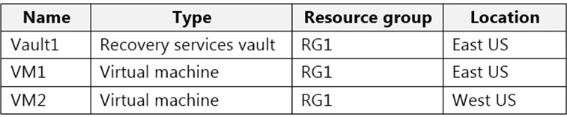

All virtual machines run Windows Server 2016.

On VM1, you back up a folder named Folder1 as shown in the following exhibit.

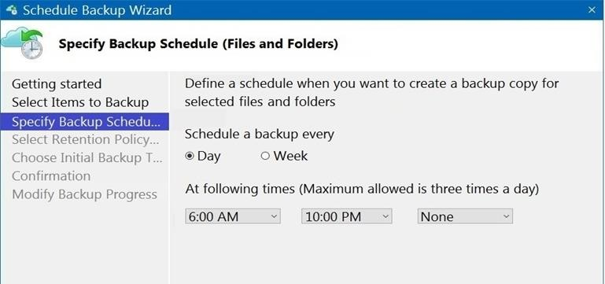

You plan to restore the backup to a different virtual machine. You need to restore the backup to VM2.

What should you do first?

|  |  |
| --- | --- |
| A. | From VM1, install the Windows Server Backup feature. |
| B. | From VM2, install the Microsoft Azure Recovery Services Agent. |
| C. | From VM1, install the Microsoft Azure Recovery Services Agent. |
| D. | From VM2, install the Windows Server Backup feature. |

**Answer:** B

**Explanation:**

https://docs.microsoft.com/en-us/azure/backup/backup-azure-restore-windows-server

### QUESTION 450

**Note: This question is part of a series of questions that present the same scenario. Each question in the series contains a unique solution that might meet the stated goals. Some question sets might have more than one correct solution, while others might not have a correct solution.**

**After you answer a question in this section, you will NOT be able to return to it. As a result, these questions will not appear in the review screen.**

You deploy an Azure Kubernetes Service (AKS) cluster named AKS1. You need to deploy a YAML file to AKS1.

Solution: From Azure Cloud Shell, you run az aks. Does this meet the goal?

|  |  |
| --- | --- |
| A. | Yes |

|  |  |
| --- | --- |
| B. | No |

**Answer:** B

**Explanation:**

https://docs.microsoft.com/en-us/azure/aks/kubernetes-walkthrough

### QUESTION 451

**Note: This question is part of a series of questions that present the same scenario. Each question in the series contains a unique solution that might meet the stated goals. Some question sets might have more than one correct solution, while others might not have a correct solution.**

**After you answer a question in this section, you will NOT be able to return to it. As a result, these questions will not appear in the review screen.**

You deploy an Azure Kubernetes Service (AKS) cluster named AKS1. You need to deploy a YAML file to AKS1.

Solution: From Azure Cloud Shell, you run the kubectl client. Does this meet the goal?

|  |  |
| --- | --- |
| A. | Yes |
| B. | No |

**Answer:** A

**Explanation:**

https://docs.microsoft.com/en-us/azure/aks/kubernetes-walkthrough

### QUESTION 452

**Note: This question is part of a series of questions that present the same scenario. Each question in the series contains a unique solution that might meet the stated goals. Some question sets might have more than one correct solution, while others might not have a correct solution.**

**After you answer a question in this section, you will NOT be able to return to it. As a result, these questions will not appear in the review screen.**

You deploy an Azure Kubernetes Service (AKS) cluster named AKS1. You need to deploy a YAML file to AKS1.

Solution: From Azure CLI, you run azcopy. Does this meet the goal?

|  |  |
| --- | --- |
| A. | Yes |
| B. | No |

**Answer:** B

**Explanation:**

https://docs.microsoft.com/en-us/azure/aks/kubernetes-walkthrough

### QUESTION 453

You have an Azure subscription that contains two virtual machines as shown in the following table.

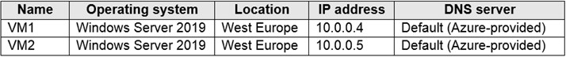

You perform a reverse DNS lookup for 10.0.0.4 from VM2. Which FQDN will be returned?

|  |  |
| --- | --- |
| A. | vm1.core.windows.net |
| B. | vm1.azure.com |
| C. | vm1.westeurope.cloudapp.azure.com |
| D. | vm1.internal.cloudapp.net |

**Answer:** B

### QUESTION 454

**Note: This question is part of a series of questions that present the same scenario. Each question in the series contains a unique solution that might meet the stated goals. Some question sets might have more than one correct solution, while others might not have a correct solution.**

**After you answer a question in this section, you will NOT be able to return to it. As a result, these questions will not appear in the review screen.**

You have an app named App1 that is installed on two Azure virtual machines named VM1 and VM2. Connections to App1 are managed by using an Azure Load Balancer.

The effective network security configurations for VM2 are shown in the following exhibit.

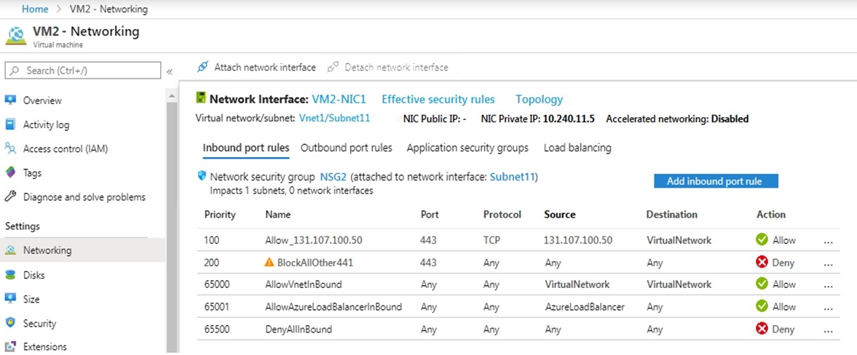

You discover that connections to App1 from 131.107.100.50 over TCP port 443 fail.

You verify that the Load Balancer rules are configured correctly.

You need to ensure that connections to App1 can be established successfully from 131.107.100.50 over TCP port 443.

Solution: You create an inbound security rule that allows any traffic from the AzureLoadBalancer source and has a cost of 150.

Does this meet the goal?

|  |  |
| --- | --- |
| A. | Yes |
| B. | No |

**Answer:** A

**Explanation:**

https://docs.microsoft.com/en-us/azure/virtual-network/network-security-groups-overview

### QUESTION 455

**Case Study 5 - Contoso, Ltd Overview**

**General Overview**

Contoso, Ltd. is a consulting company that has a main office in Montreal and branch offices in Seattle and New York.

**Environment Existing Environment**

Contoso has an Azure subscription named Sub1 that is linked to an Azure Active Directory (Azure AD) tenant. The network contains an on-premises Active Directory domain that syncs to the Azure AD tenant.

The Azure AD tenant contains the users shown in the following table.

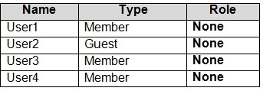

Sub1 contains two resource groups named RG1 and RG2 and the virtual networks shown in the following table.

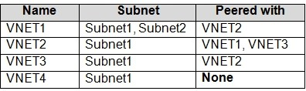

User1 manages the resources in RG1. User4 manages the resources in RG2.

Sub1 contains virtual machines that run Windows Server 2019 as shown in the following table

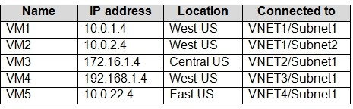

No network security groups (NSGs) are associated to the network interfaces or the subnets. Sub1 contains the storage accounts shown in the following table.

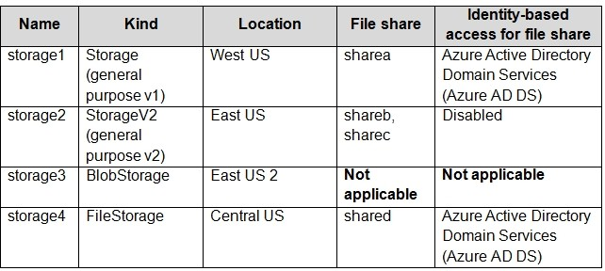

**Requirements Planned Changes**

Contoso plans to implement the following changes:

 Create a blob container named container1 and a file share named share1 that will use the Cool storage tier.

 Create a storage account named storage5 and configure storage replication for the Blob service.

 Create an NSG named NSG1 that will have the custom inbound security rules shown in the following table.

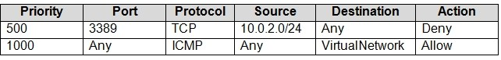

 Associate NSG1 to the network interface of VM1.

 Create an NSG named NSG2 that will have the custom outbound security rules shown in the following table.

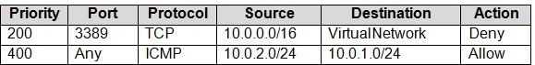

 Associate NSG2 to VNET1/Subnet2.

**Technical Requirements**

Contoso must meet the following technical requirements:

 Create container1 and share1.

 Use the principle of least privilege.

 Create an Azure AD security group named Group4.

 Back up the Azure file shares and virtual machines by using Azure Backup.

 Trigger an alert if VM1 or VM2 has less than 20 GB of free space on volume C.

 Enable User1 to create Azure policy definitions and User2 to assign Azure policies to RG1.  Create an internal Basic Azure Load Balancer named LB1 and connect the load balancer to

VNET1/Subnet1

 Enable flow logging for IP traffic from VM5 and retain the flow logs for a period of eight months.

 Whenever possible, grant Group4 Azure role-based access control (Azure RBAC) read-only permissions to the Azure file shares.

You need to ensure that VM1 can communicate with VM4. The solution must minimize the administrative effort.

What should you do?

|  |  |
| --- | --- |
| A. | Create an NSG and associate the NSG to VM1 and VM4. |
| B. | Establish peering between VNET1 and VNET3. |
| C. | Assign VM4 an IP address of 10.0.1.5/24. |
| D. | Create a user-defined route from VNET1 to VNET3. |

**Answer:** C

**Explanation:**

Reference:

https://docs.microsoft.com/en-us/azure/vpn-gateway/tutorial-site-to-site-portal

### QUESTION 456

**Case Study 5 - Contoso, Ltd Overview**

**General Overview**

Contoso, Ltd. is a consulting company that has a main office in Montreal and branch offices in Seattle and New York.

**Environment Existing Environment**

Contoso has an Azure subscription named Sub1 that is linked to an Azure Active Directory (Azure AD) tenant. The network contains an on-premises Active Directory domain that syncs to the Azure AD tenant.

The Azure AD tenant contains the users shown in the following table.



Sub1 contains two resource groups named RG1 and RG2 and the virtual networks shown in the following table.



User1 manages the resources in RG1. User4 manages the resources in RG2.

Sub1 contains virtual machines that run Windows Server 2019 as shown in the following table



No network security groups (NSGs) are associated to the network interfaces or the subnets. Sub1 contains the storage accounts shown in the following table.



**Requirements Planned Changes**

Contoso plans to implement the following changes:

 Create a blob container named container1 and a file share named share1 that will use the Cool storage tier.

 Create a storage account named storage5 and configure storage replication for the Blob service.

 Create an NSG named NSG1 that will have the custom inbound security rules shown in the following table.



 Associate NSG1 to the network interface of VM1.

 Create an NSG named NSG2 that will have the custom outbound security rules shown in the following table.



 Associate NSG2 to VNET1/Subnet2.

**Technical Requirements**

Contoso must meet the following technical requirements:

 Create container1 and share1.

 Use the principle of least privilege.

 Create an Azure AD security group named Group4.

 Back up the Azure file shares and virtual machines by using Azure Backup.

 Trigger an alert if VM1 or VM2 has less than 20 GB of free space on volume C.

 Enable User1 to create Azure policy definitions and User2 to assign Azure policies to RG1.  Create an internal Basic Azure Load Balancer named LB1 and connect the load balancer to

VNET1/Subnet1

 Enable flow logging for IP traffic from VM5 and retain the flow logs for a period of eight months.

 Whenever possible, grant Group4 Azure role-based access control (Azure RBAC) read-only permissions to the Azure file shares.

Hotspot Question

You need to create container1 and share1.

Which storage accounts should you use for each resource? To answer, select the appropriate options in the answer area.

NOTE: Each correct selection is worth one point.

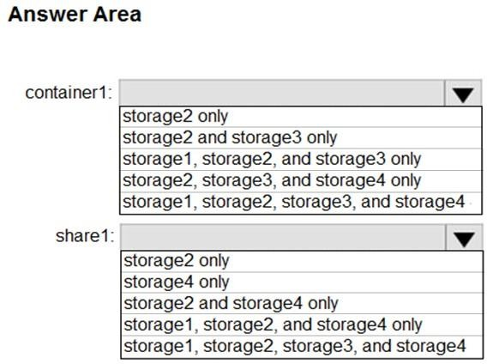

**Answer:**

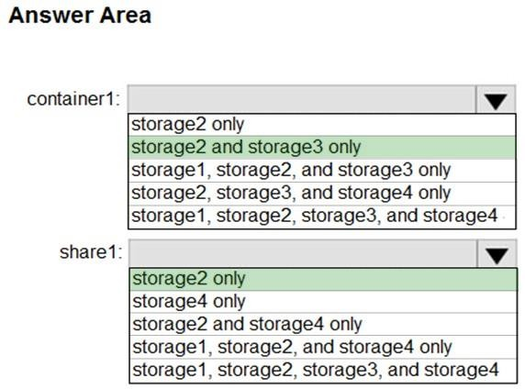

**Explanation:**

https://docs.microsoft.com/en-us/azure/storage/blobs/storage-blob-storage-tiers https://docs.microsoft.com/en-us/azure/storage/common/storage-account-overview

### QUESTION 457

**Case Study 5 - Contoso, Ltd Overview**

**General Overview**

Contoso, Ltd. is a consulting company that has a main office in Montreal and branch offices in Seattle and New York.

**Environment Existing Environment**

Contoso has an Azure subscription named Sub1 that is linked to an Azure Active Directory (Azure AD) tenant. The network contains an on-premises Active Directory domain that syncs to the Azure AD tenant.

The Azure AD tenant contains the users shown in the following table.



Sub1 contains two resource groups named RG1 and RG2 and the virtual networks shown in the following table.



User1 manages the resources in RG1. User4 manages the resources in RG2.

Sub1 contains virtual machines that run Windows Server 2019 as shown in the following table



No network security groups (NSGs) are associated to the network interfaces or the subnets. Sub1 contains the storage accounts shown in the following table.



**Requirements Planned Changes**

Contoso plans to implement the following changes:

Create a blob container named container1 and a file share named share1 that will use the Cool storage tier.

Create a storage account named storage5 and configure storage replication for the Blob service.

Create an NSG named NSG1 that will have the custom inbound security rules shown in the following table.



 Associate NSG1 to the network interface of VM1.

 Create an NSG named NSG2 that will have the custom outbound security rules shown in the following table.



 Associate NSG2 to VNET1/Subnet2.

**Technical Requirements**

Contoso must meet the following technical requirements:

 Create container1 and share1.

 Use the principle of least privilege.

 Create an Azure AD security group named Group4.

 Back up the Azure file shares and virtual machines by using Azure Backup.

 Trigger an alert if VM1 or VM2 has less than 20 GB of free space on volume C.

 Enable User1 to create Azure policy definitions and User2 to assign Azure policies to RG1.  Create an internal Basic Azure Load Balancer named LB1 and connect the load balancer to

VNET1/Subnet1

 Enable flow logging for IP traffic from VM5 and retain the flow logs for a period of eight months.

 Whenever possible, grant Group4 Azure role-based access control (Azure RBAC) read-only permissions to the Azure file shares.

Hotspot Question

You need to create storage5. The solution must support the planned changes.

Which type of storage account should you use, and which account should you configure as the destination storage account? To answer, select the appropriate options in the answer area.

NOTE: Each correct selection is worth one point.

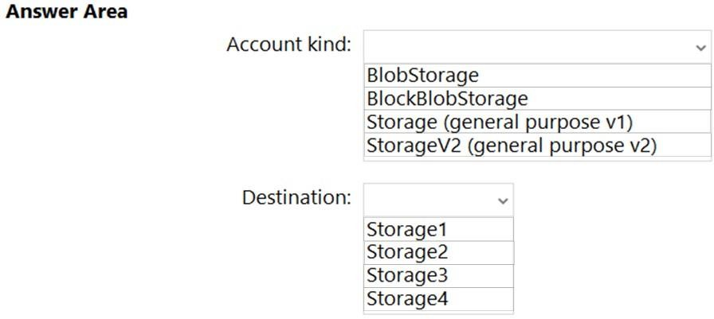

**Answer:**

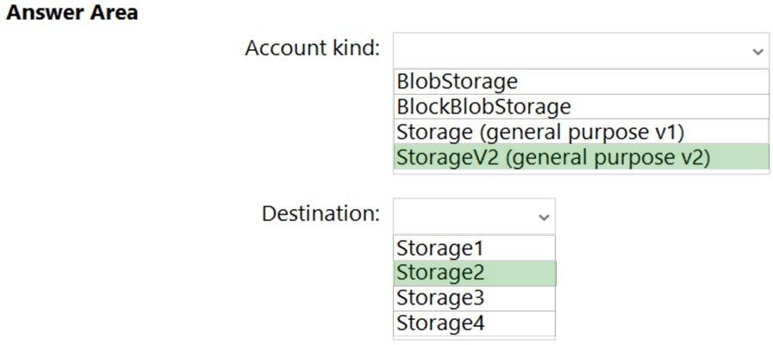

**Explanation:**

https://docs.microsoft.com/en-us/azure/storage/blobs/object-replication-configure?tabs=portal

### QUESTION 458

Your company has serval departments. Each department has a number of virtual machines (VMs).

The company has an Azure subscription that contains a resource group named RG1. All VMs are located in RG1.

You want to associate each VM with its respective department. What should you do?

|  |  |
| --- | --- |
| A. | Create Azure Management Groups for each department. |
| B. | Create a resource group for each department. |

|  |  |
| --- | --- |
| C. | Assign tags to the virtual machines. |
| D. | Modify the settings of the virtual machines. |

**Answer:** C

**Explanation:**

https://docs.microsoft.com/en-us/azure/azure-resource-manager/resource-group-using-tags

### QUESTION 459

**Note: The question is included in a number of questions that depicts the identical set-up. However, every question has a distinctive result. Establish if the solution satisfies the requirements.**

Your company has an Azure Active Directory (Azure AD) subscription. You want to implement an Azure AD conditional access policy.

The policy must be configured to require members of the Global Administrators group to use Multi-Factor Authentication and an Azure AD-joined device when they connect to Azure AD from untrusted locations.

Solution: You access the multi-factor authentication page to alter the user settings. Does the solution meet the goal?

|  |  |
| --- | --- |
| A. | Yes |
| B. | No |

**Answer:** B

### QUESTION 460

**Note: The question is included in a number of questions that depicts the identical set-up. However, every question has a distinctive result. Establish if the solution satisfies the requirements.**

Your company has an Azure Active Directory (Azure AD) subscription. You want to implement an Azure AD conditional access policy.

The policy must be configured to require members of the Global Administrators group to use Multi-Factor

Authentication and an Azure AD-joined device when they connect to Azure AD from untrusted locations.

Solution: You access the Azure portal to alter the session control of the Azure AD conditional access policy.

Does the solution meet the goal?

|  |  |
| --- | --- |
| A. | Yes |
| B. | No |

**Answer:** B

### QUESTION 461

**Note: The question is included in a number of questions that depicts the identical set-up. However, every question has a distinctive result. Establish if the solution satisfies the requirements.**

Your company has an Azure Active Directory (Azure AD) subscription. You want to implement an Azure AD conditional access policy.

The policy must be configured to require members of the Global Administrators group to use Multi-Factor Authentication and an Azure AD-joined device when they connect to Azure AD from untrusted locations.

Solution: You access the Azure portal to alter the grant control of the Azure AD conditional access policy.

Does the solution meet the goal?

|  |  |
| --- | --- |
| A. | Yes |
| B. | No |

**Answer:** A

### QUESTION 462

You are planning to deploy an Ubuntu Server virtual machine to your company's Azure subscription.

You are required to implement a custom deployment that includes adding a particular trusted root certification authority (CA).

Which of the following should you use to create the virtual machine?

|  |  |
| --- | --- |
| A. | The New-AzureRmVm cmdlet. |
| B. | The New-AzVM cmdlet. |
| C. | The Create-AzVM cmdlet. |
| D. | The az vm create command. |

**Answer:** D

**Explanation:**

Once Cloud-init.txt has been created, you can deploy the VM with az vm create cmdlet, using the

--custom- data parameter to provide the full path to the cloud-init.txt file.

Reference:

https://docs.microsoft.com/en-us/azure/virtual-machines/linux/tutorial-automate-vm-deployment

### QUESTION 463

**Note: The question is included in a number of questions that depicts the identical set-up. However, every question has a distinctive result. Establish if the solution satisfies the requirements.**

Your company makes use of Multi-Factor Authentication for when users are not in the office. The

Per Authentication option has been configured as the usage model.

After the acquisition of a smaller business and the addition of the new staff to Azure Active Directory (Azure AD) obtains a different company and adding the new employees to Azure Active Directory (Azure AD), you are informed that these employees should also make use of Multi- Factor Authentication.

To achieve this, the Per Enabled User setting must be set for the usage model. Solution: You reconfigure the existing usage model via the Azure portal.

Does the solution meet the goal?

|  |  |
| --- | --- |
| A. | Yes |
| B. | No |

**Answer:** B

**Explanation:**

Since it is not possible to change the usage model of an existing provider as it is right now, you have to create a new one and reactivate your existing server with activation credentials from the new provider.

Reference:

https://365lab.net/2015/04/11/switch-usage-model-in-azure-multi-factor-authentication-server/

### QUESTION 464

**Note: The question is included in a number of questions that depicts the identical set-up. However, every question has a distinctive result. Establish if the solution satisfies the requirements.**

Your company's Azure solution makes use of Multi-Factor Authentication for when users are not in the office. The Per Authentication option has been configured as the usage model.

After the acquisition of a smaller business and the addition of the new staff to Azure Active Directory (Azure AD) obtains a different company and adding the new employees to Azure Active Directory (Azure AD), you are informed that these employees should also make use of Multi- Factor Authentication.

To achieve this, the Per Enabled User setting must be set for the usage model. Solution: You reconfigure the existing usage model via the Azure CLI.

Does the solution meet the goal?

|  |  |
| --- | --- |
| A. | Yes |
| B. | No |

**Answer:** B

**Explanation:**

Since it is not possible to change the usage model of an existing provider as it is right now, you have to create a new one and reactivate your existing server with activation credentials from the new provider.

Reference:

https://365lab.net/2015/04/11/switch-usage-model-in-azure-multi-factor-authentication-server/

### QUESTION 465

**Note: The question is included in a number of questions that depicts the identical set-up. However, every question has a distinctive result. Establish if the solution satisfies the requirements.**

Your company's Azure solution makes use of Multi-Factor Authentication for when users are not in the office. The Per Authentication option has been configured as the usage model.

After the acquisition of a smaller business and the addition of the new staff to Azure Active Directory (Azure AD) obtains a different company and adding the new employees to Azure Active Directory (Azure AD), you are informed that these employees should also make use of Multi- Factor Authentication.

To achieve this, the Per Enabled User setting must be set for the usage model.

Solution: You create a new Multi-Factor Authentication provider with a backup from the existing Multi-Factor Authentication provider data.

Does the solution meet the goal?

|  |  |
| --- | --- |
| A. | Yes |
| B. | No |

**Answer:** A

**Explanation:**

Since it is not possible to change the usage model of an existing provider as it is right now, you have to create a new one and reactivate your existing server with activation credentials from the new provider.

Reference:

https://365lab.net/2015/04/11/switch-usage-model-in-azure-multi-factor-authentication-server/

### QUESTION 466

**Note: The question is included in a number of questions that depicts the identical set-up. However, every question has a distinctive result. Establish if the solution satisfies the requirements.**

Your company has an Azure Active Directory (Azure AD) tenant named weyland.com that is configured for hybrid coexistence with the on-premises Active Directory domain.

You have a server named DirSync1 that is configured as a DirSync server.

You create a new user account in the on-premise Active Directory. You now need to replicate the user information to Azure AD immediately.

Solution: You run the Start-ADSyncSyncCycle -PolicyType Initial PowerShell cmdlet. Does the solution meet the goal?

|  |  |
| --- | --- |
| A. | Yes |
| B. | No |

**Answer:** A

**Explanation:**

https://blog.kloud.com.au/2016/03/08/azure-ad-connect-manual-sync-cycle-with-powershell-start- adsyncsynccycle/

### QUESTION 467

**Note: The question is included in a number of questions that depicts the identical set-up. However, every question has a distinctive result. Establish if the solution satisfies the requirements.**

Your company has an Azure Active Directory (Azure AD) tenant named weyland.com that is configured for hybrid coexistence with the on-premises Active Directory domain.

You have a server named DirSync1 that is configured as a DirSync server.

You create a new user account in the on-premise Active Directory. You now need to replicate the user information to Azure AD immediately.

Solution: You use Active Directory Sites and Services to force replication of the Global Catalog on a domain controller.

Does the solution meet the goal?

|  |  |
| --- | --- |
| A. | Yes |
| B. | No |

**Answer:** B

### QUESTION 468

**Note: The question is included in a number of questions that depicts the identical set-up. However, every question has a distinctive result. Establish if the solution satisfies the requirements.**

Your company has an Azure Active Directory (Azure AD) tenant named weyland.com that is configured for hybrid coexistence with the on-premises Active Directory domain.

You have a server named DirSync1 that is configured as a DirSync server.

You create a new user account in the on-premise Active Directory. You now need to replicate the user information to Azure AD immediately.

Solution: You restart the NetLogon service on a domain controller. Does the solution meet the goal?

|  |  |
| --- | --- |
| A. | Yes |
| B. | No |

**Answer:** B

### QUESTION 469

Your company has a Microsoft Azure subscription.

The company has datacenters in Los Angeles and New York.

You are configuring the two datacenters as geo-clustered sites for site resiliency. You need to recommend an Azure storage redundancy option.

You have the following data storage requirements:

* Data must be stored on multiple nodes.
* Data must be stored on nodes in separate geographic locations.
* Data can be read from the secondary location as well as from the primary location.

Which of the following Azure stored redundancy options should you recommend?

|  |  |
| --- | --- |
| A. | Geo-redundant storage |
| B. | Read-only geo-redundant storage |
| C. | Zone-redundant storage |
| D. | Locally redundant storage |

**Answer:** B

**Explanation:**

RA-GRS allows you to have higher read availability for your storage account by providing "read only" access to the data replicated to the secondary location. Once you enable this feature, the secondary location may be used to achieve higher availability in the event the data is not available in the primary region. This is an "opt-in" feature which requires the storage account be geo-replicated.

Reference:

https://docs.microsoft.com/en-us/azure/storage/common/storage-redundancy

### QUESTION 470

**Note: The question is included in a number of questions that depicts the identical set-up. However, every question has a distinctive result. Establish if the solution satisfies the requirements.**

Your company has an azure subscription that includes a storage account, a resource group, a blob container and a file share.

A colleague named Jon Ross makes use of a solitary Azure Resource Manager (ARM) template to deploy a virtual machine and an additional Azure Storage account.

You want to review the ARM template that was used by Jon Ross. Solution: You access the Virtual Machine blade.

Does the solution meet the goal?

|  |  |
| --- | --- |
| A. | Yes |
| B. | No |

**Answer:** B

**Explanation:**

You should use the Resource Group blade.

Reference:

https://docs.microsoft.com/en-us/azure/azure-resource-manager/resource-manager-export- template

### QUESTION 471

**Note: The question is included in a number of questions that depicts the identical set-up. However, every question has a distinctive result. Establish if the solution satisfies the requirements.**

Your company has an azure subscription that includes a storage account, a resource group, a blob container and a file share.

A colleague named Jon Ross makes use of a solitary Azure Resource Manager (ARM) template to deploy a virtual machine and an additional Azure Storage account.

You want to review the ARM template that was used by Jon Ross. Solution: You access the Resource Group blade.

Does the solution meet the goal?

|  |  |
| --- | --- |
| A. | Yes |
| B. | No |

**Answer:** A

**Explanation:**

To view a template from deployment history:

Go to the resource group for your new resource group. Notice that the portal shows the result of the last deployment. Select this link.

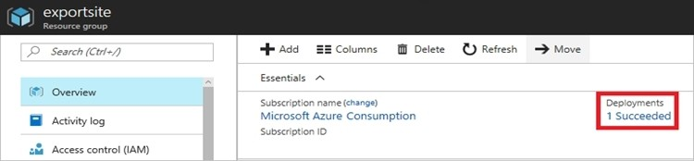

You see a history of deployments for the group. In your case, the portal probably lists only one deployment.

Select this deployment.

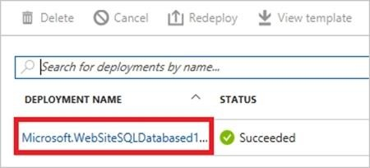

The portal displays a summary of the deployment. The summary includes the status of the deployment and its operations and the values that you provided for parameters. To see the template that you used for the deployment, select View template.

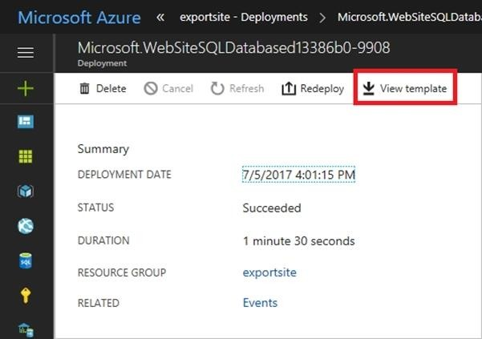

Reference:

https://docs.microsoft.com/en-us/azure/azure-resource-manager/resource-manager-export- template

### QUESTION 472

**Note: The question is included in a number of questions that depicts the identical set-up. However, every question has a distinctive result. Establish if the solution satisfies the requirements.**

Your company has an azure subscription that includes a storage account, a resource group, a blob container and a file share.

A colleague named Jon Ross makes use of a solitary Azure Resource Manager (ARM) template to deploy a virtual machine and an additional Azure Storage account.

You want to review the ARM template that was used by Jon Ross. Solution: You access the Container blade.

Does the solution meet the goal?

|  |  |
| --- | --- |
| A. | Yes |
| B. | No |

**Answer:** B

**Explanation:**

You should use the Resource Group blade Reference:

https://docs.microsoft.com/en-us/azure/azure-resource-manager/resource-manager-export- template

### QUESTION 473

Your company has three virtual machines (VMs) that are included in an availability set. You try to resize one of the VMs, which returns an allocation failure message.

It is imperative that the VM is resized.

Which of the following actions should you take?

|  |  |
| --- | --- |
| A. | You should only stop one of the VMs. |
| B. | You should stop two of the VMs. |
| C. | You should stop all three VMs. |
| D. | You should remove the necessary VM from the availability set. |

**Answer:** C

**Explanation:**

If the VM you wish to resize is part of an availability set, then you must stop all VMs in the availability set before changing the size of any VM in the availability set. The reason all VMs in the availability set must be stopped before performing the resize operation to a size that requires different hardware is that all running VMs in the availability set must be using the same physical hardware cluster. Therefore, if a change of physical hardware cluster is required to change the VM size then all VMs must be first stopped and then restarted one-by-one to a different physical hardware clusters.

Reference:

https://azure.microsoft.com/es-es/blog/resize-virtual-machines/

### QUESTION 474

You have an Azure virtual machine (VM) that has a single data disk. You have been tasked with attaching this data disk to another Azure VM.

You need to make sure that your strategy allows for the virtual machines to be offline for the least amount of time possible.

Which of the following is the action you should take FIRST?

|  |  |
| --- | --- |
| A. | Stop the VM that includes the data disk. |
| B. | Stop the VM that the data disk must be attached to. |
| C. | Detach the data disk. |
| D. | Delete the VM that includes the data disk. |

**Answer:** A

**Explanation:**

https://docs.microsoft.com/en-us/azure/virtual-machines/windows/detach-disk https://docs.microsoft.com/en-us/azure/lab-services/devtest-lab-attach-detach-data-disk

### QUESTION 475

Your company has an Azure subscription.

You need to deploy a number of Azure virtual machines (VMs) using Azure Resource Manager (ARM) templates.

You have been informed that the VMs will be included in a single availability set.

You are required to make sure that the ARM template you configure allows for as many VMs as possible to remain accessible in the event of fabric failure or maintenance.

Which of the following is the value that you should configure for the platformFaultDomainCount property?

|  |  |
| --- | --- |
| A. | 10 |
| B. | 30 |
| C. | Min Value |
| D. | Max Value |

**Answer:** D

**Explanation:**

The number of fault domains for managed availability sets varies by region - either two or three per region.

Reference:

https://docs.microsoft.com/en-us/azure/virtual-machines/windows/manage-availability

### QUESTION 476

Your company has an Azure subscription.

You need to deploy a number of Azure virtual machines (VMs) using Azure Resource Manager (ARM) templates. You have been informed that the VMs will be included in a single availability set.

You are required to make sure that the ARM template you configure allows for as many VMs as possible to remain accessible in the event of fabric failure or maintenance.

Which of the following is the value that you should configure for the platformUpdateDomainCount

property?

|  |  |
| --- | --- |
| A. | 10 |
| B. | 20 |
| C. | 30 |
| D. | 40 |

**Answer:** B

**Explanation:**

Each virtual machine in your availability set is assigned an update domain and a fault domain by the underlying Azure platform. For a given availability set, five non-user-configurable update domains are assigned by default (Resource Manager deployments can then be increased to provide up to 20 update domains) to indicate groups of virtual machines and underlying physical hardware that can be rebooted at the same time.

Reference:

https://docs.microsoft.com/en-us/azure/virtual-machines/windows/manage-availability

### QUESTION 477

Your company has an Azure Active Directory (Azure AD) tenant that is configured for hybrid coexistence with the on-premises Active Directory domain.

The on-premise virtual environment consists of virtual machines (VMs) running on Windows Server 2012 R2 Hyper-V host servers.

You have created some PowerShell scripts to automate the configuration of newly created VMs. You plan to create several new VMs.

You need a solution that ensures the scripts are run on the new VMs. Which of the following is the best solution?

|  |  |
| --- | --- |
| A. | Configure a SetupComplete.cmd batch file in the %windir%\setup\scripts directory. |
| B. | Configure a Group Policy Object (GPO) to run the scripts as logon scripts. |
| C. | Configure a Group Policy Object (GPO) to run the scripts as startup scripts. |
| D. | Place the scripts in a new virtual hard disk (VHD). |

**Answer:** A

**Explanation:**

After you deploy a Virtual Machine you typically need to make some changes before it's ready to use. This is something you can do manually or you could use Remote PowerShell to automate the configuration of your VM after deployment for example.

But now there's a third alternative available allowing you customize your VM: the CustomScriptextension.

This CustomScript extension is executed by the VM Agent and it's very straightforward: you specify which files it needs to download from your storage account and which file it needs to execute. You can even specify arguments that need to be passed to the script. The only requirement is that you execute a .ps1 file.

Reference:

https://docs.microsoft.com/en-us/windows-hardware/manufacture/desktop/add-a-custom-script- to-windows-setup

https://azure.microsoft.com/en-us/blog/automating-vm-customization-tasks-using-custom-script- extension/

### QUESTION 478

Your company has an Azure Active Directory (Azure AD) tenant that is configured for hybrid coexistence with the on-premises Active Directory domain.

You plan to deploy several new virtual machines (VMs) in Azure. The VMs will have the same operating system and custom software requirements.

You configure a reference VM in the on-premise virtual environment. You then generalize the VM to create an image.

You need to upload the image to Azure to ensure that it is available for selection when you create the new Azure VMs.

Which PowerShell cmdlets should you use?

|  |  |
| --- | --- |
| A. | Add-AzVM |
| B. | Add-AzVhd |
| C. | Add-AzImage |
| D. | Add-AzImageDataDisk |

**Answer:** B

**Explanation:**

The Add-AzVhd cmdlet uploads on-premises virtual hard disks, in .vhd file format, to a blob storage account as fixed virtual hard disks.

Reference:

https://docs.microsoft.com/en-us/azure/virtual-machines/windows/upload-generalized-managed

### QUESTION 479

**Note: The question is included in a number of questions that depicts the identical set-up. However, every question has a distinctive result. Establish if the solution satisfies the requirements.**

Your company's Azure subscription includes two Azure networks named VirtualNetworkA and VirtualNetworkB.

VirtualNetworkA includes a VPN gateway that is configured to make use of static routing. Also, a site-to-site VPN connection exists between your company's on-premises network and VirtualNetworkA.

You have configured a point-to-site VPN connection to VirtualNetworkA from a workstation running Windows 10. After configuring virtual network peering between VirtualNetworkA and VirtualNetworkB, you confirm that you are able to access VirtualNetworkB from the company's on-premises network. However, you find that you cannot establish a connection to VirtualNetworkB from the Windows 10 workstation.

You have to make sure that a connection to VirtualNetworkB can be established from the Windows 10 workstation.

Solution: You choose the Allow gateway transit setting on VirtualNetworkA. Does the solution meet the goal?

|  |  |
| --- | --- |
| A. | Yes |
| B. | No |

**Answer:** B

**Explanation:**

https://docs.microsoft.com/en-us/azure/vpn-gateway/vpn-gateway-about-point-to-site-routing

### QUESTION 480

**Note: The question is included in a number of questions that depicts the identical set-up. However, every question has a distinctive result. Establish if the solution satisfies the requirements.**

Your company's Azure subscription includes two Azure networks named VirtualNetworkA and VirtualNetworkB.

VirtualNetworkA includes a VPN gateway that is configured to make use of static routing. Also, a site-to-site VPN connection exists between your company's on-premises network and VirtualNetworkA.

You have configured a point-to-site VPN connection to VirtualNetworkA from a workstation running Windows 10. After configuring virtual network peering between VirtualNetworkA and VirtualNetworkB, you confirm that you are able to access VirtualNetworkB from the company's on-premises network. However, you find that you cannot establish a connection to VirtualNetworkB from the Windows 10 workstation.

You have to make sure that a connection to VirtualNetworkB can be established from the Windows 10 workstation.

Solution: You choose the Allow gateway transit setting on VirtualNetworkB. Does the solution meet the goal?

|  |  |
| --- | --- |
| A. | Yes |
| B. | No |

**Answer:** B

**Explanation:**

https://docs.microsoft.com/en-us/azure/vpn-gateway/vpn-gateway-about-point-to-site-routing

### QUESTION 481

**Note: The question is included in a number of questions that depicts the identical set-up. However, every question has a distinctive result. Establish if the solution satisfies the requirements.**

Your company's Azure subscription includes two Azure networks named VirtualNetworkA and VirtualNetworkB.

VirtualNetworkA includes a VPN gateway that is configured to make use of static routing. Also, a site-to-site VPN connection exists between your company's on-premises network and VirtualNetworkA.

You have configured a point-to-site VPN connection to VirtualNetworkA from a workstation

running Windows 10. After configuring virtual network peering between VirtualNetworkA and VirtualNetworkB, you confirm that you are able to access VirtualNetworkB from the company's on-premises network. However, you find that you cannot establish a connection to VirtualNetworkB from the Windows 10 workstation.

You have to make sure that a connection to VirtualNetworkB can be established from the Windows 10 workstation.

Solution: You download and re-install the VPN client configuration package on the Windows 10 workstation.

Does the solution meet the goal?

|  |  |
| --- | --- |
| A. | Yes |
| B. | No |

**Answer:** A

**Explanation:**

https://docs.microsoft.com/en-us/azure/vpn-gateway/vpn-gateway-about-point-to-site-routing

### QUESTION 482

Your company has virtual machines (VMs) hosted in Microsoft Azure. The VMs are located in a single Azure virtual network named VNet1.

The company has users that work remotely. The remote workers require access to the VMs on VNet1.

You need to provide access for the remote workers. What should you do?

|  |  |
| --- | --- |
| A. | Configure a Site-to-Site (S2S) VPN. |
| B. | Configure a VNet-toVNet VPN. |
| C. | Configure a Point-to-Site (P2S) VPN. |
| D. | Configure DirectAccess on a Windows Server 2012 server VM. |
| E. | Configure a Multi-Site VPN |

**Answer:** C

**Explanation:**

A Point-to-Site (P2S) VPN gateway connection lets you create a secure connection to your virtual network from an individual client computer.

Reference:

https://docs.microsoft.com/en-us/azure/vpn-gateway/vpn-gateway-about-vpngateways

### QUESTION 483

**Note: The question is included in a number of questions that depicts the identical set-up. However, every question has a distinctive result. Establish if the solution satisfies the requirements.**

Your company has a Microsoft SQL Server Always On availability group configured on their Azure virtual machines (VMs).

You need to configure an Azure internal load balancer as a listener for the availability group. Solution: You create an HTTP health probe on port 1433.

Does the solution meet the goal?

|  |  |
| --- | --- |
| A. | Yes |
| B. | No |

**Answer:** B

### QUESTION 484

**Note: The question is included in a number of questions that depicts the identical set-up. However, every question has a distinctive result. Establish if the solution satisfies the requirements.**

Your company has a Microsoft SQL Server Always On availability group configured on their Azure virtual machines (VMs).

You need to configure an Azure internal load balancer as a listener for the availability group. Solution: You set Session persistence to Client IP.

Does the solution meet the goal?

|  |  |
| --- | --- |
| A. | Yes |
| B. | No |

**Answer:** B

**Explanation:**

https://docs.microsoft.com/en-us/azure/virtual-machines/windows/sql/virtual-machines-windows- portal-sql-alwayson-int-listener

### QUESTION 485

**Note: The question is included in a number of questions that depicts the identical set-up. However, every question has a distinctive result. Establish if the solution satisfies the requirements.**

Your company has a Microsoft SQL Server Always On availability group configured on their Azure virtual machines (VMs).

You need to configure an Azure internal load balancer as a listener for the availability group. Solution: You enable Floating IP.

Does the solution meet the goal?

|  |  |
| --- | --- |
| A. | Yes |
| B. | No |

**Answer:** A

### QUESTION 486

Your company has two on-premises servers named SRV01 and SRV02. Developers have created an application that runs on SRV01. The application calls a service on SRV02 by IP address.

You plan to migrate the application on Azure virtual machines (VMs). You have configured two VMs on a single subnet in an Azure virtual network.

You need to configure the two VMs with static internal IP addresses. What should you do?

|  |  |
| --- | --- |
| A. | Run the New-AzureRMVMConfig PowerShell cmdlet. |
| B. | Run the Set-AzureSubnet PowerShell cmdlet. |
| C. | Modify the VM properties in the Azure Management Portal. |
| D. | Modify the IP properties in Windows Network and Sharing Center. |
| E. | Run the Set-AzureStaticVNetIP PowerShell cmdlet. |

**Answer:** E

**Explanation:**

Specify a static internal IP for a previously created VM If you want to set a static IP address for a VM that you previously created, you can do so by using the following cmdlets. If you already set an IP address for the VM and you want to change it to a different IP address, you'll need to remove the existing static IP address before running these cmdlets. See the instructions below to remove a static IP.

For this procedure, you'll use the Update-AzureVM cmdlet. The Update-AzureVM cmdlet restarts the VM as part of the update process. The DIP that you specify will be assigned after the VM restarts. In this example, we set the IP address for VM2, which is located in cloud service StaticDemo.

Get-AzureVM -ServiceName StaticDemo -Name VM2 | Set-AzureStaticVNetIP -IPAddress 192.168.4.7 | Update-AzureVM

### QUESTION 487

Your company has an Azure Active Directory (Azure AD) subscription.

You need to deploy five virtual machines (VMs) to your company's virtual network subnet.

The VMs will each have both a public and private IP address. Inbound and outbound security rules for all of these virtual machines must be identical.

Which of the following is the least amount of network interfaces needed for this configuration?

|  |  |
| --- | --- |
| A. | 5 |
| B. | 10 |
| C. | 20 |
| D. | 40 |

**Answer:** A

### QUESTION 488

Your company has an Azure Active Directory (Azure AD) subscription.

You need to deploy five virtual machines (VMs) to your company's virtual network subnet.

The VMs will each have both a public and private IP address. Inbound and outbound security rules for all of these virtual machines must be identical.

Which of the following is the least amount of security groups needed for this configuration?

|  |  |
| --- | --- |
| A. | 4 |
| B. | 3 |
| C. | 2 |
| D. | 1 |

**Answer:** D

### QUESTION 489

Your company's Azure subscription includes Azure virtual machines (VMs) that run Windows Server 2016.

One of the VMs is backed up every day using Azure Backup Instant Restore.

When the VM becomes infected with data encrypting ransomware, you decide to recover the VM's files.

Which of the following is TRUE in this scenario?

|  |  |
| --- | --- |
| A. | You can only recover the files to the infected VM. |
| B. | You can recover the files to any VM within the company's subscription. |
| C. | You can only recover the files to a new VM. |
| D. | You will not be able to recover the files. |

**Answer:** A

### QUESTION 490

Your company's Azure subscription includes Azure virtual machines (VMs) that run Windows Server 2016.

One of the VMs is backed up every day using Azure Backup Instant Restore.

When the VM becomes infected with data encrypting ransomware, you are required to restore the VM.

Which of the following actions should you take?

|  |  |
| --- | --- |
| A. | You should restore the VM after deleting the infected VM. |
| B. | You should restore the VM to any VM within the company's subscription. |
| C. | You should restore the VM to a new Azure VM. |
| D. | You should restore the VM to an on-premise Windows device. |

**Answer:** B

### QUESTION 491

You administer a solution in Azure that is currently having performance issues.

You need to find the cause of the performance issues pertaining to metrics on the Azure infrastructure.

Which of the following is the tool you should use?

|  |  |
| --- | --- |
| A. | Azure Traffic Analytics |
| B. | Azure Monitor |
| C. | Azure Activity Log |
| D. | Azure Advisor |

**Answer:** B

**Explanation:**

Metrics in Azure Monitor are stored in a time-series database which is optimized for analyzing time-stamped data. This makes metrics particularly suited for alerting and fast detection of issues.

Reference:

https://docs.microsoft.com/en-us/azure/azure-monitor/platform/data-platform

### QUESTION 492

Your company has an Azure subscription that includes a Recovery Services vault.

You want to use Azure Backup to schedule a backup of your company's virtual machines (VMs) to the Recovery Services vault.

Which of the following VMs can you back up? Choose all that apply.

|  |  |
| --- | --- |
| A. | VMs that run Windows 10. |
| B. | VMs that run Windows Server 2012 or higher. |
| C. | VMs that have NOT been shut down. |
| D. | VMs that run Debian 8.2+. |
| E. | VMs that have been shut down. |

**Answer:** ABCDE

**Explanation:**

Azure Backup supports backup of 64-bit Windows server operating system from Windows Server 2008.

Azure Backup supports backup of 64-bit Windows 10 operating system.

Azure Backup supports backup of 64-bit Debian operating system from Debian 7.9+. Azure Backup supports backup of VM that are shutdown or offline.

Reference:

https://docs.microsoft.com/en-us/azure/backup/backup-support-matrix-iaas https://docs.microsoft.com/en-us/azure/virtual-machines/linux/endorsed-distros

### QUESTION 493

You have a registered DNS domain named contoso.com. You create a public Azure DNS zone named contoso.com.

You need to ensure that records created in the contoso.com zone are resolvable from the

internet.

What should you do?

|  |  |
| --- | --- |
| A. | Create NS records in contoso.com. |
| B. | Modify the SOA record in the DNS domain registrar. |
| C. | Create the SOA record in contoso.com. |
| D. | Modify the NS records in the DNS domain registrar. |

**Answer:** D

**Explanation:**

Reference:

https://docs.microsoft.com/en-us/azure/dns/dns-delegate-domain-azure-dns

### QUESTION 494

You have an Azure Storage account named storage1 that contains a blob container named container1.

You need to prevent new content added to container1 from being modified for one year. What should you configure?

|  |  |
| --- | --- |
| A. | the access tier |
| B. | an access policy |
| C. | the Access control (IAM) settings |
| D. | the access level |

**Answer:** B

**Explanation:**

https://docs.microsoft.com/en-us/azure/storage/blobs/immutable-storage-overview?tabs=azure- portal

### QUESTION 495

You have an Azure subscription.

In the Azure portal, you plan to create a storage account named storage1 that will have the following settings:

* Performance: Standard
* Replication: Zone-redundant storage (ZRS)
* Access tier (default): Cool
* Hierarchical namespace: Disabled

You need to ensure that you can set Account kind for storage1 to BlockBlobStorage. Which setting should you modify first?

|  |  |
| --- | --- |
| A. | Performance |
| B. | Replication |
| C. | Access tier (default) |
| D. | Hierarchical namespace |

**Answer:** A

**Explanation:**

https://docs.microsoft.com/en-us/azure/storage/common/storage-account-overview https://docs.microsoft.com/en-us/azure/storage/blobs/storage-blob-performance-tiers

### QUESTION 496

**Note: This question is part of a series of questions that present the same scenario. Each question in the series contains a unique solution that might meet the stated goals. Some question sets might have more than one correct solution, while others might not have a correct solution.**

**After you answer a question in this section, you will NOT be able to return to it. As a result, these questions will not appear in the review screen.**

You have an Azure virtual machine named VM1 that runs Windows Server 2016.

You need to create an alert in Azure when more than two error events are logged to the System event log on VM1 within an hour.

Solution: You create an Azure Log Analytics workspace and configure the Agent configuration settings. You install the Microsoft Monitoring Agent on VM1. You create an alert in Azure Monitor and specify the Log Analytics workspace as the source.

Does this meet the goal?

|  |  |
| --- | --- |
| A. | Yes |
| B. | No |

**Answer:** A

**Explanation:**

Alerts in Azure Monitor can identify important information in your Log Analytics repository. They are created by alert rules that automatically run log searches at regular intervals, and if results of the log search match particular criteria, then an alert record is created and it can be configured to perform an automated response.

The Log Analytics agent collects monitoring data from the guest operating system and workloads of virtual machines in Azure, other cloud providers, and on-premises. It collects data into a Log Analytics workspace.

References:

https://docs.microsoft.com/en-us/azure/azure-monitor/learn/tutorial-response https://docs.microsoft.com/en-us/azure/azure-monitor/platform/agents-overview

### QUESTION 497

**Note: This question is part of a series of questions that present the same scenario. Each question in the series contains a unique solution that might meet the stated goals. Some question sets might have more than one correct solution, while others might not have a correct solution.**

**After you answer a question in this section, you will NOT be able to return to it. As a result, these questions will not appear in the review screen.**

You manage a virtual network named VNet1 that is hosted in the West US Azure region.

VNet1 hosts two virtual machines named VM1 and VM2 that run Windows Server.

You need to inspect all the network traffic from VM1 to VM2 for a period of three hours. Solution: From Azure Monitor, you create a metric on Network In and Network Out.

Does this meet the goal?

|  |  |
| --- | --- |
| A. | Yes |
| B. | No |

**Answer:** B

**Explanation:**

https://azure.microsoft.com/en-us/updates/general-availability-azure-network-watcher-connection- monitor-in-all-public-regions/

### QUESTION 498

**Note: This question is part of a series of questions that present the same scenario. Each question in the series contains a unique solution that might meet the stated goals. Some question sets might have more than one correct solution, while others might not have a correct solution.**

**After you answer a question in this section, you will NOT be able to return to it. As a result, these questions will not appear in the review screen.**

You have an app named App1 that is installed on two Azure virtual machines named VM1 and VM2. Connections to App1 are managed by using an Azure Load Balancer.

The effective network security configurations for VM2 are shown in the following exhibit.

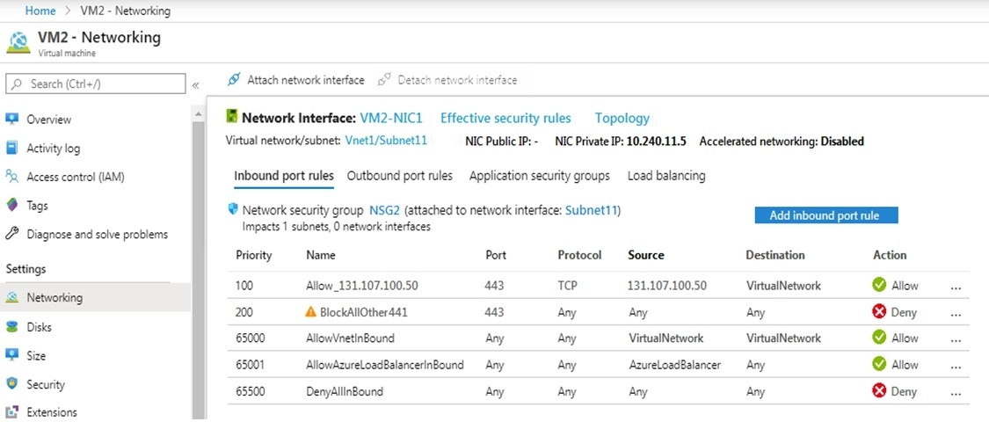

You discover that connections to App1 from 131.107.100.50 over TCP port 443 fail. You verify that the Load Balancer rules are configured correctly.

You need to ensure that connections to App1 can be established successfully from 131.107.100.50 over TCP port 443.

Solution: You create an inbound security rule that denies all traffic from the 131.107.100.50 source and has a priority of 64999.

Does this meet the goal?

|  |  |
| --- | --- |
| A. | Yes |
| B. | No |

**Answer:** B

**Explanation:**

https://fastreroute.com/azure-network-security-groups-explained/

### QUESTION 499

You have a virtual network named VNet1 as shown in the exhibit. (Click the Exhibit tab.)

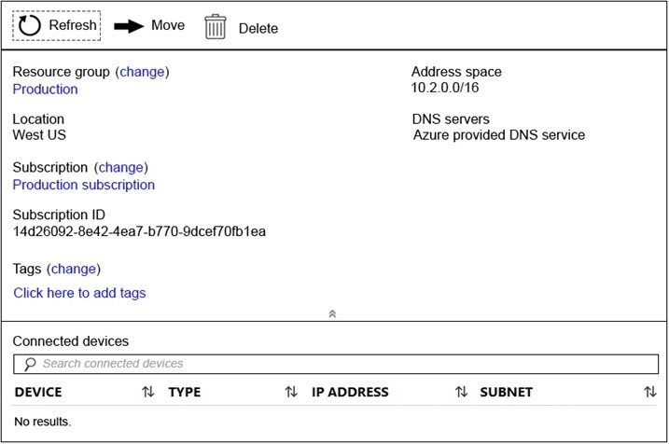

No devices are connected to VNet1.

You plan to peer VNet1 to another virtual network named VNet2. VNet2 has an address space of 10.2.0.0/16.

You need to create the peering. What should you do first?

|  |  |
| --- | --- |
| A. | Modify the address space of VNet1. |
| B. | Add a gateway subnet to VNet1. |
| C. | Create a subnet on VNet1 and VNet2. |
| D. | Configure a service endpoint on VNet2. |

**Answer:** A

**Explanation:**

The virtual networks you peer must have non-overlapping IP address spaces. The exhibit indicates that VNet1 has an address space of 10.2.0.0/16, which is the same as VNet2, and thus overlaps. We need to change the address space for VNet1.

Reference:

https://docs.microsoft.com/en-us/azure/virtual-network/virtual-network-manage- peering#requirements-and-constraints

https://docs.microsoft.com/en-us/azure/virtual-network/virtual-networks-faq

### QUESTION 500

You have the Azure virtual machines shown in the following table.

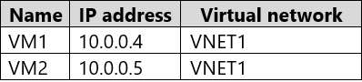

VNET1 is linked to a private DNS zone named contoso.com that contains the records shown in the following table.

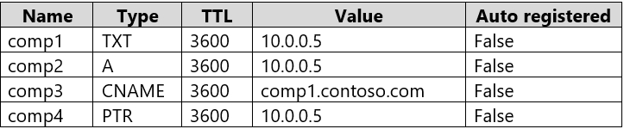

You need to ping VM2 from VM1.

Which DNS names can you use to ping VM2?

|  |  |
| --- | --- |
| A. | comp2.contoso.com and comp4.contoso.com only |
| B. | comp1.contoso.com, comp2.contoso.com, comp3.contoso.com, and comp4.contoso.com |
| C. | comp2.contoso.com only |
| D. | comp1.contoso.com and comp2.contoso.com only |
| E. | comp1.contoso.com, comp2.contoso.com, and comp4.contoso.com only |

**Answer:** B

**Explanation:**

Reference:

https://medium.com/azure-architects/exploring-azure-private-dns-be65de08f780 https://simpledns.plus/help/dns-record-types

### QUESTION 501

**Note: This question is part of a series of questions that present the same scenario. Each question in the series contains a unique solution that might meet the stated goals. Some**

**question sets might have more than one correct solution, while others might not have a correct solution.**

**After you answer a question in this section, you will NOT be able to return to it. As a result, these questions will not appear in the review screen.**

You have a computer named Computer1 that has a point-to-site VPN connection to an Azure virtual network named VNet1. The point-to-site connection uses a self-signed certificate.

From Azure, you download and install the VPN client configuration package on a computer named Computer2.

You need to ensure that you can establish a point-to-site VPN connection to VNet1 from Computer2.

Solution: On Computer2, you set the Startup type for the IPSec Policy Agent service to Automatic.

Does this meet the goal?

|  |  |
| --- | --- |
| A. | Yes |
| B. | No |

**Answer:** B

**Explanation:**

Each client computer that connects to a VNet using Point-to-Site must have a client certificate installed. You generate a client certificate from the self-signed root certificate, and then export and install the client certificate. If the client certificate is not installed, authentication fails.

Reference:

https://docs.microsoft.com/en-us/azure/vpn-gateway/vpn-gateway-certificates-point-to-site

### QUESTION 502

Drag and Drop Question

You have downloaded an Azure Resource Manager (ARM) template to deploy numerous virtual machines (VMs). The ARM template is based on a current VM, but must be adapted to reference an administrative password.

You need to make sure that the password cannot be stored in plain text. You are preparing to create the necessary components to achieve your goal.

Which of the following should you create to achieve your goal? Answer by dragging the correct option from the list to the answer area.

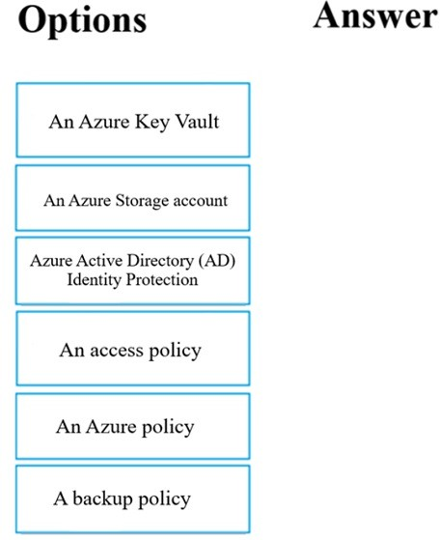

**Answer:**

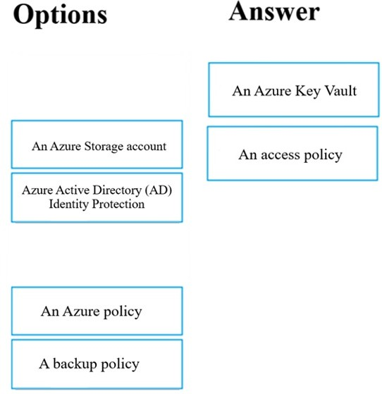

**Explanation:**

You can use a template that allows you to deploy a simple Windows VM by retrieving the password that is stored in a Key Vault. Therefore, the password is never put in plain text in the template parameter file.

### QUESTION 503

Drag and Drop Question

Your company has an Azure subscription that includes a number of Azure virtual machines (VMs), which are all part of the same virtual network.

Your company also has an on-premises Hyper-V server that hosts a VM, named VM1, which must be replicated to Azure.

Which of the following objects that must be created to achieve this goal? Answer by dragging the correct option from the list to the answer area.

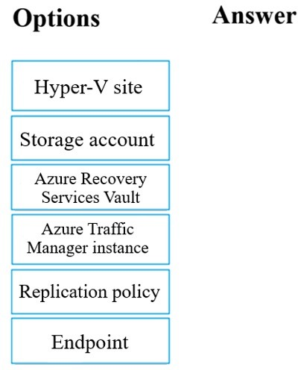

**Answer:**

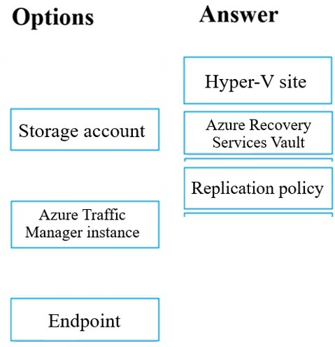

### QUESTION 504

Hotspot Question

You have an Azure subscription that contains a storage account named storage1. The subscription is linked to an Azure Active Directory (Azure AD) tenant named contoso.com that syncs to an on-premises Active Directory domain.

The domain contains the security principals shown in the following table.

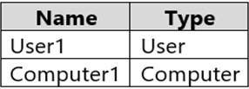

In Azure AD, you create a user named User2.

The storage1 account contains a file share named share1 and has the following configurations.

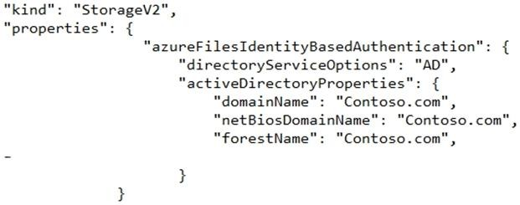

For each of the following statements, select Yes if the statement is true. Otherwise, select No. NOTE: Each correct selection is worth one point.

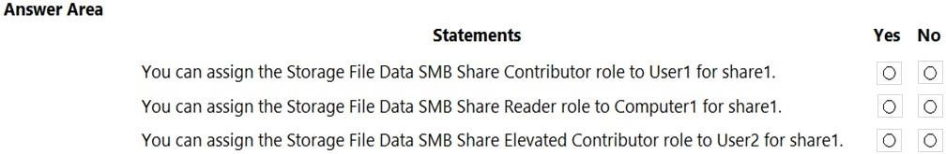

**Answer:**

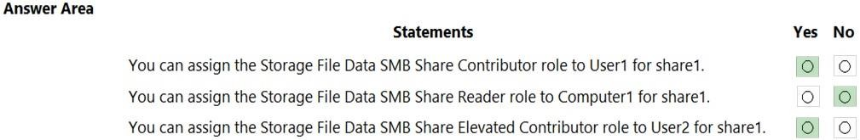

**Explanation:**

https://docs.microsoft.com/en-us/azure/storage/files/storage-files-identity-ad-ds-assign- permissions?tabs=azure-portal

### QUESTION 505

Hotspot Question

You have an Azure subscription named Subscription1 that contains a virtual network VNet1. You add the users in the following table.

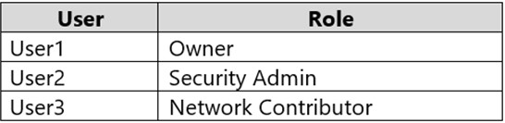

Which user can perform each configuration? To answer, select the appropriate options in the answer area.

NOTE: Each correct selection is worth one point.

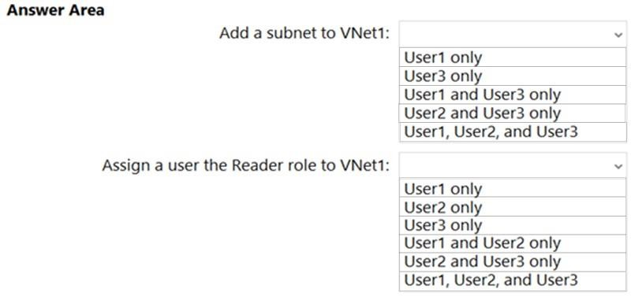

**Answer:**

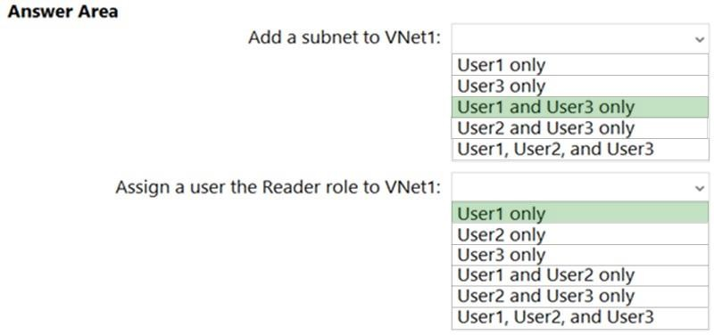

**Explanation:**

Box 1: User1 and User3 only.

User1: The Owner Role lets you manage everything, including access to resources. User3: The Network Contributor role lets you manage networks, including creating subnets.

Box 2: User1 only.

The Security Admin role: In Security Center only: Can view security policies, view security states, edit security policies, view alerts and recommendations, dismiss alerts and recommendations.

Reference:

https://docs.microsoft.com/en-us/azure/role-based-access-control/built-in-roles https://docs.microsoft.com/en-us/azure/role-based-access-control/resource-provider- operations#microsoftnetwork

### QUESTION 506

Hotspot Question

You have the Azure resources shown on the following exhibit.

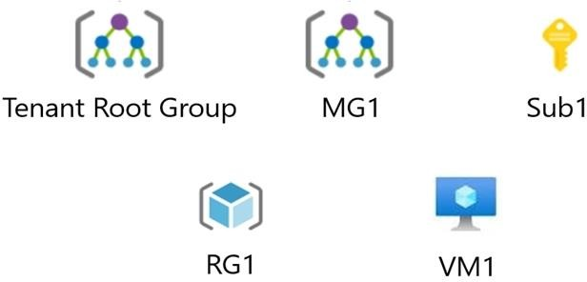

You plan to track resource usage and prevent the deletion of resources.

To which resources can you apply locks and tags? To answer, select the appropriate options in the answer area.

NOTE: Each correct selection is worth one point.

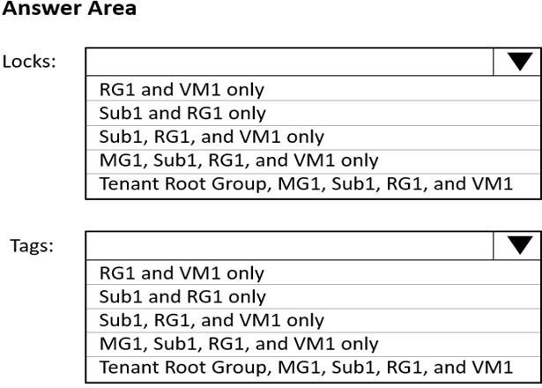

**Answer:**

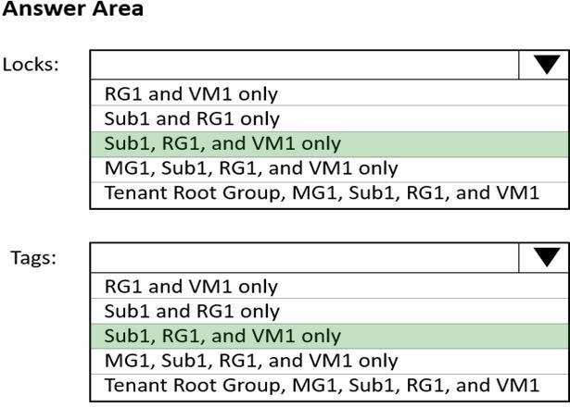

**Explanation:**

Box 1: Sub1, RG1, and VM1 only

You can lock a subscription, resource group, or resource to prevent other users in your organization from accidentally deleting or modifying critical resources.

Box 2: Sub1, RG1, and VM1 only

You apply tags to your Azure resources, resource groups, and subscriptions.

Reference:

https://docs.microsoft.com/en-us/azure/azure-resource-manager/management/lock- resources?tabs=json

https://docs.microsoft.com/en-us/azure/azure-resource-manager/management/tag- resources?tabs=json

### QUESTION 507

Hotspot Question

You have an Azure Storage account named storage1 that contains a blob container. The blob container has a default access tier of Hot. Storage1 contains a container named conainer1.

You create lifecycle management rules in storage1 as shown in the following table.

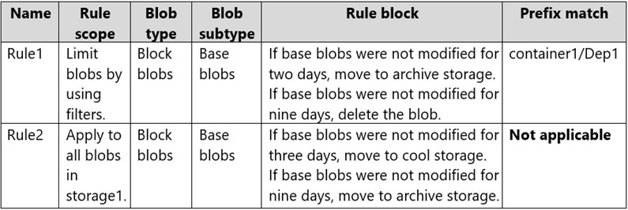

You perform the actions shown in the following table.

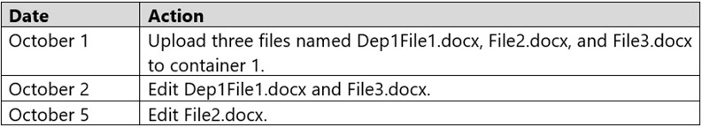

For each of the following statements, select Yes if the statement is true. Otherwise, select No. NOTE: Each correct selection is worth one point.

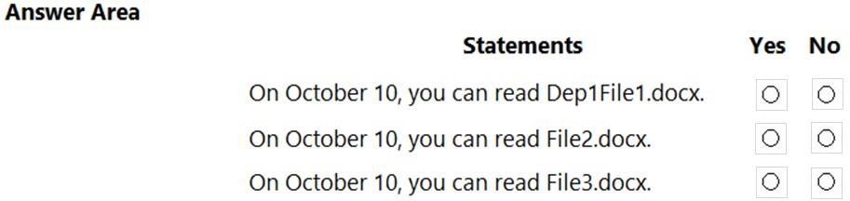

**Answer:**

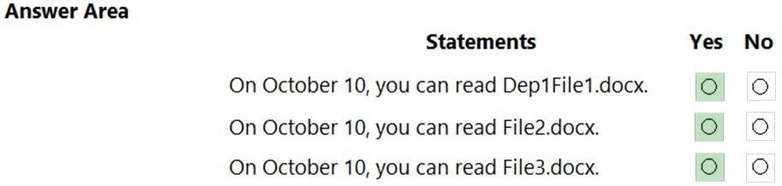

### QUESTION 508

Hotspot Question

You have an Azure subscription.

You plan to use Azure Resource Manager templates to deploy 50 Azure virtual machines that will be part of the same availability set.

You need to ensure that as many virtual machines as possible are available if the fabric fails or during servicing.

How should you configure the template? To answer, select the appropriate options in the answer area.

NOTE: Each correct selection is worth one point.

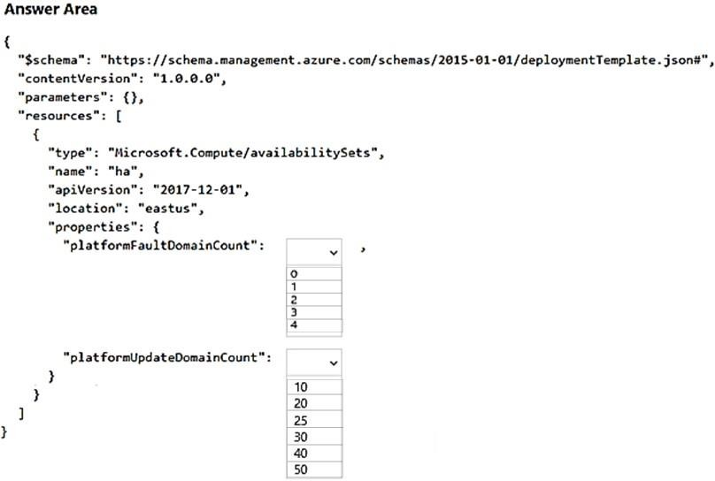

**Answer:**

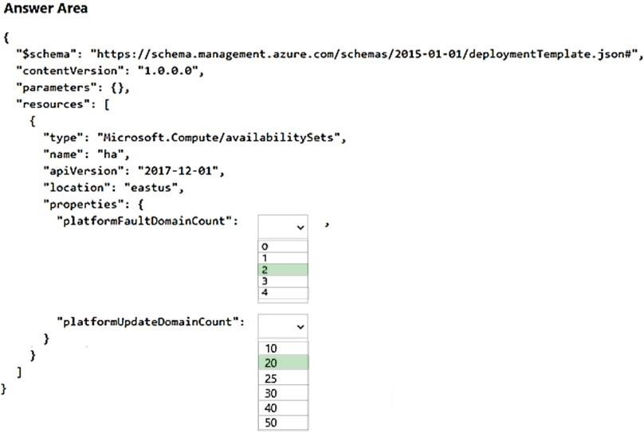

**Explanation:**

Box 1: 2

Use two fault domains.

2 or 3 is max, depending on which region you are in.

Box 2: 20

Use 20 for platformUpdateDomainCount

Increasing the update domain (platformUpdateDomainCount) helps with capacity and availability planning when the platform reboots nodes.

A higher number for the pool (20 is max) means that fewer of their nodes in any given availability set would be rebooted at once.

Reference:

https:/[/www.itprotoday.com/microsoft-azure/check-if-azure-region-supports-2-or-3-fault-domains-](http://www.itprotoday.com/microsoft-azure/check-if-azure-region-supports-2-or-3-fault-domains-) managed-disks

https://github.com/Azure/acs-engine/issues/1030

### QUESTION 509

Drag and Drop Question

You have an Azure subscription that contains the resources shown in the following table.

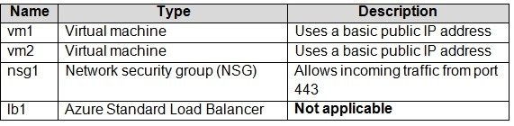

You need to load balance HTTPS connections to vm1 and vm2 by using lb1.

Which three actions should you perform in sequence? To answer, move the appropriate actions from the list of actions to the answer area and arrange them in the correct order.

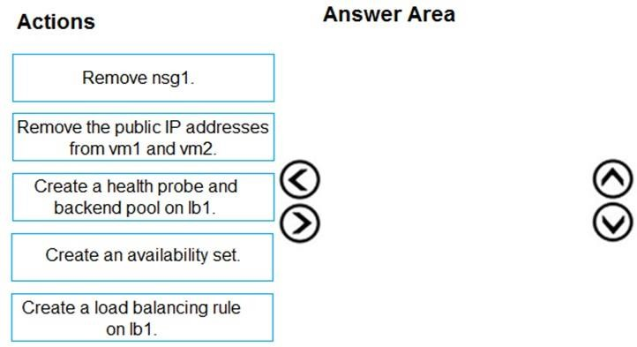

**Answer:**

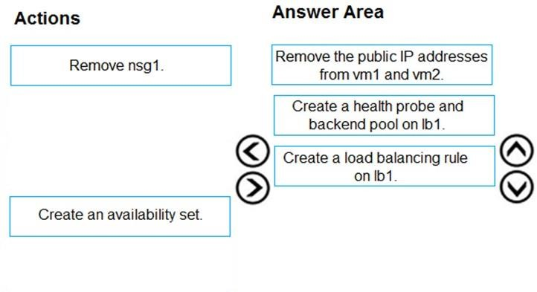

**Explanation:**

https://docs.microsoft.com/en-us/azure/load-balancer/tutorial-load-balancer-standard-public-zone- redundant-portal

### QUESTION 510

Drag and Drop Question

You have an Azure subscription that contains two om-premises locations named site1 and site2. You need to connect site1 and site2 by using an Azure Virtual WAN.

Which four actions should you perform in sequence? To answer, move the appropriate actions from the list of actions to the answer area and arrange them in the correct order.

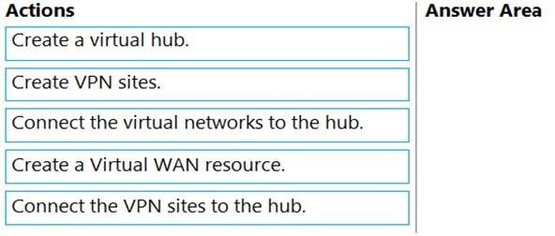

**Answer:**

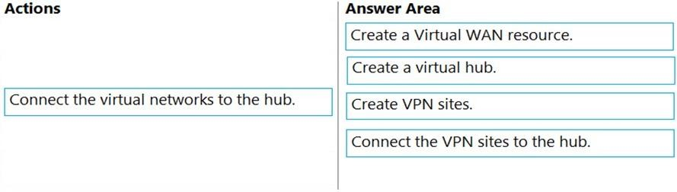

**Explanation:**

https://docs.microsoft.com/en-us/azure/virtual-wan/virtual-wan-site-to-site-portal

### QUESTION 511

Hotspot Question

You have an Azure subscription that contains the virtual networks shown in the following table.

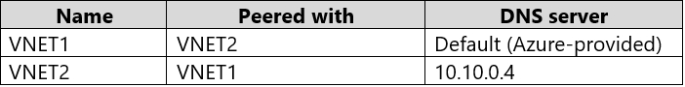

You have the virtual machines shown in the following table.

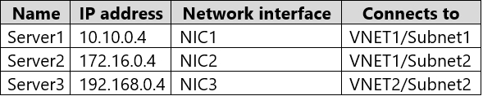

You have the virtual network interfaces shown in the following table.

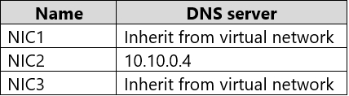

Server1 is a DNS server that contains the resources shown in the following table.

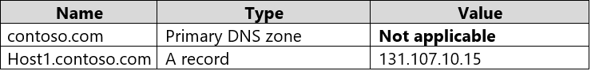

You have an Azure private DNS zone named contoso.com that has a virtual network link to VNET2 and the records shown in the following table.

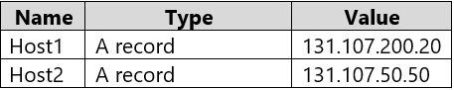

For each of the following statements, select Yes if the statement is true. Otherwise, select No. NOTE: Each correct selection is worth one point.

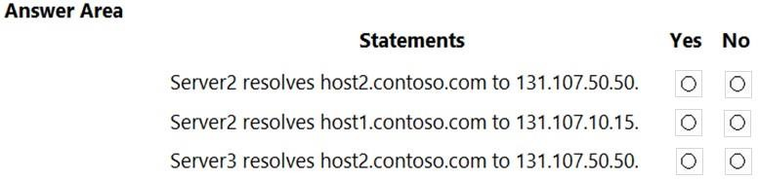

**Answer:**

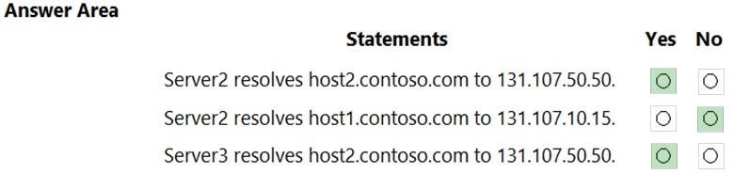

### QUESTION 512

Hotspot Question

You have a network security group (NSG) named NSG1 that has the rules defined in the exhibit. (Click the Exhibit tab.)

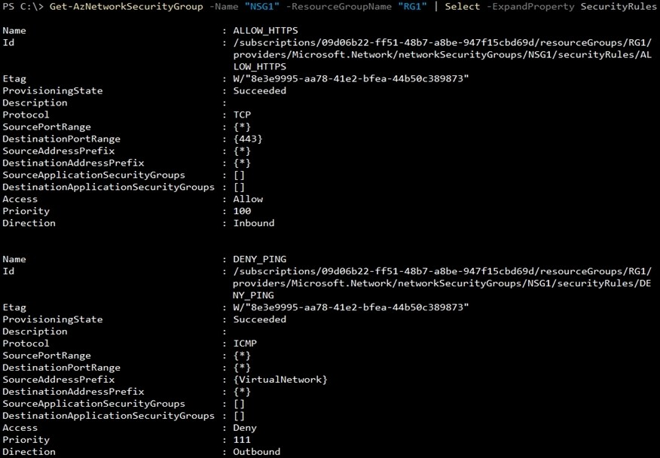

NSG1 is associated to a subnet named Subnet1. Subnet1 contains the virtual machines shown in the following table.

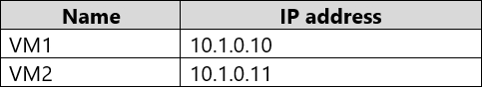

You need to add a rule to NSG1 to ensure that VM1 can ping VM2. The solution must use the principle of least privilege.

How should you configure the rule? To answer, select the appropriate options in the answer area. NOTE: Each correct selection is worth one point.

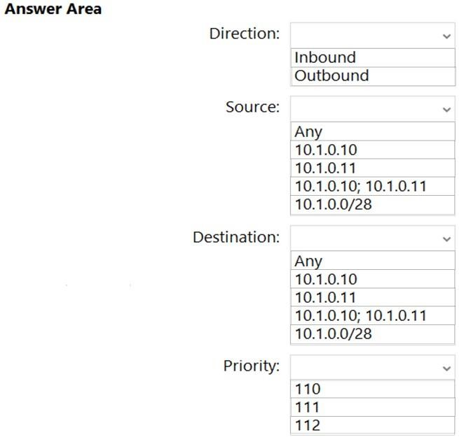

**Answer:**

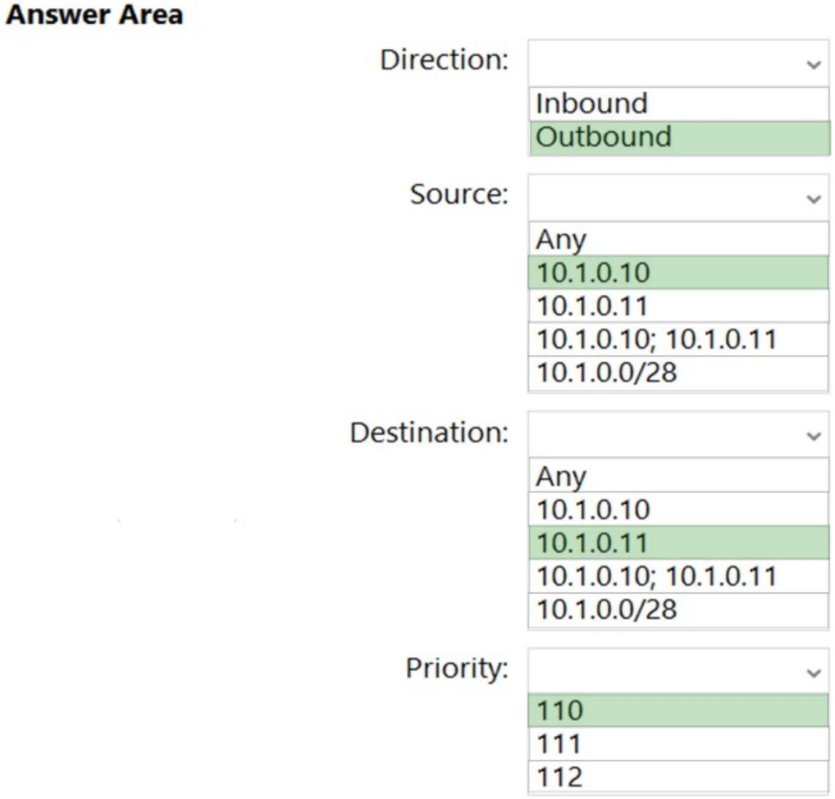

**Explanation:**

Direction: Outbound Source 10.1.0.10 (VM1)

Destination: 10.1.0.11 (VM2)

Priority: 110

All the virtual machines within the same virtual network can communicate with each other when it comes to Inbound traffic by default so this means an Outbound direction rule is needed.

10.1.0.10/10.1.0.11 for both source and destination as the ICMP packet would have to go in both directions. Priority has to come before the ICMP blocking of 111.

### QUESTION 513

You create the following resources in an subscription:

* An Azure Container Registry instance named Registry1
* An Azure Kubernetes Service (AKS) cluster named Cluster1

You create a container image named App1 on your administrative workstation.

You need to deploy App1 to cluster1. What should you do first?

|  |  |
| --- | --- |
| A. | Run the aa aks create command. |
| B. | Create a host pool on Cluster1 |
| C. | Upload App1 to Registry1. |
| D. | Run the kubect1 apply command. |

**Answer:** C

### QUESTION 514

You have a .NET Core application running in Azure App Services.

You are expecting a huge influx of traffic to your application in the coming days.

When your application experiences this spike in traffic, you want to detect any anomalies such as request errors or failed queries immediately.

What service can you use to assure that you know about these types of errors related to your .NET application immediately?

|  |  |
| --- | --- |
| A. | Application Insights Search |
| B. | Log analytics workspace |
| C. | Client-side monitoring |
| D. | Live Metrics Stream in Application Insights |

**Answer:** D

**Explanation:**

Live metrics stream includes such information as the number of incoming requests, the duration of those requests, and any failures that occur. You can also inspect critical performance metrics such as processor and memory.

### QUESTION 515

You have a general purpose v1 storage account named storageaccount1 that has a private container named container1.

You need to allow read access to the data inside container1, but only within a 14 day window. How do you accomplish this?

|  |  |
| --- | --- |
| A. | Create a stored access policy |
| B. | Create a service SAS |
| C. | Create a shared access signatures |
| D. | Upgrade the storage account to general purpose v2 |

**Answer:** AC

**Explanation:**

A Stored Access Policy allows granular control over a single storage container using a Shared Access Signature (SAS).

A Shared Access Signature (SAS) allows you to have granular control over your storage account, including access to only certain services (i.e. Azure Blobs) and permitting only read, write, delete, list, add, or create access.

### QUESTION 516

You have an Azure web app named App1.

You need to monitor the availability of App1 by using a multi-step web test. What should you use in Azure Monitor?

|  |  |
| --- | --- |
| A. | Azure Application Insights |
| B. | the Diagnostic settings |
| C. | metrics |
| D. | Azure Service Health |

**Answer:** A

### QUESTION 517

Hotspot Question

You have an Azure subscription that contains the resources shown in the following table

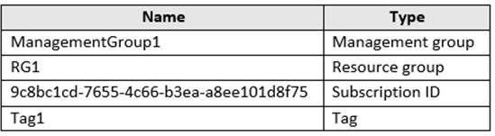

In Azure Cloud Shell, you need to create a virtual machine by using an Azure Resource Manager (ARM) template.

How should you complete the command? To answer, select the appropriate options in the answer area,

NOTE: Each correct selection is worth one point.

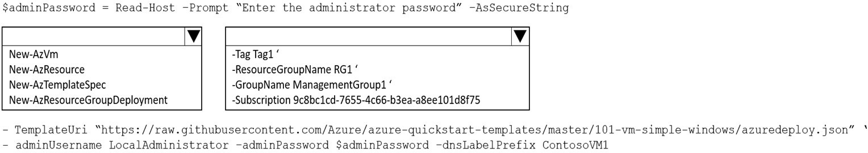

**Answer:**

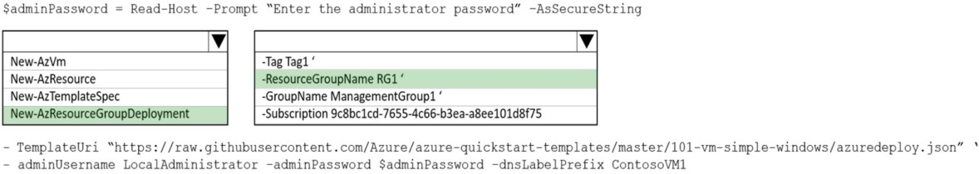

### QUESTION 518

Hotspot Question

You have the web apps shown in the following table.

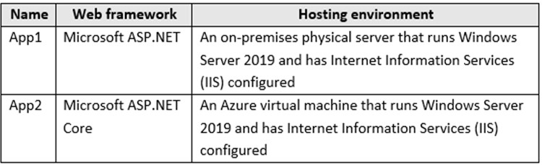

You need to monitor the performance and usage of the apps by using Azure Application Insights. The solution must minimize modifications to the application code.

What should you do on each app? To answer, select the appropriate options in the answer area. NOTE: Each correct selection is worth one point.

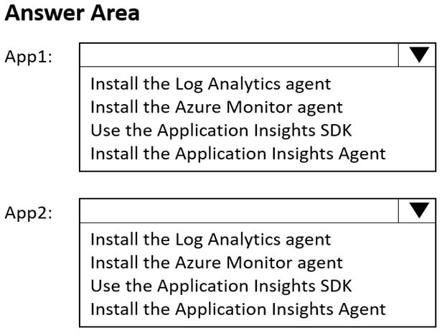

**Answer:**

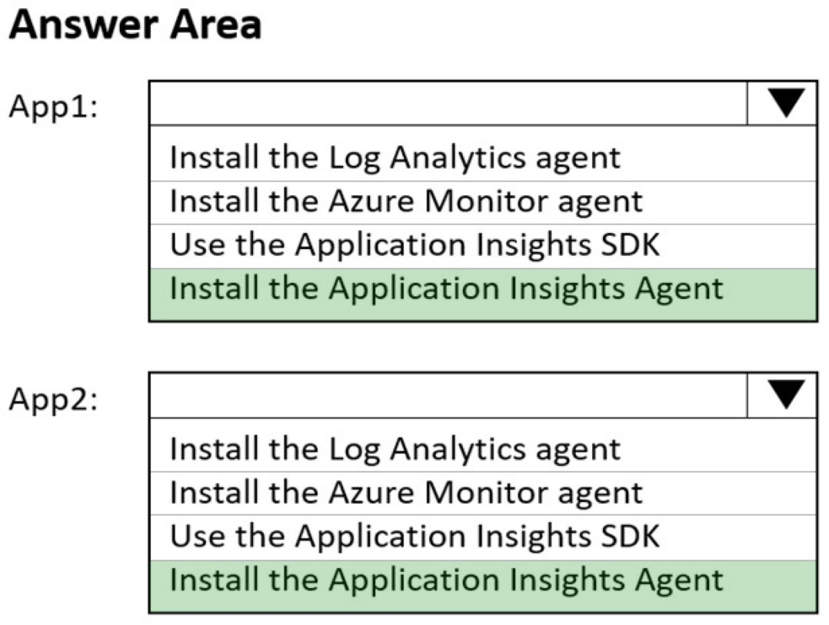

### QUESTION 519

Hotspot Question

You need to configure Azure Backup to back up the file shares and virtual machines.

What is the minimum number of Recovery Services vaults and backup policies you should create? To answer, select the appropriate options in the answer area.

NOTE: Each correct selection is worth one point.

**Answer:**

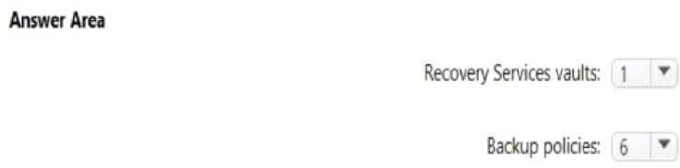

### QUESTION 520

You have an Azure subscription that contains a storage account named storage.

You have the devices shown in the following table.

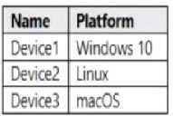

From which devices can you use AzCopy to copy data to storage1?

|  |  |
| --- | --- |
| A. | Device1 and Device2 only |
| B. | Device1, Device2 and Device3 |
| C. | Device1 only |
| D. | Device2 and Device3 only |

**Answer:** D

### QUESTION 521

You have the Azure virtual machines shown in the following table.

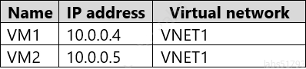

VNNET1 is linked to a private DNS zone named contoso.com that contains the records shown in the following table.

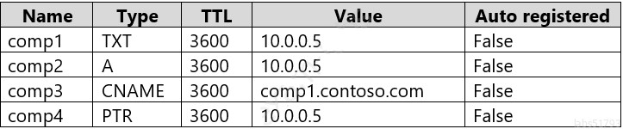

Which DNS names can you use to ping VM2?

|  |  |
| --- | --- |
| A. | comp1.contoso.com and comp2.contoso.com only |
| B. | comp2.contoso.com and comp4.contoso.com only |
| C. | comp2.contoso.cam only |
| D. | comp1.contoso.com, comp2.contoso.com, and comp4.contoso.com only |
| E. | comp1.contoso.com, comp2.contoso.com, comp3.contoso.com, and comp4.contoso.com |

**Answer:** E

**Explanation:**

https://medium.com/azure-architects/exploring-azure-private-dns-be65de08f780

https://simpledns.plus/help/dns-record-types

### QUESTION 522

You have an Azure subscription.

You are deploying an Azure Kubemetes Service (AKS) cluster that will contain multiple pods. The pods will use kubermetes networking,

You need to restrict network traffic between the pods. What should you configure on the AKS cluster?

|  |  |
| --- | --- |
| A. | pod security policies |
| B. | the Calico network policy |
| C. | an application security group |
| D. | the Azure network policy |

**Answer:** D

### QUESTION 523

You have an Azure subscription that contains two virtual machines named VM1 and VM2 You create an Azure load balancer.

You plan to create a load balancing rule that will load balance HTTPS traffic between VM1 and VM2.

Which two additional load balance resources should you create before you can create the load balancing rule? Each correct answer presents part of the solution

MOTL Each correct selection 5 worth one point.

|  |  |
| --- | --- |
| A. | a frontend IP address |
| B. | a backend pool |
| C. | a health probe |
| D. | an inbound NAT rule |
| E. | a virtual network |

**Answer:** BC

### QUESTION 524

You have an Azure subscription that uses the public IP addresses shown in the following table.

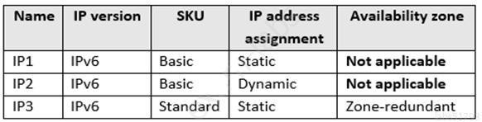

You need to create a public Azure Standard Load Balancer. Which public IP addresses can you use?

|  |  |
| --- | --- |
| A. | IPI and IP3 only |
| B. | IP1, IP2, and IP3 |
| C. | IP2 only |
| D. | IP3 only |

**Answer:** D

**Explanation:**

Matching SKUs are required for load balancer and public IP resources. You can't have a mixture of Basic SKU resources and standard SKU resources.

Reference:

https://docs.microsoft.com/en-us/azure/virtual-network/ip-services/public-ip-addresses

### QUESTION 525

You have an Azure subscription that contains the resources shown in the following table.

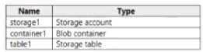

You need to perform the tasks shown in the following table.

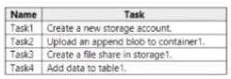

Which tasks can you perform by using Azure Storage Explorer?

|  |  |
| --- | --- |
| A. | Task1 and Task3 only |
| B. | Task1. Task2 and Task3 only |
| C. | Task1Task2 and Task3 only |
| D. | Task2, Task3, and Task4 only |
| E. | Take1,Take2, Take3, and Take4 |

**Answer:** A

### QUESTION 526

You have web app in the West US, Central US and East US Azure regions. You have the App plans shown in the following table.

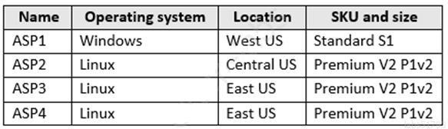

You plan to create an additional App Service plan named ASPs that will use the Linux operating system.

You need to identify in which of the currently used locations you can deploy ASPs. What should you recommend?

|  |  |
| --- | --- |
| A. | West US only |
| B. | East US only |
| C. | Central US only |
| D. | West US, Central US, or East US |

**Answer:** B

### QUESTION 527

You have an Azure subscription that contains the resources shown in the following table.

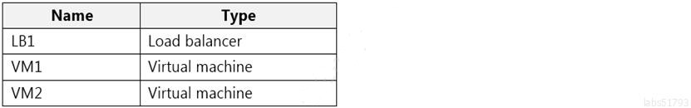

LB1 is configured as shown in the following table.

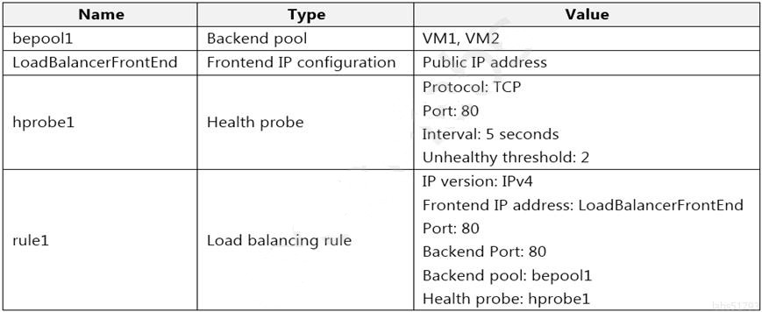

You plan to create new inbound NAT rules that meet the following requirements:

* Provide Remote Desktop access to VM1 from the internet by using port 3389.
* Provide Remote Desktop access to VM2 from the internet by using port 3389. What should you create on LB1 before you can create the new inbound NAT rules?

|  |  |
| --- | --- |
| A. | A frontend IP address |
| B. | A health probe |
| C. | A load balancing rule |
| D. | A backend pool |

**Answer:** A

### QUESTION 528

You have a registered DNS domain named contoso.com. You create a public Azure DNS zone named contoso.com.

You need to ensure that records created in the contoso.com zone are resolvable from the internet.

What should you do?

|  |  |
| --- | --- |
| A. | Create NS records in contoso.com. |
| B. | Modify the SOA record in the DNS domain registrar. |
| C. | Create the SOA record in contoso.com. |
| D. | Modify the NS records in the DNS domain registrar. |

**Answer:** D

**Explanation:**

https://docs.microsoft.com/en-us/azure/dns/dns-delegate-domain-azure-dns

### QUESTION 529

Hotspot Question

You have an Azure Storage account named storage1 that stores images.

You need to create a new storage account and replicate the images in storage1 to the new account by using object replication.

How should you configure the new account? To answer, select the appropriate options in the answer area.

NOTE: Each correct selection is worth one point.

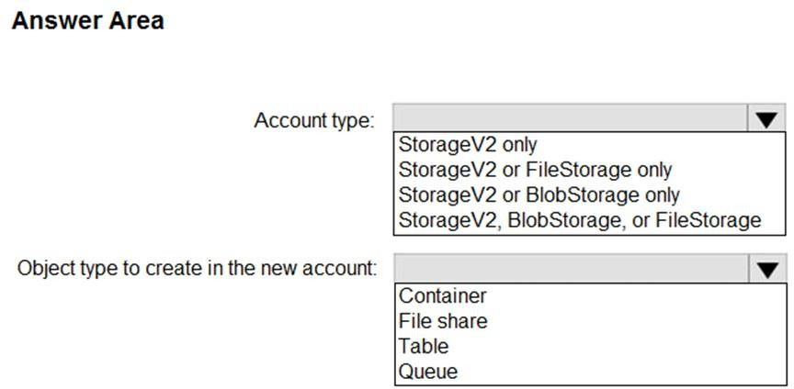

**Answer:**

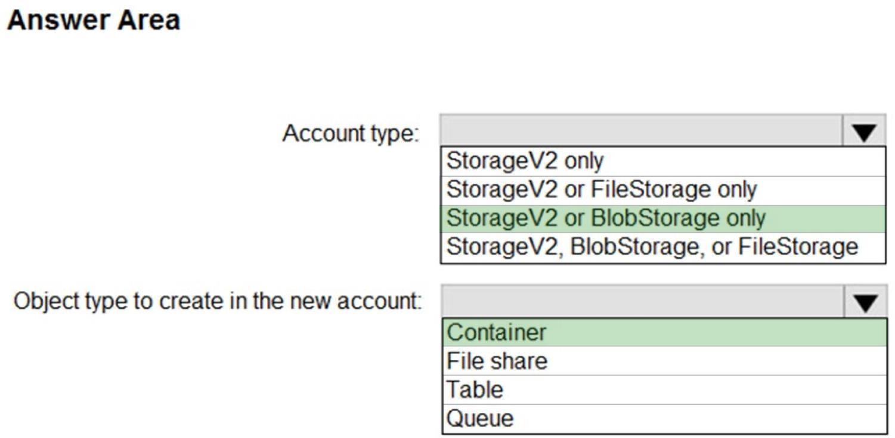

**Explanation:**

https://docs.microsoft.com/en-us/azure/storage/blobs/object-replication-overview

### QUESTION 530

Hotspot Question

You have an Azure subscription that contains a virtual network named VNET1 in the East Us 2

region. A network interface named VM1-NI is connected to VNET1.

You successfully deploy the following Azure Resource Manager template.

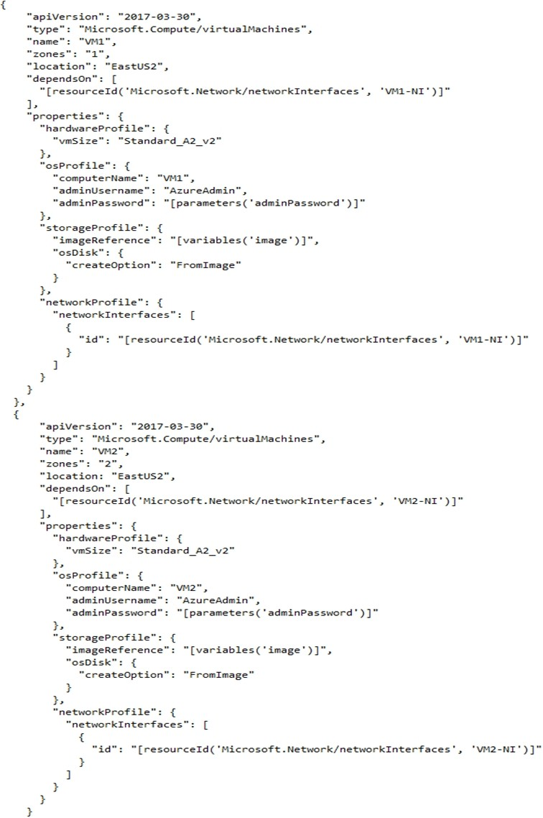

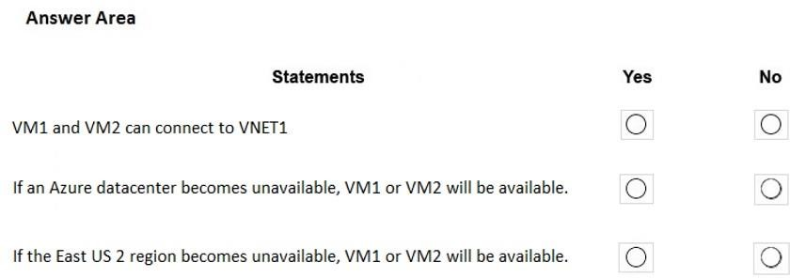

**Answer:**

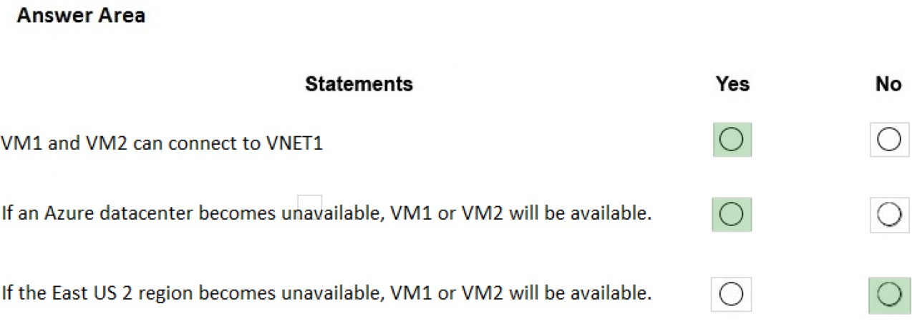

**Explanation:**

Box 1: Yes

Box 2: Yes

VM1 is in Zone1, while VM2 is on Zone2. Box 3: No

Reference:

https://docs.microsoft.com/en-us/azure/architecture/resiliency/recovery-loss-azure-region

### QUESTION 531

Hotspot Question

You have the Azure virtual machines shown in the following table.

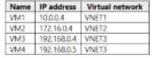

VNET1, VNET2, and VNET3 are peered.

VM4 has a DNS server that is authoritative for a zone named Contoso.com and contains the records shown in the following table.

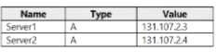

VNET1 and VNET2 are linked to an Azure private DNS zone named Contoso.com that contains the records shown in the following table.

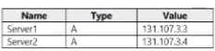

The virtual networks are configured to use the DNS servers shown in the following table.

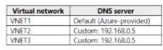

For each of the following statements, select Yes if the statement is true. Otherwise, select No. NOTE: Each correct selection is worth one point.

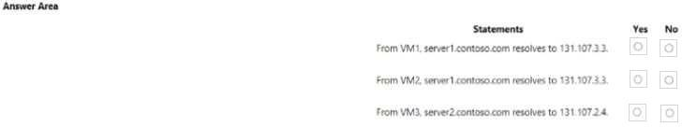

**Answer:**

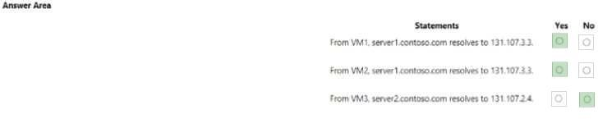

### QUESTION 532

Drag and Drop Question

You have an Azure subscription that contains the storage accounts shown in in the following table.

You plan to use AzCopy to copy a blob from container1 directly to share1.

You need to identity which authentication method to use when you use AzCopy.

What should you identify for each account? To answer, drag the appropriate authentication methods to the correct accounts Each method may be used once, or not at all. You may need to drag the split bar between panes or scroll to view content.

NOTE: Each correct selection is worth one point.

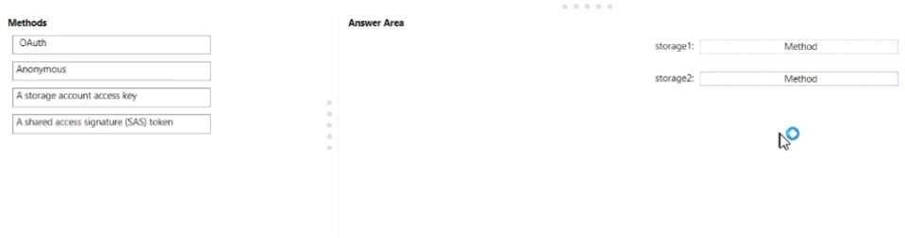

**Answer:**

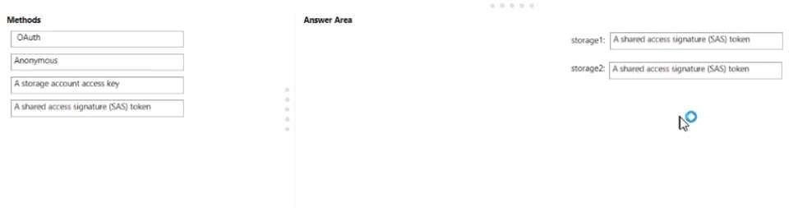

### QUESTION 533

Hotspot Question

You have an Azure subscription.

You deploy a virtual machine scale set that is configure as shown in the following exhibit.

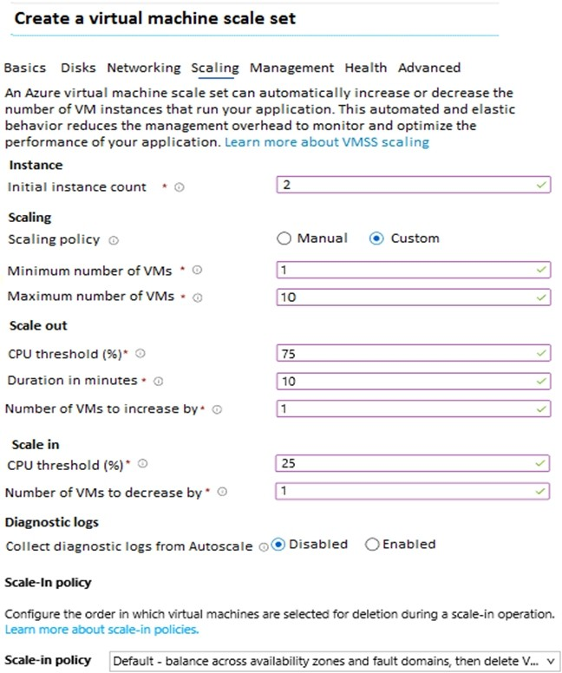

Use the drop-down menus to select the answer choice that answers each questions based on the information presented in the graphic.

NOTE: Each correct selection is worth one point.

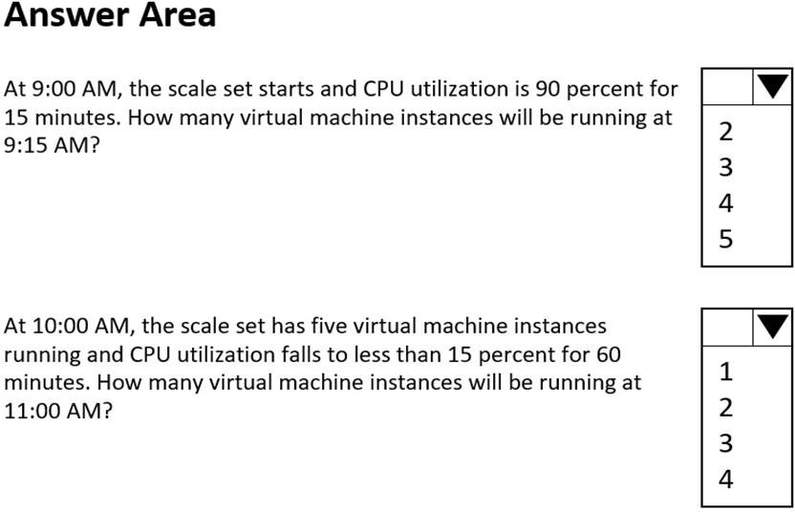

**Answer:**

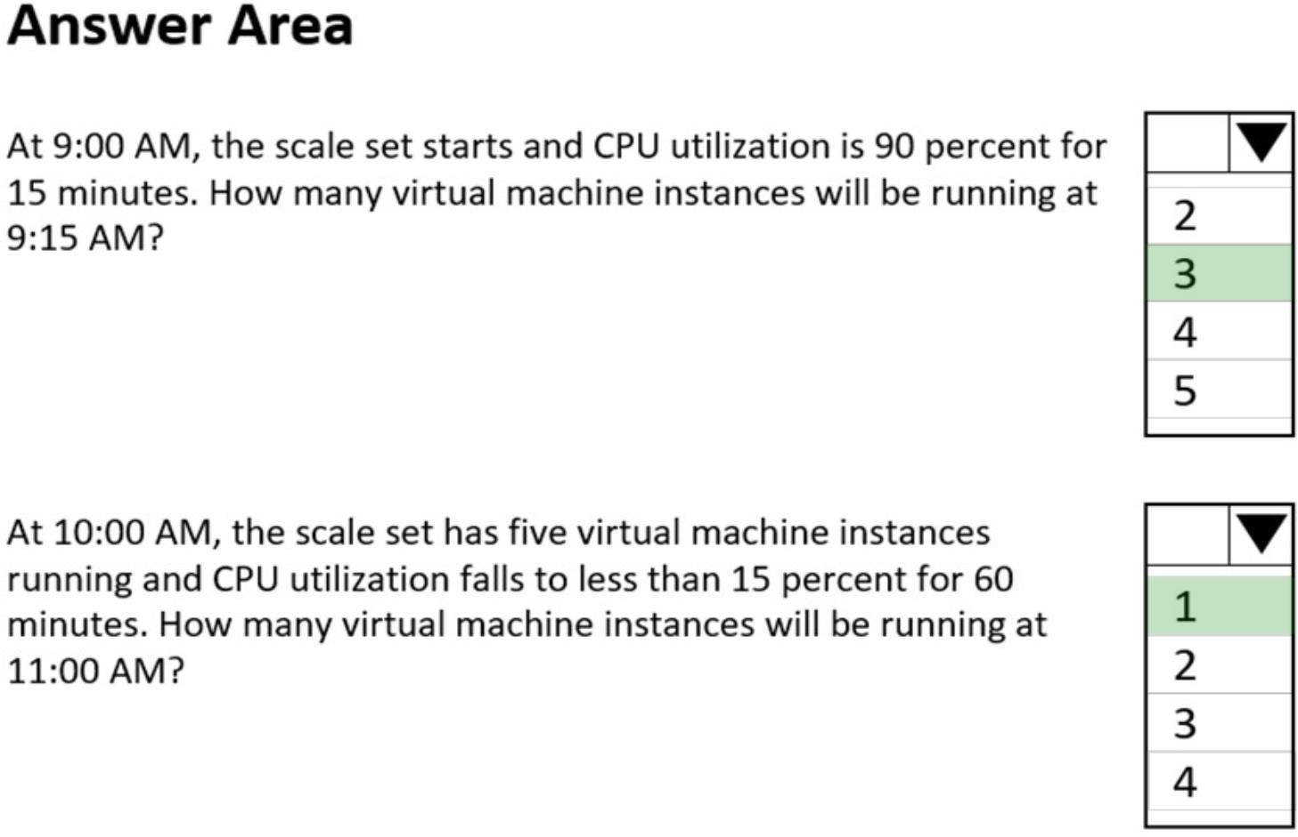

**Explanation:**

https://docs.microsoft.com/en-us/azure/virtual-machine-scale-sets/virtual-machine-scale-sets- autoscale-portal

### QUESTION 534

**Case Study 5 - Contoso, Ltd Overview**

**General Overview**

Contoso, Ltd. is a consulting company that has a main office in Montreal and branch offices in Seattle and New York.

**Environment Existing Environment**

Contoso has an Azure subscription named Sub1 that is linked to an Azure Active Directory (Azure AD) tenant. The network contains an on-premises Active Directory domain that syncs to the Azure AD tenant.

The Azure AD tenant contains the users shown in the following table.



Sub1 contains two resource groups named RG1 and RG2 and the virtual networks shown in the following table.



User1 manages the resources in RG1. User4 manages the resources in RG2.

Sub1 contains virtual machines that run Windows Server 2019 as shown in the following table



No network security groups (NSGs) are associated to the network interfaces or the subnets. Sub1 contains the storage accounts shown in the following table.



**Requirements Planned Changes**

Contoso plans to implement the following changes:

 Create a blob container named container1 and a file share named share1 that will use the Cool storage tier.

 Create a storage account named storage5 and configure storage replication for the Blob service.

 Create an NSG named NSG1 that will have the custom inbound security rules shown in the following table.



 Associate NSG1 to the network interface of VM1.

 Create an NSG named NSG2 that will have the custom outbound security rules shown in the following table.



 Associate NSG2 to VNET1/Subnet2.

**Technical Requirements**

Contoso must meet the following technical requirements:

 Create container1 and share1.

 Use the principle of least privilege.

 Create an Azure AD security group named Group4.

 Back up the Azure file shares and virtual machines by using Azure Backup.

 Trigger an alert if VM1 or VM2 has less than 20 GB of free space on volume C.

 Enable User1 to create Azure policy definitions and User2 to assign Azure policies to RG1.  Create an internal Basic Azure Load Balancer named LB1 and connect the load balancer to

VNET1/Subnet1

 Enable flow logging for IP traffic from VM5 and retain the flow logs for a period of eight months.

 Whenever possible, grant Group4 Azure role-based access control (Azure RBAC) read-only permissions to the Azure file shares.

Hotspot Question

You need to ensure that User1 can create initiative definitions, and User4 can assign initiatives to RG2. The solution must meet the technical requirements.

Which role should you assign to each user? To answer, select the appropriate options in the answer area.

**NOTE:** Each correct selection is worth one point.

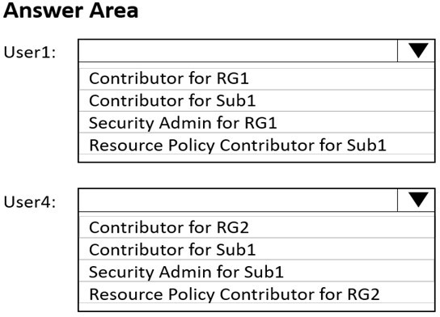

**Answer:**

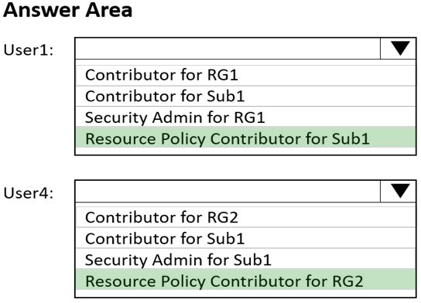

**Explanation:**

https://docs.microsoft.com/en-us/azure/governance/policy/overview

### QUESTION 535

You have an Azure Active Directory (Azure AD) tenant.

You plan to delete multiple users by using Bulk delete in the Azure Active Directory admin center. You need to create and upload a file for the bulk delete.

Which user attributes should you include in the file?

|  |  |
| --- | --- |
| A. | The user principal name and usage location of each user only |
| B. | The user principal name of each user only |
| C. | The display name of each user only |
| D. | The display name and usage location of each user only |
| E. | The display name and user principal name of each user only |

**Answer:** B

**Explanation:**

https://docs.microsoft.com/en-us/azure/active-directory/enterprise-users/users-bulk-delete

### QUESTION 536

Hotspot Question

You have an Azure subscription named Sub1 that contains the Azure resources shown in the

following table.

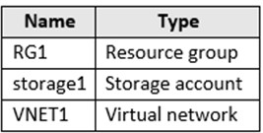

You assign an Azure policy that has the following settings:

 Scope: Sub1

 Exclusions: Sub1/RG1/VNET1

 Policy definition: Append a tag and its value to resources  Policy enforcement: Enabled

 Tag name: Tag4  Tag value: value4

You assign tags to the resources as shown in the following table.

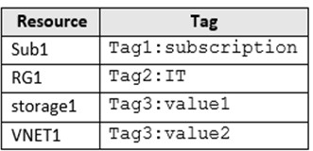

For each of the following statements, select Yes if the statement is true. Otherwise, select No.

**NOTE:** Each correct selection is worth one point.

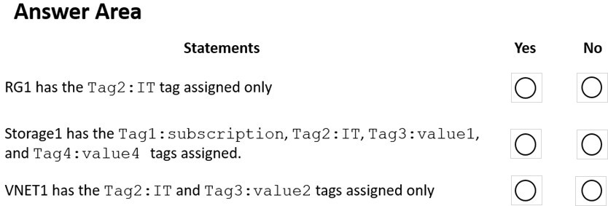

**Answer:**

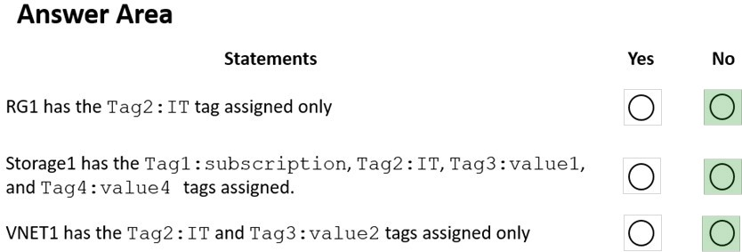

**Explanation:**

Box 1: No

The Azure Policy will add Tag4 to RG1.

Box 2: No

Tags applied to the resource group or subscription aren't inherited by the resources although you can enable inheritance with Azure Policy. Storage1 has Tag3: Value1 and the Azure Policy will add Tag4.

Box 3: No

Tags applied to the resource group or subscription aren't inherited by the resources so VNET1 does not have Tag2.

VNET1 has Tag3:value2. VNET1 is excluded from the Azure Policy so Tag4 will not be added to VNET1.

Reference:

https://docs.microsoft.com/en-us/azure/azure-resource-manager/management/tag- resources?tabs=json

### QUESTION 537

**Note: This question is part of a series of questions that present the same scenario. Each question in the series contains a unique solution that might meet the stated goals. Some question sets might have more than one correct solution, while others might not have a correct solution.**

**After you answer a question in this section, you will NOT be able to return to it. As a result, these questions will not appear in the review screen.**

You need to ensure that an Azure Active Directory (Azure AD) user named Admin1 is assigned the required role to enable Traffic Analytics for an Azure subscription.

Solution: You assign the Traffic Manager Contributor role at the subscription level to Admin1. Does this meet the goal?

|  |  |
| --- | --- |
| A. | Yes |
| B. | No |

**Answer:** B

**Explanation:**

https://docs.microsoft.com/en-us/azure/network-watcher/traffic-analytics-faq

### QUESTION 538

You have three offices and an Azure subscription that contains an Azure Active Directory (Azure AD) tenant.

You need to grant user management permissions to a local administrator in each office. What should you use?

|  |  |
| --- | --- |
| A. | Azure AD roles |
| B. | administrative units |
| C. | access packages in Azure AD entitlement management |
| D. | Azure roles |

**Answer:** B

**Explanation:**

https://docs.microsoft.com/en-us/azure/active-directory/roles/administrative-units

### QUESTION 539

Hotspot Question

You have an Azure subscription that contains an Azure Storage account named storageaccount1.

You export storageaccount1 as an Azure Resource Manager template. The template contains the following sections.

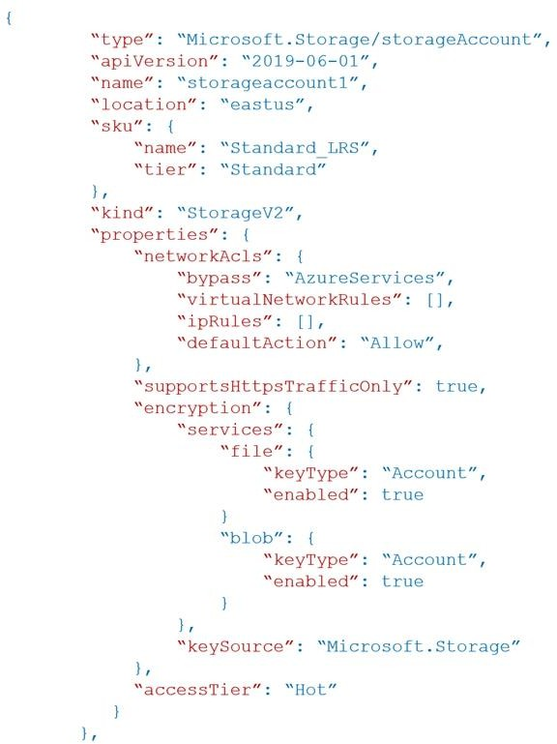

For each of the following statements, select Yes if the statement is true. Otherwise, select No.

**NOTE:** Each correct selection is worth one point

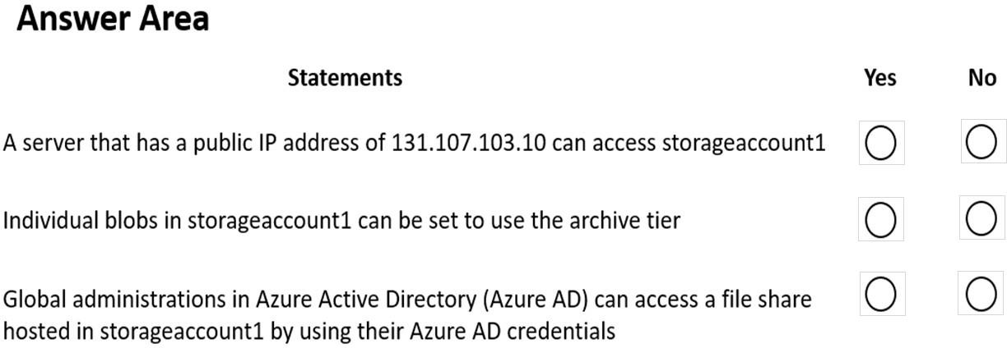

**Answer:**

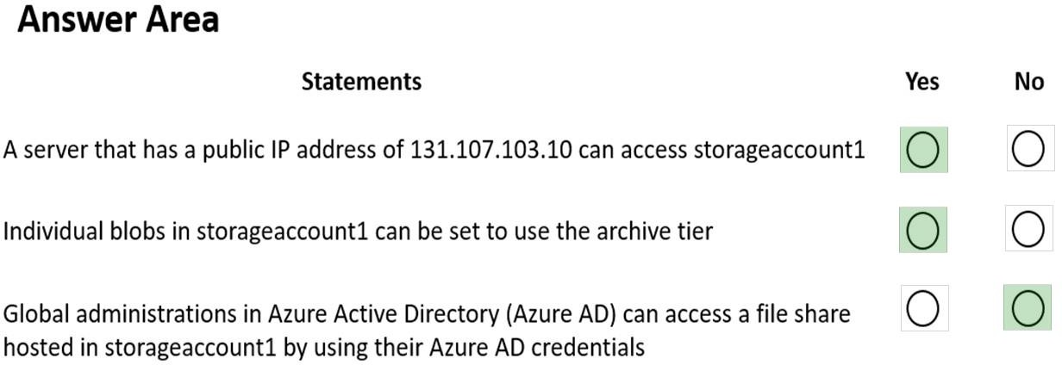

**Explanation:**

https://docs.microsoft.com/en-us/azure/templates/microsoft.storage/storageaccounts?tabs=json

### QUESTION 540

Hotspot Question

You have an Azure Load Balancer named LB1.

You assign a user named User1 the roles shown in the following exhibit.

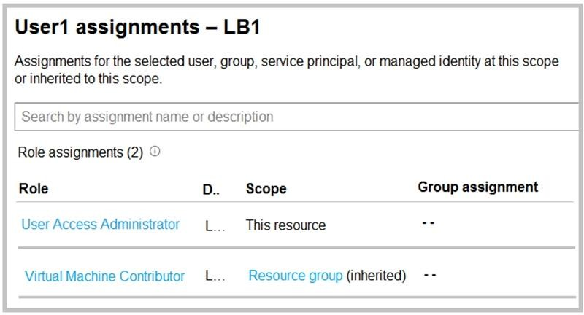

Use the drop-down menus to select the answer choice that completes each statement based on the information presented in the graphic.

**NOTE:** Each correct selection is worth one point.

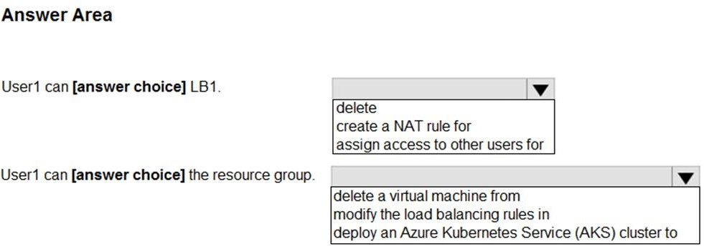

**Answer:**

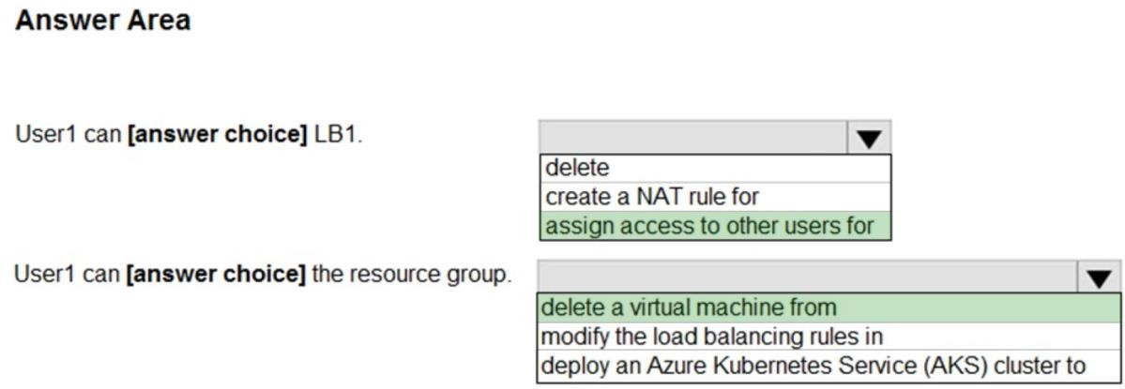

**Explanation:**

https://docs.microsoft.com/en-us/azure/role-based-access-control/built-in-roles#virtual-machine- contributor

https://docs.microsoft.com/en-us/azure/role-based-access-control/rbac-and-directory-admin-roles

### QUESTION 541

Hotspot Question

You have two Azure App Service app named App1 and App2. Each app has a production deployment slot and a test deployment slot.

The Backup Configuration settings for the production slots are shown in the following table.

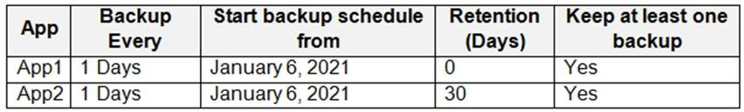

For each of the following statements, select Yes if the statement is true. Otherwise, select No.

**NOTE:** Each correct selection is worth one point.

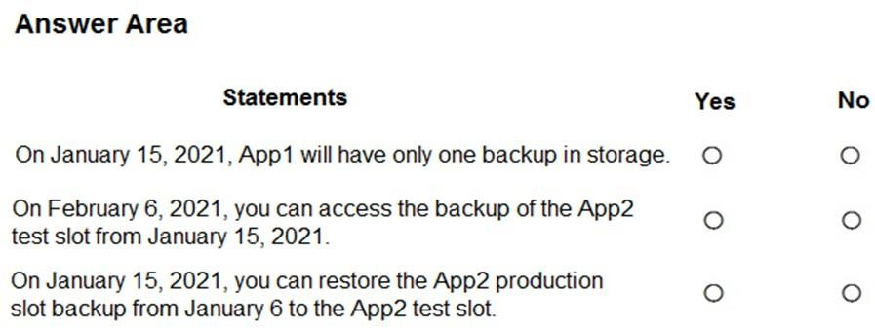

**Answer:**

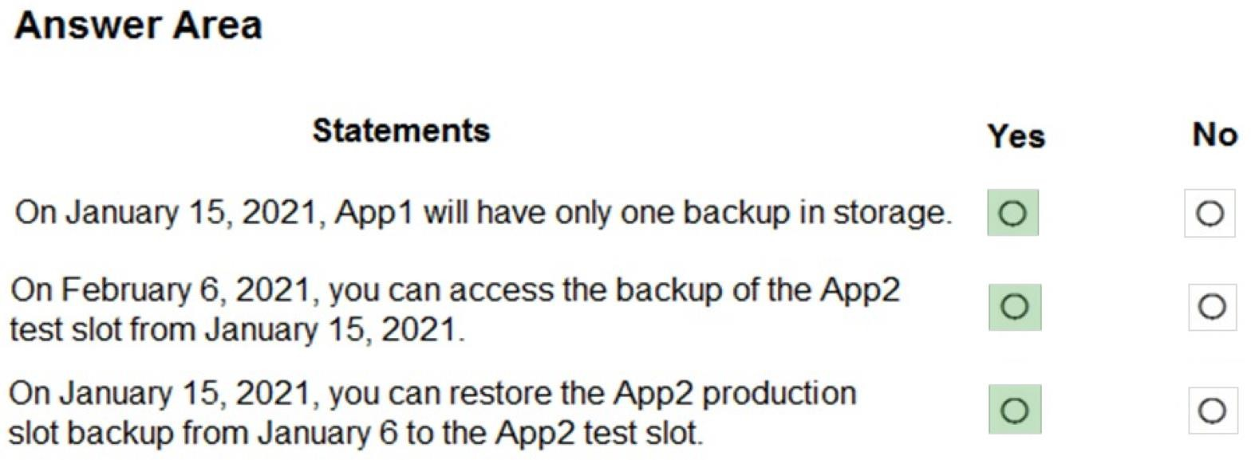

### QUESTION 542

Hotspot Question

You have an Azure subscription that contains an Azure Active Directory (Azure AD) tenant named contoso.com. The tenant is synced to the on-premises Active Directory domain. The domain contains the users shows in the following table.

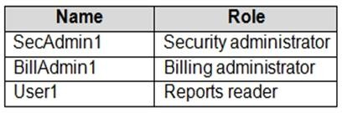

You enable self-service password reset (SSPR) for all users and configure SSPR to have the following authentication methods:

 Number of methods required to reset: 2

 Methods available to users: Mobile phone, Security questions  Number of questions required to register: 3

Number of questions required to reset: 3 You select the following security questions:

What is your favorite food?

In what city was your first job?

What was the name of your first pet?

For each of the following statements, select Yes if the statement is true. Otherwise, select No.

**NOTE:** Each correct selection is worth one point.

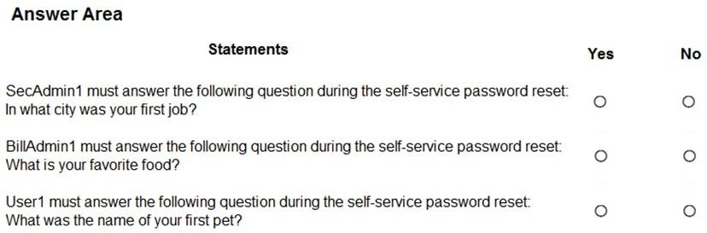

**Answer:**

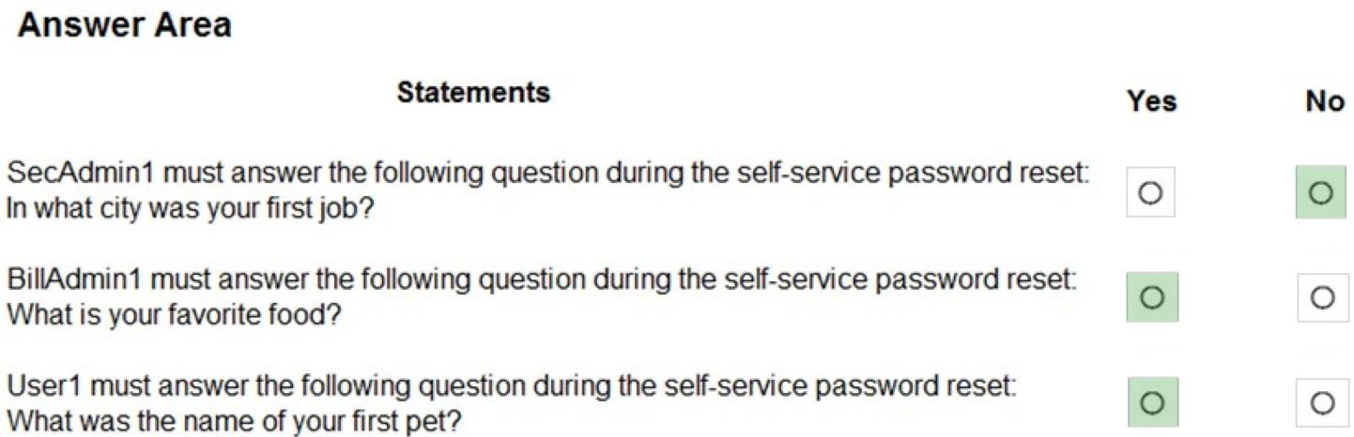

**Explanation:**

Box 1: No

Administrator accounts are special accounts with elevated permissions. To secure them, the following restrictions apply to changing passwords of administrators:

On-premises enterprise administrators or domain administrators cannot reset their password through Self-service password reset (SSPR). They can only change their password in their on- premises environment. Thus, we recommend not syncing on-prem AD admin accounts to Azure AD. An administrator cannot use secret Questions & Answers as a method to reset password.

Box 2: Yes

Self-service password reset (SSPR) is an Azure Active Directory feature that enables employees to reset their passwords without needing to contact IT staff.

Box 3: Yes

Reference:

https://docs.microsoft.com/en-us/azure/active-directory/authentication/howto-sspr-deployment

### QUESTION 543

You are configuring Azure Active Directory (Azure AD) authentication for an Azure Storage account named storage1.

You need to ensure that the members of a group named Group1 can upload files by using the Azure portal. The solution must use the principle of least privilege.

Which two roles should you configure for storage!? Each correct answer presents part of the solution.

NOTE: Each correct selection is worth one point

|  |  |
| --- | --- |
| A. | Reader |
| B. | Storage Blob Data Contributor |
| C. | Storage Account Contributor |
| D. | Storage Blob Data Reader |
| E. | Contributor |

**Answer:** AB

### QUESTION 544

You plan to deploy route-based Site-to-Site VPN connections between several on-premises locations and an Azure virtual network. Which tunneling protocol should you use?

|  |  |
| --- | --- |
| A. | L2TP |
| B. | |KEv2 |
| C. | PPTP |
| D. | IKEv1 |

**Answer:** B

### QUESTION 545

Your on-premises network contains a VPN gateway.

You have an Azure subscription that contains the resources shown in the following table.

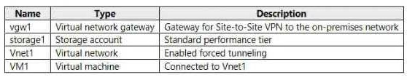

You need to ensure that all the traffic from VM1 to storage! travels across the Microsoft backbone network.

What should you configure?

|  |  |
| --- | --- |
| A. | service endpoints |
| B. | Azure Active Directory (Azure AD) Application Proxy |
| C. | a network security group (NSG) |
| D. | Azure Virtual WAN |

**Answer:** C

### QUESTION 546

You develop the following Azure Resource Manager (ARM) template to create a resource group and deploy an Azure Storage account to the resource group.

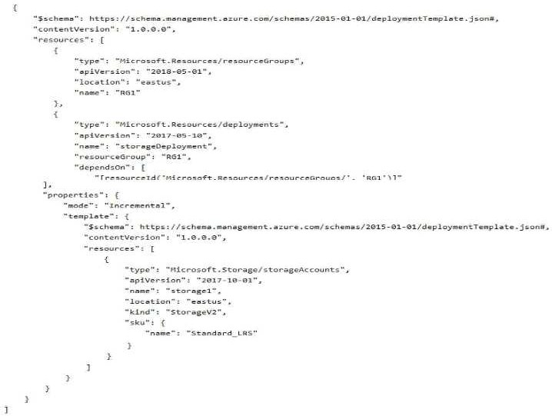

Which cmdtet should you run to deploy the template?

|  |  |
| --- | --- |
| A. | New-AzResourceGroupDeployment |
| B. | New-AzDeployment |
| C. | New-AzResource |
| D. | new-AzTenantDeploynent |

**Answer:** A

### QUESTION 547

You have an Azure subscription that contains a storage account named storageacct1234 and two users named User1 and User2.

You assign User1 the roles shown in the following exhibit.

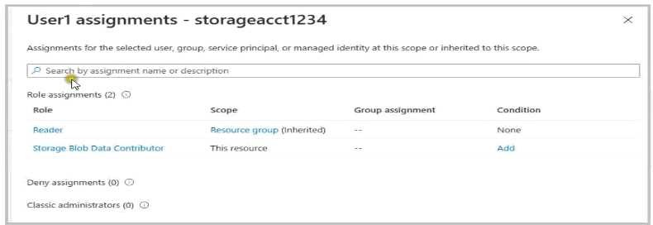

Which two actions can User1 perform? Each correct answer presents a complete solution. NOTE: Each correct selection is worth one point.

|  |  |
| --- | --- |
| A. | Modify the firewall of storageacct1234. |
| B. | View blob data in storageacct1234. |
| C. | View file shares in storageacct1234. |
| D. | Upload blob data to storageacct1234. |
| E. | Assign roles to User2 for storageacct1234. |

**Answer:** DE

### QUESTION 548

You have five Azure virtual machines that run Windows Server 2016. The virtual machines are configured as web servers.

You have an Azure load balancer named LB1 that provides load balancing services for the virtual machines.

You need to ensure that visitors are serviced by the same web server for each request. What should you configure?

|  |  |
| --- | --- |
| A. | Session persistence to None |
| B. | Floating IP (direct server return) to Disabled |
| C. | a health probe |
| D. | Session persistence to Client IP |

**Answer:** D

### QUESTION 549

**Note: This question is part of a series of questions that present the same scenario. Each question in the series contains a unique solution that might meet the stated goals. Some question sets might have more than one correct solution, while others might not have a correct solution.**

**After you answer a question in this section, you will NOT be able to return to it. As a result, these questions will not appear in the review screen.**

You have an Azure Active Directory (Azure AD) tenant named contoso.com.

You have a CSV file that contains the names and email addresses of 500 external users.

You need to create a quest user account in contoso.com for each of the 500 external users. Solution: From Azure AD in the Azure portal, you use the Bulk create user operation.

Does this meet the goal?

|  |  |
| --- | --- |
| A. | Yes |
| B. | No |

**Answer:** A

### QUESTION 550

**Note: This question is part of a series of questions that present the same scenario. Each question in the series contains a unique solution that might meet the stated goals. Some question sets might have more than one correct solution, while others might not have a correct solution.**

**After you answer a question in this section, you will NOT be able to return to it. As a result, these questions will not appear in the review screen.**

You have an Azure Active Directory (Azure AD) tenant named contoso.com.

You have a CSV file that contains the names and email addresses of 500 external users. You need to create a guest user account in contoso.com for each of the 500 external users.

Solution: You create a Power Shell script that runs the New-AZureADUser cmdlet for each user. Does this meet the goal?

|  |  |
| --- | --- |
| A. | Yes |
| B. | NO |

**Answer:** B

### QUESTION 551

Hotspot Question

You have an Azure subscription. The subscription contains a virtual machine that runs Windows 10.

You need to join the virtual machine to an Active Directory domain.

How should you complete the Azure Resource Manager (ARM) template? To answer, select the appropriate options in the answer area.

NOTE: Bach correct selection is worth one point.

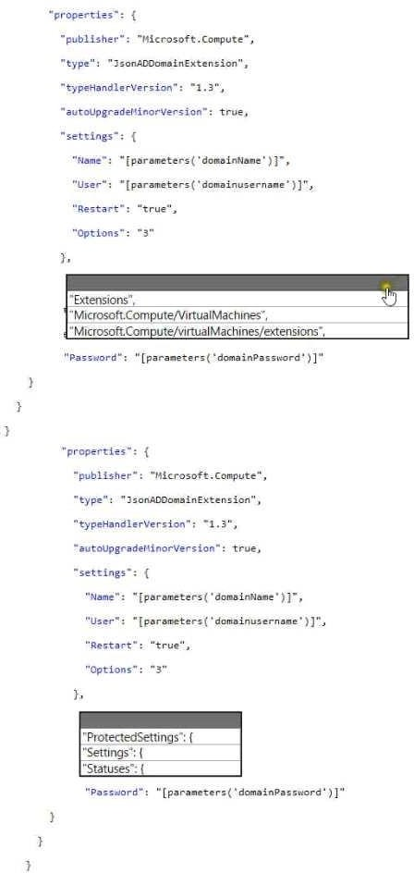

**Answer:**

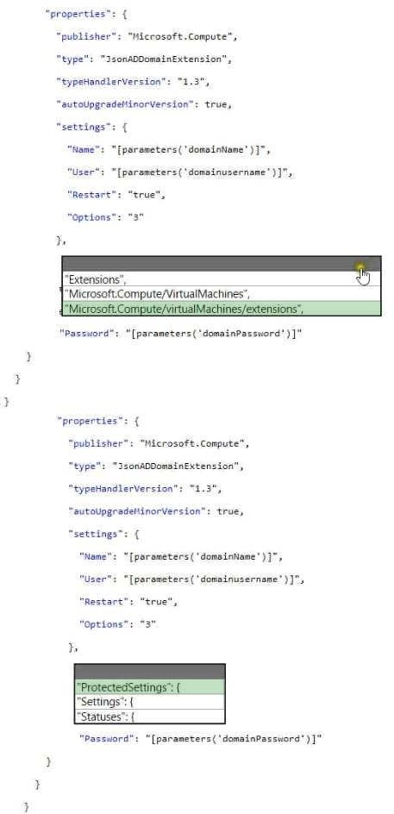

**Explanation:**

Azure Resource Manager template overview

Resource Manager templates let you define Azure infrastructure in code. The required resources, network connections, or configuration of VMs can all be defined in a template. These templates create consistent, reproducible deployments each time, and can be versioned as you make

changes. For more information, see Azure Resource Manager templates overview. Each resource is defined in a template using JavaScript Object Notation (JSON). The following JSON example uses the Microsoft.Compute/virtualMachines/extensions resource type to install the Active Directory domain join extension. Parameters are used that you specify at deployment time. When the extension is deployed, the VM is joined to the specified managed domain.

JSON

{

"apiVersion": "2015-06-15",

"type": "Microsoft.Compute/virtualMachines/extensions", "name": "[concat(parameters('dnsLabelPrefix'),'/joindomain')]", "location": "[parameters('location')]", "dependsOn": [

"[concat('Microsoft.Compute/virtualMachines/', parameters('dnsLabelPrefix'))]" ], "properties": {

"publisher": "Microsoft.Compute", "type": "JsonADDomainExtension", "typeHandlerVersion": "1.3", "autoUpgradeMinorVersion": true, "settings": {

"Name": "[parameters('domainToJoin')]",

"OUPath": "[parameters('ouPath')]",

"User": "[concat(parameters('domainToJoin'), '\\', parameters('domainUsername'))]", "Restart": "true",

"Options": "[parameters('domainJoinOptions')]"

},

"protectedSettings": {

"Password": "[parameters('domainPassword')]"

}

}

}

This VM extension can be deployed even if you don't create a VM in the same template. The examples in this article show both of the following approaches:

Create a Windows Server VM and join to a managed domain Join an existing Windows Server VM to a managed domain

### QUESTION 552

Hotspot Question

You have two Azure virtual machines as shown in the following table.

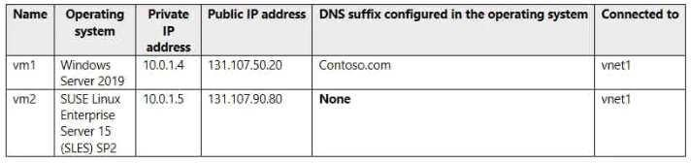

You create the Azure DNS zones shown in the following table.

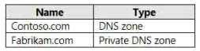

You perform the following actions:

* To fabrikam.com, you add a virtual network link to vnet1 and enable auto registration.
* For contoso.com, you assign vm1 and vm2 the Owner role.

For each of the following statements, select Yes if the statement is true. Otherwise, select No. NOTE: Each correct selection is worm one point.

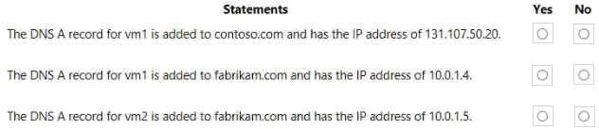

**Answer:**

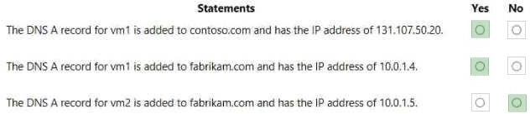

### QUESTION 553

Hotspot Question

You need to create a bar chart that shows the number of distinct computers that have sent heartbeats each week.

How should you complete the Log Analytics query? To answer, select the appropriate options in the answer area. NOTE; Each correct selection is worth one point.

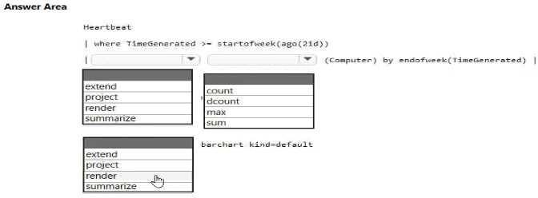

**Answer:**

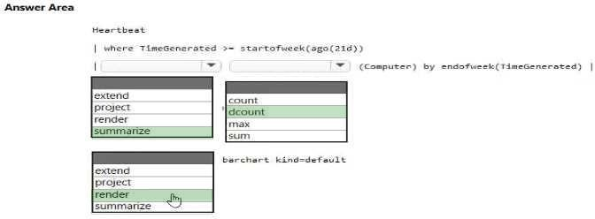

**QUESTION 554**

# Case Study 3 - Contoso, Ltd

**Overview**

Contoso, Ltd. is a consulting company that has a main office in Montreal and two branch offices in Seattle and New York.

The Montreal office has 2,000 employees. The Seattle office has 1,000 employees. The New York office has 200 employees.

All the resources used by Contoso are hosted on-premises.

Contoso creates a new Azure subscription. The Azure Active Directory (Azure AD) tenant uses adomain named contoso.onmicrosoft.com. The tenant uses the P1 pricing tier.

**Existing Environment**

The network contains an Active Directory forest named contoso.com. All domain controllers are configured as DNS servers and host the contoso.com DNS zone.

Contoso has finance, human resources, sales, research, and information technology departments. Each department has an organizational unit (OU) that contains all the accounts of that respective department. All the user accounts have the department attribute set to their respective department. New users are added frequently.

Contoso.com contains a user named User1. All the offices connect by using private links.

Contoso has data centers in the Montreal and Seattle offices. Each data center has a firewall that can be configured as a VPN device.

All infrastructure servers are virtualized.

The virtualization environment contains the servers in the following table.



Contoso uses two web applications named App1 and App2. Each instance on each web application requires 1GB of memory.

The Azure subscription contains the resources in the following table.



The network security team implements several network security groups (NSGs).

**Planned Changes**

Contoso plans to implement the following changes:

* Deploy Azure ExpressRoute to the Montreal office.
* Migrate the virtual machines hosted on Server1 and Server2 to Azure.
* Synchronize on-premises Active Directory to Azure Active Directory (Azure AD).
* Migrate App1 and App2 to two Azure web apps named WebApp1 and WebApp2.

**Technical requirements**

Contoso must meet the following technical requirements:

* Ensure that WebApp1 can adjust the number of instances automatically based on the load and can scale up to five instances.
* Ensure that VM3 can establish outbound connections over TCP port 8080 to the applications servers in the Montreal office.
* Ensure that routing information is exchanged automatically between Azure and the routers in the Montreal office.
* Ensure Azure Multi-Factor Authentication (MFA) for the users in the finance department only.
* Ensure that webapp2.azurewebsites.net can be accessed by using the name app2.contoso.com
* Connect the New York office to VNet1 over the Internet by using an encrypted connection.
* Create a workflow to send an email message when the settings of VM4 are modified.
* Create a custom Azure role named Role1 that is based on the Reader role.
* Minimize costs whenever possible.

Hotspot Question

You implement the planned changes for NSG1 and NSG2.

For each of the following statements, select Yes if the statement is true. Otherwise, select No. NOTE: Each correct selection is worth one point.

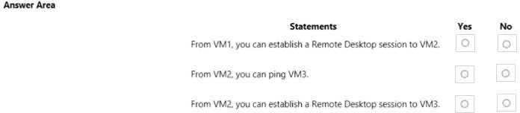

**Answer:**

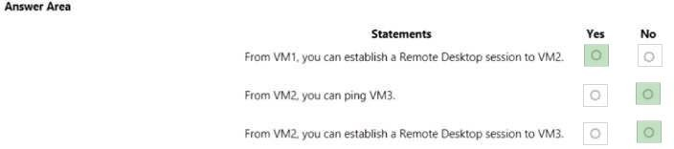

### QUESTION 555

**Case Study 5 - Contoso, Ltd Overview**

**General Overview**

Contoso, Ltd. is a consulting company that has a main office in Montreal and branch offices in Seattle and New York.

**Environment Existing Environment**

Contoso has an Azure subscription named Sub1 that is linked to an Azure Active Directory (Azure AD) tenant. The network contains an on-premises Active Directory domain that syncs to the Azure AD tenant.

The Azure AD tenant contains the users shown in the following table.



Sub1 contains two resource groups named RG1 and RG2 and the virtual networks shown in the following table.



User1 manages the resources in RG1. User4 manages the resources in RG2.

Sub1 contains virtual machines that run Windows Server 2019 as shown in the following table



No network security groups (NSGs) are associated to the network interfaces or the subnets. Sub1 contains the storage accounts shown in the following table.



**Requirements Planned Changes**

Contoso plans to implement the following changes:

 Create a blob container named container1 and a file share named share1 that will use the Cool storage tier.

 Create a storage account named storage5 and configure storage replication for the Blob service.

 Create an NSG named NSG1 that will have the custom inbound security rules shown in the following table.



 Associate NSG1 to the network interface of VM1.

Create an NSG named NSG2 that will have the custom outbound security rules shown in the following table.



 Associate NSG2 to VNET1/Subnet2.

**Technical Requirements**

Contoso must meet the following technical requirements:

 Create container1 and share1.

 Use the principle of least privilege.

 Create an Azure AD security group named Group4.

 Back up the Azure file shares and virtual machines by using Azure Backup.

 Trigger an alert if VM1 or VM2 has less than 20 GB of free space on volume C.

 Enable User1 to create Azure policy definitions and User2 to assign Azure policies to RG1.  Create an internal Basic Azure Load Balancer named LB1 and connect the load balancer to

VNET1/Subnet1

 Enable flow logging for IP traffic from VM5 and retain the flow logs for a period of eight months.

 Whenever possible, grant Group4 Azure role-based access control (Azure RBAC) read-only permissions to the Azure file shares.

You need to ensure that you can grant Group4 Azure RBAC read-only permissions to all the Azure file shares. What should you do?

|  |  |
| --- | --- |
| A. | On storagel and storage4, change the Account kind type to StorageV2 (general purpose v2). |
| B. | Recreate storage2 and set Hierarchical namespace to Enabled. |
| C. | On storage2, enable identity-based access for the file shares. |
| D. | Create a shared access signature (SAS) for storagel, storage2, and storage4. |

**Answer:** A

### QUESTION 556

**Case Study 5 - Contoso, Ltd Overview**

**General Overview**

Contoso, Ltd. is a consulting company that has a main office in Montreal and branch offices in Seattle and New York.

**Environment Existing Environment**

Contoso has an Azure subscription named Sub1 that is linked to an Azure Active Directory (Azure AD) tenant. The network contains an on-premises Active Directory domain that syncs to the Azure AD tenant.

The Azure AD tenant contains the users shown in the following table.



Sub1 contains two resource groups named RG1 and RG2 and the virtual networks shown in the following table.



User1 manages the resources in RG1. User4 manages the resources in RG2.

Sub1 contains virtual machines that run Windows Server 2019 as shown in the following table



No network security groups (NSGs) are associated to the network interfaces or the subnets. Sub1 contains the storage accounts shown in the following table.



**Requirements Planned Changes**

Contoso plans to implement the following changes:

Create a blob container named container1 and a file share named share1 that will use the Cool storage tier.

Create a storage account named storage5 and configure storage replication for the Blob service.

Create an NSG named NSG1 that will have the custom inbound security rules shown in the following table.



 Associate NSG1 to the network interface of VM1.

 Create an NSG named NSG2 that will have the custom outbound security rules shown in the following table.



 Associate NSG2 to VNET1/Subnet2.

**Technical Requirements**

Contoso must meet the following technical requirements:

 Create container1 and share1.

 Use the principle of least privilege.

 Create an Azure AD security group named Group4.

 Back up the Azure file shares and virtual machines by using Azure Backup.

 Trigger an alert if VM1 or VM2 has less than 20 GB of free space on volume C.

 Enable User1 to create Azure policy definitions and User2 to assign Azure policies to RG1.  Create an internal Basic Azure Load Balancer named LB1 and connect the load balancer to

VNET1/Subnet1

 Enable flow logging for IP traffic from VM5 and retain the flow logs for a period of eight months.

 Whenever possible, grant Group4 Azure role-based access control (Azure RBAC) read-only permissions to the Azure file shares.

Hotspot Question

You implement the planned changes for NSG1 and NSG2.

For each of the following statements, select Yes if the statement is true. Otherwise, select No. NOTE: Each correct selection is worth one point.

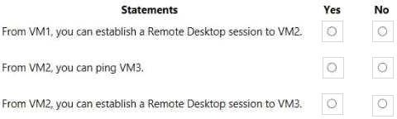

**Answer:**

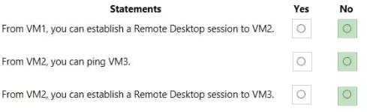

### QUESTION 557

**Case Study 5 - Contoso, Ltd Overview**

**General Overview**

Contoso, Ltd. is a consulting company that has a main office in Montreal and branch offices in Seattle and New York.

**Environment Existing Environment**

Contoso has an Azure subscription named Sub1 that is linked to an Azure Active Directory (Azure AD) tenant. The network contains an on-premises Active Directory domain that syncs to the Azure AD tenant.

The Azure AD tenant contains the users shown in the following table.



Sub1 contains two resource groups named RG1 and RG2 and the virtual networks shown in the following table.



User1 manages the resources in RG1. User4 manages the resources in RG2.

Sub1 contains virtual machines that run Windows Server 2019 as shown in the following table



No network security groups (NSGs) are associated to the network interfaces or the subnets. Sub1 contains the storage accounts shown in the following table.



**Requirements Planned Changes**

Contoso plans to implement the following changes:

 Create a blob container named container1 and a file share named share1 that will use the Cool storage tier.

 Create a storage account named storage5 and configure storage replication for the Blob service.

 Create an NSG named NSG1 that will have the custom inbound security rules shown in the following table.



 Associate NSG1 to the network interface of VM1.

 Create an NSG named NSG2 that will have the custom outbound security rules shown in the following table.



 Associate NSG2 to VNET1/Subnet2.

**Technical Requirements**

Contoso must meet the following technical requirements:

 Create container1 and share1.

 Use the principle of least privilege.

 Create an Azure AD security group named Group4.

 Back up the Azure file shares and virtual machines by using Azure Backup.

 Trigger an alert if VM1 or VM2 has less than 20 GB of free space on volume C.

 Enable User1 to create Azure policy definitions and User2 to assign Azure policies to RG1.  Create an internal Basic Azure Load Balancer named LB1 and connect the load balancer to

VNET1/Subnet1

 Enable flow logging for IP traffic from VM5 and retain the flow logs for a period of eight months.

 Whenever possible, grant Group4 Azure role-based access control (Azure RBAC) read-only permissions to the Azure file shares.

You need to add VM1 and VM2 to the backend pool of LB1. What should you do first?

|  |  |
| --- | --- |
| A. | Create a new NSG and associate the NSG to VNET1/Subnet1. |
| B. | Connect VM2 to VNET1/Subnet1. |
| C. | Redeploy VM1 and VM2 to the same availability zone. |
| D. | Redeploy VM1 and VM2 to the same availability set. |

**Answer:** D

### QUESTION 558

**Case Study 5 - Contoso, Ltd Overview**

**General Overview**

Contoso, Ltd. is a consulting company that has a main office in Montreal and branch offices in Seattle and New York.

**Environment Existing Environment**

Contoso has an Azure subscription named Sub1 that is linked to an Azure Active Directory (Azure AD) tenant. The network contains an on-premises Active Directory domain that syncs to the Azure AD tenant.

The Azure AD tenant contains the users shown in the following table.



Sub1 contains two resource groups named RG1 and RG2 and the virtual networks shown in the following table.



User1 manages the resources in RG1. User4 manages the resources in RG2.

Sub1 contains virtual machines that run Windows Server 2019 as shown in the following table



No network security groups (NSGs) are associated to the network interfaces or the subnets. Sub1 contains the storage accounts shown in the following table.



**Requirements Planned Changes**

Contoso plans to implement the following changes:

 Create a blob container named container1 and a file share named share1 that will use the Cool storage tier.

 Create a storage account named storage5 and configure storage replication for the Blob service.

 Create an NSG named NSG1 that will have the custom inbound security rules shown in the following table.



 Associate NSG1 to the network interface of VM1.

 Create an NSG named NSG2 that will have the custom outbound security rules shown in the following table.



 Associate NSG2 to VNET1/Subnet2.

**Technical Requirements**

Contoso must meet the following technical requirements:

 Create container1 and share1.

 Use the principle of least privilege.

 Create an Azure AD security group named Group4.

 Back up the Azure file shares and virtual machines by using Azure Backup.

 Trigger an alert if VM1 or VM2 has less than 20 GB of free space on volume C.

Enable User1 to create Azure policy definitions and User2 to assign Azure policies to RG1. Create an internal Basic Azure Load Balancer named LB1 and connect the load balancer to

VNET1/Subnet1

Enable flow logging for IP traffic from VM5 and retain the flow logs for a period of eight months.

Whenever possible, grant Group4 Azure role-based access control (Azure RBAC) read-only permissions to the Azure file shares.

You need to identify which storage account to use for the flow logging of IP traffic from VM5. The solution must meet the retention requirements.

Which storage account should you identify?

|  |  |
| --- | --- |
| A. | storage4 |
| B. | storage1 |
| C. | storage2 |
| D. | storage3 |

**Answer:** D

### QUESTION 559

Hotspot Question

You have an Azure App Service plan named ASP1. CPU usage for ASP1 is shown in the following exhibit.

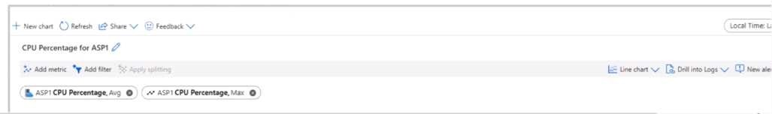

Use the drop-down menus to select the answer choice that answers each question based on the information presented in the graphic. NOTE Each correct selection is worth one point.

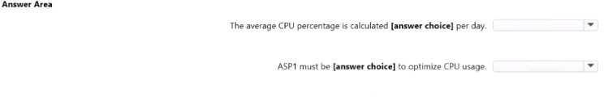

**Answer:**

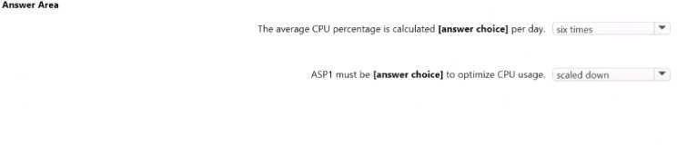

### QUESTION 560

You have an Azure subscription that contains a storage account named storage1. The storage1 account contains a file share named share1. The subscription is linked to a hybrid Azure Active Directory (Azure AD) tenant that contains a security group named Group1.

You need to gram Group1 the Storage File Data SMB Share Elevated Contributor role for share1. What should you do first?

|  |  |
| --- | --- |
| A. | Enable Active Directory Domain Service (ADDS) authentication for storage1. |
| B. | Grant share-level permissions by using File Explorer. |
| C. | Mount share1 by using File Explorer. |
| D. | Create a private endpoint. |

**Answer:** A

### QUESTION 561

You have an Azure App Services web app named App1. You plan to deploy App1 by using Web Deploy.

You need to ensure that the developers of App1 can use their Azure Active Directory (Azure AD) credentials to deploy content to App1.

The solution must use the principle of least privilege. What should you do?

|  |  |
| --- | --- |
| A. | Configure app-level credentials for FTPS. |
| B. | Assign The Website Contributor role to the developers. |
| C. | Assign the Owner role to the developers. |
| D. | Configure user-level credentials for FTPS. |

**Answer:** C

### QUESTION 562

Hotspot Question

You have an Azure subscription.

You need to deploy a virtual machine by using an Azure Resource Manager (ARM) template.

How should you complete the template? To answer, select the appropriate options in the answer area.

NOTE: Each correct selection is worth one point.

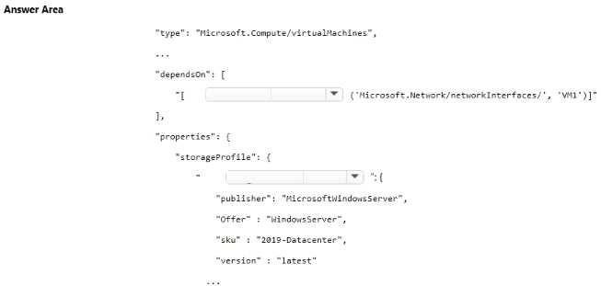

**Answer:**

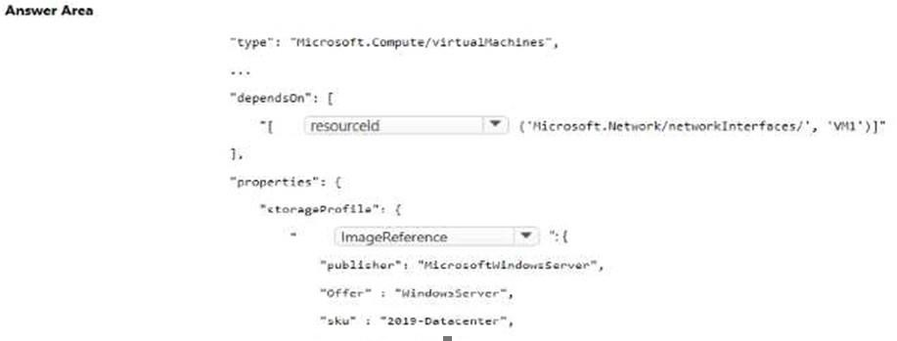

### QUESTION 563

Drag and Drop Question

You need to configure the alerts for VM1 and VM2 to meet the technical requirements.

Which three actions should you perform in sequence? To answer, move all actions from the list of actions to the answer area and arrange them in the correct order.

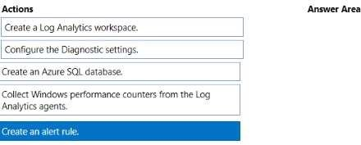

**Answer:**

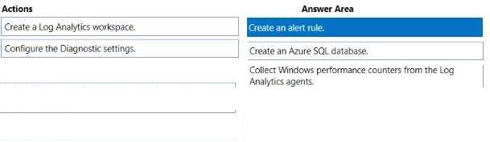

### QUESTION 564

Hotspot Question

You have an Azure App Service web app named app1. You configure autoscaling as shown in following exhibit.

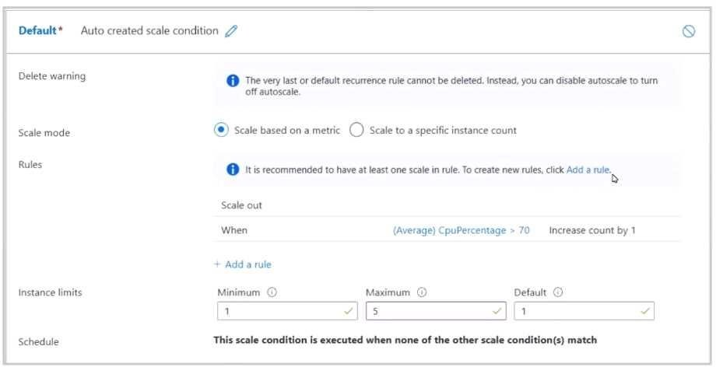

You configure the autoscale rule criteria as shown in the following exhibit.

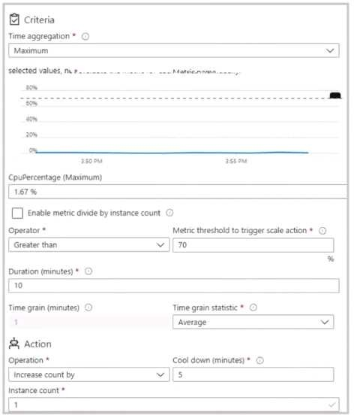

Use the drop-down menus to select the answer choice that answers each question based on the information presented in the graphic. NOTE Each correct selection is worth one point.

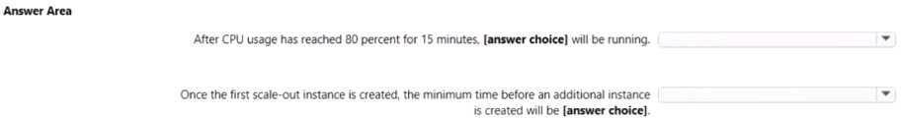

**Answer:**

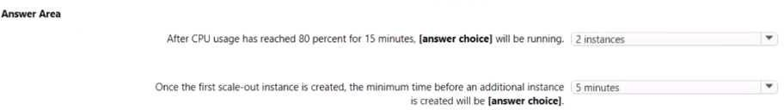

### QUESTION 565

Hotspot Question

You have an Azure Active Directory (Azure AD) tenant named contoso.com.

You have two external partner organizations named fabrilcam.com and litwareinc.com. FabtAam.com is configured as a connected organization.

You create an access package as shown in the Access package exhibit. (Click the Access package lab.)

You configure the external user lifecycle settings as shown in the Lifecycle exhibit. (Click the lifecycle tab)

For each of the following statements, select Yes if the statement is true Otherwise, select No Note: Each correct selection is worth one point.

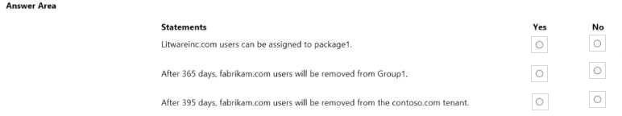

**Answer:**

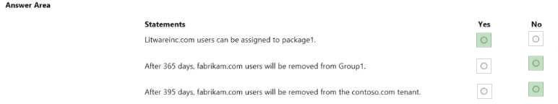

### QUESTION 566

Hotspot Question

You have two Azure subscriptions named Sub1 and Sub2. Sub1 is in a management group named MG1. Sub2 is in a management group named MG2.

You have the resource groups shown in the following table.

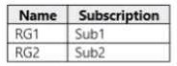

You have the virtual machines shown in the following table.

Use the drop-down menus to select the answer choice that answers each question based on the information presented in the graphic. NOTE Each correct selection is worth one point.

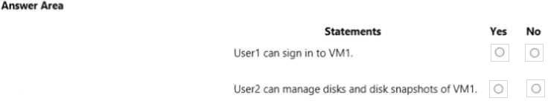

**Answer:**

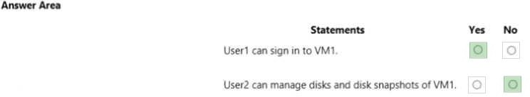

### QUESTION 567

Drag and Drop Question

You have an Azure subscription that contains a virtual network named VNET1. VNET1 contains the subnets shown in the following table.

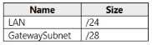

VNET1 contains a virtual network gateway named VNG1 that uses policy-based routing and has a single Site-to-Site VPN connection to an on-premises datacenter.

You need to Implement ExpressRoute. The solution must include a Site-to-Site VPN as a backup.

Which four actions should you perform in sequence? To answer, move the appropriate actions from the list of actions to the answer area and arrange them in the correct order.

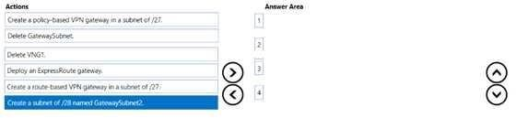

**Answer:**

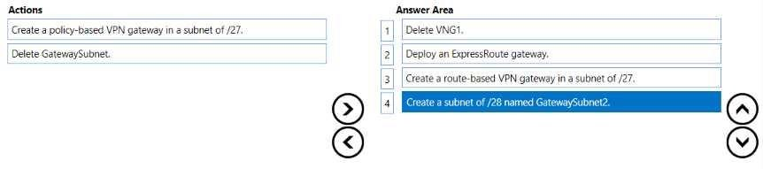

### QUESTION 568

You have an Azure subscription mat contains a virtual machine named VM1 and an Azure function named App1.

You need to create an alert rule that will run App1 if VM1 stops. What should you create for the alert rule?

|  |  |
| --- | --- |
| A. | a security group that has dynamic device membership |
| B. | an action group |
| C. | an application security group |
| D. | an application group |

**Answer:** B

### QUESTION 569

Your on-premises network contains a VPN gateway.

You have an Azure subscription that contains the resources shown in the following table.



You need to ensure that all the traffic from VM1 to storage! travels across the Microsoft backbone network.

What should you configure?

|  |  |
| --- | --- |
| A. | private endpoints |
| B. | Azure Firewall |
| C. | Azure AD Application Proxy |
| D. | Azure Peering Service |

**Answer:** C

### QUESTION 570

You have an Azure subscription that contains eight virtual machines and the resources shown in the following table.

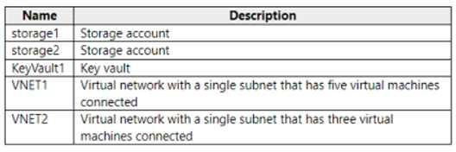

You need to configure access for VNET1. The solution must meet the following requirements:

* The virtual machines connected to VNET1 must be able to communicate with the virtual machines connected to VNET2 by using the Microsoft backbone.
* The virtual machines connected to VNET1 must be able to access storage1, storage2 and Azure AD by using the Microsoft backbone.

What is the minimum number of service endpoints you should add to VNET1?

|  |  |
| --- | --- |
| A. | 1 |
| B. | 2 |
| C. | 5 |
| D. | 3 |

**Answer:** B

### QUESTION 571

You have an Azure subscription. The subscription contains a storage account named storage1 that has the lifecycle management rules shown in the following table.

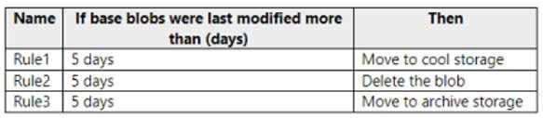

On June 1, you store a blob named File1 in the Hot access tier of storage1. What is the state of File1 on June 7?

|  |  |
| --- | --- |
| A. | stored in the Archive access tier |
| B. | stored in the Hot access tier |
| C. | stored in the Cool access tier |
| D. | deleted |

**Answer:** C

### QUESTION 572

You have an Azure subscription.

You need to receive an email alert when a resource lock is removed from any resource in the subscription.

What should you use to create an activity log alert in Azure Monitor?

|  |  |
| --- | --- |
| A. | a resource a condition, and an action group |
| B. | a resource, a condition and a Microsoft 365 group |
| C. | a Log Analytics workspace a resource, and an action group |
| D. | a data collection endpoint, an application security group, and a resource group |

**Answer:** C

### QUESTION 573

You have an Azure subscription that has the public IP addresses shown in the following table.

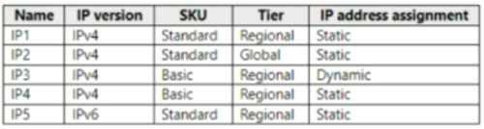

You plan to deploy an instance of Azure Firewall Premium named FW1. Which IP addresses can you use?

|  |  |
| --- | --- |
| A. | IP2 Only |
| B. | IP1 and lP2 only |
| C. | IP1, IP2 and IP5 only |
| D. | IP1, IP2, IP4 and IP5 only |

**Answer:** C

### QUESTION 574

You have an Azure subscription that contains the resources shown in the following table.

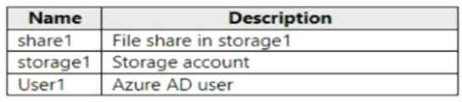

You need to assign User1 the Storage File Data SMB Share Contributor role for share1. What should you do first?

|  |  |
| --- | --- |
| A. | Modify the security profile for the file shares in storage1. |

|  |  |
| --- | --- |
| B. | Configure Access control (I AM) for share1. |
| C. | Select Default to Azure Active Directory authorization in the Azure portal for storage!. |
| D. | Enable identity-based data access for the file shares in storage1. |

**Answer:** A

### QUESTION 575

Hotspot Question

You have an Azure Load Balancer named LB1.

You assign a user named User1 the roles shown in the following exhibit.

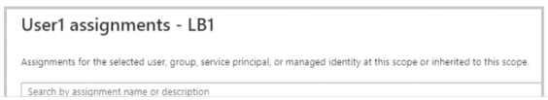

Use the drop-down menus to select the answer choice that completes each statement based on the information presented in the graphic NOTE; Each correct selection is worth one point.

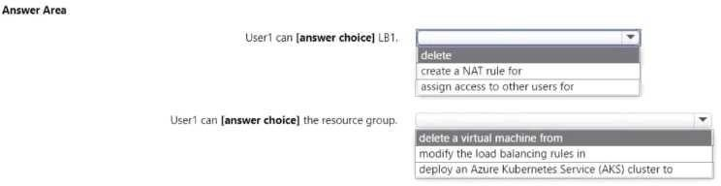

**Answer:**

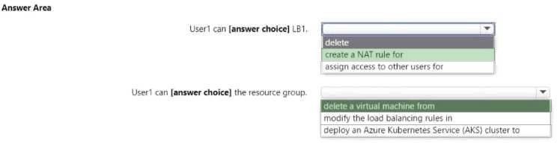

### QUESTION 576

Hotspot Question

You have the role assignment file shown in the following exhibit.

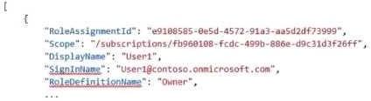

Use the drop-down menus to select the answer choice that completes each statement based on the information presented in the graphic NOTE; Each correct selection is worth one point.

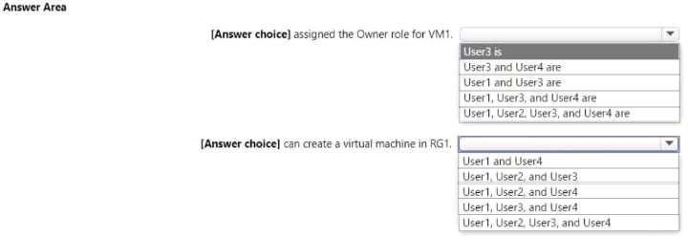

**Answer:**

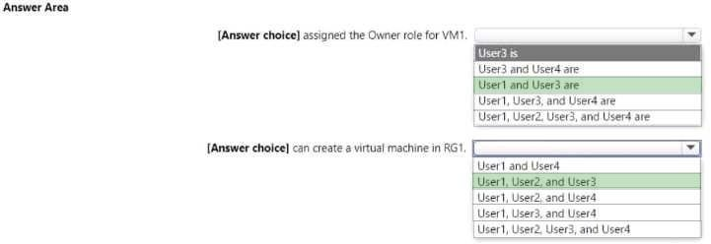

### QUESTION 577

Hotspot Question

You are creating an Azure Kubernetes Services (AKS) cluster as shown in the following exhibit.

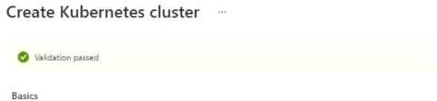

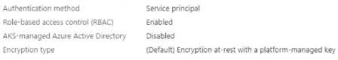

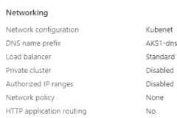

Use the drop-down menus to select the answer choice that completes each statement based on the information presented in the graphic NOTE; Each correct selection is worth one point.

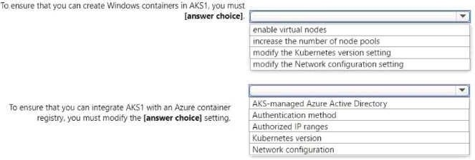

**Answer:**

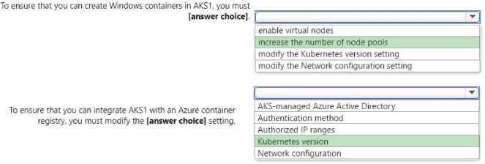

### QUESTION 578

Hotspot Question

You have an Azure subscription.

You plan to deploy a new storage account.

You need to configure encryption for the account. The solution must meet the following requirements:

* Use a customer-managed key stored in an key vault
* Use the maximum supported bit length.

Which type of key and which bit length should you use?

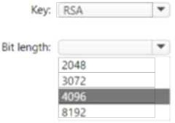

**Answer:**

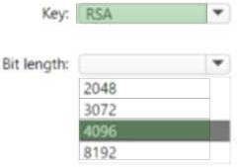

### QUESTION 579

Hotspot Question

You have an Azure subscription.

You plan to deploy a storage account named storage1 by using the following Azure Resource Manager (ARM) template.

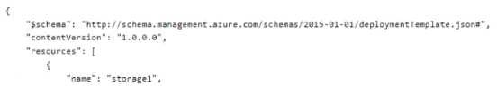

For each of the following statements, select Yes if the statement is true Otherwise, select No Note: Each correct selection is worth one point.

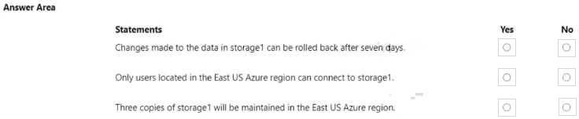

**Answer:**

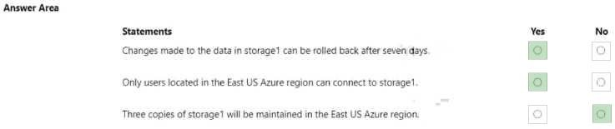

### QUESTION 580

You have an on-premises network.

You have an Azure subscription that contains three virtual networks named VNET1, VNET2, and VNET3. The virtual networks are peered and connected to the on-premises network. The subscription contains the virtual machines shown in the following table.

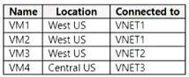

You need to monitor connectivity between the virtual machines and the on-premises network by using Connection Monitor.

What is the minimum number of connection monitors you should deploy?

|  |  |
| --- | --- |
| A. | 1 |
| B. | 2 |
| C. | 3 |
| D. | 4 |

**Answer:** B

### QUESTION 581

You have an Azure AD tenant that is linked to 10 Azure subscriptions. You need to centrally monitor user activity across all the subscriptions. What should you use?

|  |  |
| --- | --- |
| A. | Activity log filters |

|  |  |
| --- | --- |
| B. | Log Analytics workspace |
| C. | access reviews |
| D. | Azure Application Insights Profiler |

**Answer:** B

### QUESTION 582

You have an Azure subscription that contains 10 virtual machines, a key vault named Vault 1, and a network security group (NSG) named NSG1. All the resources are deployed to the East US Azure region.

The virtual machines are protected by using NSG1. NSG1 is configured to block all outbound traffic to the internet.

You need to ensure that the virtual machines can access Vault1. The solution must use the principle of least privilege and minimize administrative effort.

What should you configure as the destination of the outbound security rule for NSG1 ?

|  |  |
| --- | --- |
| A. | an application security group |
| B. | an IP address range |
| C. | a service tag |

**Answer:** C

### QUESTION 583

Hotspot Question

You have an Azure subscription that contains an Azure Kubernetes Service (AKS) cluster named Cluster1. Cluster1 hosts a node pool named Pool1 that has four nodes.

You need to perform a coordinated upgrade of Cluster1. The solution must meet the following requirements:

* Deploy two new nodes to perform the upgrade.
* Minimize costs.

How should you complete the command?

**Answer:**



### QUESTION 584

Hotspot Question

You plan to deploy the following Azure Resource Manager (ARM) template.

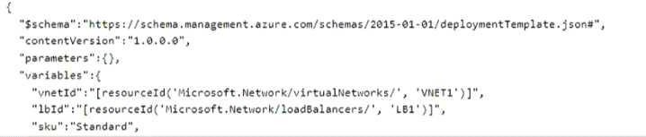

For each of the following statements, select Yes if the statement is true Otherwise, select No Note: Each correct selection is worth one point.

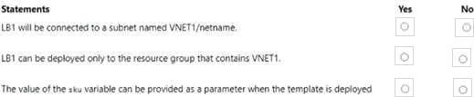

**Answer:**

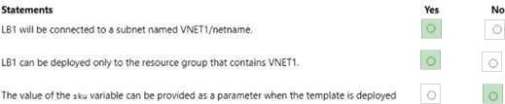

### QUESTION 585

Drag and Drop Question

You have an Azure subscription named Sub1 that contains two users named User1 and User2. You need to assign role-based access control (RBAC) roles to User1 and User2. The users must be able to perform the following tasks in Sub1:

* User1 must view the data in any storage account.
* User2 must assign users the Contributor role for storage accounts. The solution must use the principle of least privilege.

Which RBAC role should you assign to each user? To answer, drag the appropriate roles to the correct users. Each role may be used once, more than once, or not at all.

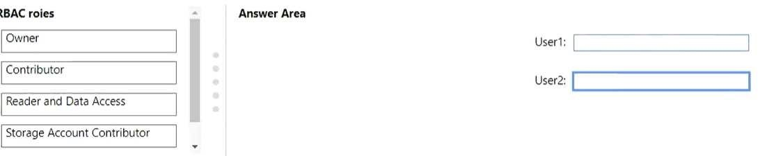

**Answer:**

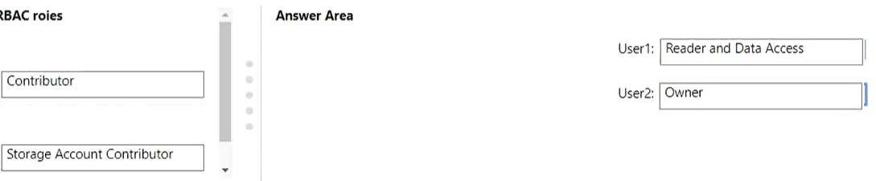

### QUESTION 586

Hotspot Question

You have an Azure subscription that is linked to an Azure AD tenant. The tenant contains the custom role-based access control (RBAC) roles shown in the following table.

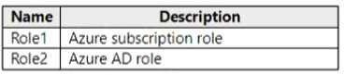

From the Azure portal, you need to create two custom roles named Role3 and Role4. Role3 will be an Azure subscription role. Role4 will be an Azure AD role.

Which roles can you clone to create the new roles? To answer, select the appropriate options in the answer area.

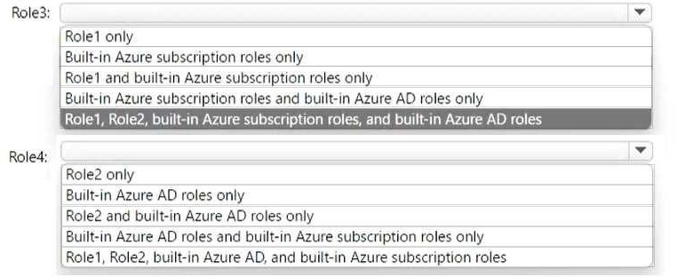

**Answer:**

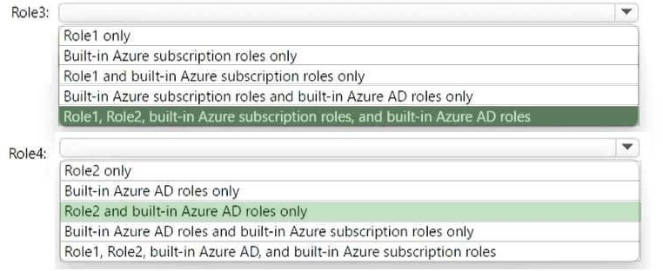

### QUESTION 587

Your company has an Active Directory forest named lead2pass.com. You go ahead and install and configure Azure AD Connect to use password hash synchronization as the single sign-on (SSO) method.

You have also enabled staging mode. After careful review, you see that the Synchronization Service Manager does not display any sync jobs. You need to ensure that the synchronization completes successfully.

Which of the following would you implement to resolve this issue?

|  |  |
| --- | --- |
| A. | From Synchronization Service Manager, run a complete import. |
| B. | Run the Azure AD Connect configuration and set the synchronization method to Pass-through Authentication. |
| C. | From Azure PowerShell, run Start-ADSyncSyncCycle command |
| D. | Run the Azure AD Connect configuration and disable staging mode. |

**Answer:** D

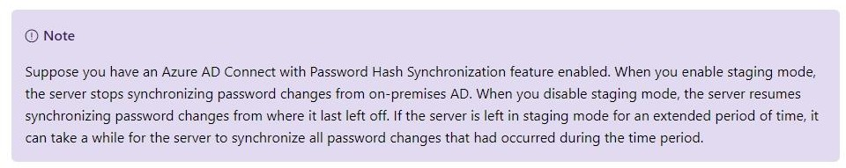**Explanation:**

None of the other options will work unless you first disable staging mode. https://docs.microsoft.com/en-us/azure/active-directory/hybrid/how-to-connect-sync-operations

### QUESTION 588

Your company has an Azure subscription that is used by multiple departments in your company. The subscription contains around 5 resource groups. Each department uses resources in several resource groups.

Your supervisor has requested to send a report that details the costs for each department. Which of the following actions would you need to perform for this purpose? Choose 3 answers from the options given below.

|  |  |
| --- | --- |
| A. | Assign a tag to each resource group |
| B. | Use the Resource costs blade of each resource group |
| C. | Download the usage report |
| D. | Assign a tag to each resource |
| E. | From the Costs Analysis blade, filter the view by tag |

**Answer:** CDE

**Explanation:**

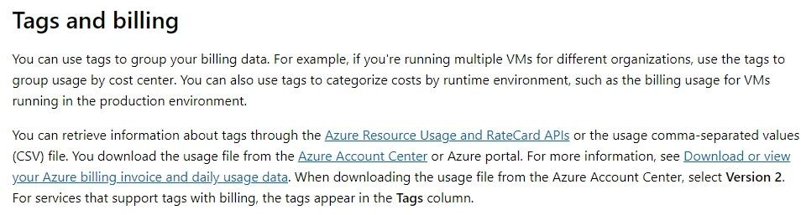

Option A is incorrect since here the resources are used across various departments and are not constrained via resource groups.

Option B is incorrect since the costing on a tag basis needs to be seen from Cost Analysis. https://docs.microsoft.com/en-us/azure/azure-resource-manager/resource-group-using-tags

### QUESTION 589

Your company goes ahead and registers a domain name of lead2pass.com. You then go ahead and create an Azure DNS zone named lead2pass.com.

You then add an A record to the zone for a host named www that has an IP address of 123.10.9.147.

But the users complain that they cannot resolve the U[RLwww.lead2pass.com](http://www.lead2pass.com/) to 123.10.9.147. This issue needs to be resolved.

You propose a solution to add an NS record to the lead2pass.com zone. Would this solution resolve the issue?

|  |  |
| --- | --- |
| A. | Yes |
| B. | No |

**Answer:** B

**Explanation:**

No, the right solution is to modify the name server at the domain register. https://docs.microsoft.com/en-us/azure/active-directory/fundamentals/add-custom-domain

### QUESTION 590

Your company has an account and subscription in Azure. They have the requirement of creating multiple Linux servers for their test environment.

Some of these servers need to have web servers such as NGINX pre-installed. The installation needs to be carried out in an automated fashion.

Which of the following file would you need to create for the automated deployment?

|  |  |
| --- | --- |
| A. | template.yaml |
| B. | deployment.json |
| C. | cloud-init |

|  |  |
| --- | --- |
| D. | deploy.xml |

**Answer:** C

**Explanation:**

Cloud-initis a widely used approach to customize a Linux VM as it boots for the first time. You can use cloud-init to install packages and write files, or to configure users and security. As cloud-init runs during the initial boot process, there are no additional steps or required agents to apply your configuration.

https://docs.microsoft.com/en-us/azure/virtual-machines/linux/tutorial-automate-vm-deployment

### QUESTION 591

Your team is creating a CDN profile and endpoint for an application. The endpoint is pointing to Azure BLOB storage.

It needs to be ensured that users are directed to the CDN endpoint via the URL https:/[/www.lead2pass.com.](http://www.lead2pass.com/)

Which of the following steps would you perform for this requirement? Choose 3 answers from the options given below

|  |  |
| --- | --- |
| A. | Register the URLhttps:/[/www.lead2pass.comin](http://www.lead2pass.comin/) Azure DNS |
| B. | Associate the custom domain with your CDN endpoint |
| C. | Create a CNAME DNS record |
| D. | Modify the custom domain to the CDN endpoint |
| E. | Verify the custom domain. |

**Answer:** BCE

**Explanation:**

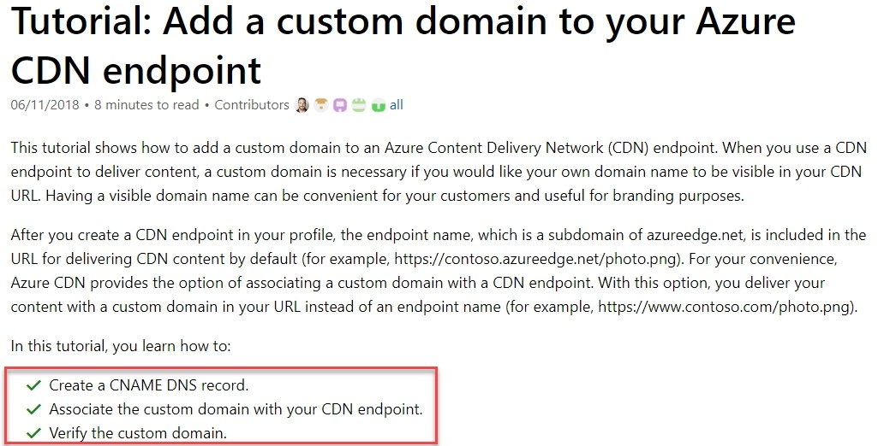

https://docs.microsoft.com/en-us/azure/cdn/cdn-map-content-to-custom-domain

### QUESTION 592

A team needs to deploy a scaleset to Azure. You have to create the required Azure CLI script for the same.

You have to write the part of the script to scale the scaleset to a new capacity of 4. Which of the following is the right command for this?

|  |  |
| --- | --- |
| A. | az vmss scale --resource-group "whizlabs-rg" --name lead2passset --scale-capacity 4 |
| B. | az vmss scale --resource-group "whizlabs-rg" --name lead2passset --new-capacity 4 |
| C. | az vmss new-scale --resource-group "whizlabs-rg" --name lead2passset --new-capacity 4 |
| D. | az vmss new-scale --resource-group "whizlabs-rg" --name lead2passset --scale-capacity 4 |

**Answer:** B

**Explanation:**

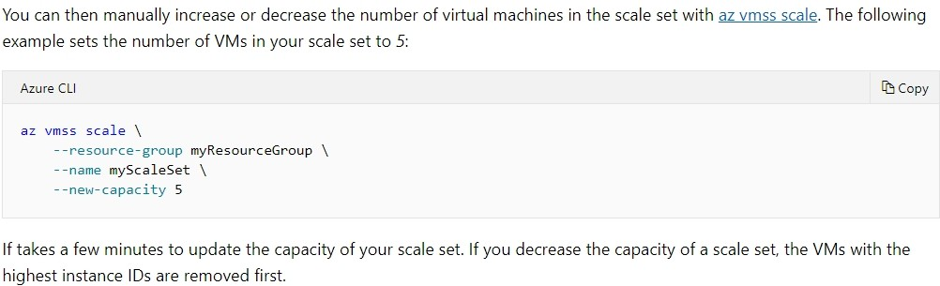

https://docs.microsoft.com/en-us/azure/virtual-machine-scale-sets/virtual-machine-scale-sets- manage-cli

### QUESTION 593

A company has the following virtual networks defined in Azure.

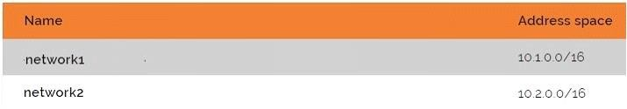

The following virtual machines have been defined as well:

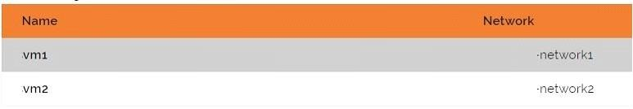

Which of the following can be used by the security department to check for any network intrusions?

|  |  |
| --- | --- |
| A. | IP Flow Verify |
| B. | Variable packet capture |
| C. | Azure connection monitor |
| D. | Application Insights |

**Answer:** B

**Explanation:**

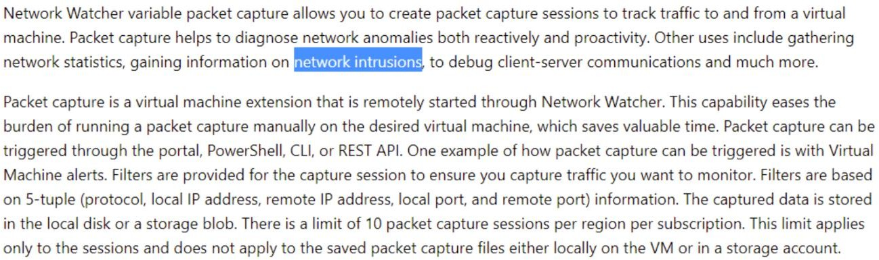

https://docs.microsoft.com/en-us/azure/network-watcher/network-watcher-packet-capture- overview

### QUESTION 594

You have a virtual network named VNet2 that has the configuration shown in the following exhibit.

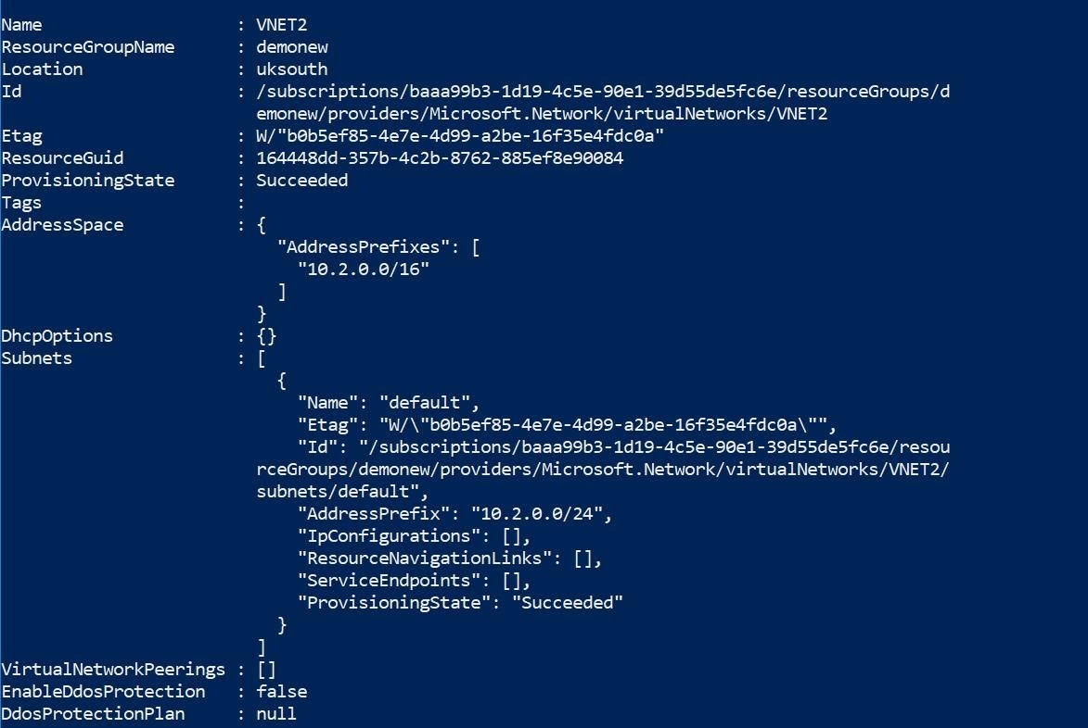

Before a virtual machine on VNET2 can receive an IP address from 192.168.1.0/24 you must first?

|  |  |
| --- | --- |
| A. | Add a network interface |
| B. | Add a subnet |
| C. | Add an address space |
| D. | Delete a subnet |
| E. | Delete an address space |

**Answer:** C

**Explanation:**

The Virtual Network has no address space which is relative to 192.168.1.0/24 as per the powershell output given in the Exhibit.

Hence first, you need to add an address space as shown below.

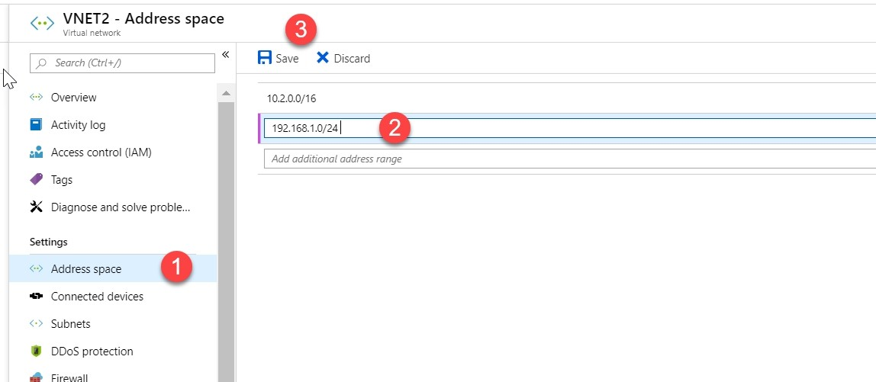

After you save the address space, create a new subnet with the address space and then ensure the VM is put in the new subnet

Option A is incorrect since the network interface can only receive an address from 10.2.0.0/24 as per the powershell output given in the Exhibit.

Option B is incorrect since you need to add the address space 192.168.1.0/24 before adding the subnet

Options D and E are incorrect since you need to add the address space and subnet and not delete the address space and subnet

https://docs.microsoft.com/en-us/azure/virtual-network/virtual-networks-overview

### QUESTION 595

You have an Azure subscription.

You need to implement a custom policy that meet the following requirements:

* Ensures that each new resource group in the subscription has a tag named organization set to a value of whizlabs
* Ensures that resource group can be created from the Azure portal.
* Ensures that compliance reports in the Azure portal are accurate.

You need to complete the below policy to match this requirement

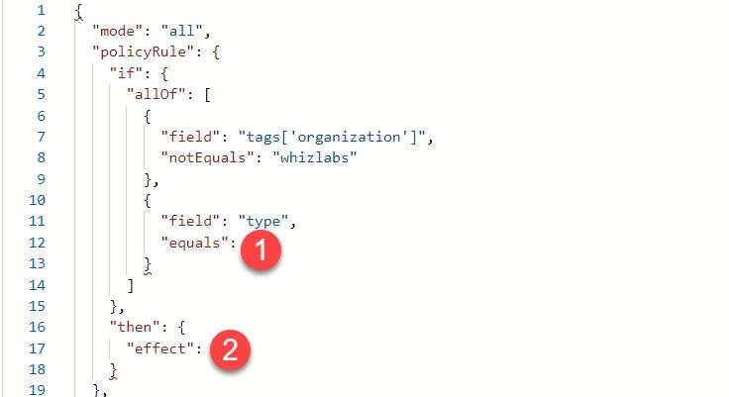

Which of the following would be the value in position 2 for the “effect” field?

|  |  |
| --- | --- |
| A. | "Append" |
| B. | "Deny" |
| C. | "DeployifNotExists" |
| D. | 0 |

**Answer:** B

**Explanation:**

If you look at the default policy which is in place for enforcing tags, you can see that the effect should be Deny:

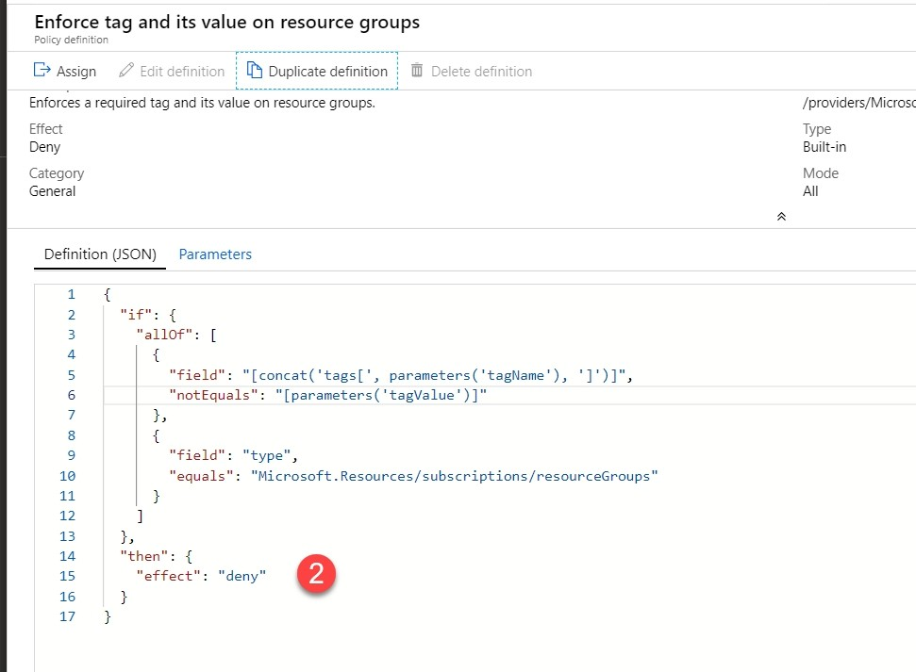

Since this option is clearly mentioned in the Azure in-built policy, all other options are incorrect. https://docs.microsoft.com/en-us/azure/governance/policy/overview

### QUESTION 596

Your company wants to deploy a blogging solution on Azure. Below are the key deployment requirements:

* Ability to connect to Azure BLOB storage as the origin
* Ensure that users across the world get the same performance when they access the blogging site

You provide a solution of using the cloud tiering service. Does this solution meet the requirement?

|  |  |
| --- | --- |
| A. | Yes |
| B. | No |

**Answer:** B

**Explanation:**

The cloud tiering feature is used to ensure volumes have a percentage of free space when you use the Azure File Sync service. The ideal solution to use here is the Content Delivery service https://docs.microsoft.com/en-us/azure/storage/files/storage-sync-cloud-tiering

### QUESTION 597

You work as an Azure Administrator for a company. You have to ensure that a role can be in

place that would have the following requirements:

* View all the resources in the Azure subscription
* Issue support requests to Microsoft.
* Use the principle of least privilege.

You have to complete the below JSON role definition

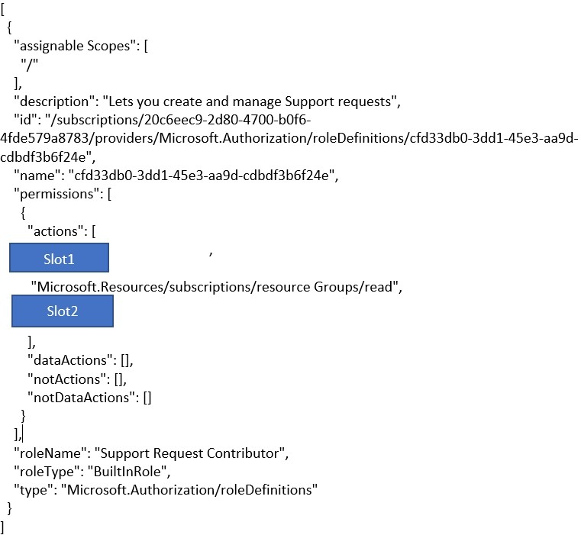

Which of the following would go into Slot2?

|  |  |
| --- | --- |
| A. | "*/*" |
| B. | "*/Microsoft.Support" |
| C. | "Microsoft.Support/*" |
| D. | 0 |

**Answer:** C

**Explanation:**

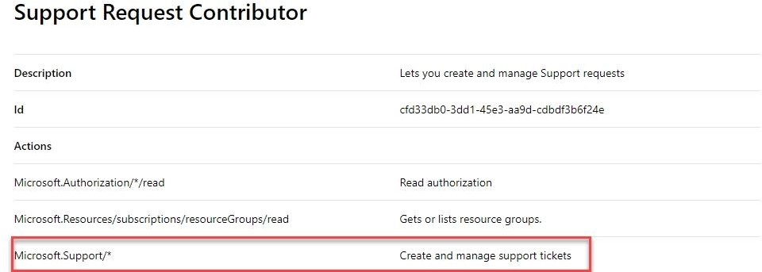

https://docs.microsoft.com/en-us/azure/role-based-access-control/built-in-roles

### QUESTION 598

A company currently has an Azure subscription. They have deployed a Virtual Network to the subscription. The details of the Network are given below:

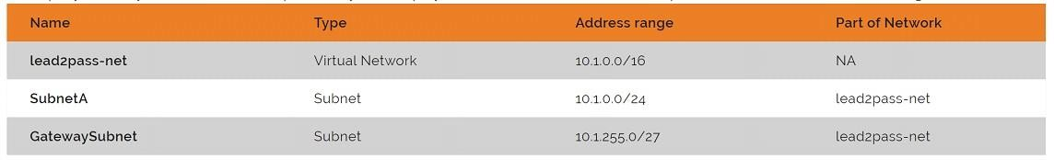

You have to setup a Site-to-Site VPN connection with your on-premise network.

The VPN device has an IP address of 12.10.79.10. Your on-premise network has an IP address range of 10.101.1.0/24.

You now have to configure the local network gateway as shown below:

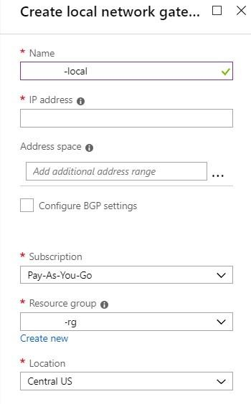

Which of the following would you enter as the address range for the Local Network gateway?

|  |  |
| --- | --- |
| A. | 10.1.0.0/24 |
| B. | 10.1.255.0/27 |
| C. | 10.101.1.0/24 |
| D. | 10.1.0.0/16 |

**Answer:** C

**Explanation:**

The address space needs to be that of the Address range of the local network in your on-premise environment.

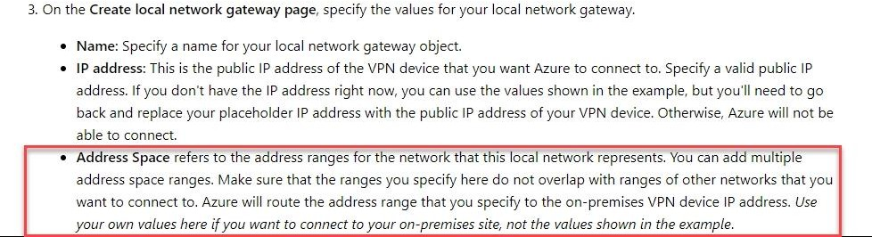

https://docs.microsoft.com/en-us/azure/vpn-gateway/vpn-gateway-howto-site-to-site-resource- manager-portal

### QUESTION 599

A company has just setup an Azure account and subscription. The Senior management want to keep a control on costs during the initial deployment of resources.

Which of the following can be used to keep a tabs on overall costs incurred for hosting resources in Azure?

|  |  |
| --- | --- |
| A. | Use the pricing calculator to calculate the costs beforehand. |
| B. | Create a budget and then an action group to notify when thresholds are breached. |
| C. | Use the Azure Advisor to notify when costs are being breached. |
| D. | Use resource tags for all resources |

**Answer:** B

**Explanation:**

You can create a budget in Azure cost management and also create an action group to notify when costs are being breached.

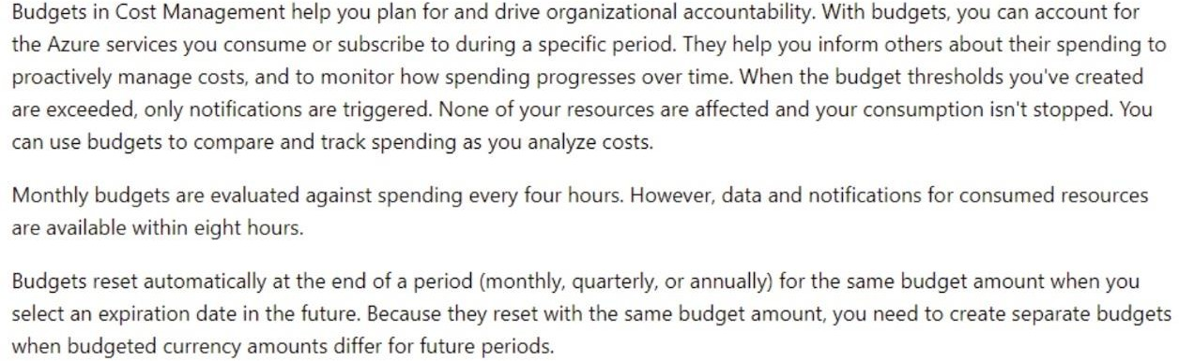

Option A is partially correct but is only viable before creating resources in Azure.

Option C is incorrect since this is ideal when you want to have recommendations in place in Azure.

Option D is incorrect since this is ideal from a billing perspective and segregation on costs. https://docs.microsoft.com/en-us/azure/cost-management/tutorial-acm-create-budgets

### QUESTION 600

An IT administrator has a setup a Web app in Azure called lead2pass-app. Currently the Application is part of a Free App service plan.

The Web app just stops after 60 minutes of usage every day. You need to ensure that the

application can run continuously every day.

You propose to change the App Service Plan to Shared. Would this solution resolve the issue?

|  |  |
| --- | --- |
| A. | True |
| B. | False |

**Answer:** B

**Explanation:**

With the Shared service plan, you are only allowed to run an App for 240 minutes a day. So, this will not resolve the issue.

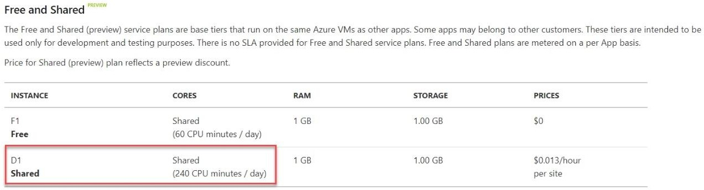

https://azure.microsoft.com/en-us/pricing/details/app-service/plans/

### QUESTION 601

An IT administrator has a setup a Web app in Azure called lead2pass-app. Currently the Application is part of a Free App service plan.

The Web app just stops after 60 minutes of usage every day. You need to ensure that the application can run continuously every day.

You propose to change the App Service Plan to Basic. Would this solution resolve the issue?

|  |  |
| --- | --- |
| A. | True |
| B. | False |

**Answer:** A

**Explanation:**

Yes, this will work, since here the Apps will run on Instances associated with the plan.

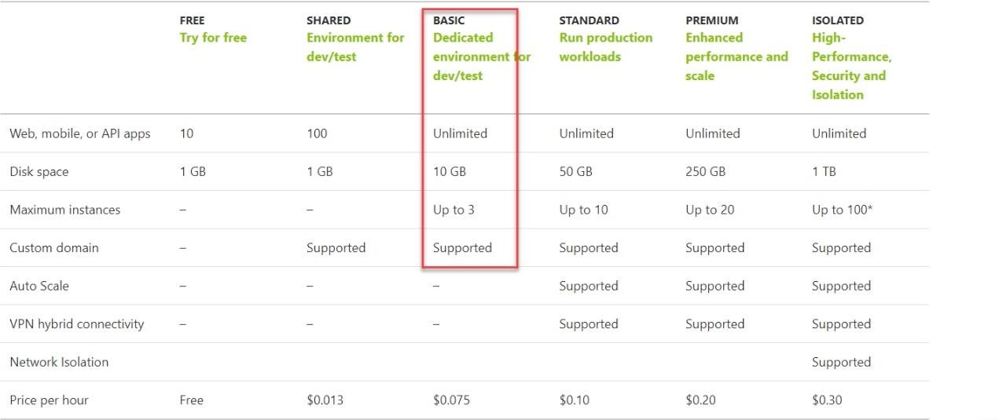

https://azure.microsoft.com/en-us/pricing/details/app-service/plans/

### QUESTION 602

An IT administrator has a setup a Web app in Azure called lead2pass-app. Currently the Application is part of a Free App service plan.

The Web app just stops after 60 minutes of usage every day. You need to ensure that the application can run continuously every day.

You propose to add a web job so that the app could run on a continuous basis. Would this solution resolve the issue?

|  |  |
| --- | --- |
| A. | True |
| B. | False |

**Answer:** B

**Explanation:**

No, because even if you have a web job, you can still can only consume 60 minutes of CPU time per day.

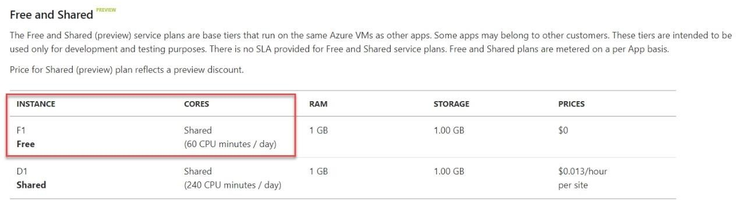

https://azure.microsoft.com/en-us/pricing/details/app-service/plans/

### QUESTION 603

An IT Administrator has deployed an Azure Web App to a service plan. The details of the App service plan are shown below:

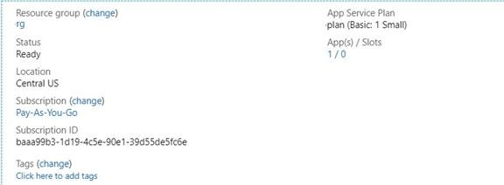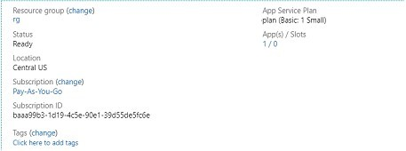

The IT Administrator needs to ensure that the Web application can scale on demand. If the CPU percentage of the Web application goes beyond 60% for a duration of 10 minutes, then the application should scale accordingly.

Which of the following are steps that need to be performed to fulfil this requirement?

|  |  |
| --- | --- |
| A. | From the Scale Out blade of the App Service Plan, choose Autoscale |
| B. | From the Scale Up blade of the App Service Plan, choose Autoscale |
| C. | From the Scale Up blade of the App Service Plan, change the service plan |
| D. | From the Scale Out blade of the App Service Plan, change the service plan |
| E. | Add a scale condition to scale to a specific Instance count |
| F. | Add a scale condition to scale to a specific metric |

**Answer:** ACF

**Explanation:**

Option B is incorrect since the Scale up option is used to change the App service plan Option D is incorrect since this is used to enable Autoscale

Option E is incorrect since the Qmentions that we need to scale based on the CPU percentage metric

https://docs.microsoft.com/en-us/azure/app-service/overview-hosting-plans

### QUESTION 604

A web developer has deployed an App to Azure Web Apps.

The Web app is part of the standard App Service Plan. You have to ensure that anonymous access is disabled when test users try to access the web application.

In order to access the web application, they would need to enter a user name and password. Which of the following would be used to configure this setting?

|  |  |
| --- | --- |
| A. | Advanced Tools |
| B. | Authentication/ Authorization |
| C. | Access control (IAM) |

|  |  |
| --- | --- |
| D. | Deployment credentials |

**Answer:** B

**Explanation:**

An example screenshot is given below on the setting on the Azure Web app which is used to disable anonymous access.

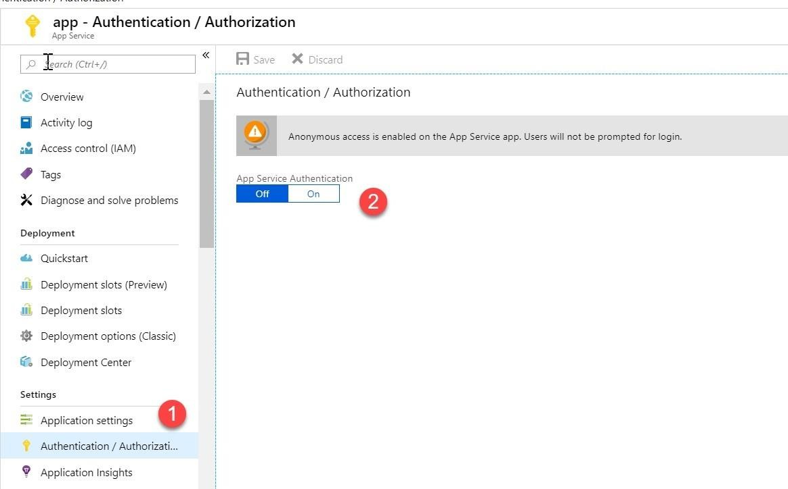

Since this is clearly evident from the Azure portal, all other options are invalid. https://docs.microsoft.com/en-us/azure/app-service/overview-authentication-authorization

### QUESTION 605

An IT Administrator has been instructed to create a service Bus queue. Its needs to be ensured that the Service Bus queue guarantees first in first-out (FIFO) delivery of messages.

Which of the following needs to be implemented for this requirement?

|  |  |
| --- | --- |
| A. | Set the Lock Duration setting to 5 seconds. |
| B. | Enable duplicate detection. |
| C. | Set the Max Size setting of the queue to 1 GB. |
| D. | Enable partitioning. |
| E. | Enable sessions. |

**Answer:** E

**Explanation:**

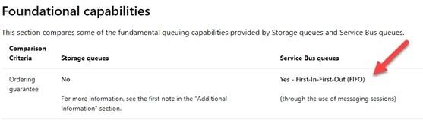

https://docs.microsoft.com/en-us/azure/service-bus-messaging/service-bus-azure-and-service- bus-queues-compared-contrasted

### QUESTION 606

A company is planning on using Azure Site recovery for migrating a set of On-premise servers onto Azure. As an IT Administrator you are going to setup Azure and the configuration/process servers in your on-premise environment.

Which of the following needs to be configured to ensure that the replication can be carried out? Choose 2 answers from the options given below

|  |  |
| --- | --- |
| A. | Ensure that the machines that need to be replicated can communicate with Azure on port 443 |
| B. | Ensure that the machines that need to be replicated can communicate with the process server on port 443 |
| C. | Ensure that the process server can communicate with Azure on port 443 |
| D. | Ensure that the process server can communicate with Azure on port 359 |

**Answer:** BC

**Explanation:**

Option A is incorrect since it is the process server that sends the replication data Option D is incorrect since the process server needs to communicate over port 359 https://docs.microsoft.com/en-us/azure/site-recovery/physical-azure-architecture

### QUESTION 607

A company has an Azure subscription and resources on their on-premise network. The On- premise network contains the following:

* A Hyper-V host named lead2pass-server
* The host runs Windows Server 2016
* The host is currently running 5 Virtual Machines , all running Windows Server 2016

You have to migrate the virtual machines from lead2pass-server to Azure. You create a recovery services vault and create a Hyper-V site. You now need to add the Hyper-V host to the recovery services vault.

Which of the following is the right series of steps that need to be followed to accomplish this requirement?

|  |  |
| --- | --- |
| A. | Download the installation file for the Azure Site Recovery Provider. Download the vault registration key. Install the Azure Site Recovery Provider on lead2pass-server and register the  server |

|  |  |
| --- | --- |
| B. | Download the installation file for the Azure Site Recovery Provider. Download the storage key.  Install the Azure Site Recovery Provider on lead2pass-server and register the server |
| C. | Download the installation file for the Azure Site Recovery Provider. Download the vault registration key. Install the Azure Site Recovery Provider on each virtual machine and register the virtual machines |
| D. | Download the installation file for the Azure Site Recovery Provider. Download the storage key. Install the Azure Site Recovery Provider on each virtual machine and register the virtual machines |

**Answer:** A

**Explanation:**

https://docs.microsoft.com/en-us/azure/site-recovery/hyper-v-azure-tutorial

### QUESTION 608

Your company is planning on migrating their on-premise VMWare Virtual Machines to Azure. For this purpose, they are planning on using the Azure Migrate tool. You first need to discover which of the on-premise machines need to be assessed for the migration.

Which of the below mentioned steps need to be followed for this requirement. Choose 3 answers from the options given below

|  |  |
| --- | --- |
| A. | Create a collector virtual machine |
| B. | Download the OVA file for the collector appliance |
| C. | Create a migration group in the project |
| D. | Configure the collector and start discovery |
| E. | Create an assessment in the project |

**Answer:** ABD

**Explanation:**

https://docs.microsoft.com/en-us/azure/migrate/tutorial-assessment-vmware

### QUESTION 609

Your company has an Azure subscription and has setup the following Virtual Networks and subnets in Azure:

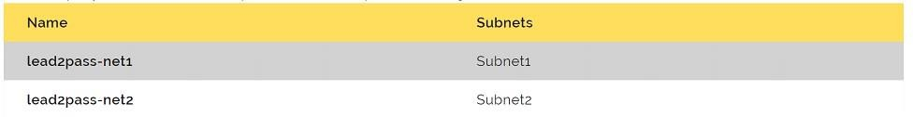

The following Virtual Machines have been deployed in the subnets:

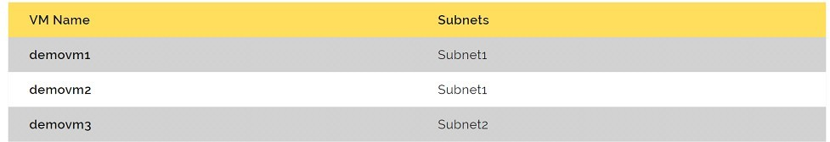

You now need to add an application gateway to the Virtual Network lead2pass-net1. Which of the following would you do first?

|  |  |
| --- | --- |
| A. | Add a service endpoint. |
| B. | Add a virtual network. |
| C. | Move demovm3 to Subnet1. |
| D. | Stop demovm1 and demovm2 |

**Answer:** D

**Explanation:**

When you deploy an application gateway to a Virtual Network, it needs to have an empty subnet to deploy the application gateway resources. As an example shown below, a Virtual Machine exists in a subnet in the Virtual Network lead2pass-net.

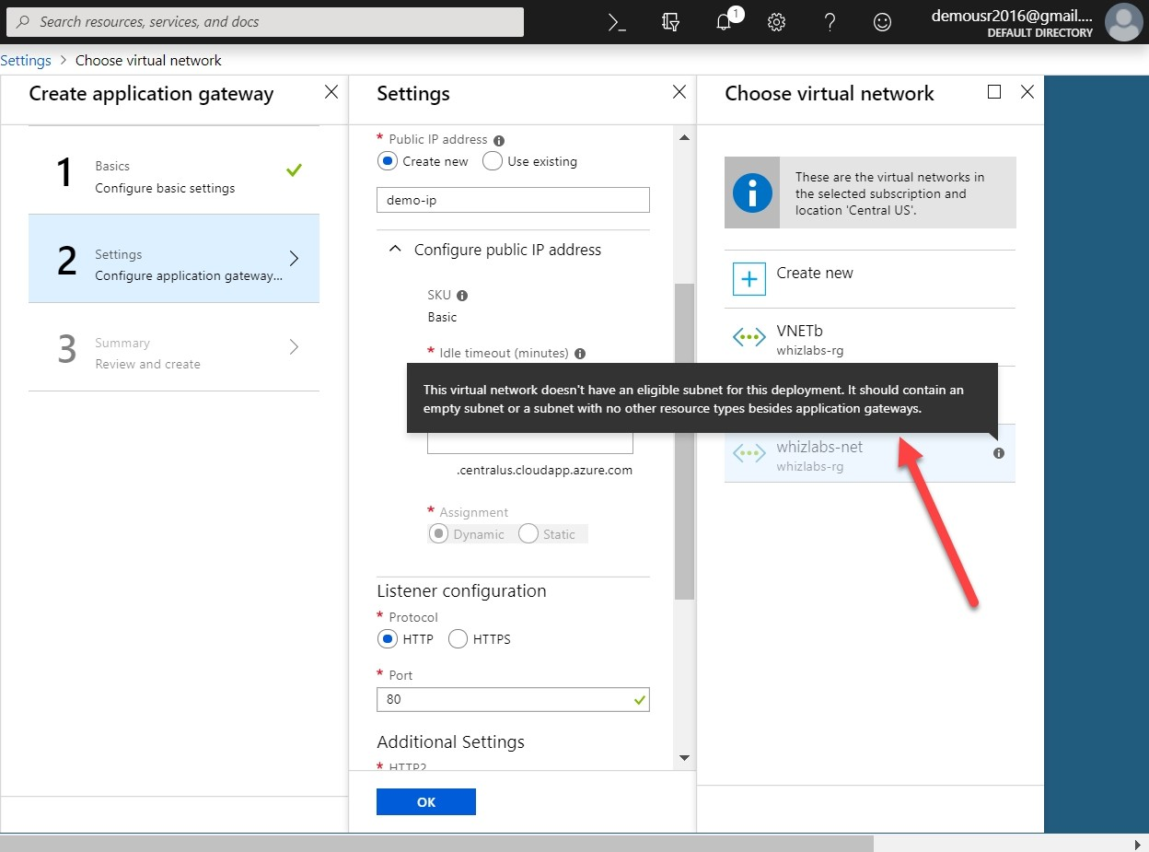

This is why we can't use this Network to deploy the application gateway.

So, in our question, the only way to deploy the application gateway is to first stop the virtual machines and deallocate them. This seems to be the most suitable answers from the options given. The other options provided would not assist in the creation of the gateway. https://docs.microsoft.com/en-us/azure/application-gateway/quick-create-portal

### QUESTION 610

A company has setup a Load balancer that load balances traffic on port 80 and 443 across 3 virtual machines.

You have to ensure that all RDP traffic is directed towards a VM named demovm. How would you achieve this?

|  |  |
| --- | --- |
| A. | By creating a new public load balancer for demovm |
| B. | By creating a new internal load balancer for demovm |

|  |  |
| --- | --- |
| C. | By creating an inbound NAT rule |
| D. | By creating a new IP configuration |

**Answer:** C

**Explanation:**

https://docs.microsoft.com/en-us/azure/load-balancer/tutorial-load-balancer-port-forwarding-portal

### QUESTION 611

A company has an Azure account and current has an Azure premium P2 based subscription. As an IT administrator, you have to configure a conditional access policy as shown below:

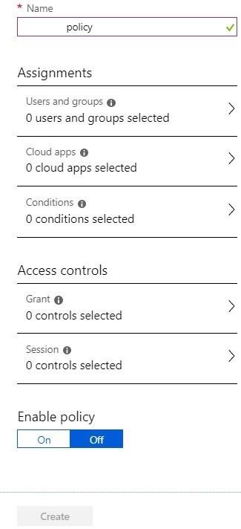

You have to ensure the following key requirement:

- Users from select locations would need to authenticate using MFA.

In which of the following sections would you configure the locations for the policy?

|  |  |
| --- | --- |
| A. | Users and Groups |

|  |  |
| --- | --- |
| B. | Conditions |
| C. | Grants |
| D. | Session |

**Answer:** B

**Explanation:**

https://docs.microsoft.com/en-us/azure/active-directory/conditional-access/overview

### QUESTION 612

A company has an Azure account and current has an Azure premium P2 based subscription. As an IT administrator, you have to configure a conditional access policy as shown below:



You have to ensure the following key requirement:

- Users from select locations would need to authenticate using MFA.

In which of the following sections would you configure the MFA requirement for the policy?

|  |  |
| --- | --- |
| A. | Users and Groups |

### QUESTION 613

You are working as an IT Administrator for a company. You are managing an Azure AD tenant named lead2pass.com.

You assign the Conditional Access Administrator role to a user named lead2passadmin.

You need to ensure that the user has just-in-time access as a conditional access administrator. Which of the following needs to be done to achieve this requirement?

|  |  |
| --- | --- |
| A. | Enable MFA for the directory |
| B. | Set lead2passadmin as Eligible for the Privileged Role Administrator role. |
| C. | Set lead2passadmin as Eligible for the Conditional Access Administrator role. |
| D. | Enable Azure AD Identity Protection |

**Answer:** C

**Explanation:**

Option A is incorrect since there is no requirement for MFA

Option B is incorrect since the role should be Conditional Access Administrator role Option D is incorrect since we have to assume that Azure AD Identity Protection is already enabled for the tenant.

https://docs.microsoft.com/en-us/azure/active-directory/privileged-identity-management/pim-how- to-add-role-to-user

### QUESTION 614

Your company has an Azure subscription. The subscription contains an Azure Virtual Machine named demovm that is deployed to a resource group named lead2pass-rg.

The Virtual Machine is used to run services that can be used to deploy resources to the Resource Group.

You have to ensure that the service running on the Virtual Machine can be used to manage resources in the Resource Group.

Which of the following must you do to fulfil this requirement?

|  |  |
| --- | --- |
| A. | From the Azure portal modify the Access control settings of the virtual machine |
| B. | From the Azure portal, modify the Policies settings of the resource group |
| C. | From the Azure portal, modify the value of the Managed Service Identity option for the virtual machine |
| D. | From the Azure portal, modify the Access control settings of the resource group |

**Answer:** C

**Explanation:**

https://docs.microsoft.com/en-us/azure/active-directory/managed-identities-azure-resources/qs- configure-portal-windows-vm

### QUESTION 615

You plan to deploy five virtual machines to a virtual network subnet.

Each virtual machine will have a public IP address and a private IP address. Each virtual machine requires the same inbound and outbound security rules. What is the minimum number of network interfaces that you require?

|  |  |
| --- | --- |
| A. | 5 |
| B. | 10 |
| C. | 15 |
| D. | 20 |

**Answer:** A

**Explanation:**

So, when you attach or have a network interface for a Virtual Machine, that network interface can have both a private and public IP address.

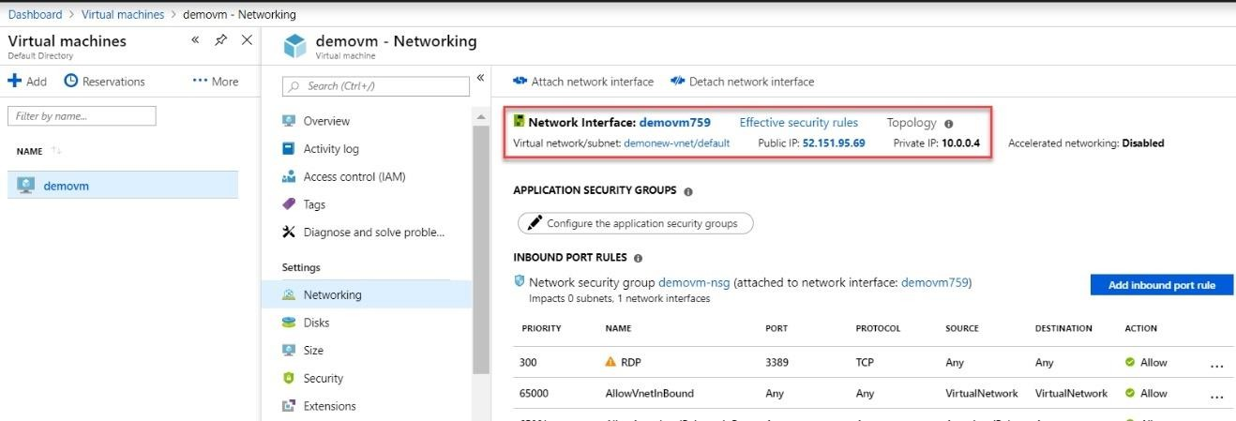

So, by this measure, we only need to define 5 network interface cards, one for each virtual machine.

https://docs.microsoft.com/en-us/azure/virtual-network/virtual-network-network-interface